1.How to get array first element without knowing the key of Array using PHP built-in function only?

<?php
$array = ['a' => "hello", 'b' => "how", 'c' => "are", 'd'=>"you"];
$firstKey = reset($array);
echo $firstKey;
?>

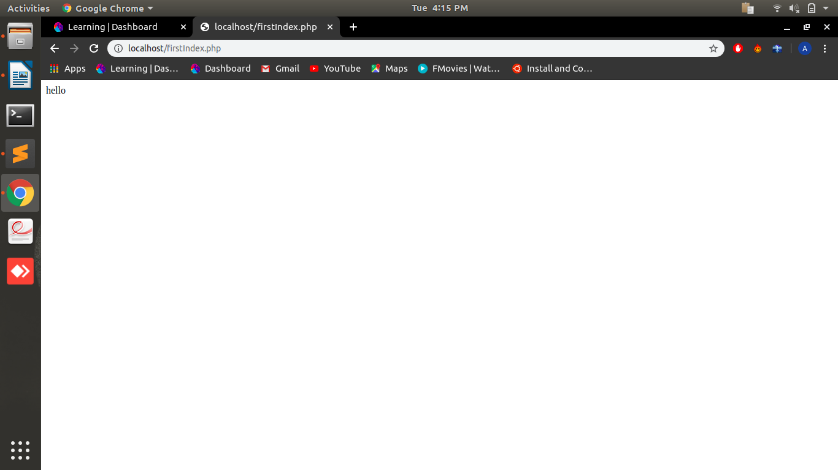

2.How can we get the second of the current time using date built-in functions?

<?php
echo date("s") . "\n";
?>

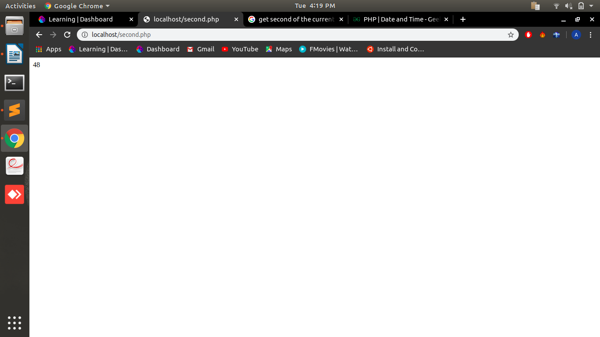
3.What is the difference between the functions unlink and unset?

UNLINK: unlink() is a predefined function which is defined in php file handeling. It is used to delete a file that is previously uploaded by code.

EX:
<?php
$file = fopen("test.txt","w");
echo fwrite($file,"Hello World. Testing!");
fclose($file);
unlink("test.txt");
?>

UNSET: unset() is also a predfined function which is used to destroy a variable which was defined earlier or makes the value of that variable null.

EX:
<?php
$x='Hello';
echo "before unset : ".$x;
echo"<br>";
unset($x);
echo "after unset : " .$x;
?>

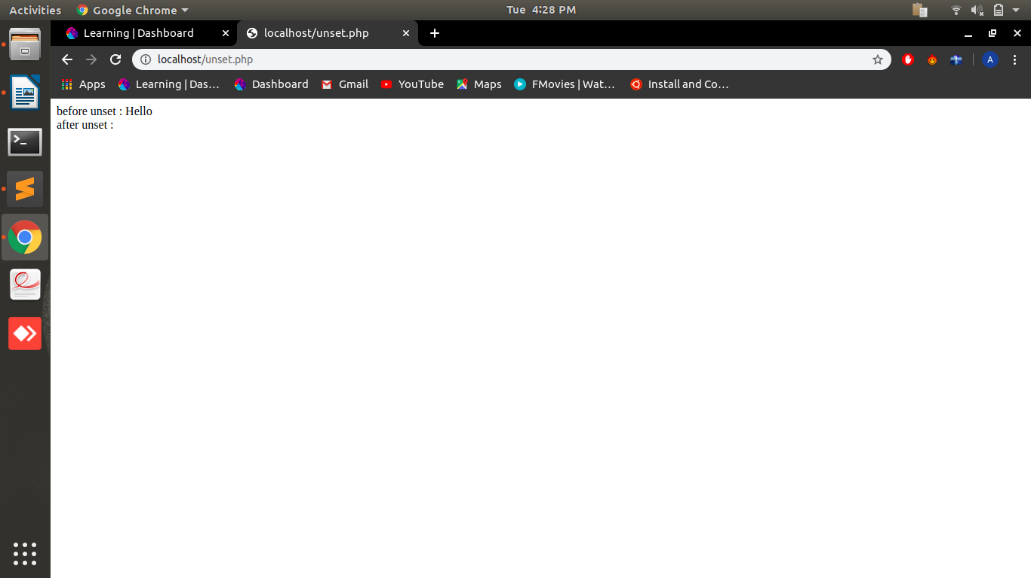
4.How to append data into a file named 'abc.txt'?

STEPS:
1.Open file in append mode using fopen with a flag
2.Write in file using fwrite which appends the data inside the file
3.Close the file using fclose

EX:
<?php
$fp = fopen('data.txt','a');
fwrite($fp, ' hello ');
fwrite($fp, 'world');
fclose($fp);
?>

5.How can we get the properties (size, type, width, height) of an image using PHP built-in functions?

<?php
$x=getimagesize("dino.jpg");
$x1=filesize("dino.jpg");
echo "<br>";
echo "size of image : " . $x1 . "<br>";
echo "type of image : " . $x[2] . "<br>";
echo "width of image :" . $x[0] . "<br>";
echo "height of image :" .$x[1];
?>

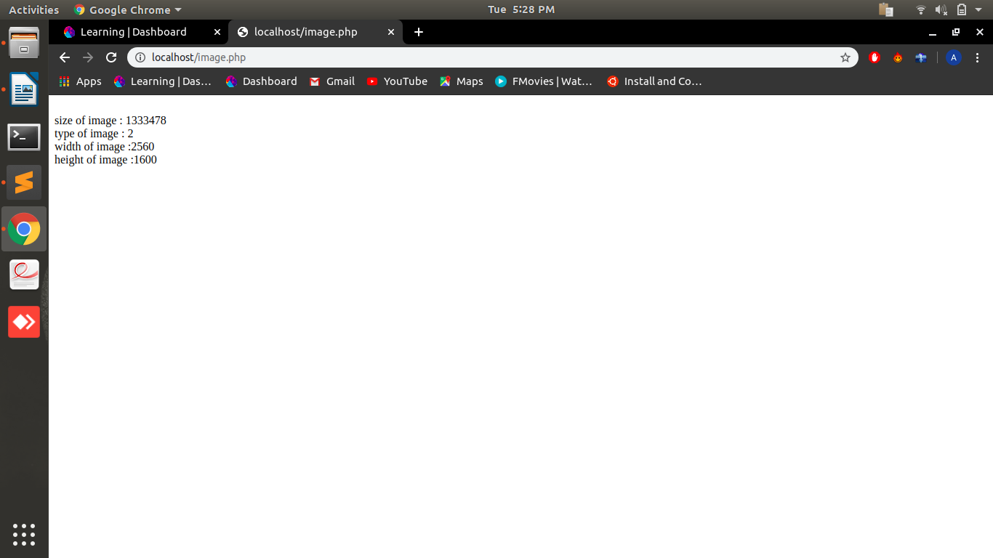
6.Write a program to check if a string is a PALINDROME or not using built-in functions?

<?php
$str1="aba";
echo $str1." : ";
$x=strrev($str1);
if($str1==$x)
{
echo "palindrome";
}
else
{
echo "not palindrome";
}
?>

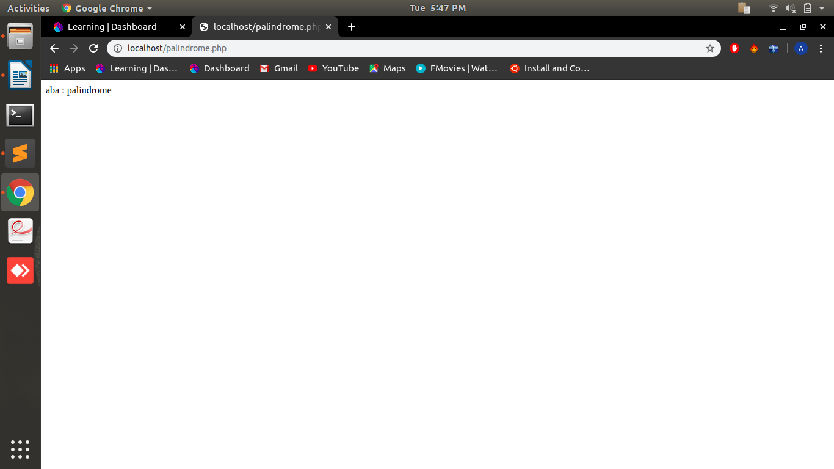
7.How to pass variables by value and reference in PHP? Explain with code snippets.

1.Call By Value
<?php
function hello(int $x, int $y)
{
return $x+$y;
}
echo hello(10,20);
?>

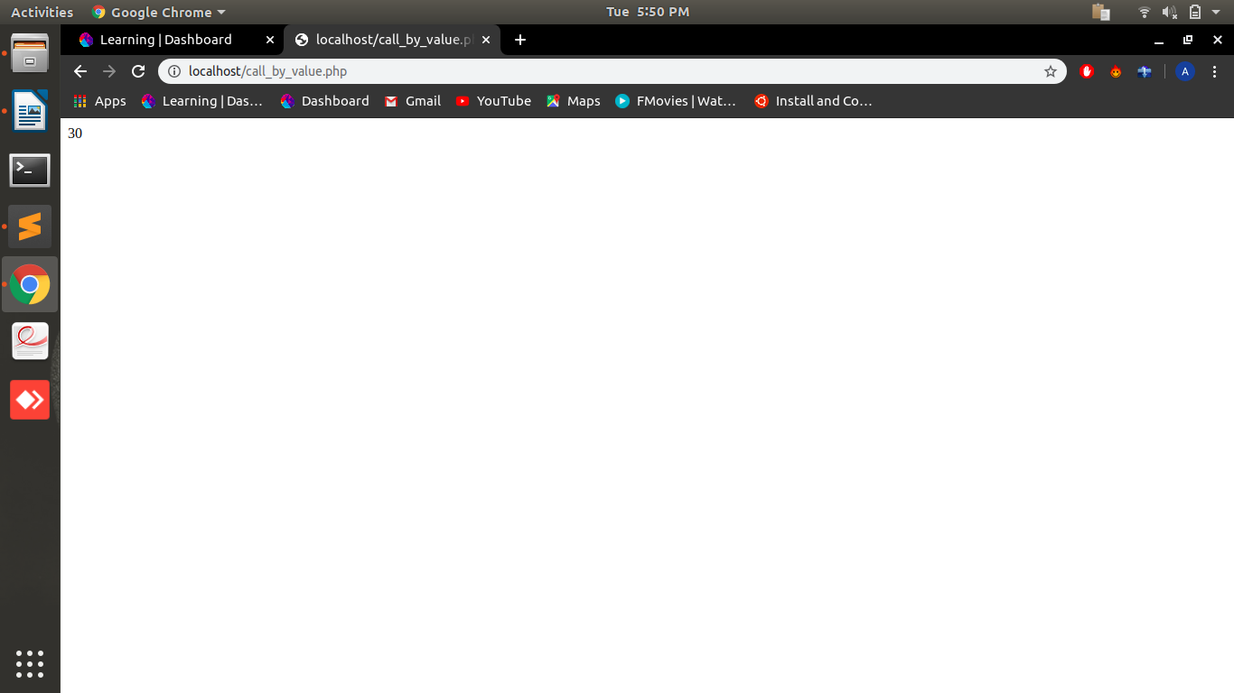
2.Call By Refrence

<?php
function hello(&$str1)
{
$str1=$str1.'world';
}
$str = 'hello ';
hello($str);
echo $str;
?>

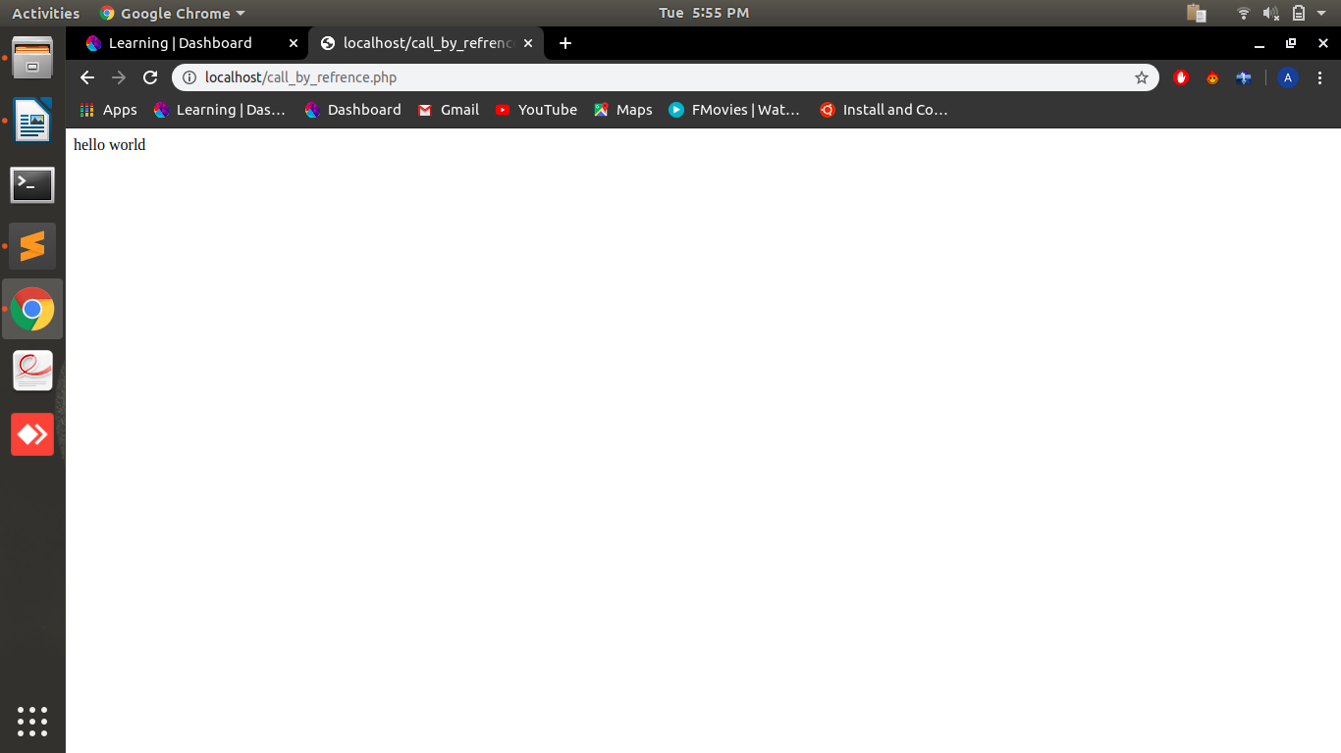
8.What’s the difference between the include() and require() functions? Show with an example.

File which is imported by both methods with wrong name: abc.php

Include(): when we import a file to our php page using include function if the imported file not present the page still execute the rest of the code.

EX:
<?php
include "abc1.php";
echo "<br>"."hello";
?>

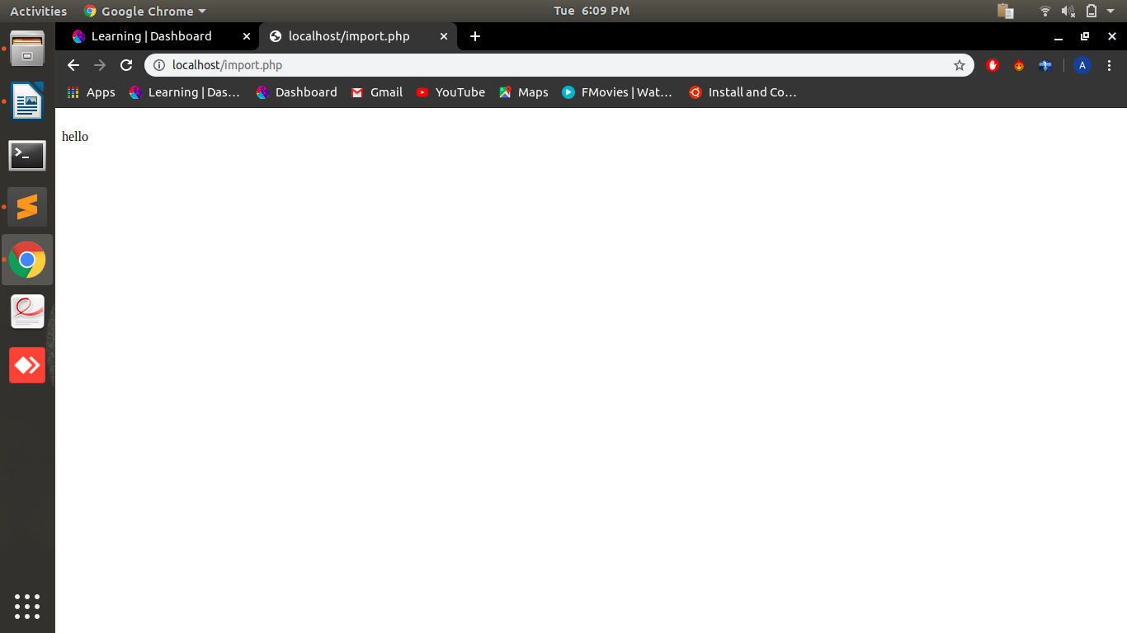

Require():when a file is import using require function if the file is not available at the location from which we import the file the php page doesn’t execute further and shows the error.

EX:
<?php
require "abc1.php";
echo "<br>"."hello";
?>

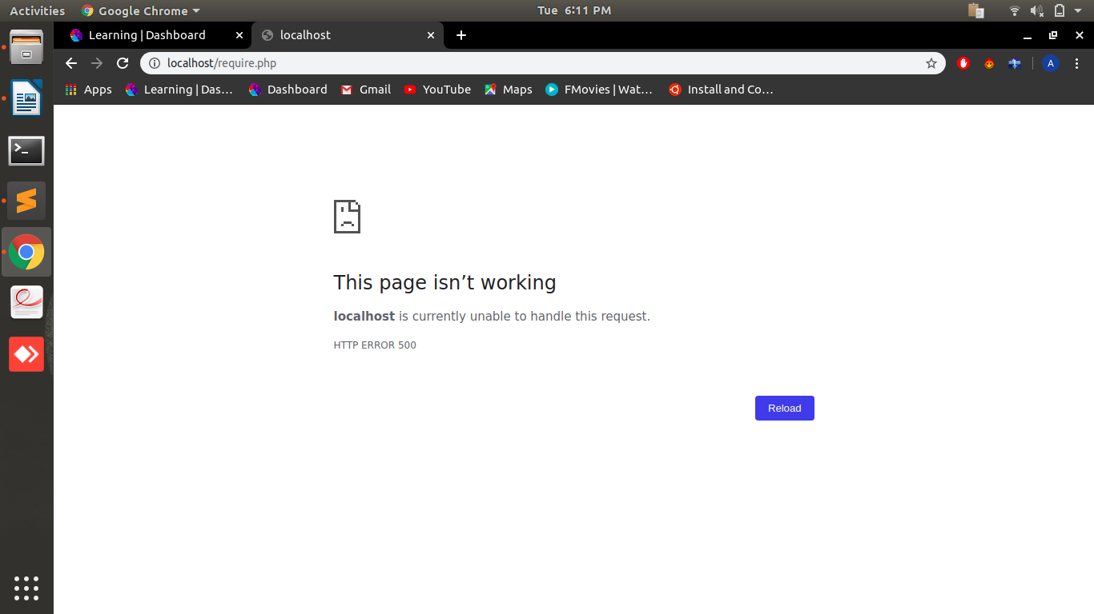
9.Explain different sorting function in PHP? Show with Examples.

1.Sort(): This function sort the array in ascending order and set the index values by default start from 0 to n.

<?php
$x=array("a"=>"hello", "b"=>"arjun", "c"=>"what", "d"=>"you", "e"=>"do");
echo"before sort : <br>";
foreach ($x as $key => $value) {
echo "$key : $value<br>";
}
echo"<br><br>after sort : <br>";
sort($x);
foreach ($x as $key => $value) {
echo "$key : $value<br>";
}
?>
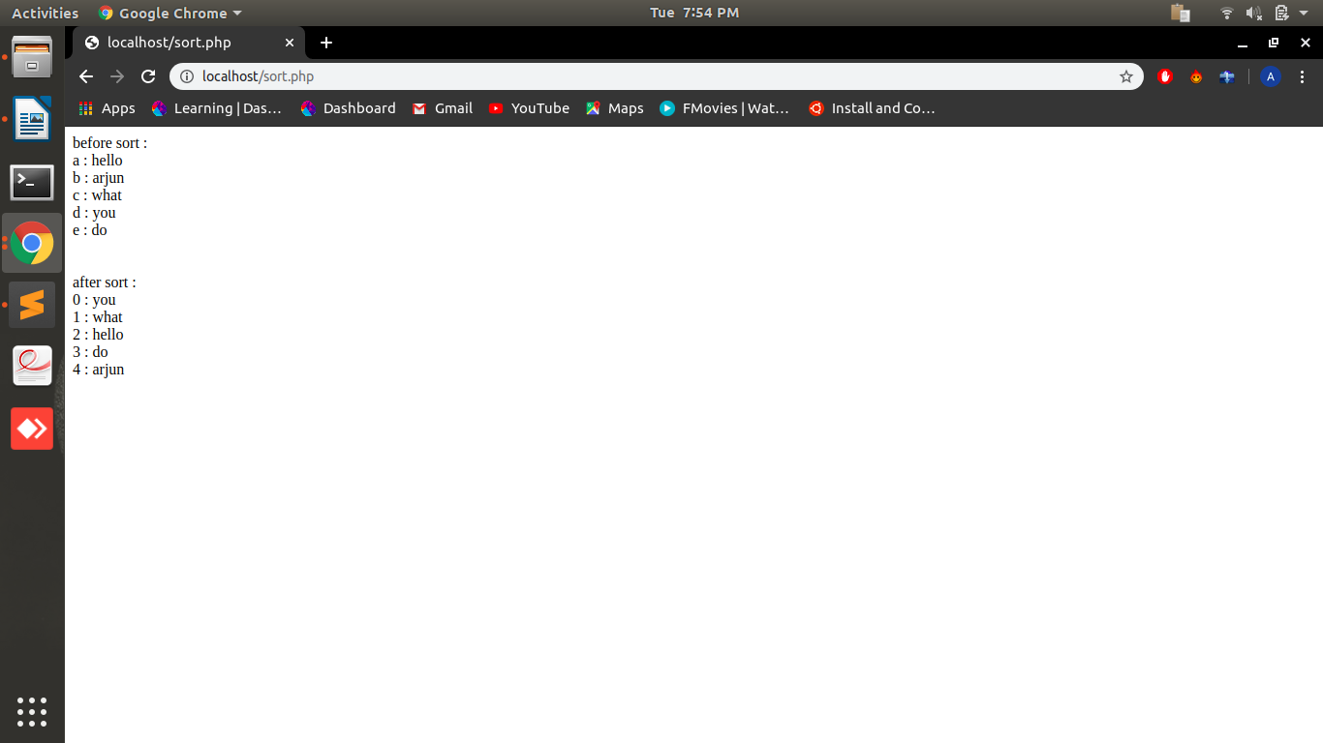
2.rsort(): This function sort the array in descending order and set the index values by default start from 0 to n.

<?php
$x=array("a"=>"hello", "b"=>"arjun", "c"=>"what", "d"=>"you", "e"=>"do");
echo"before sort : <br>";
foreach ($x as $key => $value) {
echo "$key : $value<br>";
}
echo"<br><br>after sort : <br>";
rsort($x);
foreach ($x as $key => $value) {
echo "$key : $value<br>";
}
?>
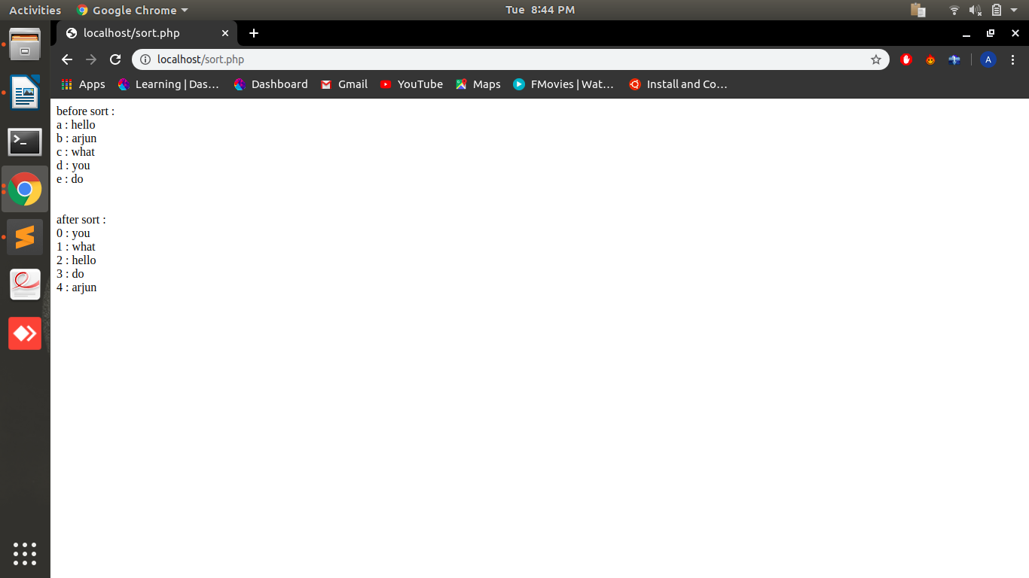
3.asort(): This function sort the values in ascending order also reset the index with their values.

<?php
$x=array("a"=>"hello", "b"=>"arjun", "c"=>"what", "d"=>"you", "e"=>"do");
echo"before sort : <br>";
foreach ($x as $key => $value) {
echo "$key : $value<br>";
}
echo"<br><br>after sort : <br>";
asort($x);
foreach ($x as $key => $value) {
echo "$key : $value<br>";
}
?>

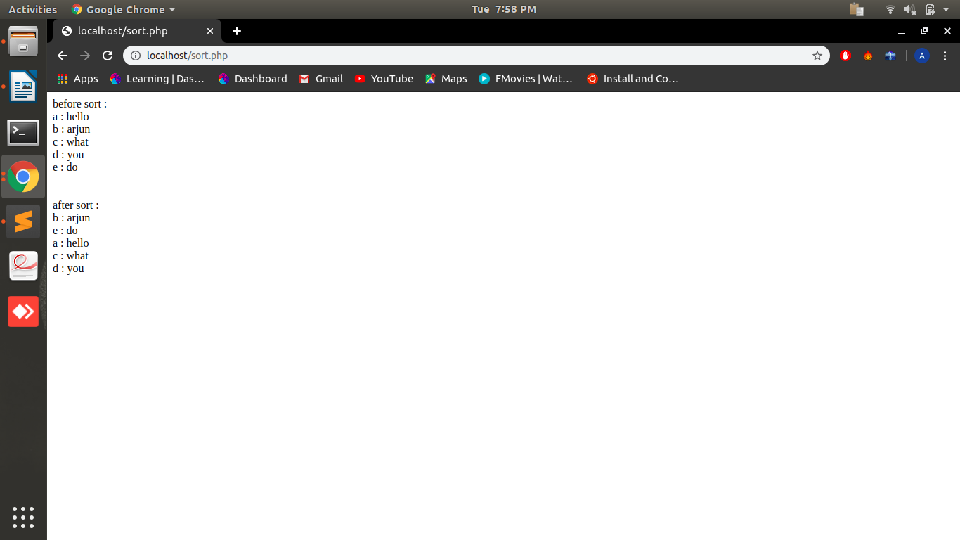
4.ksort():This function sort the keys of array in ascending order with these key their values also change their place

<?php
$x=array("e"=>"hello", "b"=>"arjun", "d"=>"what", "c"=>"you", "a"=>"do");
echo"before sort : <br>";
foreach ($x as $key => $value) {
echo "$key : $value<br>";
}
echo"<br><br>after sort : <br>";
ksort($x);
foreach ($x as $key => $value) {
echo "$key : $value<br>";
}
?>

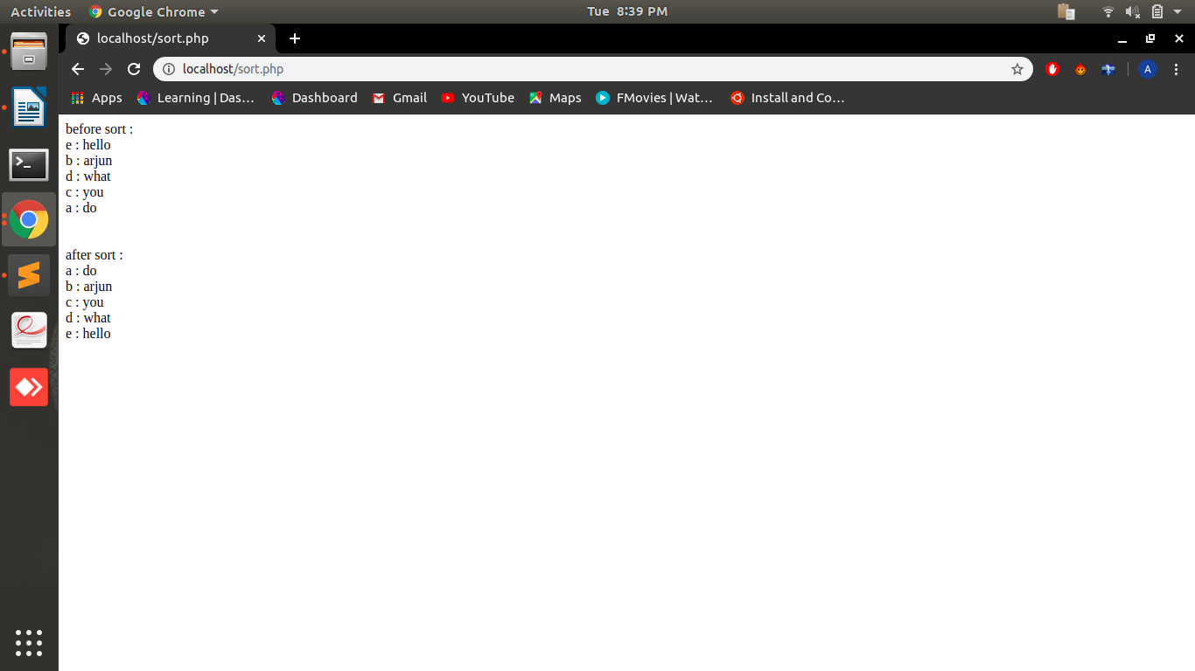
5.arsort():This function sort the array on the basis of their value in descending order.

<?php
$x=array("a"=>"hello", "b"=>"arjun", "c"=>"what", "d"=>"you", "e"=>"do");
echo"before sort : <br>";
foreach ($x as $key => $value) {
echo "$key : $value<br>";
}
echo"<br><br>after sort : <br>";
arsort($x);
foreach ($x as $key => $value) {
echo "$key : $value<br>";
}
?>

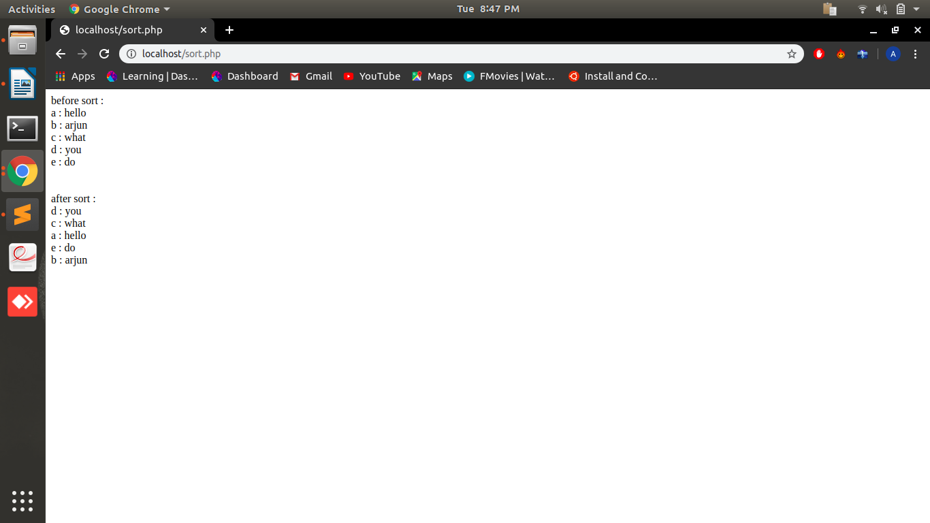
6.krsort():This function sort the array in descending order on the basis of their keys.

<?php
$x=array("d"=>"hello", "b"=>"arjun", "c"=>"what", "e"=>"you", "a"=>"do");
echo"before sort : <br>";
foreach ($x as $key => $value) {
echo "$key : $value<br>";
}
echo"<br><br>after sort : <br>";
krsort($x);
foreach ($x as $key => $value) {
echo "$key : $value<br>";
}
?>

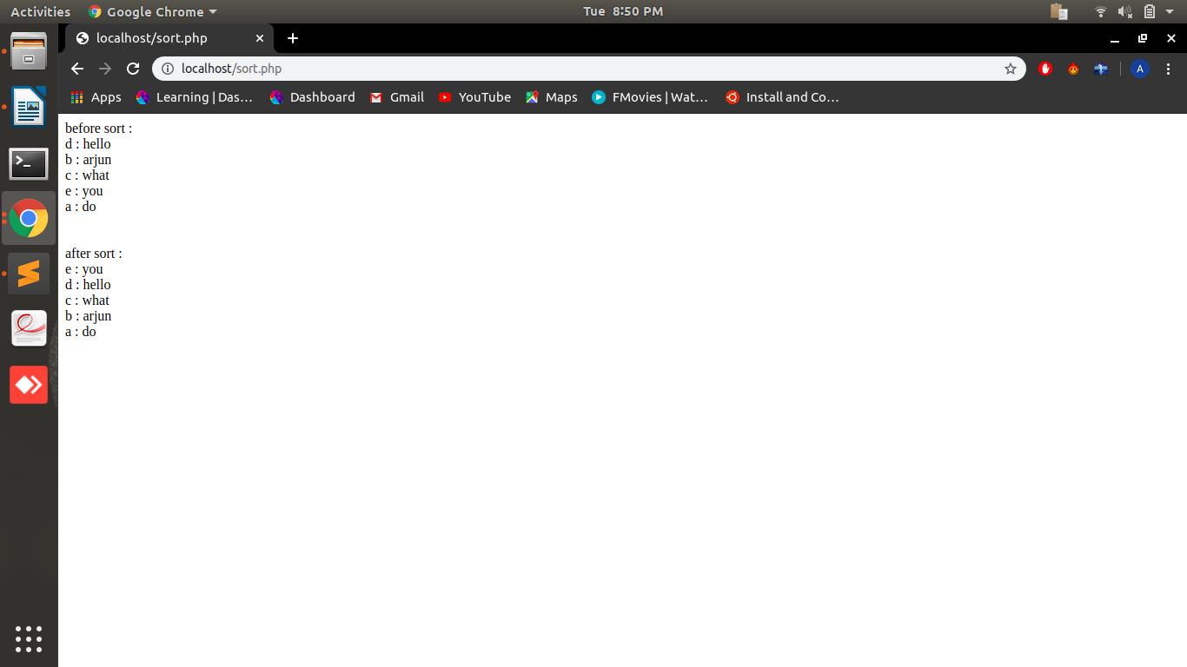
10.Differences between printf, print, echo, sprintf,vprintf, vfprintf, vsprintf in PHP?
1.printf:Printf function gives the output in a sequential way in which format specifiers are defined.

EX:
<?php
$x=”arjun”;
printf("Hello %s",$x);
?>

2.print:Print statement takes only one argument and returns a value 1. It is slower than echo.It doesn’t support any format specifiers.

EX:
<?php
print "Hello world";
?>

3.echo:echo statement has no return value it is faster than print and takes multiple parameters.It doesn’t support any format specifiers.

EX:
<?php echo “hello world”; ?>

4.sprintf: The sprintf function writes formated string to a variable.

EX:
<?php
$num=1;
echo"sprintf=> ";
$greet=sprintf("hello %u Arjun ",$num);
echo $greet;
?>

5.vprintf:The vprintf is used to give output of an formated string.It takes array to insert the value at the place of format specifier.

EX:
<?php
$number =9;
$str ="Beijing";
vprintf("There are %u million bicycles in %s.",array($number,$str));
?>

6.vfprintf:It writes the formatted string to a specified output stream (example file or databases).It also takes arguments inside an array to put the value in place of format specifier.

EX:
<?php
$number =9;
$str = "Beijing";
$file = fopen("test.txt","w");
echo vfprintf($file,"There are %u million bicycles in %s.",array($number,$str));
?>

7vsprintf: writes formatted string and assign it to a variable and uses array to take arguments.

EX:
<?php
$number = 9;
$str = "Beijing";
$txt = vsprintf("There are %u million bicycles in %s.",array($number,$str));
echo $txt;
?>
11.Find Time Difference between two dates
'2012-11-04 05:04:00' => Timezone = GMT
'2012-11-05 10:44:00' => Timezone = IST
And Return Date Time in GMT format.

Doubt...............................................................................................

12.Return contents of your working directory in descending order by name in PHP

<?php
$dir = "/var/www/html";
$b = scandir($dir,1);
foreach ($b as $key => $value) {
echo"$value<br>";
}
?>

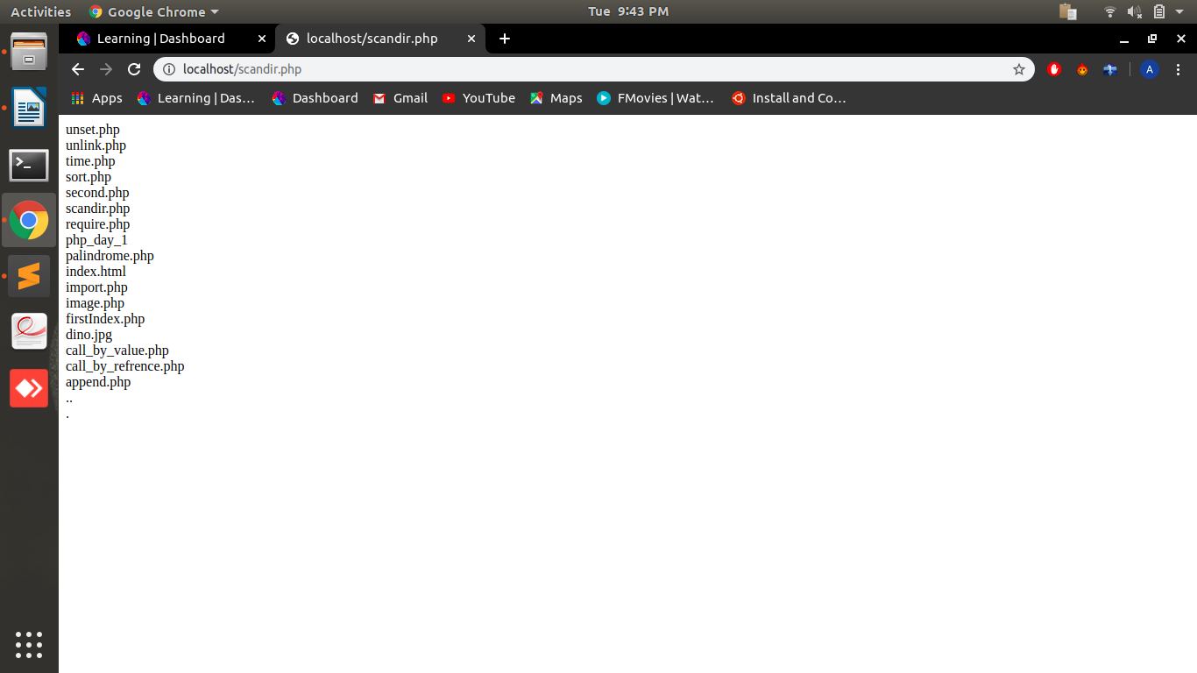
13.Write a Code using your knowledge of builtin functions to convert Sample string to Resultant String.
Sample string: '082307'
Resultant String: ‘08:23:07’

<?php
$str= '082307';
echo substr(chunk_split($str, 2, ':'), 0, -1);
?>
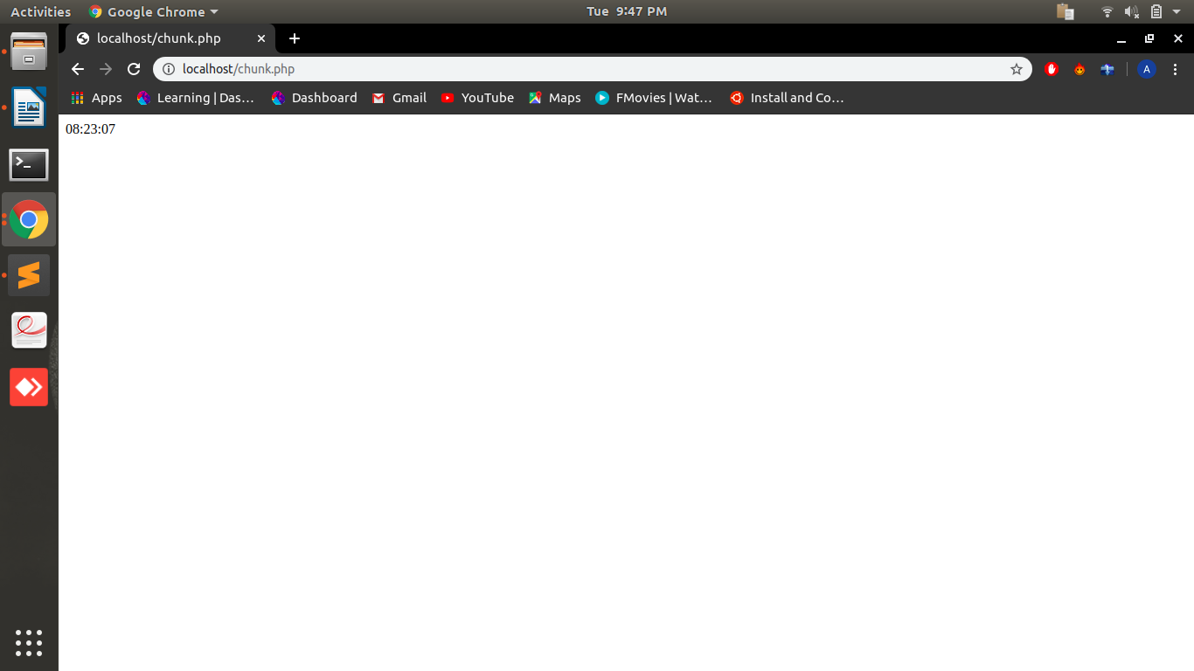
14.Write code to extract the file name from the following string.
Sample String: 'www.example.com/public_html/index.php?q=123'
Expected output: ‘index.php’
Using Built-In Functions only!

<?php
$path = 'www.example.com/public_html/index.php?q=123';
$x = substr(strrchr($path,"/"),1);
$file_name = explode("?",$x);
$firstKey = reset($file_name);
echo $firstKey;
?>
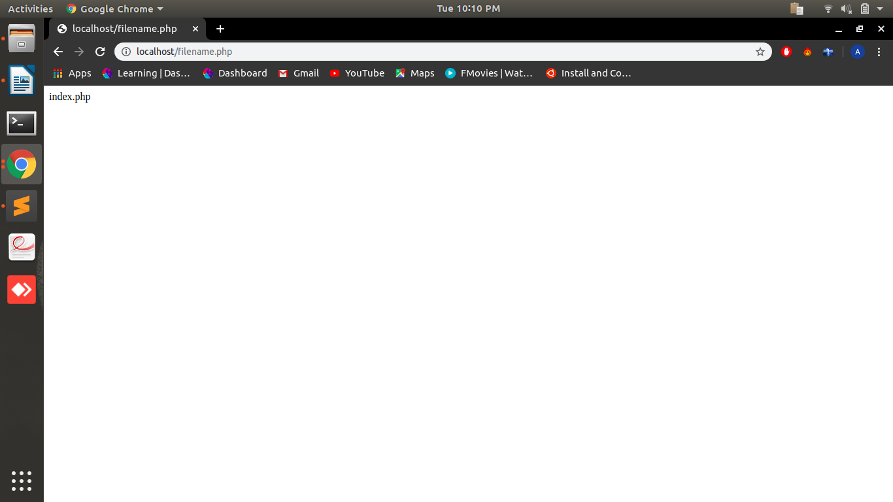
15.Write a PHP script to extract the user name from the following email ID.
Sample String: 'rayy@example.com'
Using Built-In Functions only!

<?php
$path = 'rayy@example.com';
$file_name = explode("@",$path);
$firstKey = reset($file_name);
echo $firstKey;
?>

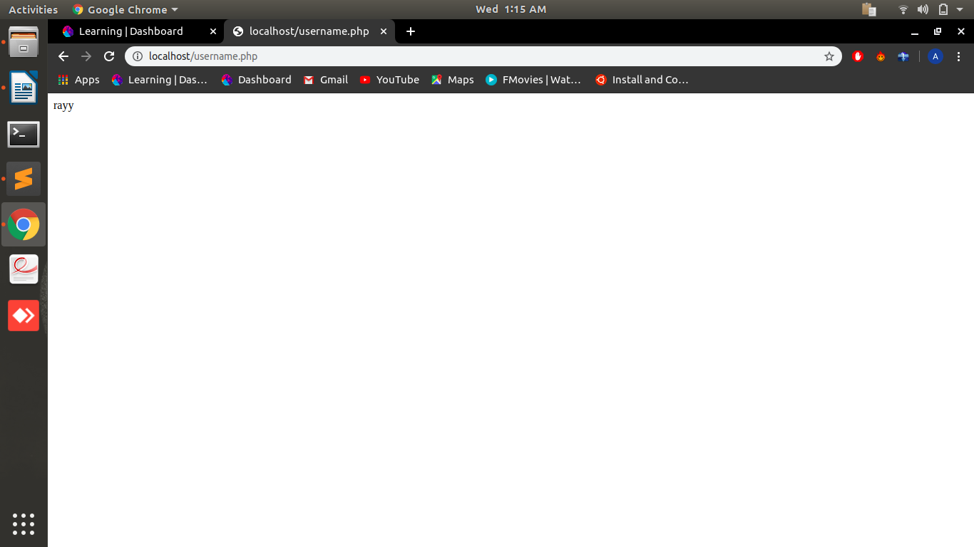

16.Generate Random Password of 7 characters form this string '1234567890ABCDEFGHIJKLMNOPQRSTUVWXYZabcefghijklmnopqrstuvwxyz';
Note: Don’t use the rand() function. Check other built-in functions to get the result.

<?php
function password_generate($chars)
{
$data = '1234567890ABCDEFGHIJKLMNOPQRSTUVWXYZabcefghijklmnopqrstuvwxyz';
return substr(str_shuffle($data), 0, $chars);
}
echo password_generate(7);
?>

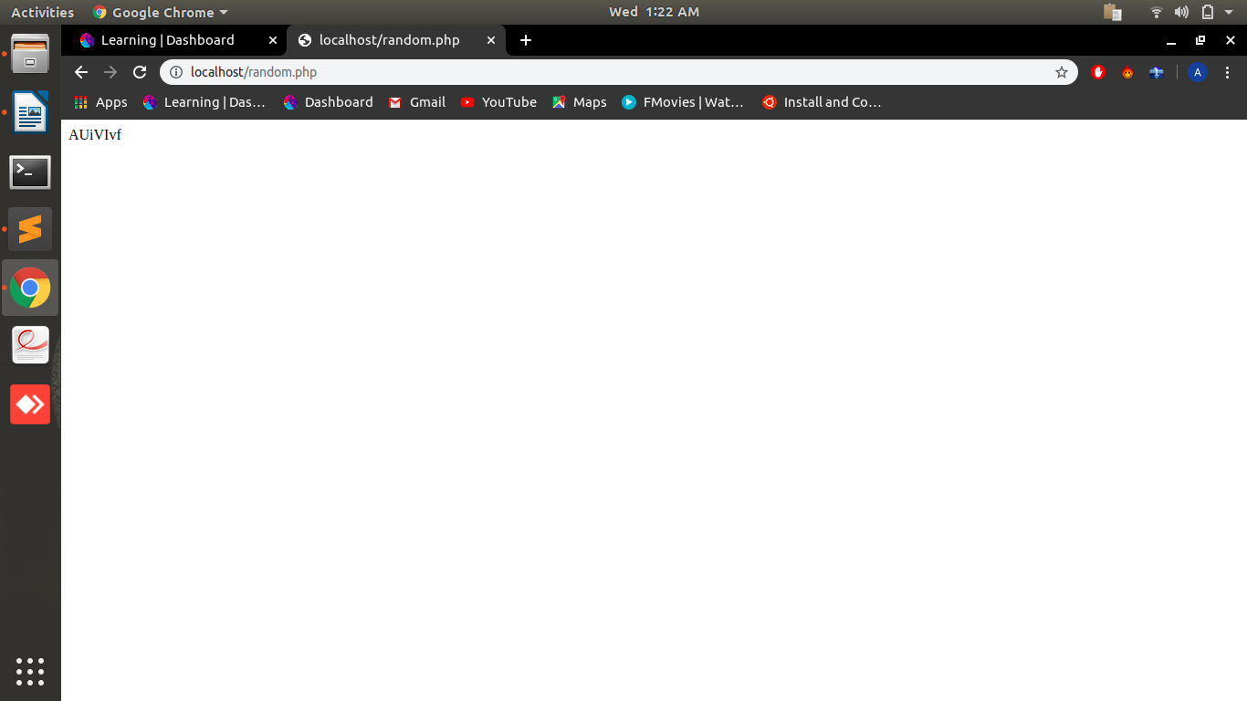
17.Write a Code to insert a string at the specified position in a given string.
String: 'The brown fox'
Insert 'quick' between 'The' and 'brown'.
Using Built-In Functions Only

<?php
$sentence = 'The brown fox';
$string = 'quick ';
$position = '4';
echo substr_replace( $sentence, $string, $position, 0 );
?>

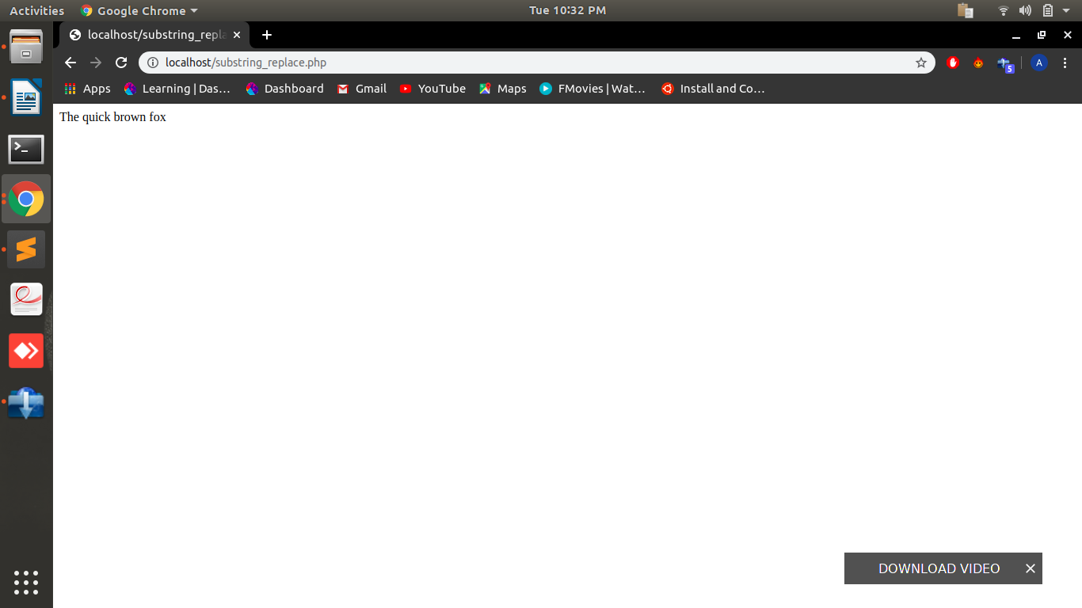
18.Write a program in PHP which performs the same function as built-in function array_count_values

<?php
$arr=["hello", "how", "hello", "are", "you", "are","do"];
sort($arr);
$len=count($arr);
$sum=1;
for($i=0;$i<$len;$i++)
{
if($arr[$i]==$arr[$i+1])
{
$sum++;
}
else
{
echo $arr[$i]." : ".$sum."<br>";
$sum=1;
}
}
?>

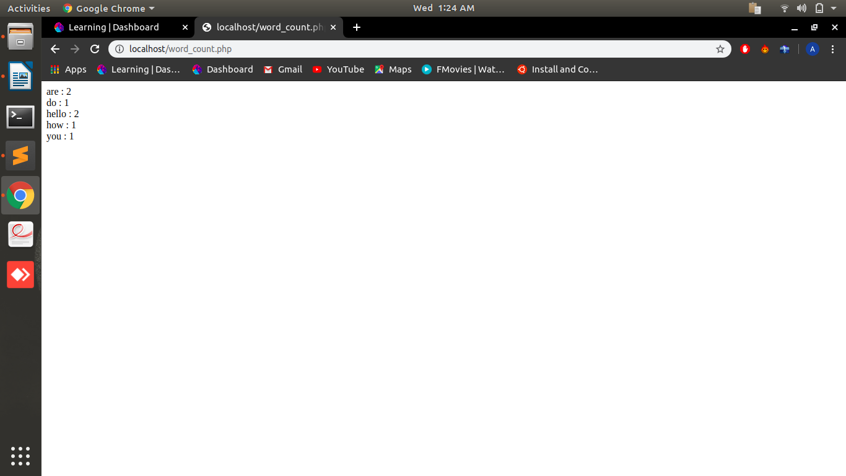

19.What is the use of sessions and cookies in PHP? How to set a session and a cookie with a code snippet.

Session:Session is used to provide more security to during the exchange of information from client to server . It stored on both client and server sides.
When a session is created it availables on all the pages of website and gets destroyed after closing the page.

<?php
$_SESSION["favcolor"] = "hello";
$_SESSION["favanimal"] = "world";
?>

Cookies:Cookies are used to increase the user experience and stores the important information provided by user when the user comes next time he don’t have to provide all the information again. These are stored on the client side permanently unless someone delete the cookie by itself or set the expire date of cookie.

<?php
$cookie_name = "user";
$cookie_value = "arjun singh";
setcookie($cookie_name, $cookie_value, time() + (86400 * 30), "/");
?>

20.at is the output of this question ?
<?php
$a = array_fill(5, 6, 'banana');
$b = array_fill(-2, 4, 'pear');
print_r($a);
print_r($b);
?>

Array ( [5] => banana [6] => banana [7] => banana [8] => banana [9] => banana [10] => banana )
Array ( [-2] => pear [0] => pear [1] => pear [2] => pear )

