1.Upgrade PHP version to PHP 7.4

Steps to install php 7.4:
1.sudo apt-get update
2.sudo apt -y install software-properties-common
3.sudo add-apt-repository ppa:ondrej/php
4.sudo apt-get update
5.sudo apt -y install php7.4
6.sudo php -v

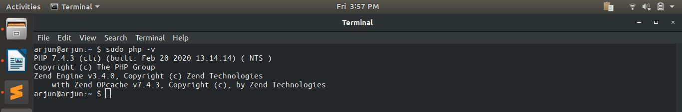
2.What are the advantages of spread operator over array_merge in PHP?

i.Spread operator is faster than array_merge. It gives better compile time optimization.
ii.Spread operator is a language structure while array_merge is a function call.
iii.Spread operator supports traversable interface while array_merge only supports array.
iv.Spread operator also called through a function.

EX:Spread Operator...
<?php
$a = [3, 4, 5];
$b = [1, 2, ...$a];
var_dump($b);
?>

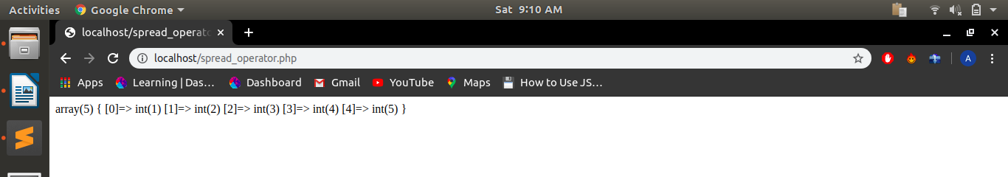
EX:array_merge...
<?php
$a = [3, 4, 5];
$b = [1, 2];
$c = array_merge($b, $a);
var_dump($c);
?>

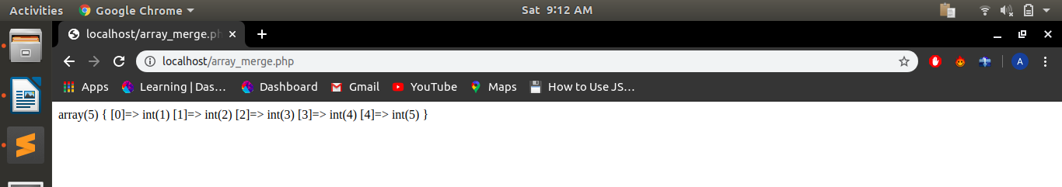
3.Write the output of these;
$arr1 = [1, 2, 3];
$arr2 = [...$arr1];
$arr3 = [0, ...$arr1];
$arr4 = array(...$arr1, ...$arr2, 111);
what will be the output of $arr2, $arr3, $arr4.

i.$arr2 => 1, 2, 3
ii.$arr3 => 0, 1, 2, 3
iii.$arr4 => 1, 2, 3, 1, 2, 3, 111

4.Write a program to print an array in which output is returned by function using the spread operator.

<?php
class hello{
function spread(){
$a= [3, 4];
return $a;
}
function disp(){
$b = [1, 2, ...$this->spread()];
print_r($b);
}
}
$obj= new hello();
$obj->disp();
?>

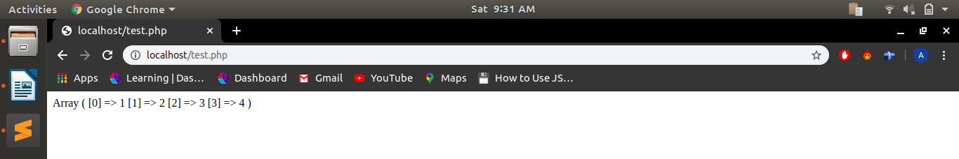
5.What is dependency Injection?

Dependency Injection is a type of designing pattern which tell us to follow a particular pattern by which we can make independent library or function which can be used in our code further to make the code efficient, faster and less complex.

EX:
<?php
class derived{
public function login($message){
echo "login success : $message <br>";
}
}
class base{
private $user;
function __construct($login){
$this->user= $login;
}
public function createuser(){
$this->user->login("user created");
}
public function deleteuser(){
$this->user->login("user deleted");
}
}
$login= new derived();
$users = new base($login);
$users->createuser();
$users->deleteuser();
?>

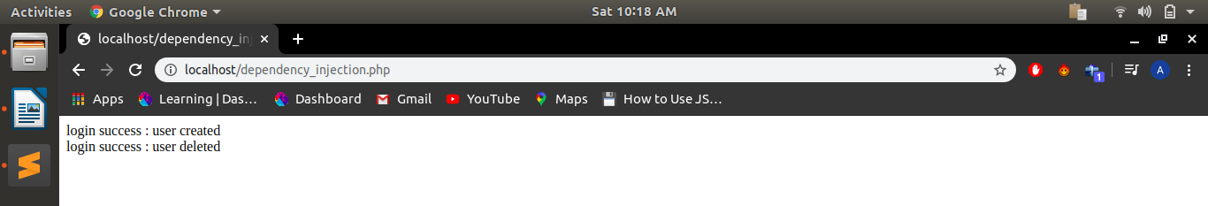
6.Write an example of a factory class where we pass 4 different car models and it returns price and builds year of the car.

<?php
class car{
private $model;
private $price;
private $build;
public function __construct($model, $price, $build){
$this->model=$model;
$this->price=$price;
$this->build=$build;
}
public function disp(){
return "Model : $this->model , Price : $this->price , Build in : $this->build<br>";
}
}
class carfactory{
public static function factory($model){
if($model=="Toyota Fortuner"){
$price="Rs.30.19 Lakh*";
$build="year 2019";
return new car($model, $price, $build);
}
if($model=="Ferrari Portofino"){
$price="Rs.3.50 crore*";
$build="year 2020";
return new car($model, $price, $build);
}
if($model=="Rolls Royce Ghost"){
$price="Rs.7.00 crore*";
$build="year 2010";
return new car($model, $price, $build);
}
if($model=="Lamborghini Veneno"){
$price="$4.5 million*";
$build="year 2014";
return new car($model, $price, $build);
}
}
}
$car1=carfactory::factory("Toyota Fortuner");
$car2=carfactory::factory("Ferrari Portofino");
$car3=carfactory::factory("Rolls Royce Ghost");
$car4=carfactory::factory("Lamborghini Veneno");
echo $car1->disp();
echo $car2->disp();
echo $car3->disp();
echo $car4->disp();
?>

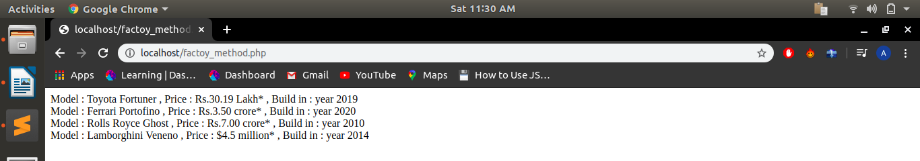
7.Give an example of singleton class.

<?php
class abc{
private function __construct(){
echo "hello <br>";
}
public static function set_val(){
static $val= null;
if($val==null)
{
$val= new conn();
}else{
echo "world <br>";
}
return $val;
}
}
$obj1 =abc::set_val();
$obj2 =abc::set_val();
$obj3 =abc::set_val();
var_dump($obj1);
var_dump($obj2);
var_dump($obj3);
?>

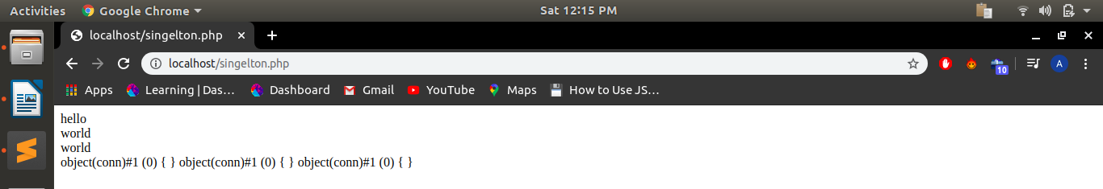
8.What are the benefits of following design patterns?

1.Design patterns are reusable in multiple projects and provide general solutions.
2.Design patterns tell the relationship between classes and objects.
3.Design patterns make the code faster and easy to understand.
4.Design patterns speed up the development of a software by providing us previously developed and tested paradiagrams.
5.Design patterns can be improve over the time.

9.Define a class with type properties.

<?php
class hello{
var int $x;
var float $y;
public string $name;
public bool $flag;
public function __construct(int $x, float $y, string $name, bool $flag)
{
$this->x = $x;
$this->y = $y;
$this->name = $name;
$this->flag = $flag;
}
}
$obj = new hello(1234, 1.009, "hello", true);
echo " $obj->x <br>";
echo " $obj->y <br>";
echo " $obj->name <br>";
echo " $obj->flag ";
?>

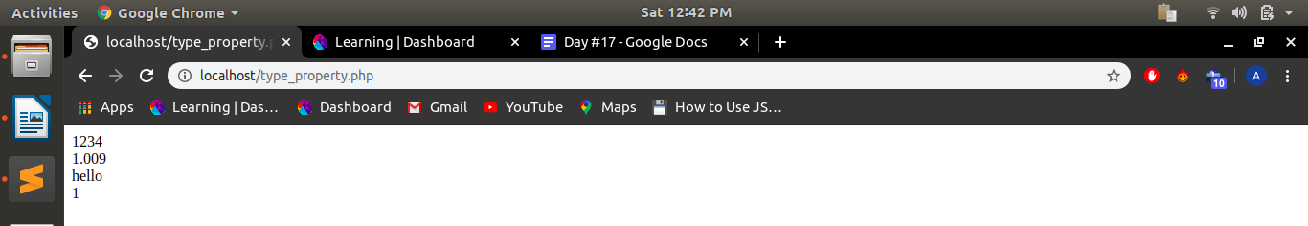
10.Write a function using arrow function array_map.

<?php
function fact($num)
{
$fact=1;
for($i=1;$i<=$num;$i++)
{
$fact=$fact*$i;
}
return($fact);
}
$a=array(1,2,3,4,5);
$b=array_map("fact",$a);
print_r($b);
?>

