Theming 2
Folder Link:https://github.com/arjun73362/assesments/tree/Theming2/drupal_up
1) Create full width banner on top of the page using views and Responsive Image & Breakpoints
a) Create a banner content type with image field.
Ans:
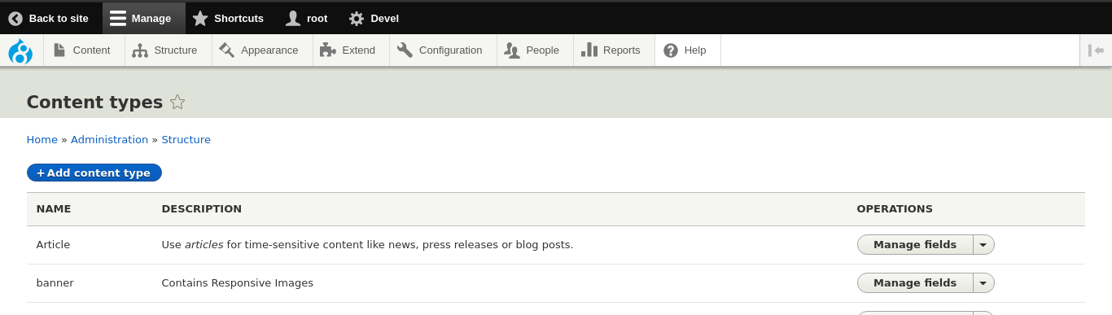
Step1:Create content type banner
Step2:Add image field
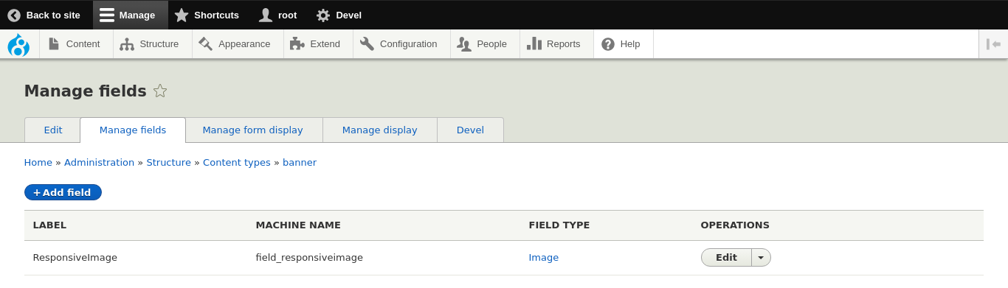
b) Create 3 breakpoints with max-width 767, 1024 and for all other resolutions.
Ans:
Step1:Install core modules Breakpoint & Responsive Image
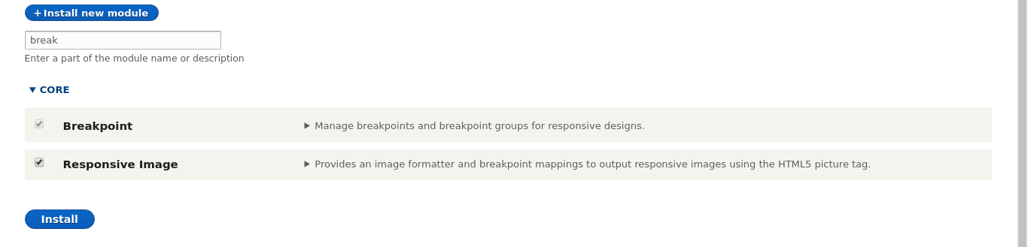

Step2:Now Responsive Image Styles appear in Configuration/MEDIA
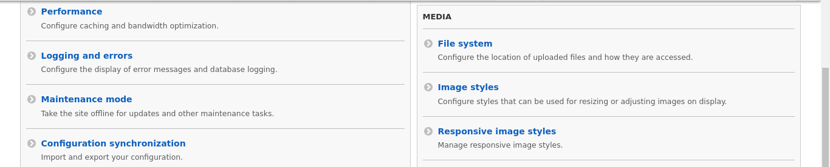
Step3:3 Breakpoints for my custom theme drupal_up are
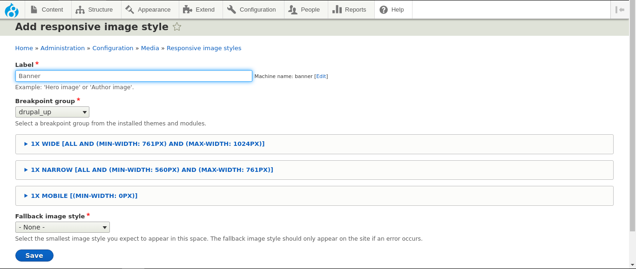
c) Use views and Responsive Image & Breakpoints to render the image on node page.
Step1:Add Image Styles for all the breakpoints created above
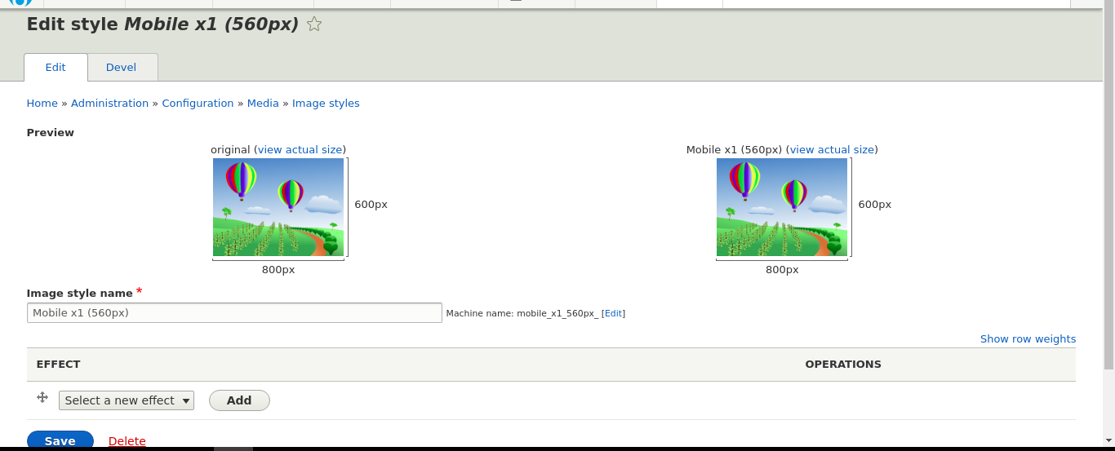
same as for: Narrow x1 (761px), Wide x1 (1024px).

Step2:Add a Responsive Image Style (Responsive Banner) for image styles, I have created in Step1
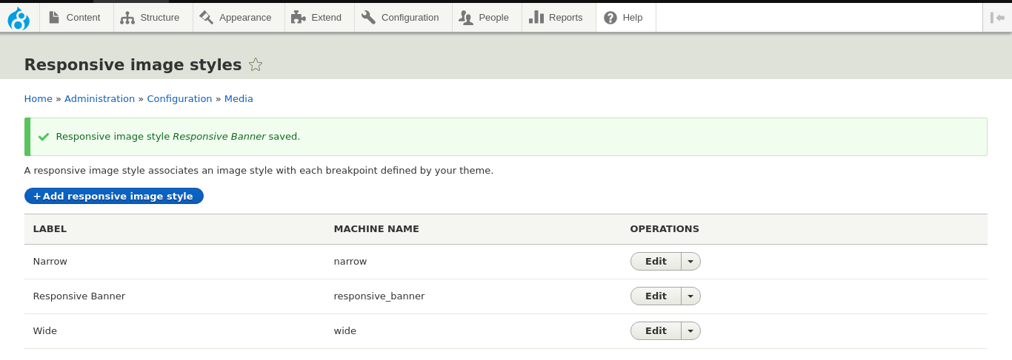
Step3:Create banner content type with responsive image style
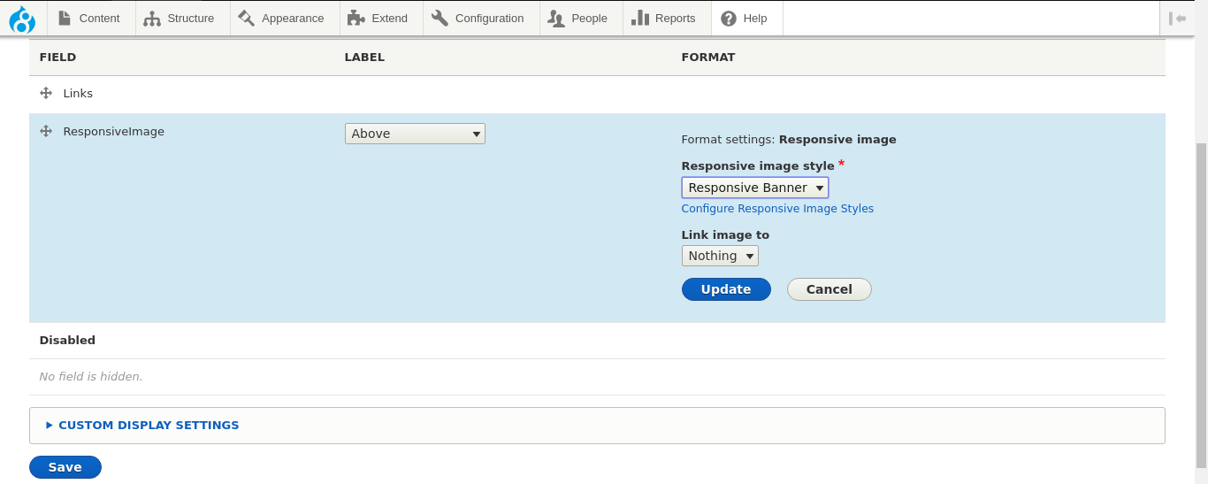
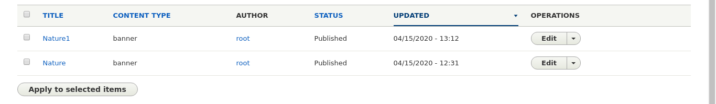
Step4:Create a View block and add contextual filter id & place it into header
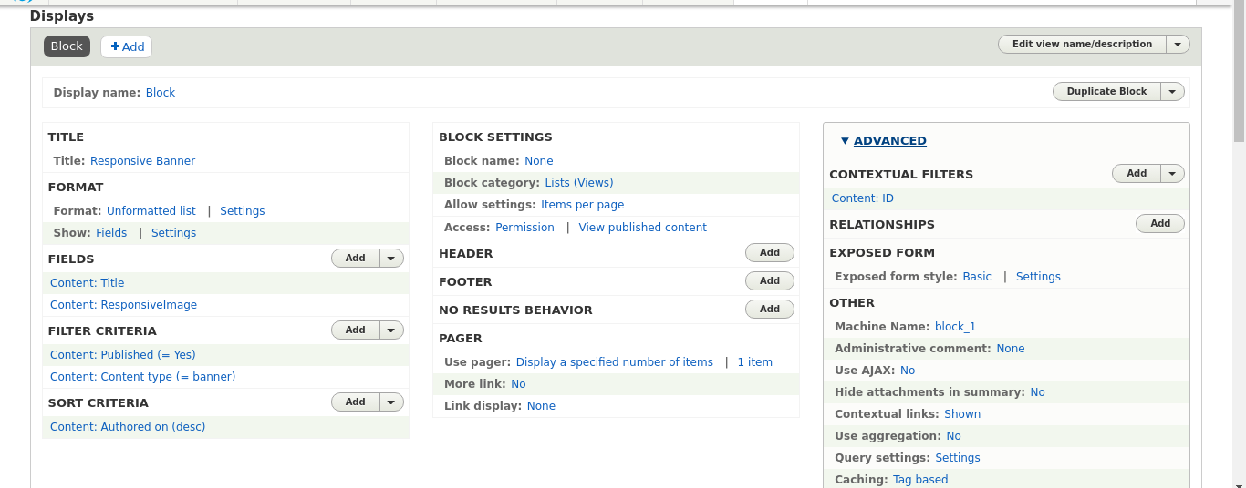
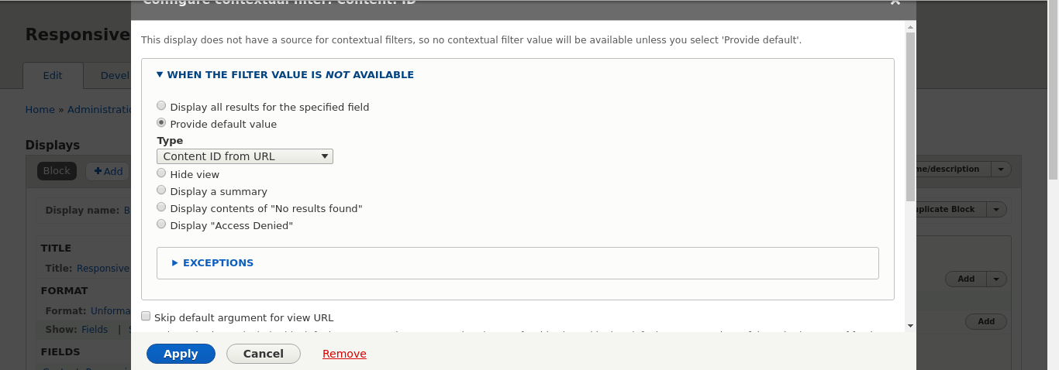
For node/1:
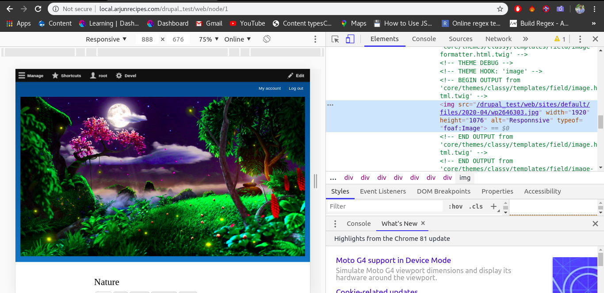
For node/2:
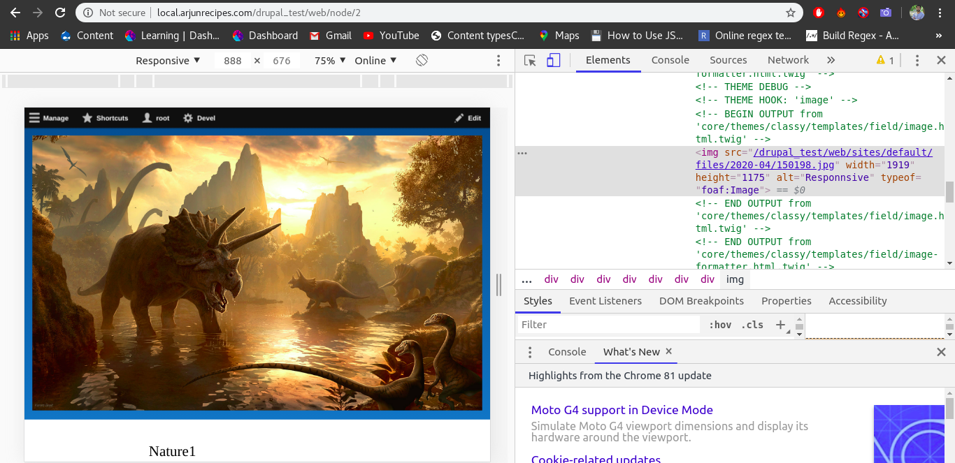
picture tag should be generated in frontend with different resolution rendering different size of image.
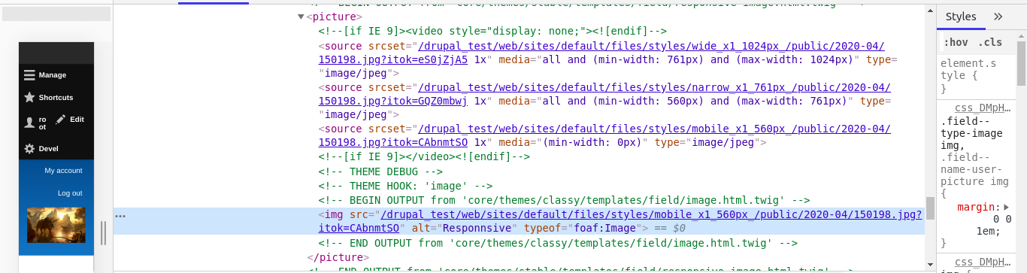
2) Render image of article content type with a custom image style using twig
Ans:
node—article.html.twig:
{% set imagestyle = {
'#theme': 'image_style',
'#style_name': 'medium',
'#uri': node.field_image['0'].entity.uri.value,
'#alt': node.field_image['0'].alt,
'#attributes': { class: 'swiper-image' },
} %}
{{ imagestyle }}
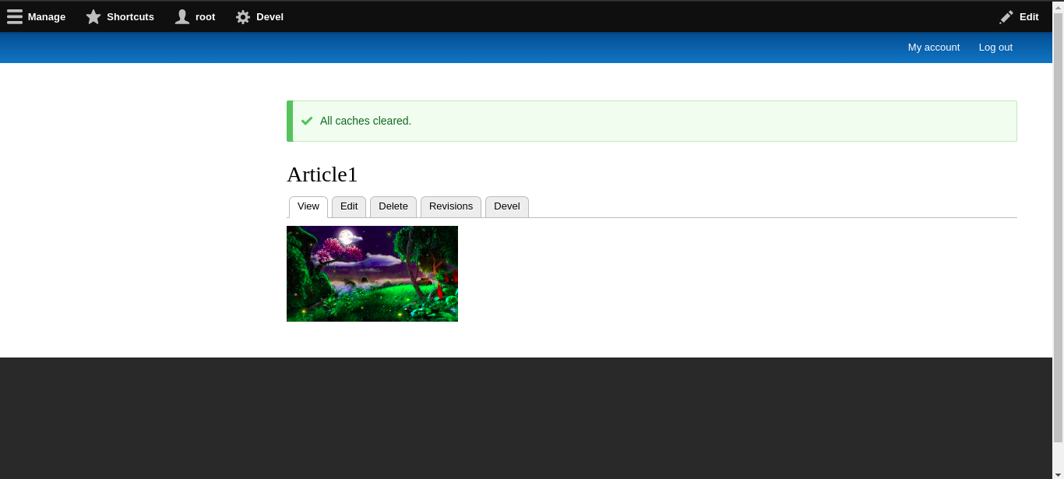
3) Place a logo of any brand and link it to its site in footer region twig
Ans:
page.html.twig:
<footer class="site-footer">
{% set imagestyle = {
'#theme': 'image_style',
'#style_name': 'medium',
'#uri': node.field_image['0'].entity.uri.value,
'#alt': node.field_image['0'].alt,
'#attributes': { class: 'swiper-image' },
} %}
<a href="{{ file_url(node.field_slides[key].entity.uri.value) }}">{{ imagestyle }}</a>
<div class="layout-container">
{% if page.footer_first or page.footer_second or page.footer_third or page.footer_fourth %}
<div class="site-footer__top clearfix">
{{ page.footer_first }}
{{ page.footer_second }}
{{ page.footer_third }}
{{ page.footer_fourth }}
</div>
{% endif %}
{% if page.footer_fifth %}
<div class="site-footer__bottom">
{{ page.footer_fifth }}
</div>
{% endif %}
</div>
</footer>
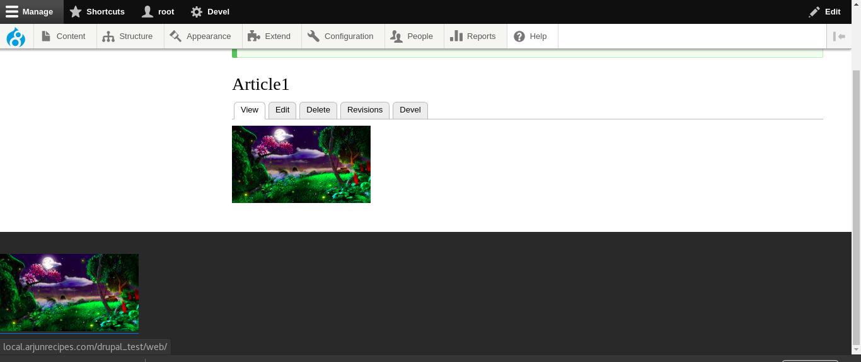

4) Add a custom twig to title block using theme suggestion hooks
Ans:
drupal_up.theme:
<?php
function drupal_up_theme_suggestions_page_title_alter(array &$suggestions, array $variables, $hook)
{
if($hook == 'page_title')
{
$suggestions[] = 'page__title__arjun';
}
}
page—title—arjun.html.twig:
<h1 style="color:red">Hello I'm Custom Title Twig Created by hook_theme_suggestions_page_title_alter(array &$suggestions, array $variables, $hook)</h1>
