Q1. Create a Custom Entity having the following fields :
Name
Email
Contact number
answer1 folder:https://github.com/arjun73362/assesments/blob/customEntity/answer1.zip
answer1.php:fields added in this file by custom code given below
//Email field

$fields['email'] = BaseFieldDefinition::create('string')
->setLabel(t('Email'))
->setDescription(t('The email of the Answer1 entity.'))
->setSettings([
'max_length' => 50,
'text_processing' => 0,
])
->setDefaultValue('')
->setDisplayOptions('view', [
'label' => 'above',
'type' => 'string',
'weight' => -4,
])
->setDisplayOptions('form', [
'type' => 'string_textfield',
'weight' => -4,
])
->setDisplayConfigurable('form', TRUE)
->setDisplayConfigurable('view', TRUE)
->setRequired(TRUE);

//Contact Field

$fields['number'] = BaseFieldDefinition::create('integer')
->setLabel(t('Contact'))
->setDescription(t('The contact of the Answer1 entity.'))
->setSettings([
'max_length' => 50,
'text_processing' => 0,
])
->setDefaultValue('')
->setDisplayOptions('view', [
'label' => 'above',
'type' => 'integer',
'weight' => -4,
])
->setDisplayOptions('form', [
'type' => 'string_textfield',
'weight' => -4,
])
->setDisplayConfigurable('form', TRUE)
->setDisplayConfigurable('view', TRUE)
->setRequired(TRUE);

1.create a module with: sudo drupal gm
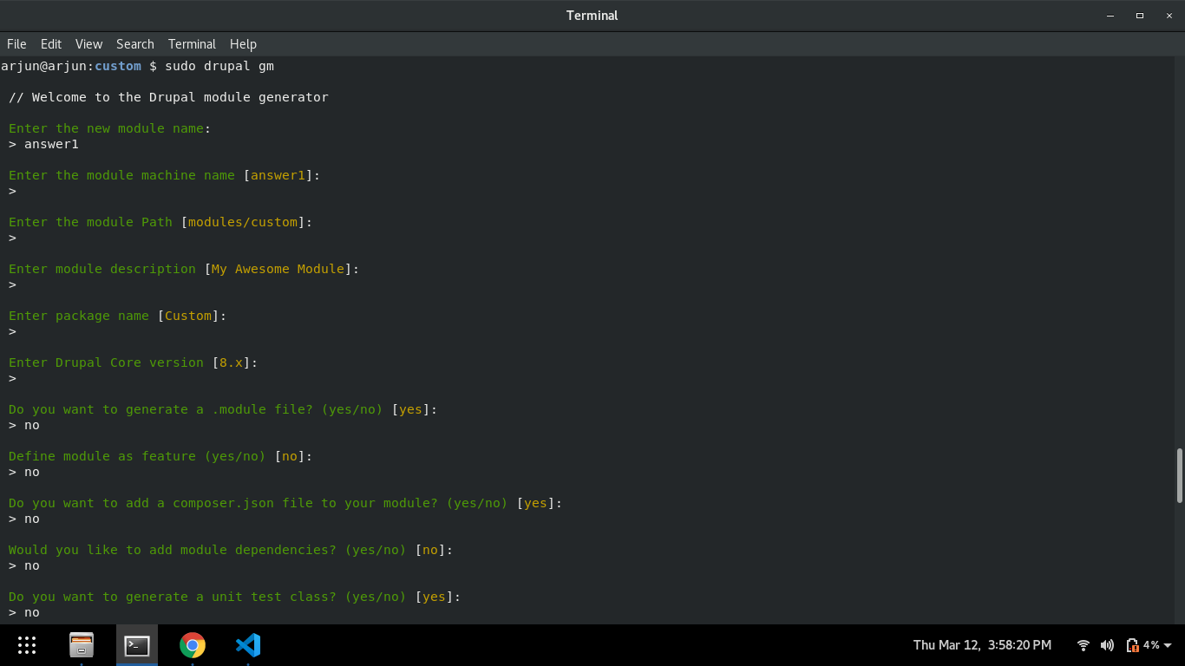
2.create Custom Entity with: sudo drupal geco

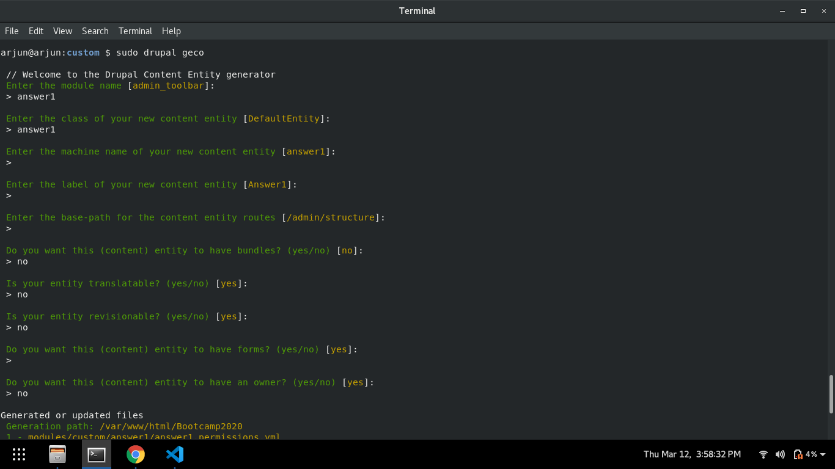
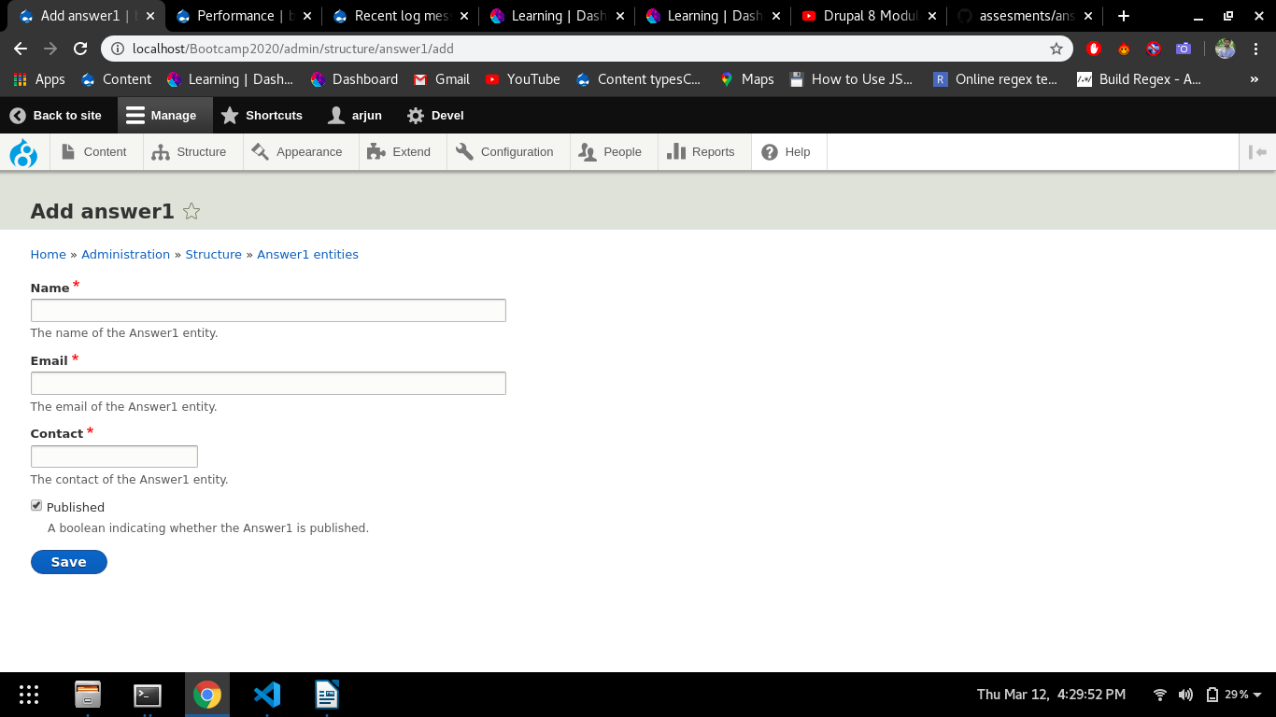
Q2. Create a Config Entity to store diff time slots for customers.

answer2 folder:https://github.com/arjun73362/assesments/blob/customEntity/answer2.zip
answer2.php: custom code given below to add diff time slots for customers
$form['timeslot'] = [
'#type' => 'select',
'#options'=>[1=>'Time slot -1 (9:00 Am - 11:00 Am)' ,2=>'Time slot - 2( 11:00 Am - 2:00 pm)',3=>'Time slot -3 (2:00 pm - 5:00 pm)' ],
'#title' => 'Timeslot',
// '#default_value' => $detailcustomer->timeslot(),
// '#machine_name' => [
// 'exists' => '\Drupal\seecont\Entity\detailcustomer::load',
// ],
// '#disabled' => !$detailcustomer->isNew(),
];

answer2.schema.yml: code added in file
timeslot:
type: 'string'
lable: 'Timeslot'

1.create a module with: sudo drupal gm
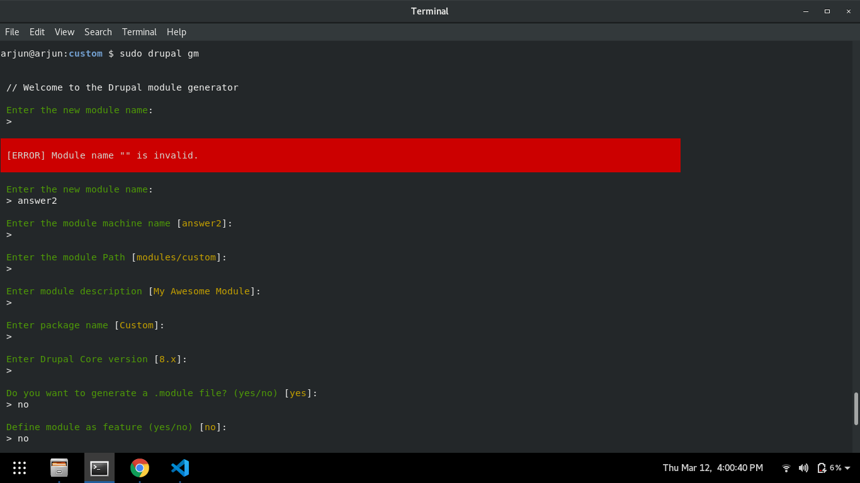
2.create Config Entity with: sudo drupal gec

