1.Fetch employee's Name, address, Phone, Dob, Department, salary whose salary is greater than the average salary.

Query:select employee.name, employee.dob, employee.contact, employee.address, employee.department, salaries.salary from employee INNER JOIN salaries ON employee.id=salaries.id AND salaries.salary>(select avg(salary) from salaries);

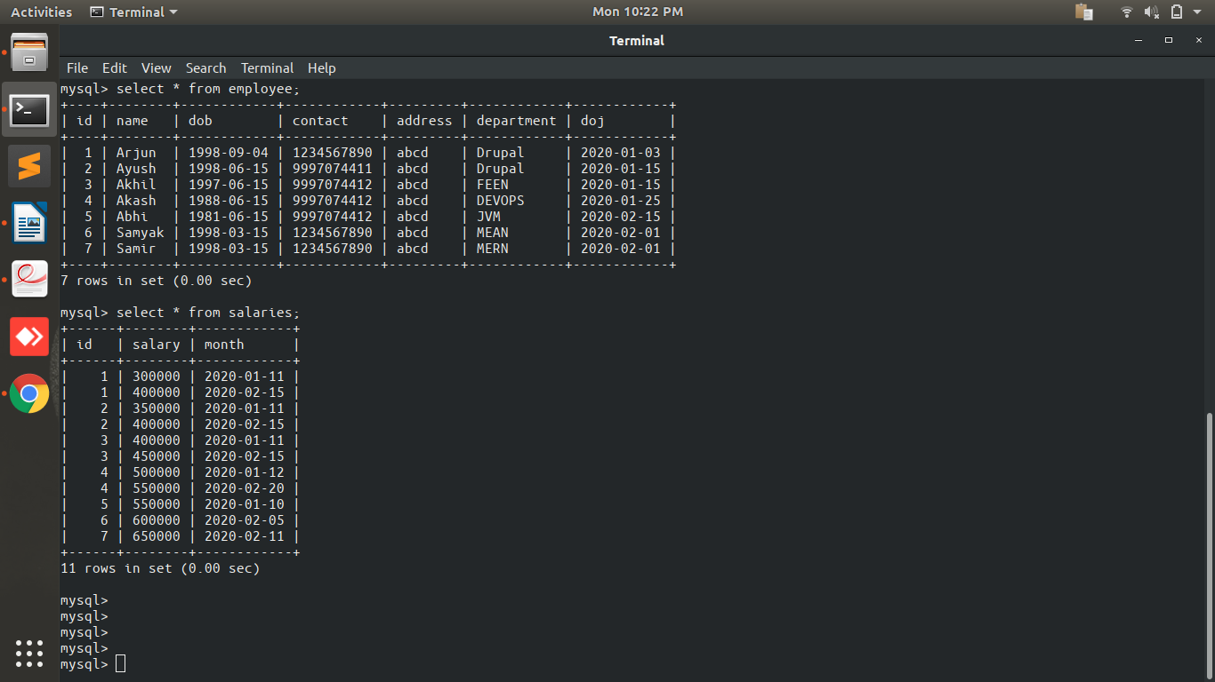
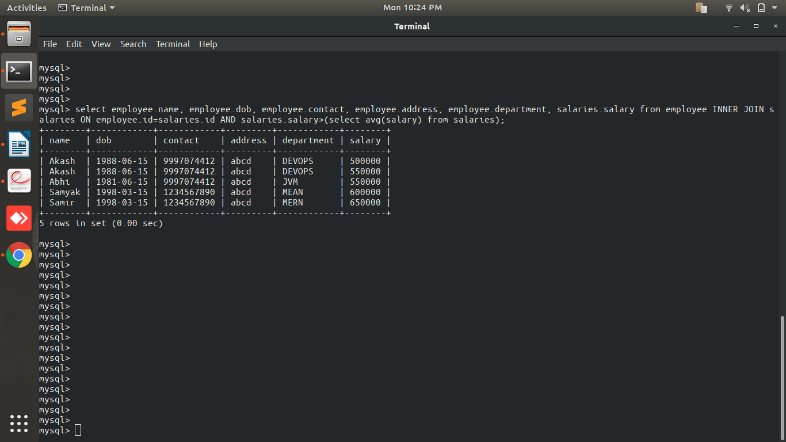

2.Fetch Paid average salary for the current month

Query: select avg(salary) from salaries where MONTH(month)=MONTH(NOW());

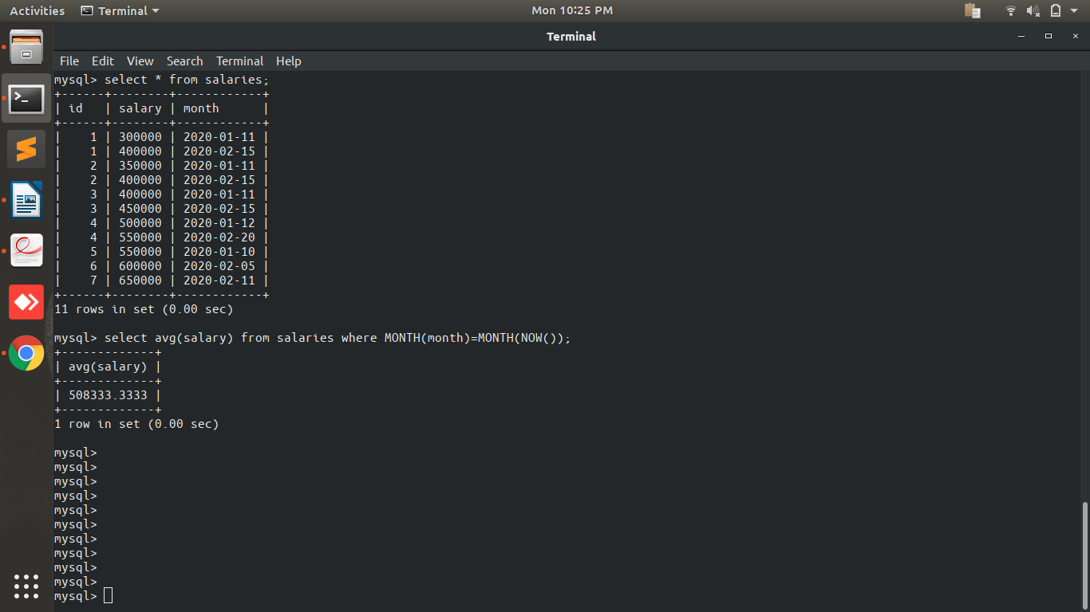
3.Fetch the top 5 Employee's Name, Phone, Salary month, Paid salary for the current month

QUERY:select employee.name, employee.contact, salaries.month, salaries.salary from employee INNER JOIN salaries ON employee.id=salaries.id AND MONTH(salaries.month)=MONTH(NOW()) order by salaries.salary desc limit 0,5;

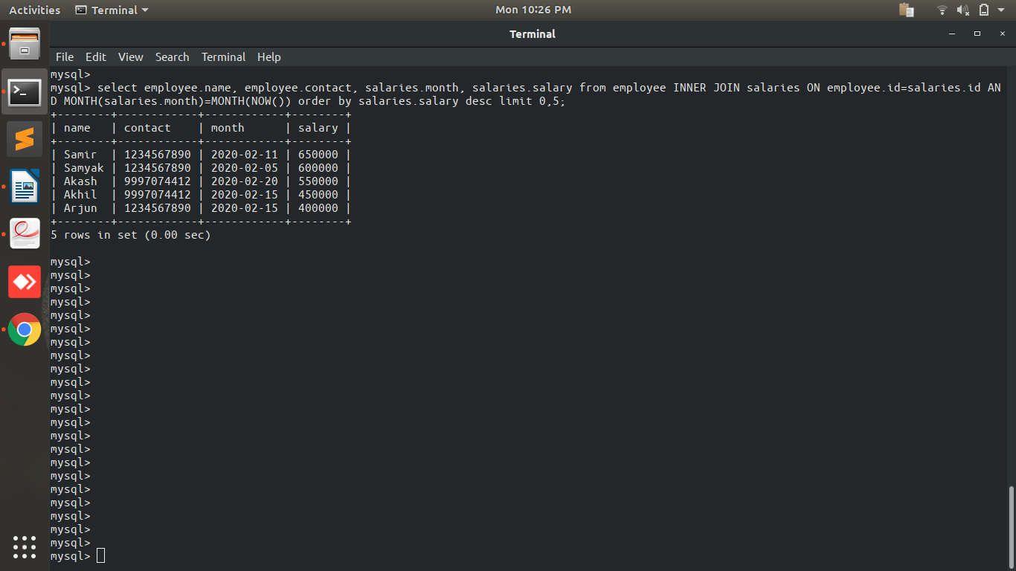

4.Fetch the employee's name, phone, dob, department name, salary who join last month.

QUERY: select e.name,e.contact,e.dob,e.department,s.salary from employee e INNER JOIN salaries s ON e.id=s.id AND e.id in (select distinct(id) from salaries) AND MONTH(e.doj)=MONTH(NOW())-1 AND MONTH(s.month)=MONTH(NOW());

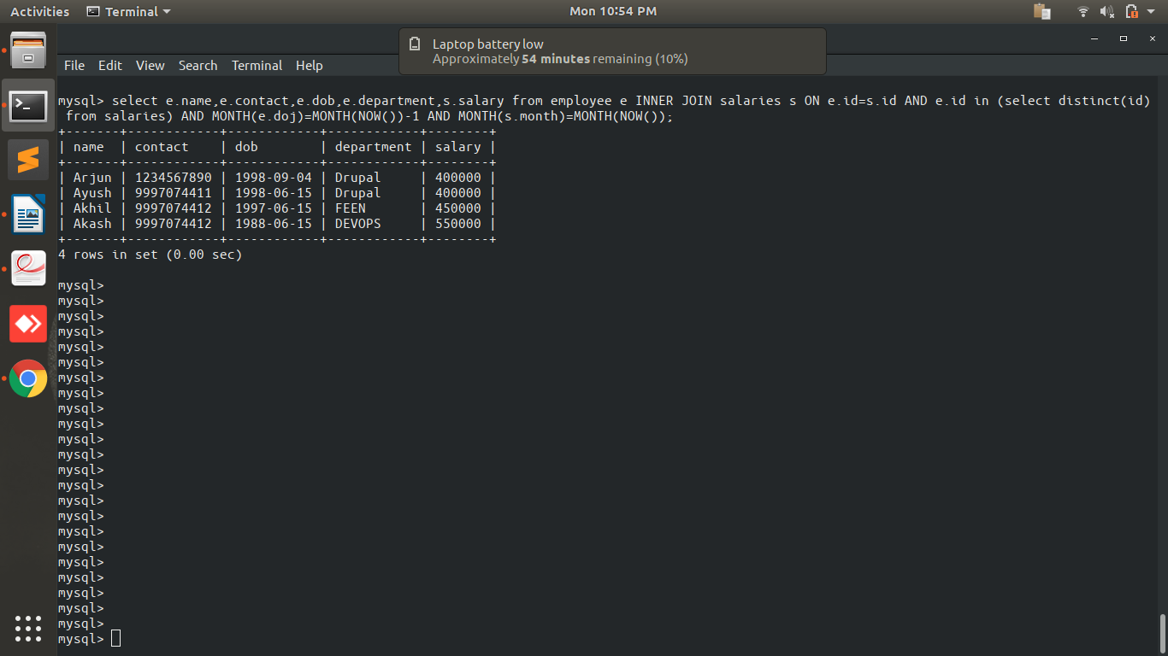
5.Create a Program in PHP that will fetch and show employee details whose DOB is today?

QUERY:select * from employee where DAY(dob)=DAY(CURDATE())
Connection.php:https://github.com/arjun73362/assesments/blob/mongo/connection1.php
search.php:https://github.com/arjun73362/assesments/blob/mongo/search.php
salaries.sql:https://github.com/arjun73362/assesments/blob/mongo/salaries.sql
employee.sql:https://github.com/arjun73362/assesments/blob/mongo/employee.sql

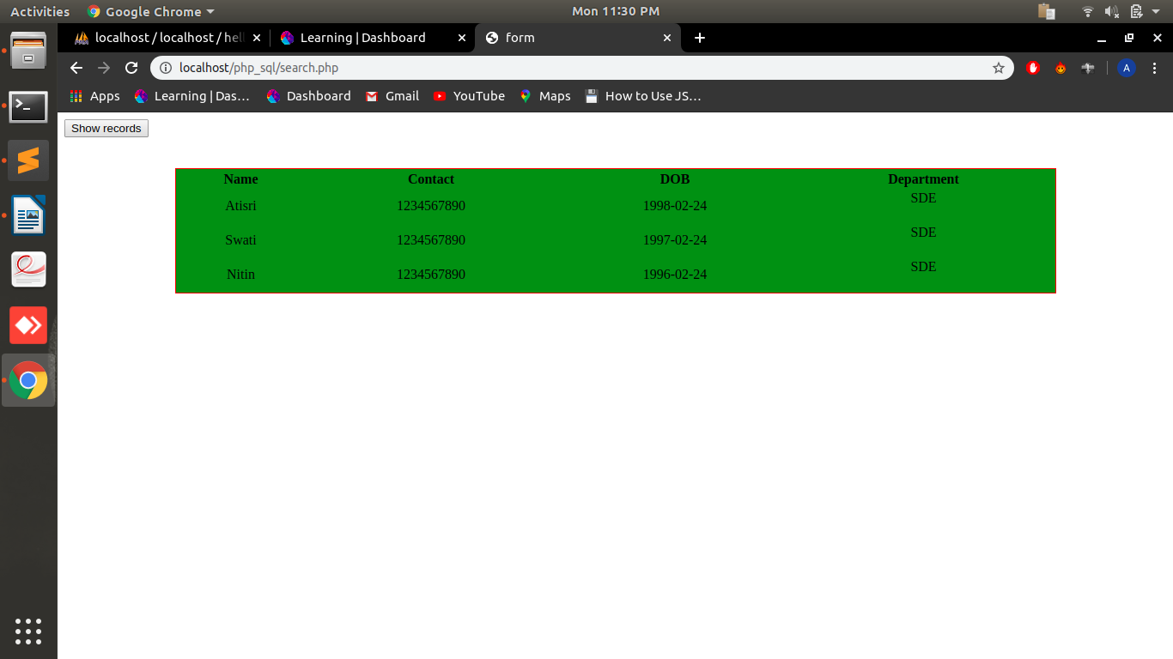
6.What are the advantage & disadvantage of Index?

Advantages:
i.Indexes give better performance and able to quickly retrive the data from a table.
ii.Indexes can be used to sort the data.
iii.Unique indexes gives unique data from the database.

Disadvantages:
i.Indexes decrease the performance on insert, update, and delete operations.
ii.Indexes takes extra space.

7.Create two tables in MYSQL that shows working of INNER,LEFT, RIGHT

QUERY:
i.select c.cname, c.city, o.oname, c.cid, o.oid from customer c LEFT OUTER JOIN orders o ON c.cid=o.oid;

LEFT JOIN select all the records from the left table and the matched records from the right table. Right side gives NULL if there is no matching record.

ii.select c.cname, c.city, o.oname, c.cid, o.oid from customer c RIGHT OUTER JOIN orders o ON c.cid=o.oid;

RIGHT JOIN select all the records from the right table and the matched records from the left table. Left side gives NULL if there is no matching record.

iii.select c.cname, c.city, o.oname, c.cid, o.oid from customer c INNER JOIN orders o ON c.cid=o.oid;

INNER JOIN select the records which matched in both tables.

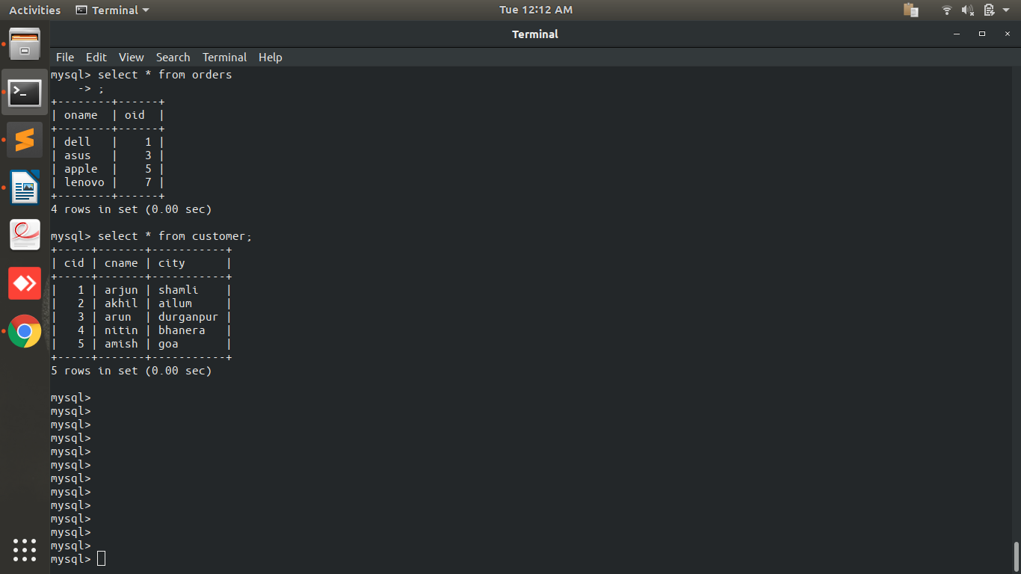

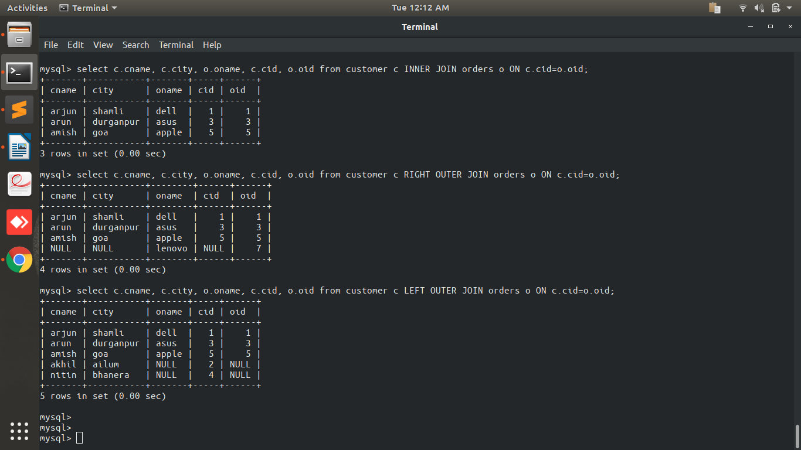
8.create a database "Bootcamp" with table "mongo".

i.show dbs
ii.use bootcamp
iii.db.mongo.insert({name:"arjun", age:"21", id:"1"})
iv.db.mongo.find()

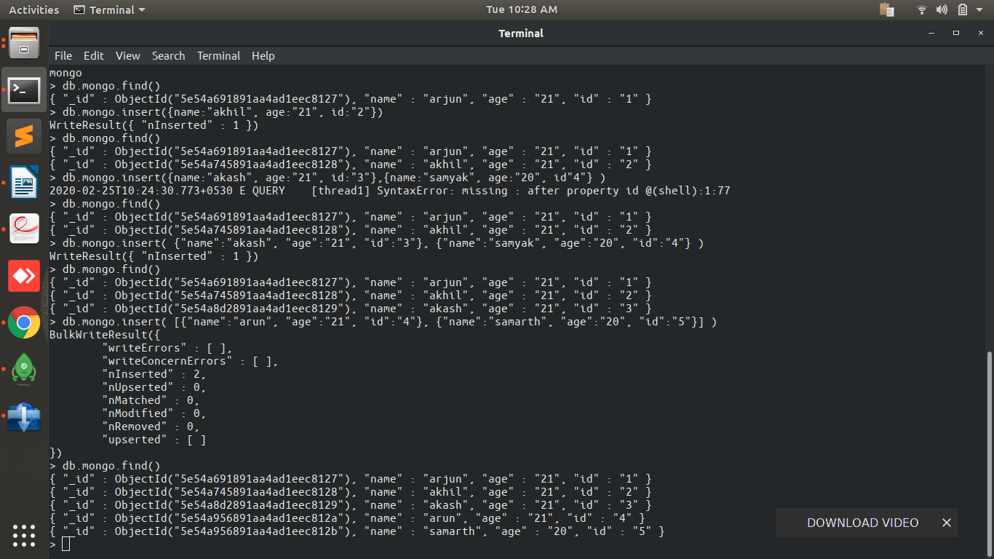
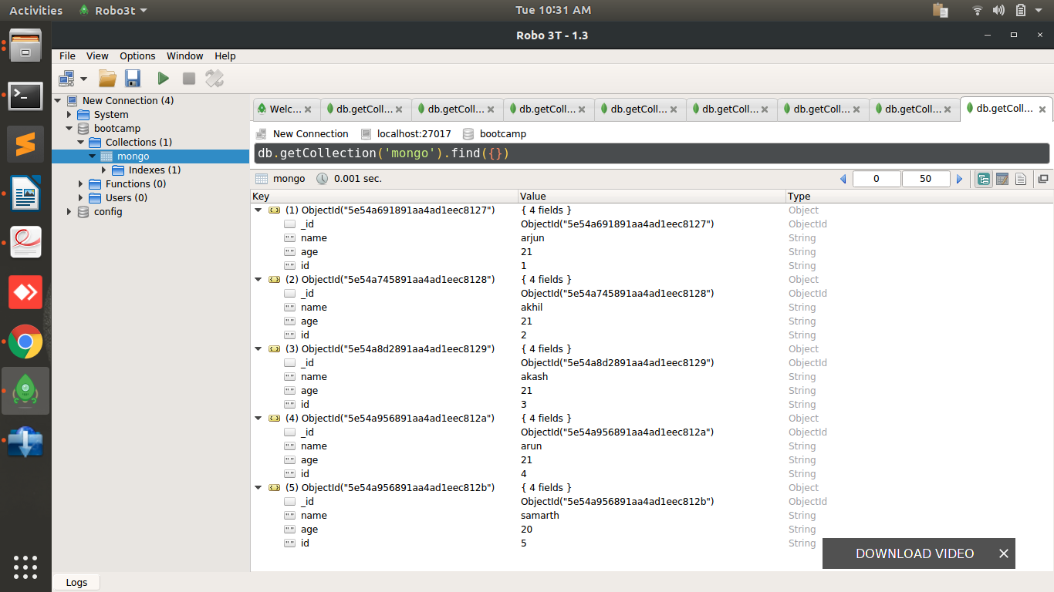
9.Write a PHP program to perform Create, Read, Update and Delete Operations.

Connection.php:https://github.com/arjun73362/assesments/blob/mongo/connection.php
Insert.php:https://github.com/arjun73362/assesments/blob/mongo/insert.php
Display.php:https://github.com/arjun73362/assesments/blob/mongo/display.php
Update.php:https://github.com/arjun73362/assesments/blob/mongo/update.php
Delete.php:https://github.com/arjun73362/assesments/blob/mongo/delete.php

CREATE:

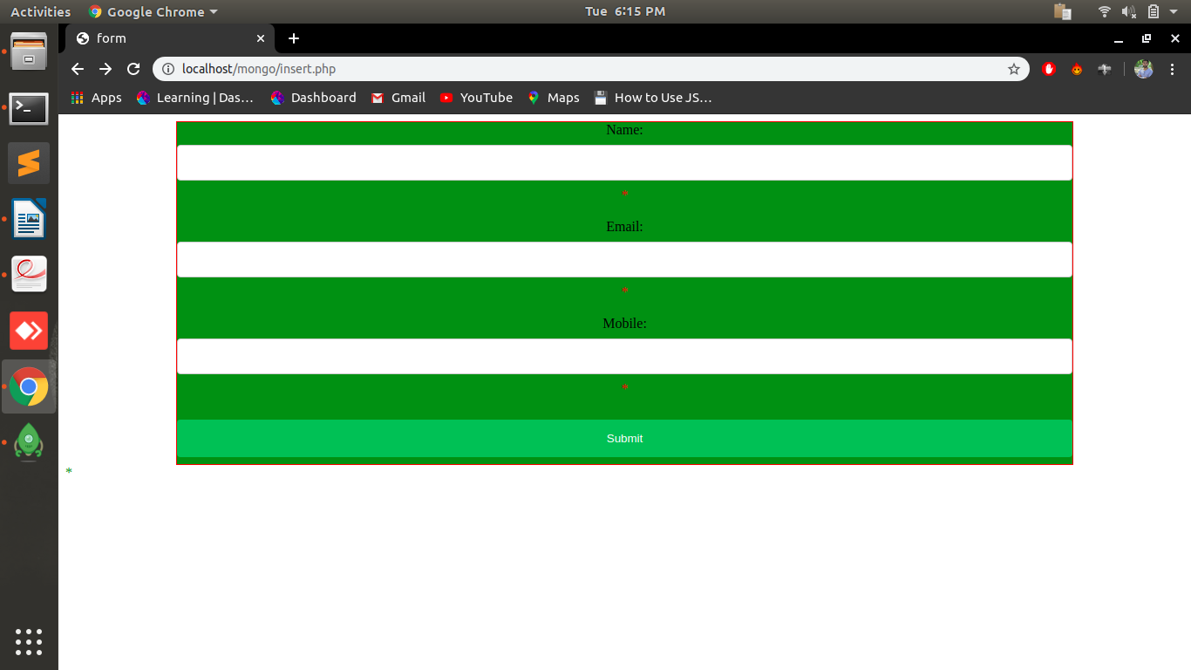
READ/UPDATE/DELETE:

