TASKITTO – Advanced Task Management App

Crafted by Arjun Kumbakkara  
“Discipline your day. Dominate your goals.”  
  
TASKITTO is an advanced productivity app that combines proven time management techniques with elegant design. Built on the foundations of the Eisenhower Matrix, Pomodoro timing, and Mel Robbins' 5 Second Rule, TASKITTO is your companion for mastering momentum and conquering daily tasks with intention and clarity.

Live Demo: https://deft-strudel-6ad146.netlify.app

# 🏁 Landing Page

Welcome to TASKITTO – a clean, elegant, and motivating entry point to your productivity journey. The homepage introduces you to its quadrant layout, Pomodoro engine, and cloud sync features.

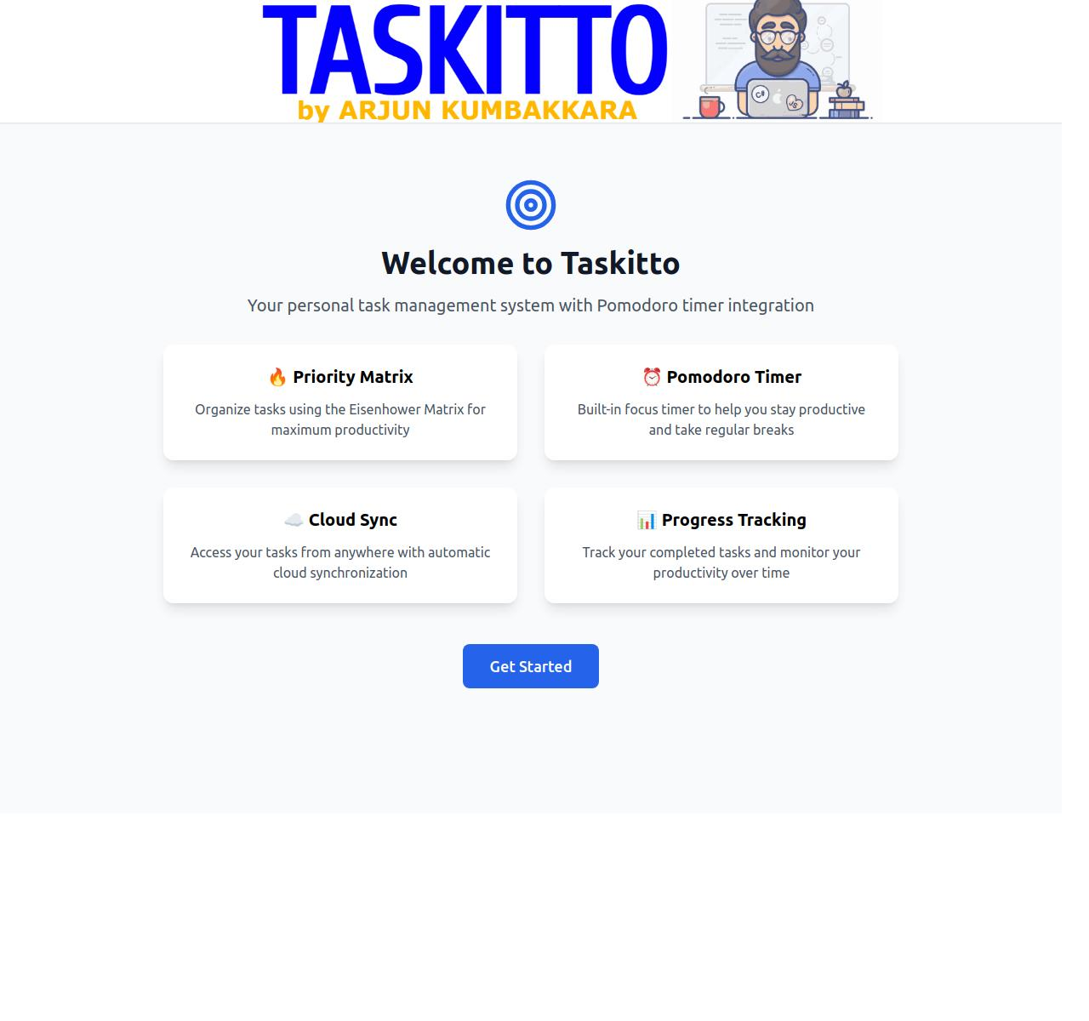

# 🔲 Quadrant-Based Task Layout

Inspired by the Eisenhower Matrix, TASKITTO offers four color-coded productivity zones:  
• Immediate Now – Urgent tasks needing attention  
• Today – Must-complete tasks for the current day  
• This Week – Planned milestones for the week  
• This Month – Long-range strategic goals  
  
Tasks can be dragged across quadrants, and each entry is timestamped and tracked.

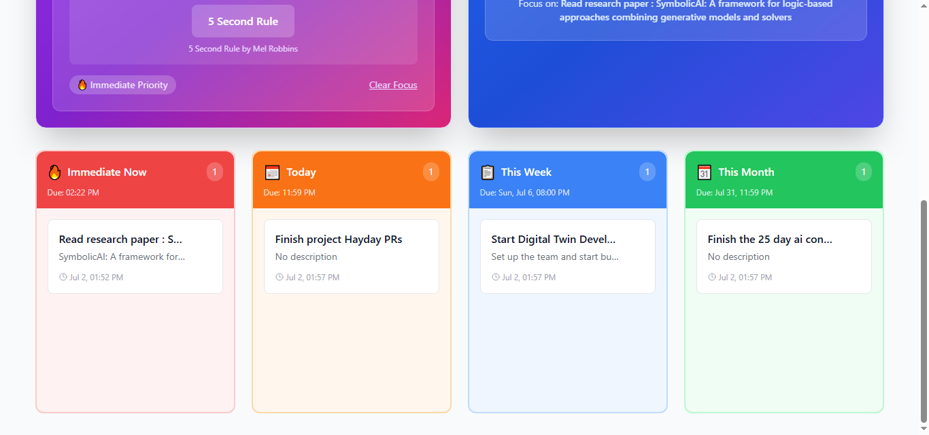

# 🎯 Focus Mode – Pomodoro + 5 Second Rule

When a task enters the 'Immediate Now' zone, TASKITTO initiates a Focus Mode experience:  
• The task is locked in as the focus of a 25-minute Pomodoro session  
• The 5 Second Rule activates, encouraging you to begin without delay  
• The UI transforms to enhance concentration

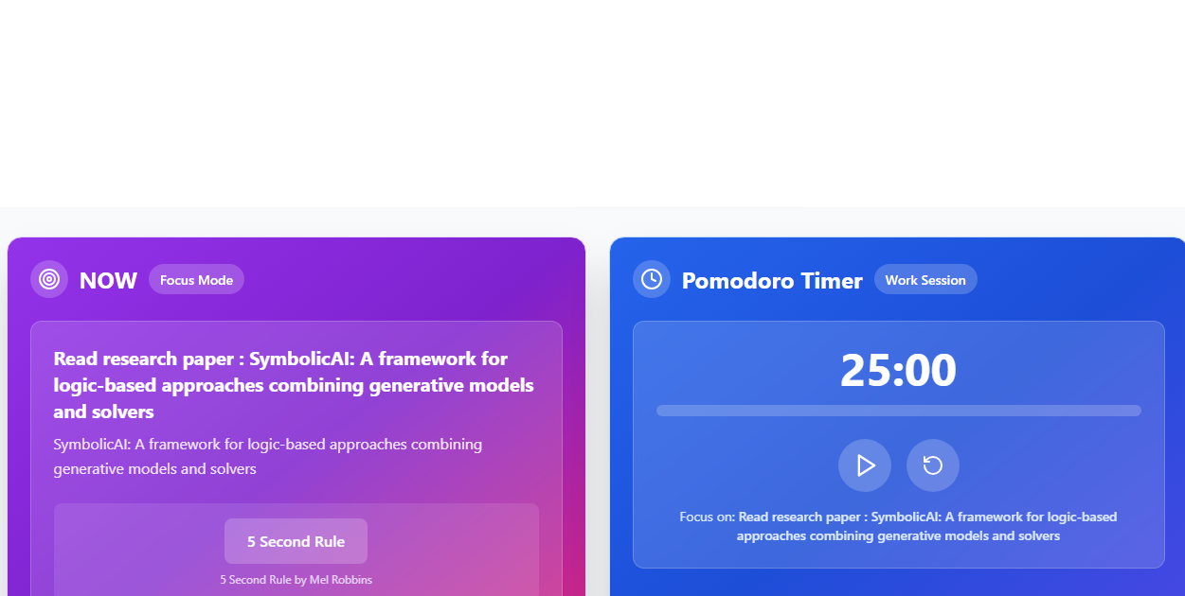

# 🔔 Real-Time Focus Notifications

Never miss your next task transition. When a new task is selected as your current focus, TASKITTO triggers browser-based push notifications to keep you locked in and mindful.

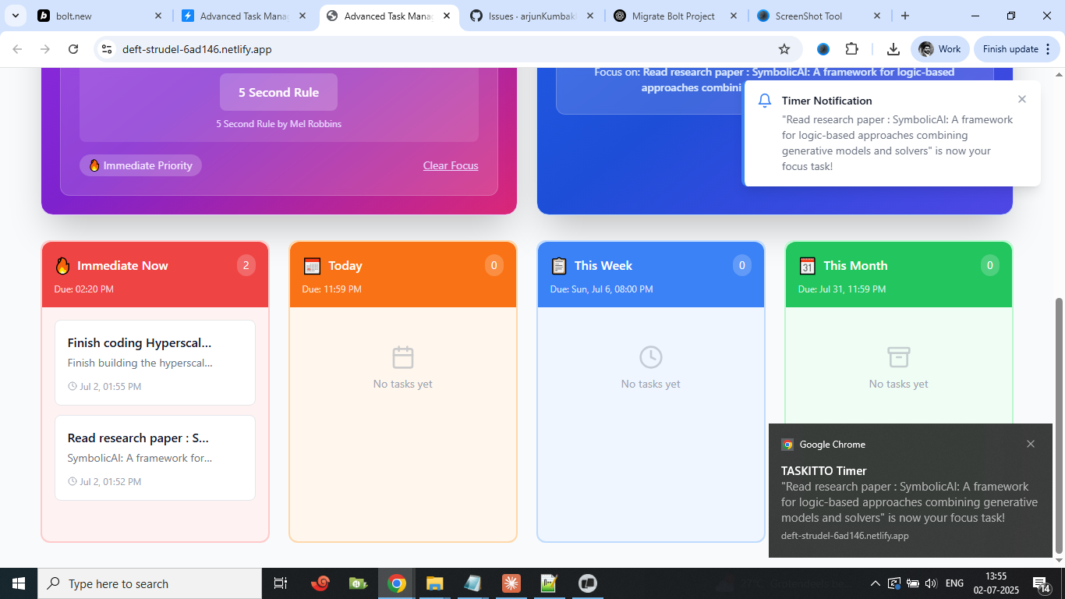

# 📜 Task History & Completion Tracking

View, sort, and search through all your completed tasks. Each task shows creation and completion timestamps, providing clear insight into your productivity rhythm. You can also clear history as needed to start fresh.

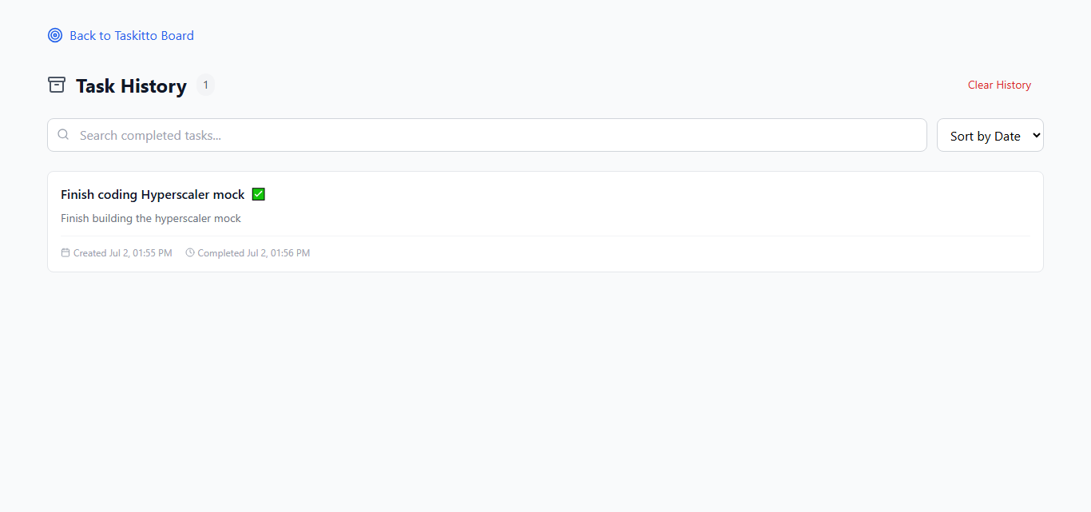

# ✨ Key Features

• Eisenhower Matrix-based quadrant layout  
• Pomodoro Timer integration  
• 5 Second Rule activation  
• Supabase-authenticated cloud sync  
• Task history with filtering and sorting  
• Real-time browser notifications

# 🛠 Tech Stack

• React.js – Frontend UI  
• Tailwind CSS – Styling  
• Supabase – Authentication & backend  
• Context API – State Management  
• Netlify – Hosting and CI/CD

# 📌 Roadmap

• Dark Mode  
• Mobile-first PWA  
• Google Calendar Integration  
• AI-based Task Prioritization  
• Weekly Productivity Insights