Adverts from Spreadsheets
Overview
The Innovate DataBroker is capable of extracting information from spreadsheets which can be used to automatically generate ‘Adverts’ for the spreadsheets.
At present this only works for spreadsheets in Microsoft Excel 2007/2010/2010 XML format and which have been prepared as below.
Spreadsheet Preparation
- Each sheet within the spreadsheet should have a meaningful name. These are used in the advert, so more informative names can be helpful.
- Each sheet should contain a table.
- Each column should have a meaningful name in row one. Again, these are used in the advert, so more informative names can be helpful. (Columns without a name will be ignored).
- If the cell containing the column name has a comment associated with it then that will be used as additional information in the advert. See the ‘Summary’ field in the example below.
Example
The sheet has a meaningful name.
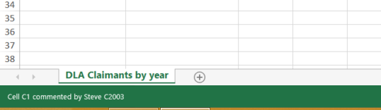

The sheet is a table, each column has a meaningful name (in the first row). There is a comment associated with the name of column C.
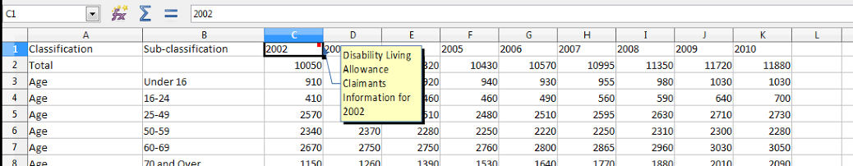

The automatically generated advert (within the Advert Portal) is shown below:
