
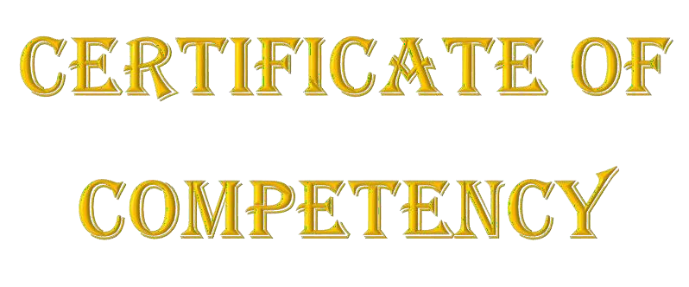
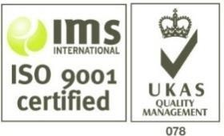
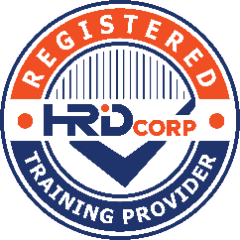

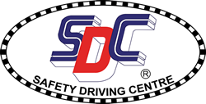
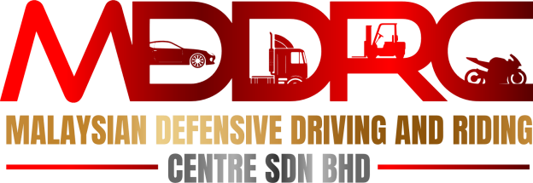
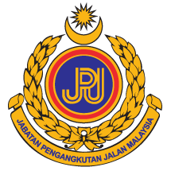
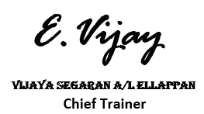
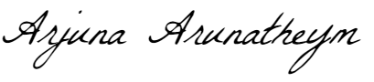

PRESENTED TO >>
{{PARTICIPANT_NAME}}
I.C. No: {{IC_NUMBER}}
Of
{{COMPANY_NAME}}
IN RECOGNITION OF SUCCESSFUL COMPLETION OF
{{CERTIFICATE_TITLE}}
> {{CERTIFICATE_SUBTITLE}}>
CONDUCTED BY:
Malaysian Defensive Driving and Riding Centre Sdn Bhd
On {{TRAINING_DATE}}-{{END_DATE}}
Venue: {{VENUE}}

Validity Date: {{VALIDITY_START}}– {{VALIDITY_END}}

ARJUNA ARUNATHEYM
Chief Executive Officer

Certificate Serial No: {{CERTIFICATE_NUMBER}}

