- Experiment No.: 1

- Title: Demonstrate use of inline, internal, and external JavaScript. Use console methods such as console.log(), console.error(), console.table(), and console.trace(). Create a simple webpage that logs user environment info and shows a welcome message.
- Software/Tools Required:
- Visual Studio Code (VS Code)
- Google Chrome
- HTML5
- JavaScript
- CSS
- Theory: JavaScript is a client-side scripting language used to make web pages interactive and dynamic. It can be included in an HTML document in three ways:
- Inline JavaScript: JavaScript code is written directly inside an HTML element using event attributes such as onclick, onmouseover, etc.
- Internal JavaScript: JavaScript code is written inside the <script> tag within the HTML document and is used for page-specific functionality.
- External JavaScript: JavaScript code is written in a separate .js file and linked to the HTML document using the <script src="filename.js"></script> tag, which improves code reusability and maintenance.

- Output:
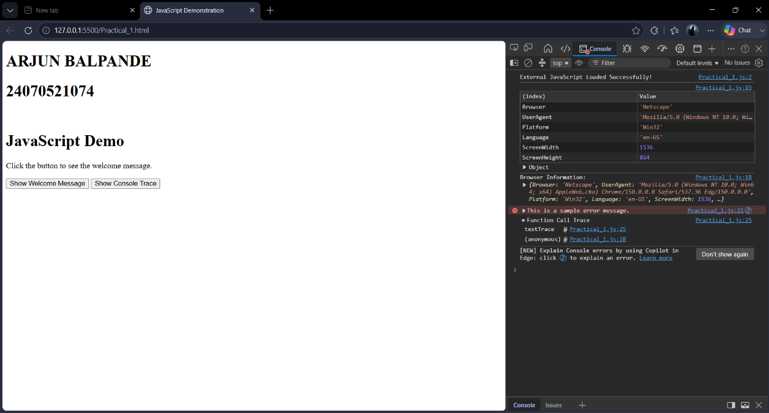

- Result/Conclusion:
The experiment was successfully performed to demonstrate the use of inline, internal, and external JavaScript in a webpage. A welcome message was displayed, and user environment information was obtained and shown in the browser console. Various console methods such as console.log(), console.error(), console.table(), and console.trace() were used for debugging and displaying information. The experiment helped in understanding different ways of including JavaScript in HTML and the importance of console methods during development and debugging. Thus, the objectives of the experiment were achieved successfully.

