T.ARJUNA BOOPATHI

*B.sc Information Technology*

# PROFILE

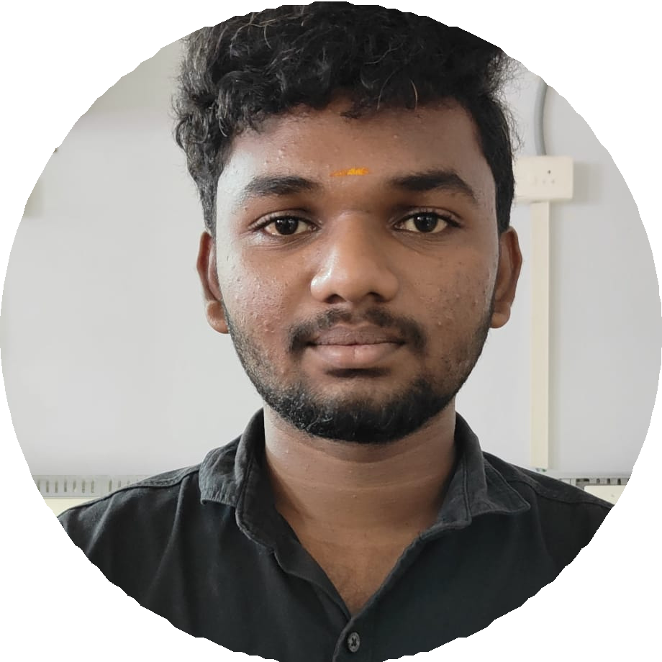

Information Technology student.

I consider my self a

responsible and orderly person.

I am looking foward for my skills and Travel

experience.

# CONTACT ME

7708078569

boopathiboopathi36574 @gmail.com

1/124

Sakthi nagar 3rd Street,

Boyampalayam Tiruppur.

641603.

# EDUCATION

**BHARATHIAR UNIVERSITY**

*Cherraan's Arts science college, Kangayam.*

*2021-2024*

# LANGUAGE

Native Tamil.

Advanced English.

# COMPUTER SKILLS

Python Java

C++

Microsoft Excel

# SKILLS

Cricket

Programming Editor