CREDIT ASSISTANT
Credit Health Monitoring and Financial Diagnostic Platform
Project Report Based on the Provided Interface References

Project | Credit Assistant
Domain | Personal finance / credit awareness
Reference material | Three supplied interface screenshots

1. Executive Summary
Credit Assistant is a web-based concept for helping users understand and monitor their credit profile. The supplied screens show a public landing page, a financial overview dashboard, and a credit-health breakdown page. The interface combines credit-score reporting, revolving-credit utilization, debt-to-income or fixed-obligation-to-income ratios, payment punctuality, progress tracking, calculators, what-if simulation, and an AI-advisor entry point.
The design uses a restrained navy-and-white visual system with green indicators for positive or healthy conditions. It is tailored to the Indian financial context and references credit bureaus such as CIBIL, Experian, CRIF, and Equifax. The figures shown in the screenshots should be treated as illustrative or self-reported demo data unless they are verified against a real credit-bureau report.

2. Project Objectives
- Present credit-related information in a clear, approachable dashboard.
- Help users understand the main factors that can influence credit health.
- Make financial ratios easier to interpret through visual indicators and explanatory text.
- Offer what-if testing and free calculators for exploring potential financial scenarios.
- Provide a central place for progress tracking, profile management, and educational guidance.
- Promote privacy-conscious engagement through the interface’s stated soft-inquiry and zero-spam positioning.

3. Reference Screens and Interface Overview

3.1 Public landing page
The landing page introduces the product with the headline “Understand Your Credit. Build Your Borrowing Power.” It describes diagnostic insights, what-if simulations, and personalized action steps. The main calls to action are “Check My Credit Health Free” and “Explore Free Calculators.” A compact interactive diagnostic panel lets visitors adjust salary, card spending, card limit, and existing monthly EMIs to see example utilization and FOIR/DTI indicators.
The page also highlights an Indian financial ecosystem context and communicates three trust-related messages: soft inquiry, a zero-spam guarantee, and RBI data localization. These are product claims visible in the design; they should be substantiated by the actual implementation, policies, and applicable compliance review before launch.
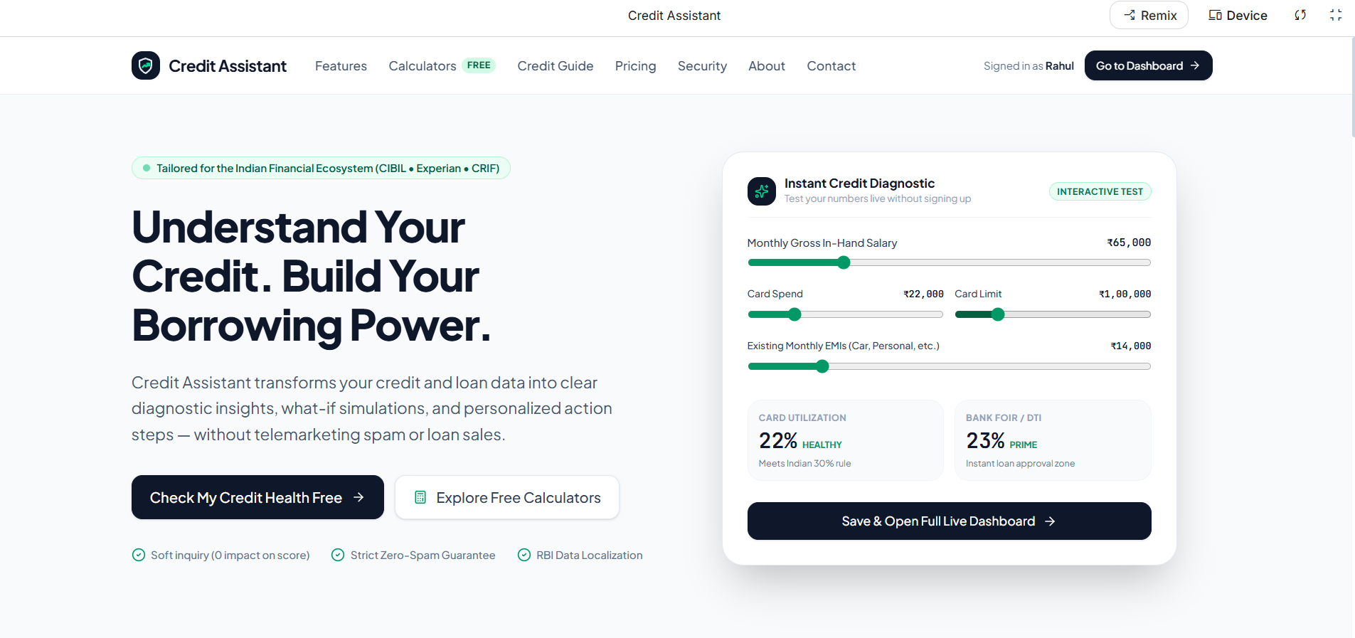
Figure 1. Credit Assistant public landing page and instant credit diagnostic.

3.2 Financial overview dashboard
The overview dashboard presents a summarized credit-health report for a signed-in user. The reference shows a reported CIBIL score of 742/900, revolving-credit utilization of 24%, debt-to-income / FOIR of 28%, and payment punctuality of 100%. It also includes navigation to Credit Health, AI Advisor, Progress, What-If Simulator, Free Calculators, Credit Guide, Profile, and Settings.
Additional dashboard elements include a credit-score progress section, an update-financials action, and shortcuts to run a what-if test or ask the AI advisor. The layout prioritizes high-level metrics so users can quickly spot their current status before exploring detailed explanations.
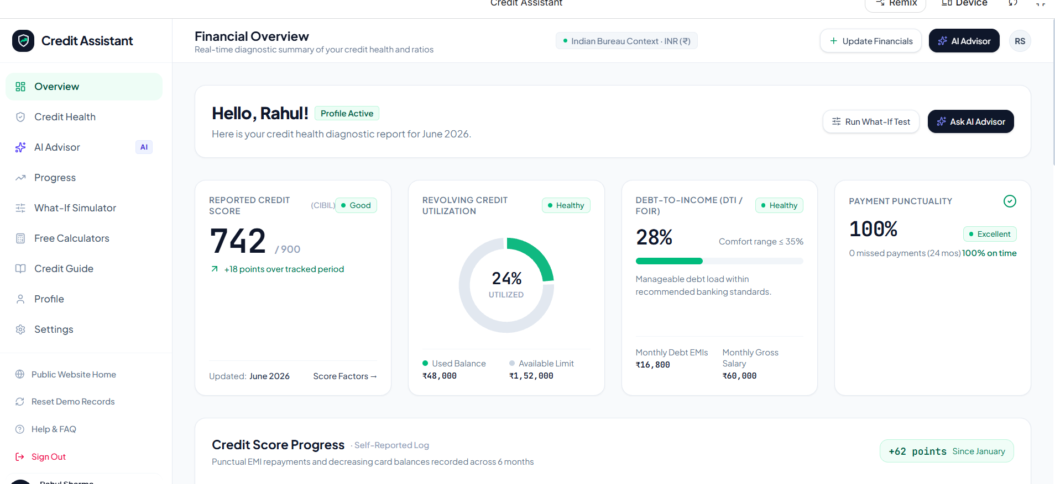
Figure 2. Financial overview dashboard with credit and repayment indicators.

3.3 Credit health and factors
The Credit Health page expands the summary into five core scoring pillars. The visible categories are payment punctuality (weight 35%), credit utilization (30%), credit age (15%), credit portfolio mix (10%), and hard inquiries (10%). Each card contains a status label, a value or description, and a short practical insight.
The sample data shows 100% on-time payments, utilization of ₹48,000 out of ₹2,00,000 (24%), an average credit age displayed as 3.5 years, a portfolio of two cards and two loans, and one hard inquiry. These values are illustrations from the reference interface, not a determination of any real user’s creditworthiness.
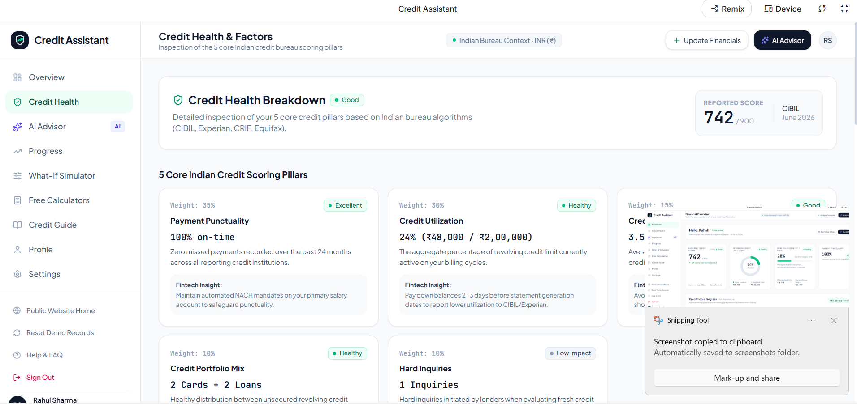
Figure 3. Credit Health breakdown and five credit-scoring pillars.

4. Main Features Identified
Feature | Purpose
Credit score summary | Displays a reported score, a status label, and score movement over a tracked period.
Credit utilization | Compares used revolving balance with total available credit and visualizes the percentage.
DTI / FOIR calculator | Compares monthly debt obligations with gross monthly income to show a debt-burden ratio.
Payment punctuality | Summarizes on-time repayment behaviour and missed-payment history.
Credit profile factors | Explains payment history, utilization, credit age, portfolio mix, and hard inquiries.
What-if simulator | Allows users to explore hypothetical changes to salary, card spending, credit limits, and EMIs.
AI advisor | Provides a visible entry point for personalized explanations and suggested next steps.
Progress tracking | Shows reported changes over time, such as score movement and balance trends.
Free calculators and credit guide | Supports financial literacy with self-service tools and educational material.
Profile and settings | Provides navigation for financial information and user preferences.

5. Sample Metrics Shown in the References
The following table records the principal figures visible in the supplied screenshots. They are reproduced for documentation purposes only and should not be interpreted as verified financial information.
Metric | Reference value | Notes
Reported credit score | 742 / 900 | Labelled “Good”
Revolving credit utilization | 24% | ₹48,000 used of ₹2,00,000 total limit
Debt-to-income / FOIR | 28% | Comfort range shown as ≤35%
Payment punctuality | 100% | 0 missed payments in the displayed 24-month period
Payment punctuality factor weight | 35% | Largest listed factor weight
Credit utilization factor weight | 30% | Second-largest listed factor weight
Credit age factor weight | 15% | Displayed average credit age: 3.5 years
Credit portfolio mix weight | 10% | Displayed portfolio: 2 cards + 2 loans
Hard inquiries factor weight | 10% | Displayed inquiry count: 1

6. User Journey
- A visitor reaches the public landing page and reads the product benefits.
- The visitor tests the instant diagnostic by adjusting income, card spend, credit limit, and monthly EMIs.
- The user opens the dashboard to review their reported credit score and key ratios.
- The user selects Credit Health to understand the factors behind the summary.
- The user can continue to the What-If Simulator, AI Advisor, Progress, calculators, or credit guide.
- The user updates financial details and revisits progress to compare changes over time.

7. Design and Usability Observations
- Clear information hierarchy: large score and ratio values make the dashboard easy to scan.
- Consistent status language: green labels such as Healthy, Good, and Excellent communicate positive states.
- Useful progressive disclosure: the overview is concise, while the Credit Health page gives more detail.
- Strong navigation: the sidebar keeps core tools visible across dashboard pages.
- Action-oriented layout: buttons such as Update Financials, Run What-If Test, and Ask AI Advisor make next steps obvious.
- Responsive design should be tested: the references are desktop screenshots, so mobile and tablet layouts still need validation.

8. Recommendations and Improvements
- Clarify data provenance: Label each metric as bureau-sourced, user-entered, calculated, or demo data. Show the date and source of every score or report.
- Explain calculations: Provide concise formulas and definitions for utilization and DTI/FOIR, including which income and debt fields are included.
- Avoid overpromising outcomes: Describe diagnostic labels as estimates or educational indicators rather than guarantees of loan approval or score improvement.
- Strengthen privacy transparency: Link to clear privacy, consent, data-retention, deletion, and grievance procedures. Verify claims about data localization and soft inquiries.
- Improve accessibility: Check keyboard navigation, screen-reader labels, contrast, focus states, and non-colour status indicators.
- Add validation and edge cases: Test empty values, negative inputs, unusually high values, inconsistent financial data, and calculation rounding.
- Provide explainable AI guidance: Show why a recommendation is made, distinguish general education from personalized advice, and encourage verification of important decisions.
- Test responsive behaviour: Review the sidebar, charts, cards, and tables on smaller screens and at increased text sizes.
- Include security controls: Use secure authentication, least-privilege access, encryption, audit logging, and appropriate handling of sensitive financial information.

9. Suggested Technical Modules
Based on the visible interface, a practical implementation could be organized into the following modules. This is a proposed structure inferred from the screens, not a claim about the actual codebase.
Module | Responsibilities
Frontend interface | Landing page, dashboard cards, navigation, forms, charts, responsive layouts.
Financial calculation layer | Credit utilization, DTI/FOIR, what-if scenarios, input validation, rounding rules.
User profile and data layer | Profile settings, financial inputs, timestamps, history and consent records.
Credit report integration | Authorized bureau data retrieval, source attribution, report freshness, error handling.
AI guidance layer | Explainable suggestions grounded in available data and guarded against unsupported guarantees.
Security and compliance layer | Authentication, authorization, secure storage, audit trail, privacy notices, retention rules.

10. Conclusion
The supplied references present Credit Assistant as a polished credit-awareness platform that combines a simple entry page with a detailed financial dashboard and a factor-based credit-health view. Its strongest design qualities are clear metric presentation, consistent status cues, and easy access to educational and simulation tools. Before real-world deployment, the most important next steps are to validate the calculations, identify the source of every displayed value, substantiate privacy and bureau-related claims, and test security, accessibility, and responsive behaviour.

Appendix: Scope and Limitations
This report is based only on the three screenshots supplied by the user. It describes the visible interface and proposes improvements; it does not inspect the source code, verify live bureau connections, audit regulatory compliance, or validate the accuracy of the example calculations. All sample names, scores, amounts, and ratios are treated as interface examples.

