**TRAFFIC MANAGEMENT SYSTEM**

**PHASE – 3**

**DEVELOPE PART -1**

**How IoT is transforming the transportation industry?**

* Over the past decade, the Internet of Things has made a quantum leap forward and has become the basis for intelligent digital solutions, which are so lacking in logistics and transport.
* According to [a report](https://www.grandviewresearch.com/press-release/global-iot-device-management-market)by Grand View Research, the global IoT device management market will grow to $5.1 billion by 2025 at a compound annual growth rate of 28.3%.
* Digitalization and the urgent need for communication and network technologies, including the transport industry, have become the market’s driving forces.
* These innovative solutions prepare the city’s infrastructure for the next technology milestone, including connected vehicles and full 5G deployment.

**Traffic management:**

* When it comes to implementing IoT technologies in transport, the first goal is traffic jam problem-solving. The American Transportation Research Institute [estimates](https://www.statista.com/chart/21085/annual-economic-losses-from-traffic-congestion/) that [congestion costs](https://internationalfleetworld.com/the-true-cost-of-congestion/) the U.S. freight sector $74.1 billion annually. Traffic management Internet of Things solutions allows you to increase the capacity of city streets without actually adding new roads and play a vital role in the transition to smart cities.
* They optimize traffic flow and keep traffic safe using sensors, cameras, routers, and cellular technologies to dynamically adjust controls such as traffic lights, highway exit counters, expressway bus lanes, highway bulletin boards, and even speed limits.

For example, Ford has[introduced](https://media.ford.com/content/fordmedia/feu/en/news/2015/12/02/new-ford-autonomous-tech-turns-traffic-jams-into-chill-time-and-.html) Traffic Jam Assist, a mode that allows the vehicle to match the car’s speed in front of a traffic jam. This speed matching makes it easier for drivers and smoothes traffic flows, and reduces congestion patterns.

In the future, these systems will be able to directly control vehicles when needed – for example, breaking them at intersections to prevent collisions with pedestrians or other vehicles.

Application for traffic jams using IoT technology include:

**Smart parking.**IoT sensors in parking lots can transmit information about accessible parking spaces in real-time.

**IoT traffic light.** Sensors installed in strategic locations can use IoT technology to collect data on congestion, moving vehicles away from these locations.

[IoT Big Data](https://relevant.software/blog/iot-big-data-empower-business/)solutions can analyze this information, determine alternative routes, and improve traffic signaling to reduce congestion. Roadside lights can also work by the weather sensors installed on them. With a light control system, roadside lighting will change with the onset of day or night and when weather conditions require it.

**Smart ambulance.** Video surveillance systems and road sensors can help locate incidents and report them to the nearest emergency room.

**IoT in Smart traffic management system: How does it work?**

Intelligent Transportation Systems can help solve the traffic problem by integrating IoT technology with existing infrastructure. Take, for example, an IoT-based smart traffic signal monitoring system.

It relies on a priori information provided by the IoT sensors and adjusts the traffic signals so that the time interval depends on the number of vehicles on that particular part of the road. The main advantage of this system is that it can reduce downtime and traffic density in various areas.

Some of the key functionalities that cities acquire through these systems include the following:

**Traffic jam detection.** With cameras and sensors constantly monitoring intersections, technicians can monitor all streets in a town from the city’s traffic control center.

**Adaptive control.** Congestion detection leads to dynamic systems adjustments, including traffic lights, entry alarms, and express bus lanes.

**Interaction with connected cars.** Smart Traffic Management can connect roadside devices to them to enable intelligent vehicles to communicate directly with intersections.

**Emergency routing.** A critical application of a smart traffic system using IoT is providing priority access to police, fire, and ambulance services.

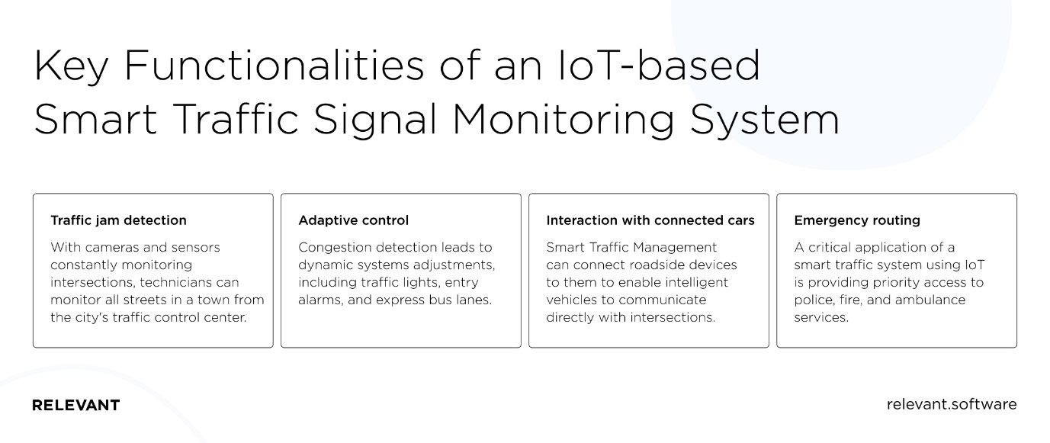

**The benefits of an IoT-based traffic monitoring/management system**

The Internet of Things in the transport industry is the unification of objects into a single network using actuators, built-in sensors, and other devices that collect and transmit data to a single central console.

One of the advantages of IoT technology is that sensors and beacons can be installed in cars and trains and integrated into street lamps, bus stops, and railway platforms. That will ensure consistent visibility and reduce accidents. In addition, transport organizations will be able to analyze the data passing through IoT devices and improve the quality and efficiency of their services. As a result of the traffic management IoT, the industry will benefit from:

**Safe travel**

The ability to track metrics such as train speed, carriageway temperature, or the number of vehicles at an intersection using IoT technology can help improve the safety of transportation systems around the world.

**Efficient processes**

Municipalities and organizations adopting IoT technologies are reaping significant productivity benefits. They can better monitor critical infrastructures and design efficient processes to minimize operating costs and increase system throughput.

**Improving the environment**

IoT-enabled systems can quickly respond to changing traffic patterns and return real-time data to help drivers plan their journeys better with better congestion monitoring. Reducing congestion and energy consumption has a positive impact on the environment.

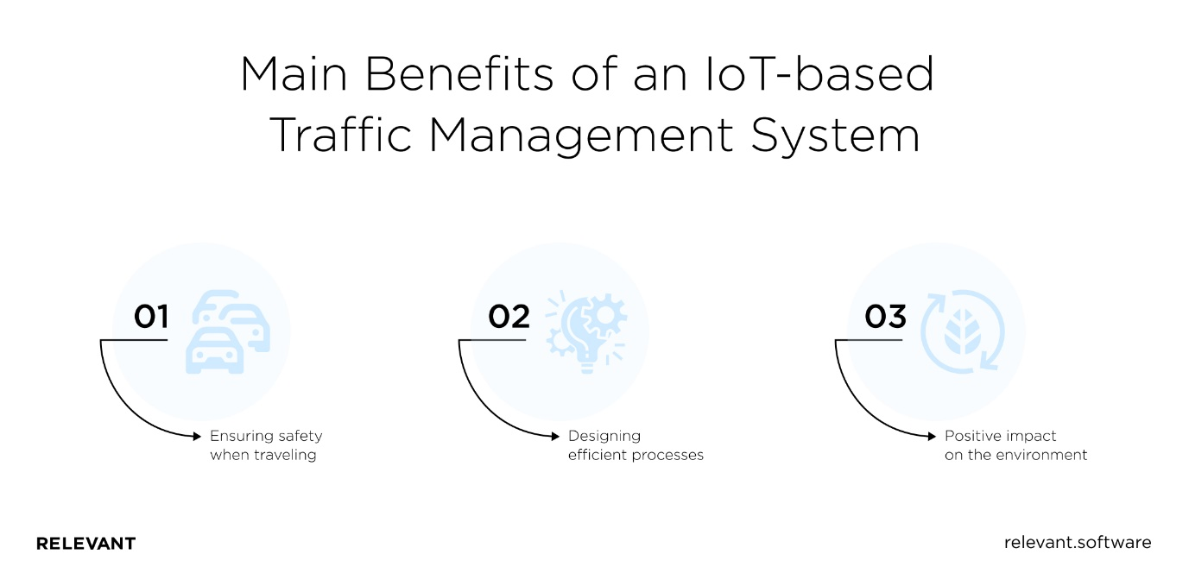

**The challenges of integrating IoT in the traffic management system**

While IoT traffic management has advanced capabilities for road infrastructure, we can not ignore some impediments. Let’s consider the most important ones;

**Additional security requirements**

As the number of IoT devices connecting to the central network grows, its vulnerability increases the likelihood of hacker attacks to take over confidential data.

Therefore, any traffic management solution must have a basic and an additional level of security.

Typically that data transmission encryption, user access control, and device authentication.

**The need for high-tech network infrastructure**

All high-tech solutions require high-speed data transfer methods. Since IoT solutions involve working with large amounts of data and many IP addresses, network facilities must maintain constant communication and collect data from sensors and other IoT devices. Thus, to operate efficiently, you need strong networks that can meet the needs of the Internet of Things as they evolve.

**Time spent on adaptation**

The IoT-based intelligent traffic management system includes thousands of sensors and devices, and it is impossible to manage all of these endpoints manually.

A digital traffic solutions provider must provide an intuitive IoT traffic control system with an automatic connection and a centralized control panel.

**Additional investment**

As mentioned above, the implementation of IoT technology in the long term reduces costs and optimizes the operations of any organization. But the initial integration requires investment.

These are the costs associated with the network infrastructure, the modernization of vehicles directly connected to the IoT solution, and the planning, implementation, management, and security of IoT systems.

Therefore, many customers immediately submit IoT development on [outsourcing to Ukraine](https://relevant.software/blog/6-key-facts-that-make-ukraine-a-great-software-development-outsourcing-destination/), known for its pool of talented programmers and quality solutions at a fair price.

**Conclusion**

The future of the transport industry looks pretty optimistic with digital traffic solutions. Therefore, we advise you to take advantage of the already apparent technological and organizational breakthroughs.

Relevant Software specializes in solving business problems using software solutions, including IoT for transportation projects. So if you want to [hire IoT developers](https://relevant.software/blog/iot-big-data-empower-business/) to create a custom-made IoT app or improve an existing one, [contact us](https://relevant.software/blog/iot-in-transportation-smart-traffic-control-system/#contact-us) right now. In addition to experience and technology, we will provide comprehensive information on emerging trends to keep your IoT solution relevant in the long term.