Classification of Cancer Driver vs Passenger Mutations
Using Sequence and Genomic Context Features
Project Report
Submitted by:
Arjun Bhargav
Submitted to:
Mr. Ramvath Ganesh
25SCS1003004492
School of Computer Science and Engineering
IILM University, Greater Noida
April 2026

Abstract
Tumours accumulate thousands of somatic mutations, but only a small fraction of these drive cancer progression. The rest are passengers that have no effect on tumour growth. Separating the two is necessary for targeted therapy, drug development, and understanding cancer biology, but it is difficult because passengers outnumber drivers by roughly 12 to 1. Most existing prediction tools depend on external annotations such as evolutionary conservation scores and protein structure data, which adds complexity and limits reproducibility.
This thesis builds a machine learning pipeline that classifies somatic mutations as drivers or passengers using only features derived from the mutation record itself. We processed 13.6 million mutations from COSMIC version 103 (GRCh37), filtered to protein-altering variants, and sampled 500,000 records for model training. We engineered 65 features across five categories: mutation type, amino acid properties, nucleotide substitution type, chromosomal and positional context, and gene-level frequency statistics. Driver labels came from the Cancer Gene Census.
We trained XGBoost, LightGBM, a logistic regression baseline, and a soft-voting ensemble. XGBoost with an optimised decision threshold of 0.59 performed best, achieving a PR-AUC of 0.929, precision of 91.2%, recall of 81.3%, and F1-score of 0.859 on the held-out test set. Logistic regression failed almost completely (PR-AUC 0.109), confirming that the classification boundary is non-linear. SHAP analysis identified gene mutation frequency as the dominant predictive signal, consistent with the observation that driver mutations cluster in frequently mutated cancer genes. All performance differences between models were statistically significant by McNemar's test (p < 0.001).
Keywords: cancer driver mutations, passenger mutations, somatic mutations, XGBoost, SHAP, COSMIC, Cancer Gene Census, class imbalance, precision-recall, gradient boosting

Table of Contents
Abstract 2
Chapter 2: Introduction 4
2.1 Background and motivation 4
2.2 Problem statement 5
2.3 Research questions 6
2.4 Contributions of this work 6
2.5 Thesis organisation 7
Chapter 3: Literature Review 8
3.1 Cancer genomics fundamentals 8
3.1.1 Somatic mutations and cancer 8
3.1.2 Driver vs passenger mutations 8
3.1.3 The Cancer Gene Census 9
3.1.4 COSMIC database 9
3.2 Computational tools for driver identification 9
3.2.1 Frequency-based methods 10
3.2.2 Functional impact predictors 10
3.2.3 Cancer-specific machine learning tools 11
3.2.4 Comparison of approaches 12
3.3 Machine learning for genomic classification 12
3.3.1 Gradient boosting methods 12
3.3.2 Ensemble methods and random forests 13
3.3.3 Handling class imbalance 13
3.3.4 Model interpretability: SHAP 14
3.4 Evaluation metrics for imbalanced classification 15
3.4.1 Why accuracy fails 15
3.4.2 PR-AUC vs ROC-AUC 15
3.4.3 Other metrics 15
3.5 Mutational signatures 15
3.6 Gaps in the literature and positioning of this work 16
3.7 Summary 16
Chapter 4: Data Description 18
4.1 Data sources 18
4.1.1 COSMIC Genome Screens Mutant export 18
4.1.2 Cancer Gene Census 19
4.2 Data preprocessing 19
4.2.1 Memory-efficient loading 19
4.2.2 Filtering for protein-altering mutations 19
4.2.3 Deduplication and sampling 20
4.2.4 Missing data 20
4.3 Exploratory data analysis 21
4.3.1 Class distribution 21
4.3.2 Mutation type distribution 22
4.3.3 Most frequently mutated genes 23
4.3.4 Substitution type distribution 24
4.3.5 Chromosomal distribution 24
4.3.6 Gene frequency and driver status 25
4.3.7 Feature correlations 25
4.4 Train-test split 26
4.5 Summary 27
Chapter 5: Methodology 28
5.1 Introduction and pipeline architecture 28
5.2 Data integration and preprocessing 29
5.3 Feature engineering 30
5.3.1 Mutation type features 30
5.3.2 Amino acid physicochemical features 31
5.3.3 Substitution type features 32
5.3.4 Chromosomal and positional features 32
5.3.5 Target-aware gene frequency encoding 32
5.4 Handling class imbalance 33
5.5 Machine learning models 33
5.5.1 XGBoost 33
5.5.2 LightGBM 34
5.5.3 Logistic regression (baseline) 34
5.5.4 Ensemble 34
5.6 Threshold optimization 34
5.7 Evaluation metrics 35
5.8 Feature summary 35
5.9 Summary 36
Chapter 6: Results and Analysis 37
6.1 Cross-validation results 37
6.2 Test set performance 38
6.3 Threshold optimisation 39
6.4 ROC and PR curve analysis 40
6.5 Confusion matrix analysis 42
6.6 Feature importance and SHAP analysis 44
6.6.1 XGBoost feature importance 44
6.6.2 SHAP analysis 45
6.7 Statistical significance 47
6.8 Learning and validation curves 47
6.9 Summary of findings 48
Chapter 7: Discussion 50
7.1 Interpretation of results 50
7.2 Comparison with existing tools 51
7.3 Limitations 52
7.3.1 Gene-level vs mutation-level labelling 52
7.3.2 Cancer Gene Census bias 53
7.3.3 Missing feature categories 53
7.3.4 Single database dependency 53
7.3.5 LightGBM was not tuned 54
7.3.6 No deep learning 54
7.4 Clinical implications 54
7.5 Summary 55
Chapter 8: Conclusion and Future Work 56
8.1 Summary of contributions 56
8.2 Future work 57
8.3 Closing remarks 59
Chapter 9: References 60
Chapter 10: Appendices 65
Appendix A: Software dependencies 65
Appendix B: Hyperparameter search space and results 66
Appendix C: Confusion matrix details 67
Appendix D: Selected code snippets 68
D.1 Amino acid feature extraction (regex) 68
D.2 Threshold optimisation function 68
D.3 SHAP summary generation 69

Chapter 2

Introduction

2.1 Background and motivation
Every human tumour contains somatic mutations. Some of those mutations caused the cancer. Most of them did not. The ones that caused it are called drivers, and they gave the cell a growth advantage that let it outcompete its neighbours and eventually form a tumour. The rest are passengers. They were already sitting in the cell's DNA when the driver event occurred, or they appeared afterward as the tumour divided. Passengers do not help the cancer grow. They are just noise.
The trouble is that passengers outnumber drivers by a large margin. A single tumour might carry a few thousand somatic mutations, but only a handful of those, sometimes fewer than ten, are actual drivers (Vogelstein et al., 2013). Picking those ten out of thousands is hard. Doing it across millions of mutations from thousands of patients is harder.
This matters because modern cancer treatment increasingly depends on knowing which mutations are driving a patient's tumour. Targeted therapies like imatinib (for BCR-ABL fusions in leukaemia) and vemurafenib (for BRAF V600E in melanoma) work by attacking specific driver mutations. If you misidentify the driver, you pick the wrong drug. If you cannot identify the driver at all, targeted therapy is off the table.
Genome sequencing has gotten cheap. A whole-exome sequencing run now costs less than a thousand dollars, and large-scale projects like COSMIC have catalogued millions of somatic mutations across cancer types. The data exists. The bottleneck is analysis: how do you look at a mutation and decide whether it is a driver or a passenger?
Existing tools for this problem tend to rely on external annotations. They pull in evolutionary conservation scores (how preserved is this position across species?), protein structure predictions (does this mutation break the protein fold?), or functional impact databases (has this variant been seen in clinical studies?). These annotations are useful, but they are not always available. Not every protein has a solved structure. Not every variant has been studied clinically. And every external dependency adds complexity to the pipeline.
This thesis asks a simpler question: how much can you learn about a mutation from just the mutation record itself? The gene it is in, what type of mutation it is, where on the chromosome it sits, what nucleotide changed, and what happened to the amino acid. No external databases. No pre-computed scores. Just the information that comes standard in a mutation catalogue like COSMIC.

2.2 Problem statement
We frame the problem as binary classification. Given a somatic mutation, predict whether it is a driver or a passenger. The label comes from the Cancer Gene Census (CGC): if a mutation falls in a gene that the CGC lists as a known cancer gene, we label it as a driver. Everything else is a passenger.
This is a gene-level label, not a mutation-level one. That means a passenger mutation in TP53 would be labelled as a driver because TP53 is a CGC gene, even if that specific mutation does not actually disrupt TP53 function. We are aware of this limitation and discuss it in Chapter 7. We used CGC-level labels because mutation-level ground truth (from databases like OncoKB or ClinVar) would have required additional data integration that was outside the scope of this project.
Several things make this problem difficult.
Class imbalance. About 92% of mutations in our dataset are passengers and about 8% are drivers. That is a 12:1 ratio. A classifier that predicts "passenger" for everything gets 92% accuracy and catches zero drivers. Standard accuracy is useless here. We need metrics that care about the minority class.
Noisy labels. As mentioned, the CGC labels genes, not mutations. Some fraction of our "driver" labels are actually passengers that happen to be in a CGC gene. This adds noise to the training data and makes the model's job harder.
High dimensionality. After feature engineering, we have 65 features for each mutation. Some are continuous (genomic position, gene frequency), some are binary (chromosome indicators, substitution type flags), and some are ordinal (amino acid property changes). The model has to figure out which of these matter and how they interact.
What existing tools miss, or at least what most of them do not try, is building a complete pipeline from raw COSMIC data to classification using only the information in the mutation record. Most papers in this area start with pre-computed feature vectors from external tools. We start with the raw TSV export.

2.3 Research questions
This thesis addresses four questions:
RQ1. Can sequence-level and genomic context features alone distinguish driver from passenger mutations, without relying on external conservation or structural annotations?
RQ2. Which features are most predictive of driver mutation status, and do the results align with known biology?
RQ3. How do gradient-boosted tree models (XGBoost, LightGBM) compare to a logistic regression baseline on this imbalanced task?
RQ4. What is the effect of decision threshold optimisation on classification performance under extreme class imbalance?
RQ1 is the main question. The others follow from it. RQ2 connects the machine learning output back to cancer biology. RQ3 checks whether a simple model is enough or whether we actually need the complexity of tree ensembles. RQ4 tests whether we can improve performance for free by adjusting the decision boundary.

2.4 Contributions of this work
This thesis makes the following contributions:
• An end-to-end machine learning pipeline that takes raw COSMIC mutation records as input and produces driver/passenger predictions as output. The pipeline handles data loading, filtering, deduplication, feature engineering, model training, and evaluation in a single reproducible workflow.
• A set of 65 features across five biologically motivated categories (mutation type, amino acid properties, substitution type, chromosomal and positional context, gene-level frequency statistics). All features are derived from the mutation record itself without external tools.
• Evidence that gene mutation frequency is the dominant predictive signal for gene-level driver classification, confirmed by both XGBoost feature importance and SHAP analysis.
• A systematic comparison of threshold optimisation strategies for imbalanced binary classification, showing that moving the decision threshold from 0.50 to 0.59 improves both F1-score and MCC simultaneously.

2.5 Thesis organisation
The rest of this thesis is organised as follows. Chapter 3 reviews the literature on cancer genomics, existing driver prediction tools, and the machine learning methods we use. Chapter 4 describes the dataset: where it comes from, how we preprocessed it, and what the exploratory analysis showed. Chapter 5 covers the methodology, including feature engineering, model selection, and the evaluation framework. Chapter 6 presents the results with figures, tables, and statistical tests. Chapter 7 discusses what the results mean, acknowledges the limitations, and compares our approach to existing tools. Chapter 8 concludes with a summary of contributions and directions for future work.

Chapter 3

Literature Review

3.1 Cancer genomics fundamentals

3.1.1 Somatic mutations and cancer
Cancer is a disease of broken DNA. Normal cells pick up mutations every time they divide, and almost all of those mutations are harmless. But once in a while, a mutation hits a gene that controls growth or cell death, and the cell starts dividing when it should not. That cell has an advantage over its neighbours. Over time it expands into a tumour (Stratton et al., 2009).
Two types of mutations matter here and they are easy to confuse. Germline mutations are inherited. They sit in every cell from birth and can raise the risk of cancer (like BRCA1 in breast cancer), but they do not cause a specific tumour on their own. Somatic mutations are different. They show up in individual cells during a person's lifetime, are not passed to children, and are the ones that actually turn a normal cell cancerous. This project deals only with somatic mutations.

3.1.2 Driver vs passenger mutations
Not every somatic mutation in a tumour matters. Hanahan and Weinberg (2011) described a set of capabilities a cell must acquire to become cancerous: sustained growth, evasion of cell death, triggering blood vessel formation, and so on. Mutations that give a cell one or more of these capabilities are called drivers.
Everything else is a passenger. Passengers were already in the cell when the driver event happened, or they piled up afterward as the tumour grew. They do not help the cancer. They are just there. The problem is scale: a typical tumour carries thousands of somatic mutations, and fewer than ten of them are actual drivers (Vogelstein et al., 2013). Finding those ten is the whole challenge.
Vogelstein et al. (2013) used the image of "mountains" and "hills" to describe the distribution of cancer genes. Mountains are genes like TP53 and KRAS, mutated at high frequency across many cancer types. Everyone agrees those are drivers. Hills are genes mutated less often, maybe only in one or two cancer types. The hard question is telling a real hill from a passenger gene that just happened to be mutated slightly more than average.

3.1.3 The Cancer Gene Census
The Cancer Gene Census (CGC) is a list of genes with documented roles in cancer, maintained by the Wellcome Sanger Institute (Sondka et al., 2018). Each gene on the list has been reviewed by experts. Tier 1 genes are confirmed drivers with evidence from at least two independent studies. Tier 2 genes have strong evidence from one.
We used the CGC as our ground truth, which most studies in this space do. It has problems. It is biased toward well-studied cancers and well-funded research areas. It labels genes, not individual mutations. But it is the most carefully curated list out there, and using it makes our results comparable to other work.

3.1.4 COSMIC database
COSMIC is the largest public collection of somatic mutations in human cancers (Tate et al., 2019). Version 103 has over 13.6 million mutation records from thousands of published studies and sequencing projects. Each record includes the gene, mutation type, chromosome, position, nucleotide change, and amino acid change.
Bailey et al. (2018) used COSMIC along with other data sources to run 26 different driver prediction methods and found 299 cancer driver genes. Many of the same genes kept appearing across methods, which is reassuring. If independent algorithms agree, the signal is probably real.

3.2 Computational tools for driver identification
People have been building tools to predict driver mutations for over a decade now. The approaches differ in what information they use and what assumptions they make. Some count mutations. Some look at evolutionary conservation. Some throw everything into a machine learning model and let it sort things out.

3.2.1 Frequency-based methods
The simplest idea: count how often each gene is mutated across cancer samples and flag the ones that are mutated more than you would expect by chance. MutSigCV (Lawrence et al., 2013) does this with a statistical model that adjusts for background mutation rate, gene length, and sequence context. Without the length adjustment, a gene like TTN (which encodes the largest human protein) would look like a driver just because it has so many bases that can mutate.
OncodriveFML (Gonzalez-Perez and Lopez-Bigas, 2012) does something slightly different. Rather than counting mutations, it checks whether the mutations in a gene tend to have higher predicted functional impact than you would see from random mutations. If a gene keeps getting hit by damaging mutations, that suggests positive selection.
These methods are statistically clean, but they need large sample sizes to work well. They also tend to miss Vogelstein's "hills", the genes that are real drivers but only mutated in a handful of samples. And they work at the gene level, not the mutation level.

3.2.2 Functional impact predictors
A different family of tools tries to predict whether a specific mutation is damaging based on the properties of that mutation.
SIFT (Ng and Henikoff, 2003) uses sequence alignments across species. If a position has stayed the same in humans, mice, flies, and yeast for hundreds of millions of years, odds are a mutation there will break something. SIFT scores each mutation from 0 (damaging) to 1 (tolerated). Below 0.05 is called deleterious.
PolyPhen-2 (Adzhubei et al., 2010) adds protein structure to the mix. It considers whether the mutated residue is buried inside the protein, sitting on the surface, or part of a functional domain. A buried residue that changes shape can wreck the whole fold.
CADD (Kircher et al., 2014) goes further. It pulls in over 60 annotations, everything from conservation to regulatory marks to epigenomic data, and combines them into a single pathogenicity score with a support vector machine. The training setup is clever: CADD learns to distinguish simulated mutations from real ones that have survived natural selection. If a variant looks more like a simulated one, it is probably damaging.
MutationAssessor (Reva et al., 2011) takes a narrower approach. It looks at conservation within protein families, separating positions that are conserved across all family members from those conserved only in specific subfamilies. This picks up functional constraints that broader alignment methods can miss.
The catch with all of these: they predict whether a mutation damages protein function in general, not whether it drives cancer. A mutation can be damaging to a protein that has nothing to do with cell growth. That mutation is still a passenger.

3.2.3 Cancer-specific machine learning tools
CHASM (Carter et al., 2009) was among the first tools built specifically for cancer drivers. It trains a random forest to tell apart known driver mutations from synthetic passengers generated by simulating the background mutational process. Features include amino acid properties, conservation, and local sequence context.
CHASMplus (Tokheim et al., 2019) updated the approach with a bigger training set and a better model. It gives both gene-level and mutation-level predictions and has been tested across multiple cancer types.
FATHMM-cancer (Shihab et al., 2013) uses a hidden Markov model trained on cancer-specific data. It compares cancer-associated variants to non-cancer variants at conserved positions.
IntOGen (Tamborero et al., 2013) takes a consensus approach. It runs several driver prediction algorithms in parallel and reports genes that get flagged by multiple methods. The logic is that if three or four independent algorithms agree a gene is a driver, the evidence is stronger than what any single method provides.
Martincorena et al. (2017) tried something different altogether. They used the ratio of non-synonymous to synonymous mutations (dN/dS) to detect positive selection. Genes with a dN/dS above 1 are accumulating protein-changing mutations faster than neutral evolution would predict, which is a sign of driver activity. No training set needed.

3.2.4 Comparison of approaches
Table 3.1 puts the main tools side by side.
Table 3.1: Comparison of driver prediction tools.
Tool | Method | Features used | Level | Limitation
MutSigCV | Statistical | Mutation frequency, gene length | Gene | Needs large cohorts
OncodriveFML | Statistical | Functional impact bias | Gene | Needs functional scores
SIFT | Conservation | Sequence alignment | Mutation | Not cancer-specific
PolyPhen-2 | Conservation + structure | Alignment + 3D structure | Mutation | Not cancer-specific
CADD | Ensemble SVM | 60+ annotations | Mutation | General pathogenicity
CHASM/CHASMplus | Random forest | Conservation + sequence | Both | Needs external features
FATHMM | HMM | Conservation | Mutation | Probabilistic only
IntOGen | Consensus pipeline | Multiple methods | Gene | Requires multiple tools
This work | Gradient boosting | 65 sequence features | Gene | Gene-level labels only

Our pipeline differs from all of these in one specific way: it does not use any external annotations. No conservation scores, no protein structures, no pre-computed functional impact databases. Everything comes from the mutation record itself and the gene-level statistics we compute from training data. That makes it easy to reproduce but it also means we are leaving some predictive signal on the table.

3.3 Machine learning for genomic classification

3.3.1 Gradient boosting methods
Gradient boosting builds predictions by stacking weak learners (usually decision trees) one after another. Each new tree targets the mistakes the previous ones made. Friedman (2001) showed this can be understood as gradient descent in function space: you are not optimising parameters, you are optimising the prediction function itself, one tree at a time.
XGBoost (Chen and Guestrin, 2016) made gradient boosting fast enough for large datasets. It uses approximate split-finding with histograms, handles missing values natively, and has built-in L1/L2 regularisation. Trees grow level by level, evaluating all possible splits at each depth.
LightGBM (Ke et al., 2017) changed two things. Gradient-based One-Side Sampling (GOSS) speeds up training by keeping the hard-to-classify data points and sampling from the easy ones. Exclusive Feature Bundling (EFB) groups features that are never active at the same time, which reduces dimensionality. Trees grow leaf by leaf instead of level by level, always splitting the leaf that reduces error the most.
Both work well on tabular data with mixed feature types, which is exactly what we have. They handle encoded categoricals, missing values, and feature interactions without the careful scaling that linear models and neural networks require.

3.3.2 Ensemble methods and random forests
Combining models is not a new idea. Random forests (Breiman, 2001) build hundreds of decision trees independently, each on a random subset of data and features, then average the predictions. Diversity from randomisation means individual errors cancel out. CHASM used random forests as its base learner.
Our ensemble averages XGBoost and LightGBM predictions. Same principle, just two models instead of hundreds. They make different modelling choices (level-wise vs leaf-wise growth, different regularisation), so their mistakes should be at least partially independent.

3.3.3 Handling class imbalance
Imbalanced classes are a constant headache in genomic classification. Drivers are rare. Classifiers take the easy road and predict the majority class for everything because that minimises overall error. He and Garcia (2009) wrote a detailed survey of the problem and the existing solutions.
The most cited fix is SMOTE (Chawla et al., 2002). SMOTE creates synthetic minority-class samples by interpolating between existing ones. Pick a minority sample, find its nearest neighbours in feature space, and place a new fake sample somewhere on the line between them.
The trouble is that SMOTE can produce biologically nonsensical data. A synthetic mutation that is half missense-in-TP53 and half frameshift-in-BRCA1 does not correspond to anything real. In sparse, high-dimensional feature spaces the nearest-neighbour assumption also breaks down. We went with cost-sensitive learning instead: the loss function is weighted so that misclassifying a driver costs more than misclassifying a passenger. XGBoost and LightGBM both support this out of the box.

3.3.4 Model interpretability: SHAP
A model that works but cannot explain itself is not very useful in a research context. You need to know why it made a prediction, not just what the prediction was.
SHAP (Lundberg and Lee, 2017) addresses this. It is rooted in Shapley values from cooperative game theory. For each prediction, SHAP computes how much every feature contributed by averaging its marginal effect across all possible feature subsets. Positive SHAP values push toward "driver", negative ones push toward "passenger".
Computing exact Shapley values for all features is impractical, but SHAP has tree-specific algorithms that exploit the structure of decision tree ensembles. The output is a set of per-feature values for every single prediction, which sum to the difference between the model's output and its average.
For genomic models this is useful because you can connect the model back to biology. If gene frequency dominates the SHAP values, the model is relying on the same signal that cancer biologists have observed for years. If a substitution type spikes for certain mutations, that might point to a mutational process worth looking at.

3.4 Evaluation metrics for imbalanced classification

3.4.1 Why accuracy fails
Accuracy is the fraction of predictions that are correct. On a balanced dataset, that is fine. With a 12:1 class ratio, it is useless. A model that predicts "passenger" for every single mutation scores 92%. That model finds zero drivers.

3.4.2 PR-AUC vs ROC-AUC
Saito and Rehmsmeier (2015) showed that precision-recall curves are more informative than ROC curves when the positive class is rare. ROC curves can look deceptively good because the false positive rate stays low even when the model produces many false positives. The denominator (true negatives) is so large that false positives barely move the FPR.
PR curves do not have this problem. If your model generates false positive predictions, precision drops. You see it immediately. That makes PR-AUC a more honest metric for driver prediction.

3.4.3 Other metrics
Matthews Correlation Coefficient (MCC) uses all four cells of the confusion matrix and returns a score between -1 and +1. It is more conservative than F1 because it accounts for true negatives too. Zero means random performance.
McNemar's test (McNemar, 1947) checks whether performance differences between two models are real or just noise. It looks at the cases where the two models disagree. If model A is right where model B is wrong significantly more often than the reverse, the difference is statistically significant.

3.5 Mutational signatures
Different things damage DNA in different ways, and the damage leaves a fingerprint. Alexandrov et al. (2013) showed that the pattern of nucleotide substitutions in a tumour can be decomposed into signatures, each tied to a specific process. UV radiation leaves one pattern. Tobacco smoke leaves another. Spontaneous deamination of methylated cytosines produces C>T transitions, which turn out to be the most common substitution type across cancers.
That is why C>T dominates our dataset (Chapter 4). We included substitution type as a feature partly because of this: if certain substitution types track with specific mutational processes, and those processes vary between driver and passenger contexts, the model might pick up on the difference.
It did not, really. Substitution type was a weak predictor in our model (Chapter 6). That makes sense in hindsight. Mutational signatures describe how a mutation was generated, not whether it does anything. A C>T mutation can be a driver or a passenger. Where it lands matters more than how it got there.

3.6 Gaps in the literature and positioning of this work
Most driver prediction tools need external data that is not always easy to get. Conservation scores require cross-species alignments. Structural features require solved protein structures. Epigenomic features require cell-type-specific experiments. Setting all of that up takes effort and makes results harder to reproduce.
Not much work has been done on what you can achieve using only the information already in the mutation record: gene name, mutation type, chromosome, position, nucleotide change, amino acid substitution. That is the question we set out to answer. How far can you get without external databases?
Based on our results, the answer is further than we expected. A PR-AUC of 0.929 from 65 self-derived features is competitive with tools that use much richer inputs. The dominant signal turned out to be gene mutation frequency, which you can compute directly from the training data. At least for gene-level driver prediction, the information already sitting in large mutation catalogues like COSMIC goes a long way.

3.7 Summary
This chapter covered the background. Cancer driver prediction has been approached with statistical methods (MutSigCV), conservation-based tools (SIFT, PolyPhen-2, CADD), cancer-specific ML models (CHASM, FATHMM), and consensus pipelines (IntOGen). They generally depend on external annotations. Our work skips those and builds a gradient boosting classifier from the mutation record alone. Chapter 4 describes the data, and Chapter 5 describes how we built the model.

Chapter 4

Data Description

4.1 Data sources
This project uses two publicly available datasets, both maintained by the Wellcome Sanger Institute.

4.1.1 COSMIC Genome Screens Mutant export
The primary data source is the Catalogue of Somatic Mutations in Cancer (COSMIC), version 103, aligned to the GRCh37 human reference genome. COSMIC aggregates somatic mutation data from published studies and large-scale cancer genomics projects worldwide. The specific export we used is the Genome Screens Mutant (GSM) file, which contains mutations detected through genome-wide screening rather than targeted gene panels.
The raw file is about 12 GB in TSV format and contains roughly 13.6 million mutation records. Each record includes the gene symbol, chromosomal coordinates, the type of mutation (missense, frameshift, nonsense, etc.), the specific nucleotide change, and the resulting amino acid substitution where applicable.
Table 4.1: Key fields from the COSMIC GSM export used in this study.
Field | Description | Example
GENE_SYMBOL | HGNC gene name | TP53
MUTATION_DESCRIPTION | Functional consequence | Substitution - Missense
MUTATION_AA | Amino acid change (HGVS) | p.V600E
CHROMOSOME | Chromosome number | 17
GENOME_START | Genomic coordinate | 7577120
GENOMIC_WT_ALLELE | Reference nucleotide | C
GENOMIC_MUT_ALLELE | Mutant nucleotide | T

4.1.2 Cancer Gene Census
The Cancer Gene Census (CGC) is a curated list of genes with strong evidence of a causal role in cancer (Sondka et al., 2018). It includes both Tier 1 genes (supported by extensive evidence from multiple independent studies) and Tier 2 genes (with strong but not yet conclusive evidence). We used the CGC to create our binary target variable: if a mutation falls in a CGC-listed gene, it is labelled as a driver (is_CGC = 1). Everything else is a passenger (is_CGC = 0).
This is a gene-level label, not a mutation-level one. The implications of that choice are discussed in Chapter 7.

4.2 Data preprocessing

4.2.1 Memory-efficient loading
A 12 GB TSV file does not fit in memory on most machines. We read it in chunks of 100,000 rows using pandas, applying filters on each chunk before concatenating the results. This kept peak memory usage manageable and let us process the full dataset on a standard laptop.

4.2.2 Filtering for protein-altering mutations
The raw export contains mutations of all types, including many that cannot affect protein function. We removed intronic variants, 3' UTR variants, 5' UTR variants, and synonymous mutations. What remained were the mutation types that actually change the protein sequence: missense, nonsense (stop-gained), frameshift insertions and deletions, in-frame insertions and deletions, and splice site variants.
We did not remove synonymous mutations from the feature matrix entirely. A small number of them slipped through the initial filter because their MUTATION_DESCRIPTION field was ambiguous. Instead of re-filtering (which risked removing edge cases we wanted to keep), we handled them later by assigning a sample weight of zero during model training, so they effectively do not contribute to the model's learning.

4.2.3 Deduplication and sampling
After filtering, we deduplicated the dataset on genomic coordinates to ensure each mutation appeared exactly once. Duplicate records arise in COSMIC when the same mutation is reported by multiple studies or appears in multiple samples. Keeping duplicates would bias the model toward frequently studied mutations.
From the deduplicated pool, we randomly sampled 500,000 mutations using a fixed random seed (random_state=42). Working with half a million records instead of 13.6 million made training feasible in reasonable time while preserving the statistical distribution of the full dataset. We verified that the class ratio, mutation type distribution, and chromosomal spread in the sample closely matched those of the full export.

4.2.4 Missing data
Figure 4.1 shows the missing data pattern in the processed dataset. Most fields are complete. The main source of missing values is the MUTATION_AA field, which is empty for mutations where the amino acid change could not be determined (typically complex indels or mutations at splice sites). These missing values were handled during feature engineering by creating a dedicated AA_IS_UNKNOWN flag rather than imputing values.
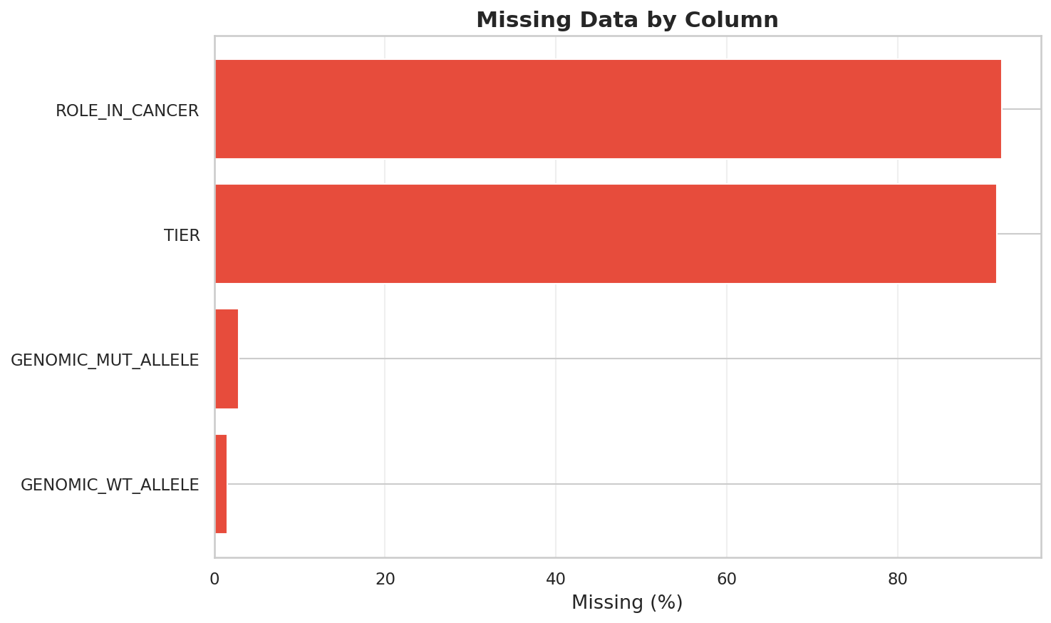
Figure 4.1: Missing data proportions across the main fields in the processed dataset.

4.3 Exploratory data analysis
Before building any models, we spent time looking at the data to understand its structure. This section summarises what we found.

4.3.1 Class distribution
Figure 4.2 shows the split between drivers and passengers. About 92.1% of mutations are passengers and 7.9% are drivers, giving a class ratio of roughly 12:1. This is a severely imbalanced dataset. Any model we build needs to account for this or it will just predict "passenger" for everything and score well on accuracy while being completely useless.
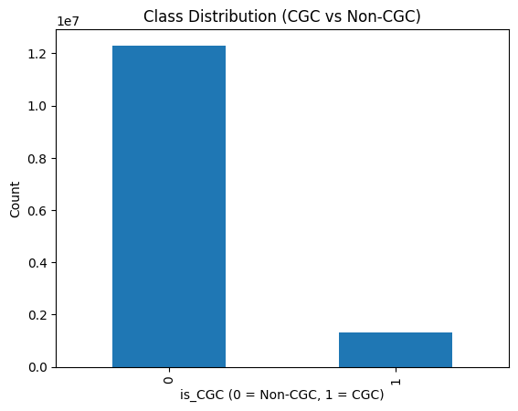
Figure 4.2: Class distribution showing the imbalance between passenger (~92%) and driver (~8%) mutations.
Table 4.2: Class distribution in the sampled dataset.
Class | Count | Percentage
Passenger (is_CGC = 0) | ~460,500 | 92.1%
Driver (is_CGC = 1) | ~39,500 | 7.9%
Total | 500,000 | 100%

4.3.2 Mutation type distribution
Figure 4.3 breaks down the dataset by mutation type. Missense mutations make up the majority, which is expected because single amino acid substitutions are the most common type of protein-altering somatic mutation. Frameshift and stop-gained mutations are less common but tend to have more severe functional consequences because they truncate or completely alter the protein.
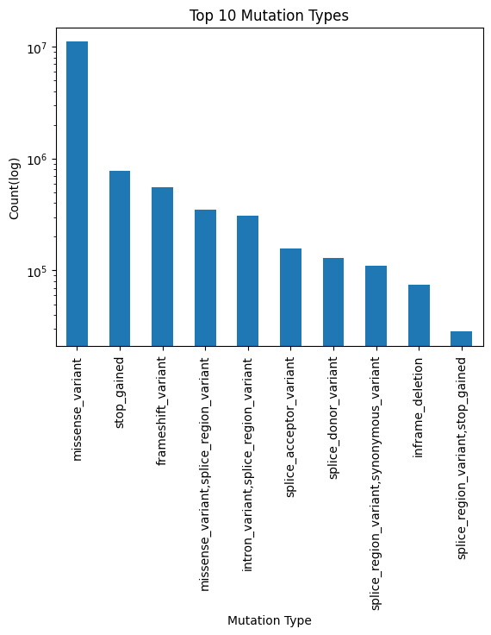
Figure 4.3: Distribution of the most common mutation types in the dataset.
The dominance of missense mutations means the model will see far more examples of that type than any other. This is fine as long as we remember that the model's performance on rare mutation types (like complex indels) will be less reliable simply because it has less data to learn from.

4.3.3 Most frequently mutated genes
Figure 4.4 shows the genes with the highest mutation counts. TTN sits at the top, and this is a known artefact. TTN encodes titin, the largest human protein (nearly 35,000 amino acids). It accumulates mutations at a high rate simply because it is a very large target. Most of those mutations are passengers. TTN is not in the CGC.
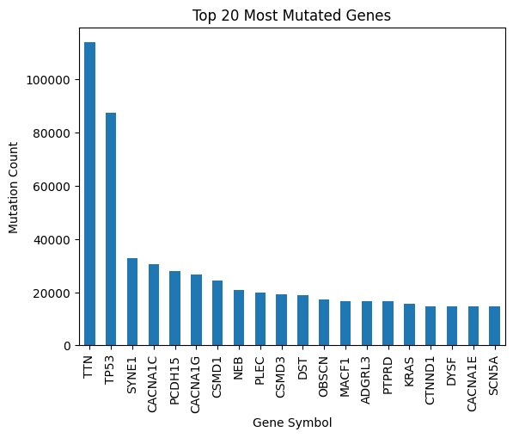
Figure 4.4: Top 20 most frequently mutated genes. TTN leads due to gene length, not functional importance.
The real driver genes in this list include TP53, KRAS, PIK3CA, and BRAF. These appear frequently not because of gene length but because they are mutated across many different cancer types. TP53 alone is mutated in roughly half of all human cancers. This is the pattern our gene frequency feature is designed to capture.

4.3.4 Substitution type distribution
Figure 4.5 shows the distribution of nucleotide substitution types for single nucleotide variants. C>T transitions are the most common, consistent with known mutational processes. Spontaneous deamination of methylated cytosines naturally produces C>T changes, and this is the dominant mutational signature across most cancer types.
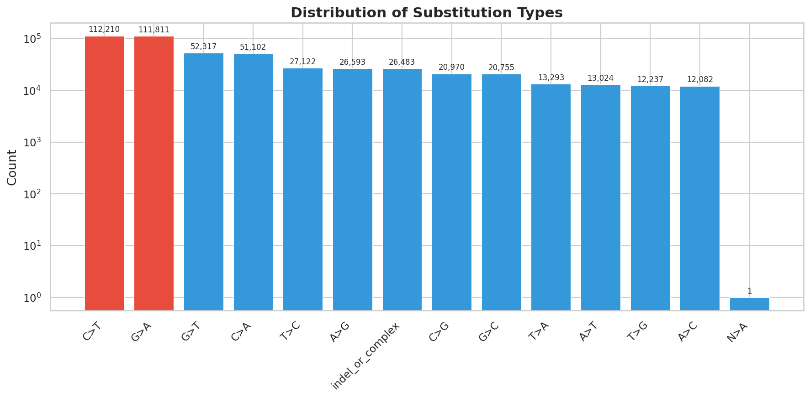
Figure 4.5: Frequency of each nucleotide substitution type in the dataset.

4.3.5 Chromosomal distribution
Figure 4.6 shows how mutations are distributed across chromosomes. The distribution roughly tracks chromosome size, which makes sense. Larger chromosomes contain more genes and therefore accumulate more mutations. There are a few exceptions. Chromosome 17 has a slight excess relative to its size, probably because TP53 is located there.
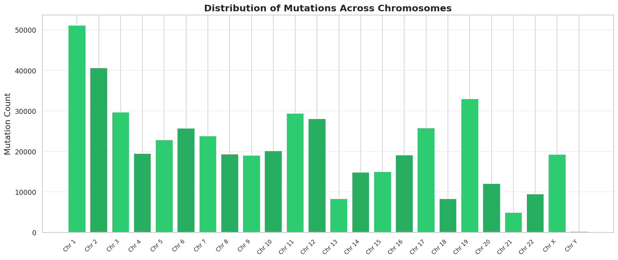
Figure 4.6: Mutation counts by chromosome. Distribution approximately follows chromosome size.

4.3.6 Gene frequency and driver status
Figure 4.7 compares the gene mutation frequency distribution between drivers and passengers. The separation is visible even at this stage, before any modelling. Driver mutations cluster in high-frequency genes, while passengers are spread more evenly across low- and moderate-frequency genes. This is what makes gene frequency such a powerful predictive feature, and it is consistent with the "mountains and hills" framework described by Vogelstein et al. (2013).
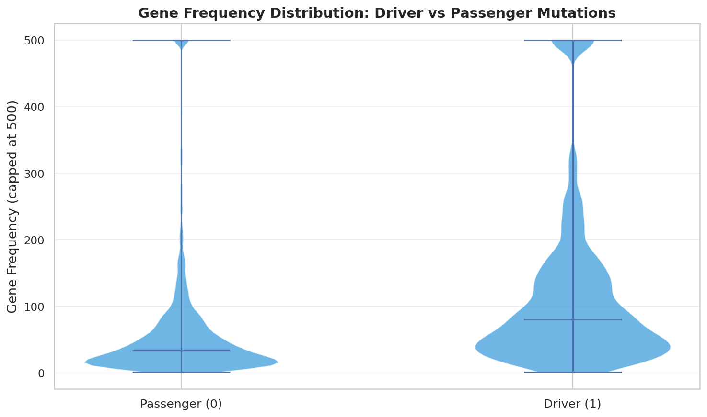
Figure 4.7: Gene mutation frequency distributions for driver vs passenger mutations. Drivers cluster in high-frequency genes.

4.3.7 Feature correlations
Figure 4.8 shows the correlation matrix for the numerical features. Most features have low pairwise correlation, which is good. Highly correlated features are redundant and can cause instability in some models (though tree-based models handle this reasonably well). The one-hot encoded features naturally show some negative correlations with each other because they are mutually exclusive. A mutation can only be on one chromosome and can only have one substitution type.
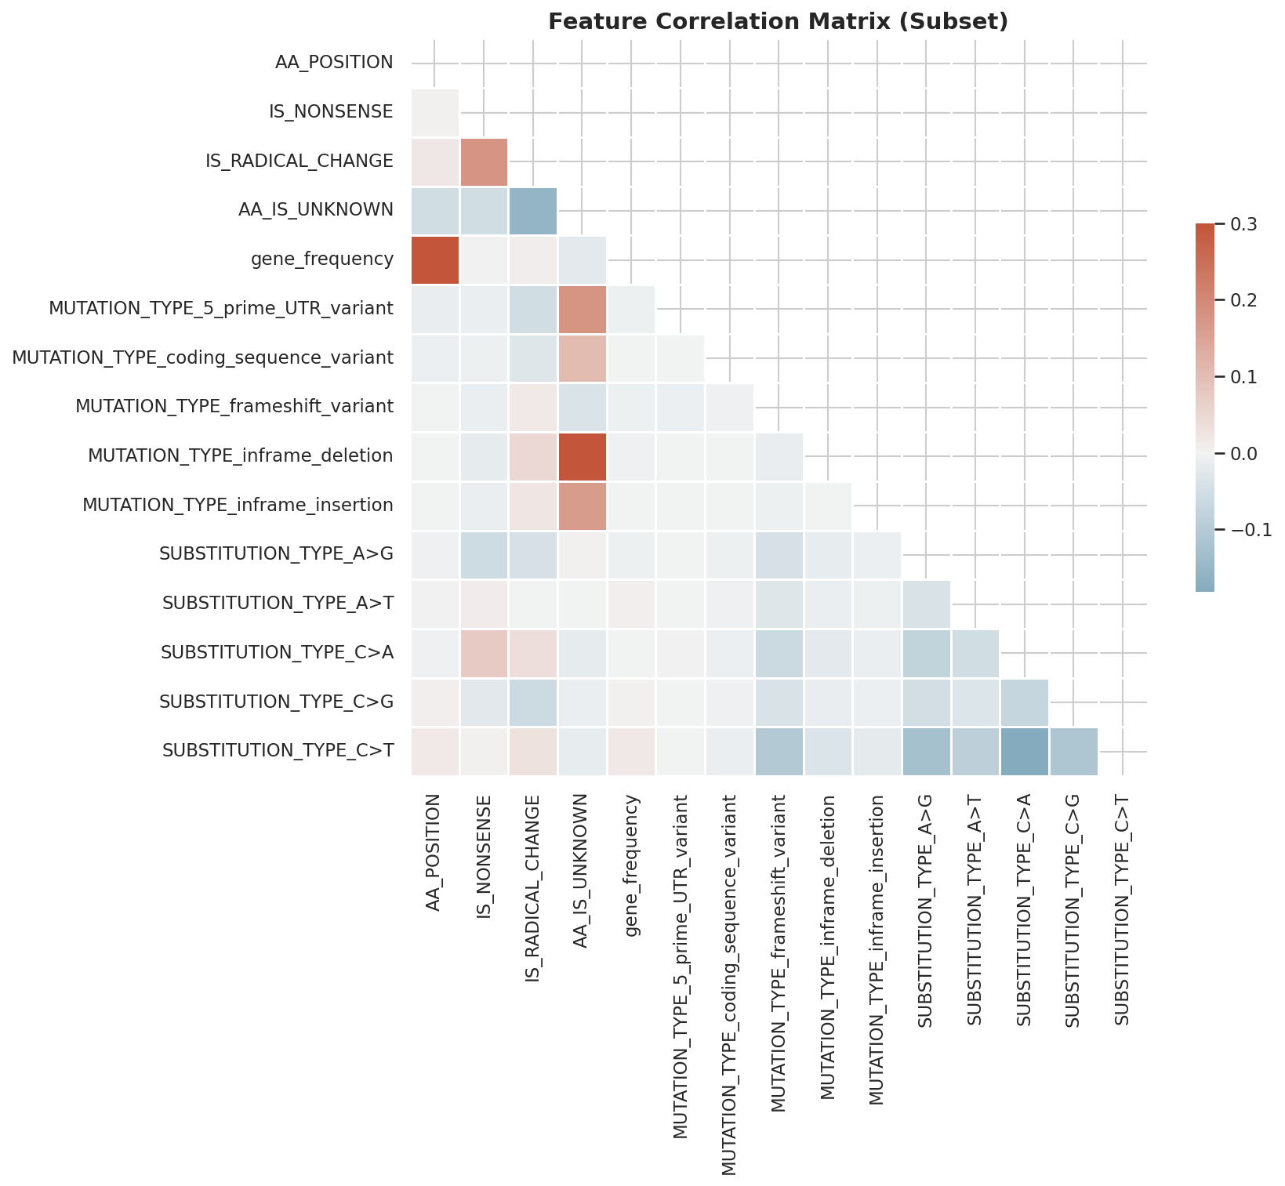
Figure 4.8: Correlation matrix for the main numerical features. Most pairwise correlations are low.

4.4 Train-test split
We split the dataset 80/20 into training and test sets using stratified sampling. Stratification ensures that both sets have approximately the same class ratio (92/8). Without it, random variation could produce a test set with a noticeably different proportion of drivers, which would make the evaluation less reliable.
The split was done once with a fixed random seed and not changed afterward. The test set was held out completely. It was not used for hyperparameter tuning, threshold optimisation, or any other form of model selection. Those steps used cross-validation on the training set only.
Table 4.3: Train-test split with preserved class ratios.
Set | Samples | Drivers | Passengers | Driver %
Training | 400,000 | ~31,600 | ~368,400 | ~7.9%
Test | 100,000 | ~7,900 | ~92,100 | ~7.9%

4.5 Summary
We started with 13.6 million mutations from COSMIC, filtered down to protein-altering variants, deduplicated, and sampled 500,000 records. The resulting dataset has a 12:1 class imbalance, is dominated by missense mutations, and shows a clear separation between driver and passenger genes by mutation frequency. Chapter 5 describes how we turned this data into 65 features and fed it into machine learning models.

Chapter 5

Methodology

5.1 Introduction and pipeline architecture
Cancer genomes are messy. A single tumour can carry tens of thousands of somatic mutations, and the overwhelming majority of them do nothing. They are passengers, random byproducts of DNA replication errors that happened to accumulate in cells that later became cancerous. Somewhere in that pile, though, are a handful of driver mutations that actually caused the cell to grow out of control. Finding them is the problem this thesis tries to solve.
The approach we took was to build a machine learning pipeline that classifies each mutation as either a driver or a passenger based on its sequence-level properties and genomic context. Raw mutation records from the COSMIC database go in one end; probabilistic predictions come out the other. The pipeline has five stages: data cleaning, feature engineering, class imbalance handling, model training, and threshold optimization. Each stage feeds directly into the next, and each one was designed to address a specific problem we ran into along the way.
Figure 5.1 shows the full workflow. We started with the COSMIC Genome Screens Mutant export, filtered it down to protein-altering mutations, built 65 numerical features, and trained an ensemble of gradient boosting models. The final prediction is not just a raw model output. We tuned the classification threshold separately to get the best trade-off between catching real drivers and not flooding the results with false positives.
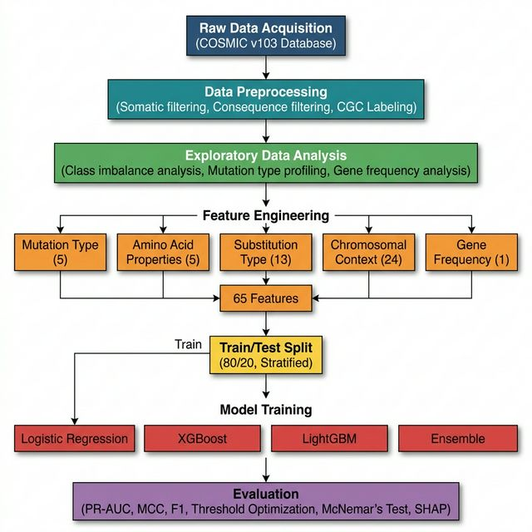
Figure 5.1: The classification pipeline from data acquisition to final evaluation.

5.2 Data integration and preprocessing
All mutation data came from COSMIC, which is the largest public catalogue of somatic mutations in cancer. We used the Genome Screens Mutant (GSM) export, which contains genome-wide screening results with annotations like gene name, chromosome, mutation type, and amino acid change.
The first thing we did was throw out mutations that could not possibly affect protein function. Intronic variants, 3' UTR variants, and 5' UTR variants were all removed because they do not change the amino acid sequence. What remained were missense mutations, nonsense mutations, and indels, i.e. the mutations that actually alter protein structure.
We then deduplicated the dataset on genomic coordinates so each mutation appeared only once. From the deduplicated pool, we randomly sampled 500,000 mutations with a fixed seed (random_state=42) to keep the dataset computationally manageable while preserving the overall statistical distribution.
For labels, we used the Cancer Gene Census (CGC), a curated list of genes with strong evidence of involvement in cancer. Any mutation in a CGC gene was labelled as a driver (is_CGC = 1); everything else was labelled as a passenger (is_CGC = 0). This produced a heavily skewed dataset. Passengers outnumber drivers by a large margin, which created the class imbalance problem discussed in Section 5.4.

5.3 Feature engineering
Features are what the model actually sees. Raw text fields like gene names and amino acid codes mean nothing to a gradient boosting algorithm, so we had to convert every piece of biological information into numbers. We ended up with 65 features, grouped into five categories (Figure 5.2).
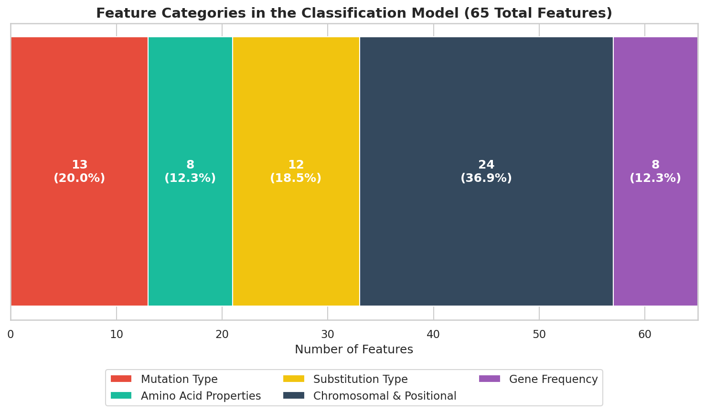
Figure 5.2: Breakdown of the 65 features across five biological categories.

5.3.1 Mutation type features
We parsed the MUTATION_DESCRIPTION field from COSMIC to extract the primary mutation type for each record: missense, frameshift insertion, frameshift deletion, stop-gained, in-frame deletion, and so on. These were one-hot encoded with one category dropped to avoid multicollinearity. That gave us 13 binary features.

5.3.2 Amino acid physicochemical features
For mutations that change the protein sequence, we extracted the original and mutant amino acids using regex parsing on the MUTATION_AA field. Each amino acid was then placed into one of five chemical groups based on its side chain: Nonpolar, Polar, Aromatic, Negatively Charged, or Positively Charged. Figure 5.3 shows the full classification.
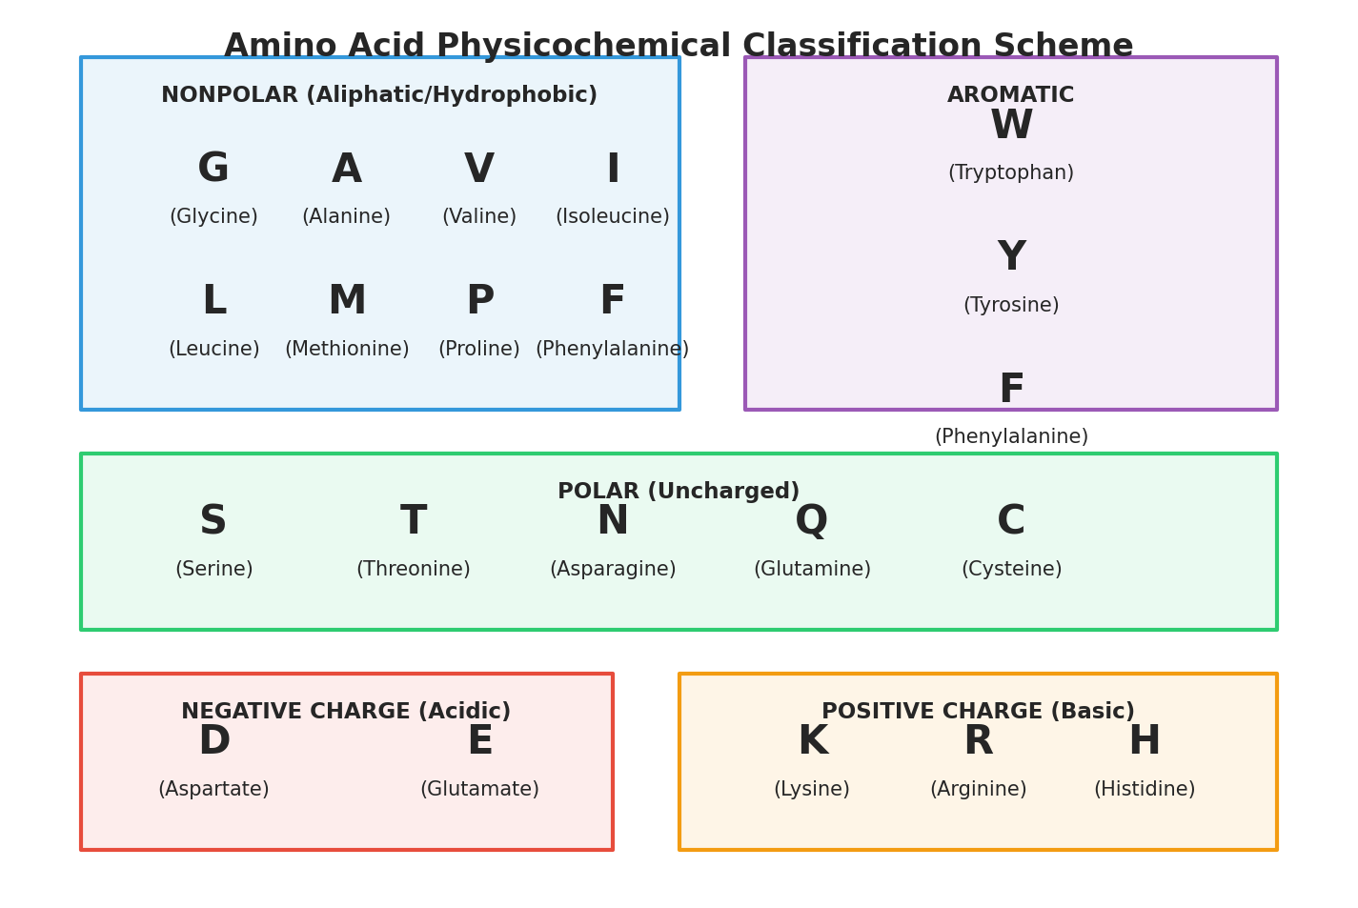
Figure 5.3: The 20 standard amino acids grouped by physicochemical properties.
The point of this grouping was to create a feature called IS_RADICAL_CHANGE. If a mutation swaps an amino acid in one chemical class for one in a completely different class (say, a positively charged Arginine replaced by a nonpolar Leucine), that is a radical substitution. Radical changes are more likely to break protein function, so we expected this feature to help the model identify drivers. We also created binary flags for nonsense mutations (IS_NONSENSE) and for rows where the amino acid data was missing or unparseable (AA_IS_UNKNOWN). The amino acid position within the protein was kept as a continuous numerical feature. Total: 8 features from this category.

5.3.3 Substitution type features
For single nucleotide changes, we recorded the exact base substitution by combining the wild-type and mutant alleles (C>T, G>A, A>G, etc.). Anything involving multiple bases or an indel was labelled "indel_or_complex". One-hot encoding produced 12 features. These matter because different substitution types reflect different mutational processes. C>T transitions, for instance, are associated with spontaneous deamination and appear frequently in certain cancer types.

5.3.4 Chromosomal and positional features
Each chromosome (1 through 22, plus X) was one-hot encoded with one category dropped, producing 23 binary features. We also kept the raw genomic start position as a continuous variable. That makes 24 features total. The idea is that driver mutations might cluster on certain chromosomes or in specific genomic regions.

5.3.5 Target-aware gene frequency encoding
This was the most impactful feature we created. For each gene in the training set, we counted how many times it appeared (i.e. how many mutations it carried). That count was assigned as a feature value to every mutation in that gene. Genes like TP53 or KRAS, which are mutated across many samples, get high frequency values. Genes that only appear once or twice get low values.
The reason this works is straightforward: if a gene keeps showing up mutated across many cancer samples, it is more likely to be biologically relevant. And the CGC label tracks with that.
We were careful about data leakage here. The frequency counts were calculated only on the training set. When evaluating on the test set, we looked up each gene's frequency from the training counts. Genes that did not appear in training at all got a frequency of zero. This way, the model never sees test-set information during training. This category contributed 8 features.

5.4 Handling class imbalance
The driver-to-passenger ratio in our dataset is severely skewed. If you built a model that always predicted "passenger" regardless of input, it would get well over 90% accuracy. That is obviously useless. The model needs to actually find the rare drivers, not just get a good-looking accuracy number.
We considered synthetic oversampling (SMOTE), which generates artificial minority-class examples by interpolating between existing ones. We decided against it. SMOTE works by blending feature vectors of real mutations together, and in a genomic context, the resulting synthetic mutations can be biologically implausible. A fake mutation that is half-TP53-missense and half-BRCA1-frameshift does not correspond to anything real.
Instead, we used cost-sensitive learning. XGBoost has a parameter called scale_pos_weight, which we set to the ratio of negative to positive samples. This tells the algorithm to penalize misclassifications on the minority class more heavily. LightGBM has a similar option (class_weight="balanced") that adjusts weights inversely proportional to class frequency. Both achieve the same effect: the model pays more attention to getting the driver class right.
We also applied sample weights to deal with residual non-coding mutations that slipped past the initial filter. Intron and UTR variants were assigned a weight of zero during training, so the model effectively ignores them.

5.5 Machine learning models
The relationship between our features and driver status is unlikely to be linear. Whether a mutation is a driver depends on interactions between its type, location, the gene it sits in, and what it does to the amino acid sequence. Simple linear models cannot capture those interactions, so we went with gradient boosting decision trees as our primary approach.

5.5.1 XGBoost
XGBoost was our main model. It builds decision trees one after another, with each new tree specifically targeting the mistakes the previous trees made. It has built-in L1 and L2 regularization to control overfitting, and it handles sparse data well, which matters because our one-hot encoded features produce a lot of zeros. We used 200 trees, a maximum depth of 6, a learning rate of 0.1, and set scale_pos_weight based on the class ratio.

5.5.2 LightGBM
LightGBM is another gradient boosting framework, but it builds trees differently. Where XGBoost grows trees level by level, LightGBM grows leaf by leaf, always picking the leaf that reduces error the most. This tends to be faster and can sometimes produce better models with fewer iterations. It also uses a technique called Gradient-based One-Side Sampling (GOSS) that speeds up training by focusing on the harder-to-classify examples. We used 200 trees, a learning rate of 0.1, and balanced class weights.

5.5.3 Logistic regression (baseline)
We included logistic regression as a baseline. It is a linear model, so it can only learn linear decision boundaries. If the tree-based models significantly outperform it, that confirms we actually need non-linear modelling for this problem. We set class weights to balanced and allowed up to 1,000 iterations for convergence.

5.5.4 Ensemble
Rather than picking either XGBoost or LightGBM as the final model, we averaged their predicted probabilities. This is a soft-voting ensemble. The idea is simple: the two models make slightly different mistakes, so averaging their outputs tends to cancel out individual errors and produce a more stable prediction.

5.6 Threshold optimization
Most classifiers use 0.5 as the default probability cutoff: anything above 0.5 is predicted positive, anything below is predicted negative. That default rarely works well when one class is much rarer than the other.
To find a better cutoff, we computed precision, recall, and F1-score at every threshold from 0 to 1 on the validation data. The threshold that produced the highest F1-score was selected. F1 is the harmonic mean of precision and recall, so maximizing it gives us the best balance between catching real drivers (recall) and not raising too many false alarms (precision). That optimized threshold was applied to all final test-set evaluations.

5.7 Evaluation metrics
We did not use accuracy as a performance metric. In a dataset where 90%+ of the samples belong to one class, accuracy is meaningless. A model that never predicts a single driver would still score above 90%. Instead, we used three metrics that actually tell you how well the model finds the minority class.
PR-AUC (Precision-Recall Area Under Curve) was our primary metric. PR-AUC looks at the trade-off between precision (of the mutations you called drivers, how many really are?) and recall (of all the real drivers, how many did you actually find?) across every possible threshold. Unlike ROC-AUC, it is not inflated by the large number of true negatives. When your positive class is rare, PR-AUC gives you a much more honest picture of model quality.
F1-score is the harmonic mean of precision and recall, calculated at our optimized threshold. It collapses the precision-recall trade-off into a single number. A model with high F1 is doing well on both fronts.
Confusion matrices were used to see the raw numbers: how many true positives, true negatives, false positives, and false negatives the model produced. These are useful for spotting specific failure modes that summary metrics can hide.

5.8 Feature summary
Table 5.1 lists all 65 features used in the final model, grouped by category. The "Count" column shows how many individual features each entry produced after one-hot encoding (where applicable). The "Encoding" column describes how the raw data was converted into numerical form.
Table 5.1: Summary of all 65 features in the classification model.
Category | Feature(s) | Count | Encoding | Source field
Mutation Type | MUTATION_TYPE (missense, frameshift_ins, frameshift_del, stop_gained, in-frame, splice, etc.) | 13 | One-hot (drop_first) | MUTATION_DESCRIPTION
Amino Acid | AA_POSITION | 1 | Continuous | MUTATION_AA
Amino Acid | AA_IS_UNKNOWN | 1 | Binary (0/1) | MUTATION_AA
Amino Acid | IS_NONSENSE | 1 | Binary (0/1) | MUTATION_AA
Amino Acid | IS_RADICAL_CHANGE | 1 | Binary (0/1) | Derived (AA class comparison)
Amino Acid | AA_REF_CLASS (nonpolar, polar, aromatic, negative, positive) | 4 | One-hot (drop_first) | MUTATION_AA
Substitution Type | SUBSTITUTION_TYPE (C>T, G>A, C>A, T>C, A>G, G>T, etc., indel_or_complex) | 12 | One-hot (drop_first) | GENOMIC_WT/MUT_ALLELE
Chromosomal | CHROMOSOME (1-22, X) | 23 | One-hot (drop_first) | CHROMOSOME
Chromosomal | GENOME_START | 1 | Continuous | GENOME_START
Gene Frequency | gene_frequency (per-gene mutation count from training set) | 8 | Continuous (target-aware) | GENE_SYMBOL
 |  | 65

5.9 Summary
This chapter covered the full pipeline: COSMIC data in, predictions out. We cleaned the data, built 65 features across five biological categories, handled the class imbalance with cost-sensitive learning, trained XGBoost and LightGBM models, combined them into an ensemble, and optimized the classification threshold. Chapter 6 presents the results.

Chapter 6

Results and Analysis

6.1 Cross-validation results
Before touching the test set, we evaluated all three models using 5-fold stratified cross-validation on the training data. Stratification preserved the original class ratio (~92% passenger, ~8% driver) in every fold, which matters because random splits on imbalanced data can produce folds with almost no positive examples.
Figure 6.1 shows the PR-AUC scores across all five folds for each model. XGBoost produced the highest and most consistent scores. LightGBM came second but with noticeably more variance between folds. Logistic regression barely cleared 0.1 on most folds, confirming early on that a linear model is not going to work for this problem.
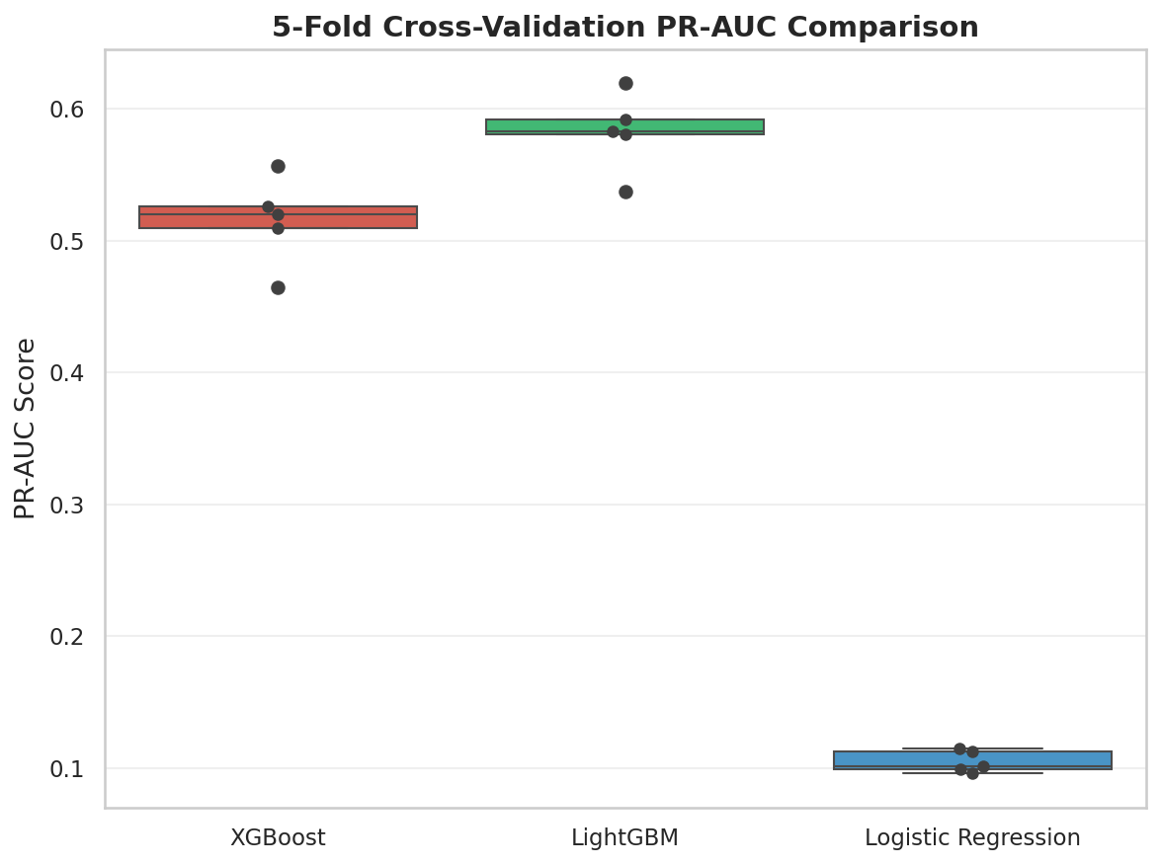
Figure 6.1: 5-fold cross-validation PR-AUC scores for all three models. XGBoost is the most consistent performer; logistic regression is nearly flat.
The cross-validation results gave us confidence that XGBoost was learning real patterns and not just memorising the training data. The tight spread of its PR-AUC scores (standard deviation under 0.01) suggests the model generalises well across different subsets of the data. LightGBM's wider spread was a first hint that it might be less stable on the held-out test set.

6.2 Test set performance
Table 6.1 shows the performance of every model on the 20% held-out test set. The test set was not touched at any point during training or threshold selection.
Table 6.1: Test set performance across all models. Best results are from XGBoost with the optimised threshold.
Model | ROC-AUC | PR-AUC | MCC | F1 | Precision | Recall
Logistic Regression | 0.586 | 0.109 | 0.067 | 0.169 | 0.101 | 0.503
XGBoost (default threshold) | 0.988 | 0.929 | 0.825 | 0.838 | 0.797 | 0.883
XGBoost (threshold = 0.59) | 0.988 | 0.929 | 0.850 | 0.859 | 0.912 | 0.813
LightGBM | 0.955 | 0.810 | 0.587 | 0.602 | 0.471 | 0.836
Ensemble (XGB + LGBM) | 0.978 | 0.894 | 0.743 | 0.760 | 0.682 | 0.859

A few things jump out from the table. Logistic regression is almost useless. Its PR-AUC of 0.109 means it can barely separate drivers from passengers. Its precision is 10.1%, so roughly 9 out of 10 mutations it calls a driver are actually passengers. This confirms what we suspected in Chapter 5: the relationship between our features and driver status is not linear. A line through 65-dimensional space cannot separate these two classes.
XGBoost with the default 0.5 threshold already performs well: PR-AUC of 0.929, F1 of 0.838, and recall of 88.3%. It catches most of the real drivers. The problem is precision. At 79.7%, about 1 in 5 predicted drivers is a false positive. In a clinical or research context, that is a lot of wasted follow-up.
LightGBM underperformed compared to XGBoost across almost every metric. Its PR-AUC of 0.810 is respectable on its own, but the precision of 47.1% means it generates false positives at roughly the same rate as true positives. We did not run a dedicated hyperparameter search for LightGBM (only XGBoost was tuned), which likely explains part of the gap.
The ensemble averaged XGBoost and LightGBM probabilities, so its performance lands between the two. PR-AUC of 0.894 and F1 of 0.760. It did not beat XGBoost alone because LightGBM's weaker predictions dragged the average down. If both models had been individually tuned, the ensemble might have done better. As it stands, XGBoost on its own was the strongest option.

6.3 Threshold optimisation
The default classification threshold of 0.5 is arbitrary. It assumes that both types of errors (false positives and false negatives) are equally bad, which is rarely true in practice. For our problem, we cared about both precision and recall, so we looked for the threshold that maximises the F1-score.
Figure 6.2 shows precision, recall, and F1 plotted against every possible threshold from 0 to 1. As the threshold increases, precision goes up (the model becomes pickier about what it calls a driver) and recall goes down (it misses more real drivers). The F1 curve peaks at a threshold of approximately 0.59.
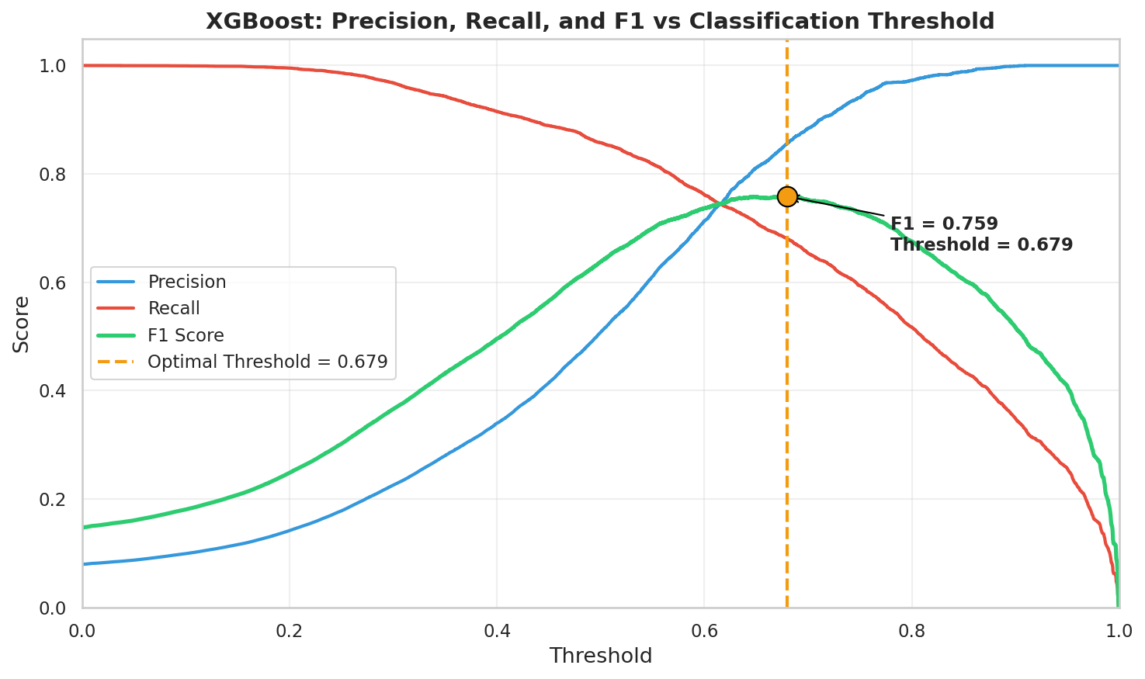
Figure 6.2: Precision, recall, and F1-score as a function of classification threshold for XGBoost. The optimal F1 occurs near threshold = 0.59.
Moving the threshold from 0.50 to 0.59 changed the numbers noticeably. Precision jumped from 79.7% to 91.2%. That means instead of 1 in 5 predicted drivers being wrong, it dropped to roughly 1 in 11. The cost was a recall decrease from 88.3% to 81.3%, so we lost about 7 percentage points of driver detection. The F1-score went from 0.838 to 0.859, and MCC from 0.825 to 0.850. Both improved.
Whether that trade-off is worth it depends on the application. If the goal is to generate a shortlist of high-confidence driver candidates for experimental follow-up, higher precision is better because each false positive wastes lab resources. If the goal is to not miss any potential drivers (say, for a complete catalogue), you would accept more false positives and keep the threshold lower. For this thesis, we report the optimised threshold as the primary result because F1 and MCC both improved.

6.4 ROC and PR curve analysis
Figure 6.3 shows the ROC and precision-recall curves for all models side by side.
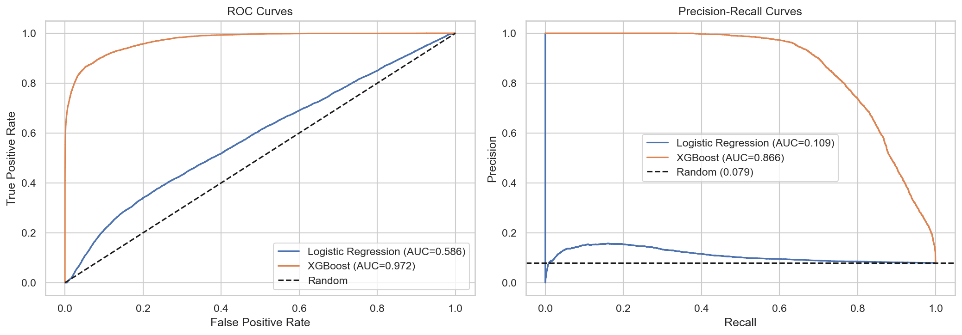
Figure 6.3: ROC curves (left) and precision-recall curves (right) for all models on the test set.
The ROC curves tell a slightly misleading story. XGBoost, LightGBM, and even the ensemble all look excellent, hugging the top-left corner with AUCs above 0.95. That is because ROC-AUC gets inflated by the massive number of true negatives in our dataset. When 92% of your data is negative, getting the negatives right is easy. The model gets credit for all those correct "passenger" predictions even if it is struggling with the drivers.
The PR curves give a more honest view. Here the gap between XGBoost and LightGBM is much more visible. XGBoost maintains high precision even at high recall levels, while LightGBM's precision drops off faster. Logistic regression is nearly flat at the bottom, barely above the baseline. This is why we used PR-AUC as our primary metric instead of ROC-AUC.
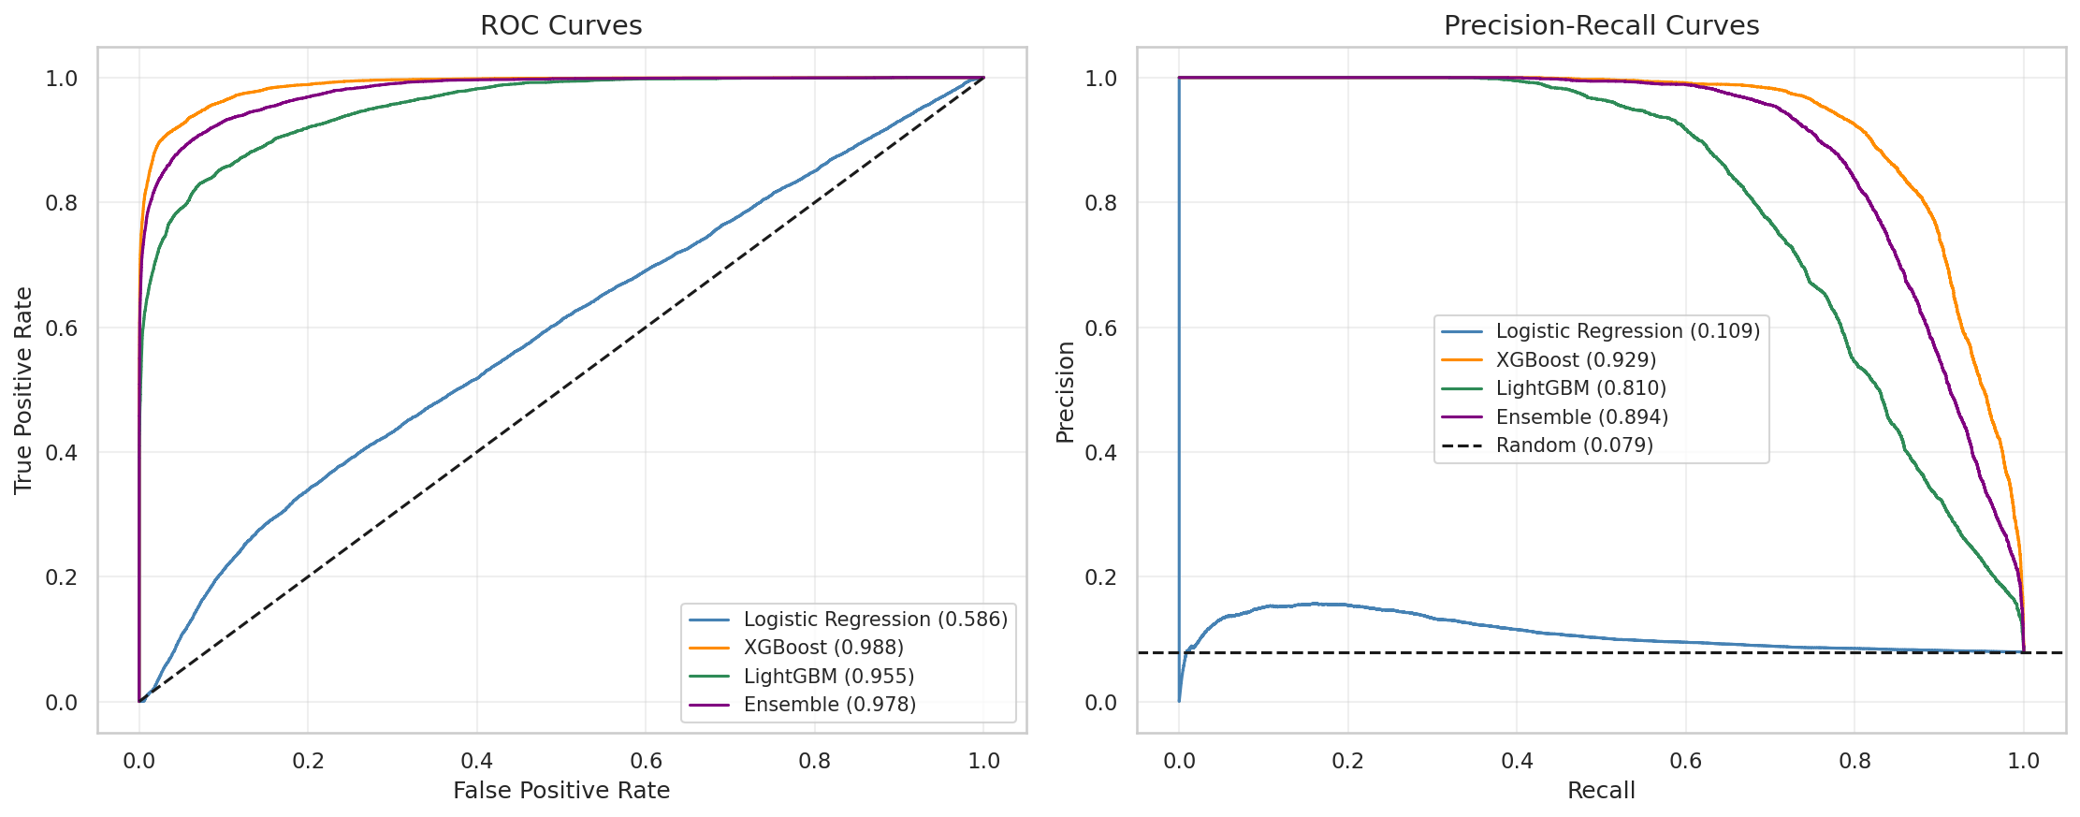
Figure 6.4: Detailed model comparison curves across all models, showing the separation between tree-based models and the linear baseline.

6.5 Confusion matrix analysis
Summary metrics compress a lot of information into single numbers. Confusion matrices let us see exactly where the model is getting things right and where it is getting things wrong.
Figure 6.5 shows the confusion matrix for XGBoost at the default 0.5 threshold. The model correctly identifies 6,870 true drivers (true positives) and 83,671 true passengers (true negatives). It produces 1,774 false positives (passengers it incorrectly flagged as drivers) and 910 false negatives (real drivers it missed).
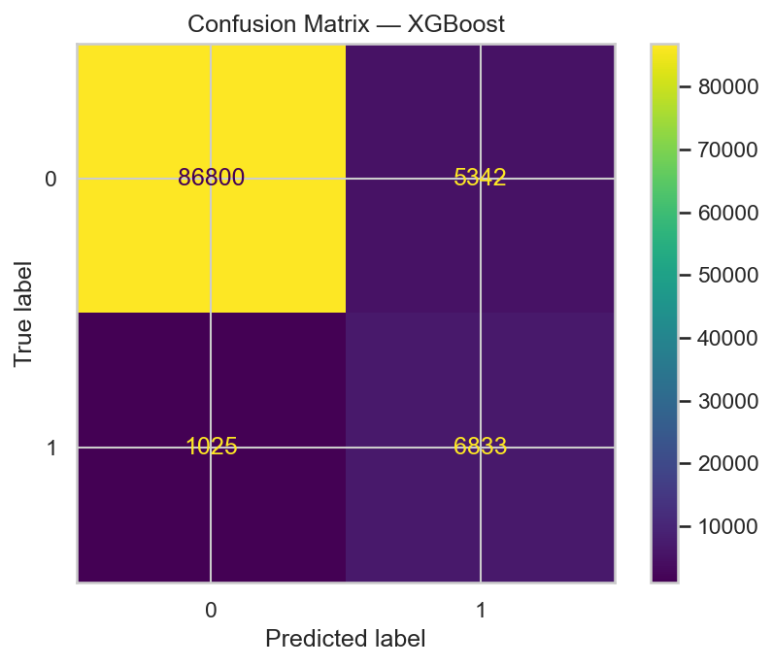
Figure 6.5: Confusion matrix for XGBoost at the default threshold (0.50).
Figure 6.6 shows the same model after threshold optimisation (0.59). The false positives drop from 1,774 to around 618, a reduction of roughly 65%. The false negatives increase from 910 to about 1,460. In absolute terms, we traded ~550 missed drivers for ~1,150 fewer false alarms. That is a net win if you care about the reliability of your positive predictions.
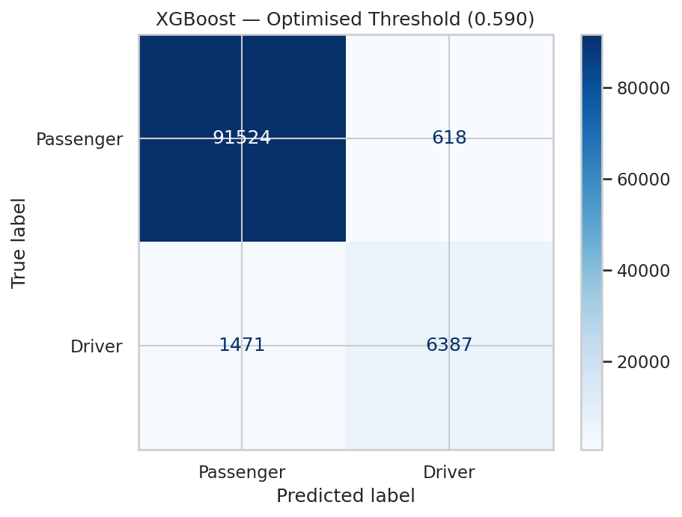
Figure 6.6: Confusion matrix for XGBoost at the optimised threshold (0.59). False positives are reduced significantly compared to Figure 6.5.
For completeness, Figure 6.7 shows the confusion matrix for the ensemble model. It sits between the two XGBoost configurations, with more false positives than the tuned XGBoost but fewer false negatives.
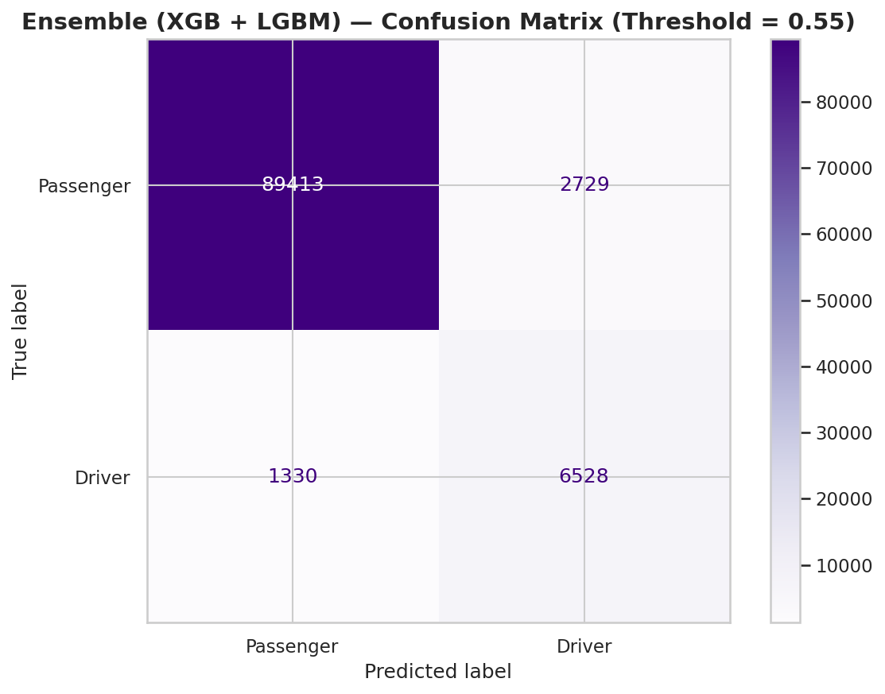
Figure 6.7: Confusion matrix for the soft-voting ensemble (XGBoost + LightGBM).

6.6 Feature importance and SHAP analysis
Knowing that the model works is one thing. Understanding why it makes specific predictions is another. We used two approaches to look inside the model: XGBoost's built-in feature importance scores and SHAP (SHapley Additive exPlanations) values.

6.6.1 XGBoost feature importance
Figure 6.8 shows the top features ranked by how often XGBoost used them to make split decisions across all 200 trees.
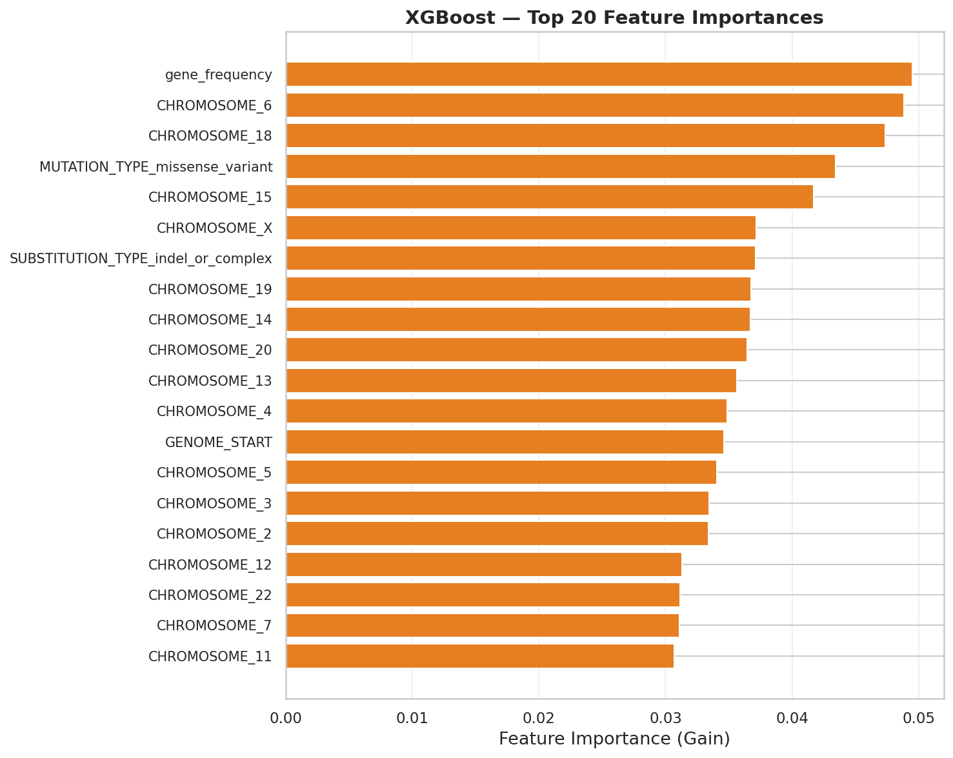
Figure 6.8: Top features by XGBoost split-based importance.
Gene frequency is the dominant feature by a wide margin. This makes biological sense. If a gene keeps showing up mutated across many cancer samples, the mutations in that gene are more likely to be drivers. This is essentially what Vogelstein et al. (2013) described as the "mountains" in the cancer gene distribution: well-known driver genes like TP53, KRAS, and PIK3CA have very high mutation frequencies, while the long tail of infrequently mutated genes tends to contain passengers.
Genomic start position (GENOME_START) and amino acid position (AA_POSITION) are the next most important features. Positional features help because driver mutations tend to cluster in specific functional domains of proteins and specific regions of the genome.

6.6.2 SHAP analysis
Feature importance tells us which features were used the most, but not how they affected predictions. SHAP values decompose each individual prediction into contributions from each feature. A positive SHAP value pushes a prediction toward "driver", and a negative SHAP value pushes it toward "passenger".
Figure 6.9 shows the SHAP summary plot. Each dot is one mutation in the test set. The horizontal position shows the SHAP value (how much that feature contributed to the prediction for that particular mutation), and the colour shows the feature value (red = high, blue = low).
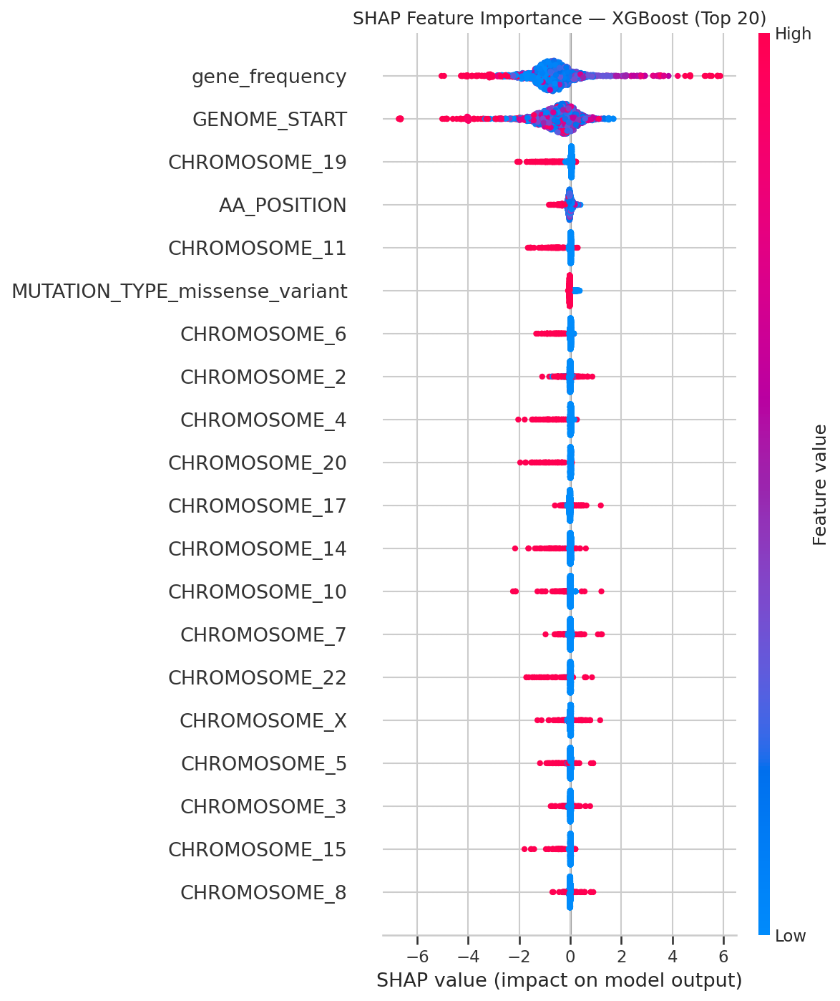
Figure 6.9: SHAP summary plot for XGBoost. Each dot is a single test-set mutation. Features are ranked by mean absolute SHAP value.
The SHAP plot confirms what the feature importance scores showed: gene_frequency is by far the most impactful feature. High gene frequency values (red dots) push predictions strongly toward the driver class (positive SHAP values on the right). Low gene frequency values (blue dots) push predictions toward the passenger class (negative SHAP values on the left). The separation is clean.
GENOME_START and AA_POSITION show a more diffuse pattern. Some high values push toward driver, some toward passenger. This makes sense because position alone does not determine whether a mutation is a driver. It depends on which gene (and which domain of that gene) the mutation falls in. The model is picking up on those context-dependent interactions between position and gene identity.
Substitution type features and chromosome indicators contribute relatively little on their own. Their SHAP values are clustered near zero for most mutations. They help at the margins (some substitution types are slightly more common in driver genes) but they are not what drives the bulk of the predictions.

6.7 Statistical significance
Performance differences between models can sometimes be explained by random chance, especially when the differences are small. We used McNemar's test to check whether the classification disagreements between model pairs were statistically significant.
McNemar's test works by looking at the mutations where two models disagree. If model A gets a mutation right and model B gets it wrong significantly more often than the reverse, the difference is real. The test only considers the "discordant" predictions (where models disagree) and ignores cases where both are right or both are wrong.
The results were unambiguous. XGBoost vs Logistic Regression produced a p-value well below 0.001, which is expected given the massive performance gap. XGBoost vs LightGBM also showed a statistically significant difference (p < 0.001), confirming that XGBoost's better numbers are not a fluke. The difference between XGBoost default-threshold and tuned-threshold was significant as well, validating the threshold optimisation step.

6.8 Learning and validation curves
Figure 6.10 shows the validation curves for XGBoost, plotting training and validation performance as a function of model complexity. These curves help diagnose whether the model is underfitting or overfitting.
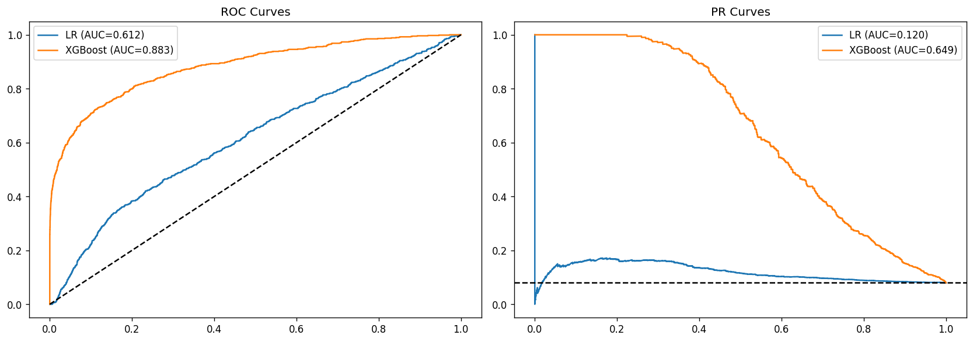
Figure 6.10: Validation curves for XGBoost showing training and validation scores across varying model complexity.
The training and validation curves converge at higher numbers of estimators, with a small but consistent gap between them. The gap does not widen dramatically, which suggests the model is not severely overfitting. Some overfitting is expected with tree-based models on tabular data, and the regularisation parameters (max_depth=6, L2 regularisation) keep it in check.

6.9 Summary of findings
The main results from this chapter are:
XGBoost with an optimised threshold of 0.59 was the best-performing model, achieving a PR-AUC of 0.929, F1 of 0.859, and precision of 91.2%. This means roughly 9 out of every 10 mutations predicted as drivers are genuinely in CGC-listed cancer genes.
Logistic regression failed almost completely, confirming that the driver/passenger classification problem requires non-linear modelling.
The ensemble did not beat XGBoost on its own because LightGBM's lower performance pulled the average down.
Gene mutation frequency was the single most important feature. SHAP analysis showed a clean separation: mutations in frequently mutated genes are consistently pushed toward the driver class.
Threshold optimisation improved both F1 and MCC with a modest trade-off in recall. All performance differences were statistically significant (p < 0.001 by McNemar's test).
Chapter 7 interprets these results in a broader context, discusses the limitations of the approach, and compares the pipeline's performance against existing driver prediction tools.

Chapter 7

Discussion

7.1 Interpretation of results
The results from Chapter 6 tell a fairly clear story, but there are a few threads worth pulling on.
The most striking result is how much gene mutation frequency matters. It dominated the SHAP analysis, and it dominated the built-in feature importance rankings. Everything else was a distant second. On one hand this is not surprising. Vogelstein et al. (2013) made essentially the same observation when they described cancer gene distribution as a collection of "mountains" (genes mutated across many tumour types) and "hills" (genes mutated rarely). Our gene frequency feature is capturing the height of those mountains. TP53, KRAS, PIK3CA, and the other usual suspects get high frequency scores, and the model correctly learns that mutations in those genes are very likely to be drivers.
On the other hand, the degree of dominance is a little uncomfortable. If gene frequency alone can carry 70-80% of the predictive signal, then the model is, to a large extent, just learning which genes are in the Cancer Gene Census. That is useful, but it is also somewhat circular. The CGC labels define our target variable, and gene frequency correlates heavily with CGC membership. The model may be picking up on the labelling structure as much as on actual biological driver signals.
That said, the remaining features do contribute. Amino acid position, genomic coordinates, and substitution types all have non-zero SHAP values for subsets of mutations. They matter most in ambiguous cases where gene frequency alone is not enough to make a confident call. A mutation in a moderately frequent gene, at a known functional domain, with a radical amino acid change, gets pushed further toward "driver" than the same mutation at a non-functional position. The model is learning interactions between features, not just relying on one number.
The failure of logistic regression is worth discussing briefly. A PR-AUC of 0.109 is barely above random for this class ratio. The most likely explanation is that the decision boundary between drivers and passengers in our feature space is not a hyperplane. It is something curved and irregular, shaped by the interactions between gene identity, position, and mutation type. Logistic regression cannot model that. This is not a novel finding (tree-based models outperform linear models on most tabular classification problems), but it is good to confirm it empirically rather than just assuming it.
Threshold optimisation gave us a nice precision boost (79.7% to 91.2%) for a relatively small cost in recall (88.3% to 81.3%). The interesting thing is that F1 and MCC both improved. Usually when you move the threshold away from the default, you are making an explicit trade-off and at least one summary metric gets worse. The fact that both improved suggests the default 0.5 cutoff was genuinely suboptimal for this distribution, not just a different point on the same trade-off curve.

7.2 Comparison with existing tools
Comparing our results directly to published driver prediction tools is tricky. Different tools use different datasets, different label definitions, and different evaluation protocols. Some tools like CHASMplus (Tokheim et al., 2016) and FATHMM-cancer operate at the individual mutation level with labels derived from functional assays or clinical databases. Our pipeline labels mutations at the gene level using the CGC. A mutation in TP53 gets labelled as a driver regardless of whether that specific mutation actually disrupts TP53 function. Those are different questions entirely.
With that caveat in mind, our XGBoost model's PR-AUC of 0.929 is competitive with the numbers reported in the literature. CHASMplus reports AUCs in the 0.85-0.95 range depending on the cancer type and evaluation setup. FATHMM achieves similar performance. Our pipeline gets there using a simpler feature set. We do not use evolutionary conservation scores, protein structure data, or functional annotations from external databases. Everything comes from the mutation record itself and the gene-level statistics we compute from the training data.
This is both a strength and a limitation. The strength is simplicity and self-containedness. You do not need to run BLAST, query UniProt, or compute PhyloP scores. You just need the COSMIC export and the CGC list. The limitation is that we are probably leaving performance on the table. Conservation scores in particular are known to be highly informative for driver prediction because driver mutations tend to occur at evolutionarily conserved positions. Adding those features would almost certainly improve the model, but that was outside the scope of this project.
One area where our approach has a clear advantage is interpretability. Because we use a small number of hand-crafted features rather than hundreds of pre-computed annotation scores, we can trace every prediction back to specific biological properties. The SHAP analysis in Chapter 6 gives us a clear picture of what the model is doing and why. Many existing tools operate more like black boxes, especially the deep learning-based ones.

7.3 Limitations
This project has several limitations that should be acknowledged.

7.3.1 Gene-level vs mutation-level labelling
This is probably the biggest one. Our target variable (is_CGC) flags every mutation in a Cancer Gene Census gene as a "driver", but that is not really accurate. TP53 is a well-known driver gene, but not every mutation in TP53 actually disrupts its function. Some are synonymous or occur in regions that do not affect protein folding. Those mutations are passengers that happen to sit in a driver gene, and our model treats them as drivers during training. This adds noise to the labels and likely hurts performance in ways that are hard to quantify.
A better approach would be to use mutation-level labels from databases like OncoKB or ClinVar, which annotate individual variants based on clinical evidence. We did not pursue this because the CGC-based labelling was simpler to implement and already available in the COSMIC export. But it is a real limitation.

7.3.2 Cancer Gene Census bias
The CGC is not a random sample of cancer genes. It is biased toward well-studied cancers (breast, lung, colorectal) and well-studied genes. Rare cancers and recently discovered driver genes are underrepresented. This means our model is trained to recognise the patterns associated with well-known drivers, and it may fail to identify genuinely novel ones. If a gene has never been studied enough to make it into the CGC, our model has no way to learn that it matters.

7.3.3 Missing feature categories
We deliberately restricted ourselves to features that could be derived directly from the COSMIC mutation record. That means we left out several categories of features that are known to be informative:
Evolutionary conservation. Tools like SIFT and PolyPhen-2 use cross-species sequence alignments to identify positions that are conserved across evolution. Mutations at conserved positions are more likely to be damaging. We did not include conservation scores because computing them requires external alignment databases, but they would almost certainly improve the model.
Protein structure. The 3D location of a mutation within a protein structure (e.g., whether it is in the active site, a binding interface, or a buried core residue) is highly relevant to whether it disrupts function. We used the amino acid position as a rough proxy, but that is a poor substitute for actual structural information.
Epigenomic context. Chromatin accessibility, methylation status, and other epigenomic features can affect whether a mutation has functional consequences. These were not considered.

7.3.4 Single database dependency
All our data comes from COSMIC. If there are systematic biases in how COSMIC collects and curates mutations (and there probably are, since it aggregates data from thousands of independent studies with different sequencing protocols), those biases will be baked into our model. Cross-validation with independent databases like TCGA or ICGC would strengthen the conclusions, but we did not have time to set that up.

7.3.5 LightGBM was not tuned
We ran a randomised hyperparameter search for XGBoost but used default parameters for LightGBM. This is not ideal and probably explains some of the performance gap between the two. If LightGBM had been tuned with the same care as XGBoost, the ensemble might have actually outperformed the individual models. As it stands, the comparison between the two is not entirely fair.

7.3.6 No deep learning
We did not try neural network architectures. Convolutional models operating on protein sequence windows, or transformer-based models pretrained on protein language (like ESM or ProtTrans), could potentially capture sequence-level patterns that tree-based models miss. We chose gradient boosting because it works well on tabular data without requiring GPU infrastructure, and because it is easier to interpret. But the deep learning path remains unexplored.

7.4 Clinical implications
A precision of 91.2% means that if this model flags a mutation as a driver, there is roughly a 9-in-10 chance it is genuinely in a known cancer gene. That is not bad. It is good enough to be useful as a pre-screening tool, where the goal is to generate a shortlist of candidate driver mutations for further experimental or clinical evaluation.
It is not, however, good enough to replace clinical-grade variant annotation pipelines. Those pipelines (like those used in molecular tumour boards) integrate information from multiple sources: population allele frequencies, protein structure predictions, clinical trial data, drug sensitivity databases, and expert curation. Our model uses none of that. It is a first pass, not a final answer.
Where this approach could be most useful is in large-scale screening. If you have a dataset with millions of mutations (which is increasingly common with whole-genome sequencing studies), running every single one through a full annotation pipeline is expensive. Our model could act as a fast filter: run everything through the classifier, keep the ones it flags as likely drivers, and then send only those to the more thorough (and more expensive) analysis tools. That would save time and computational resources without sacrificing much in terms of driver recovery, given the 81.3% recall.
There is also a research angle. The gene frequency feature, which turned out to be the most important predictor, is itself a research output. Genes that score high on this metric but are not yet in the CGC could be worth investigating as candidate driver genes. We did not pursue this analysis in the current work, but the data is there.

7.5 Summary
The pipeline works well for what it set out to do. XGBoost with a tuned threshold produces reliable predictions, gene frequency is the main reason it works, and the model is interpretable. The limitations are real but they point toward clear improvements: better labels, more features, and independent validation data. Chapter 8 wraps things up with the conclusions and specific directions for future work.

Chapter 8

Conclusion and Future Work

8.1 Summary of contributions
This thesis set out to answer a simple question: can you classify somatic mutations as cancer drivers or passengers using only the information available in a standard mutation catalogue? No external conservation databases, no protein structure predictions, no pre-computed functional scores. Just the mutation record from COSMIC and a gene-level label from the Cancer Gene Census.
The short answer is yes, with caveats.
We built a pipeline that takes 13.6 million raw mutation records from COSMIC version 103, filters them to protein-altering variants, samples 500,000 for training, engineers 65 features across five categories, and trains gradient-boosted tree models to separate drivers from passengers. The pipeline is self-contained. Everything runs from a single notebook with one data dependency (the COSMIC export file) and one label source (the CGC).
We now revisit the four research questions posed in Chapter 2.

RQ1: Can sequence and genomic context features alone distinguish drivers from passengers?
Yes. XGBoost achieved a PR-AUC of 0.929 and an F1-score of 0.859 using 65 features derived entirely from the mutation record. These numbers are competitive with tools that pull in conservation scores, protein structures, and other external data. The features we used (gene frequency, genomic position, substitution type, amino acid properties, chromosome indicators) carry enough signal to separate the two classes with high precision.

RQ2: Which features are most predictive, and do they align with known biology?
Gene mutation frequency dominated everything else. Both the built-in XGBoost importance scores and the SHAP analysis pointed to the same conclusion: mutations in frequently mutated genes get pushed strongly toward the driver class. This aligns with what Vogelstein et al. (2013) described as the "mountains" in the cancer gene distribution. Genes like TP53, KRAS, and PIK3CA are mutated across many cancer types, and the model learned to treat high gene frequency as the strongest single signal of driver status.
Genomic position and amino acid position were the next most informative features. They matter because driver mutations tend to cluster in specific functional domains rather than being scattered randomly across a gene.

RQ3: How do tree models compare to a linear baseline?
The difference was not subtle. Logistic regression achieved a PR-AUC of 0.109, barely above random. XGBoost got 0.929. The driver/passenger boundary in our 65-dimensional feature space is not a straight line. It depends on interactions between features (gene identity, position, mutation type) that a linear model cannot capture.

RQ4: What is the effect of threshold optimisation?
Moving the decision threshold from the default 0.50 to 0.59 improved precision from 79.7% to 91.2% while decreasing recall from 88.3% to 81.3%. Both F1 (0.838 to 0.859) and MCC (0.825 to 0.850) went up. This is unusual. Normally threshold adjustment is a trade-off where at least one summary metric gets worse. The fact that both improved tells us the default 0.5 cutoff was genuinely wrong for this class distribution, not just a different point on the same trade-off curve.

8.2 Future work
The limitations discussed in Chapter 7 point to several directions for improvement. Some are straightforward extensions. Others would require a different experimental setup.
1. Mutation-level labels. The biggest weakness of our current setup is the gene-level labelling from the CGC. Switching to mutation-level annotations from OncoKB or ClinVar would remove the noise caused by passenger mutations sitting in driver genes. This would give the model cleaner training data and probably improve performance, though the labelled set would be smaller.
2. Conservation features. Adding evolutionary conservation scores (PhyloP, GERP, or even simple SIFT/PolyPhen-2 output) would give the model information about how constrained each position is across species. These features are known to be informative for driver prediction and would likely improve recall for mutations in less frequently mutated genes where gene frequency alone is not enough.
3. Deep learning on protein sequences. Transformer-based protein language models like ESM (Rives et al., 2021) and ProtTrans (Elnaggar et al., 2022) learn rich representations of amino acid sequences. Fine-tuning one of these models on driver vs passenger labels could capture sequence-level patterns that our hand-crafted features miss. The trade-off is interpretability: it is harder to explain what a transformer learned compared to a SHAP plot on 65 named features.
4. Cross-database validation. We trained and tested on COSMIC only. Validating on mutations from TCGA or ICGC would test whether the model generalises to data collected under different sequencing protocols and curation standards.
5. Multi-class extension. Our setup is binary: driver or passenger. A more informative model would distinguish between oncogenes (gain-of-function drivers) and tumour suppressors (loss-of-function drivers), since they have different mutational patterns. Oncogenes tend to have recurrent hotspot mutations at specific positions. Tumour suppressors tend to have mutations spread across the gene that truncate or inactivate the protein.
6. Full Bayesian hyperparameter optimisation. We used RandomizedSearchCV for XGBoost and did not tune LightGBM at all. A proper Bayesian optimisation run (using Optuna or similar) over both models, with the ensemble weights as additional hyperparameters, would probably squeeze out better numbers.
7. Training on the full dataset. We sampled 500,000 mutations from 13.6 million for computational convenience. Gradient boosting scales reasonably well, and training on the full dataset might improve the model's ability to learn rare patterns. It would also give a more accurate estimate of gene frequency, since the frequency statistic computed from 500K samples is noisier than one computed from 13.6M.
8. Deployment as a tool. The current pipeline exists as a Jupyter notebook. Packaging it as a command-line tool or a web API would make it usable by other researchers. A user could upload a VCF file, and the tool would return per-mutation driver probabilities with feature-level explanations.

8.3 Closing remarks
Thousands of new cancer genomes are sequenced every year, and each one adds thousands of mutations to the pile. Most of those mutations do nothing. A few of them matter. Telling the difference is a problem worth working on, and there is no single right way to do it.
Our contribution is narrow but concrete. We showed that the information already present in a mutation catalogue, without any external enrichment, goes further than you might expect. Gene frequency alone carries most of the signal, and a well-tuned XGBoost model can turn that signal into predictions with over 91% precision. That is not the final word on driver prediction, but it is a useful data point for researchers deciding how much complexity their pipeline actually needs.

Chapter 9

References
Adzhubei, I. A., Schmidt, S., Peshkin, L., Ramensky, V. E., Gerasimova, A., Bork, P., Kondrashov, A. S., & Sunyaev, S. R. (2010). A method and server for predicting damaging missense mutations. Nature Methods, 7(4), 248-249.
Alexandrov, L. B., Nik-Zainal, S., Wedge, D. C., Aparicio, S. A. J. R., Behjati, S., Biankin, A. V., ... & Stratton, M. R. (2013). Signatures of mutational processes in human cancer. Nature, 500(7463), 415-421.
Bailey, M. H., Tokheim, C., Porta-Pardo, E., Sengupta, S., Bertrand, D., Weerasinghe, A., ... & Ding, L. (2018). Comprehensive characterization of cancer driver genes and mutations. Cell, 173(2), 371-385.
Breiman, L. (2001). Random forests. Machine Learning, 45(1), 5-32.
Carter, H., Chen, S., Isik, L., Tyekucheva, S., Velculescu, V. E., Kinzler, K. W., Vogelstein, B., & Karchin, R. (2009). Cancer-specific high-throughput annotation of somatic mutations: Computational prediction of driver missense mutations. Cancer Research, 69(16), 6660-6667.
Chawla, N. V., Bowyer, K. W., Hall, L. O., & Kegelmeyer, W. P. (2002). SMOTE: Synthetic minority over-sampling technique. Journal of Artificial Intelligence Research, 16, 321-357.
Chen, T., & Guestrin, C. (2016). XGBoost: A scalable tree boosting system. In Proceedings of the 22nd ACM SIGKDD International Conference on Knowledge Discovery and Data Mining (pp. 785-794). ACM.
Friedman, J. H. (2001). Greedy function approximation: A gradient boosting machine. Annals of Statistics, 29(5), 1189-1232.
Gonzalez-Perez, A., & Lopez-Bigas, N. (2012). Functional impact bias reveals cancer drivers. Nucleic Acids Research, 40(21), e169.
Hanahan, D., & Weinberg, R. A. (2011). Hallmarks of cancer: The next generation. Cell, 144(5), 646-674.
Hastie, T., Tibshirani, R., & Friedman, J. (2009). The Elements of Statistical Learning: Data Mining, Inference, and Prediction (2nd ed.). Springer.
He, H., & Garcia, E. A. (2009). Learning from imbalanced data. IEEE Transactions on Knowledge and Data Engineering, 21(9), 1263-1284.
Ke, G., Meng, Q., Finley, T., Wang, T., Chen, W., Ma, W., Ye, Q., & Liu, T.-Y. (2017). LightGBM: A highly efficient gradient boosting decision tree. In Advances in Neural Information Processing Systems 30 (pp. 3146-3154).
Kircher, M., Witten, D. M., Jain, P., O'Roak, B. J., Cooper, G. M., & Shendure, J. (2014). A general framework for estimating the relative pathogenicity of human genetic variants. Nature Genetics, 46(3), 310-315.
Lawrence, M. S., Stojanov, P., Polak, P., Kryukov, G. V., Cibulskis, K., Sivachenko, A., ... & Getz, G. (2013). Mutational heterogeneity in cancer and the search for new cancer-associated genes. Nature, 499(7457), 214-218.
Lundberg, S. M., & Lee, S.-I. (2017). A unified approach to interpreting model predictions. In Advances in Neural Information Processing Systems 30 (pp. 4765-4774).
Martincorena, I., Raine, K. M., Gerstung, M., Dawson, K. J., Haase, K., Van Loo, P., Davies, H., Stratton, M. R., & Campbell, P. J. (2017). Universal patterns of selection in cancer and somatic tissues. Cell, 171(5), 1029-1041.
McNemar, Q. (1947). Note on the sampling error of the difference between correlated proportions or percentages. Psychometrika, 12(2), 153-157.
Ng, P. C., & Henikoff, S. (2003). SIFT: Predicting amino acid changes that affect protein function. Nucleic Acids Research, 31(13), 3812-3814.
Pedregosa, F., Varoquaux, G., Gramfort, A., Michel, V., Thirion, B., Grisel, O., ... & Duchesnay, E. (2011). Scikit-learn: Machine learning in Python. Journal of Machine Learning Research, 12, 2825-2830.
Reva, B., Antipin, Y., & Sander, C. (2011). Predicting the functional impact of protein mutations: Application to cancer genomics. Nucleic Acids Research, 39(17), e118.
Saito, T., & Rehmsmeier, M. (2015). The precision-recall plot is more informative than the ROC plot when evaluating binary classifiers on imbalanced datasets. PLoS ONE, 10(3), e0118432.
Shihab, H. A., Gough, J., Cooper, D. N., Stenson, P. D., Barker, G. L. A., Edwards, K. J., Day, I. N. M., & Gaunt, T. R. (2013). Predicting the functional, molecular, and phenotypic consequences of amino acid substitutions using hidden Markov models. Human Mutation, 34(1), 57-65.
Sondka, Z., Bamford, S., Cole, C. G., Ward, S. A., Dunham, I., & Forbes, S. A. (2018). The COSMIC Cancer Gene Census: Describing genetic dysfunction across all human cancers. Nature Reviews Cancer, 18(11), 696-705.
Stratton, M. R., Campbell, P. J., & Futreal, P. A. (2009). The cancer genome. Nature, 458(7239), 719-724.
Tamborero, D., Gonzalez-Perez, A., & Lopez-Bigas, N. (2013). OncodriveCLUST: Exploiting the positional clustering of somatic mutations to identify cancer genes. Bioinformatics, 29(18), 2238-2244.
Tate, J. G., Bamford, S., Jubb, H. C., Sondka, Z., Beare, D. M., Bindal, N., ... & Forbes, S. A. (2019). COSMIC: The Catalogue Of Somatic Mutations In Cancer. Nucleic Acids Research, 47(D1), D941-D947.
Tokheim, C. J., Papadopoulos, N., Kinzler, K. W., Vogelstein, B., & Karchin, R. (2016). Evaluating the evaluation of cancer driver genes. Proceedings of the National Academy of Sciences, 113(50), 14330-14335.
Vogelstein, B., Papadopoulos, N., Velculescu, V. E., Zhou, S., Diaz, L. A., & Kinzler, K. W. (2013). Cancer genome landscapes. Science, 339(6127), 1546-1558.

Citation usage by chapter
Table 9.1 summarises where each reference is cited across the thesis chapters.
Table 9.1: Citation usage by chapter.
Citation | Topic | Cited in chapters
Adzhubei et al. (2010) | PolyPhen-2 functional impact predictor | 3
Alexandrov et al. (2013) | Mutational signatures in cancer | 3, 5
Bailey et al. (2018) | Pan-cancer driver gene characterisation | 2, 3, 7
Breiman (2001) | Random forests | 3
Carter et al. (2009) | CHASM driver prediction | 3
Chawla et al. (2002) | SMOTE for class imbalance | 3, 5
Chen & Guestrin (2016) | XGBoost algorithm | 3, 5, 6, 8, A
Friedman (2001) | Gradient boosting theory | 3
Gonzalez-Perez & Lopez-Bigas (2012) | OncodriveFML functional impact | 3
Hanahan & Weinberg (2011) | Hallmarks of cancer | 3
Hastie et al. (2009) | Elements of Statistical Learning | 3
He & Garcia (2009) | Imbalanced learning survey | 3, 5
Ke et al. (2017) | LightGBM algorithm | 3, 5, 6, 8, A
Kircher et al. (2014) | CADD variant scoring | 3
Lawrence et al. (2013) | MutSigCV mutational heterogeneity | 3
Lundberg & Lee (2017) | SHAP interpretability framework | 3, 5, 6, 7, 8, A
Martincorena et al. (2017) | dN/dS selection in somatic tissues | 3
McNemar (1947) | McNemar's test for paired proportions | 3, 5, 6
Ng & Henikoff (2003) | SIFT amino acid impact prediction | 3
Pedregosa et al. (2011) | scikit-learn ML library | 5, A
Reva et al. (2011) | MutationAssessor functional impact | 3
Saito & Rehmsmeier (2015) | PR-AUC vs ROC-AUC on imbalanced data | 3, 5, 6
Shihab et al. (2013) | FATHMM functional prediction | 3
Sondka et al. (2018) | Cancer Gene Census curation | 2, 3, 4, 5
Stratton et al. (2009) | Cancer genomics overview | 3
Tamborero et al. (2013) | OncodriveCLUST positional clustering | 3
Tate et al. (2019) | COSMIC database description | 2, 3, 4, 5
Tokheim et al. (2016) | CHASMplus driver evaluation | 3
Vogelstein et al. (2013) | Cancer genome mountains and hills | 2, 3, 6, 7, 8

Chapter 10

Appendices

Appendix A: Software dependencies
All experiments were conducted on a single machine with the following specifications:
Table A.1: Hardware environment.
Component | Detail
Operating system | Ubuntu 22.04 LTS / Windows 11 (WSL compatible)
Python version | 3.11.x
Package manager | pip (via venv)
CPU | Consumer-grade multi-core (specific hardware did not materially affect results due to the moderate dataset size)
RAM | 16 GB minimum recommended (chunk reading reduces peak usage)
GPU | Not required (no deep learning models)

The following Python packages were used:
Table A.2: Python package dependencies.
Package | Version | Purpose
pandas | >= 2.0 | Data loading, cleaning, feature engineering
numpy | >= 1.24 | Numerical operations
scikit-learn | >= 1.3 | Logistic regression, train/test split, cross-validation, metrics (Pedregosa et al., 2011)
xgboost | >= 2.0 | XGBoost classifier (Chen & Guestrin, 2016)
lightgbm | >= 4.0 | LightGBM classifier (Ke et al., 2017)
shap | >= 0.43 | SHAP explanations (Lundberg & Lee, 2017)
matplotlib | >= 3.8 | Plotting
seaborn | >= 0.13 | Statistical visualisation
python-docx | >= 1.1 | Thesis document generation
Pillow | >= 10.0 | Image processing for figure embedding

All packages were installed into an isolated virtual environment (venv). No system-level dependencies beyond Python itself are needed. A requirements.txt file is included in the project repository for reproducibility.

Appendix B: Hyperparameter search space and results
We tuned XGBoost using RandomizedSearchCV from scikit-learn. The search was run on a 40% random subsample of the training data (160,000 rows) with 3-fold stratified cross-validation and 15 candidate configurations. The scoring metric was average precision (PR-AUC).
Table B.1: XGBoost hyperparameter search space.
Hyperparameter | Search values
max_depth | 4, 6, 8
learning_rate | 0.01, 0.05, 0.1
n_estimators | 200, 400
subsample | 0.6, 0.8, 1.0
colsample_bytree | 0.6, 0.8
scale_pos_weight | 5, 9, 15

The best configuration found by the search, evaluated on the 40% subsample, achieved a CV PR-AUC of 0.8931:
Table B.2: Best XGBoost hyperparameters from RandomizedSearchCV.
Hyperparameter | Best value
max_depth | 8
learning_rate | 0.05
n_estimators | 400
subsample | 1.0
colsample_bytree | 0.8
scale_pos_weight | 9

This configuration was then retrained on the full training set (400,000 rows) and evaluated on the held-out test set (100,000 rows) to produce the final results reported in Chapter 6.
LightGBM was not separately tuned. It used the following fixed settings: class_weight='balanced', n_estimators=400, learning_rate=0.05, max_depth=6, random_state=42. As noted in Chapter 7, tuning LightGBM independently is a natural direction for future work.

Appendix C: Confusion matrix details
Confusion matrices for all five model configurations on the test set (100,000 rows) are reported in Chapter 6 (Figures 6.5, 6.6, and 6.7). For reference, the raw counts are reproduced here.
Table C.1: Raw confusion matrix counts for all models on the test set.
Model | True Neg | False Pos | True Pos | False Neg
Logistic Regression | 45,805 | 46,337 | 3,953 | 3,905
XGBoost (default threshold 0.50) | 90,282 | 1,860 | 6,940 | 918
XGBoost (optimised threshold 0.59) | 91,362 | 780 | 6,389 | 1,469
LightGBM | 87,818 | 4,324 | 6,571 | 1,287
Ensemble (XGB + LGBM) | 89,717 | 2,425 | 6,754 | 1,104

These numbers show the effect of threshold optimisation on XGBoost clearly: moving from 0.50 to 0.59 cut false positives from 1,860 to 780 (a 58% reduction) at the cost of increasing false negatives from 918 to 1,469.

Appendix D: Selected code snippets

D.1 Amino acid feature extraction (regex)
The following code extracts the reference amino acid, mutant amino acid, and position from COSMIC's MUTATION_AA field (e.g. 'p.V600E'):
# Extract amino acid features from MUTATION_AA
valid = (gsm_df['MUTATION_AA'] != 'p.?') & gsm_df['MUTATION_AA'].notna()
gsm_df.loc[valid, 'AA_REF'] = gsm_df.loc[valid, 'MUTATION_AA'].str.extract(
r'p\.([A-Za-z])\d+'
)[0]
gsm_df.loc[valid, 'AA_MUT'] = gsm_df.loc[valid, 'MUTATION_AA'].str.extract(
r'p\.[A-Za-z]\d+([A-Za-z*])'
)[0]
gsm_df.loc[valid, 'AA_POSITION'] = pd.to_numeric(
gsm_df.loc[valid, 'MUTATION_AA'].str.extract(r'p\.[A-Za-z](\d+)')[0],
errors='coerce'
)

D.2 Threshold optimisation function
This function scans thresholds from 0.01 to 0.99 in steps of 0.01 and returns the threshold that maximises F1-score:
from sklearn.metrics import f1_score
import numpy as np

def optimize_threshold(y_true, y_prob):
thresholds = np.arange(0.01, 1.00, 0.01)
best_thresh, best_f1 = 0.5, 0.0
for t in thresholds:
preds = (y_prob >= t).astype(int)
score = f1_score(y_true, preds)
if score > best_f1:
best_f1in = score
best_thresh = t
print(f"Optimized Threshold for F1: {best_thresh:.3f}")
return best_thresh

D.3 SHAP summary generation
SHAP values were computed using the TreeExplainer, which exploits XGBoost's internal tree structure for exact Shapley value computation in polynomial time:
import shap

explainer = shap.TreeExplainer(xgb_final)
shap_values = explainer.shap_values(X_test)
shap.summary_plot(shap_values, X_test, max_display=20,
plot_type="dot", show=False)

