Lip Reading using Neural Network and Deep learning

In this paper author is using Deep Learning Convolution Neural Network Algorithm to predict or read lip movement and to implement this project author has used LRW dataset which is 10 GB size and its not possible to train that much dataset with normal laptops so I have used few images from dataset to train CNN model. This application is trained on 10 words but can predict 4 words as I have reduce dataset to avoid out of memory error.

I am using below 10 words images to train CNN

'Begin','Choose','Connection','Navigation','Next','Previous','Start','Stop','Hello','Web'

From above 10 words application can predict ‘Start, connection, web and Hello’ perfectly and each word is assigned one index from 1 to 10. Below are then images

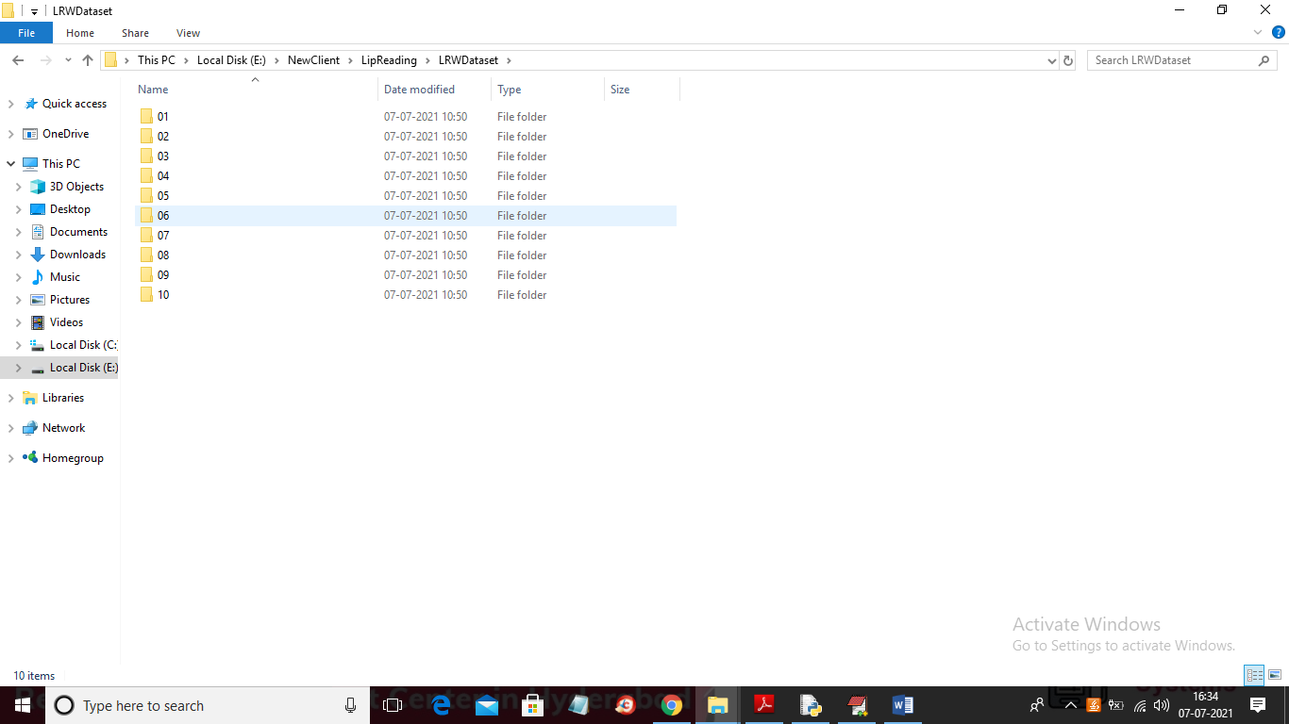

In above screen each folder contains related images where folder 01 contains ‘Begin’ images and similarly other folders contains other images and just go inside any folder to see its images

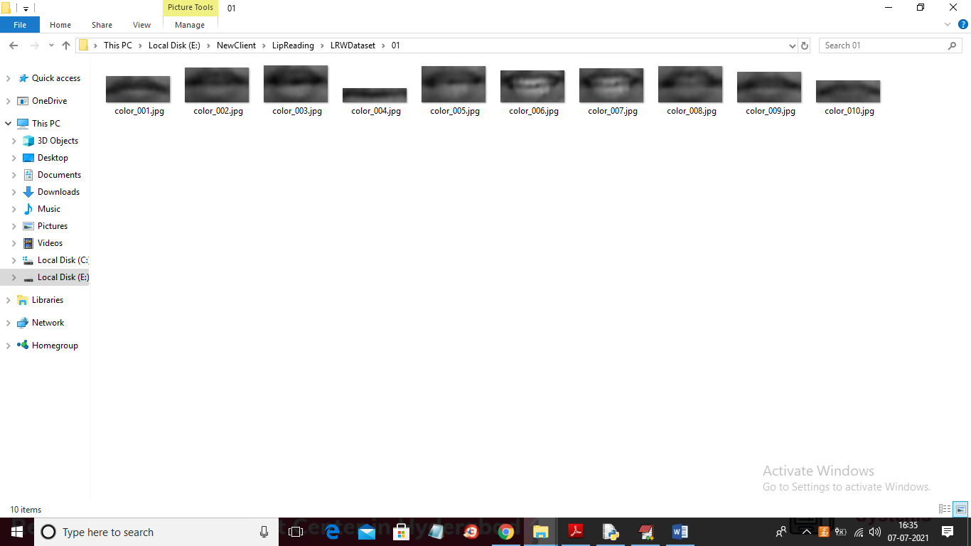

In above screen we can see images for “begin” words and here I extracted only mouth and lips from dataset images.

To predict lip reading application will take images from webcam and then apply HAAR CASCADE files to detect face and mouth and then detected mouth will be input to CNN to identify word based on lips movement.

Note: this is computer program and its cannot work 100% perfectly

To run project double click on ‘run.bat’ file to get below screen

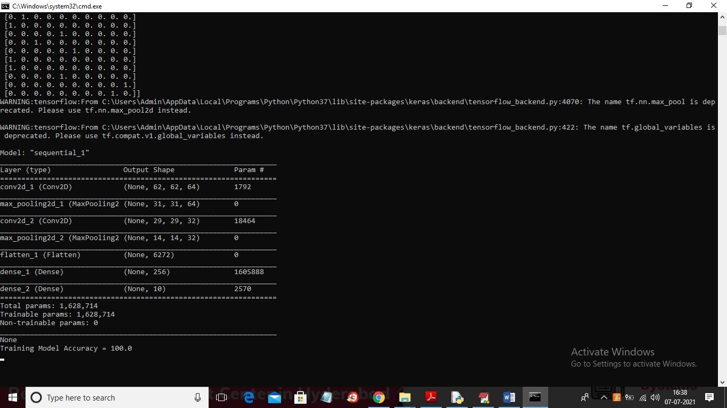

In above screen CNN model training is done on dataset and we got 100% accuracy

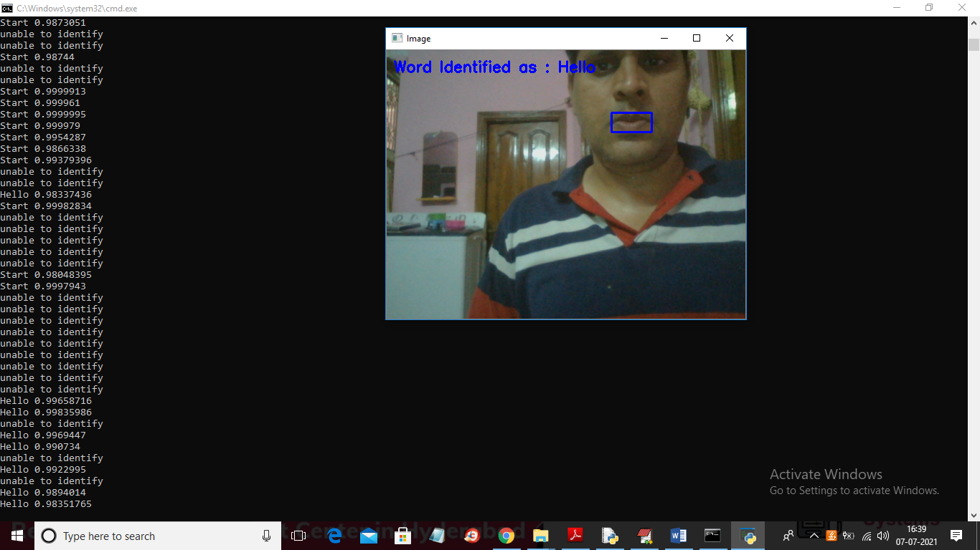

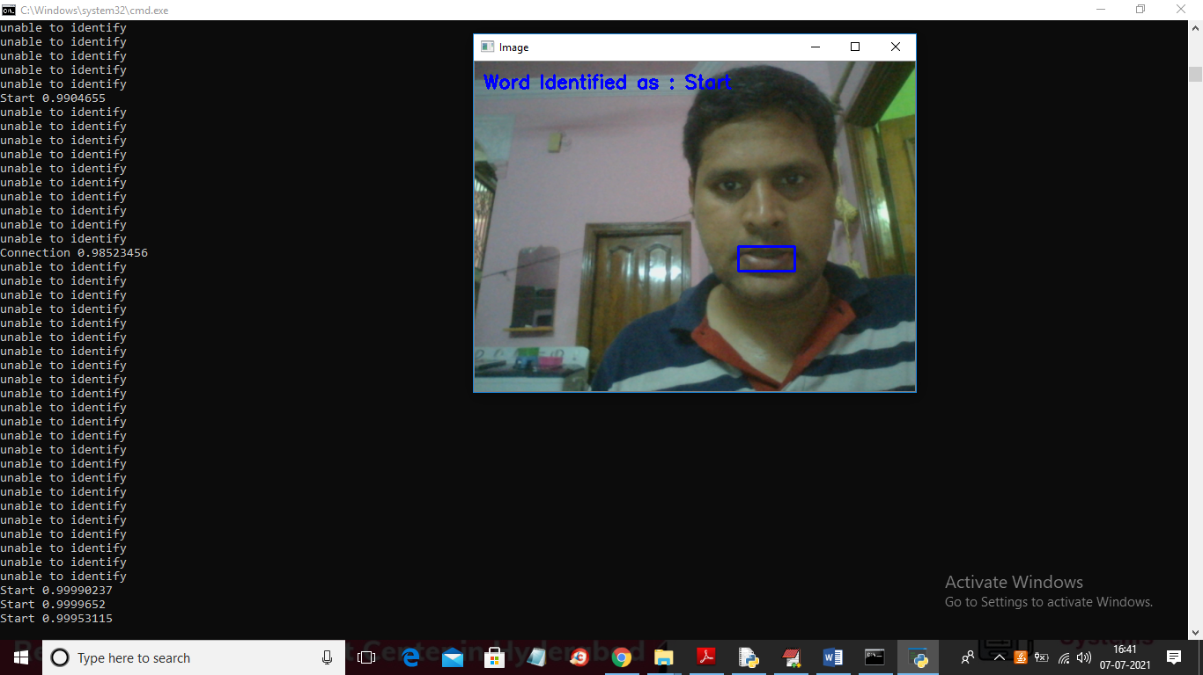

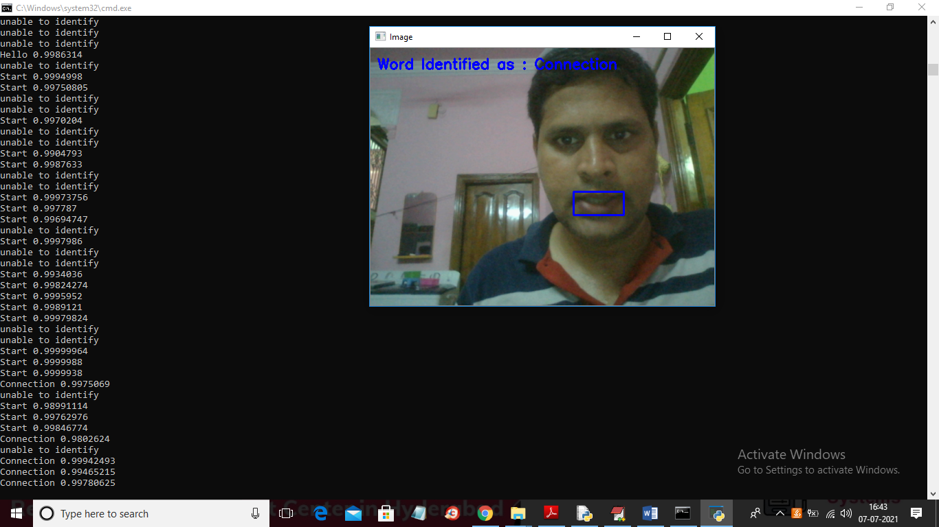

Note: some time application may identify wrong word also and to get perfect output we need to train with huge dataset which will not happen in normal computers