Whats is Kubernetes

Kubernetes is an open source container orchestration engine for automating deployment, scaling, and management of containerized applications. The open source project is hosted by the Cloud Native Computing Foundation ([CNCF](https://www.cncf.io/about)).

Cluster means collection of one or more nodes

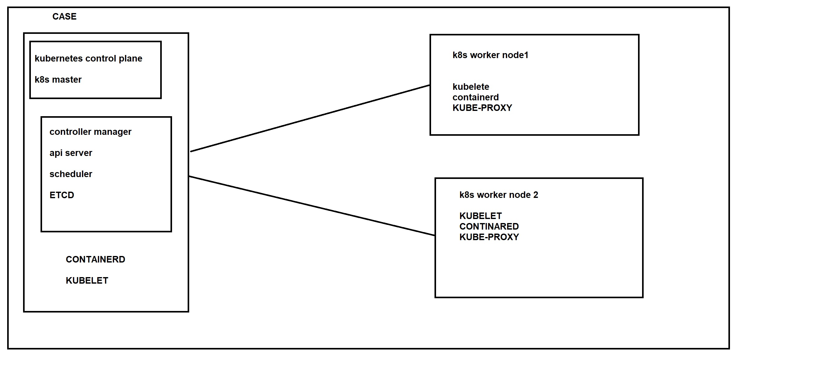

1.Api server = is medium of commuction between master node and worker node

2.SCHEDULER = schedules the objects on the worker nodes

3.CONTROLLER MANGER = where and how to deploy will decided

4.ETCD= is the data base which holds the cluster information

5.Kubelet = is a agent which runs on worker node it will do all the docker commands

6. conatinerd= is basically creating containers

7. kubeproxy = is basically for networking purposes

In kubersnetes we create a pod inside a pod we can have one or 2 container

Kubeproxy will do pod to pod commuction

We can create cluster by using

Minikube

Kubeadum

Eks

Aks

Gke

Kops

Kubeproxy

sudo kubeadm init --pod-network-cidr=192.168.0.0/16 --apiserver-advertise-address=172.31.24.237

sudo

kubeadm join 172.31.24.237:6443 --token vscf6d.va279fpe8rxf3jbq \

--discovery-token-ca-cert-hash sha256:a2019c52305a3fd0d9f839a186be5ee9ad456701b2818df439e3ef1eb5135ce8

Commands

Kubectl get pods (to check running pod s)

Kubectl get ns (to check default

kubectl get all -n kube-public ( to check kubeam services )

==================================

1 nodes ==> 110 pods

1 cluster => 5000 nodes

1 cluster => 3 lakh containers

1 cluster => 1 lakh 50000 pods

===============================

Service object of Kubernetes

clusterIp

nodePort

loadbalancer