**Software Requirements Specification**

**for**

**21. Pharmacy Management System**

**Version 0.1**

**Prepared by**

**Student Roll Number: M210670CA Student Name: Dikshant Bisht**

**Student Roll Number: M210683CA Student Name: Arjun Nandlal Bhardwaj**

**Student Roll Number: M210702CA Student Name: Shivam Kumar Jha**

**Project Owner: Neethu Ma’am**

**Course: CS4097D Object Oriented Systems Laboratory**

**Date: 7-11-2022**

1

|  |  |  |
| --- | --- | --- |
| **1 Introduction** | | 2 |
| 1.1 | Document Purpose | 2 |
| 1.2 | Product Scope | 3 |
| 1.3 | Definitions, Acronyms and Abbreviations | 3 |
| 1.4 | Document Conventions | 3 |
| 1.5 | References and Acknowledgments | 4 |
| **2 Overall Description** | | 4 |
| 2.1 | Product Overview | 4 |
| 2.2 | Product Functionality | 4 |
| **3 Specific Requirements** | | 4 |
| 3.1 | External Interface Requirements | 5 |
| 3.1.1 User Interfaces | | 6,7 |
| 3.2 | Functional Requirements | 8 |
| 3.3 | Use Case Model | 9,10 |
| 3.4 | Flow Diagram | 11,12 |
| 3.4.1 Use Case #1 (use case name and unique identifier – e.g. U1) | | 13 |

**1 Introduction**

**1.1 Document Purpose**

This document presents the Software Requirement Specification (SRS) for the Pharmacy Management System(PMS), which is built for the sake of ensuring effective and clear data saving and manipulating as well as neat work on the pharmacy medical products. This refers the PMS project highly minimize time and resource by which, searching the medicine data you can get the data and bill generation in quickest time . And almost the resources are wise used since most actions are done on the pharmacy system. Some of the resources minimized include paper, manpower and related things. The other thing is for storing data's in secure way. All requirements specified here are high priority and committed for release 1.0.

***2***

**1.2** **Product Scope**

With the development of specific and potent synthetic drugs, the emphasis of the pharmacist's responsibility has moved substantially towards the utilization of scientific knowledge in the proper use of modern medicines and the protection of the public against dangers that are inherent in their use. Pharmacists are employed in regulatory control and drug management, community pharmacy, hospital pharmacy, the pharmaceutical industry, academic activities, training of other health workers, and research. In all these fields, their aim is to ensure optimum drug therapy, both by contributing to the preparation, supply and control of medicines and associated products, and by providing information and advice to those who prescribe or use pharmaceutical products.

**1.3 Definitions, Acronyms and Abbreviations**

PMS = Pharmacy Management System

**1.4 Document Conventions**

**Formatting Convention**

1. Arial font style of size 12 is used throughout the document. For heading font size of 14,18,25,30 is used.
2. Italics is used for comments.
3. Bold is used for Headings.
4. 1’’ margin is maintained throughout the document.
5. Lists are represented using numbered list.

**Naming Convention**

1. Heading are all starting with capital letter and rest small letters.
2. Functions calls are written in camelCase.

**1.5 References and Acknowledgments**

* 1. The Definitive Guide to Java Swing Third Edition JOHN ZUKOWSKI , <https://www.cs.buap.mx/~ygalicia/Libros/JavaSwing.pdf>

1. For oops concept: https://www.javatpoint.com/java-oops-concepts

***3***

**2 Overall Description**

**2.1 Product Overview**

The Pharmacy Management system helps pharmacists in managing their medicines and in generating their bills. It saves their time and their resources and make their work way more easier. It also act as billing system for pharmacists and admin can add any number of agents who can create, update, delete new medicines or either generate their bills.

Medicines

Agents

Manage Medicines

Manage Agents

Pharmacy Management System

Request Bills

Generate Bills

Manage Companies

Billing

Companies

**Figure 1**

*Context diagram of the Pharmacy Management System.*

**2.2 Product Functionality**

* Admin can either update or delete or create new Agents.
* Admin can add, edit, delete medicines .
* Admin can manage Companies.
* Admin and Agents can Generate bill in the form of DOCX or PDF also print it.

***4***

**3** **Specific Requirements**

**3.1** **User Interfaces**

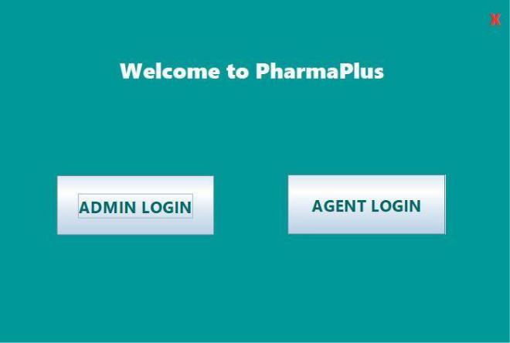

Fig 1.Choice for Login

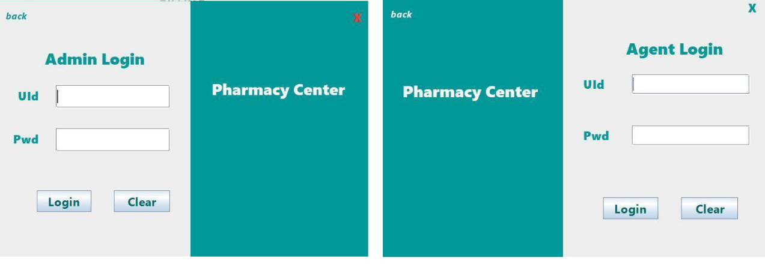

Fig 1.1 Login for Admin Fig 1.2 Login for Agent

***5***

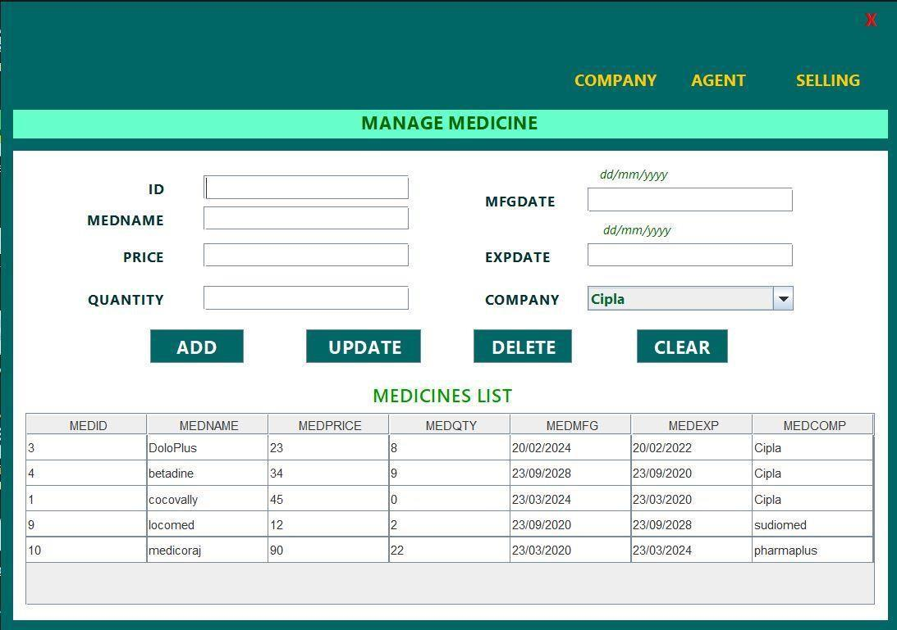

Fig 2. Manage Medicine (Only accessible to Admin)

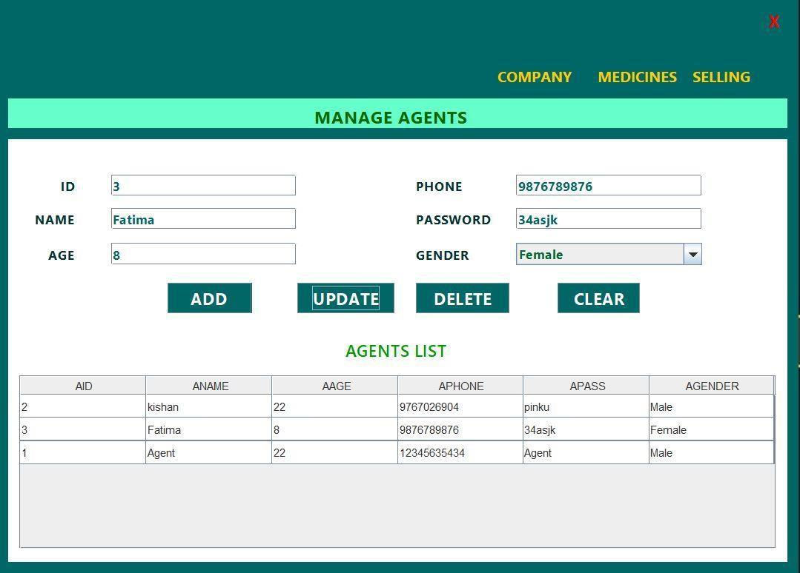

Fig 3. Manage Agents (Only accessible to Admin)

***6***

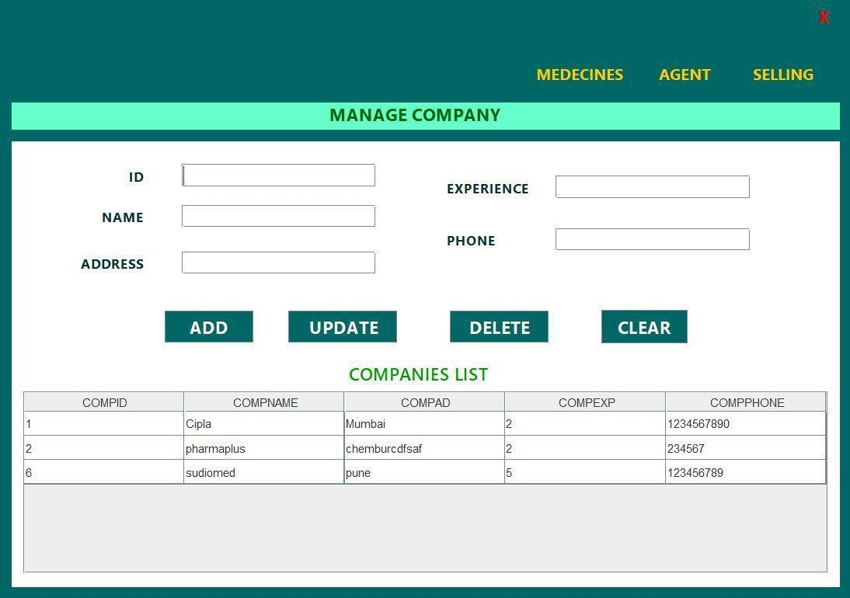

Fig 4. Manage Company (Only accessible to Admin)

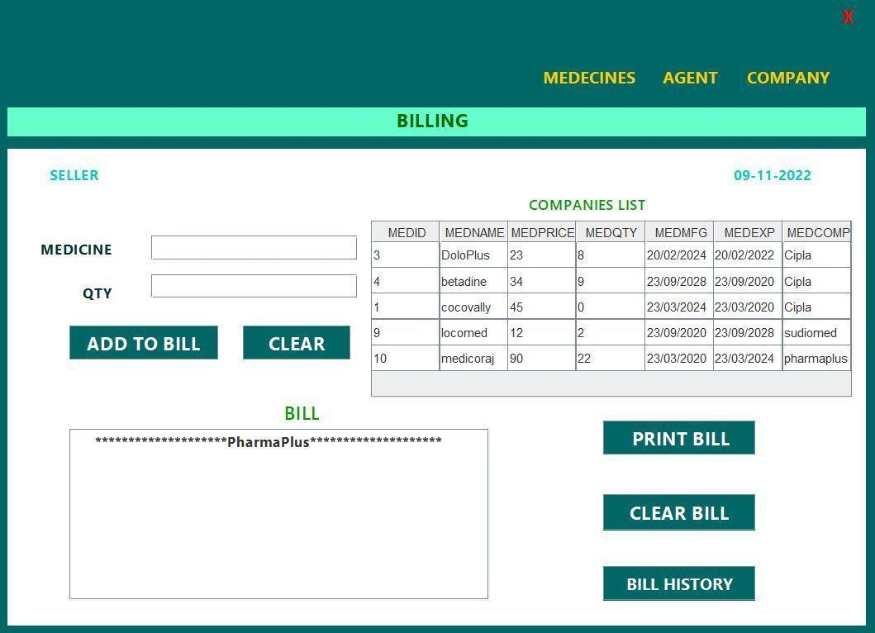

Fig 5. Manage Billing (Accessible to both Admin and Agent)

***7***

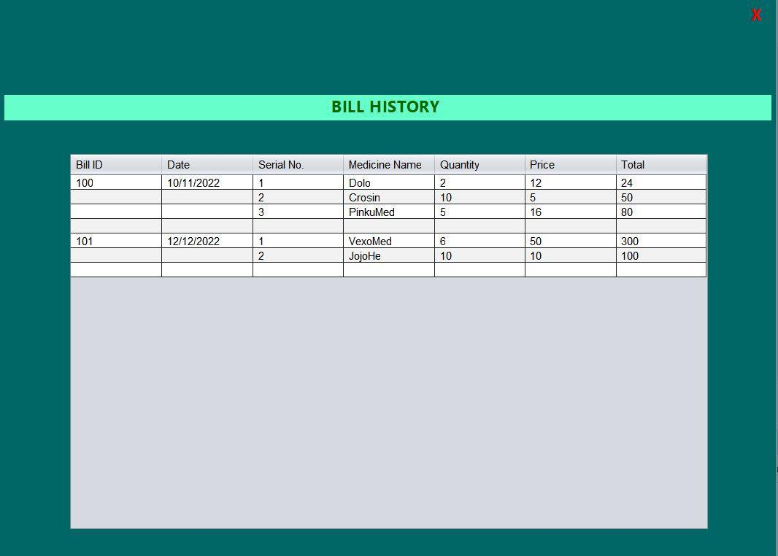

Fig 6. Bill History (Accessible to both Admin and Agent)

**3.2** **Functional Requirements**

F1: The system shall allow Admin and Agent to SignIn.

F2: The system shall check if the medicine admin is adding has a Name, Company, Id, expiry date and Price field set.

F3: The system shall show all available medicines in a table.

F4: On clicking any row of medicine table the text fields Name, Company and Price etc get auto-filled.

F5: On clicking the Edit button Admin can update the Medicine Name, Id ,Company, Expiry date or Price.

F6: On clicking the Delete button the currently selected row of medicine table is deleted.

F7: The system shall check if the new added agent has a Name, Id, Phone, Gender and password field set.

***8***

F8: The system shall show all available agents in a table only visible to admin.

F9: On clicking any row of agent table the text fields Name, Id and phone number etc. get auto-filled.

F10: On clicking the update button Admin can update the Agent Name, Id , password, gender or Phone no.

F11: On clicking the Delete button the currently selected row of agent table is deleted.

Company.ShowCompany: The system shall show all available companies in a table.

F12: The system shall check if the Company admin is adding has a Name, Id, Experience, phone and Address field set.

F13: On clicking any row of company table the text fields Name, Id, experience, address and phone no. get auto-filled.

F14: On clicking the update button Admin can update the company Name, Id, experience, address and phone no.

F15: On clicking the Delete button the currently selected row of company table is deleted.

F16: The system shall show all available Bills in a table.

F17: On button click the bill is added to a Bill table with bill id, medicine and Quantity.

F18: On clicking Print button the system shall print the bill in DOCX or PDF format.

F19: System shall save the bill in the database.

***9***

**3.3** **Use Case Model**

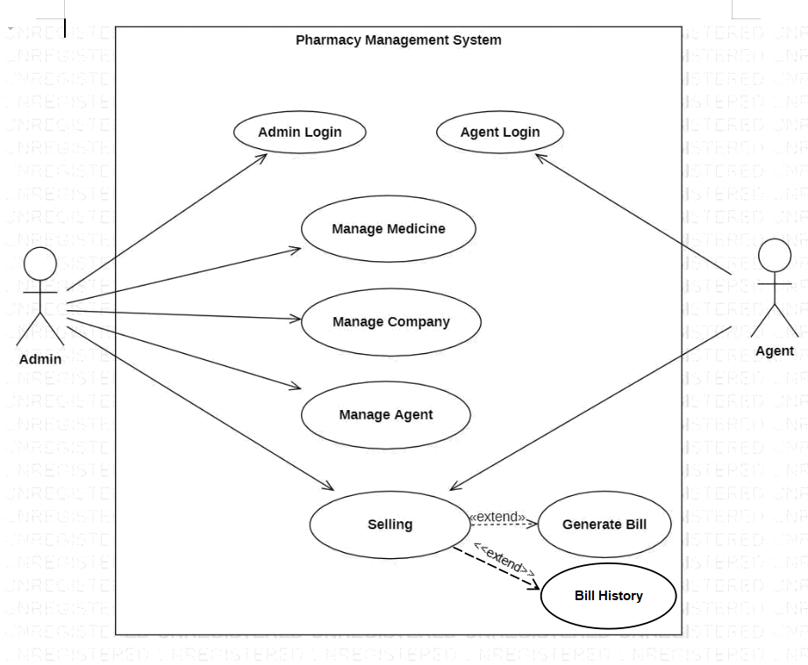

***10***

**FLOW DIAGRAM:**

**1) FOR ADMIN**

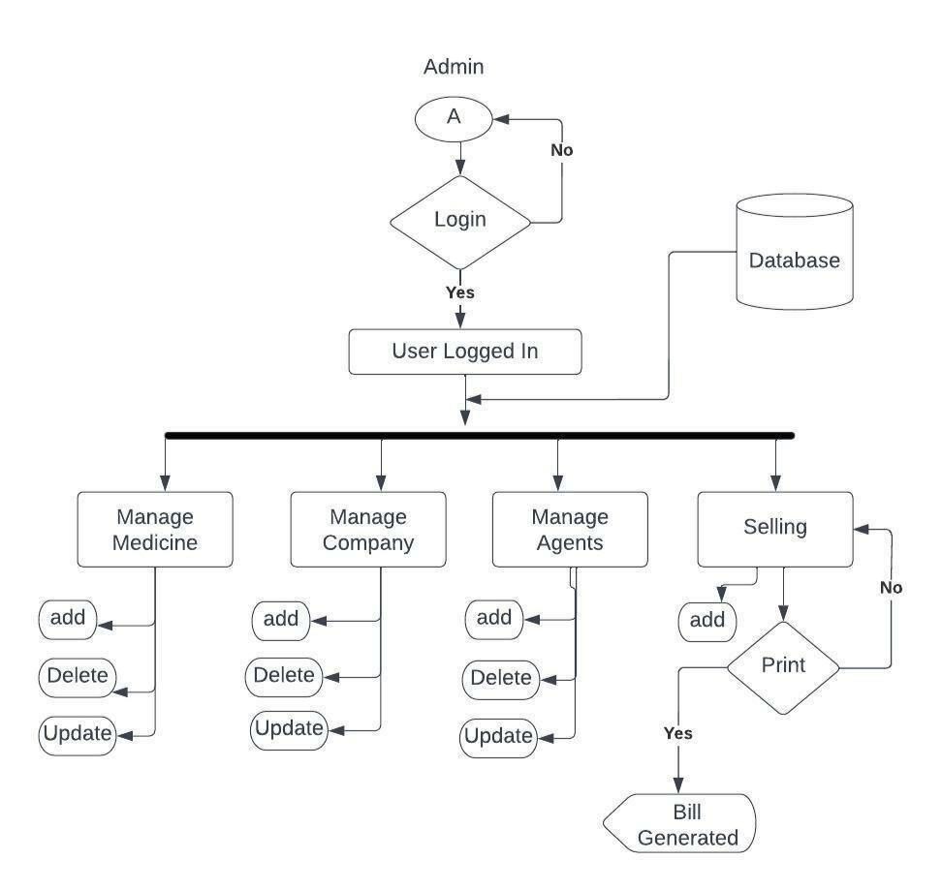

***11***

**2) FOR AGENT**

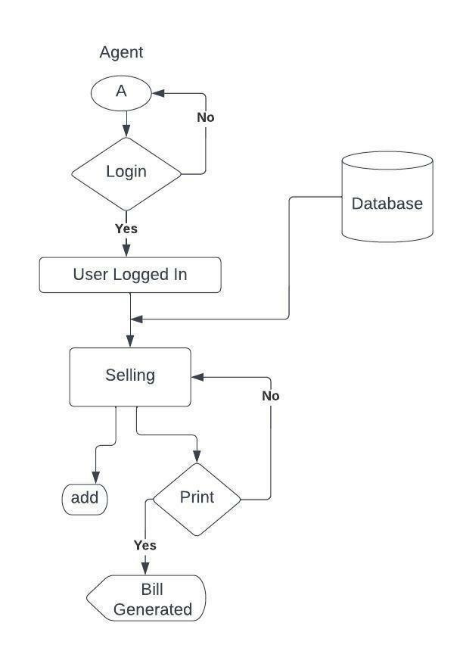

**3.4.1 Use Case**

**Purpose** – Managing medicines and generating bills.

**Requirements Traceability –**

1) Username and Password

Login. :The system shall allow Admin and Agent to Sign In. (ie. F1) 2)Medicine name, Id, quantity, company, Expiry date and price

(Only Admin can access this)

Medicines.AddBtnActionPerformed: The system shall check if the medicine admin is adding has a Name, Company, Id, expiry date and Price field set.

***12***

Medicines.UpdateBtnActionPerformed: The system shall check if the medicine admin is updating is already existed or not and new values are valid or not. Medicines.DeleteBtnActionPerformed: The system shall check if the medicine admin is deleting is available or not.

3) Agents name, Id, Phone, Gender and password (Only Admin can access this)

Agents.AddBtnActionPerformed: The system shall check if the new added agent has a Name, Id, Phone, Gender and Password field set.

Company.UpdateBtnActionPerformed: The system shall check if the agent admin is updating is already existed or not and new values are valid or not.

Company.DeleteBtnActionPerformed: The system shall check if the agent admin is deleting is available or not.

4) Company name, Id, Experience, phone and Address (Only Admin can access this)

Company.AddBtnActionPerformed: The system shall check if the Company admin is adding has a Name, Id, Experience, phone and Address field set.

Company.UpdateBtnActionPerformed: The system shall check if the Company admin is updating is already existed or not and new values are valid or not. Company.DeleteBtnActionPerformed: The system shall check if the company admin is deleting is available or not.

5) Billing Bill Id, Medicine and Qty

(Both Admin and Agent can perform this action)

Billing.AddBtnActionPerformed: The system shall check if the Bill admin is adding has a bill Id, medicine and qty field set.

Billing.PrintBtnActionPerformed: The system shall check if the bill admin is printing is in records or not.

**Actors** – Admin, Agent.

***13***

<Leave this page blank>

**_________________________________**

**Design Document**

**for**

**Pharmacy Management System**

Version<0.1>

Prepared by Team 21:

(Based on SRS Version 0.1 prepared by Team 21)

|  |  |  |
| --- | --- | --- |
| **Arjun Nandlal Bhardwaj** | **M210683CA** | **arjun_m210683ca@nitc.ac.in** |
| **Dikshant Bisht** | **M210670CA** | **dikshant_m210670ca@nitc.ac.in** |
| **Shivam Kumar Jha** | **M210702CA** | **shivam_m210702ca@nitc.ac.in** |
|  |  |  |
|  |  |  |

## 

|  |  |
| --- | --- |
| **Project Owner:** | **Neethu Mam** |
| **Course:** | **CS4096 Software Engineering Laboratory** |
| **Date:** | **14-11-2022** |

# Glossary

|  |  |
| --- | --- |
| PMS | Pharmacy Management System |
| ER | Entity Relationship |
| TC | Test Case |

## **Table of contents**

**Glossary** 4

**Table of contents** 5

**Detailed Design through UML diagrams** 6

1.1 System model using Class Diagram 6

1.1.1 Class Diagram 6,7,8

1.2 Responsibilities - Usecase Diagram 9

1.3 Static snapshot of the system - Object Diagram 10,11

1.4 System Interactions through Sequence Diagrams 11

1.4.1 Admin Sequence Diagram 12

1.4.2 Agent Sequence Diagram 13

**Database Design 14**

2.1 ER Diagram 14

**Implementation Plans 14**

3.1 Technology Stack **14**

**3.2** User Interface Prototyping **15,16,17,18**

**Test Cases 18**

**4.1 Test Case #1 (TC_Login) 18**

**4.2 Test Case #2 (TC_AdminLogin) 19**

**4.3 Test Case #3 (TC_AgentLogin) 20**

**4.4 Test Case #4 (TC_MedicineAdding) 20,21**

**4.5 Test Case #5 (TC_AgentAdding) 22**

**4.4 Test Case #6 (TC_AgentUpdating) 23**

**4.4 Test Case #7 (TC_ComanyDeleting) 24**

**4.4 Test Case #8 (TC_Billing) 25**

**References 25**

# Detailed Design through UML diagrams

## 1.1 System model using Class Diagram

Class Diagram in the Unified Modelling Language is a type of static structure diagram that describes the structure of a system by showing the system’s classes, their attributes, operations (or methods) and the relationships among classes.

### Class Diagram

## 1

**P R A(Access Layer)**

**P R A(Access Layer)**

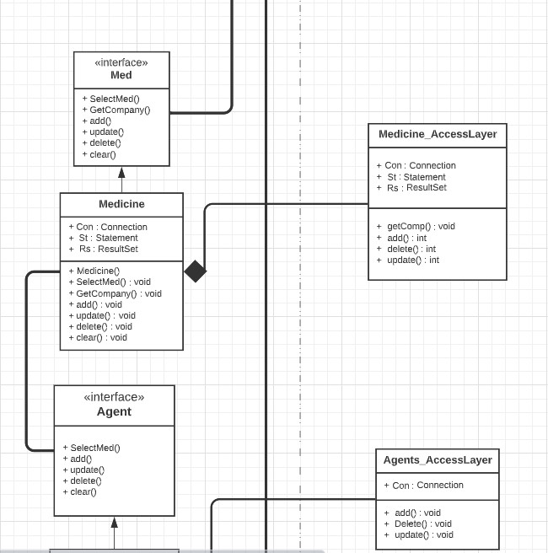

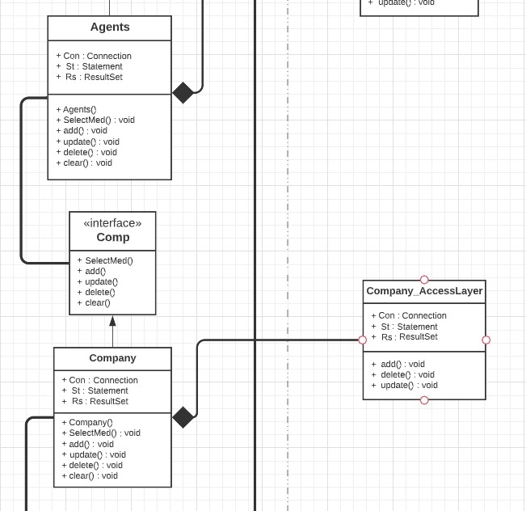

**T R A(Access Layer)**

## 54

**T R S(Service Layer) A(Access Layer)**

**MODEL LAYER**

## 1.2 Responsibilities - Usecase Diagram



## 

## Static snapshot of the system - Object Diagram

* + 1. Object Diagram of Admin

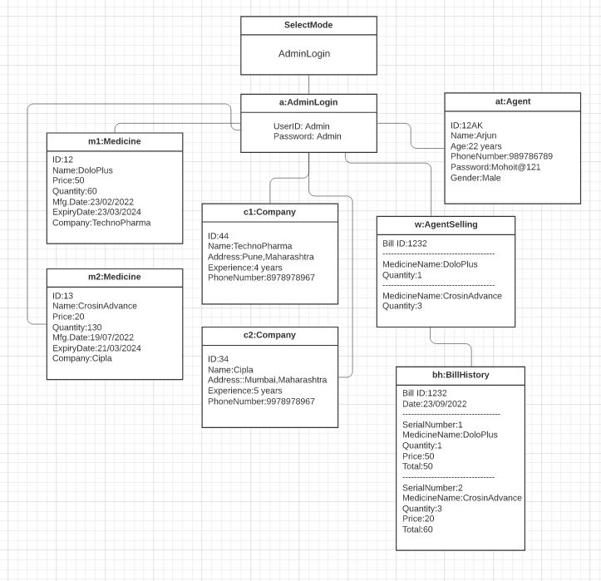

## 1.2.2 Object Diagram for Agent

## 17

## 1.4 System Interactions through Sequence Diagrams

Sequence diagrams are interaction diagrams that show the sequence of messages exchanged by the set of objects performing a certain task. A sequence diagram shows, as parallel vertical lines (lifeline), different processes or objects that live simultaneously, and as horizontal arrows, the messages exchanged between them, in the order in which they occur.

### 1.4.1 Admin Sequence Diagram

This Diagram Shows us that how Admins will interact with out system.

1. First for accessing our management system admin must fill his login credentials.
2. Then his login credentials will sent to database for verification.
3. After verification if his credentials are correct then he will logged in to Pharmacy Management System else he will be redirected to login page with a prompt box wrong information.
4. After successful verification Admin can either create, update or delete Medicines, Agents and Companies.
5. Admin can also add bills if he want to and can also print those bills if he want to.
6. Admin can also view bill history.

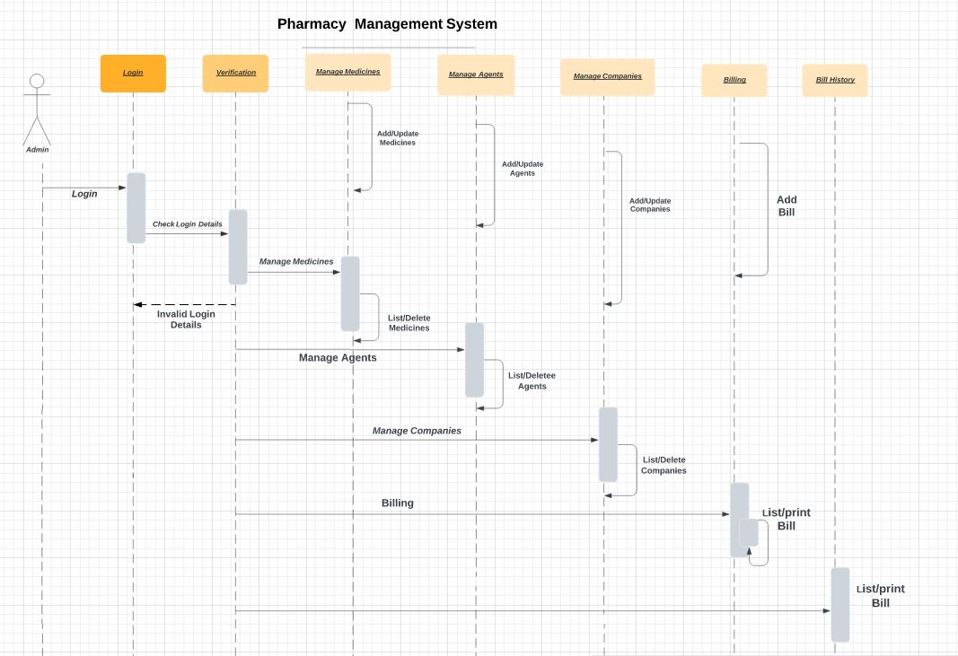

### 1.4.2 Agents sequence diagram

This Diagram Shows us that how Agents will interact with out system.

1. First for accessing our management system agent must fill his login credentials.
2. Then his login credentials will sent to database for verification.

3. After verification if his credentials are correct then he will logged in to Pharmacy Management System else he will be redirected to login page with a prompt box wrong information.

4. After successful verification Agent can add bills and can also print those bills if he want to.

5.Agent can see Bill History.

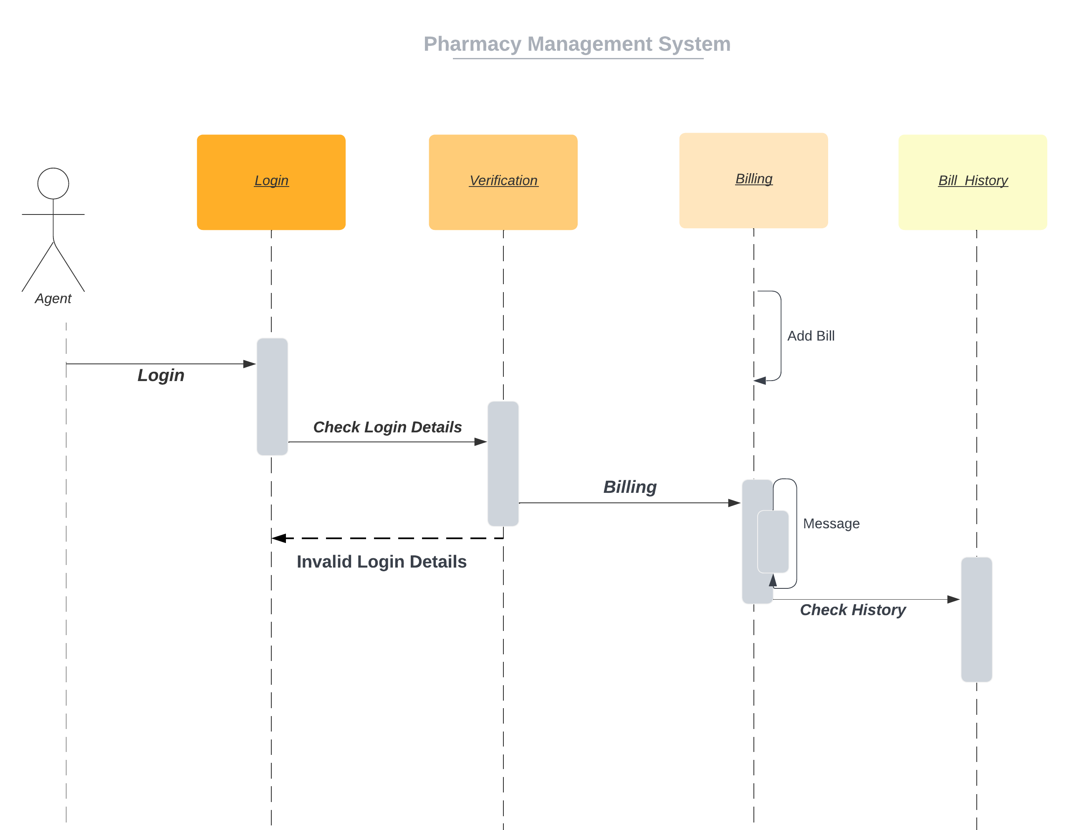

List/Print

Bill History

# Database Design

## ER Diagram

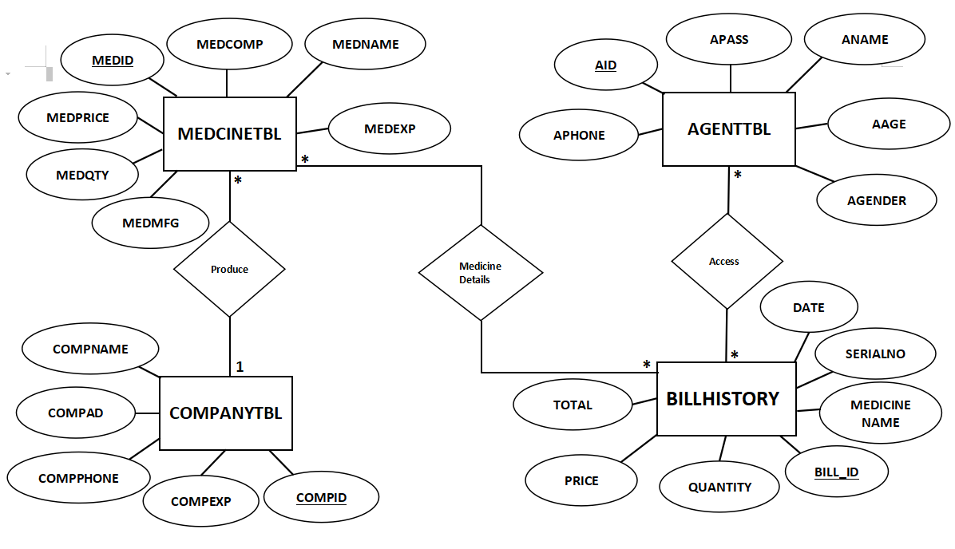

# Implementation Plans

## 3.1 Technology Stack

Our Project will run on Windows, Mac OS and Linux.We used Java programming language and Java Swing toolkit for implementing the project*.*

## 3.2 User Interface Prototyping



Fig 1. Choice for Login

*Fi*g 1.1 *Login for Admin Fig 1*.2 *Login for Agent*



Fig 2. Manage Medicine(Only accessible to Admin)



Fig 3. Manage Agents(Only accessible to Admin)



Fig 4. Manage Company(only accessible to Admin)



Fig 5. Manage Billing(Accessible to both Admin and Agent)



*Fig 6. Bill History(Accessible to both Admin and Agent)*

1. Test Cases

### **4.1 Test Case #1 (TC_LOGIN**)

**Author:** Dikshant Bisht

**Test Case Description:**

Test scenario: Selecting Agent login or Admin Login.

Test case: Click either Agent Login button or Admin Login button.

**Pre-Conditions:**

User must know which login he wants to access.

**Test Steps:**

Click Admin Login Button>

Or

Click Agent Login Button>

**Test Data:**

No Test Data is Required

**Expected Result:**

Admin login>Admin login page will open.

Agent login>Agent login page will open.

**Post Condition:**

If user selects Admin login button then admin login page will open else if he selects Agent login page then agent login page will open.

### **4.2 Test Case #2 (TC_ADMINLOGIN**)

**Author:** Dikshant Bisht

**Test Case Description:**

Test scenario: Verifying the login for Admin

Test case: Enter a valid username and valid password

**Pre-Conditions:**

Admin must be registered before trying to login into Pharmacy management system.

**Test Steps:**

Enter Username

Enter Password

Click Login button >

**Test Data:**

Username: Admin

Password: Admin

**Expected Result:**

Successful login>If login credentials of user is correct than the user will be directed to Manage Medicine page.

Incorrect Details>If login credentials of user is incorrect than a alert box will pop-up “Wrong Username or Password”.

Incomplete Details>If user don’t fill either username or password or both than a alert box will pop-up “Fill All Details”.

**Post Condition:**

If Login credentials are correct then user will be directed to Manage Medicine page but if login credentials are wrong or either incomplete then a alert box will pop-up.

### 

### **4.3 Test Case #3(TC_AgentLogin**)

**Author:** Shivam Kumar Jha

**Test Case Description:**

Test scenario: Verifying the login for Agent.

Test case: Enter a valid username and valid password

**Pre-Conditions:**

Agent must be registered by admin before trying to login into Pharmacy management system.

**Test Steps:**

Enter Username

Enter Password

Click Login button >

**Test Data:**

Username: Agent

Password: Agent

**Expected Result:**

Successful login>If login credentials of user is correct than the user will be directed to Selling page.

Incorrect Details>If login credentials of user is incorrect than a alert box will pop-up “Wrong Username or Password”.

Incomplete Details>If user don’t fill either username or password or both than a alert box will pop-up “Fill All Details”.

**Post Condition:**

If Login credentials are correct then user will be directed Selling page but if login credentials are wrong or either incomplete then a alert box will pop-up.

### **4.4 Test Case #4(TC_MedicineAdding**)

**Author:** Shivam Kumar Jha

**Test Case Description:**

Test scenario:Storing details of medicines into database.

Test case: Enter valid details such as Id, medicine name, price, Quantity, Expiry Date , Manufacturing Date and Company

**Pre-Conditions:**

Admin must be logged in and admin must have complete information about medicine which he wants to add. Medicine Id must be Unique.

**Test Steps:**

Login As Admin

Enter ID

Enter Medicine Name

Enter Price

Enter Quantity

Enter Expiry Date

Enter Manufacturing Date

Select Company

Click Add button >

**Test Data:**

ID: 1

Medicine Name: Disprin

Price:10

Quantity:100

Expiry Date:12/5/2023

Manufacturing Date:10/11/2022

Company:Paracetamol

**Expected Result:**

Successfully added>If all details are correct then medicine details will be added in database and it will show a pop-up “Medicine Added Successfully”. Now the newly added medicine will be visible in medicine table.

Incorrect Details>If user fill wrong information such as non-unique Medicine Id or incorrect price or quantity than it will show a pop-up “Incorrect Information”.

Incomplete Details>If user don’t fill all the text boxes than it will show a pop-up “Missing Information”.

**Post Condition:**

If Admin fill all correct details of medicine then it will show a pop-up “Medicine Added Successfully” and the newly added medicine is now stored in database and is now visible in medicine table. Else if details of medicine is wrong or incomplete then it will show a pop-up “incorrect information” , “Missing Information” respectively.

### **4.5 Test Case #5(TC_AgentAdding**)

**Author:** Shivam Kumar Jha

**Test Case Description:**

Test scenario:Making new Agents for our Pharmacy Management System .

Test case: Enter valid details such as Id, Agent name, Phone, Password, Age and Gender.

**Pre-Conditions:**

Admin must be logged in and admin must have complete information about agents which he wants to add. Agent Id must be Unique.

**Test Steps:**

Login As Admin

Open Agent Page

Enter ID

Enter Agent Name

Enter Phone

Enter Password

Enter Age

Select Gender

Click Add button >

**Test Data:**

ID: 1

Agent Name: Dikshant

Phone:9988841556

Password:goodboy

Age:23

Gender:Male

**Expected Result:**

Successfully added>If all details are correct then Agent details will be added in database and it will show a pop-up “Agent Added Successfully”. Now the newly added Agent will be visible in Agent table.

Incorrect Details>If user fill wrong information such as non-unique Agent Id or incorrect age or phone than it will show a pop-up “Incorrect Information”.

Incomplete Details>If user don’t fill all the text boxes than it will show a pop-up “Missing Information”.

**Post Condition:**

If Admin fill all correct details of Agent then it will show a pop-up “Agent Added Successfully” and the newly added Agent is now stored in database and is now visible in Agent table. Else if details of Agent is wrong or incomplete then it will show a pop-up “incorrect information” , “Missing Information” respectively.

### **4.6 Test Case #6(TC_AgentUpdating**)

**Author:** Arjun Nandlal Bhardwaj

**Test Case Description:**

Test scenario:Updating an Agent.

Test case: Enter valid details such as Id, Agent name, Phone, Password, Age and Gender.

**Pre-Conditions:**

Admin must be logged in and admin must know the agent id of the agent which he wants to update. Agent must be Stored in Database.

**Test Steps:**

Login As Admin

Open Agent Page

View Agent Table and Find agent id which you want to update

Click on that row of agent table>

Update details

Click Update Button>

**Test Data:**

ID: 1

Agent Name: Dikshant

Phone:9988841556

Password:verygoodboy

Age:22

Gender:Male

**Expected Result:**

Successfully Updated>If all details are correct then Agent details will be updated in database and it will show a pop-up “Agent Updated Successfully”. Now the updated details of that Agent will be visible in Agent table.

Incorrect Details>If user try to update Agent Id than it will show a pop-up “Incorrect Information”.

Incomplete Details>If any of the text boxes is empty than it will show a pop-up “Missing Information”.

**Post Condition:**

If Admin fill all correct details of Agent then it will show a pop-up “Agent Added Successfully” and the newly updated Agent is now updated in database and updated details are now visible in Agent table. Else if details of Agent is wrong or incomplete then it will show a pop-up “incorrect information” , “Missing Information” respectively.

### **4.7 Test Case #7(TC_CompanyDeleting**)

**Author:** Arjun Nandlal Bhardwaj

**Test Case Description:**

Test scenario:Deleting any Company from our database .

Test case: Select correct Company from Company table which you want to delete.

**Pre-Conditions:**

Admin must be logged in and admin must know Company id which he wants to Delete. Company must be stored in database.

**Test Steps:**

Login As Admin

Open Company Page

View Company Table and Find Company Id which you want to delete

Click on that row of Company table>

Click Delete Button>

**Test Data:**

**No Test Data**

**Expected Result:**

Successfully Deleted>The selected company is now deleted and it will show a pop-up “Company deleted Successfully” and removed from database and now its no longer visible in Company table.

**Post Condition:**

The selected company will be removed from database and it will show a pop-up

“Company Deleted Successfully” and its no longer visible in company table.

### **4.8 Test Case #8(TC_Billing**)

**Author:** Arjun Nandlal Bhardwaj

**Test Case Description:**

Test scenario:Generating Bill.

Test case: Select correct Medicine from Medicine table and then add correct quantity.

**Pre-Conditions:**

Admin or Agent must be logged in and admin/agent must know medicine name and quantity for generating bil. Medicine must be stored in database and quantity should not be more than avialable medicines.

**Test Steps:**

Login As Admin or Agent

Open Selling Page

View Medicine Table and Find Medicine name which you want to add in your Bill

Click on that row of Medicine table>

Enter Quantity

Click Button>

**Test Data:**

Select Medicine

Enter Quantity

Click Add Bill Button>

**Expected Result:**

Successfully Added to Bill>The selected Medicine is now added to bill and its available quantity is now reduced and it will show a pop-up “Medicine Updated Successfully”.

Not Available>The required quantity is more than available quantity so it will show a pop-up “Required Quantity is not available”.

Incomplete>If quantity or medicine name is empty than it will show a pop-up “ Missing Information”.

**Post Condition:**

The selected medicinename , medicine id ,its quantity and total amount(price of medicine * quantity) is now added to our bill if there is no error.

# References

1. The Definitive Guide to Java Swing Third Edition JOHN ZUKOWSKI , <https://www.cs.buap.mx/~ygalicia/Libros/JavaSwing.pdf>
2. For oops concept: https://www.javatpoint.com/java-oops-concepts