Software Requirements Specification

for

“Videocorum”
Video Player with offline subtitle generation

Prepared by:

111503042 Mihir Mistry

111503045 Yash Nahar

111503051 Sumedh Pendurkar

111503059 Ritu Raut

College of Engineering Pune

25/10/2017

Revision: 12/04/2018
Software Requirements Specification for Video Player with Offline Subtitle Generation Page ii

Table of Contents

Table of Contents ii

Revision History ii
1. Introduction 1
1.1Purpose 1
1.2Intended Audience and Reading Suggestions 1
1.3Product Scope 1
1.4References 1
2. Overall Description 2
2.1Product Perspective 2
2.2Product Functions 2
2.3Operating Environment 2
2.4Design and Implementation Constraints 2
2.5User Documentation 3
2.6Dependencies 3
3. External Interface Requirements 3
3.1User Interfaces 3
3.2Hardware Interfaces 4
3.3Software Interfaces 4
3.4Communications Interfaces 4
4. System Features 4
4.1Playing Videos 4
4.2Changing speed of video 5
4.3Use of subtitles 5
4.4Real time subtitles generation 6
5. Other Nonfunctional Requirements 6
5.1Performance Requirements 6
5.2Security Requirements 6
5.3Software Quality Attributes 6
5.4Business Rules 6
6. Other Requirements 6

7. Presently Out of Scope..............................................................................................6

Software Requirements Specification for Video Player with Offline Subtitle Generation

Page 1

Introduction

1.1 Purpose:

The last ten years have been the witnesses of the emergence of any kind of video content. Moreover, the appearance of dedicated websites for this phenomenon has increased the importance the public gives to it.

Today in this increasingly globalist world, instead of knowing multiple foreign languages, having a ready platform to interpret any media in English is more doable , practical and useful.

At the same time, certain individuals are deaf and occasionally cannot understand the meanings of such videos because there is not any text transcription available. Therefore, it is necessary to find solutions for the purpose of making these media artifacts accessible for most people. Several software propose utilities to create subtitles for videos but all require an extensive participation of the user. Hence, a more automated concept is envisaged.

1.2 Intended Audience:

- Multimedia Users,
- Educational Users and students,
- Specially hearing impaired people,
- People who need to watch videos in foreign languages

1.3 Product Scope:

- Equip the users with a video player software that can generate subtitles for the videos played in it

- Allow users to view the video with seamless integration with desktops. Allow users to generate fairly accurate subtitle for videos.
  - User will be able to achieve above objectives without active Internet connection.
Software Requirements Specification for Video Player with Offline Subtitle Generation Page 2

1.4 References:

www.java-forums.org
www.codeproject.com
www.quora.com
www.stackoverflow.com
www.geeksforgeeks.com

- Overall Description

2.1 Product Perspective:

- Video is one of the most popular multimedia used on PCs.
- So it is essential to make information encompassed in form of sound in videos comprehensible to people with auditory problems.
- The most natural way lies in the use of subtitles.
- However, manual subtitle creation is a tedious activity and requires active participation of the user.
- Hence, the study of automatic subtitle generation presents as a valid subject of research.

2.2 Product Functions:

. Validate formats of input video

. Raise exceptions incase of incorrect formats

. Select suitable methodology for subtitle generation . Generate fairly accurate subtitles offline
. Store results for later use

2.3 Operating Environment:

Desktops system : Linux and Windows builts

RAM : Minimum 2GB

Hard Disk Space : (min) < 1 GB

2.4 Design and Implementation Constraints:

Refer to point 2.3 and 2.6 for design and implementation constraints.
Software Requirements Specification for Video Player with Offline Subtitle Generation Page 3

2.5 User Documentation:

Help Page would be provided to the user to the users.

FAQ section would also be provided to answer some of the basic questions related to the application.

2.6 Dependencies:

- Python
- pyaudio
- pygtk
- gstreamer
- Pocketsphinx
- SpeechRecognition
- pysrt
- pydub

- External Interface Requirements

3.1 Proposed User Interfaces vs Actual User Interface:

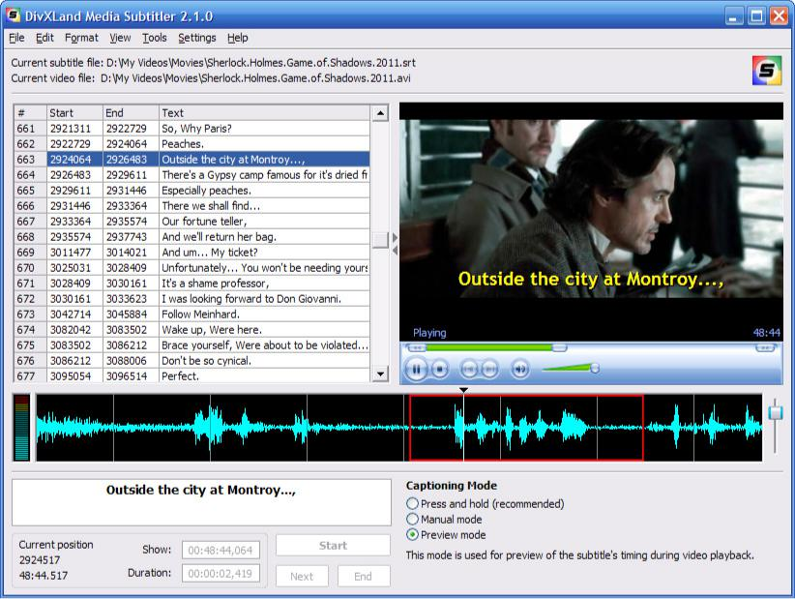

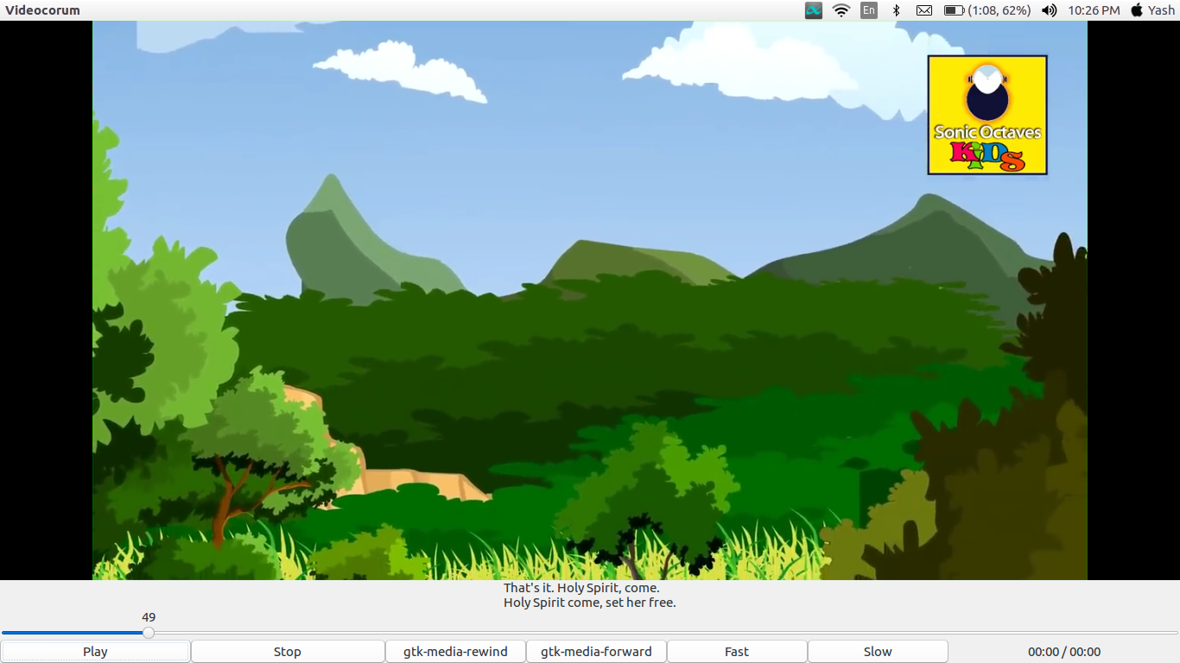

Software Requirements Specification for Video Player with Offline Subtitle Generation Page 4

3.2 Hardware Interfaces:

The app would be available through any desktop machine having:

- RAM : Minimum 4GB
- Hard Disk Space : Minimum 10 GB
- OS: Windows / Linux
- Processor: Intel / AMD

3.3 Software Interfaces:

- Video Player and its GUI developed using pygtk.
- Video playing, pipelining, seeking, etc achieved using gstreamer.
- Audio extraction and Segmentation using pyaudio and pydub.
- Speech Recognition using PocketSphinx and SpeechRecognition module.
- Subtitle addition to video and handling .srt files using pysrt.
- Principle Programming Language: Python

3.4 Communications Interfaces:

This app has no communication interfaces.

- System Features

4.1 Playing Videos & GUI of APP:

4.1.1 Playing videos with support to multiple formats.

4.1.2 User friendly interface for use.

4.1.3 Menu Bar, Status Bar, Pop up Windows for Video & SRT file selection

4.1.4 Basic Play, Pause, Stop, Resume, Close, Minimise, Maximise,functions using buttons.

4.1.5 Video Forwarding & Rewinding

4.1.6 Seek Bar

Software Requirements Specification for Video Player with Offline Subtitle Generation Page 5

4.2 Changing speed of video:

4.2.1 User can change the playback speed of video

4.3 Use of subtitles:

4.3.1 User can use standard .srt files of subtitles to view subtitles on top of videos.

4.4 Real time subtitle generation :

4.4.1 Get the subtitle as the user watches the video.

4.4.2 Do this without having Internet connection.

- Other Nonfunctional Requirements

5.1 Performance Requirements

Performance requirements are under consideration. The accuracy and delay introduced while generation is uncertain.

5.2 Security and Safety Requirements

Not Applicable

5.3 Software Quality Attributes

Correctness: Accuracy is fair but not definite presently.

Reliability: Software is reliable.

Adequacy: Takes only required input, adequate.

Learnability: User friendly and easily learnable GUI.

Robustness: Minimal operational and hardware errors in this software

Software Requirements Specification for Video Player with Offline Subtitle Generation Page 6

Maintainability: Suitable for debugging as Python is highly developed and used language

Readability: Highly Readable as Python is highly developed, lucid, and high used language

Extensibility: Easily extensible. Software is structured, consistent, and well documented.

Testability: Easily testing of large volume of input.

Efficiency: Fair not definite.

Portability: Easily Portable due to use of Python as principle programming language and structure of code

5.4 Business Rules

Not Applicable

- Other Requirements:

NONE

7. Presently Out of Scope:

Extensibility to MAC OS, Increasing Accuracy, Track Synchronisation, Support to Multiple Formats, And Certain GUI Enhancements to make it more user friendly are planned for next updates of the software cycle.

Support for languages other than English is planned for future software development cycle though not immediate.

