When a mobile host moves beyond the range of one base station and into the range of another, it will change its point of attachment into the larger network (i.e., change the base station with which it is associated)—a process referred to as handoff.

At the highest level we can classify wireless networks according to two criteria: *(i)* whether a packet in the wireless network crosses exactly *one wireless hop or multiple wireless hops*, and *(ii)* whether there is *infrastructure* such as a base station in the network:

* *Single-hop, infrastructure-based*  : internet on phones 3G
* *Single-hop, infrastructure-less.*  : Bluetooth
* *Multi-hop, infrastructure-based.*
* *Multi-hop, infrastructure-less*

WIRELESS LINKS AND NETWORK CHARACTERISTICS

Difference from Wired

1. *decreased signal strength*
2. *interference from other sources:*
3. *multipath propagation*

*The signal-to-noise ratio (SNR) is a relative measure of the strength of the received signal (i.e., the information being transmitted) and this noise. The SNR is typically measured in units of decibels (dB),*

*Higher SNR -> Lower Bit Error Rate : Changes in transmission power : Link layer*

Hidden Terminal Problem : Station A and C are transmitting to B :

Caused by Obstruction or Fading : Signals weak enough to not detect each other but strong enough to cause interference

*CDMA*

Codes used : You know how

WIFI

Wifi : 802.11 Wireless LAN -> b, a , g and now n

ARCHITECTURE

* Consists of Access Point and Basic Service Set
* Each wireless device has a **6 BYTE** MAC Addr
* Each Wireless station needs to connect to an AP before send/recv data
* SSID : Server Set Identifier
* 802.11 operates on 2.4 - 2.485 GHz
  + 11 Partially Overlapping Channels : 1,6,11 are non-overlapping
    - Distance of 4 bands req
* WIFI JUNGLE
  + Many access points available
  + AP’s send Beacons on all channels (11) with SSID and MAC Addr
    - Chose 1 and connect
  + ACTIVE ASSO
    - Send Frame : Recivee Frame : Choose one : Send request for IP blah blah : 2 way handshake
* 802.11 MAC PROTOCOL
  + Random Access : CSMA (Carrier Sense Multiple Access) with Collision Avoidance (**NO COLLISION DETECTION)**
    - Difficuilt to send and reciveve stuff
    - Problem of hidden terminal and fading
* Uses Link-Layer Acknowledgment : RECIEVER
  + After reciveing a FRAME that passes CRC, it waits for some time
    - Short Inter-Frame Spacing
    - Then sends ACK Frame
    - If transmiter does not get ACK, it transmits again and finally gives up
* PROTOCOL
  + SENDER :
    - Senses Channel is idle, waits for some time before sending frame
      * This time is called Distributed Inter-Frame Space
    - Else Chooses Random Backoff
      * Value deceases only when channel is idle
      * Transmit when timer expires
  + Why is this good : Reduces chance of collosion : No detection tech
    - Hidden Terminal Problem still there

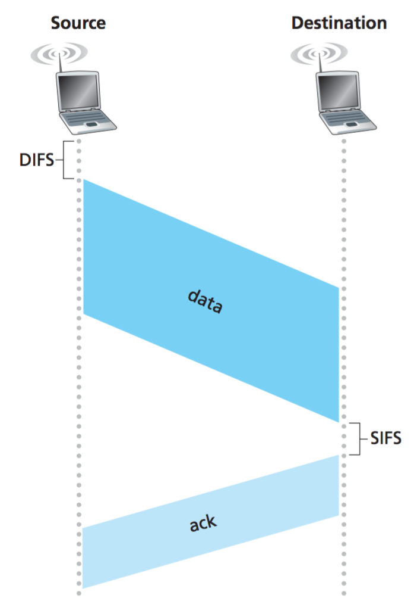

* Dealing with Hidden Terminals
  + Sender sends a RTS (Request to Send)
  + AP sends CTS ( Clear to Send) : Complete permission to send
  + RTS and CTS are short frames : Collisions will not last too long

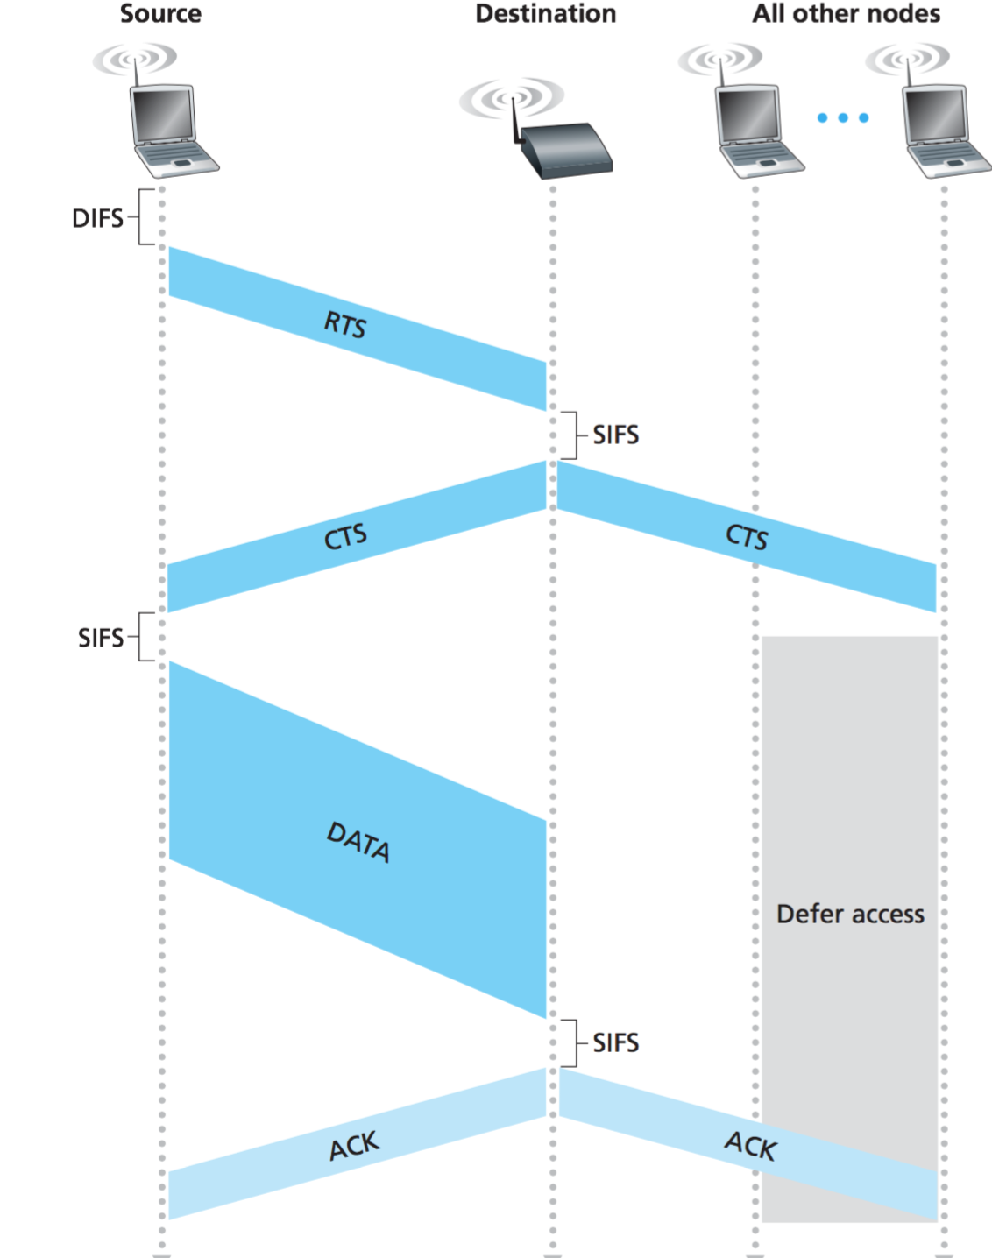

STRUCTURE OF A FRAME

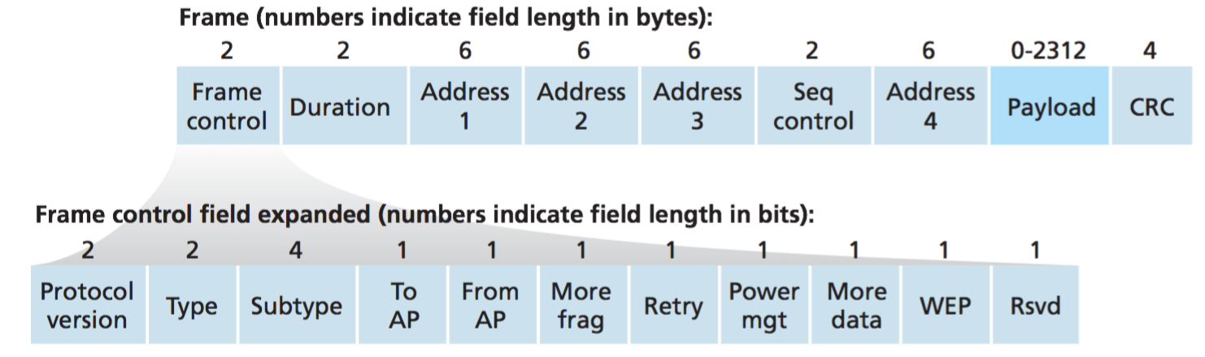

* Heart is the Payload : IP Datagram/ARP Packet : 2312 Bytes (Mainly <1500)
* 32 Bit CRC check
* Address Fields
  + 4 different addr fields : Each hold a 6 byte MAC addr
  + ADDR 2: Senders MAC
  + ADDR 1 : Reciever MAC
  + ADDR 3 : MAC of Router
  + Addr 4 : Used for Ad-Hoc
* Seq and Duration are the same

ADVANCED FEATURES :

Adapts the transmission rate for better sending

If a node sends two frames in a row without receiving an acknowledgment (an implicit indication of bit errors on the channel), the transmission rate falls back to the next lower rate. If 10 frames in a row are acknowledged, or if a timer that tracks the time since the last fallback expires, the transmission rate increases to the next higher rate

Mobility Management :

* Permanent home of a mobile network called : Home Network
  + Entity managing the home network called home agent
* How to address stuff to a user if on a foreign network
* Option 1
  + Foreign network advertises that it has new guy to all neighbours and so on
  + All routing tables adjusted
    - Difficult : Not scalable
* Option 2 : Push this job from network core to network edge
  + Foreign agents create a Care of Address
  + Now mobile node has two main address : Home and Foriegn (COA)
  + Foreign agent tell home that node is with him
* How does COA Change
  + When it moves to new FA, the new FA send its COA, the HA simply discards the old COA
* INDIRECT ROUTING
  + Mobile node registers with foreign agent
  + FA tell HA its COA
  + Corrosponding node sends message to HA of mobile node (Does not know where it is)
  + HA encapsulates datagram from Corrosponding node and sends to COA
  + COA Extracts datagram and gives to MN
  + MN Responds directly to CN (Not thru HA)
  + Suffers from triangle problem
* DIRECT Routing
  + The CN first gets COA from HA
  + Then Directly sends data to the COA
  + If MN changes FA
    - New FA registers itself with old FA.
    - Old FA forwards data to new FA
    - More complex

Mobile IP

Standard consists of three major parts

1. Agent Discovery
2. Registration with home network
3. Indirect Routing of Datagrams

AGENT DISCOVERY

* Must join a network where ever it goes, whether HA or FA
* Two ways
  + Agent Solicitation
  + Agent Advertisement
* Solicitation : MN send broadcast and waits for reply :ICMP 10
* Agent Advestisement
  + HA/FA advertises services periodically
    - ICMP message of type 9
  + Includes IP and some other headers
  + Registration steps
    - MN gets advertisement from FA
    - Send reply with
      * UDP : 434
      * COA advertised
      * Address of HA
      * Self Addr
      * Lifetime Req
      * 64 bit ID
    - FA gets reply
      * Registers IP of MN
      * Send request to HA with same info
    - HA gets request form FA
      * Binds FA addr with COA
      * Replied to FA with same info and yes
    - FA gets reply from HA and fwds it to MN

