**Arjun dhawan**

**102016055**

**2CS10**

Q3)Use Gauss Seidel method to find the solution of the following linear systems with an initial vector [0,0,0,0] and tolerance value 10-5 in the . ∞ norm:

A) 10x + 8y – 3z + u = 16

2x + 10y + z – 4u = 9

3x – 4y + 10z + u = 10

2x + 2y – 3z + 10u = 11

CODE:(GAUSS)

clc;

A = input('enter the matrix: ');

B = input('enter the vector: ');

O = input('enter the initial guess vector: ');

n = input('enter the number of iterations: ');

tol = input('enter the tolerance: ');

N = length(B);

X = zeros(N,1);

Y = zeros(N,1);

for j = 1:n

for i = 1:N

X(i) = (B(i) / A(i,i)) - (A(i,[1:i-1 , i+1:N]) * O([1:i-1 , i+1:N])) / A(i,i);

O(i) = X(i);

end

fprintf('iteration number %d \n' , j)

X

if (norm(Y-X,inf)<tol)

break

end

Y = X;

end

OUTPUT:

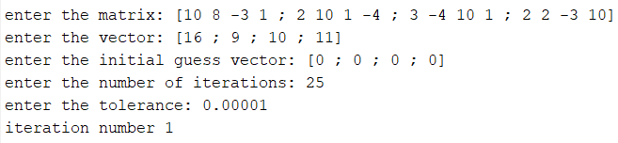

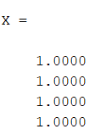

CODE:(SOR)

clc;

clear;

A=[10 8 -3 1;2 10 1 -4; 3 -4 10 1 ; 2 2 -3 10 ];

B=[16;9;10;11];

tol = 0.001;

w = 1.2;

n=4;

error = 1;

x = zeros(1,n);

x0 = zeros(1,n);

while error > tol

for i=1:n

x0(i) = x(i);

sum =0;

for j=1:n

if(i~=j)

sum = sum + A(i,j)*x(j);

end

end

x(i) = (1-w)*x0(i) + (w*(B(i,:) - sum))/A(i,i);

end

error = norm(x0(i)-x(i),inf);

end

disp("THE VALUES OF X,Y,Z,U ARE THE FOLLOWING:");

disp(x);

OUTPUT:



B)4x1 + x2 − x3 + x4 = −2

x1 + 4x2 − x3 − x4 = −1

−x1 − x2 + 5x3 + x4 = 0

x1 − x2 + x3 + 3x4 = 1

CODE:(GAUSS)

clc;

A = input('enter the matrix: ');

B = input('enter the vector: ');

O = input('enter the initial guess vector: ');

n = input('enter the number of iterations: ');

tol = input('enter the tolerance: ');

N = length(B);

X = zeros(N,1);

Y = zeros(N,1);

for j = 1:n

for i = 1:N

X(i) = (B(i) / A(i,i)) - (A(i,[1:i-1 , i+1:N]) * O([1:i-1 , i+1:N])) / A(i,i);

O(i) = X(i);

end

fprintf('iteration number %d \n' , j)

X

if (norm(Y-X,inf)<tol)

break

end

Y = X;

end

OUTPUT:

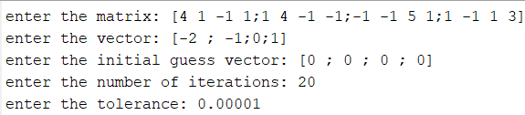

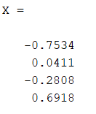

CODE:(SOR)

clc;

clear;

A=[4 1 -1 1 ; 1 4 -1 -1 ; -1 -1 5 1 ; 1 -1 1 3 ];

B=[-2;-1;0;1];

tol = 0.001;

w = 1.2;

n=4;

error = 1;

x = zeros(1,n);

x0 = zeros(1,n);

while error > tol

for i=1:n

x0(i) = x(i);

sum =0;

for j=1:n

if(i~=j)

sum = sum + A(i,j)*x(j);

end

end

x(i) = (1-w)*x0(i) + (w*(B(i,:) - sum))/A(i,i);

end

error = norm(x0(i)-x(i),inf);

end

disp("THE VALUES OF X1,X2,X3,X4 ARE THE FOLLOWING:");

disp(x);

OUTPUT:



Q4.Use Gauss Seidel method to solve the following linear system with an initial vector [0,0,0] and tolerance value 10-3 in the . ∞ norm:

4.63x1 − 1.21x2 + 3.22 x3 = 2.22

−3.07x1 + 5.48x2 + 2.11x3 = −3.17

1.26x1 + 3.11x2 + 4.57x3 = 5.11

CODE:(GAUSS)

clc;

A = input('enter the matrix: ');

B = input('enter the vector: ');

O = input('enter the initial guess vector: ');

n = input('enter the number of iterations: ');

tol = input('enter the tolerance: ');

N = length(B);

X = zeros(N,1);

Y = zeros(N,1);

for j = 1:n

for i = 1:N

X(i) = (B(i) / A(i,i)) - (A(i,[1:i-1 , i+1:N]) * O([1:i-1 , i+1:N])) / A(i,i);

O(i) = X(i);

end

fprintf('iteration number %d \n' , j)

X

if (norm(Y-X,inf)<tol)

break

end

Y = X;

end

OUTPUT:

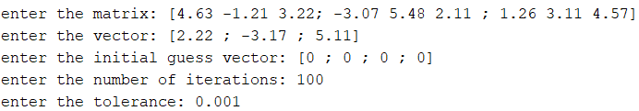

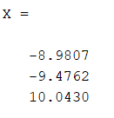

CODE:(SOR)

clc;

clear;

A=[4.63 -1.21 3.22; -3.07 5.48 2.11 ; 1.26 3.11 4.57];

B=[2.22 ; -3.17 ; 5.11];

tol = 0.001;

w = 1.2;

n=3;

error = 1;

x = zeros(1,n);

x0 = zeros(1,n);

while error > tol

for i=1:n

x0(i) = x(i);

sum =0;

for j=1:n

if(i~=j)

sum = sum + A(i,j)*x(j);

end

end

x(i) = (1-w)*x0(i) + (w*(B(i,:) - sum))/A(i,i);

end

error = norm(x0(i)-x(i),inf);

end

disp("THE VALUES OF X,Y,Z,U ARE THE FOLLOWING:");

disp(x);

OUTPUT:

