TravelMemory Deployment Guide
MERN application on AWS with two load-balanced tiers
This guide records the deployment flow for TravelMemory: MongoDB Atlas, a Node/Express backend, a React frontend, and two EC2 instances in each tier behind separate Application Load Balancers. It includes the observed recovery from a missing frontend index file and the final healthy target-group state.
Verified infrastructure state Frontend target group shows 2 healthy targets and 0 unhealthy. The React build was deployed to both frontend instances and each returned HTTP 200 locally.

Architecture
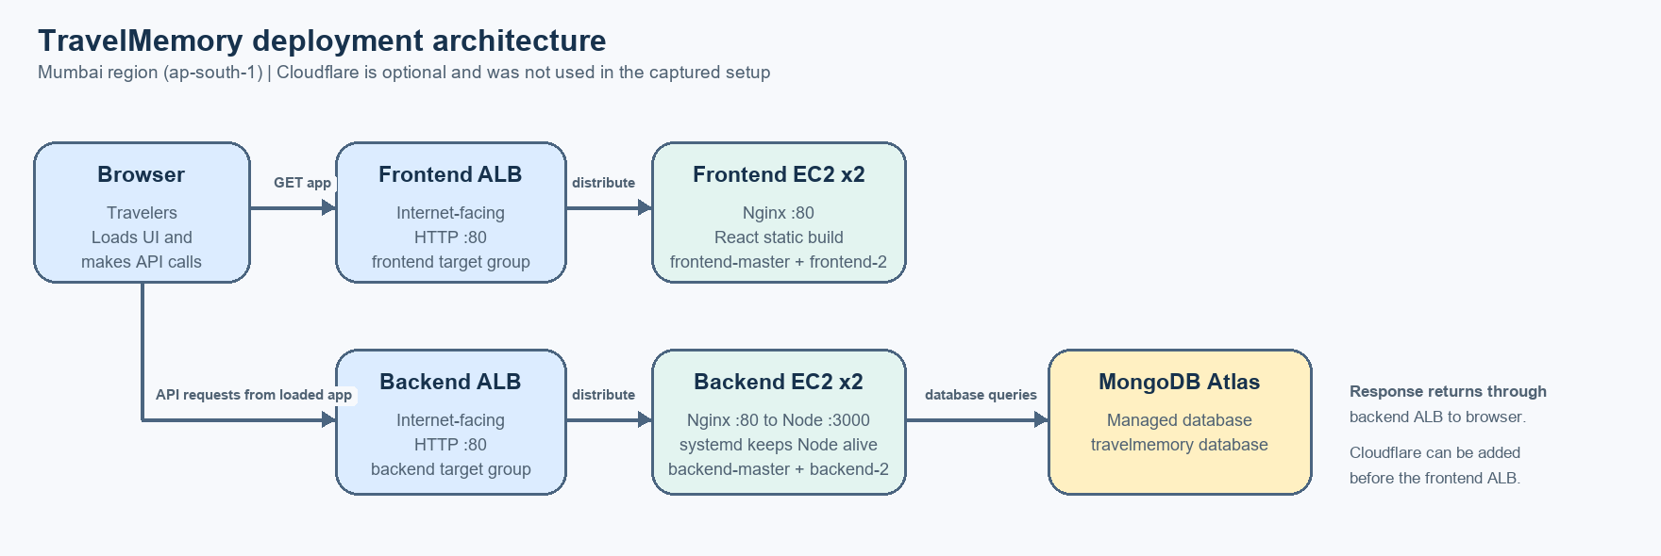
Cloudflare was optional and is not shown in the active request path. The browser loads the static UI through the frontend ALB; JavaScript in that page sends API requests directly to the backend ALB.

Deployment endpoints
Service | DNS / route
Frontend ALB | http://travelmemory-frontend-alb-865817933.ap-south-1.elb.amazonaws.com
Backend ALB | http://travelmemory-backend-alb-2120813830.ap-south-1.elb.amazonaws.com
Region | Asia Pacific (Mumbai), ap-south-1
Final browser check Open the frontend ALB URL, confirm trips load, add one test experience, then refresh and confirm it remains. Capture that result before submission; it is not evidenced by the screenshots included here.

1 Prepare MongoDB Atlas
- Create a MongoDB Atlas cluster and database user. Save the username and password securely.
- Create the TravelMemory database connection string and place it in the backend environment file. The guide used the database name travelmemory.
- Add network access for the EC2 backend. The learner guide used 0.0.0.0/0 because instance egress addresses can vary; narrow this to known egress ranges or private connectivity for a production deployment.
MONGO_URI=mongodb+srv://<username>:<password>@<cluster-host>/travelmemory?retryWrites=true&w=majority
PORT=3000

2 Launch the master instances
In ap-south-1, launch one Ubuntu EC2 instance for each tier and label them backend-master and frontend-master. Allow SSH for administration, HTTP 80 for web traffic, and keep the Node port private behind Nginx where possible. The frontend and backend target groups later use port 80.

3 Install and verify the backend
sudo apt update
sudo apt install -y nodejs npm git nginx
git clone https://github.com/UnpredictablePrashant/TravelMemory.git
cd ~/TravelMemory/backend
npm install
nano .env
node index.js
The backend package has no npm start script. Start it for a one-off check with node index.js; use systemd for the deployed service. With PORT=3000, verify locally with curl http://localhost:3000/hello. The captured browser check returned “Hello World!”.

Backend endpoint check: the /hello route returned Hello World.

4 Keep the backend running with systemd
[Unit]
Description=TravelMemory Backend
After=network.target
[Service]
Type=simple
User=ubuntu
WorkingDirectory=/home/ubuntu/TravelMemory/backend
EnvironmentFile=/home/ubuntu/TravelMemory/backend/.env
ExecStart=/usr/bin/node index.js
Restart=always
RestartSec=5
[Install]
WantedBy=multi-user.target
sudo systemctl daemon-reload
sudo systemctl enable --now travelmemory-backend
sudo systemctl status travelmemory-backend --no-pager
Save the unit as /etc/systemd/system/travelmemory-backend.service. Enabling it before imaging lets the cloned backend instance start automatically at boot.

5 Put Nginx in front of Node
location / {
proxy_pass http://localhost:3000;
proxy_set_header Host $host;
proxy_set_header X-Real-IP $remote_addr;
proxy_set_header X-Forwarded-For $proxy_add_x_forwarded_for;
}
Add this location to /etc/nginx/sites-available/default, then run sudo nginx -t and sudo systemctl restart nginx. Verify through port 80 with curl http://localhost/hello.

6 Build the frontend on frontend-master
Clone the repository on the frontend master and install dependencies. Before building the AMI, point the frontend at backend-master for the baseline test. The final backend ALB does not exist yet at imaging time.
cd ~/TravelMemory/frontend
npm install
nano src/url.js
export const baseUrl = process.env.REACT_APP_BACKEND_URL || "http://13.201.229.251";
Keep exactly one export of baseUrl. If .env defines REACT_APP_BACKEND_URL, it overrides the fallback; set that value before building. Build and deploy the static site:
npm run build
sudo cp -a build/. /var/www/html/
sudo nginx -t && sudo systemctl reload nginx
curl -I http://localhost/
A successful deploy has build/index.html and returns HTTP 200 from the local Nginx check. The app’s frontend EC2 instances serve the built files from /var/www/html.

7 Verify the baseline, then create AMIs
- Open the frontend master’s public address and verify that trips load and a new experience can be saved to Atlas.
- Create travelmemory-backend-ami from backend-master after systemd is enabled and the backend is working.
- Create travelmemory-frontend-ami from frontend-master after the React build is deployed and the site works.
- Wait until both AMIs are Available before launching clones.

8 Launch the second instances
Launch backend-2 from the backend AMI and frontend-2 from the frontend AMI. Confirm the backend clone serves /hello on port 80. Confirm the frontend clone serves / on port 80. The AMI provides the installed code and service configuration; systemd starts the backend automatically.
Security group intent Public ALBs accept web traffic on TCP 80. Instance security groups should accept the relevant tier traffic from the ALB security group. Restrict SSH to the EC2 Instance Connect prefix list or a trusted administrator IP. Do not leave Node port 3000 open to the public internet.

9 Create the backend target group and ALB
- Create travelmemory-backend-tg with target type Instance, HTTP port 80, and health check path /hello. Register backend-master and backend-2.
- Create travelmemory-backend-alb as internet-facing in public subnets across Availability Zones. Add an HTTP:80 listener that forwards to travelmemory-backend-tg.
- Allow HTTP 80 from the internet to the ALB security group. Allow instance HTTP 80 from the ALB security group. Confirm both backend targets become healthy.

10 Create the frontend target group and ALB
- Create travelmemory-frontend-tg with target type Instance, HTTP port 80, and health check path /. Register frontend-master and frontend-2.
- Create travelmemory-frontend-alb as internet-facing across public subnets in multiple Availability Zones. Add an HTTP:80 listener forwarding to travelmemory-frontend-tg.
- Allow HTTP 80 to the ALB security group, then allow port 80 to frontend instances from the ALB security group. Confirm the target group health checks succeed.
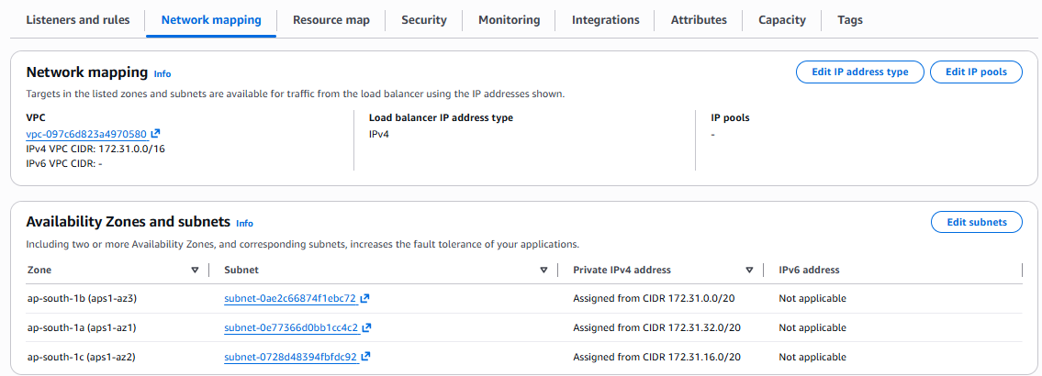
Frontend ALB network mapping across three Availability Zones in ap-south-1.
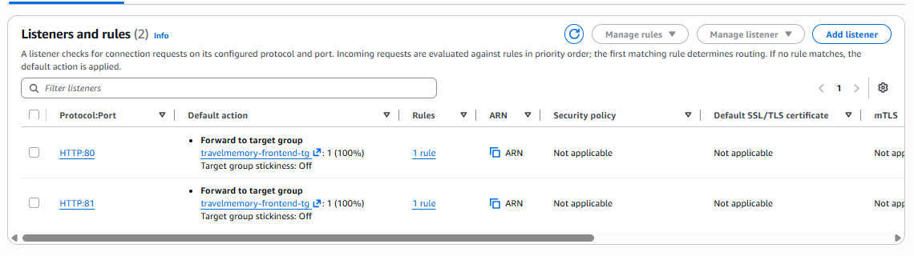
The frontend ALB HTTP:80 listener forwards traffic to travelmemory-frontend-tg. The console also showed an extra HTTP:81 listener; standard browser access uses port 80.

11 Point both frontends at the backend ALB
Do this after the backend ALB exists and after both frontend instances have been launched. Set the same backend ALB address on frontend-master and frontend-2; rebuild each instance because Create React App embeds environment values during the build.
cd ~/TravelMemory/frontend
nano src/url.js
export const baseUrl = process.env.REACT_APP_BACKEND_URL || "http://travelmemory-backend-alb-2120813830.ap-south-1.elb.amazonaws.com";
npm run build
sudo cp -a build/. /var/www/html/
sudo nginx -t && sudo systemctl reload nginx
curl -I http://localhost/
The deployment encountered two related frontend issues. First, /var/www/html had no index.html, so Nginx returned 403 and the target group rejected both instances. Second, the first build attempt failed because node_modules was owned by root. Running sudo chown -R ubuntu:ubuntu node_modules, then rebuilding as ubuntu, resolved the build permission error. Copying build/. into /var/www/html restored the index page and produced HTTP 200.
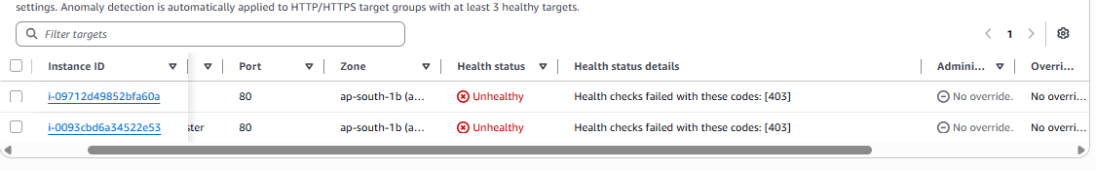
Before the fix, both frontend targets failed health checks with HTTP 403.

12 Confirm frontend target health
In EC2 → Target Groups → travelmemory-frontend-tg → Targets, confirm both frontend instances are Healthy. The final supplied console screenshot shows 2 healthy and 0 unhealthy targets.
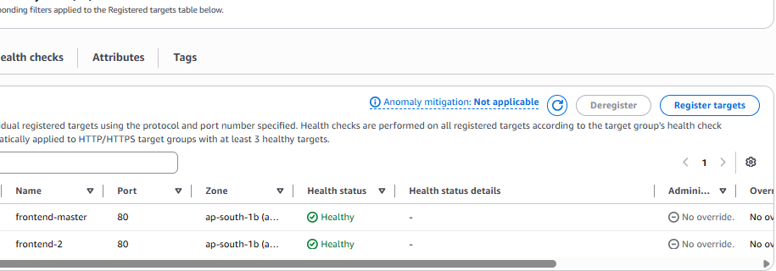
Final frontend target group state: frontend-master and frontend-2 are both healthy.

13 Final application verification
http://travelmemory-frontend-alb-865817933.ap-south-1.elb.amazonaws.com
- Open the frontend ALB URL in a browser and confirm the TravelMemory app loads.
- Confirm trips load from MongoDB Atlas. In Developer Tools → Network, check that API requests go to the backend ALB and return successfully.
- Add a test experience, confirm it appears, refresh, and confirm it persists.
- Capture screenshots of the app, successful add-and-refresh flow, both target groups healthy, and the draw.io architecture diagram for submission.
Evidence status The supplied AWS screenshot verifies both frontend targets are healthy. The complete add-and-refresh test through the frontend ALB should be performed and captured before submission.

Troubleshooting reference
Symptom | Likely check | Resolution used / next check
ALB URL times out | Listener, ALB SG, public subnets and target health | Listener was forwarding to the frontend target group; investigate target health first.
Target health 403 | GET / returns 403; Nginx error log said directory index forbidden | Build React app; confirm build/index.html; copy build/. to /var/www/html; reload Nginx.
React build EACCES | node_modules/.cache owned by root | Run sudo chown -R ubuntu:ubuntu node_modules, then npm run build as ubuntu.
Target health timeout | Instance service or instance-specific port 80 path | Check systemctl status nginx, curl -i localhost, and instance SG ingress from ALB SG.
EC2 Instance Connect fails | SSH port 22 rule, status checks and route | Check instance status checks, public IPv4, subnet route and EC2 Instance Connect access.

Operational notes
- Use systemd for the backend so it restarts after failures and starts after a reboot. The backend package does not define npm start.
- Keep one baseUrl export. Set REACT_APP_BACKEND_URL before npm run build if using the environment variable; otherwise change the fallback and rebuild both frontends.
- Protect MongoDB credentials in .env. Do not commit the file or distribute AMIs containing secrets; use a managed secret store for production.
- Cloudflare was optional and is not part of the active architecture shown. If configured later, point api to the backend ALB and the root/www name to the frontend ALB, then rebuild the frontend with the API hostname.

