Project Proposal: Community Sensor Network

Background
Local growers lose crops every summer because they cannot see when soil dries out. This proposal extends the water sensor pilot into a permanent community network.

Goals
- Keep at least 90% of sensors online through the year.
- Send growers a text message when soil moisture drops below 20%.
- Share anonymised readings with the regional water authority.

Budget
Item | Cost (EUR)
40 soil moisture sensors | 740
Gateway and SIM plan | 380
Training sessions | 450
Total | 1,570

Expected impact
The pilot already showed steady growth in three of four regions:
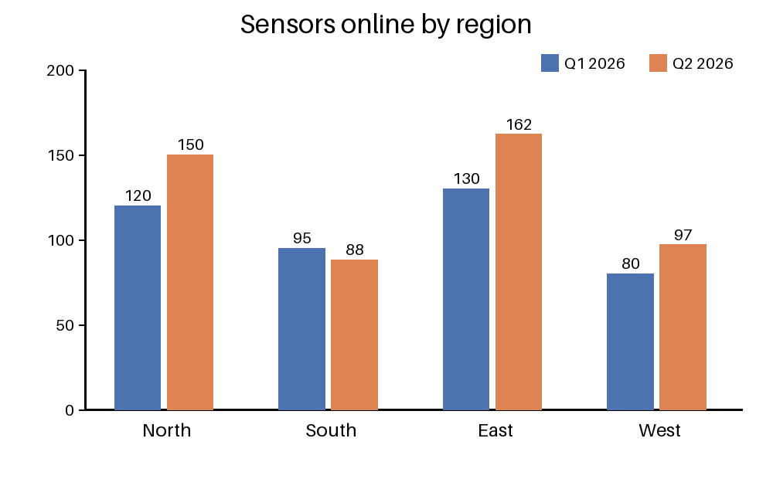
Figure 1: Sensors online per region during the pilot.

