HW10

Richard Hardis, James Trawick, Arjun Goyal, Alan Lo

10/23/2019

## 13.1)

### a) A binomial distribution can be used to model the probability of having exactly S number of made free throws out of N attemps for a certain basketball player. This distribution works if we assume each free throw attemp is independant of previous attempts. For exampe if Lebron James makes free throws with a probability of 65% the probability that he makes exactly 1 free throw in 1 attempts is trivially 65%. The probability that he makes exactly 3 free throws in 7 attempts is 14.42%…..we model this below

dbinom(3, 7, .65)

## [1] 0.1442382

we model k values between 1 and 7 below

library(stats)  
k = c(1:7)  
v = c(1:7)  
plot(dbinom(k, 7, .65), xaxt = "n") + axis(1, at = k, labels = v, tick = TRUE)

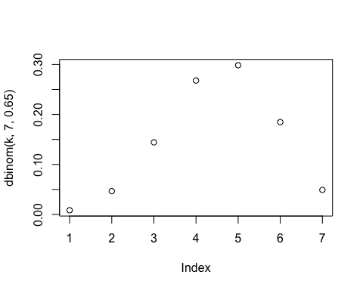

## numeric(0)

### b) Geometric Distributions can be used to model the probability of having N number of misses before a certain basketball player makes one free throw. This distribution works if we assume each free throw attempt is independent of previous attempts. For example if Lebron James makes free throws with a probability of 65%, the probability that he has 0 misses before his first make is trivially 65%. The probability that he has 4 misses before his first make is: 0.975%….We model this below

p = .65  
q = 1-p  
n = 4  
fx = p*(q^n)  
fx

## [1] 0.009754062

We model multiple such n’s below (for n 1:10):

n = c(1:10)  
plot(dgeom(n, .65), xaxt = "n") + axis(1, at = n, labels = n, tick = TRUE)

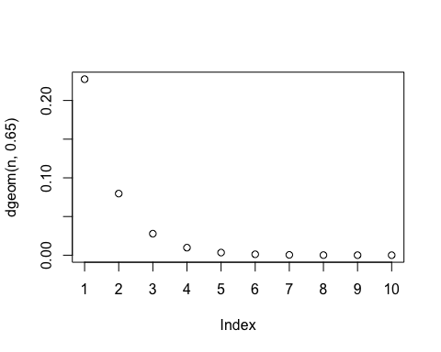

## numeric(0)

### c) A Poisson distribution is used to model situations where you measure the frequency of an event within a span of time, where each event is independent and occurring at the same rate. An example would be the number of visitors to a hospital waiting room in a given day, with each visit independent of the other, and occurring at a constant rate.

We model the scenario where patients arrive to the hospital at a rate of 12 patients/hour on average. We can see from the plot below that there is an 80% chance that 14 or fewer patients arrive to the hospital in any given hour.

x = c(1:15)  
plot(ppois(x, 12))

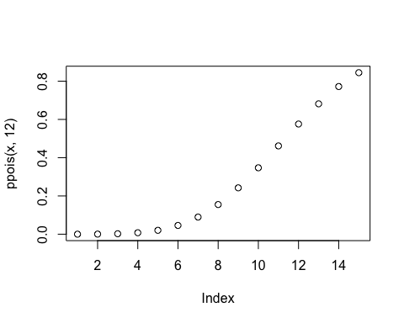

### d) Exponential distributions can be used to model failure rates that have a constant failure probability over the lifetime of the model. For example, a cloud computing user can model the probability of failure or the expected amount of time before failure of a computing job on a server with an exponential model. We model this below with a lambda of .5 and a continuous time scale.

x = seq(0, 20, length.out = 10000)  
y = c(0,20)  
plot(dexp(x, .5), xlab = "Time Before Failure", ylab = "Probability", xaxt='n') + axis(1, at = x, labels = x, tick = TRUE)

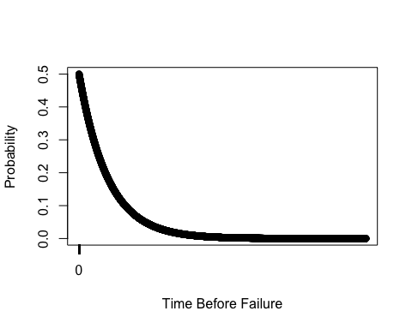

## numeric(0)

### e) Weibull distributinos can be used to model failure rates that do not require the constant failure probability over the lifetime of the model. One example is modeling the time until failure of a gear in a mechanical assembly. Gear teeth wear down over time, so the probability of failure increases as time goes on. Due to the increasing probability of failure, the gear useful lifetime can be modeled with a weibull distribution with a k>1.

We model this below with a k of 1.1:

x = c(1:10)  
plot(dweibull(x, 1.1))

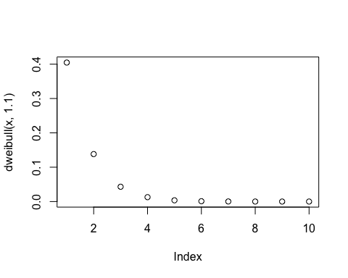

## 13.2)

Modeling the provided situation yielded the process flow below – by varying the capacity in IDBoarding from 1-4, we could observe the wait time discrepancies with different numbers of servers available at the ID/boarding-pass check. However, for the personal-check stations, each server needed to be added individually, because they have their own distinct queues. In order to model the tendency for passengers to be routed to the shortest queue amongst the personal checks, we initiated a node list containing the input node for each server at the station, and proceeded to route passengers leaving the IDBoarding check to the input of the personal check server with the smallest “AssociatedLoad”

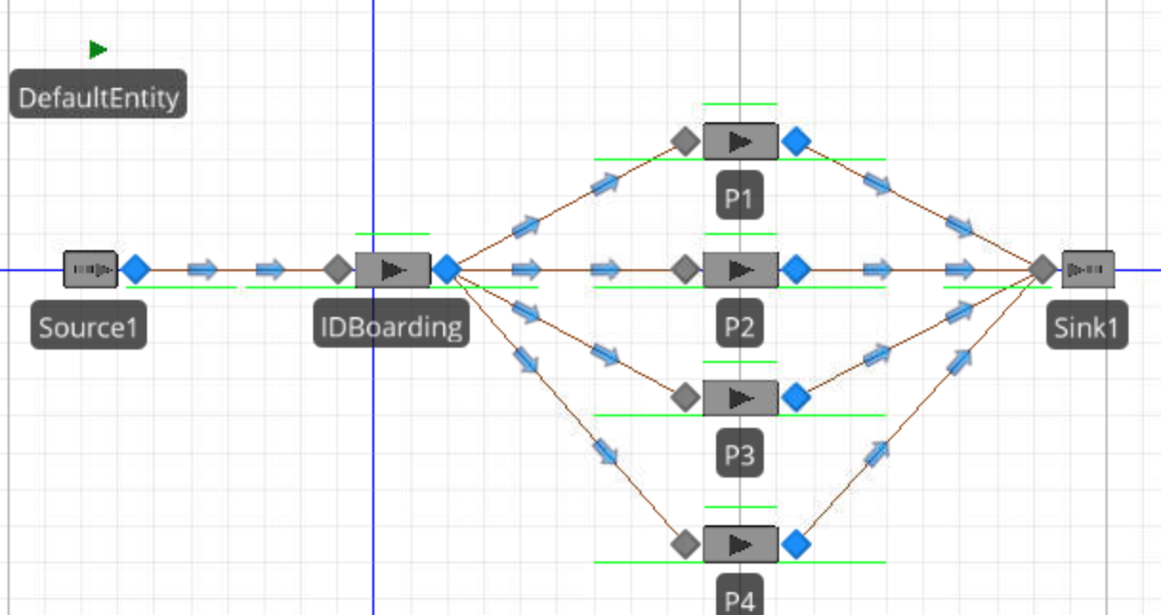

As we varied the capacity of the boarding check and number of personal checks, we observed the results below:

IDBoarding Capacity: 1, No. of Personal Checks: 1



IDBoarding Capacity: 1, No. of Personal Checks: 3

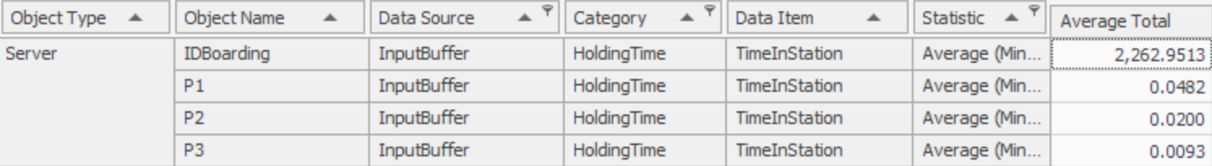

IDBoarding Capacity: 4, No. of PersonalChecks: 3

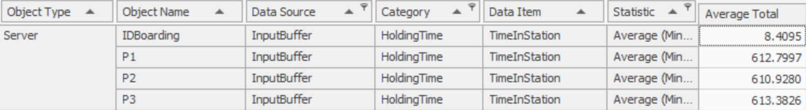

IDBoarding Capacity: 4, No. of PersonalChecks: 4

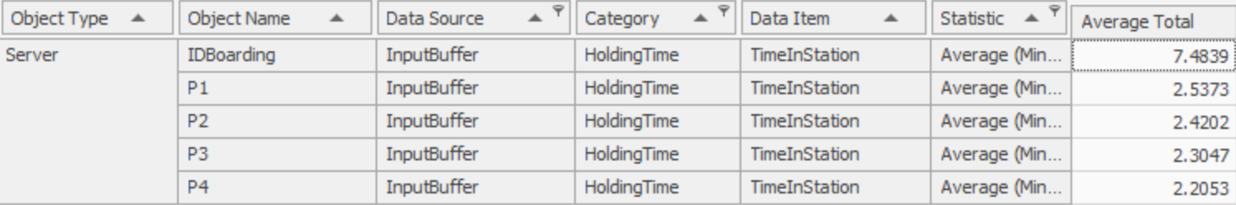

In order to determine the average time in queue, we can add the average holding time in station with each (or the average) of the average holding times in the personal checks (P1-4). As you can see, as we vary the capacities and number of servers, we find that a capacity of 4 with 4 personal checks is the number required to reach an average holding time (average time in queue) to sub 15 minutes (~9-10 minutes).