HW3Markdown

Alan Lo, Arjun Goyal, Richard Hardis, Will Trawick

9/9/2019

## Question 5.1

library(outliers)  
#setwd("/Users/alan/Dropbox (GaTech)/Fall19/6501/6501-hw/hw3")  
data_df = read.table("uscrime.txt", header = TRUE)  
grubbs.test(data_df$Crime, type=11, opposite=FALSE, two.sided=TRUE)

##   
## Grubbs test for two opposite outliers  
##   
## data: data_df$Crime  
## G = 4.26877, U = 0.78103, p-value < 2.2e-16  
## alternative hypothesis: 342 and 1993 are outliers

Upon running the two-sided grubbs test, the output notes that there are outliers at both ends with a low p-value, suggesting that both values 342 and 1993 are indeed outliers. However, upon running the one-sided grubbs test (shown below), the results seem to call this conclusion into question –

grubbs.test(data_df$Crime, type=10, opposite=FALSE, two.sided=FALSE)

##   
## Grubbs test for one outlier  
##   
## data: data_df$Crime  
## G = 2.81287, U = 0.82426, p-value = 0.07887  
## alternative hypothesis: highest value 1993 is an outlier

grubbs.test(data_df$Crime, type=10, opposite=TRUE, two.sided=FALSE)

##   
## Grubbs test for one outlier  
##   
## data: data_df$Crime  
## G = 1.45589, U = 0.95292, p-value = 1  
## alternative hypothesis: lowest value 342 is an outlier

Looking at the one-sided grubbs test for outliers, we find that the p-value for the low end outlier (342) is 1, so this outlier can’t be considered with confidence. The p-value for the upper end outlier (1993) is 0.07887, so we can consider this a true outlier in the crime dataset.

ineq_vec = data_df$Ineq  
ineq_med = median(ineq_vec)  
ineq_low = subset(data_df,Ineq<ineq_med)  
ineq_high = subset(data_df,Ineq>=ineq_med)  
boxplot(data_df$Crime,ineq_low$Crime,ineq_high$Crime)

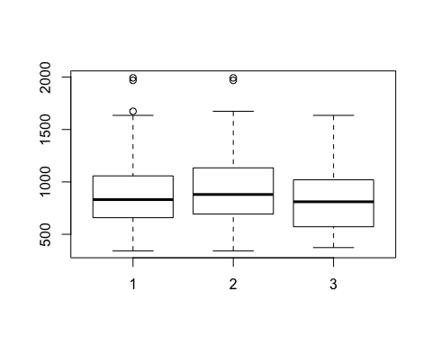 Boxplot 1 - Full Dataset Boxplot 2 - Lower Income Inequality Boxplot 3 - Higher Income Inequality

Above we partitioned the data into high and low income inequality subsets in order to observe discrepancies between the groups, noting that different partitions (i.e. on population or region) would yield different results where outlier points in one partition may not be represented as outliers in other partitions.

## Question 6.1

*Describe a situation or problem from your job, everyday life, current events, etc., for which a Change Detection model would be appropriate. Applying the CUSUM technique, how would you choose the critical value and the threshold?*

A change detection model would be appropriate for the assessing whether an NFL player has a concussion. Often times concussions are only detected after a player has been involved in a jarring hit or has extremely noticeable symptoms. Diagnosing and treating concussions is the cornerstone of NFL player preventative and rehabilitative care and NFL training staff members could improve their care by using a change detection model.

Weekly or monthly data could be collected from players on information retention and/or reaction speed. Applying a CUSUM technique could tell training staff whether a player has a concussion by analytically determining cumulative drops in reaction/recall. Critical values would have to be appropriately set in order to reduce the risk of false positives. Naturally peoples IQ’s, recall, and reaction change day to day for various reasons (sleep, nutrition, etc….). An initial critical value (C value) could be 1 standard deviation away. An initial threshold value could be 3 standard deviations away. Of course the NFL should consult concussion experts and neurologists on the validity of these numbers.

## Question 6.2

### 1

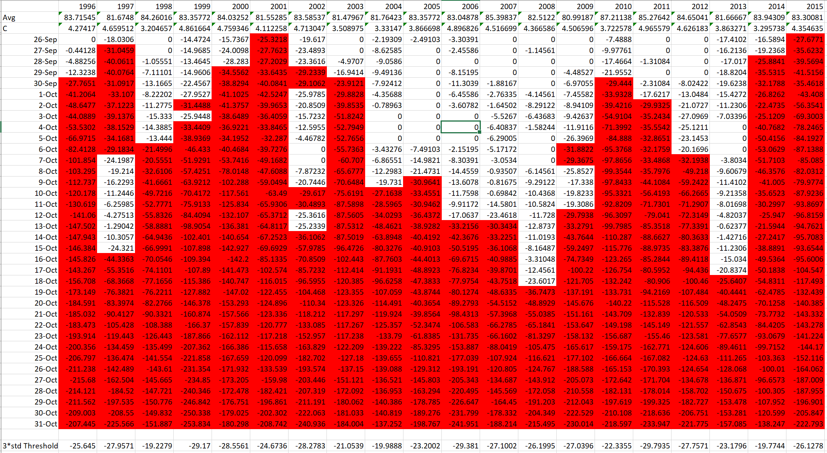

For each year, we used a min cumsum function defined by:

$$S_{t}=Min(0,S_{t−1}+(X_{i}−μ+C))$$

This function was applied with a C $0.5*std(temperature)$ and a threshold value of $3*std(temperature)$ on a year to year basis. The values of .5 and 3 come from this [article](https://www.spcforexcel.com/knowledge/variable-control-charts/keeping-process-target-cusum-charts) on statistical process control. Visually, we used conditional formatting in excel to find the date where the cumulative sum of the temparature dropped below our Threshold value. Inspection of the data revealed that in the years 2000 and 2013, there were instances of false positives where the cumsum dropped below the threshold but only for one day. We interpreted this to represent a temporary cold snap but not the end of summer. We interpreted yearly cooling off periods based on the first date at which a consistent, subsequent period of the cumsum was below the threshold value.

1996: September 30th 1997: September 27th 1998: October 6th 1999: October 2nd 2000: September 29th 2001: September 26th 2002: October 10th 2003: September 30th 2004: October 10th 2005: October 9th 2006: October 13th 2007: October 13th 2008: October 19th 2009: October 6th 2010: September 30th 2011: October 2nd 2012: October 7th 2013: October 18th 2014: September 28th 2015: September 26th

### 2

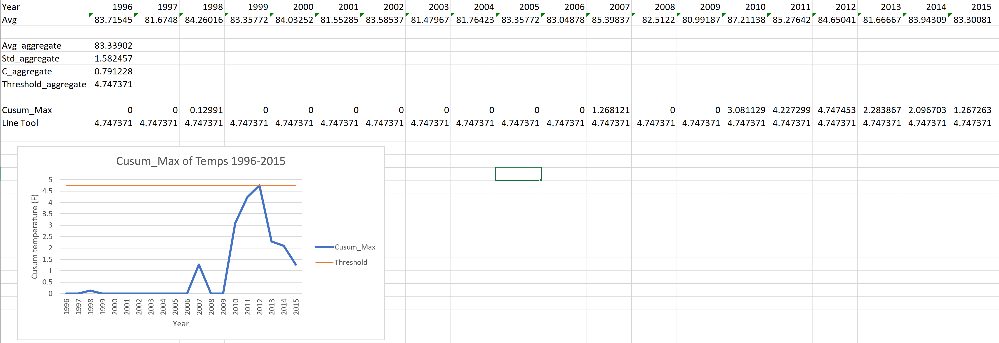

We started by taking the yearly average temperature over the entire dataset. We calculated the standard deviation in order to find C and Threshold values using the same 0.5 and 3 coefficients from part 1. We used a max cumsum function to determine whether the temperatures had consistently risen over time. The cumsum of temperatures did exceed the threshold in 2012, indicating that temperatures have been rising over time.

