Architecture for MERN Project

EC2
|
Clone the git
|
Create db in mongo bdv
|
Backend
|
Frontend
|
Test the server
|
Set nginx
|
Load balancer
|
Host on cloudfare

┌────────────────────────────┐
│ Users / Clients │
└────────────┬───────────────┘
│
▼
┌────────────────────────────┐
│ Load Balancer (e.g., │
│ (AWS ELB) │
└────────────┬───────────────┘
│
┌──────────────────────┴──────────────────────┐
│ │
▼ ▼
┌────────────────────┐ ┌────────────────────┐
│ Backend Server 1 │ │ Backend Server 2 │
│ Node.js + Express │ │ Node.js + Express │
└─────────┬───────────┘ └─────────┬───────────┘
│ │
▼ ▼
┌────────────────────┐ ┌────────────────────┐
│ MongoDB Atlas │<────────────────────►│ MongoDB Atlas │
└────────────────────┘ └────────────────────┘

▲
│
┌────────────────────────────┐
│ React.js Frontend │
│ (Hosted on CDN or S3 etc) │
└────────────────────────────┘

Steps followed for building MERN application
- Created 4 EC2 instances, 2 for backend and 2 for frontend
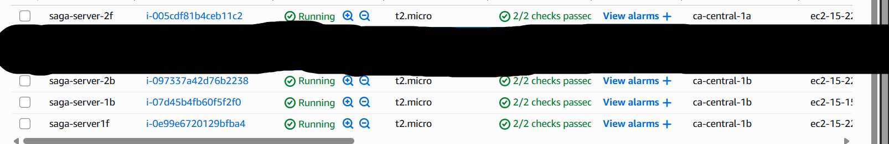

- Logged from instance to our ip
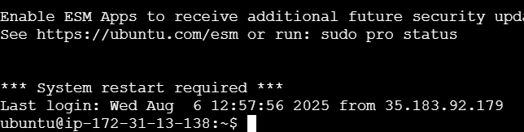

- Worked on DB as well
Cluster
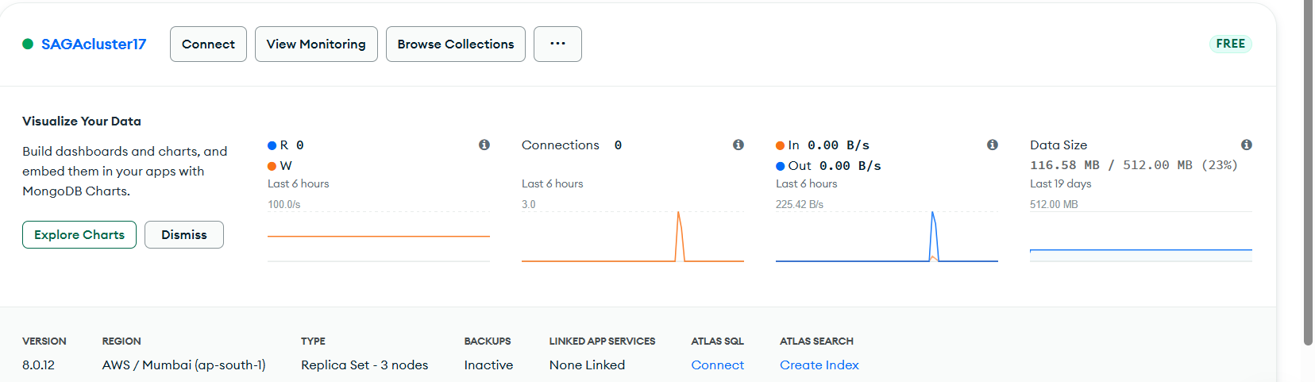

Created database user
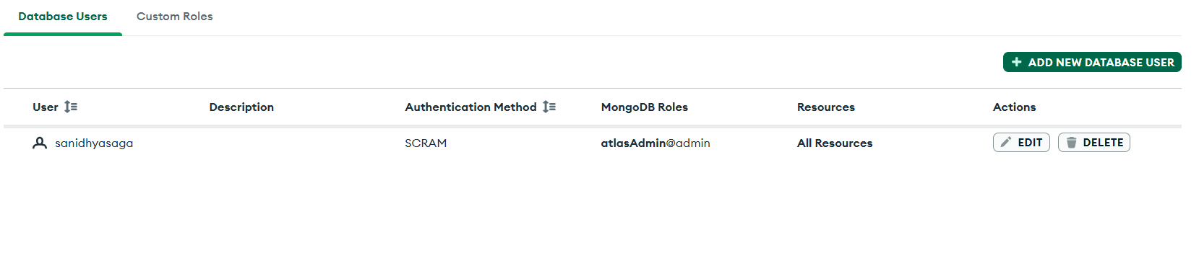

Gave network access
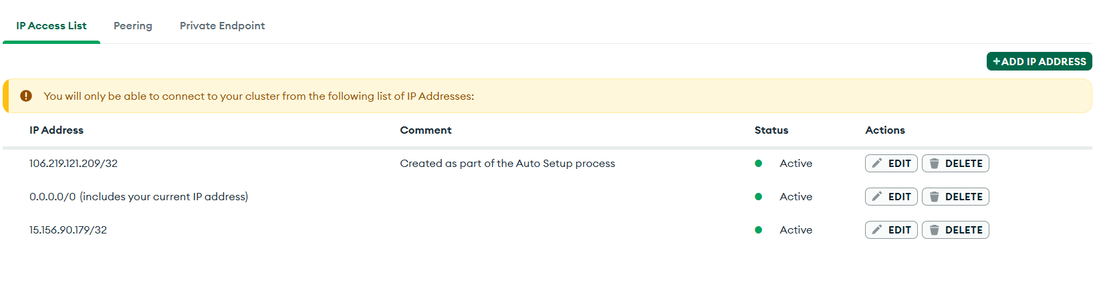

Installed Mongo DB compass

Made entries from frontend

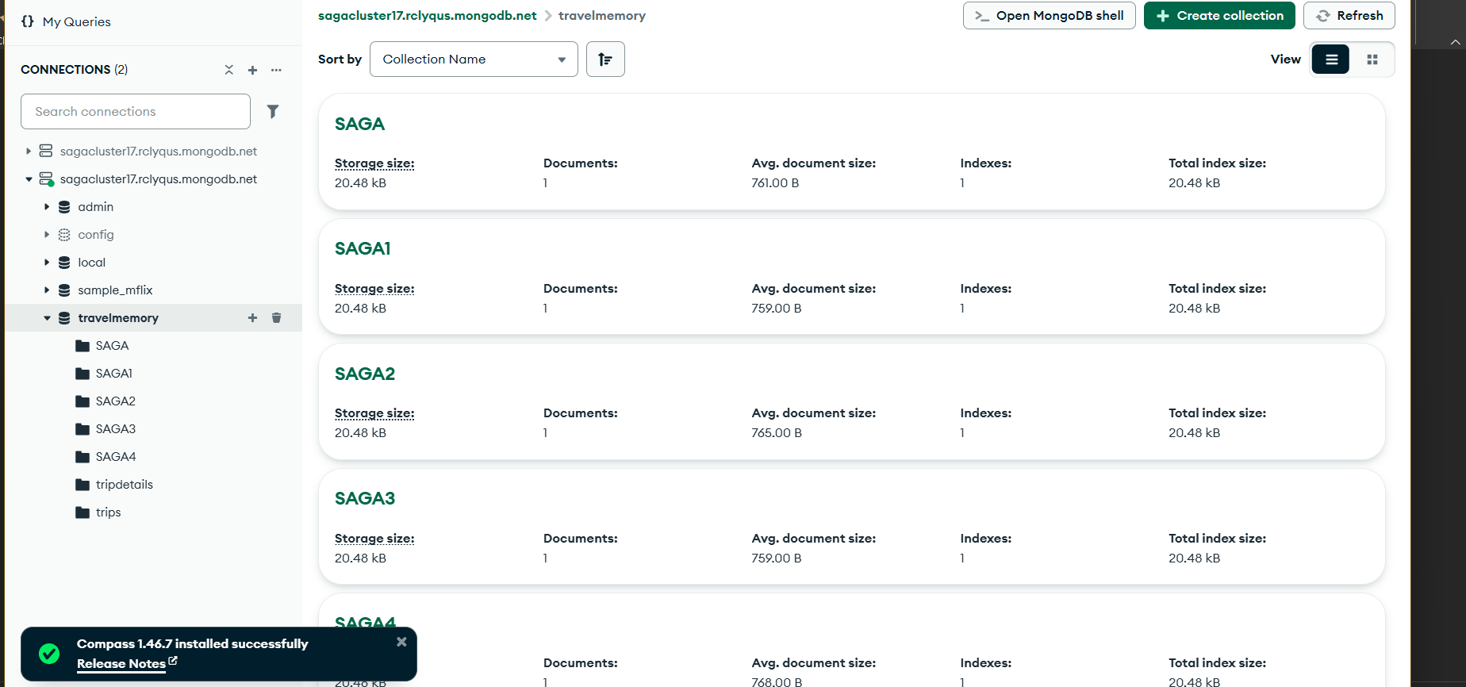

- Configured backend
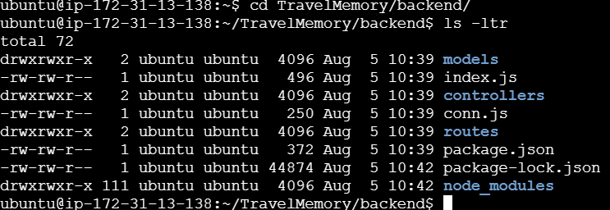
- Tested the backend
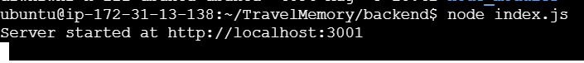
- Tesed on web also

- Configured frontend
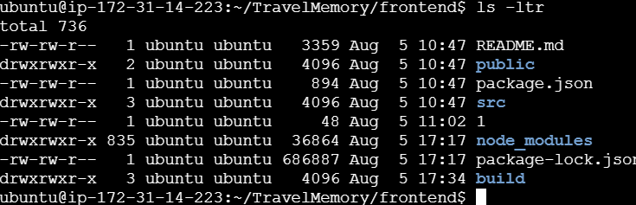
- Checked if frontend connecting
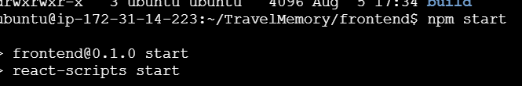
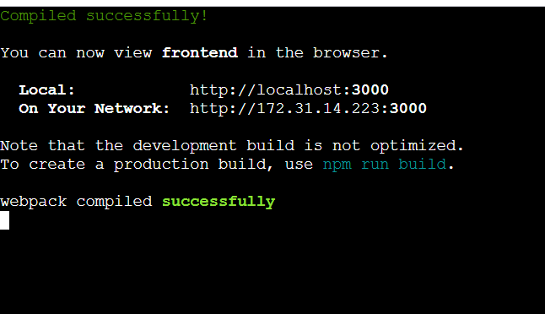
- Check on web also
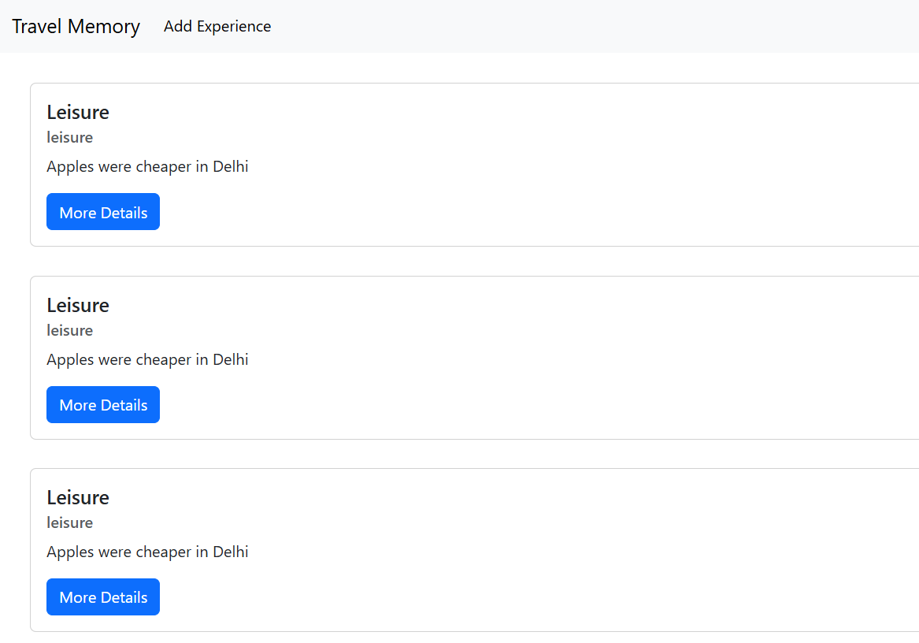

- Set up nginx
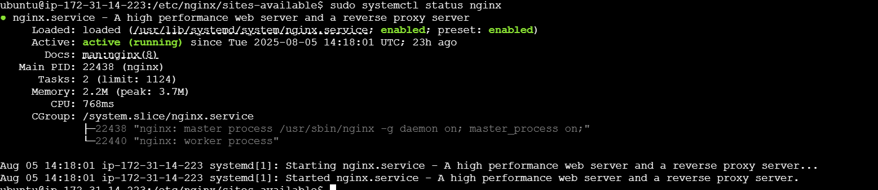
- Created loas balancer for both backend and frontend
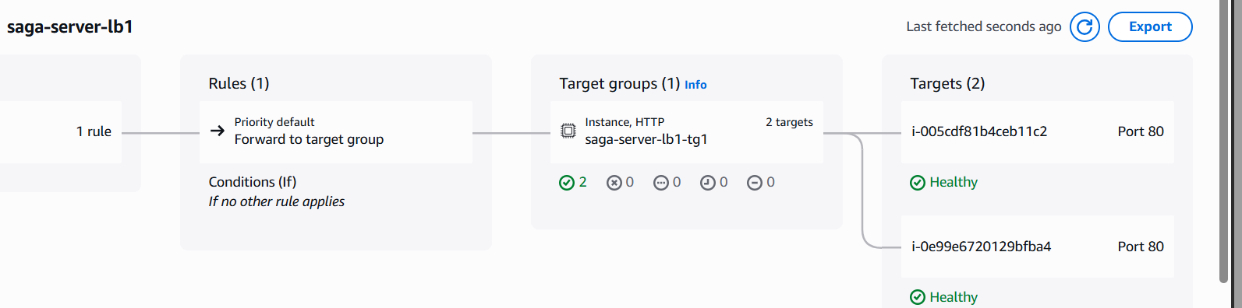
Above from frontend
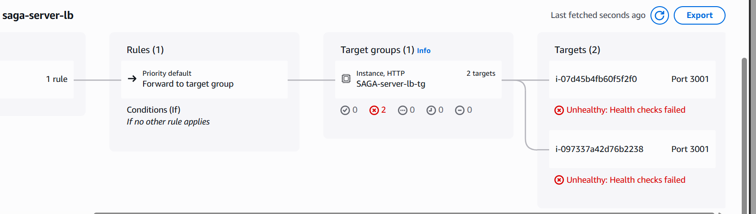
Above is backend

