COLLEGE OF DEFENCE MANAGEMENT · DATATHON - 2026
Theme 6.1: Contested and Congested – Growth of Satellites in Outer Space
PROJECT HIGH GROUND
Contested and Congested: the Crowding of Orbit, and What It Means for India and the Indian Armed Forces
Commander's Edition
How crowded orbit has become since 2014, who owns it, how dangerous it is, who is building military eyes in it, what nature adds, where it is heading by 2030, and what India and its Armed Forces should do. Told as one story, in plain words.
Submitted by
[Rank] ARJUN JAYADEV
[Service No] · [Unit / Formation]
September 2026
Companion files: Power BI dashboard (.pbix), analysis code and data

THE STUDY AT A GLANCE
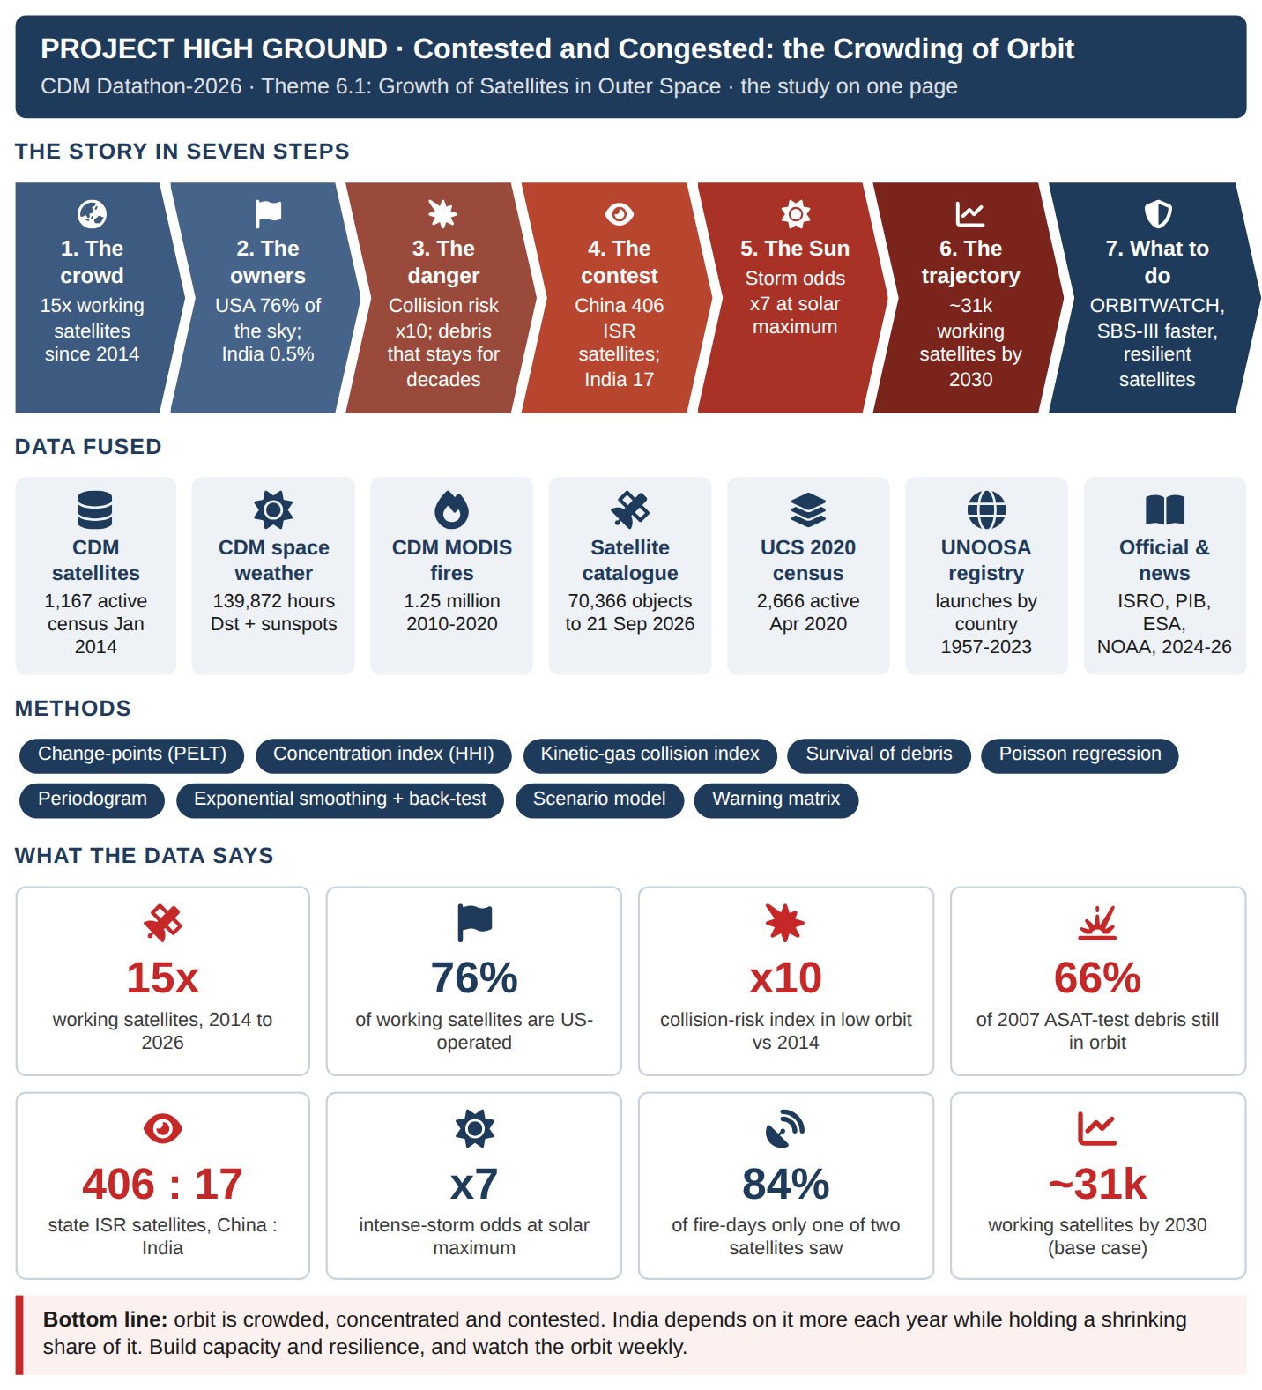

EXECUTIVE SUMMARY
BOTTOM LINE UP FRONT. Orbit has become crowded, concentrated and contested faster than any plan assumed. Working satellites rose from 1,167 to 17,062 in twelve years; collision risk in low orbit is about 10 times the 2014 level; and China now operates about 406 state and military imaging and intelligence satellites to India's 17. India's share of working satellites has fallen to 0.5%.

Situation
The CDM datasets give a census of 1,167 active satellites (Jan 2014), 140,000 hours of space-weather records and 1.25 million satellite fire detections. Open sources extend the picture to September 2026: the full public satellite catalogue (70,366 objects), the UCS 2020 census and UN launch registrations.

Assessment
1. Crowded. Payloads launched a year rose from 199 (2013) to 4,480 (2025). Growth changed gear around 2021.
2. Concentrated. The USA operates 76% of working satellites (43% in 2014); one company about 65%.
3. Risky. A live crowd of 9,964 objects sits at 450-500 km; a dead crowd of debris at 750-900 km. Debris from China's 2007 weapon test is still 66% in orbit; India's 2019 test debris has all re-entered.
4. Contested. China has launched about 43 state intelligence satellites a year since 2023; India under one. SBS-III's 52 satellites close only about 13% of today's gap.
5. Exposed to nature. At high solar activity the odds of an intense magnetic storm in a month rise from 6% to 39%.
6. Worth it. Two satellites saw 84% of fire-days that one alone would have missed: numbers buy coverage.

Deduction
India's security now depends on space, while its share of space shrinks and the environment grows more dangerous. Capacity, resilience and awareness of the space picture, not single prestige satellites, decide who keeps the high ground.

Recommendation
• Stand up ORBITWATCH under the Defence Space Agency: a weekly space-situation picture and warning matrix from open and national data.
• Accelerate SBS-III and buy commercial capacity to reach persistent coverage of the northern borders and the Indian Ocean.
• Make every new military satellite manoeuvrable and storm-hardened, and budget fuel for collision avoidance.

Decision sought
Approve a four-month ORBITWATCH proof of concept at the Defence Space Agency using the open catalogue and the pipeline already built. Continue only if it flags at least one actionable conjunction or threat event.

CONTENTS

1. The Question and How We Answered It
2. The Crowd
3. Who Owns Orbit
4. Where It Is Crowded
5. The Contest
6. The Natural Adversary
7. What Eyes in Orbit Buy
8. The Trajectory to 2030
9. Inference: What We Know and How Sure We Are
10. What It Means for the World, India and the Armed Forces
11. Way Forward
12. Conclusion
Annex A - Data Analytics in Plain Words
Annex B - Technical Summary for Assessors
Annex C - Software Used and Screenshots
Annex D - References and Data Sources
Each chapter opens with The story so far and closes with So what; every chart carries What this shows. A commander can read the Executive Summary and the coloured boxes alone in about ten minutes.

1. THE QUESTION AND HOW WE ANSWERED IT
PROLOGUE - THE QUESTION
THE STORY SO FAR
In May 2025, during Operation Sindoor, ten Indian satellites worked round the clock to see, talk and navigate for the forces. Space is no longer a support service; it is where modern operations begin. This booklet asks what has happened to that space in the last twelve years, and what India and its Armed Forces should do about it.

Theme 6.1 asks participants to derive insights into the proliferation of satellites and to predict the future trajectory. This study turns that into five questions a commander would ask: How crowded is orbit? Whose satellites are they? How dangerous has it become? Who is building military eyes in orbit? And what should India do?
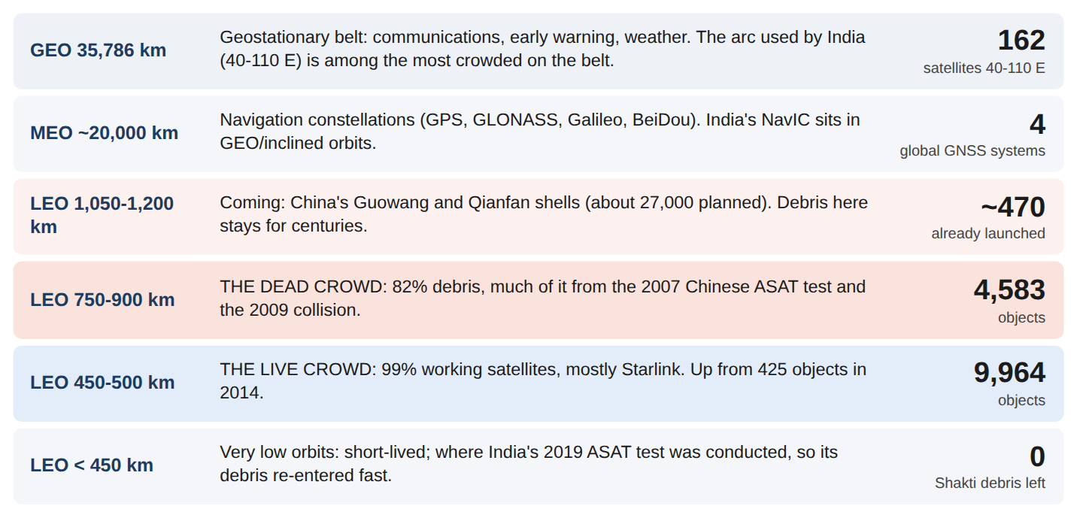
Figure 1.1 : Orbit at a glance: where the crowds are, from 300 km to 36,000 km (numbers from this study)
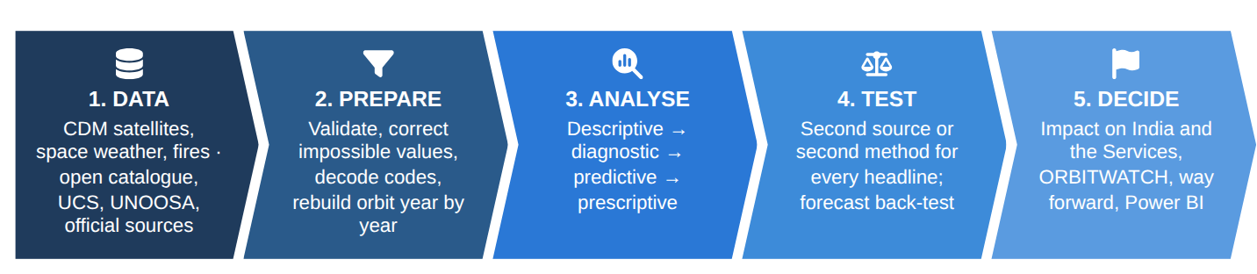
Figure 1.2 : How the question was answered
The three CDM datasets give a census of 1,167 active satellites (January 2014), 139,872 hours of space-weather records, and 1.25 million fire detections by two NASA satellites. Open sources bring the story to September 2026: the full public satellite catalogue (70,366 objects), the UCS 2020 census and UN launch registrations. The glossary at Annex A explains each technique in plain words.
SO WHAT
Five questions, three CDM datasets, four open sources and one repeatable pipeline.
Next: How crowded has orbit become?

2. THE CROWD
PART I - THE CROWD
THE STORY SO FAR
The story begins with numbers. In January 2014, the date of the CDM satellite census, about 1,200 satellites were working. What happened next?

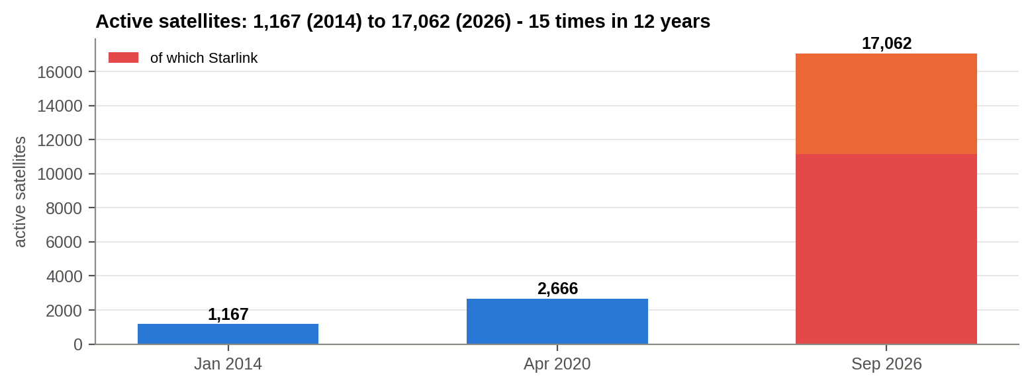
Figure 2.1 : Working satellites in three independent censuses: CDM (2014), UCS (2020), satellite catalogue (2026)
What this shows: Three independent counts of working satellites. Red is one company's constellation.

In January 2014 about 1,167 satellites were working. By April 2020 there were 2,666; by September 2026 17,062, a 15-fold rise in twelve years. About 65% of today's working satellites belong to a single constellation, Starlink.
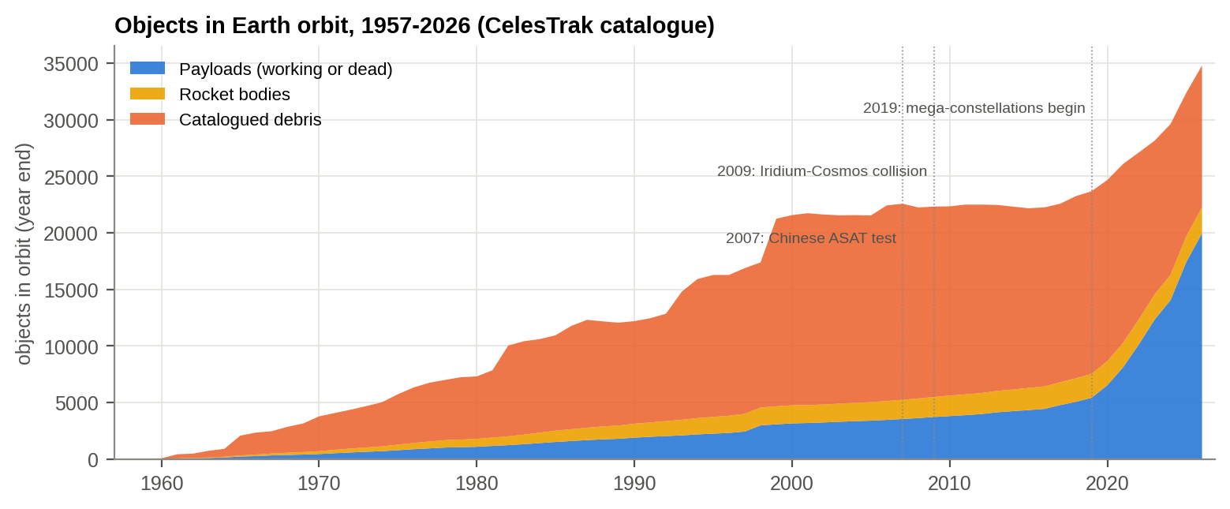
Figure 2.2 : Everything tracked in Earth orbit, 1957-2026: payloads, rocket bodies and debris
What this shows: Everything we track in orbit, year by year. Blue is satellites (working or dead), orange is debris. The blue wedge at the right is the mega-constellation era.

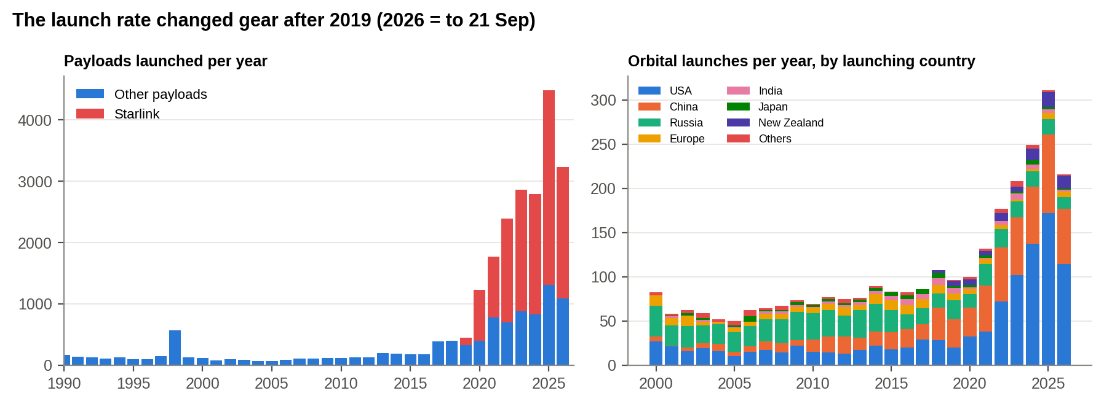
Figure 2.3 : Satellites launched and rocket launches per year
What this shows: Left: satellites launched each year (red = Starlink). Right: rocket launches each year by country.

The launch rate changed gear. In 2013, 199 satellites were launched; in 2025, 4,480. A change-point test places the break in 2021: growth of 4% a year before the mega-constellations, 47% a year after. Rocket launches rose from 76 (2013) to 311 (2025). UN registrations track the catalogue almost exactly (correlation 0.997), so the count is sound.
SO WHAT
Active satellites went from 1,167 to 17,062 in twelve years (15 times). Growth changed gear around 2021: 4% a year before, 47% after.
Next: Whose satellites are they?

3. WHO OWNS ORBIT
PART II - WHO OWNS ORBIT
THE STORY SO FAR
The sky filled 15 times over. The next question is whose satellites these are, and what they are for.

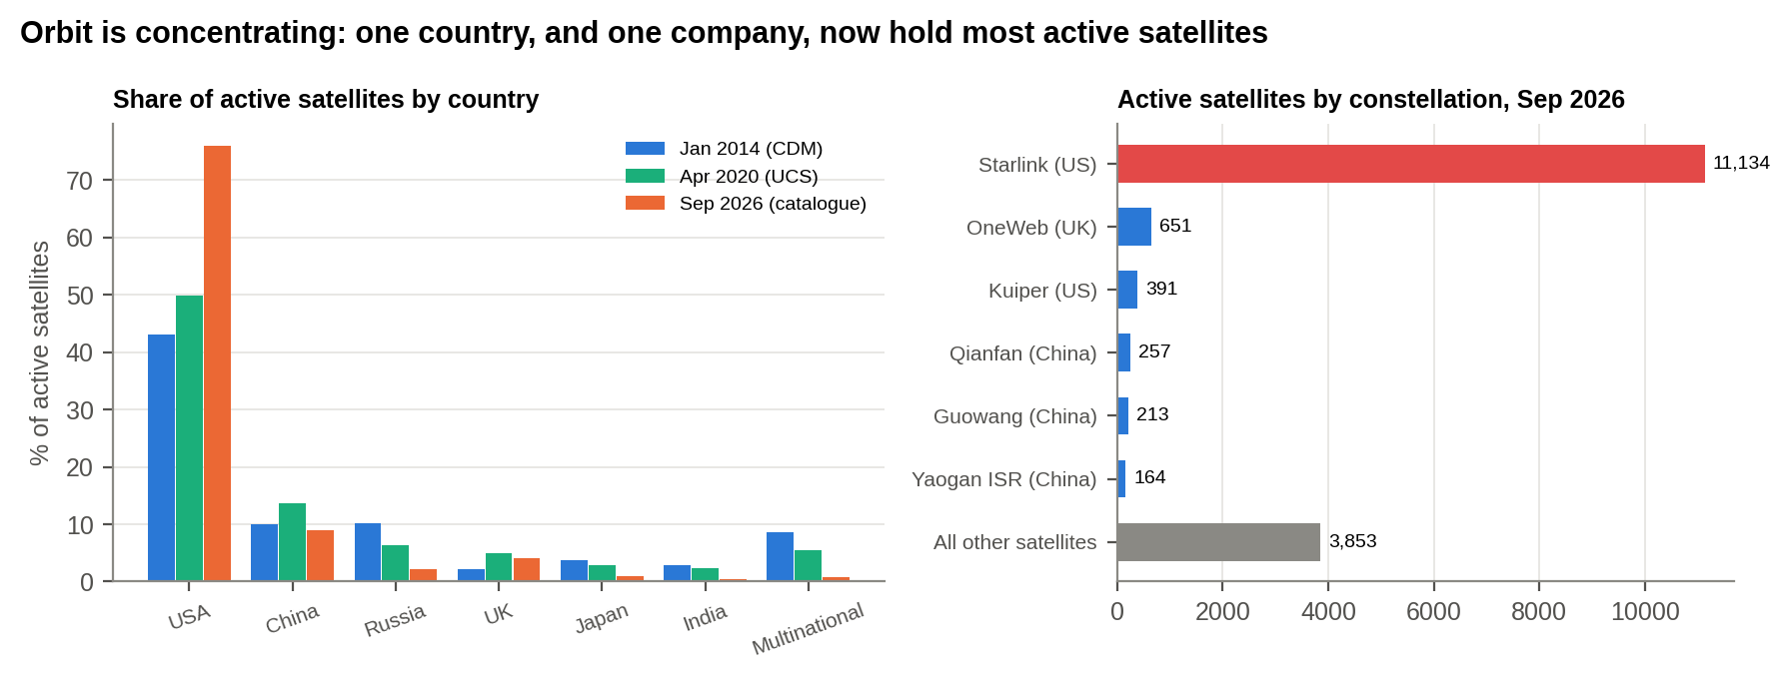
Figure 3.1 : Share of working satellites by country, and the largest constellations today
What this shows: Left: each country's share of working satellites in 2014, 2020 and 2026. Right: the largest constellations today.

In 2014 the USA operated 43% of working satellites; today 76%. The concentration index (HHI) rose from 2,171 to 5,879; anything above 2,500 counts as highly concentrated. China grew 13-fold in numbers (117 to 1,531) but held its share near 10%. India grew from 33 to 78 satellites, but its share fell from 2.8% to 0.5%.
Table 3.1 : Working satellites by country: 2014, 2020, 2026
Country | Jan 2014 (CDM) | Apr 2020 (UCS) | Sep 2026 (catalogue) | Jan 2014 (CDM) % | Sep 2026 (catalogue) %
USA | 502 | 1,327 | 12,959 | 43 | 76
China | 117 | 363 | 1,531 | 10 | 9
Russia | 118 | 169 | 380 | 10.10 | 2.20
UK | 25 | 130 | 698 | 2.10 | 4.10
Japan | 43 | 78 | 149 | 3.70 | 0.90
India | 33 | 61 | 78 | 2.80 | 0.50
Multinational | 100 | 146 | 141 | 8.60 | 0.80
All others | 229 | 392 | 1,124 | 19.60 | 6.60

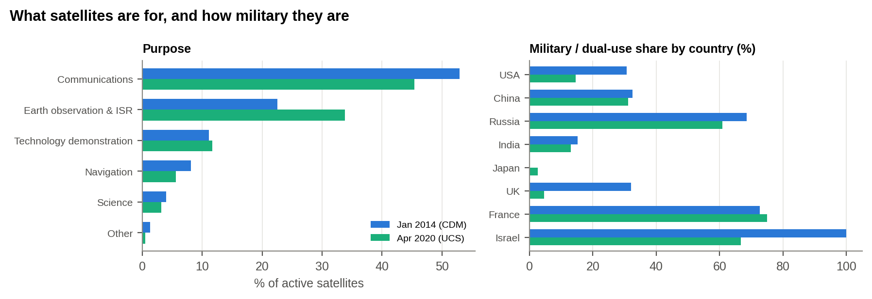
Figure 3.2 : What satellites are for, and how military each country's fleet is
What this shows: What satellites do, and what share of each country's fleet serves the military.

Commercial users rose from 36% of satellites (2014) to 54% (2020), while the military share fell from 28% to 18%. That is not demilitarisation: military satellites grew in number, and commercial constellations are now used in war (Ukraine has shown this). In 2014, 69% of Russian and 32% of Chinese satellites served the military, against 15% of India's. And 47% of the 2014 satellites were already past their design life: fleets must be renewed continuously just to stand still.
SO WHAT
One country operates 76% of working satellites and one company about 65%. India's share fell from 2.8% to 0.5%.
Next: Where is orbit crowded, and how risky is it?

4. WHERE IT IS CROWDED
PART III - WHERE IT IS CROWDED
THE STORY SO FAR
A few owners now hold most of the sky. But orbit is not one place: some altitudes are empty and some are packed. Where is the crowding, and how dangerous is it?

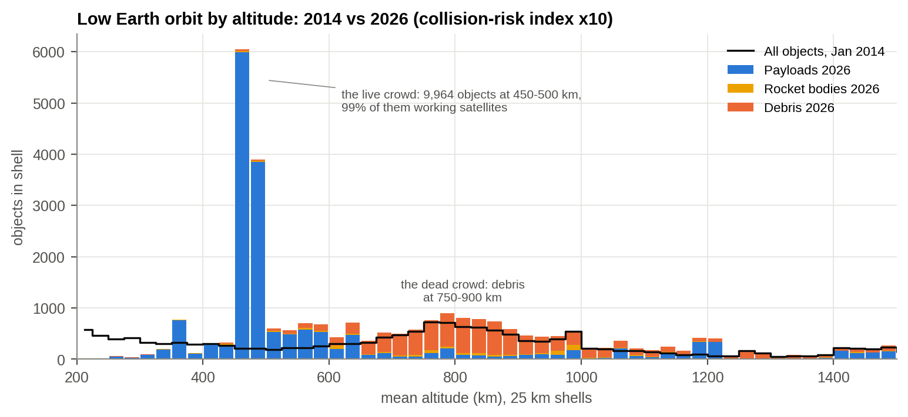
Figure 4.1 : Low Earth orbit by altitude, 2014 against 2026
What this shows: How many objects sit at each height in low orbit. The black line is 2014; bars are today. Tall blue bars are working satellites; orange is debris.

Orbit is crowded in two places. The live crowd: 9,964 objects at 450-500 km, 99% of them working satellites (there were 425 objects there in 2014). The dead crowd: 4,583 objects at 750-900 km, 82% of them debris. A kinetic-gas model, in which collisions grow with the square of the number of objects at each height, puts the collision-risk index at about 10 times the 2014 level.
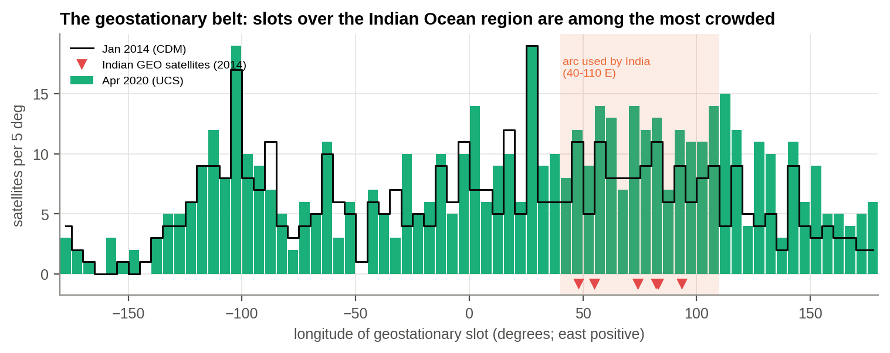
Figure 4.2 : The geostationary belt by longitude; the shaded arc is the one India uses
What this shows: Satellites parked above the equator, by longitude. The shaded band is the arc India uses; red markers are Indian satellites.

Higher up, the geostationary arc used by India (40-110 E) held 162 satellites in 2020, 29% of the whole belt, up from 115 in 2014. China (32) and the USA (33) each had more there than India (24). Slots and radio frequencies over India are a contested resource.
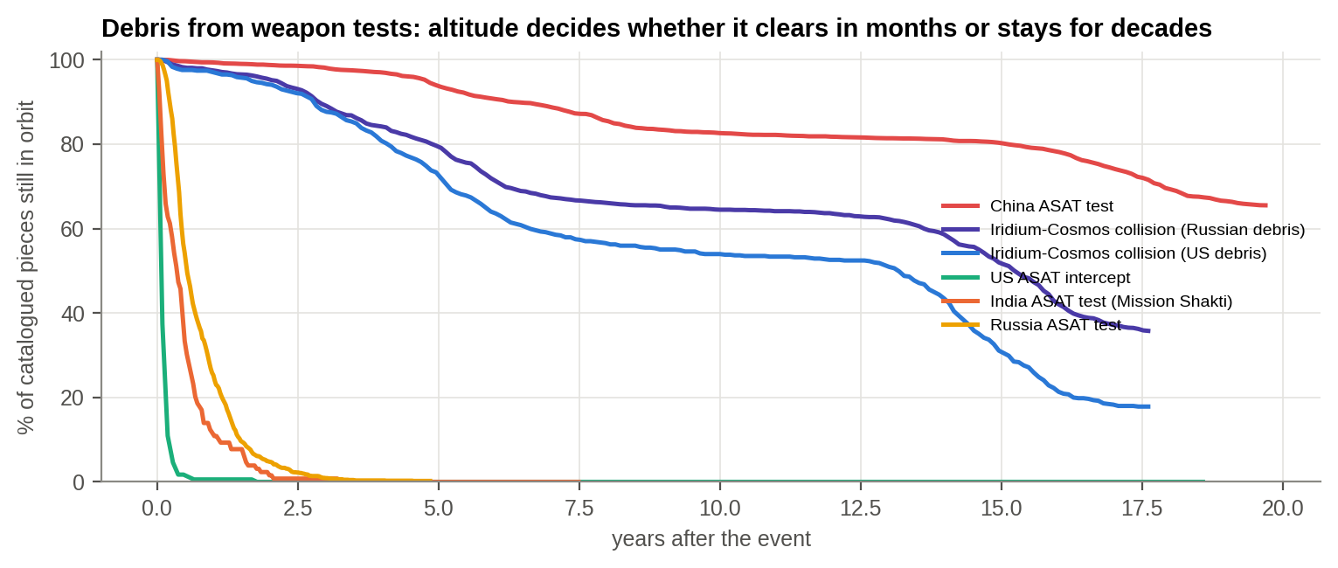
Figure 4.3 : Debris from weapon tests and the 2009 collision: share still in orbit, year by year
What this shows: Share of debris pieces from each weapon test or collision still in orbit, year by year afterwards.

Table 4.1 : Weapon tests and collisions: debris created and debris remaining
Event | Date | Pieces catalogued | Still in orbit (Sep 2026) | Still in orbit %
China ASAT test | Jan 2007 | 3,531 | 2,313 | 65.50
Iridium-Cosmos collision (Russian debris) | Feb 2009 | 1,714 | 613 | 35.80
Iridium-Cosmos collision (US debris) | Feb 2009 | 656 | 117 | 17.80
US ASAT intercept | Feb 2008 | 174 | 0 | 0
India ASAT test (Mission Shakti) | Mar 2019 | 129 | 0 | 0
Russia ASAT test | Nov 2021 | 1,806 | 4 | 0.20

Altitude decides the legacy. China's 2007 test at about 865 km made 3,531 tracked pieces; 66% are still in orbit nearly twenty years later. India's 2019 test (Mission Shakti) was done at about 280 km: all 129 pieces have re-entered, most within half a year. Russia's 2021 test (1,806 pieces) has almost cleared. A responsible test is a low one; a high one poisons an orbit for a generation.
SO WHAT
Collision risk in low orbit is about 10 times the 2014 level. Weapon tests at high altitude leave debris for decades; India's low-altitude test cleaned itself up within a year.
Next: Who is building military eyes in orbit?

5. THE CONTEST
PART IV - THE CONTEST
THE STORY SO FAR
A crowded orbit is a hazard. A crowded orbit full of military eyes is a contest. Who is building the watchers?

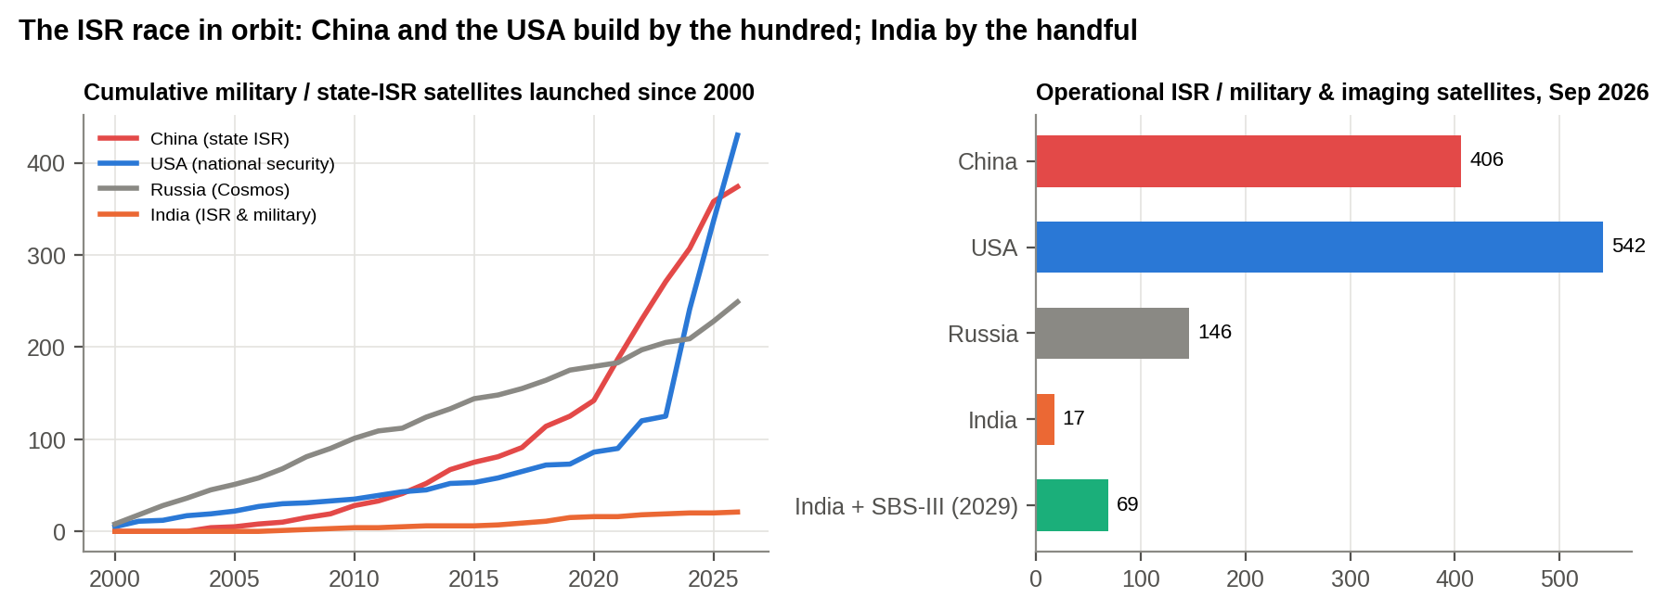
Figure 5.1 : Military and state intelligence satellites: launched since 2000, and working today
What this shows: Left: military and state intelligence satellites launched since 2000. Right: how many are working today.

Grouping satellites by their official programme names gives a transparent lower bound. China operates about 406 state and military imaging, intelligence and technology satellites (164 of them Yaogan military reconnaissance), and has launched about 43 a year since 2023. The USA has added 305 national-security payloads since 2024. India operates about 17 and launches fewer than one a year. The ratio is about 24 to 1.
Table 5.1 : Military and state-ISR programme families (name-based lower bound)
Country | Programme family | Operational Sep 2026 | Launched since 2014
China | China: Yaogan military reconnaissance | 164 | 149
China | China: other state ISR & tech (Gaofen, TJS, Shiyan, Shijian, Tianhui, Yunhai) | 183 | 173
China | China: commercial imagers (Jilin-1, Superview) | 59 | 94
USA | USA: national-security payloads (USA-nnn) | 417 | 385
USA | USA: commercial imagers (Planet, Maxar, BlackSky, Capella) | 125 | 581
Russia | Russia: military (Cosmos) | 146 | 125
India | India: ISR & military (RISAT, Cartosat, EOS, EMISAT, GSAT-7) | 17 | 15

India's answer is SBS-III: 52 surveillance satellites approved in 2023 (Rs 26,968 crore), 21 built by ISRO and 31 by industry, due by 2029. Against today's gap, SBS-III closes only about 13%. During Operation Sindoor (May 2025) ten Indian satellites supported the forces round the clock: the need is proven, the capacity is thin.
SO WHAT
China operates about 406 state and military imaging and intelligence satellites; India about 17. The gap is not closing on its own.
Next: What threat does nature add?

6. THE NATURAL ADVERSARY
PART V - THE NATURAL ADVERSARY
THE STORY SO FAR
Rivals are not the only threat. The Sun sets the weather in space, and it does not negotiate.

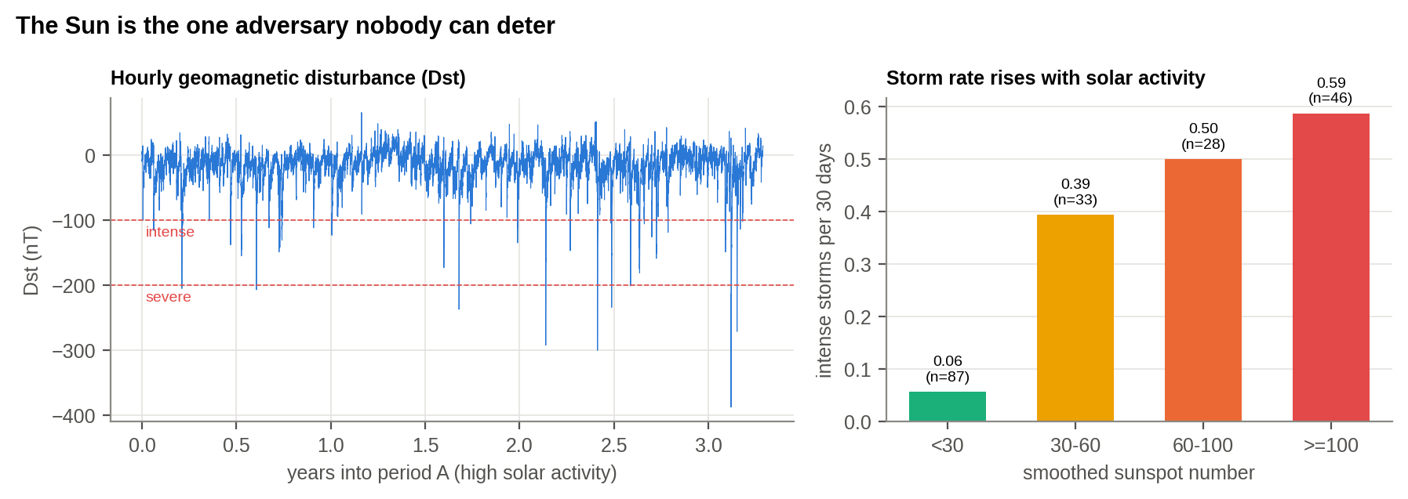
Figure 6.1 : Geomagnetic storms and solar activity (CDM space-weather data)
What this shows: Left: an hourly record of magnetic storms (dips below the red lines are dangerous). Right: storms per month at different levels of solar activity.

The CDM records hold 557 storms, 59 of them intense and 13 severe (lowest Dst -387 nT). When the Sun is active (sunspot number 100 or more), the chance of an intense storm in any 30 days is 39%, against 6% when it is quiet: about 7 times. A Poisson model gives 1.88 times the storm rate for every 50 more sunspots (p < 0.001).
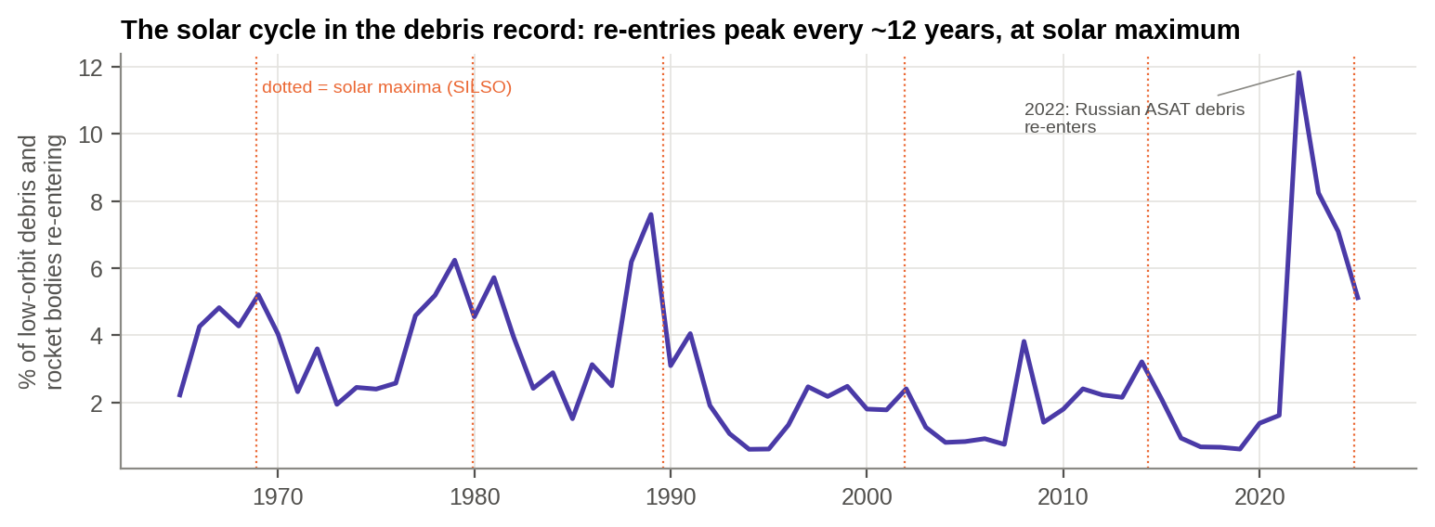
Figure 6.2 : The solar cycle in the debris record: share of low-orbit debris re-entering each year
What this shows: The share of debris falling back to Earth each year. The peaks line up with the Sun's 11-year maximum.

A heated upper atmosphere drags satellites down. A periodogram of re-entry rates finds a 12-year cycle without being told to look for one: the Sun's cycle. At solar maximum 3.9% of low-orbit debris re-enters each year, against 2.3% at minimum. The same drag killed 38 new Starlink satellites in a moderate storm in February 2022, and the May 2024 'Gannon' superstorm (Dst -412 nT) forced mass orbit corrections. Solar cycle 25 peaked in October 2024 and storms remain frequent through 2026.
SO WHAT
At high solar activity the odds of an intense geomagnetic storm in any month rise about 7-fold. The solar cycle even shows in how fast debris falls.
Next: Why take these risks at all?

7. WHAT EYES IN ORBIT BUY
PART VI - WHAT EYES IN ORBIT BUY
THE STORY SO FAR
So far the story has been about risk. Why do nations accept that risk? Because of what satellites see. The CDM fire data show it on the ground.

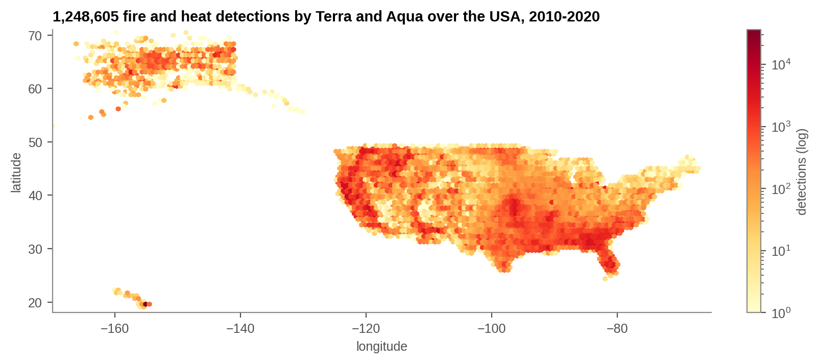
Figure 7.1 : Fire and heat detections by NASA's Terra and Aqua satellites over the USA, 2010-2020 (CDM data)
What this shows: Every fire and heat source the two satellites detected over ten years.

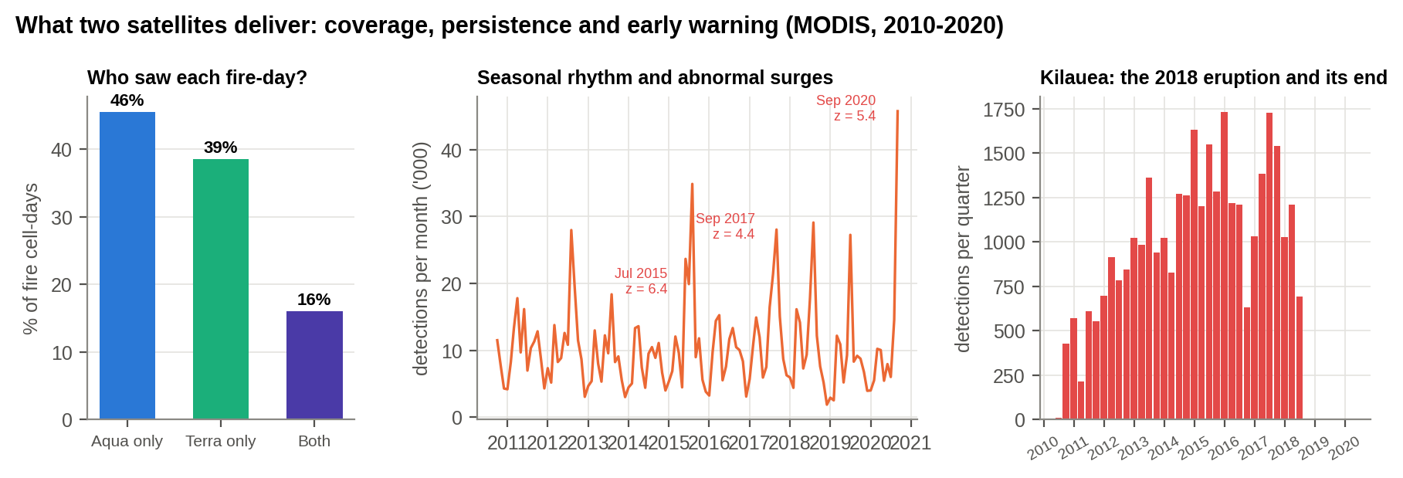
Figure 7.2 : Coverage, persistence and early warning from two satellites
What this shows: Left: which satellite saw each fire-day. Centre: monthly fire detections, with abnormal surges flagged. Right: a volcano watched through its eruption.

Terra passes in the morning and Aqua in the afternoon. Put every detection on a 10-km grid, one cell per day: 84% of fire-days were seen by only one of the two (46% Aqua only, 38% Terra only). A single satellite would have missed nearly half of what the pair saw. Thermal sensors also see at night (21% of detections). They pick out 659 persistent industrial heat sources, such as steel mills and smelters, and they followed Kilauea's 2018 eruption to its end.
A seasonal baseline flags abnormal months, the logic of any warning system: 11 surges stand out, the largest in Jul 2015 (z = 6.4). For the Services the lesson is direct: persistence comes from numbers. Revisit, not resolution alone, decides whether a mobilisation, a launcher or a convoy is caught in time.
SO WHAT
Two satellites together saw fires that either one alone would have missed 84% of the time. Numbers in orbit buy coverage, persistence and early warning.
Next: What will orbit look like by 2030?

8. THE TRAJECTORY TO 2030
PART VII - THE TRAJECTORY
THE STORY SO FAR
The past is measured. What comes next?

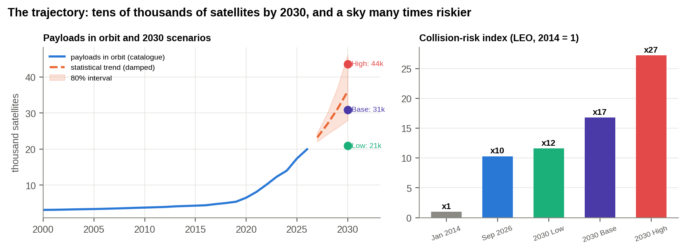
Figure 8.1 : Satellites in orbit to 2030: statistical trend, scenarios and the collision-risk index
What this shows: Left: satellites in orbit and three scenarios for 2030. Right: how collision risk grows under each.

Table 8.1 : Working satellites in 2030 under three deployment scenarios (assumptions stated)
Scenario | Starlink (US) | Kuiper (US) | Guowang (China) | Qianfan (China) | All other satellites | Total 2030
Low | 12,000 | 1,600 | 800 | 800 | 5,701 | 20,901
Base | 15,000 | 3,236 | 3,000 | 3,000 | 6,639 | 30,875
High | 19,400 | 3,236 | 6,500 | 6,500 | 7,970 | 43,606

Two independent routes agree. A damped-trend forecast of satellites in orbit reaches about 36,000 in 2030 (80% range 28,000-46,100); it missed 2022-2026 by only 8.6% when tested on held-back years. A bottom-up build from the announced constellations gives 20,901 / 30,875 / 43,606 working satellites (low / base / high). The collision-risk index rises to about 17 times the 2014 level in the base case and 27 times in the high case. China's shells at 1,050-1,200 km are the concern: debris there stays for centuries.
SO WHAT
About 31,000 working satellites by 2030 in the base case, and a collision-risk index about 17 times the 2014 level.
Next: How sure are we?

9. INFERENCE: WHAT WE KNOW AND HOW SURE WE ARE
PART VIII - HOW SURE WE ARE
THE STORY SO FAR
The findings are strong claims. Before a commander acts on them, a staff officer asks: are we sure?

Table 9.1 : Every headline finding checked by an independent route
Finding | Result | Independent check | Verdict
Growth of orbit | 15x active satellites 2014-2026 | UNOOSA registrations track catalogue launches (r = 0.997); UCS 2020 census sits on the same curve | Confirmed
Collision risk | index x10 since 2014 | Same result with 25 km shells and with objects' mean altitude; the densest shell holds mostly working satellites, the second band mostly debris | Confirmed (relative index)
ISR race | China 406 vs India 17 state ISR/military satellites | Name-based lower bound; excluding commercial imagers the ratio stays above 20:1 | Confirmed (lower bound)
Space weather | intense-storm odds x7 at high solar activity | Poisson rate ratio 1.88 per +50 sunspots (p < 0.001); Spearman rho -0.57 | Confirmed
Solar cycle in debris decay | re-entry cycle of 12 years | Found blind by periodogram; matches the ~11-year solar cycle (SILSO maxima) | Confirmed
Forecast to 2030 | ~36k payloads (statistical) vs 31k working (base scenario) | Back-test error 8.6% over 2022-2026; two independent routes agree | Moderate confidence

Table 9.2 : Key judgements (intelligence estimative language)
How likely | Judgement | Confidence
Almost certain | More than 20,000 satellites will be working by 2030 (even the low scenario). | High
Highly likely | Collision risk in low orbit keeps rising: index 12-27 times 2014 by 2030. | Moderate
Highly likely | China's lead in state ISR satellites over India persists through 2029, even with SBS-III. | High
Likely | At least one intense geomagnetic storm per quarter while sunspots stay above 100 (77%). | Moderate
Realistic possibility | Another debris-creating event (collision, break-up or weapon test) in a crowded shell by 2030. | Moderate
Almost certain | More satellites buy coverage: one satellite misses much of what a constellation sees. | High

The judgements use the estimative language of intelligence assessments. Confidence reflects the data: counts from the catalogue are high-confidence; the 2030 scenarios depend on company and state deployment plans and are moderate.
SO WHAT
Every headline finding survives an independent check.
Next: What does it mean for India and its Armed Forces?

10. WHAT IT MEANS FOR THE WORLD, INDIA AND THE ARMED FORCES
PART IX - WHAT IT MEANS
THE STORY SO FAR
The evidence holds. What does it mean for the world, for India, and for the Army, Navy and Air Force?

For the world: orbit is becoming a commons run by a few operators. A single company's decisions now shape the collision risk for everyone, and commercial constellations have become military assets in war. Norms on debris and weapon tests lag far behind the traffic.
Table 10.1 : India against China and the USA
Measure | India | China | USA
Active satellites, Sep 2026 | 78 | 1,531 | 12,959
Active satellites, Jan 2014 (CDM) | 33 | 117 | 502
Military / state-ISR satellites operational | 17 | 406 | 542
Orbital launches in 2025 | 4 | 89 | 172
GEO satellites in the 40-110 E arc (2020) | 24 | 32 | -

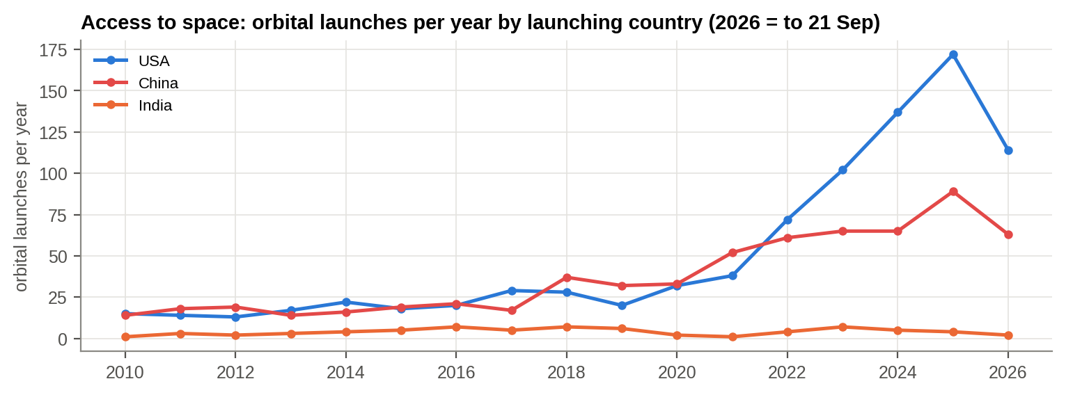
Figure 10.1 : Access to space: rocket launches per year from US, Chinese and Indian soil
What this shows: Rocket launches per year from US, Chinese and Indian soil.

For India: national dependence on space grows (banking, navigation, communications, disaster warning), while India's share of working satellites has fallen to 0.5% and it launched 4 rockets in 2025 against China's 89. Over 2021-25 China averaged about 16 times India's launch rate. Access to space is the bottleneck.
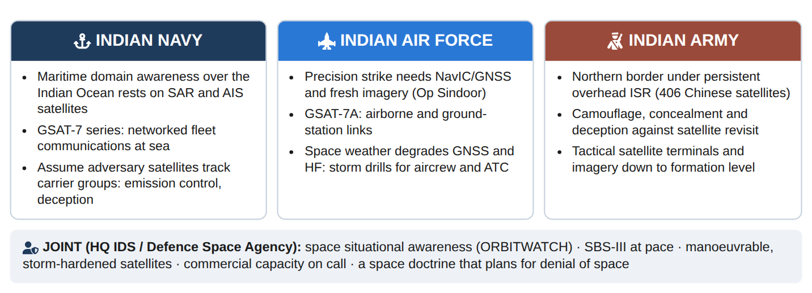
Figure 10.2 : Impact on the Indian Navy, Air Force and Army, and the joint response
For the Armed Forces: the adversary can now watch continuously; our own satellites face collisions, storms and counterspace threats; and operations increasingly assume space support that may be denied. Plans must assume being watched and losing some space services.
SO WHAT
India depends on space more every year while holding a shrinking share of it. That is the strategic problem.
Next: What should India do?

11. WAY FORWARD
PART X - WHAT WE SHOULD DO
THE STORY SO FAR
The implications are clear. The last question is the one a commander always asks: what do we do, who does it, and by when?

Table 11.1 : Seven staffed actions, traced to the evidence
Action | Lead | Timeline | Measure of effectiveness
Stand up ORBITWATCH: weekly space-situation picture and the 7-indicator warning matrix from open, ISRO NETRA and commercial data | DSA with ISRO (NETRA) | 4 months | An actionable conjunction or threat warning acted upon
Accelerate SBS-III and buy commercial imagery and radar capacity for persistent revisit of the northern borders and IOR | DSA, NSIL, IN-SPACe, industry | 2026-2029 | Revisit time over priority areas
Resilience by design: manoeuvre capability, collision-avoidance fuel and storm hardening for every new military satellite | DSA, ISRO, DRDO | Contracts from 2027 | Share of fleet able to manoeuvre
Space-weather cell: storm warnings to all Services; drills for degraded GNSS and HF communications | HQ IDS, IAF Met, ISRO | 6 months | Drill conducted each quarter
Rapid reconstitution: SSLV launch slots and spare satellites on standby | ISRO, NSIL, DSA | 2-3 years | Days to replace a lost satellite
Protect GEO slots and ITU filings in the 40-110 E arc; interference monitoring | DoT, ISRO, DSA | Ongoing | Filings secured; interference cases resolved
Concealment and deception doctrine against persistent satellite ISR for field formations | Army, HQ IDS | 12 months | Exercised in field formations

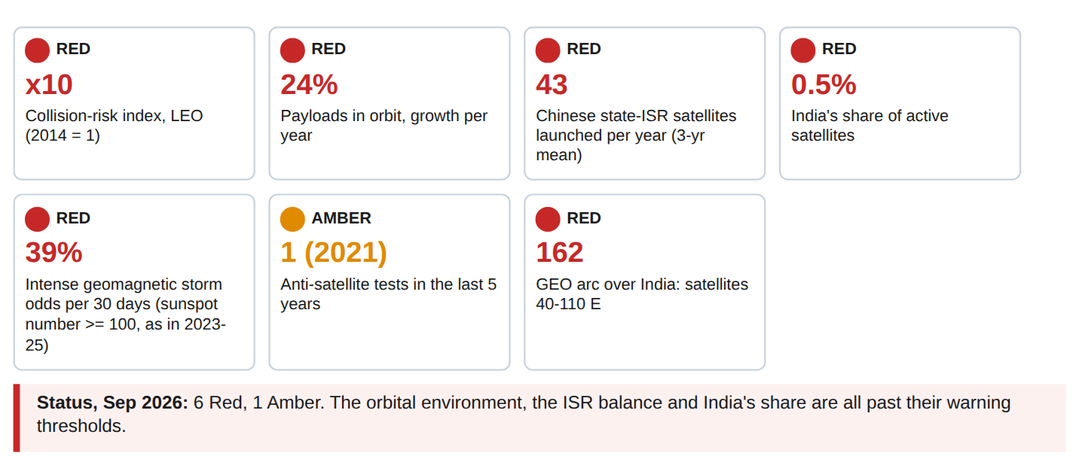
Figure 11.1 : ORBITWATCH: the seven-indicator warning matrix at September 2026
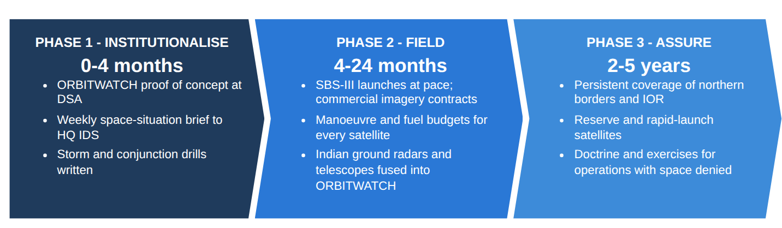
Figure 11.2 : Three-phase plan
SO WHAT
Seven actions, each with a lead, a timeline and a test of success.

12. CONCLUSION
EPILOGUE
THE STORY SO FAR
We end where we began, with the commander's questions, now answered with evidence.

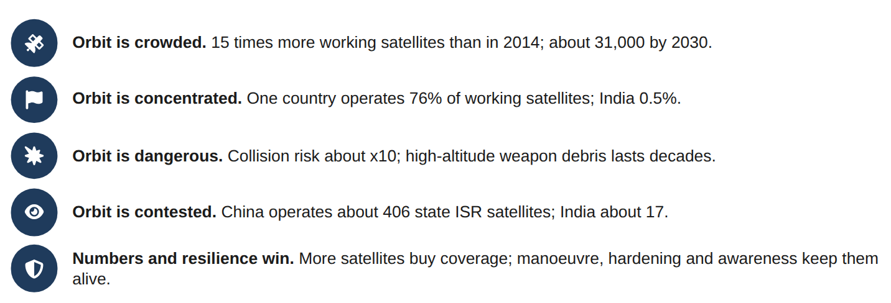
Figure 12.1 : Five takeaways
The high ground has become a crowd. In twelve years orbit went from about a thousand working satellites to seventeen thousand, owned mostly by one country and one company, circling in shells where collision risk has multiplied and where weapon debris can linger for decades. China is filling it with eyes; the Sun periodically lashes it. India, which depends on space more every year, holds a shrinking share of it. The remedy is not a single prestige satellite but numbers, resilience and awareness: SBS-III at pace, satellites that can manoeuvre and survive, and a standing ORBITWATCH so that India always knows what is overhead.

ANNEX A - DATA ANALYTICS IN PLAIN WORDS
Table A.1 : Glossary of techniques and terms
Term | What it means, in plain words
Satellite catalogue (SATCAT) | The public list of every tracked object in Earth orbit: satellites, rocket bodies and debris, with launch and re-entry dates and orbit heights.
LEO / MEO / GEO | Low Earth orbit (below 2,000 km, most satellites), medium orbit (navigation satellites) and geostationary orbit (36,000 km above the equator, where a satellite appears fixed in the sky).
Mega-constellation | Thousands of small satellites flying together to give continuous global coverage, such as Starlink.
Debris | Broken pieces of satellites and rockets: from explosions, collisions and weapon tests. At 7-8 km/s a 1 cm piece hits like a hand grenade.
ASAT test | Anti-satellite weapon test: a missile destroys a satellite in orbit, creating a cloud of debris.
Collision-risk index | A relative measure of how likely collisions are: it grows with the square of the number of objects at each height. 2014 = 1.
HHI (concentration index) | Sum of squared market shares, 0-10,000. Above 2,500 means a few players dominate.
Change-point detection | A method that finds the date when a trend shifted, without being told where to look.
Dst index | A measure of how much a magnetic storm disturbs the Earth's field. Below -100 nT is an intense storm.
Sunspot number | A count of dark spots on the Sun; high counts mean an active Sun and more storms.
Periodogram | A tool that finds repeating cycles in a time series, like finding the beat in music.
Poisson regression | A model for counts (e.g. storms per month) that measures how a factor raises the rate.
Constellation premium | What extra satellites add: the share of events that one satellite alone would have missed.
Exponential smoothing (Holt) | A forecasting method that follows the recent trend and lets it flatten over time.
Back-test | Hiding the last few years, forecasting them, and checking the error: a test of the forecast method.
ISR | Intelligence, surveillance and reconnaissance: satellites that image, listen and watch.
ORBITWATCH | The seven-indicator warning matrix proposed in this study, updated from open data.
SBS-III | India's Space-Based Surveillance phase III: 52 military surveillance satellites approved in 2023, due by 2029.

ANNEX B - TECHNICAL SUMMARY FOR ASSESSORS
Every technique used, the question it answers and the key result. All results are regenerated from the raw data by one command (analysis/run_all.py), and two consecutive runs give identical outputs.
Table B.1 : Techniques, questions and results
Technique | Commander's question | Key result | Chapter
Validation and cleaning: Excel-date conversion, impossible periods/inclinations removed, code look-ups, duplicate removal | Is the evidence sound? | 6 impossible periods and 1 impossible inclination corrected; 1 duplicate fire removed | Ch 1
Year-end population rebuilt from launch and re-entry dates; three independent censuses | How crowded is orbit? | 1,167 to 17,062 working satellites | Ch 2
Change-point detection (PELT); compound growth rates; cross-check with UNOOSA | When did growth change gear? | Break 2021; 4.1% to 46.7% a year; r = 0.997 | Ch 2
Herfindahl-Hirschman concentration index | Is control of orbit spreading or concentrating? | HHI 2,171 to 5,879 | Ch 3
Altitude-shell spatial density; kinetic-gas collision-risk index (sum n^2 / V) | How dangerous has orbit become? | Index x10.3 | Ch 4
Survival curves of debris by event | How long does weapon debris last? | FY-1C 65.5% remaining; Shakti 0% | Ch 4
Name-based programme families (transparent lower bound) | Who is building military eyes? | China 406 vs India 17 | Ch 5
Storm event detection (Dst thresholds); Poisson regression; Spearman correlation | Does solar activity raise storm risk? | Rate ratio 1.88 per +50 sunspots; odds x6.8 | Ch 6
Periodogram of de-trended re-entry rate | Does the solar cycle show in debris decay? | 12.2-year cycle | Ch 6
Grid-day matching of detections (0.1 deg); seasonal baseline z-scores | What does a constellation add? | 84% of fire-days seen by one satellite only | Ch 7
Holt damped-trend smoothing with 2,000 simulations and back-test; bottom-up scenarios | What comes by 2030? | 36,000 (trend); 30,875 (base); back-test 8.6% | Ch 8
Indicators and warnings matrix (ORBITWATCH) | What should be watched? | 6 Red, 1 Amber | Ch 11

Table B.2 : Data cleaning log
Dataset | Step | Count
CDM satellites | Rows loaded | 1,167
CDM satellites | Launch dates converted from Excel serial numbers (1 missing) | 1
CDM satellites | Impossible orbital periods (< 80 min) set to missing | 6
CDM satellites | Impossible inclinations (> 180 deg) set to missing | 1
CDM satellites | Rows after cleaning | 1,167
UCS 2020 | Active satellites | 2,666
SATCAT | Objects catalogued (1957 - Sep 2026) | 70,793
SATCAT | Earth-orbiting objects kept | 70,366
SATCAT | Objects without orbital elements (kept; excluded from altitude work) | 1,657
Space weather | Hourly Dst values (3 periods) | 139,872
Space weather | Monthly smoothed sunspot values | 192
MODIS fires | Detections loaded (archive + near real time) | 1,248,606
MODIS fires | Duplicate detections removed | 1
MODIS fires | Rows after cleaning | 1,248,605

ANNEX C - SOFTWARE USED AND SCREENSHOTS
Stack: Python 3.11 (pandas, NumPy, SciPy, statsmodels, ruptures, Matplotlib) for analysis; headless Chromium for the booklet; Microsoft Power BI Desktop for the dashboard (.pbix) built on the exported tables (FactCatalogue, FactSatellites2014, FactStormDaily, FactFiresMonthly, DimDate and the analysis tables).
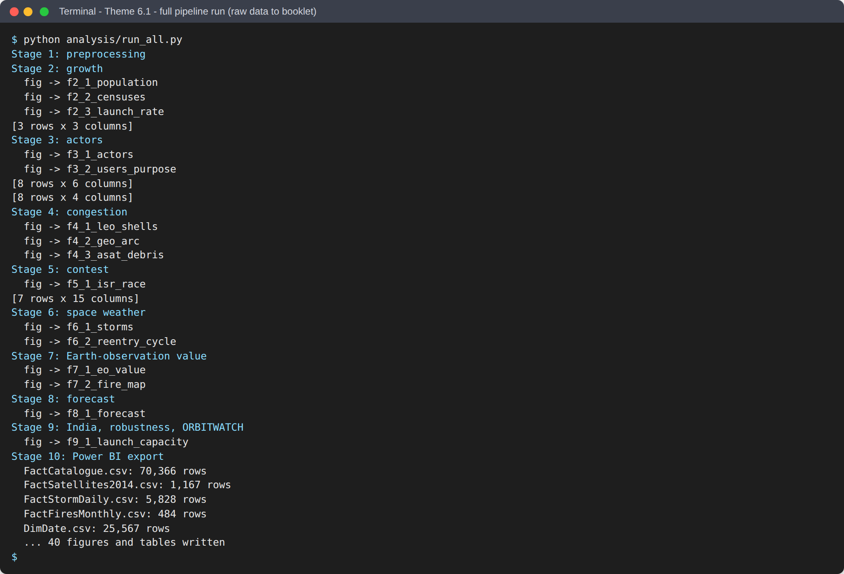
Figure C.1 : Screenshot: the complete pipeline run, raw data to every chart and table
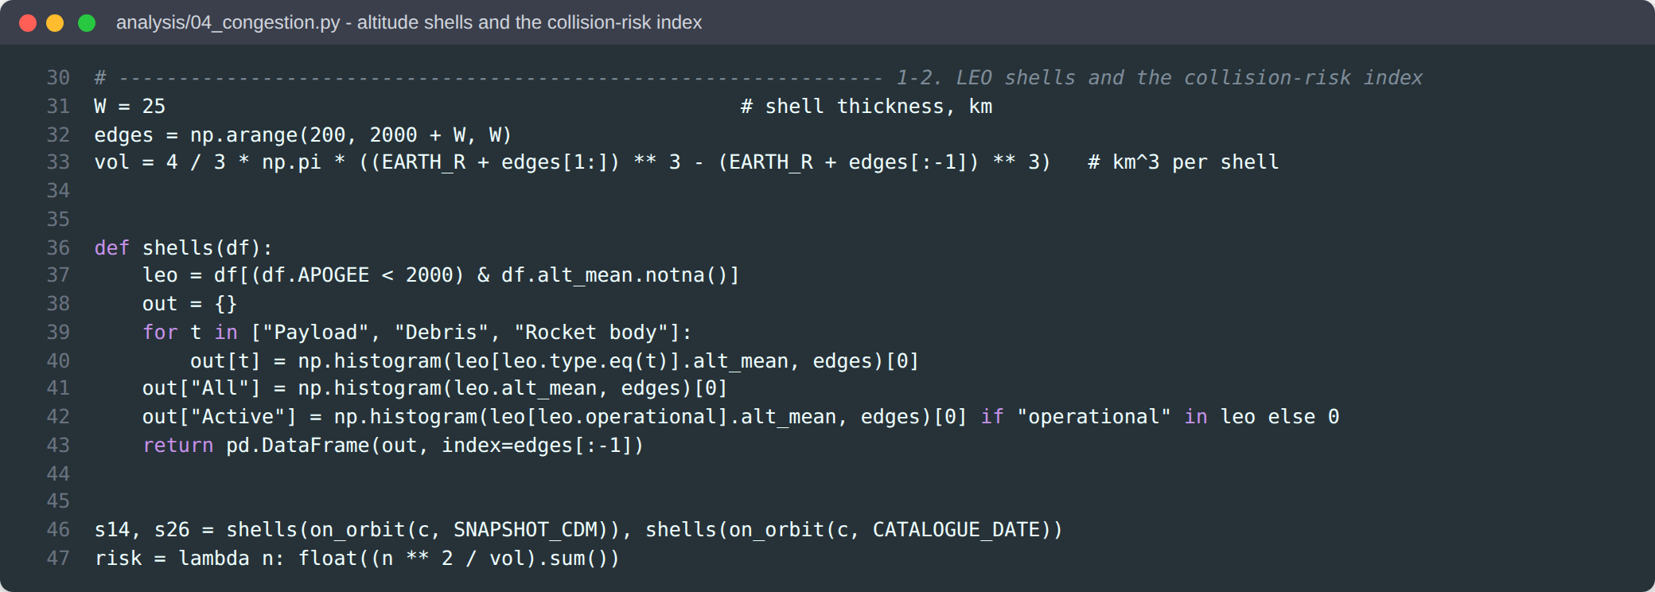
Figure C.2 : Screenshot: code excerpt, altitude shells and the collision-risk index
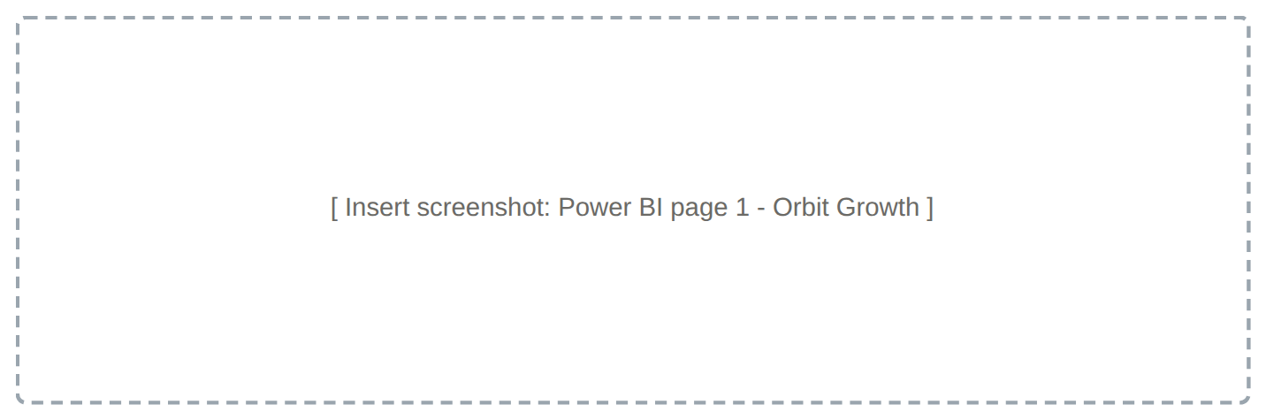
Figure C.3 : Screenshot: Power BI dashboard, page 1 - Orbit Growth (working satellites, launches and population by year)
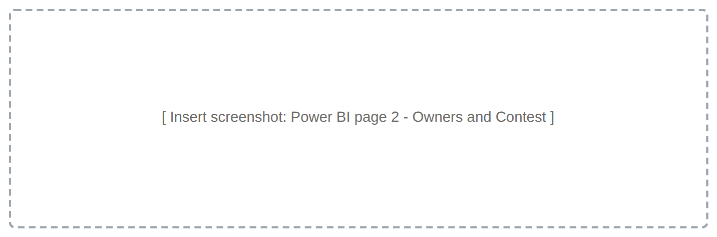
Figure C.4 : Screenshot: Power BI dashboard, page 2 - Owners and Contest (country shares and ISR families)
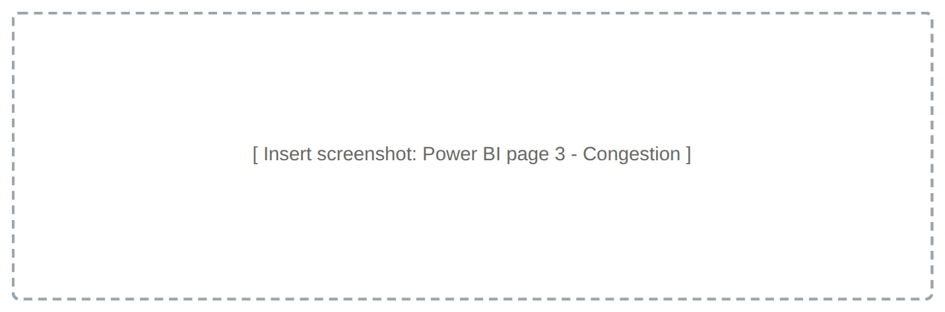
Figure C.5 : Screenshot: Power BI dashboard, page 3 - Congestion (altitude shells, GEO arc and debris events)
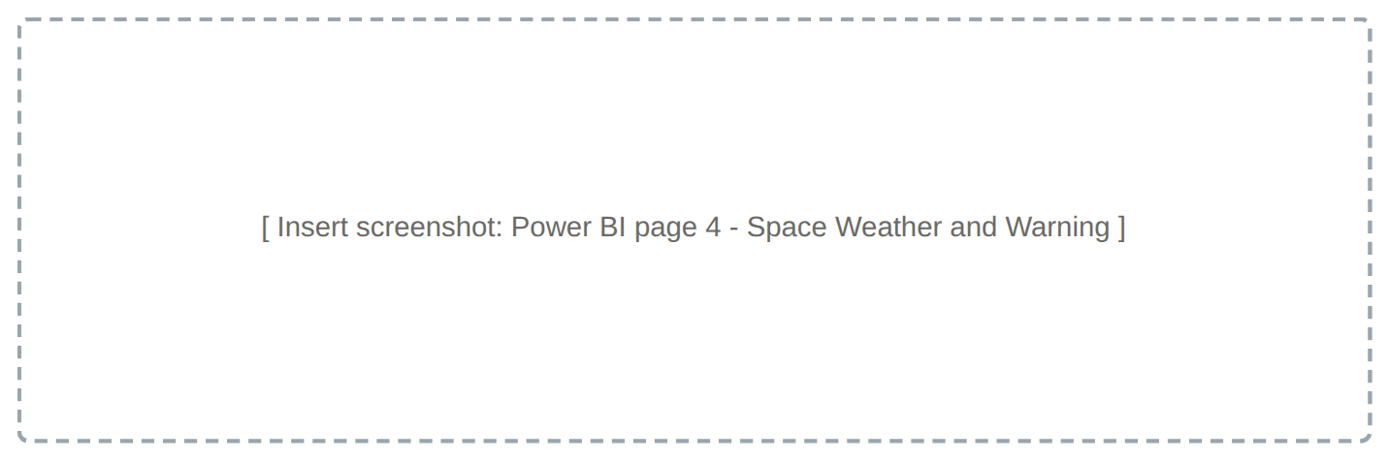
Figure C.6 : Screenshot: Power BI dashboard, page 4 - Space Weather and Warning (storms, re-entries and ORBITWATCH)

ANNEX D - REFERENCES AND DATA SOURCES
1. College of Defence Management (2026). Datathon-2026 General Instructions and Theme 6.1 datasets (satellite census; Dst and sunspot records; MODIS fire detections).
2. CelesTrak Satellite Catalogue (SATCAT), T.S. Kelso; public mirror github.com/astrion-tech/celestrak-mirror, accessed 24 Sep 2026.
3. Union of Concerned Scientists (2020). UCS Satellite Database, 1 April 2020 edition (via github.com/nfrontero20/satellites).
4. UNOOSA Online Index of Objects Launched into Outer Space, via Our World in Data (TidyTuesday, 23 Apr 2024).
5. ESA Space Debris Office (2025). ESA's Annual Space Environment Report 2025.
6. Kessler, D.J., Cour-Palais, B.G. (1978). Collision frequency of artificial satellites: the creation of a debris belt. JGR 83(A6), 2637-2646.
7. Gonzalez, W.D. et al. (1994). What is a geomagnetic storm? JGR 99(A4), 5771-5792.
8. SILSO, Royal Observatory of Belgium: international sunspot number; NASA/NOAA joint solar maximum announcement, 15 Oct 2024.
9. Hapgood, M. et al. (2022). Unexpected space weather causing the reentry of 38 Starlink satellites in February 2022. J. Space Weather Space Clim.
10. Giglio, L., Schroeder, W., Justice, C.O. (2016). The Collection 6 MODIS active fire detection algorithm and fire products. Remote Sensing of Environment 178, 31-41.
11. Killick, R., Fearnhead, P., Eckley, I.A. (2012). Optimal detection of changepoints with a linear computational cost. JASA 107, 1590-1598.
12. Hyndman, R.J., Athanasopoulos, G. (2021). Forecasting: Principles and Practice, 3rd ed. (damped trend methods).
13. U.S. Department of Justice and FTC (2023). Merger Guidelines (HHI concentration thresholds).
14. Open-source reporting: All India Radio News (ISRO Chairman on Operation Sindoor, 9 Sep 2025); Outlook Business (SBS-III, 52 satellites, Rs 26,968 crore); KeepTrack (Starlink count, Sep 2026); OrbitalRadar (Guowang and Qianfan, 2026); NOAA SWPC (solar cycle 25).
15. Jayadev, A. (2021). Predictive Maintenance in Armed Forces: A Machine Learning Based Decision Support System. M.Tech report, IIT Kharagpur.

