COLLEGE OF DEFENCE MANAGEMENT · DATATHON - 2026
Theme: Global Conflicts – Impact on Supply Chains
PROJECT DARKWATER
Global Conflicts and the Blinding of Supply Chains: Maritime Picture Assurance at Contested Chokepoints, with Implications for India and the Indian Armed Forces
Commander's Edition
What the 2026 war did to the ships that carry India's oil and trade, what it cost, how long such crises last, and what India and its Armed Forces should do. Told as one story, in plain words.
Submitted by
[Rank] ARJUN JAYADEV
[Service No] · [Unit / Formation]
September 2026
Companion documents: full technical report, Power BI dashboard (.pbix), analysis code and data

THE STUDY AT A GLANCE
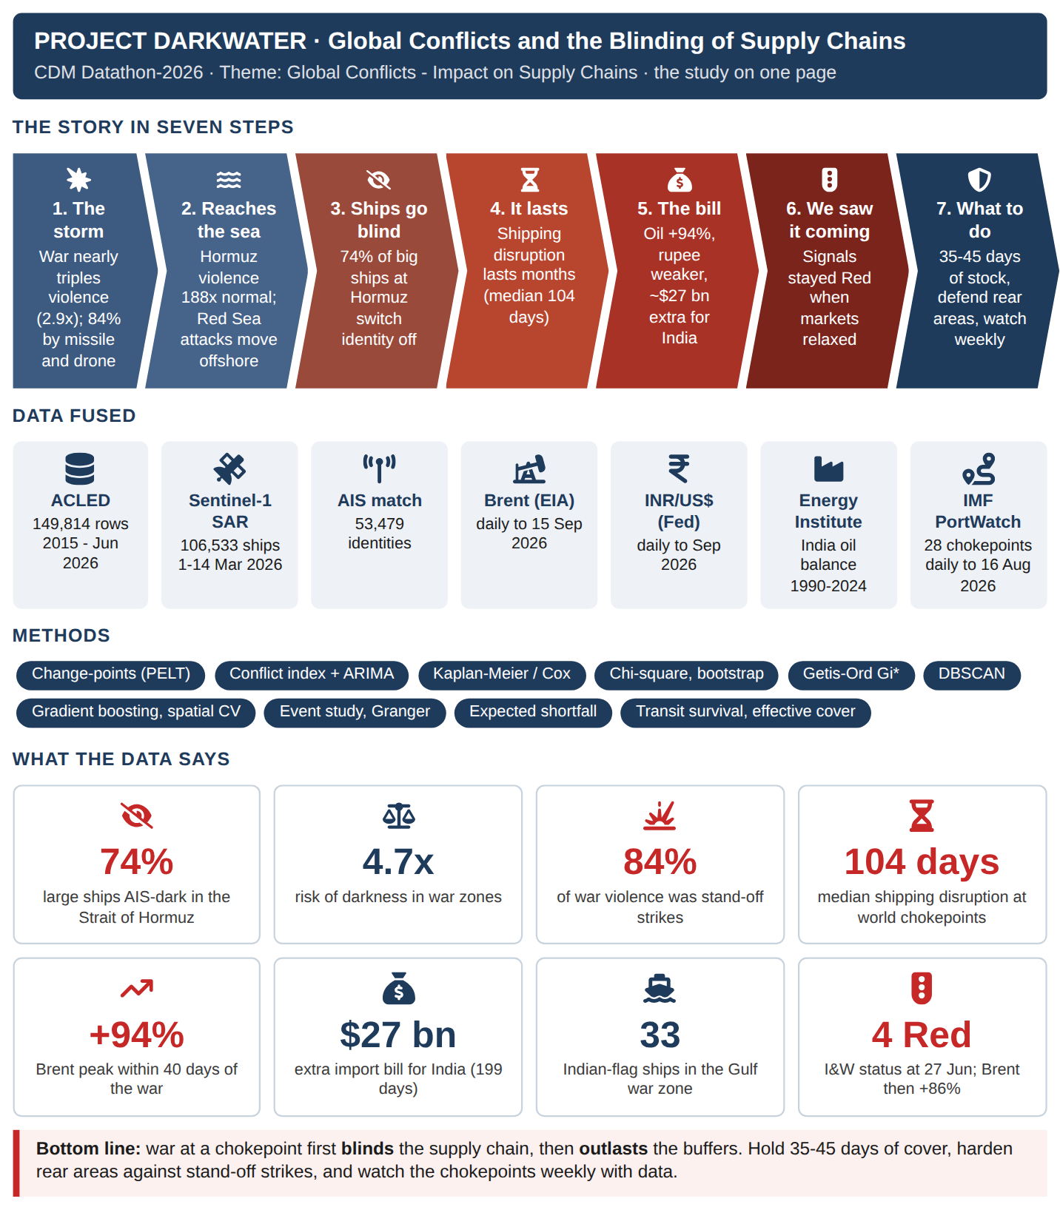

EXECUTIVE SUMMARY
BOTTOM LINE UP FRONT. When war reaches a sea chokepoint, the first thing to fail is the maritime picture: big ships stop identifying themselves, so AIS-based counts overstate how much shipping has gone and hide what is still there. The disruption then outlasts our reserves and cost India about US$27 billion in six months. Our warning signals saw it coming when the market did not.

Situation
War reached the Strait of Hormuz on 28 February 2026. This study joins 11 years of conflict data, satellite radar of 106,533 ships in the first fortnight, IMF daily transit counts at 28 world chokepoints, and open oil, rupee, energy and news sources to September 2026.

Assessment
1. The storm. Violence nearly tripled (2.9x); 84% by missiles and drones; the Gulf states were hit 124 times more than before.
2. The picture failed. 74% of big ships at Hormuz were dark against 10% in peaceful seas. AIS counts fell 83%, but radar saw most hulls still there, many of them held at anchor. The Gulf darkened 5.7 points a day faster than 11 control seas.
3. Four behaviours, not one. Concealment in the Gulf, evacuation from the Red Sea, a frozen Black Sea, and compliance in the East Med (8% dark beside heavy fighting).
4. It lasts. Fighting flares for weeks, but shipping disruption lasts months: Hormuz transits fell 92% (zero on 4 March) and at world chokepoints the median disruption ran 104 days, 62% outlasting India's 74-day national cover.
5. The bill. Brent $71 to $138; in March the extra oil bill equalled 59-70% of the monthly defence budget.
6. We saw it coming. On 26 June the market relaxed ($70); our DARKWATCH signals stayed Red. Oil then rose 86%.

Deduction
The decision variable is the state of the corridor, not AIS silence alone. Classify first (concealment, evacuation, frozen, compliance), then act. Each needs a different response: escort and surveillance, rerouting, provenance checks, or sustained presence.

Recommendation
• Make Maritime Picture Assurance a named joint warning function under HQ IDS, run through IFC-IOR, with the SDR and DARKWATCH as standing products.
• Size fuel, aviation-fuel and critical-spares reserves for all three Services at 35-45 days as a bridge, and cut exposure to any one chokepoint, because stocks bridge; diversification carries; harden rear areas against drones and missiles; GPS-resilient navigation.
• Standing rule: no AIS-derived traffic count for a contested corridor without a radar cross-check.

Decision sought
Approve a four-month Phase 1 proof of concept using existing establishment, free Copernicus Sentinel-1 imagery and the analysis pipeline already built. Continue only if a principal acts on a DARKWATCH warning in that period.

CONTENTS

1. The Question and How We Answered It
2. The Storm Gathers
3. The Storm Reaches the Sea Lanes
4. The Ships Go Blind
5. The Bill Arrives
6. Inference: What We Know and How Sure We Are
7. What It Means for the World and for India
8. What It Means for the Indian Armed Forces
9. Way Forward
10. Conclusion
Annex A - Data Analytics in Plain Words
Annex B - Technical Summary for Assessors
Annex C - Software Used and Screenshots
Annex D - Key References and Data Sources
Each chapter opens with The story so far and closes with So what; every chart carries What this shows. A commander can read the Executive Summary and the coloured boxes alone in about ten minutes.

1. THE QUESTION AND HOW WE ANSWERED IT
PROLOGUE - THE QUESTION
THE STORY SO FAR
On 28 February 2026 war reached the shores of the Strait of Hormuz, the passage for about a fifth of the world's oil and a large part of India's. This edition answers five questions a commander would ask: what happened, what did it do to the ships, what did it cost, how sure are we, and what should we do?

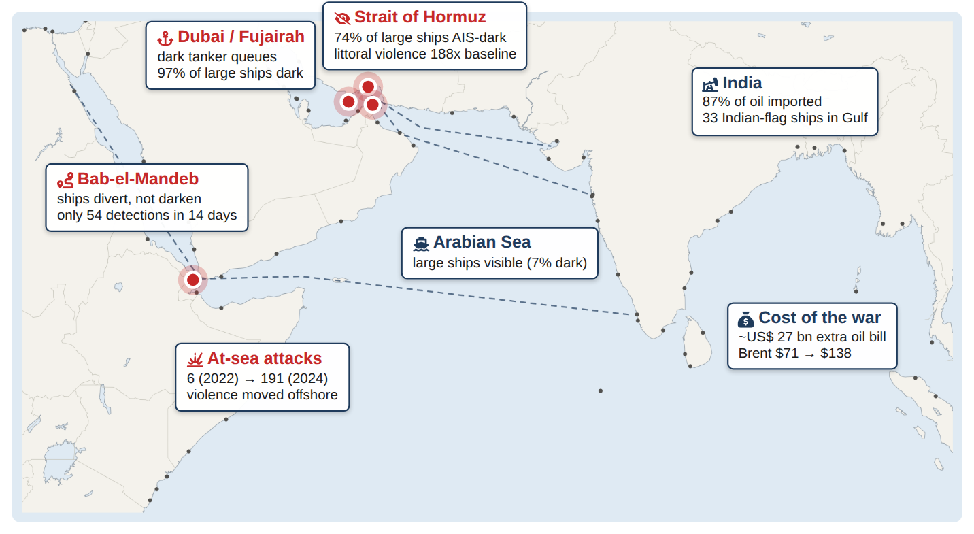
Figure 1.1 : The theatre: India's western sea lanes, the chokepoints and the headline findings
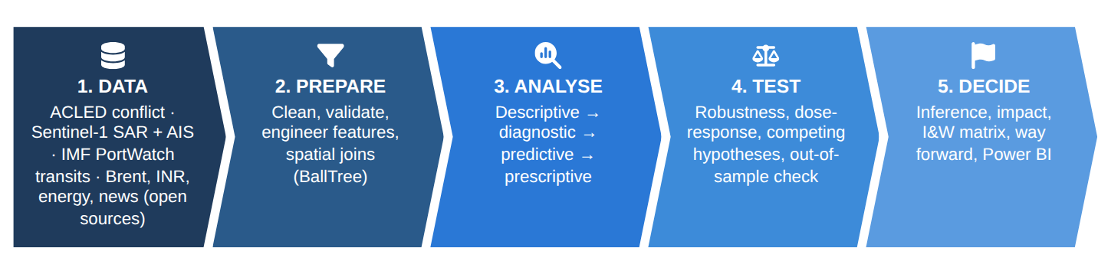
Figure 1.2 : How the question was answered
The two CDM datasets are the ACLED conflict record (every reported attack, battle and protest in the Middle East, week by week, 2015 to June 2026) and Sentinel-1 satellite radar detections of 106,533 ships in the first fortnight of the war, each checked against the ship's identity beacon (AIS). Open-source oil-price, exchange-rate and energy data (to September 2026) measure the cost. The glossary at the end explains every technique in plain words.
SO WHAT
Two datasets from CDM (11 years of conflict events; 106,533 ships seen by satellite radar) plus four open-source datasets (oil price, rupee, India's oil balance, world ports), tested with standard analytics and intelligence tradecraft.
Next: How did the conflict itself change?

2. THE STORM GATHERS
PART I - THE STORM GATHERS
THE STORY SO FAR
The story begins on land. Before the war reached the sea, it changed in size, in weapons and in geography.

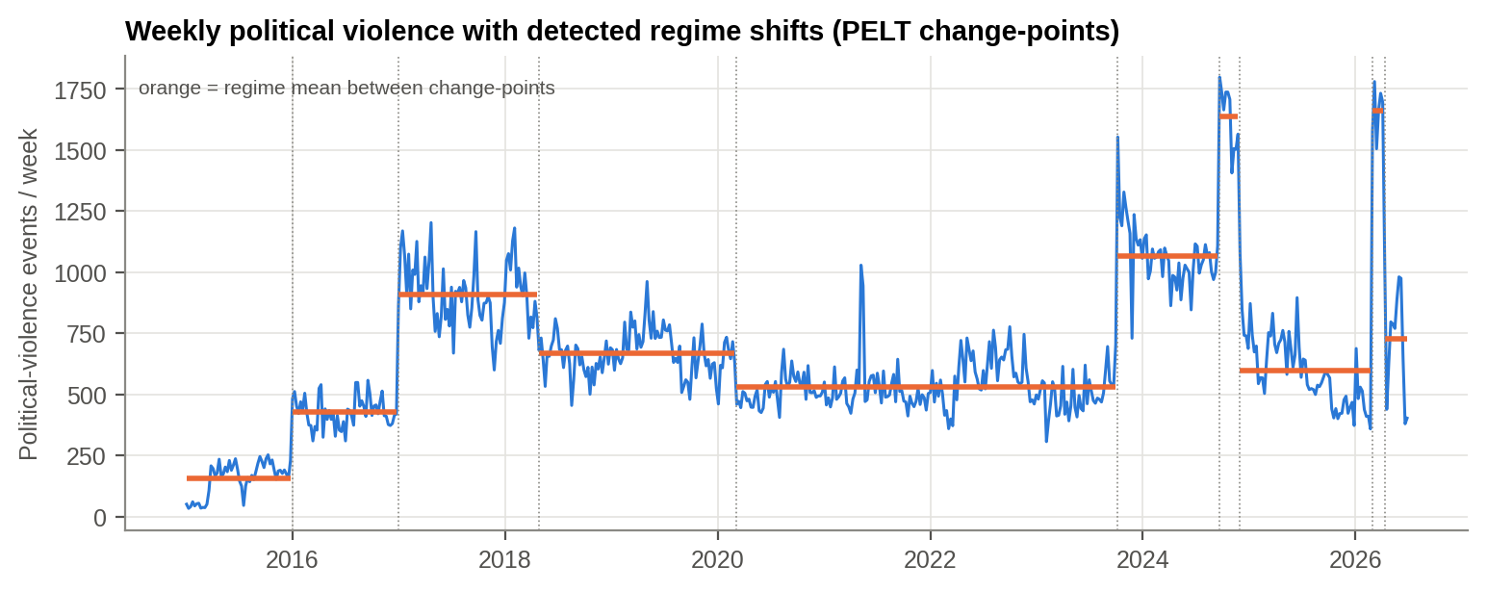
Figure 2.1 : Weekly political violence, 2015-2026, with the dates the 'battle rhythm' changed
What this shows: The orange steps are the 'battle rhythm'. The computer found, without being told, the exact weeks it changed: 7 Oct 2023 and 28 Feb 2026.

Without being told any dates, the computer found the weeks when the conflict changed: 7 October 2023 (the Gaza war) and 28 February 2026 (the regional war). In the war weeks violence ran at 2.9 times the previous year's level. 84% of it was delivered from a distance, by missiles, drones and artillery.
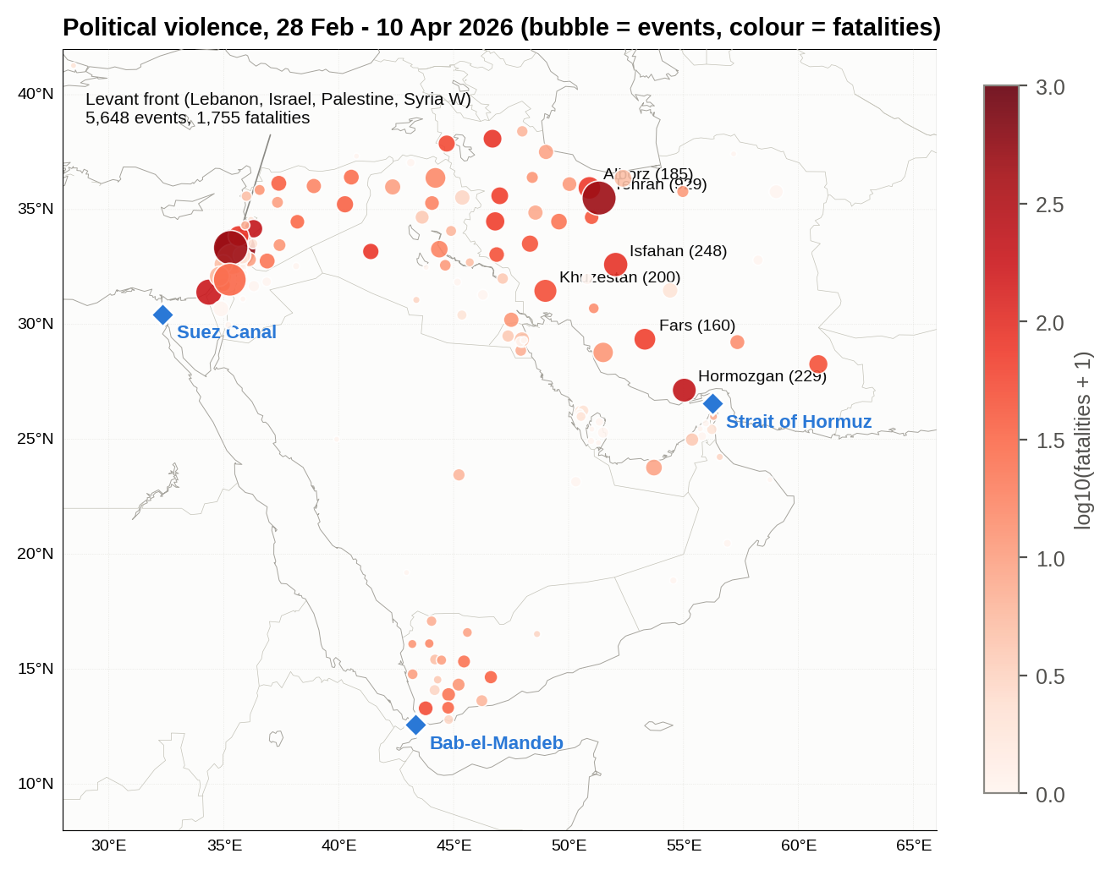
Figure 2.2 : Where the violence fell, 28 February - 10 April 2026
What this shows: Each bubble is a province: bigger means more attacks, redder means more deaths. The fighting reached the shore of the Strait of Hormuz.

The fighting reached the shore of the Strait of Hormuz (Hormozgan province: 229 attacks, 215 deaths in six weeks). The Gulf states, which had seen almost no violence, were struck every week: 124 times their pre-war rate.
SO WHAT
The war nearly tripled violence (2.9x). 84% of it was delivered by missiles and drones, and it hit the Gulf states that export the world's energy (124x).
Next: Did it reach the sea lanes?

3. THE STORM REACHES THE SEA LANES
PART II - THE STORM REACHES THE SEA LANES
THE STORY SO FAR
The war had moved to the Gulf's energy coast and was being fought with missiles and drones. The next question: did it reach the sea lanes, and how long do such crises last?

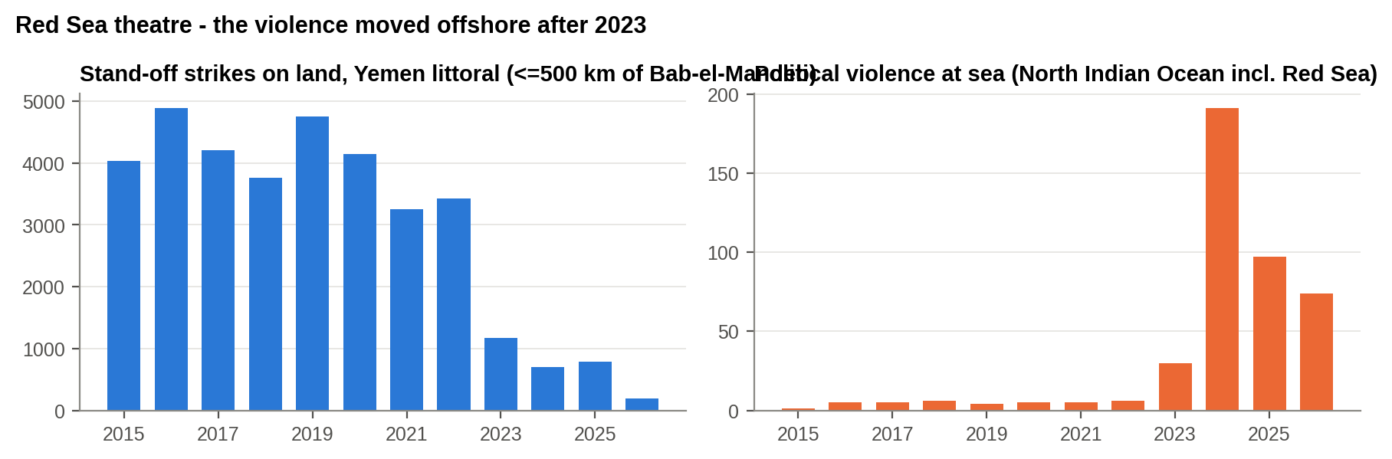
Figure 3.1 : Red Sea: attacks on land fell while attacks at sea rose
What this shows: In Yemen, attacks on land fell (left) while attacks at sea rose (right). The threat moved from the shore to the shipping lanes.

A 'thermometer' of violence was built for each sea route. Around Hormuz it reached 188 times its normal level. In the Red Sea the threat moved offshore: attacks at sea rose from 6 (2022) to 191 (2024) while the land war faded. A land-only measure would have shown the Red Sea getting safer just as it became the most dangerous waterway for merchant ships.
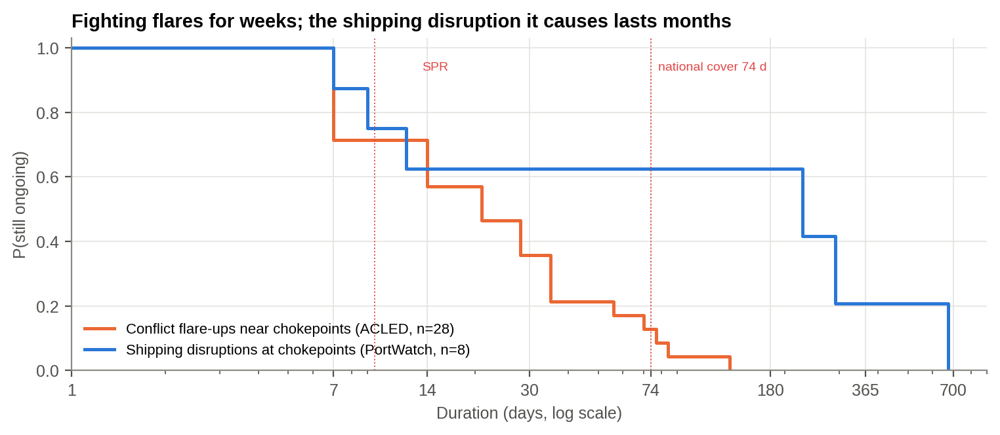
Figure 3.2 : Two clocks: fighting near a sea lane (orange) against the shipping disruption it causes (blue), 2019-2026
There are two clocks. Flare-ups of fighting near a sea lane usually end within weeks (median 2.5 weeks), although 62% still outlast India's strategic petroleum reserve (about 9.5 days). The shipping disruption they cause lasts months: the IMF's daily transit counts for 28 world chokepoints show a median of 104 days, and 62% outlasted India's total national cover of about 74 days. The Red Sea disruption ran 22 months; Hormuz had been shut 169 days when the record ended. The danger is not the spike but its duration.
SO WHAT
Yes. Violence around Hormuz reached 188x its normal level, and in the Red Sea it moved from shore to sea. Most crises end in weeks, but 62% outlast India's emergency oil reserve.
Next: What did the ships do?

4. THE SHIPS GO BLIND
PART III - THE SHIPS GO BLIND
THE STORY SO FAR
Violence reached the waters around Hormuz and the Red Sea, and such crises can outlast our reserves. What did the ships do? Satellite radar sees every ship, whether or not it wants to be seen.

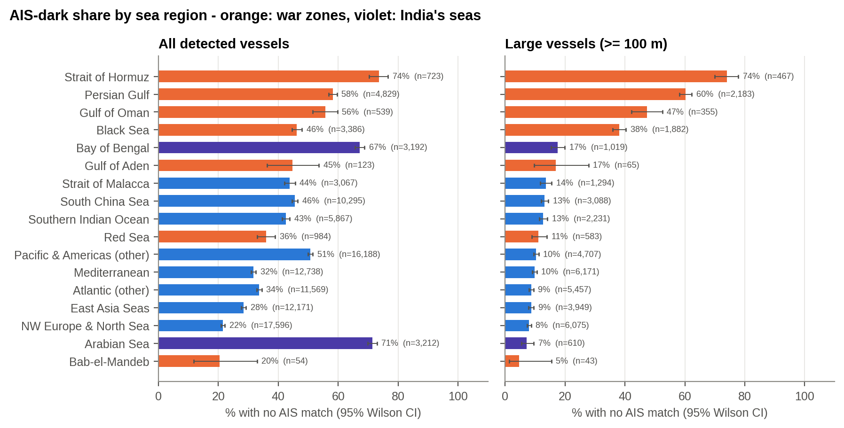
Figure 4.1 : Share of ships with their identity beacon off, by sea (right panel: big ships only)
What this shows: Look at the right-hand panel (big ships only). War zones (orange) are four to seven times darker than peaceful seas (blue).

Small boats run without beacons everywhere, so the test that matters is big ships (100 m and over), which must carry one by law. In peaceful seas about 1 in 10 is dark. At Hormuz it was 74%, in the Persian Gulf 60%, and in the Black Sea, the other war zone, 38%. Big ships in war zones were 4.7 times as likely to be dark.
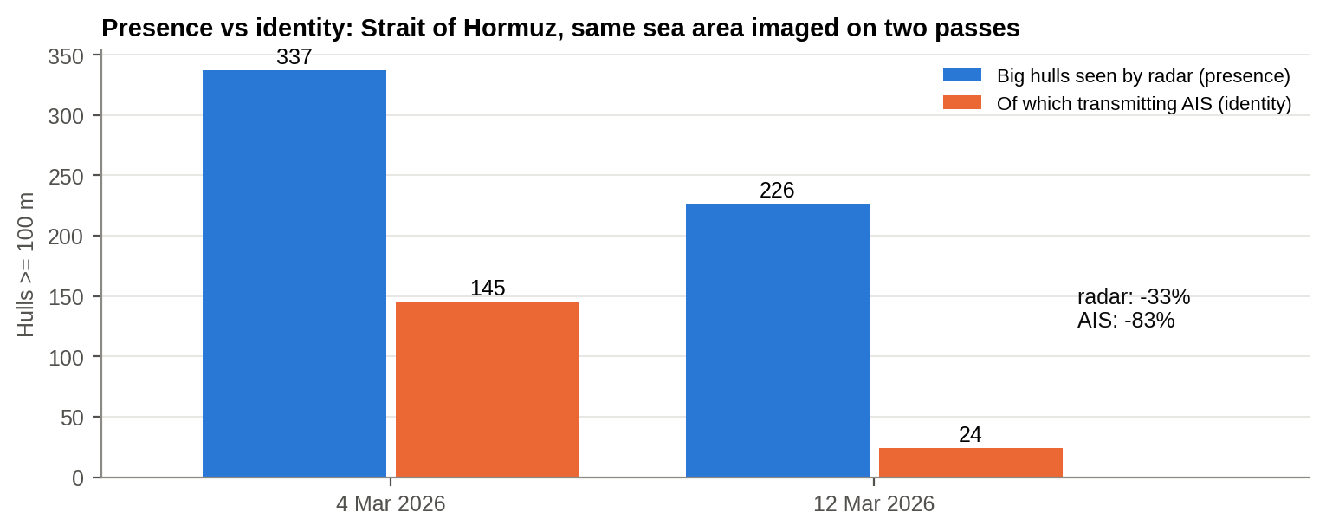
Figure 4.2 : Did the ships leave or go silent? Same sea area at Hormuz, imaged on 4 and 12 March
The ships did not simply leave. On the same patch of sea, AIS-transmitting big hulls fell 83% while radar saw the physical fleet fall only 33%, and the dark fleet did not shrink at all. Many dark hulls were held at anchor: seen in the same 100 m square on different days far more than chance allows (z = 5.3). An AIS-based traffic count therefore overstated the collapse of shipping and hid the collapse of the maritime picture.
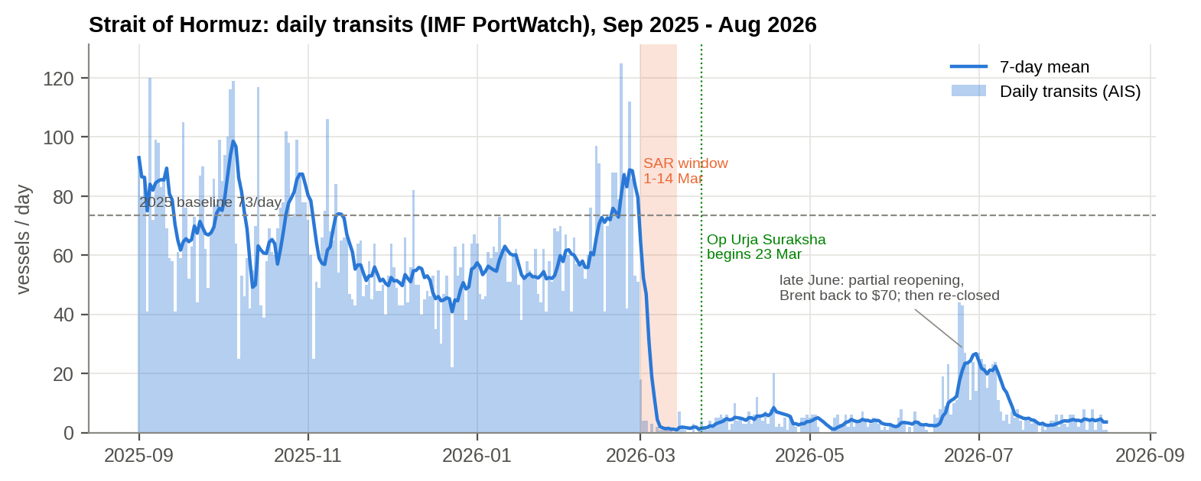
Figure 4.3 : Third witness: ships crossing the Strait of Hormuz each day (IMF PortWatch), 2025-2026
A third, independent source settles it. The IMF's daily count of ships crossing Hormuz fell from about 74 a day to 6 (92% down); on 4 March it was 0, the very day radar counted 337 big hulls inside the Gulf. Ships were there (radar), a growing share hid who they were (AIS), and almost none crossed (transits). The fleet was held, silent, inside the Gulf. Other chokepoints barely moved (-4%), so this was Hormuz, not the world.
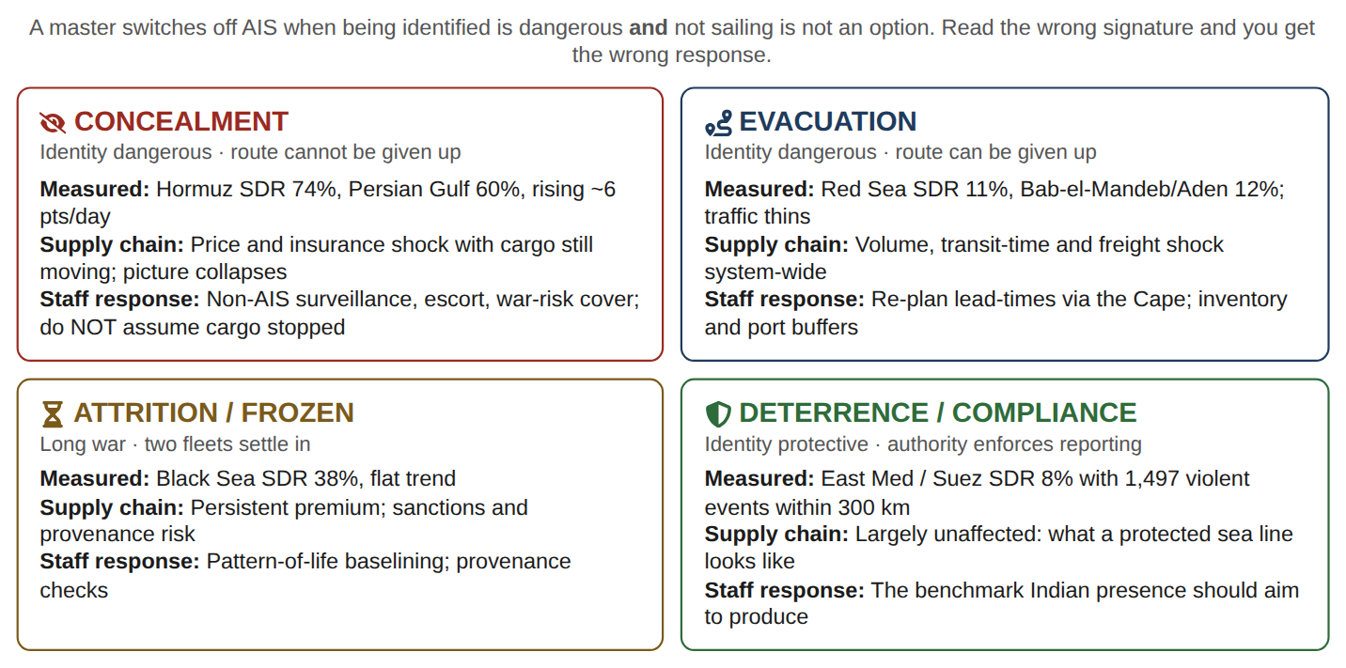
Figure 4.4 : Four behaviours at sea: the same war produced concealment, evacuation, a frozen sea and compliance
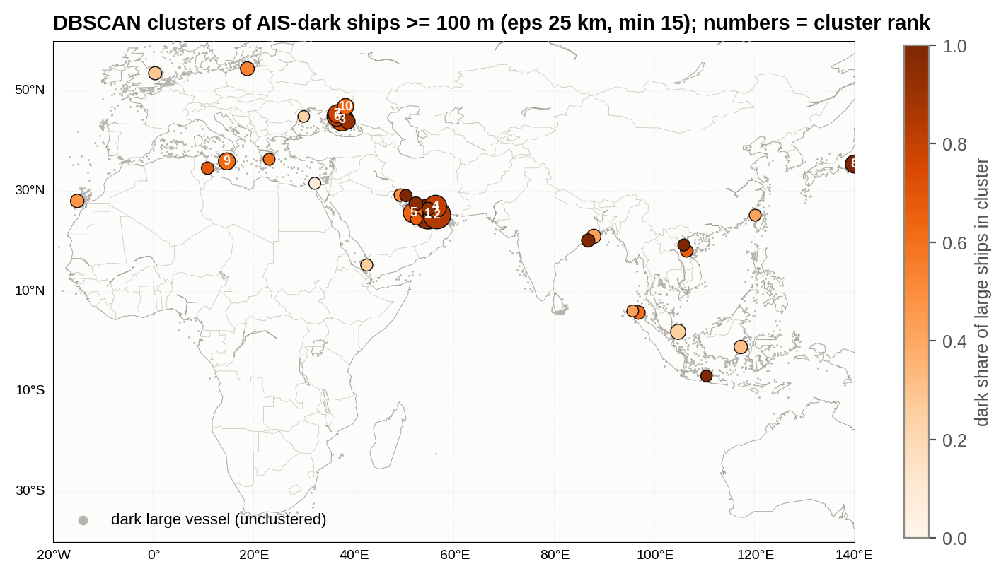
Figure 4.5 : Where dark ships gather: tanker queues off Dubai and Fujairah, and in the Black Sea
What this shows: Each circle is a group of dark ships found automatically. The biggest are tanker queues off Dubai and Fujairah, waiting with identities off.

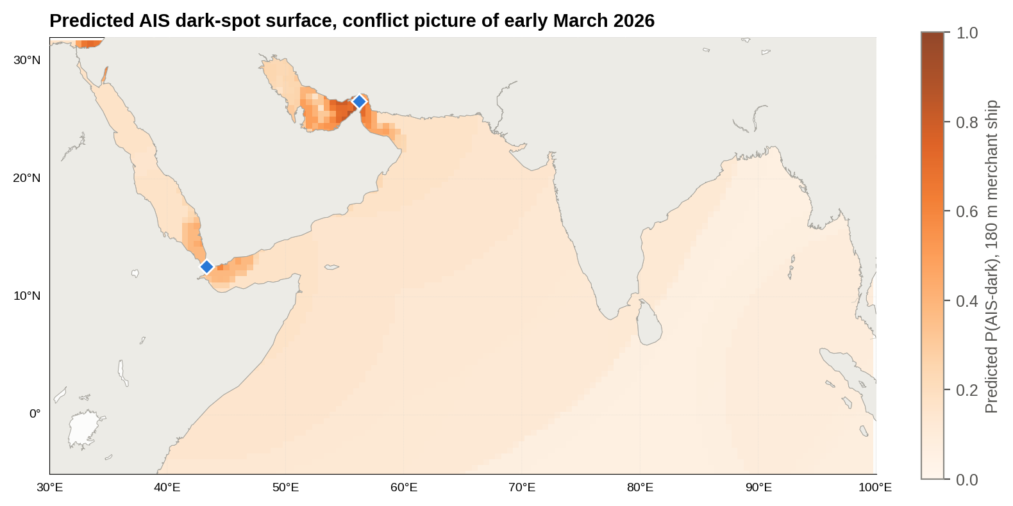
Figure 4.6 : Forecast: where a 180 m merchant ship is likely to go dark
What this shows: A forecast map of where a merchant ship is likely to go dark. Darkest near Hormuz and the UAE coast, lighter near India.

A machine-learning model, trained on 62,000 ships and tested only on seas it had never seen, forecasts where ships will go dark (score 0.69, where 0.5 is a coin toss). After a ship's size, distance from the fighting is the strongest clue. It is good enough to point satellites at the right waters.
SO WHAT
Big ships went dark: 74% at Hormuz against about 10% in peaceful seas. They did not simply leave; many were held at anchor with identities off. The same war produced four behaviours at sea, and a model can forecast where darkness will appear.
Next: What did it cost?

5. THE BILL ARRIVES
PART IV - THE BILL ARRIVES
THE STORY SO FAR
Ships near the fighting switched off their identities or stayed away. A supply chain is ultimately about goods and money, so we follow the shock to the oil price, the rupee and India's import bill.

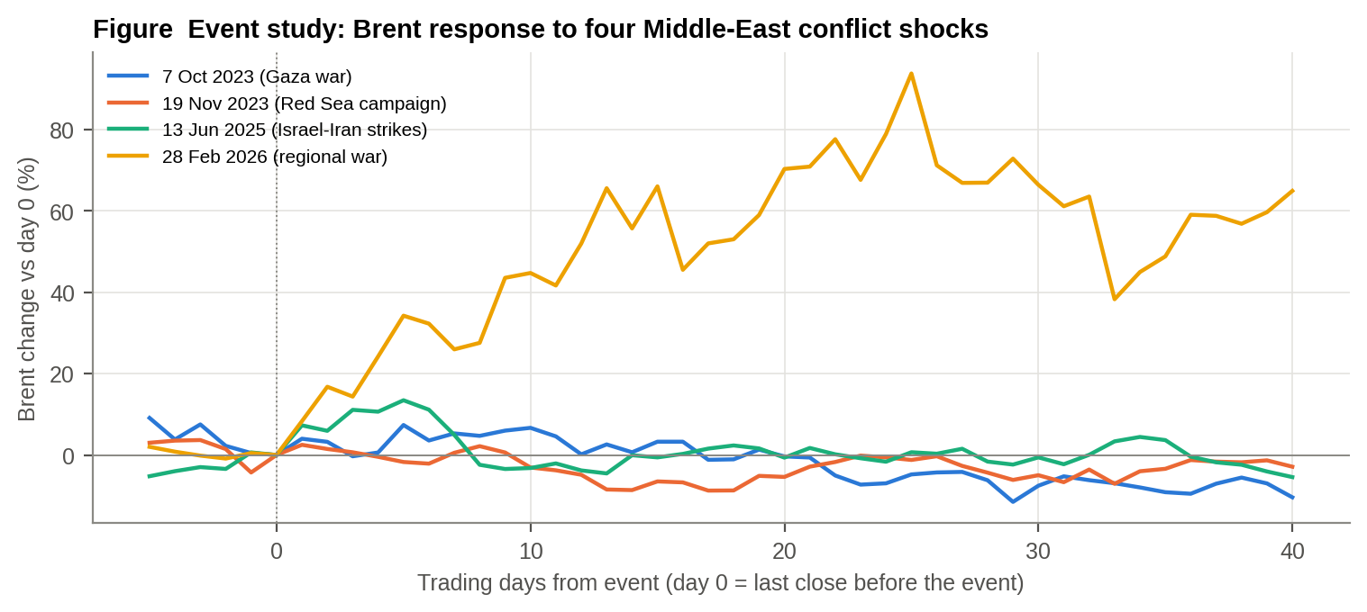
Figure 5.1 : Oil price after four Middle-East shocks (day 0 = the day before each began)
What this shows: Each line is one crisis, starting at zero on the day it began. Only the 2026 war (red) produced a lasting jump.

Only the war that reached Hormuz produced a lasting shock: Brent +94% within 40 days, from $71 to a peak of $138. The Red Sea campaign, where ships could detour, left oil lower a month later. The market confirms the signatures of Chapter 4: concealment where there is no detour produces a price shock; evacuation where there is a detour produces a freight shock instead.
Table 5.1 : What the war cost India (open-source data)
Quantity | Value
India net oil import volume (2024, OWID-derived) | 4.26 million bbl/day
India oil import dependence (2024) | 87.4%
Brent, pre-war baseline (1 Dec 2025 - 27 Feb 2026) | US$ 66.6/bbl
Brent, war period (1 Mar - 15 Sep 2026) | US$ 98.4/bbl (+48%)
INR/US$, pre-war vs war period | 90.54 -> 94.72 (+4.6%)
Extra import bill, war period (199 days), US$ | ~US$ 27 billion
Extra import bill incl. rupee effect, INR | ~Rs 2.8 lakh crore
Sensitivity: every US$10/bbl sustained for a year | ~US$ 15.6 billion

India imports 87% of its oil, and the share is rising. The war added about US$27 billion (Rs 2.8 lakh crore) to the oil bill in 199 days. Every US$10 a barrel for a year costs about US$15.6 billion.
In defence terms: in March 2026 the extra oil bill equalled 59-70% of the whole monthly defence budget; in April it reached 100%.
Could we have seen it coming? On 26 June 2026, when the conflict data end, the oil market looked calm: Brent was back at $70. The six warning signals built in this study all read Red or Amber and said hold the buffers. Oil then rose 86% to $131 by 15 Sep 2026. The dip had a cause the transit data show: in late June a few ships crossed and Hormuz traffic briefly climbed to about a third of normal, then fell back to 5% of normal. The data saw what the market missed.

SO WHAT
Oil went from $71 to $138, the rupee weakened, and India's oil bill rose by about US$27 billion. Our warning signals stayed Red when the market relaxed, and oil then rose 86%.
Next: How sure are we?

6. INFERENCE: WHAT WE KNOW AND HOW SURE WE ARE
PART V - WHAT WE KNOW, AND HOW SURE WE ARE
THE STORY SO FAR
The evidence is complete. Before acting on it, a good staff officer asks: are we sure, and could something else explain it?

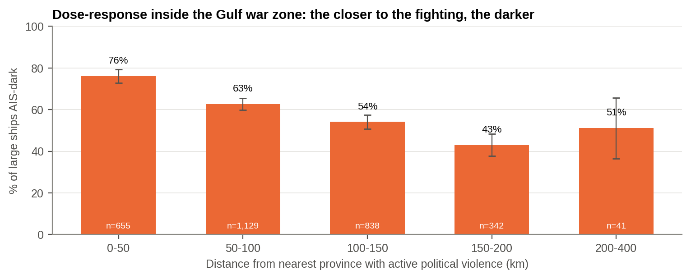
Figure 6.1 : The closer to the fighting, the more big ships went dark (Gulf war zone)
What this shows: The closer ships were to the fighting, the more of them went dark: a clear sign that the war caused it.

Four tests make the main finding solid. (1) It holds under eight different ways of measuring it (war zones 3.9 to 6.4 times darker). (2) It gets stronger nearer the fighting, from 76% within 50 km to 43% at 150-200 km. (3) It repeats in a separate war (Black Sea). (4) Of four possible explanations (deliberate switch-off, GPS jamming, radio reception gaps, computer error), only deliberate switch-off fits all the evidence. (5) It survives removing the 67 passes that were entirely dark (a possible feed outage) and holds by day and by night. (6) The Gulf darkened 5.7 points a day faster than 11 control seas (p = 0.008). A failed identity match proves the picture failed; it cannot prove intent, so that judgement is held at 'likely'.
Table 6.1 : Key judgements (intelligence estimative language)
How likely | Judgement | Confidence
Almost certain | The war caused big ships to go dark. | High
Likely | Most of the darkness is deliberate switch-off; GPS jamming probably adds to it. | Moderate
Highly likely | The Hormuz coast stays in crisis, at least on and off, through September 2026. | Moderate
Likely | A sea-lane crisis outlasts India's emergency oil reserve (62% of cases). | Moderate
Almost certain | Drones and missiles will remain the main threat to rear-area logistics and energy sites. | High
Highly likely | Conflict and satellite signals warn earlier than market prices. | Moderate

SO WHAT
Very sure of the main finding. It holds however it is measured, grows stronger closer to the fighting, repeats in another war, and no other explanation fits.
Next: What does it mean for the world and for India?

7. WHAT IT MEANS FOR THE WORLD AND FOR INDIA
PART VI - WHAT IT MEANS FOR THE WORLD AND FOR INDIA
THE STORY SO FAR
Having established what we know and how sure we are, we turn to what it means: first for the world, then for India.

For the world
• Energy: about a fifth of the world's oil passes Hormuz. Chokepoint risk is now a recurring cost, not a rare event.
• Trade: where a detour exists, conflict adds 10-14 days per Asia-Europe voyage and raises freight and insurance costs.
• Safety at sea: when most big ships are dark, collision avoidance, rescue and identification fail, and neutral ships risk being mistaken for targets.
• Shadow fleets: flags often linked to sanctions evasion are about three times over-represented among visible ships in war zones, but the dark fleet is mainly mainstream shipping: the problem is the whole fleet's behaviour, not a rogue fleet.

For India
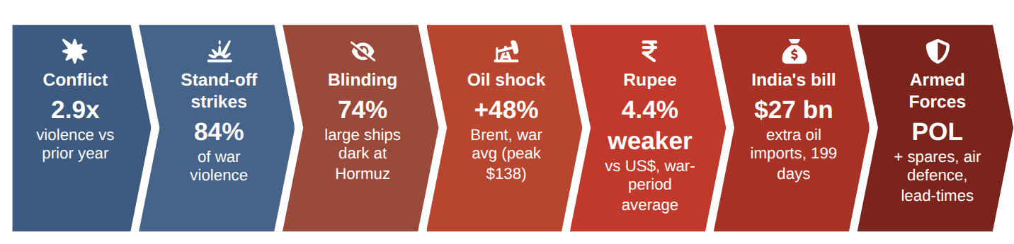
Figure 7.1 : How the shock travels from the strait to India's import bill and the Armed Forces
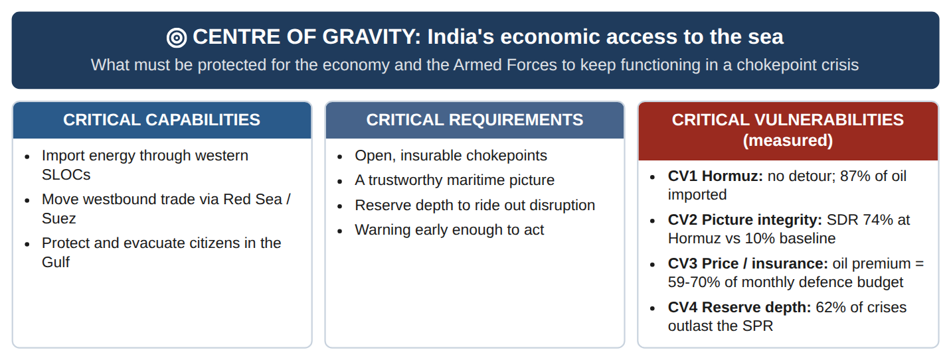
Figure 7.2 : India's centre of gravity at sea, with the vulnerabilities this study measured
• Energy: 87% of oil is imported, much of it through Hormuz, which has no detour. Only buffers and other suppliers help.
• Trade: the Red Sea diversion lengthens and raises the cost of India's westbound exports.
• Connectivity: the Chabahar corridor and IMEC run through the theatres studied.
• People: about nine million Indians live in the Gulf states, where violence rose 124-fold. At least 33 Indian-flag ships were inside the Gulf war zone.
• Home waters: India's own seas hold thousands of small boats without beacons, so coastal security cannot rely on AIS.
SO WHAT
For the world, chokepoint war is a recurring cost and a hazard at sea. For India the exposure is concentrated in oil, westbound trade, connectivity projects and nine million citizens in the Gulf.
Next: And for the Armed Forces?

8. WHAT IT MEANS FOR THE INDIAN ARMED FORCES
PART VII - WHAT IT MEANS FOR THE ARMED FORCES
THE STORY SO FAR
The same shocks that hit India's economy reach its Armed Forces through fuel, spares, threats to bases and the need to protect citizens abroad.

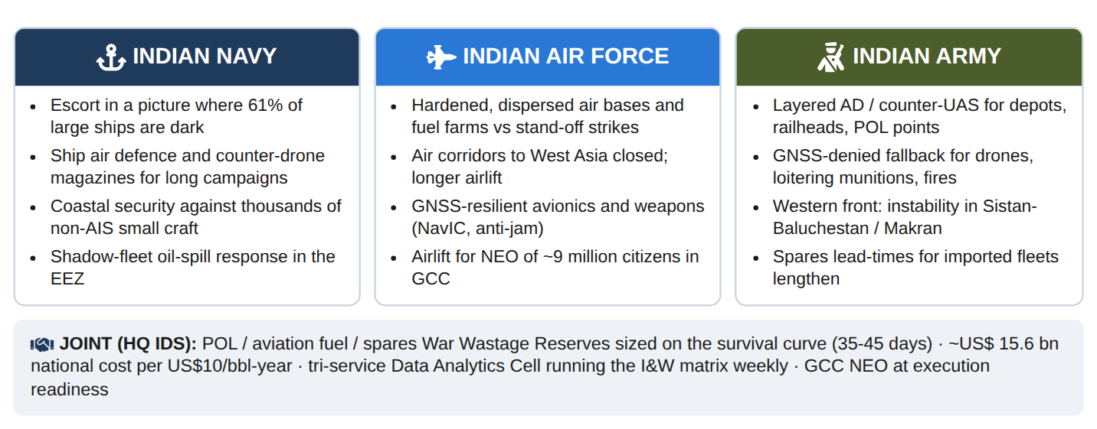
Figure 8.1 : Impact on the Indian Navy, Air Force and Army
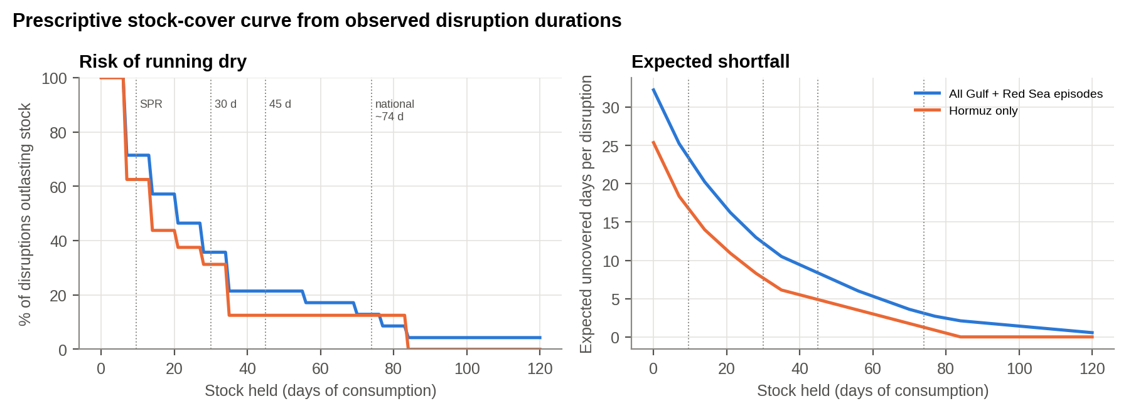
Figure 8.2 : How much stock is enough? Risk of running dry and average days short, by days of stock held
What this shows: Left: the chance that a crisis outlasts a given stock. Right: the average days short. Beyond about 35-45 days, extra stock buys little.

Table 8.1 : Planning scenarios for a Hormuz or Red Sea disruption
Scenario | Duration | P(disruption lasts at least this long) | Days beyond national cover (74 d) | Days beyond 30 d / 45 d Service holdings
S1 Short disruption | 2 weeks | 71% | 0 | 0 / 0
S2 Sustained disruption | 6 weeks | 21% | 0 | 12 / 0
S3 Prolonged disruption | 12 weeks | 9% | 10 | 54 / 39
S4 Campaign-length disruption | 26 weeks | < 5% (beyond the longest observed episode) | 108 | 152 / 137

For Service stocks, a six-week crisis is the planning case: roughly 1 in 5 flare-ups last that long. It leaves a 30-day holding 12 days short, while 45 days covers it fully. Beyond about 35 days each extra day of stock buys little. Hence 35-45 days for fuel, aviation fuel and critical spares.
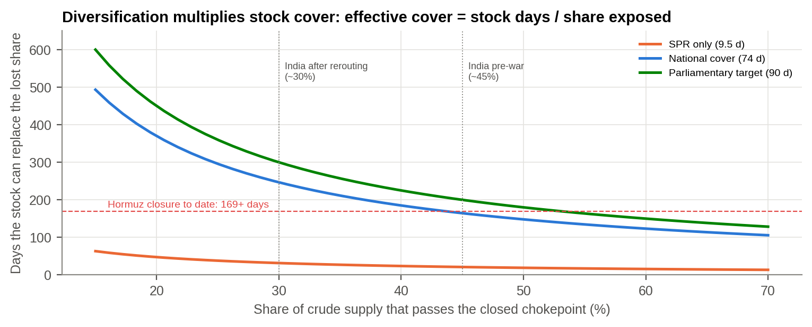
Figure 8.3 : Effective cover = days of stock / share of supply behind the closed chokepoint
For supply, the planning case is months, and stocks cannot carry it. A stock only has to replace the share of supply that is cut off. At India's pre-war exposure of about 45% to Hormuz, 74 days of national cover lasts about 164 days; cut the exposure to 30% and it lasts 246 days, longer than the 169-day closure so far. Stocks bridge; diversification carries. For the Services this means 35-45 days of holdings plus a second source for every critical fuel and spare.
SO WHAT
Fuel and spares stocks sized on evidence, rear areas defended against drones and missiles, navigation that does not depend on GPS, and a joint watch on the chokepoints.
Next: What should we do, and in what order?

9. WAY FORWARD
PART VIII - WHAT WE SHOULD DO
THE STORY SO FAR
The story has shown what happens, how long it lasts, what it costs and whom it hurts. Now: what to do, what to watch, and in what order.

Table 9.1 : Eleven staffed actions, each traced to the evidence
Action | Lead | Timeline | Measure of effectiveness
Maritime Picture Assurance as a named joint warning function; SDR and DARKWATCH as weekly products. | HQ IDS with IFC-IOR | 4 months | A principal acts on a DARKWATCH warning
Standing rule: no AIS-derived traffic count for a contested corridor without a radar cross-check. | HQ IDS | Immediate | Rule issued; cited in assessments
Fuse national satellite radar (NISAR, EOS-04) with AIS to flag every dark big ship automatically. | Navy (IFC-IOR), DSA | 6-18 months | Dark hulls cued within 24 h of a pass
Treat AIS identity as untrusted: automatic checks for cloned or fake identities. | Navy (IFC-IOR) | 6 months | Checks shared with ports and insurers
Know the small-boat population in India's seas: transponders, coastal radar, satellite radar. | Navy, Coast Guard, MoFAH | 18 months | Share of small craft identifiable
Size strategic oil and LPG reserves on crisis-duration evidence; diversify away from Hormuz. | MoPNG with MEA | 12 months | Cover set on the survival curve
Re-set fuel, aviation-fuel and critical-spares War Wastage Reserves for all three Services at 35-45 days. | HQ IDS (Log) | 6 months | Days of cover within the band
Air defence and counter-drone cover for depots, railheads, air bases and fuel points; GPS-denied fallback. | Army, IAF | 3 years, rolling | Critical nodes covered; drills done
Keep the Gulf evacuation plan (Navy sealift, IAF airlift, Army reception) ready while signals are Amber or Red. | HQ IDS with MEA | 3 months | Time to first lift from alert
Indigenise first the items that come through Hormuz or the Red Sea with long lead-times. | DDP, Services | Rolling | Exposure-weighted list adopted
Archive corridor satellite imagery and write up what shipping did after every chokepoint crisis. | HQ IDS, CDM | After each crisis | Report within 90 days

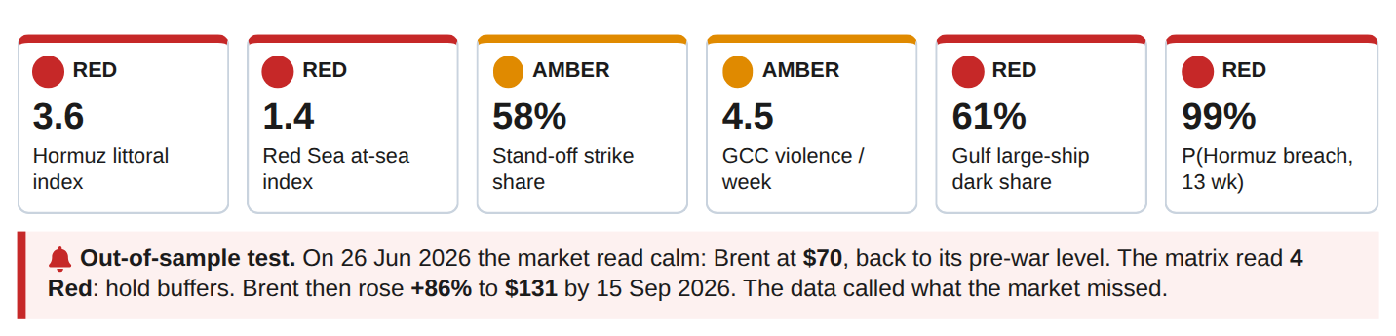
Figure 9.1 : DARKWATCH: the six-signal watch-list at 27 June 2026, and what happened next
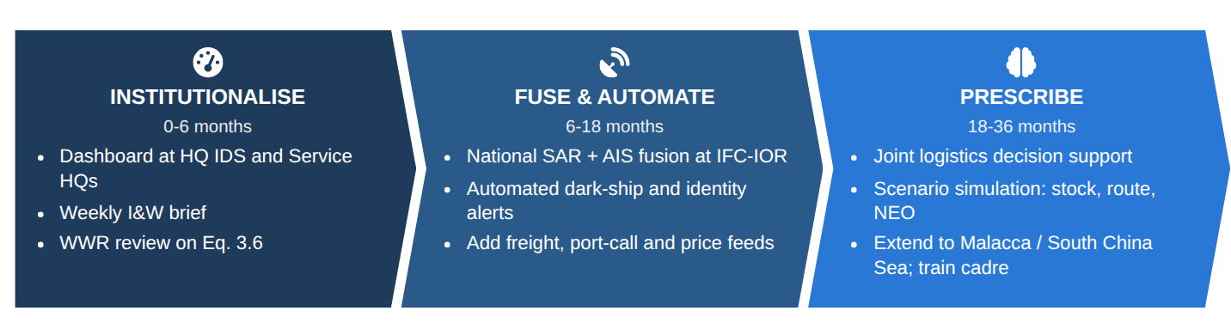
Figure 9.2 : Three-phase plan
SO WHAT
Eleven staffed actions, the DARKWATCH watch-list and a three-phase plan that starts at no new cost and stops if it does not help a decision.

10. CONCLUSION
EPILOGUE
THE STORY SO FAR
We end where we began, with the commander's questions, now answered with evidence.

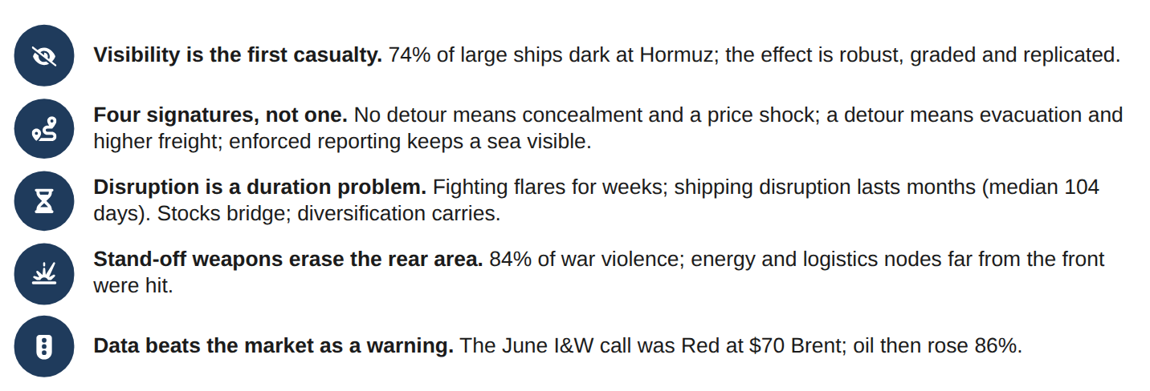
Figure 10.1 : Five takeaways
The first casualty of war at a chokepoint is visibility. Physical disruption follows, lasts longer than intuition suggests, and reaches India's energy, trade, citizens and military sustainment. The same data that measured it can warn of it. Turned into a standing weekly watch, the tools built here let India and its Armed Forces decide on evidence rather than precedent. That is the aim of this Datathon.
WHERE TO FIND THE DETAIL
The full technical report (method, all charts and tables, robustness tests, references) and the Power BI dashboard accompany this edition. Every number here is reproduced there, and can be regenerated from the raw data with one command.

ANNEX A - DATA ANALYTICS IN PLAIN WORDS
This report uses a number of data-analytics tools. None of them needs to be understood in detail to follow the story: every chapter opens with The story so far, closes with So what, and every chart carries a one-line What this shows. The terms below are explained in plain words for readers who want them.
Term | What it means, in plain words
AIS (Automatic Identification System) | A ship's identity beacon. It broadcasts name, position and course. It works like IFF for merchant ships, and a ship can switch it off.
AIS-dark ship | A ship that satellite radar can see but that is not transmitting its identity: a vehicle driving at night with its lights off.
SAR (satellite radar) | A radar satellite that sees ships day and night, through cloud, whether or not they transmit.
Chokepoint | A narrow sea passage that ships cannot easily avoid, such as Hormuz or Bab-el-Mandeb: a defile on the sea lanes.
Relative risk / 'x times more likely' | How much more often something happens in one group than another. A relative risk of 4.7 means 4.7 times as often.
p-value | The chance that a result is a fluke. Below 0.05 means less than 1 in 20. Most results here are far smaller, i.e. almost certainly real.
Confidence interval | The range in which the true value probably lies, like the beaten zone of a weapon rather than a single point.
Change-point detection | A method that finds the dates when the 'battle rhythm' changed, without being told what to look for.
Conflict intensity index (CCII) | A weekly thermometer of violence around each sea route, built from open conflict data.
Forecast (ARIMA) | Projects the thermometer forward a few months, with a band showing the likely range.
Survival analysis (Kaplan-Meier, Cox) | Measures how long crises last and what makes them last longer. It is the same tool used for time between equipment failures.
Hot-spot analysis (Getis-Ord Gi*) | Finds places where dark ships bunch together more than chance would allow, like an incident-density overlay.
Cluster finding (DBSCAN) | Automatically finds groups of ships close together, such as tanker queues at an anchorage.
Machine-learning model | A program that learns a rule from 62,000 examples. It was tested only on seas it had never seen, like testing a soldier on unfamiliar ground.
Model score (ROC-AUC) | How well a model separates dark ships from visible ones: 0.5 is a coin toss, 1.0 is perfect.
Bootstrap | Re-running the analysis 2,000 times on re-shuffled satellite pictures to check that the answer does not change.
Dose-response | The stronger the exposure, the stronger the effect. Here: the closer to the fighting, the more ships go dark.
Competing hypotheses | Standard intelligence tradecraft: list every possible explanation and keep the one the evidence does not contradict.
Event study | Tracking a price day by day after a shock, to see how big and how lasting the effect was.
Granger test | Checks whether A reliably happens before B, i.e. whether A could serve as a warning of B.
Expected shortfall | The average number of days a stock would run short in a crisis. It is used here to size fuel and spares reserves.
I&W (indicators and warnings) | A short watch-list of measurable signals with thresholds that trigger pre-agreed actions.
Strategic Dark Ratio (SDR) | Of the big ships (100 m and over) the radar sees in one satellite image, the share not transmitting their identity. Peaceful seas: about 10%.
Maritime Picture Assurance | Checking, as a standing duty, that the maritime picture used for decisions still represents the ships actually on the water.
DARKWATCH | The six-signal watch-list built in this study, with Amber and Red thresholds and a pre-agreed action for each.
Stasis index | The share of ships seen in the same 100 m square on two different days: a ship under way cannot do that, a ship at anchor can.
Difference-in-differences | Did the Gulf change more than everywhere else over the same fortnight? Compares the change, not just the level.
Estimative language | 'Almost certain' (over 95%), 'highly likely' (80-95%), 'likely' (55-80%): the standard way intelligence expresses probability.

ANNEX B - TECHNICAL SUMMARY FOR ASSESSORS
For assessors: every technique used, the plain question it answers, the key result, and where the full method, tests and tables appear in the accompanying technical report. All results are regenerated from raw data by one command, and the pipeline is deterministic (two consecutive runs give identical outputs).
Table B.1 : Techniques, questions and results
Technique | Commander's question | Key result | Full report
Validation, cleaning, feature engineering; BallTree haversine spatial join | Is the evidence sound? | 149,814 conflict rows; 106,533 ships; 724 low-confidence detections dropped | Ch 4
Change-point detection (PELT, L2 cost); Mann-Whitney U | When did the battle rhythm change? | 7 Oct 2023, 28 Feb 2026, 11 Apr 2026; war regime 2.9x (p = 4e-05) | 5.1
Chokepoint Conflict Intensity Index; ARIMA with 12-week back-test and 4,000 simulations | Is the sea lane under stress, and will it stay so? | Hormuz littoral 188x baseline; 99% of simulated paths breach by Sep 2026 | 6.1-6.2
Survival analysis: Kaplan-Meier, Cox proportional hazards, log-rank | How long do crises last? | Median 2.5 wk; 62% exceed SPR; 11% exceed 74 days | 6.3
Wilson intervals, chi-square, relative risk, odds ratio | Are war-zone ships really darker? | RR 4.7, OR 8.0, p < 10-300 | 7.1
Getis-Ord Gi* local hot-spot statistic | Where do dark ships cluster? | 43 significant cells, Qatar-Hormuz belt | 7.2
DBSCAN density clustering (haversine) | Where do they wait? | 36 clusters; Dubai 97% dark | 7.3
Logistic regression; gradient-boosted trees with monotonic constraints; leave-one-region-out CV | Can we forecast darkness? | ROC-AUC 0.69 on unseen seas (random CV 0.74, reported as leakage) | Ch 8
Event study; Granger causality; pass-through regression; import-bill model | What did it cost, and do prices warn? | Brent +94% peak; no price lead (p > 0.4); ~US$27 bn to India | 9.2-9.7
Scene-cluster bootstrap (8 specifications); dose-response logit; Analysis of Competing Hypotheses | How sure are we? | RR 3.9-6.4; 76% to 43% with distance; switch-off 0 inconsistencies | 10.4-10.6
Expected shortfall from the survival curve; scenario matrix | How much stock is enough? | Returns flatten at ~35 days; 45 days covers the 6-week case | 13.5-13.6
Presence vs identity on a common footprint; stasis index against a crowding null | Did ships leave or go silent? | AIS -83% vs radar -33%; dark hulls held in place (z = 5.3) | 7.8
Scene-level difference-in-differences with 5,000 permutations; all-dark and day/night checks | Did the Gulf change more than elsewhere? | +5.7 pts/day vs controls (p = 0.008); RR 7.5 without all-dark passes | 10.4
Flag-retention shift (chi-square); rule-based signature assignment | Who kept transmitting; what kind of event is it? | Gulf flags 11% to 20% of lit fleet; four signatures | 7.9-7.10
Chokepoint transit series (IMF PortWatch, 28 chokepoints); frozen-baseline disruption episodes; survival | Did ships stop crossing, and for how long? | Hormuz 92% down, 0 transits on 4 Mar; median disruption 104 d, 62% > 74 d | 9.9-9.12
Effective-cover model (stock days / share exposed) | Can stocks carry a months-long closure? | 74 d lasts 164 d at 45% exposure, 246 d at 30% | 13.5
Indicators & warnings matrix; out-of-sample test | Would we have been warned? | 4 Red / 2 Amber at $70 Brent; oil then +86% | 9.8, 14.2

ANNEX C - SOFTWARE USED AND SCREENSHOTS
Stack: Python 3.11 (pandas, NumPy, SciPy, statsmodels, scikit-learn, ruptures, Matplotlib/Basemap) for analysis; headless Chromium for the report; Microsoft Power BI Desktop for the dashboard (.pbix) built on the exported star schema (FactConflictWeekly, FactVesselDetections, DimAdmin1, DimDate and the analysis tables).
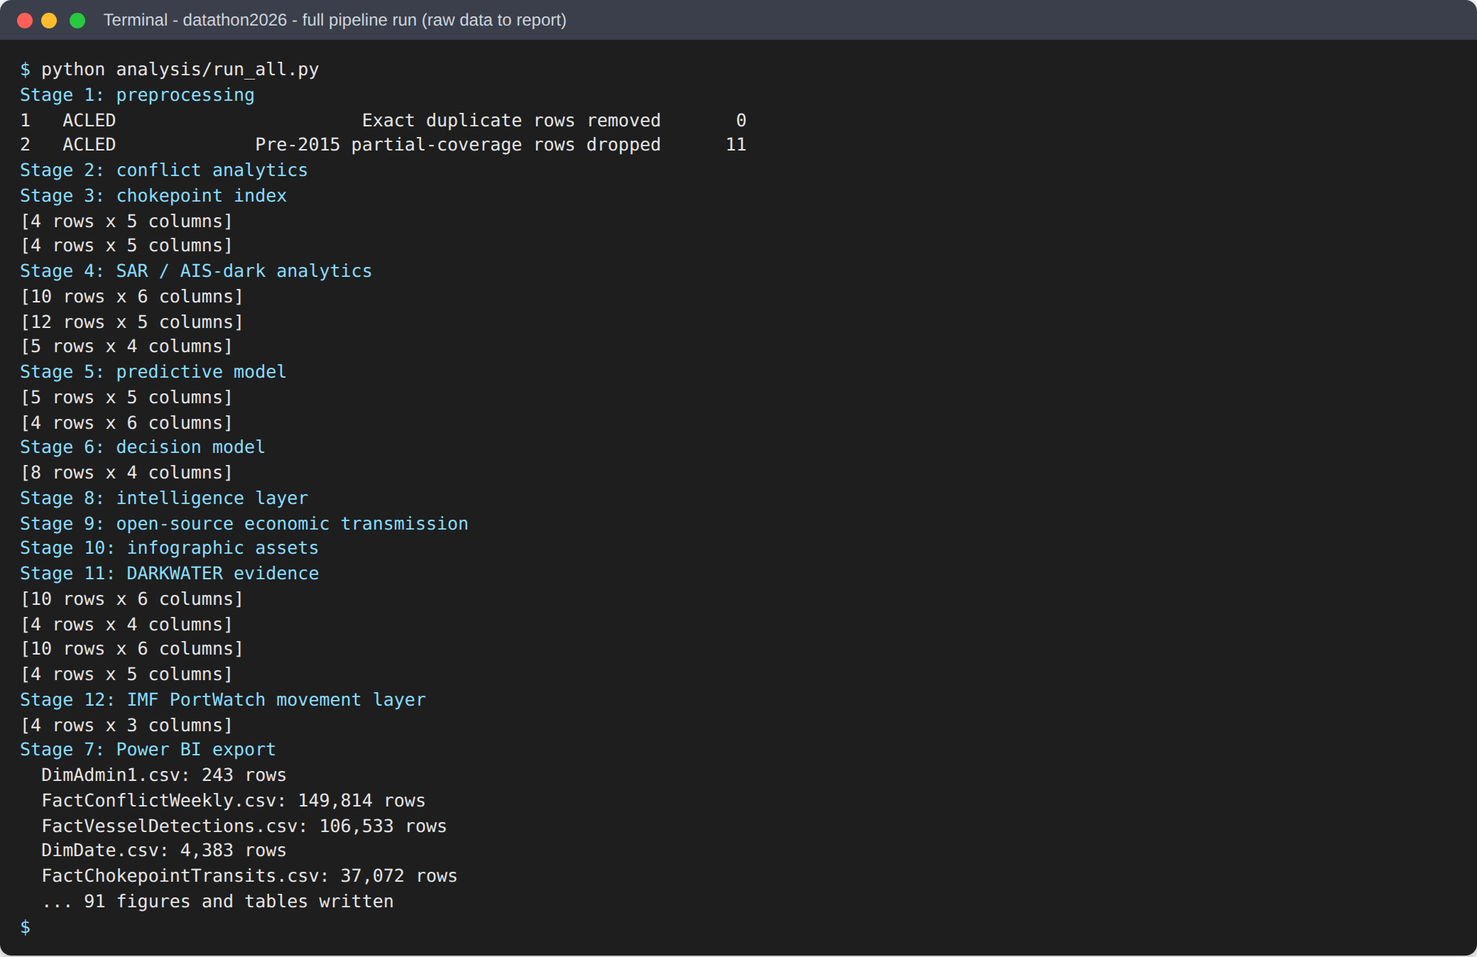
Figure C.1 : Screenshot: the complete pipeline run, raw data to every chart, table and dashboard table
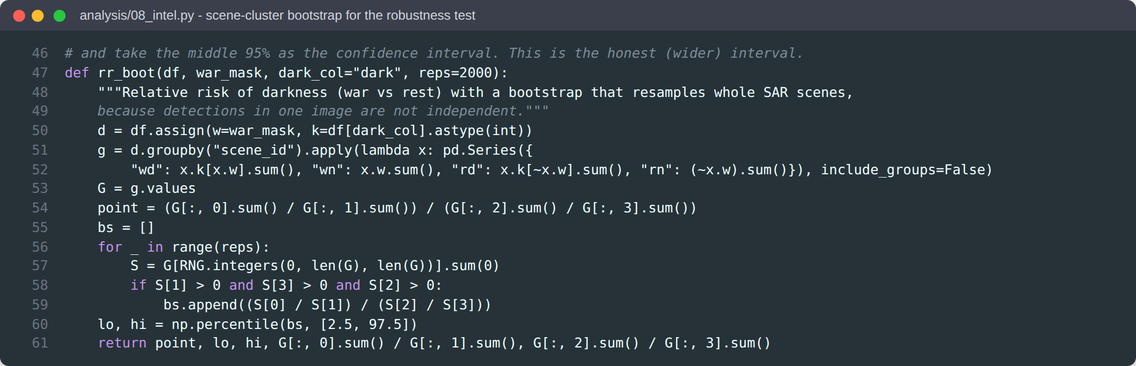
Figure C.2 : Screenshot: code excerpt, scene-cluster bootstrap behind the robustness test
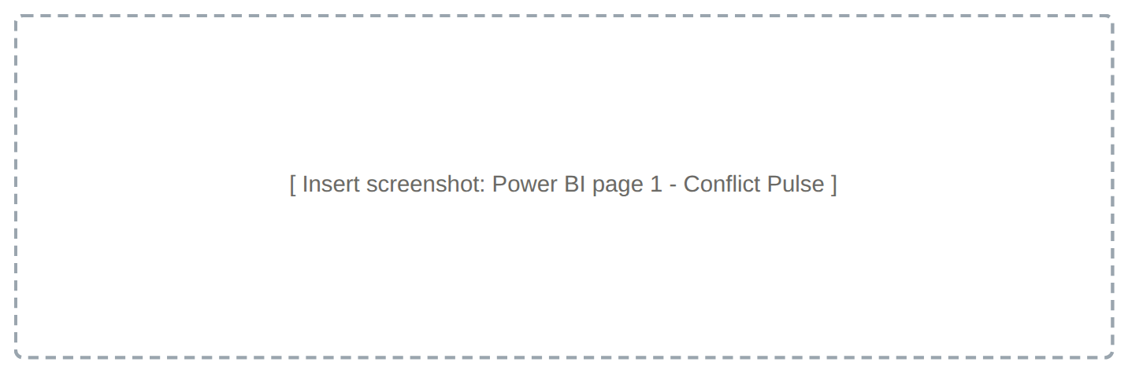
Figure C.3 : Screenshot: Power BI dashboard, page 1 - Conflict Pulse (weekly violence, event mix and map of where it fell)
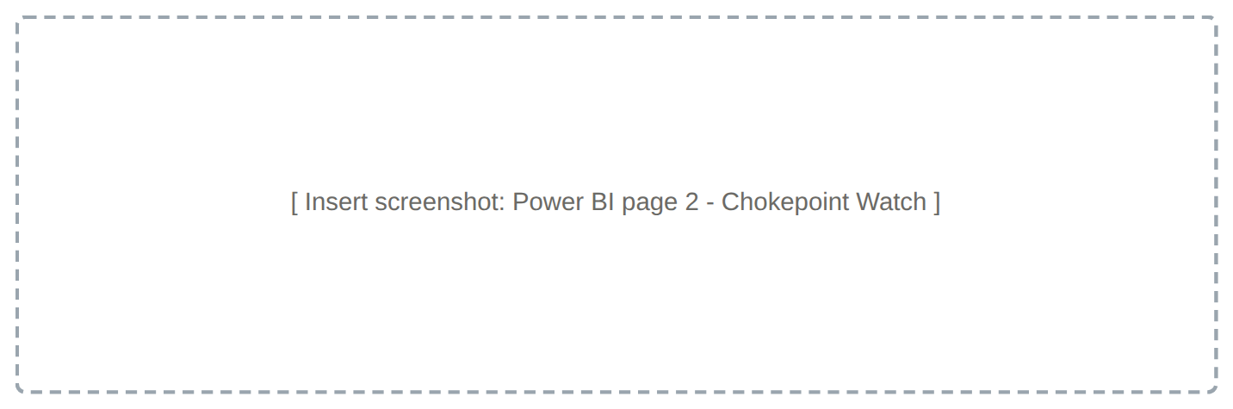
Figure C.4 : Screenshot: Power BI dashboard, page 2 - Chokepoint Watch (conflict index by sea lane, Hormuz transits and shipping disruptions)
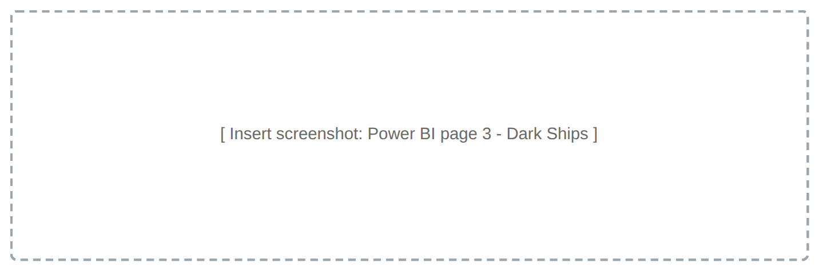
Figure C.5 : Screenshot: Power BI dashboard, page 3 - Dark Ships (SAR detections coloured by AIS status, dark share by sea and dark-ship clusters)
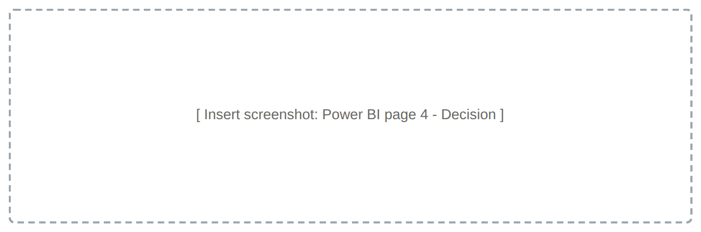
Figure C.6 : Screenshot: Power BI dashboard, page 4 - Decision (stock-days what-if, effective cover and the forecast risk of darkness)

ANNEX D - KEY REFERENCES AND DATA SOURCES
1. College of Defence Management (2026). Datathon-2026 General Instructions and theme datasets (ACLED Middle-East weekly aggregates; Sentinel-1 SAR vessel detections).
2. Raleigh, C. et al. (2010). Introducing ACLED. Journal of Peace Research 47(5), 651-660.
3. Paolo, F.S. et al. (2024). Satellite mapping reveals extensive industrial activity at sea. Nature 625, 85-91.
4. UNCTAD (2024). Review of Maritime Transport 2024. U.S. EIA (2024). World Oil Transit Chokepoints.
5. Killick, R., Fearnhead, P., Eckley, I.A. (2012). Optimal detection of changepoints with a linear computational cost. JASA 107, 1590-1598.
6. Getis, A., Ord, J.K. (1992); Ord, J.K., Getis, A. (1995). Local spatial statistics. Geographical Analysis 24(3); 27(4).
7. Ester, M. et al. (1996). DBSCAN. Proc. KDD-96, 226-231. Kaplan, E.L., Meier, P. (1958). JASA 53, 457-481. Cox, D.R. (1972). JRSS-B 34, 187-220.
8. Roberts, D.R. et al. (2017). Cross-validation strategies for structured data. Ecography 40, 913-929.
9. Open data: EIA Brent/WTI spot prices (github.com/datasets/oil-prices); Federal Reserve H.10 INR/US$ (github.com/datasets/exchange-rates); Energy Institute Statistical Review via Our World in Data (github.com/owid/energy-data); Natural Earth ports. Icons: Font Awesome Free (CC BY 4.0).
10. IMF PortWatch (2026). Daily chokepoint transit calls, 28 chokepoints, 2019-2026 (portwatch.imf.org; mirror github.com/ebiisharifi/hormuz-chokepoint-analytics).
11. Open-source reporting: Press Information Bureau (defence budget 2026-27); All India Radio News; Operation Urja Suraksha (from 23 Mar 2026); The National and Al Jazeera (Hormuz and Red Sea shipping); CNBC and straits.live (Hormuz reopening, late June 2026).
12. Jayadev, A. (2021). Predictive Maintenance in Armed Forces: A Machine Learning Based Decision Support System. M.Tech report, IIT Kharagpur.

