COLLEGE OF DEFENCE MANAGEMENT · DATATHON - 2026
Theme: Global Conflicts – Impact on Supply Chains
PROJECT DARKWATER
Global Conflicts and the Blinding of Supply Chains: Maritime Picture Assurance at Contested Chokepoints, with Implications for India and the Indian Armed Forces
Submitted by
[Rank] ARJUN JAYADEV
[Service No] · [Unit / Formation]
Submitted to the Faculty of Decision Sciences, College of Defence Management, Secunderabad
under the aegis of HQ Integrated Defence Staff
September 2026
Accompanying files: Power BI dashboard (.pbix), star-schema data tables, analysis source code

DECLARATION
I hereby certify that:
• The work in this report is original and has been done by me for Datathon-2026 of the College of Defence Management.
• The analysis uses the unclassified datasets provided on the CDM website and open-source literature. No classified information has been used.
• Due credit has been given to all data, inferences and references from external sources, and they are cited appropriately.
• All figures, tables and statistics can be reproduced from the submitted code and data.
Place: ____________
Date: September 2026
([Rank] Arjun Jayadev)
[Service No]

ACKNOWLEDGEMENT
I thank the College of Defence Management and HQ Integrated Defence Staff for conducting Datathon-2026 and for placing contemporary, unclassified datasets in the hands of serving officers. I am grateful to my Commanding Officer and superiors for their encouragement, and to the open-data communities (ACLED, Global Fishing Watch, Copernicus Sentinel-1) whose work made this study possible. The analytical grounding I received during my M.Tech at IIT Kharagpur, where I applied survival analysis to predictive maintenance of armoured vehicles, shaped much of the method used here.

ABSTRACT
The Datathon-2026 theme Global Conflicts - Impact on Supply Chains asks how conflicts affect world shipping, and specifically asks participants to identify AIS dead zones and relate them to the identification crisis created by local conflicts. This study combines eleven and a half years of weekly Middle-East conflict data (ACLED; 614,119 events) with 106,533 Sentinel-1 radar vessel detections matched to AIS during the first two weeks of the 2026 regional war (1-14 March 2026).
Change-point detection dates the regime shifts in regional violence to 7 October 2023 and 28 February 2026 without being given either date. The war regime ran at 2.9 times the previous year's rate and was dominated (84 per cent) by stand-off strikes, which reached the GCC energy coast (124-fold rise). A new Chokepoint Conflict Intensity Index shows that the Red Sea threat moved offshore and that the Hormuz littoral reached 188 times its baseline. Survival analysis of 32 disruption episodes shows a heavy tail: 62% outlast India's strategic petroleum reserve.
Large ships were AIS-dark in 74% of cases in the Strait of Hormuz and 38% in the Black Sea, against about 10 per cent in peacetime waters (relative risk 4.7, odds ratio 8.0). Getis-Ord hot spots and DBSCAN clusters locate fleets of dark tankers waiting at the Dubai and Fujairah anchorages. A gradient-boosted model validated on unseen sea regions (ROC-AUC 0.69) predicts AIS dark spots from conflict geography. Open-source oil-price, exchange-rate and energy data show the Hormuz war raised Brent by up to 94% and added about US$27 billion to India's oil bill. The study's June 2026 early-warning call (Red, with Brent back at US$70) was followed by an 86% rise in oil prices.
The main inference is that the first measurable effect of war at a chokepoint is the blinding of the supply chain, followed by physical disruption that lasts longer than national buffers. The report then assesses the impact on the globe, on India and on the Indian Armed Forces (Navy, Air Force, Army and joint), gives a prescriptive stock-cover model (returns flatten at about 35 days of cover), and sets out a way forward of fifteen staffed recommendations, a phased roadmap and a Power BI decision dashboard, before concluding.
Keywords: supply chain, chokepoints, AIS dark vessels, SAR, ACLED, change-point detection, Getis-Ord Gi*, DBSCAN, survival analysis, spatial cross-validation, Indian Armed Forces logistics.

EXECUTIVE SUMMARY
BOTTOM LINE UP FRONT. When war reaches a sea chokepoint, the first thing to fail is the maritime picture: big ships stop identifying themselves, so AIS-based counts overstate how much shipping has gone and hide what is still there. The disruption then outlasts our reserves and cost India about US$27 billion in six months. Our warning signals saw it coming when the market did not.

Situation
War reached the Strait of Hormuz on 28 February 2026. This study joins 11 years of conflict data, satellite radar of 106,533 ships in the first fortnight, IMF daily transit counts at 28 world chokepoints, and open oil, rupee, energy and news sources to September 2026.

Assessment
1. The storm. Violence nearly tripled (2.9x); 84% by missiles and drones; the Gulf states were hit 124 times more than before.
2. The picture failed. 74% of big ships at Hormuz were dark against 10% in peaceful seas. AIS counts fell 83%, but radar saw most hulls still there, many of them held at anchor. The Gulf darkened 5.7 points a day faster than 11 control seas.
3. Four behaviours, not one. Concealment in the Gulf, evacuation from the Red Sea, a frozen Black Sea, and compliance in the East Med (8% dark beside heavy fighting).
4. It lasts. Fighting flares for weeks, but shipping disruption lasts months: Hormuz transits fell 92% (zero on 4 March) and at world chokepoints the median disruption ran 104 days, 62% outlasting India's 74-day national cover.
5. The bill. Brent $71 to $138; in March the extra oil bill equalled 59-70% of the monthly defence budget.
6. We saw it coming. On 26 June the market relaxed ($70); our DARKWATCH signals stayed Red. Oil then rose 86%.

Deduction
The decision variable is the state of the corridor, not AIS silence alone. Classify first (concealment, evacuation, frozen, compliance), then act. Each needs a different response: escort and surveillance, rerouting, provenance checks, or sustained presence.

Recommendation
• Make Maritime Picture Assurance a named joint warning function under HQ IDS, run through IFC-IOR, with the SDR and DARKWATCH as standing products.
• Size fuel, aviation-fuel and critical-spares reserves for all three Services at 35-45 days as a bridge, and cut exposure to any one chokepoint, because stocks bridge; diversification carries; harden rear areas against drones and missiles; GPS-resilient navigation.
• Standing rule: no AIS-derived traffic count for a contested corridor without a radar cross-check.

Decision sought
Approve a four-month Phase 1 proof of concept using existing establishment, free Copernicus Sentinel-1 imagery and the analysis pipeline already built. Continue only if a principal acts on a DARKWATCH warning in that period.

THE STUDY AT A GLANCE
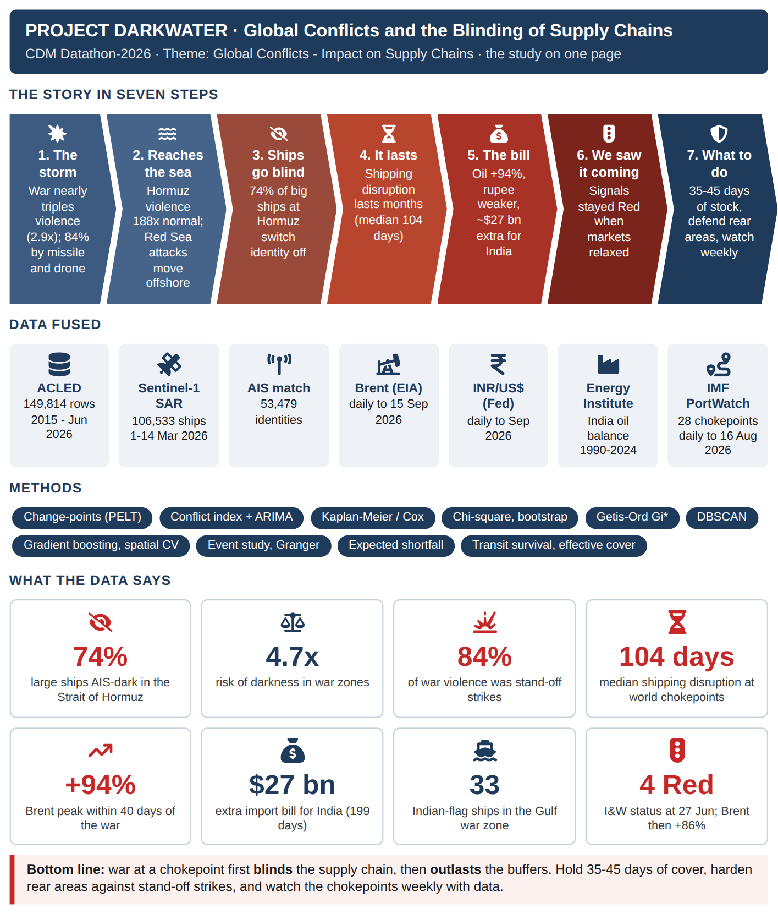

DATA ANALYTICS IN PLAIN WORDS
This report uses a number of data-analytics tools. None of them needs to be understood in detail to follow the story: every chapter opens with The story so far, closes with So what, and every chart carries a one-line What this shows. The terms below are explained in plain words for readers who want them.
Term | What it means, in plain words
AIS (Automatic Identification System) | A ship's identity beacon. It broadcasts name, position and course. It works like IFF for merchant ships, and a ship can switch it off.
AIS-dark ship | A ship that satellite radar can see but that is not transmitting its identity: a vehicle driving at night with its lights off.
SAR (satellite radar) | A radar satellite that sees ships day and night, through cloud, whether or not they transmit.
Chokepoint | A narrow sea passage that ships cannot easily avoid, such as Hormuz or Bab-el-Mandeb: a defile on the sea lanes.
Relative risk / 'x times more likely' | How much more often something happens in one group than another. A relative risk of 4.7 means 4.7 times as often.
p-value | The chance that a result is a fluke. Below 0.05 means less than 1 in 20. Most results here are far smaller, i.e. almost certainly real.
Confidence interval | The range in which the true value probably lies, like the beaten zone of a weapon rather than a single point.
Change-point detection | A method that finds the dates when the 'battle rhythm' changed, without being told what to look for.
Conflict intensity index (CCII) | A weekly thermometer of violence around each sea route, built from open conflict data.
Forecast (ARIMA) | Projects the thermometer forward a few months, with a band showing the likely range.
Survival analysis (Kaplan-Meier, Cox) | Measures how long crises last and what makes them last longer. It is the same tool used for time between equipment failures.
Hot-spot analysis (Getis-Ord Gi*) | Finds places where dark ships bunch together more than chance would allow, like an incident-density overlay.
Cluster finding (DBSCAN) | Automatically finds groups of ships close together, such as tanker queues at an anchorage.
Machine-learning model | A program that learns a rule from 62,000 examples. It was tested only on seas it had never seen, like testing a soldier on unfamiliar ground.
Model score (ROC-AUC) | How well a model separates dark ships from visible ones: 0.5 is a coin toss, 1.0 is perfect.
Bootstrap | Re-running the analysis 2,000 times on re-shuffled satellite pictures to check that the answer does not change.
Dose-response | The stronger the exposure, the stronger the effect. Here: the closer to the fighting, the more ships go dark.
Competing hypotheses | Standard intelligence tradecraft: list every possible explanation and keep the one the evidence does not contradict.
Event study | Tracking a price day by day after a shock, to see how big and how lasting the effect was.
Granger test | Checks whether A reliably happens before B, i.e. whether A could serve as a warning of B.
Expected shortfall | The average number of days a stock would run short in a crisis. It is used here to size fuel and spares reserves.
I&W (indicators and warnings) | A short watch-list of measurable signals with thresholds that trigger pre-agreed actions.
Strategic Dark Ratio (SDR) | Of the big ships (100 m and over) the radar sees in one satellite image, the share not transmitting their identity. Peaceful seas: about 10%.
Maritime Picture Assurance | Checking, as a standing duty, that the maritime picture used for decisions still represents the ships actually on the water.
DARKWATCH | The six-signal watch-list built in this study, with Amber and Red thresholds and a pre-agreed action for each.
Stasis index | The share of ships seen in the same 100 m square on two different days: a ship under way cannot do that, a ship at anchor can.
Difference-in-differences | Did the Gulf change more than everywhere else over the same fortnight? Compares the change, not just the level.
Estimative language | 'Almost certain' (over 95%), 'highly likely' (80-95%), 'likely' (55-80%): the standard way intelligence expresses probability.

LIST OF ABBREVIATIONS
ACLED | Armed Conflict Location & Event Data
AIS | Automatic Identification System
AUC | Area Under the (ROC) Curve
CCII | Chokepoint Conflict Intensity Index
CI | Confidence Interval
DBSCAN | Density-Based Spatial Clustering of Applications with Noise
FoC | Flag of Convenience
GBT | Gradient-Boosted Trees
GCC | Gulf Cooperation Council
GNSS | Global Navigation Satellite System
HR | Hazard Ratio
IFC-IOR | Information Fusion Centre - Indian Ocean Region
IMEC | India-Middle East-Europe Economic Corridor
INSTC | International North-South Transport Corridor
KM | Kaplan-Meier
MDA | Maritime Domain Awareness
MID | Maritime Identification Digits
MMSI | Maritime Mobile Service Identity
OR | Odds Ratio
PELT | Pruned Exact Linear Time
POL | Petroleum, Oil and Lubricants
RR | Relative Risk
SAR | Synthetic Aperture Radar
SPR | Strategic Petroleum Reserve
VLCC | Very Large Crude Carrier
WWR | War Wastage Reserve

LIST OF FIGURES

Figure 1.1 Analytical framework - from data to decision (SmartArt)
Figure 3.1 Theatre of study: India's western sea lines of communication, chokepoints and headline findings (infographic; ports from Natural Earth, dashed lines are schematic sea routes)
Figure 5.1 Annual events and reported fatalities, 2015-2026 (2026 = 26 weeks)
Figure 5.2 Share of event types by year
Figure 5.3 Political-violence events by country and year (log colour scale)
Figure 5.4 Weekly political violence with PELT change-points (orange = regime mean)
Figure 5.5 Share of stand-off strikes (air/drone strike, shelling/missile) in political violence, quarterly
Figure 5.6 Weekly political violence inside the GCC states, June 2025 - June 2026
Figure 5.7 Geography of political violence, 28 February - 10 April 2026
Figure 5.8 Conflict at sea: ACLED at-sea events by year and by sub-type
Figure 6.1 Chokepoint Conflict Intensity Index by theatre, 2015-2026
Figure 6.2 Red Sea theatre: stand-off strikes on the Yemeni littoral versus violence at sea
Figure 6.3 Theatre stress relative to its disruption threshold (4-week rolling mean, symmetric-log scale)
Figure 6.4 Hormuz CCII: observed values and 13-week ARIMA forecast with 80 per cent interval
Figure 6.5 Kaplan-Meier survival of disruption episodes; red lines mark India's strategic oil cover
Figure 7.1 Sentinel-1 vessel detections, 1-14 March 2026 (blue = AIS-matched, orange = AIS-dark)
Figure 7.2 AIS-dark share by sea region, all vessels and large vessels, with 95 per cent Wilson intervals
Figure 7.3 The two dominant responses of shipping to conflict: blinding versus diversion (infographic; full typology in Figure 7.13)
Figure 7.4 AIS-dark share by vessel size class and zone
Figure 7.5 Dark share and Getis-Ord Gi* hot spots, ships ≥ 60 m, India's western approaches (0.5° cells)
Figure 7.6 Global Gi* hot spots of AIS-dark ships ≥ 60 m (1° cells)
Figure 7.7 DBSCAN clusters of AIS-dark ships ≥ 100 m (numbers = rank in Table 7.3)
Figure 7.8 Gulf war zone: detections per SAR scene and share AIS-dark, 1-14 March 2026
Figure 7.9 Registry class of AIS-visible large ships by zone (MMSI MID decode)
Figure 7.10 Arabian Sea and Bay of Bengal: AIS-matched, small dark and large dark detections
Figure 7.11 Presence vs identity: big hulls seen by radar and those transmitting AIS, same sea area, 4 and 12 March 2026
Figure 7.12 Flag mix of the big hulls still transmitting AIS in the Gulf, week 1 against week 2
Figure 7.13 The four signatures of a sea line under stress (infographic)
Figure 8.1 ROC curves (leave-one-region-out) and permutation importance
Figure 8.2 Model response: predicted darkness against distance from active conflict
Figure 8.3 Predicted AIS dark-spot surface for a 180 m merchant ship, early-March-2026 conflict picture
Figure 9.1 Brent crude (daily) against the chokepoint conflict indices, 2022 - September 2026
Figure 9.2 Brent response to four Middle-East conflict shocks (per cent change from the last close before the event)
Figure 9.3 INR per US$ since 2025, and weekly pass-through from Brent to the rupee (2015-2026)
Figure 9.4 India's oil consumption, production and import dependence, 1990-2024
Figure 9.5 Strait of Hormuz daily transits, September 2025 - August 2026 (IMF PortWatch)
Figure 9.6 Change in transits at 28 world chokepoints, March-August 2026 against March-August 2025
Figure 9.7 Bab-el-Mandeb, Suez and Cape of Good Hope transits, 2023-2026 (IMF PortWatch)
Figure 9.8 Survival of conflict flare-ups (ACLED) against shipping disruptions (IMF PortWatch) at chokepoints
Figure 10.1 Relative risk of AIS darkness under alternative specifications (scene-cluster bootstrap 95% CI)
Figure 10.2 AIS-dark share of large ships by distance from the nearest province with active fighting, Gulf war zone
Figure 12.1 Impact cascade: from conflict at the chokepoint to India's import bill and the Armed Forces (SmartArt)
Figure 12.2 Centre-of-gravity analysis: India's economic access to the sea, with measured critical vulnerabilities (after Strange, 1996)
Figure 13.1 Impact on the Indian Armed Forces at a glance (infographic)
Figure 13.2 Prescriptive stock-cover curve from observed Gulf and Red Sea disruption durations
Figure 13.3 Effective cover: how long a stock can replace the share of supply lost behind a closed chokepoint
Figure 14.1 I&W dashboard at 27 June 2026, with the out-of-sample oil-price test
Figure 14.2 Way-forward roadmap (SmartArt)
Figure 15.1 Five takeaways (infographic)

LIST OF TABLES

Table 1.1 Hypotheses tested in this study
Table 4.1 Summary of the conflict dataset (ACLED Middle-East weekly aggregates)
Table 4.2 Summary of the maritime dataset (Sentinel-1 SAR detections matched to AIS)
Table 4.3 Data headings analysed
Table 4.4 Data-cleaning log
Table 5.1 Conflict regimes detected by PELT
Table 5.2 Top provinces by political-violence events, 28 Feb - 10 Apr 2026
Table 6.1 12-week hold-out back-test of forecasting models (Hormuz littoral index)
Table 6.2 Disruption episodes by theatre
Table 6.3 Cox proportional-hazards model of the hazard of a disruption ending (reference: Black Sea)
Table 7.1 AIS-dark share by region (large = hull length ≥ 100 m)
Table 7.2 Significant dark hot-spot cells (1°) by region
Table 7.3 Largest clusters of dark ships ≥ 100 m
Table 7.4 Top flag states of visible large ships, Gulf war zone against rest of world
Table 7.5 Indicators of AIS identity anomalies
Table 7.6 Presence vs identity on a common footprint, Strait of Hormuz and approaches
Table 7.7 Stasis index: share of hulls re-detected within 100 m on a different day, against a crowding null
Table 7.8 Signature assignment by rule
Table 8.1 Logistic regression: odds ratios per 1 SD of each feature (all 62,624 ships ≥ 40 m)
Table 8.2 Model skill, leave-one-region-out cross-validation
Table 8.3 Predicted probability that a 180 m merchant ship is AIS-dark at points of interest to India
Table 9.1 Open-source datasets added to the study
Table 9.2 Event study results
Table 9.3 Granger-causality tests, weekly, 2015 - June 2026
Table 9.4 Estimated war premium on India's oil import bill (open-source data)
Table 9.5 The oil premium in defence terms
Table 9.6 The four layers of the maritime picture, each measured
Table 9.7 Shipping disruptions at world chokepoints, 2019-2026 (7-day transits below half of the prior-year median)
Table 9.8 Chronology of the crisis from open sources
Table 10.1 Key findings of the study
Table 10.2 Verdict on the hypotheses
Table 10.3 Robustness of the war-zone darkness effect
Table 10.4 Pass-level checks: feed outages and satellite pass time
Table 10.5 Difference-in-differences: did the Gulf darken faster than 11 control seas?
Table 10.6 Dose-response of darkness to proximity of fighting (Gulf war zone, ships ≥ 100 m)
Table 10.7 Analysis of competing hypotheses for AIS darkness in the Gulf (C = consistent, I = inconsistent, N = neutral)
Table 10.8 Scale of estimative probability used
Table 10.9 Key judgements
Table 12.1 Indian-flagged ships detected by Sentinel-1, 1-14 March 2026
Table 13.1 Decision table: stock held against disruption risk and expected shortfall
Table 13.2 Hormuz / Red Sea disruption scenarios: likelihood and uncovered days
Table 14.1 Recommendations traced to findings (F) and inferences (I)
Table 14.2 Staffing of the recommendations
Table 14.3 Indicators and warnings matrix - status at 27 June 2026
Table 14.4 Phased roadmap
Table A.1 Software stack
Table B.1 Power BI star schema

TABLE OF CONTENTS

Abstract
Executive Summary
The Study at a Glance
Data Analytics in Plain Words
List of Abbreviations
List of Figures
List of Tables
1. Introduction
1.1 Problem Statement
1.2 Aim
1.3 Objectives
1.4 Hypotheses
1.5 Methodology Overview
1.6 Organisation of the Report
2. Literature Review
3. Background
3.1 Maritime Chokepoints and Supply Chains
3.2 AIS, SAR and the Identification Crisis
3.3 Analytical Techniques
3.3.1 Proportions, confidence intervals and association
3.3.2 Change-point detection (PELT)
3.3.3 Local spatial statistics: Getis-Ord Gi*
3.3.4 Density clustering (DBSCAN)
3.3.5 Forecasting
3.3.6 Survival analysis
3.3.7 Classification and spatial cross-validation
3.3.8 Expected shortfall of a stock policy
4. Data Preprocessing
4.1 Cleaning
4.2 Feature Engineering
5. Conflict Landscape of the Middle East, 2015-2026
5.1 Regime Shifts (H1)
5.2 Stand-off Warfare and the Spill-over to the Energy Coast (H2)
6. Chokepoint Conflict Intensity and Disruption Survival
6.1 The Chokepoint Conflict Intensity Index (CCII)
6.2 Forecasting the Hormuz Index
6.3 How Long Do Disruptions Last? Survival Analysis
7. Maritime Traffic and AIS Dark Zones
7.1 Where Are Ships Dark? (H3)
7.2 Statistically Significant Dark Hot Spots (H4)
7.3 Where Do Dark Ships Gather? DBSCAN Clusters
7.4 The Daily Picture in the Gulf
7.5 Who Is Sailing? Flag States of Visible Ships
7.6 India's Maritime Neighbourhood
7.7 Identity Integrity
7.8 Did the Ships Leave, or Stop Identifying Themselves?
7.9 Who Kept Transmitting?
7.10 Four Signatures of a Sea Line Under Stress
8. Predicting AIS Dark Spots
9. Economic and Shipping Transmission: Evidence from Open-Source Data
9.1 Open-Source Data Used
9.2 Oil Price and Chokepoint Conflict
9.3 Event Study: Four Conflict Shocks
9.4 Does Conflict Intensity Lead the Oil Price?
9.5 The Rupee
9.6 India's Structural Exposure
9.7 The War Premium on India's Import Bill
9.8 Out-of-Sample Test of the Early-Warning Call
9.9 Movement: Chokepoint Transits (IMF PortWatch)
9.10 Presence, Identity and Movement Together
9.11 Evacuation Confirmed at the Red Sea
9.12 How Long Do Shipping Disruptions Last?
9.13 Open-Source Chronology
10. Inference
10.1 Key Findings
10.2 Verdict on the Hypotheses
10.3 Inferences Drawn
10.4 Stress-Testing the Central Inference: Robustness
10.5 Dose-Response Inside the Gulf
10.6 Analysis of Competing Hypotheses
10.7 Key Judgements and Confidence
10.8 Limitations
11. Impact on the Globe
12. Impact on India
13. Impact on the Indian Armed Forces
13.1 Joint and Tri-Service Impact
13.2 Indian Navy
13.3 Indian Air Force
13.4 Indian Army
13.5 Prescriptive Model: How Much Stock Is Enough?
13.6 Scenario Matrix for Force Planning
14. Way Forward
14.1 Recommendations
14.2 DARKWATCH: the Indicators and Warnings (I&W) Matrix
14.3 Phased Roadmap
14.4 Future Research
15. Conclusion
15.1 Conflict Analytics
15.2 Disruption Survival
15.3 AIS Dark Zones
15.4 Implications
16. References
Appendix A - Toolchain and Reproducibility
Appendix B - Power BI Dashboard Data Model

1. INTRODUCTION
PROLOGUE - THE QUESTION
THE STORY SO FAR
In February 2026 a war broke out on the shores of the world's most important oil strait. This report asks a commander's questions about it. What did the war do to the ships that carry India's oil and trade? How long does such a disruption last? What did it cost? Could we have seen it coming, and what should India and its Armed Forces do next time?

Around 80 per cent of world merchandise trade by volume moves by sea, and a large share of it passes through a handful of narrow chokepoints: the Strait of Hormuz, Bab-el-Mandeb, the Suez Canal, the Strait of Malacca, the Bosphorus and a few others [1, 2]. When conflict reaches one of these straits, the effect spreads through energy prices, freight rates, insurance premia and delivery lead-times to every economy that depends on them. Between October 2023 and June 2026 the Middle East produced two such shocks in quick succession. The first was the Houthi anti-shipping campaign in the Red Sea and Gulf of Aden, which diverted a large part of Asia-Europe container traffic around the Cape of Good Hope [1]. The second was the regional war that broke out on 28 February 2026 and carried missile and drone strikes to the Iranian coast and the Gulf Cooperation Council (GCC) states around the Strait of Hormuz.
Conflict affects shipping in two ways. The obvious effect is physical: ships are struck, diverted or held in port. The less obvious effect is informational. Ships in or near a war zone switch off or manipulate their Automatic Identification System (AIS) transponders to avoid being targeted. Electronic warfare jams and spoofs satellite navigation. Sanctions-evading fleets operate dark by design. The common maritime picture, which navies, insurers, port authorities and logisticians all rely on, then loses its identities. The Datathon-2026 problem statement calls this an identification crisis and asks participants to find AIS dead zones and relate them to local conflicts such as those in the Black Sea and the Persian Gulf [3].
This report takes up that problem with two unclassified datasets from the Datathon repository and a set of descriptive, diagnostic, predictive and prescriptive techniques. The first dataset is eleven and a half years of weekly Middle-East conflict events (ACLED). The second is 1-14 March 2026 of Sentinel-1 synthetic-aperture-radar (SAR) vessel detections matched against AIS. The report works from the evidence to inferences, then to the impact on the globe, on India and on the Indian Armed Forces, and ends with a way forward and a conclusion, each traced back to a finding in the analysis.
Thesis. Conflict near a maritime chokepoint shows up in the data first as the blinding of the supply chain: large, AIS-obligated ships vanish from the cooperative picture. Only after that does it show up as the physical disruption of trade flows. In March 2026, large ships in the Gulf war zone were 4.7 times more likely to be AIS-dark than large ships elsewhere, and distance from the fighting predicts darkness even in regions the model has never seen. Disruption episodes have a heavy tail: about 62% outlast the ~9.5 days of India's strategic petroleum reserve. India's economic and military exposure therefore has to be managed as one data problem, joining maritime domain awareness with stock-holding policy.

1.1 Problem Statement
Can open conflict and satellite data be used to (i) measure how Middle-East conflict intensity near maritime chokepoints has changed, (ii) locate and explain AIS dark zones and relate them to that conflict, (iii) predict where AIS darkness will appear, and (iv) turn the results into quantified guidance for India's supply-chain security and for the Indian Armed Forces' logistics and operational preparedness?

1.2 Aim
To derive data-driven insights on the impact of global, and in particular Middle-East, conflicts on maritime supply chains, with a focus on AIS dark zones and chokepoint disruption, and to recommend measures for India and the Indian Armed Forces.

1.3 Objectives
(a) Build a clean, reproducible data pipeline for the ACLED conflict and Sentinel-1 SAR/AIS datasets (Chapter 4).
(b) Characterise the Middle-East conflict system from 2015 to 2026, detect statistically significant regime shifts and measure the spill-over of the 2026 war onto the GCC energy coast (Chapter 5).
(c) Construct a Chokepoint Conflict Intensity Index (CCII), forecast it and model how long disruption episodes last with survival analysis (Chapter 6).
(d) Map AIS darkness worldwide, test whether it is significantly higher in war zones, find statistically significant dark hot spots and dark-vessel clusters, and profile the identity and registry of ships in the war zone (Chapter 7).
(e) Train and validate a model that predicts AIS dark spots from conflict geography (Chapter 8).
(f) Measure the economic transmission of the conflict (oil price, rupee, India's import bill) with open-source data, and test the early-warning indicators out-of-sample (Chapter 9).
(g) Draw inferences from the findings and assess their impact on the globe, India and the Indian Armed Forces, with a prescriptive stock-cover model, a way forward and a conclusion (Chapters 10-15).

1.4 Hypotheses
Table 1.1 : Hypotheses tested in this study
# | Hypothesis | Test
H1 | Middle-East political violence underwent statistically significant regime shifts that coincide with the 2023 and 2026 wars. | Change-point detection (PELT), Mann-Whitney U
H2 | The 2026 war moved conflict onto the maritime/energy littoral (GCC, Hormuz) and the Red Sea threat moved offshore. | Littoral and at-sea indices, rate multipliers
H3 | Large (>=100 m) vessels are significantly more often AIS-dark in war zones than elsewhere. | Chi-square, odds ratio, Wilson intervals
H4 | AIS darkness clusters in statistically significant hot spots that coincide with conflict chokepoints. | Getis-Ord Gi*, DBSCAN
H5 | Proximity to conflict predicts AIS darkness out-of-region. | Logit, gradient-boosted trees, leave-one-region-out CV
H6 | Chokepoint disruption durations are heavy-tailed and often exceed India's strategic oil cover. | Kaplan-Meier, Cox PH, expected shortfall
H7 | Conflict shocks transmit to the oil price and the rupee, and the size of the shock depends on whether a detour exists. | Event study, Granger causality, pass-through regression

1.5 Methodology Overview
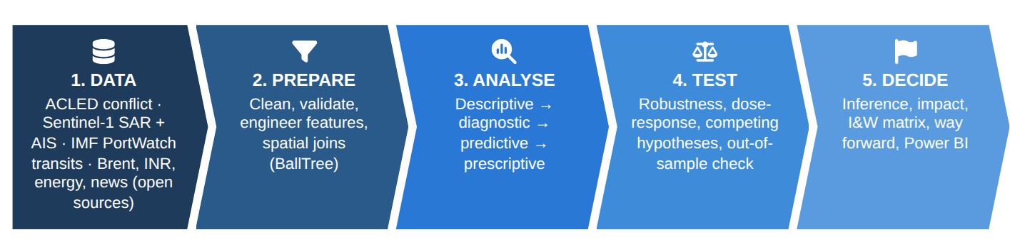
Figure 1.1 : Analytical framework - from data to decision (SmartArt)
The work was done in Python 3.11 (pandas, NumPy, SciPy, statsmodels, scikit-learn, ruptures, Matplotlib/Basemap). The cleaned star-schema tables are exported for the Power BI (.pbix) dashboard that accompanies the report (Appendix B). Running the whole pipeline with a single command (analysis/run_all.py) regenerates every figure, table and number in this report from the raw files.

1.6 Organisation of the Report
Chapter 2 reviews the literature and Chapter 3 sets out the theory behind the techniques used. Chapter 4 covers data pre-processing. Chapters 5 to 8 present the analysis: the conflict landscape, chokepoint intensity and disruption survival, AIS dark zones, and the predictive model. Chapter 9 adds open-source economic data. Chapter 10 draws the inferences. Chapters 11, 12 and 13 assess the impact on the globe, on India and on the Indian Armed Forces. Chapter 14 sets out the way forward and Chapter 15 concludes, followed by the references and appendices.
SO WHAT
A clear question and seven testable hypotheses.
Next: What do we already know from others' work?

2. LITERATURE REVIEW
BACKGROUND - WHAT OTHERS HAVE LEARNED
THE STORY SO FAR
Before looking at the evidence, we check what others have already learned about conflict data, satellite tracking of ships and supply chains, and where the gap is that this study fills.

The study drew on work in conflict-event data, maritime remote sensing, maritime security and statistical methods. The works that shaped the study most are summarised below.
(a) Raleigh et al. (2010) introduced the Armed Conflict Location and Event Data (ACLED) project, which codes political violence and protest events by date, location, actor and type [4]. The event typology used here (battles, explosions/remote violence, violence against civilians, riots, protests, strategic developments) and the weekly ADMIN1 aggregates come from ACLED. Aggregation to province centroids limits spatial precision, so this study measures distance to conflict at ADMIN1 resolution and treats the at-sea regions separately.
(b) Paolo et al. (2024), writing in Nature, combined Sentinel-1 SAR imagery with deep learning and AIS to map industrial activity at sea. They found that about 72-76 per cent of the world's industrial fishing vessels and about a quarter of transport and energy vessels are not publicly tracked [5]. The SAR detections, presence, length and fishing scores and the AIS-matching logic in the Datathon SAR dataset follow the same approach. That result gives a baseline level of darkness against which conflict-related darkness can be measured.
(c) UNCTAD, Review of Maritime Transport (2024) documented the Red Sea crisis: collapsing Suez and Bab-el-Mandeb transits, Cape of Good Hope diversions adding roughly 10-14 days to Asia-Europe voyages, and the knock-on effects on freight rates, emissions and developing-country trade costs [1]. It frames the physical-disruption channel that this study pairs with the informational (AIS) channel.
(d) U.S. Energy Information Administration (2024), World Oil Transit Chokepoints, estimates that flows through the Strait of Hormuz are about one-fifth of global petroleum liquids consumption, with most of them going to Asian buyers including India, and that alternative pipeline bypass capacity is limited [2]. This makes Hormuz the single most consequential chokepoint for India.
(e) Killick, Fearnhead and Eckley (2012) proposed PELT (Pruned Exact Linear Time), an exact change-point search with linear cost [6]. Truong, Oudre and Vayatis (2020) reviewed offline change-point methods and released the ruptures library used here [7].
(f) Getis and Ord (1992) and Ord and Getis (1995) developed the G and Gi* local statistics for finding significant spatial clusters of high or low values (hot and cold spots) [8, 9]. Ester et al. (1996) proposed DBSCAN, a density-based clustering algorithm that finds arbitrarily shaped clusters and treats sparse points as noise [10]. It suits the detection of anchorages and ship-to-ship transfer areas.
(g) Kaplan and Meier (1958) and Cox (1972) established the non-parametric survival estimator and the proportional-hazards model [11, 12]. The author's earlier work on predictive maintenance of armoured vehicles applied the same techniques to equipment time-to-failure data [13]. Here they are transferred to the time-to-end of chokepoint disruption episodes.
(h) Roberts et al. (2017) showed that ordinary random cross-validation overstates model skill when data are spatially autocorrelated and recommended blocked (e.g. leave-one-region-out) validation [14]. Friedman (2001) introduced gradient boosting [15]. Hyndman and Athanasopoulos (2021) give the forecasting practice (ARIMA, exponential smoothing, hold-out back-testing) followed here [16].
Gap addressed. The literature treats conflict data, SAR/AIS data and supply-chain economics separately. No study found joins weekly conflict intensity at chokepoints to SAR-observed AIS darkness during a live war. Nor has any study turned the resulting disruption-duration distribution into a stock-holding decision for an Indian user. That join is what this study contributes.
SO WHAT
Nobody has yet joined conflict data, satellite ship data and India's supply needs in one study. That is the gap filled here.
Next: What tools will we use?

3. BACKGROUND
BACKGROUND - THE TOOLS, IN PLAIN WORDS
THE STORY SO FAR
The investigation uses a set of analytical tools. This chapter explains what each tool does. A commander who only wants the answers can read the plain-language summaries and the glossary, and skip the equations.

3.1 Maritime Chokepoints and Supply Chains
A chokepoint is a narrow channel on a widely used sea route that cannot easily be bypassed. Closing or degrading one adds distance, time and insurance cost to every voyage that depends on it. For some cargoes (Gulf crude, LPG and LNG, Qatari gas, Gulf fertiliser) there is little or no alternative supply in the short run. The Strait of Hormuz (~39 km wide at its narrowest point) connects the Persian Gulf producers to the Arabian Sea. Bab-el-Mandeb (~29 km) connects the Gulf of Aden to the Red Sea and the Suez Canal. Both lie within 2,000-3,000 km of India's west coast.
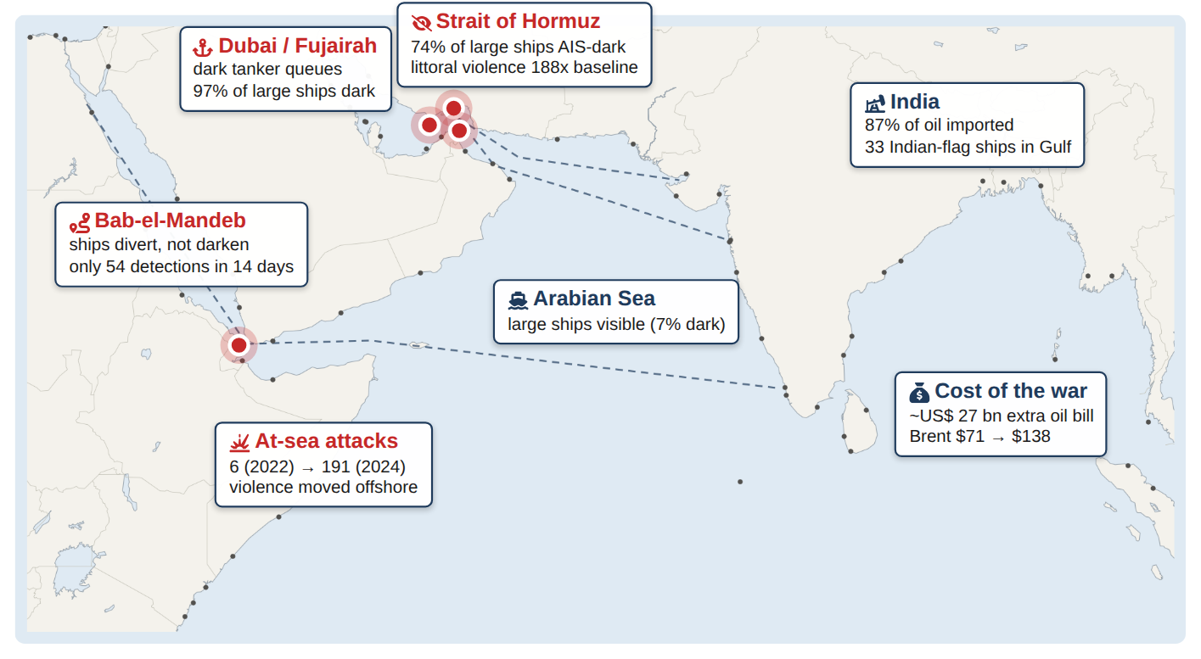
Figure 3.1 : Theatre of study: India's western sea lines of communication, chokepoints and headline findings (infographic; ports from Natural Earth, dashed lines are schematic sea routes)

3.2 AIS, SAR and the Identification Crisis
AIS is a VHF transponder system that broadcasts a ship's identity (MMSI), position, course and speed. Under SOLAS Chapter V, Regulation 19, AIS is mandatory for ships of 300 gross tonnage and above on international voyages, cargo ships of 500 GT and above, and all passenger ships [17]. The first three digits of the MMSI, the Maritime Identification Digits (MID), identify the flag state. AIS is cooperative: a ship can switch it off, transmit a false identity, or be displaced by GNSS spoofing so that its reported position no longer matches its real one.
SAR satellites such as Sentinel-1 image the sea surface day and night through cloud. A ship shows up as a bright return whatever it chooses to transmit. Matching SAR detections to AIS tracks at the image time separates cooperative (matched) ships from non-cooperative or dark (unmatched) ones. Small craft are dark almost everywhere because they are not required to carry AIS. A dark ship over 100 m long, which is almost certainly AIS-obligated, is an anomaly. This study uses the large-ship dark share as its main indicator of the identification crisis, and calls it the Strategic Dark Ratio (SDR): the share of SOLAS-class hulls (≥100 m) seen by radar in a pass that are not matched to AIS. Because both counts come from the same satellite image at the same instant, the SDR is not distorted by how often the satellite passes or how much sea it covers.
Three questions must be kept apart: presence (is a hull physically there?), identification (does it say who it is?) and movement (is it transiting or held?). A fourth, throughput, asks what cargo reaches the economy. No single sensor answers all four, and an AIS-derived traffic count answers only the second. Ensuring that the picture used for military, shipping and energy decisions still represents physical activity is called here Maritime Picture Assurance.

3.3 Analytical Techniques

3.3.1 Proportions, confidence intervals and association
The share of dark ships in a region is a binomial proportion p = x / n. Its 95 per cent Wilson score interval [18] is
( p + z²/2n ± z √( p(1-p)/n + z²/4n² ) ) / ( 1 + z²/n ), z = 1.96 (3.1)
Association between war-zone location and darkness is tested with Pearson's chi-square on the 2x2 contingency table, and its strength is expressed as the relative risk RR = p_{war} / p_{rest} and the odds ratio OR = (a·d)/(b·c). Differences in weekly event counts between periods are tested with the non-parametric Mann-Whitney U test, which assumes no particular distribution.

3.3.2 Change-point detection (PELT)
For a weekly series y_{1..T}, PELT finds the change-points τ₁<...<τ_{m} that minimise
Σ_{i=0..m} C( y_{τi+1 : τi+1} ) + β m , C = Σ( y_{t} - &ybar )² (L2 cost) (3.2)
where β is a penalty that prevents over-segmentation. The series was standardised, a penalty of 12 and a minimum segment of three weeks were used, and the search was exact (jump = 1).

3.3.3 Local spatial statistics: Getis-Ord Gi*
For grid cell i with value x_{j} (dark share) and binary neighbour weights w_{ij} (the cell itself and its eight neighbours):
G_{i}* = ( Σ_{j} w_{ij}x_{j} - X̄ Σ_{j} w_{ij} ) / ( S √( [ nΣw_{ij}² - (Σw_{ij})² ] / (n-1) ) ) (3.3)
G_{i}* is a z-score. Values above 1.96 mark a statistically significant hot spot at the 5 per cent level.

3.3.4 Density clustering (DBSCAN)
DBSCAN groups points that have at least minPts neighbours within radius ε. Using the haversine metric, ε = 25 km and minPts = 15 on dark ships of 100 m and over, it finds anchorages and loitering or transfer areas where large ships gather with their AIS off.

3.3.5 Forecasting
The weekly Hormuz index is log-transformed (y' = ln(1+y)) and modelled as ARIMA(1,0,1) with a constant:
y'_{t} = c + φ y'_{t-1} + θ ε_{t-1} + ε_{t} (3.4)
It is benchmarked against a naive forecast and damped-trend exponential smoothing on a 12-week hold-out.

3.3.6 Survival analysis
A disruption episode is a run of weeks in which a theatre's index is above its threshold (baseline mean + 3 SD). Its duration T is the survival time, and an episode still under way at the end of the data is right-censored. The Kaplan-Meier estimator of S(t) = P(T > t) is
Ŝ(t) = Π_{ti ≤ t} ( 1 - d_{i} / n_{i} ) (3.5)
where d_{i} episodes end at t_{i} out of n_{i} still at risk. Covariate effects are estimated with the Cox proportional-hazards model h(t|x) = h₀(t) exp(β'x), and theatres are compared with the log-rank test.

3.3.7 Classification and spatial cross-validation
The probability that a detected ship is dark is modelled with logistic regression, logit(p) = β₀ + β'x, which gives interpretable odds ratios, and with histogram gradient-boosted trees with monotonic constraints, which capture non-linear effects. Skill is measured by leave-one-region-out cross-validation, so every prediction is made for a sea region the model did not see in training [14], and reported as ROC-AUC, PR-AUC and Brier score.

3.3.8 Expected shortfall of a stock policy
If a disruption lasts T days and stock covers S days, the uncovered days are (T - S)+. With the Kaplan-Meier curve,
E[ (T - S)+ ] = ∫_{S}∞ Ŝ(t) dt (3.6)
This turns the disruption-duration distribution into a stock-holding decision curve (Section 13.5).
SO WHAT
Each tool answers one simple question: when did things change, where do dark ships gather, how long do crises last, and can we predict it?
Next: Is the evidence clean enough to trust?

4. DATA PREPROCESSING
BACKGROUND - CHECKING THE EVIDENCE
THE STORY SO FAR
Good decisions need clean evidence. Before any analysis, the two datasets were checked, cleaned and prepared, much as intelligence reports are collated and verified before they reach a commander.

Pre-processing is the backbone of any statistical model. Both datasets were loaded into pandas, validated, cleaned, enriched with derived features and written to a clean columnar store (Parquet). The two datasets are summarised below.
Table 4.1 : Summary of the conflict dataset (ACLED Middle-East weekly aggregates)
Parameter | Value
Study period | 03 Jan 2015 - 27 Jun 2026
Weeks covered | 600
Countries / sea areas | 17
ADMIN1 units | 243
Event-type classes | 6
Sub-event classes | 25
Total events | 614,119
Total fatalities | 552,700
Rows (country-admin1-week-subevent) | 149,814

Table 4.2 : Summary of the maritime dataset (Sentinel-1 SAR detections matched to AIS)
Parameter | Value
Observation window | 01 Mar 2026 - 14 Mar 2026
Sentinel-1 scenes | 2,833
Vessel detections | 106,533
Detections matched to AIS | 64,543 (60.6%)
Detections with no AIS match ('dark') | 41,990 (39.4%)
Median vessel length (m) | 64
Large vessels (>=100 m) | 40,179
Distinct MMSIs | 53,479
Sea regions defined | 17

Note on coverage. Although the SAR file is named indian ocean vessel, its detections cover the world (latitude -56° to 75°), with 2,833 Sentinel-1A scenes. This allows a controlled comparison: war zones (Gulf, Black Sea) against India's seas and the rest of the world, all imaged by the same sensor in the same fortnight.
Table 4.3 : Data headings analysed
Attribute | Dataset | Description
scene_id | SAR | Sentinel-1A scene identifier (image footprint)
timestamp | SAR | Image acquisition time (UTC)
lat / lon | SAR | Detected hull position
presence_score | SAR | CNN confidence that the object is a vessel (0-1)
length_m | SAR | Estimated hull length from SAR backscatter
mmsi | SAR | AIS identity of the matched track (blank when none)
matching_score | SAR | Confidence of the SAR-AIS association
fishing_score | SAR | Model probability that the hull is a fishing vessel
matched_category | SAR | AIS vessel class, or 'unmatched' (AIS-dark)
WEEK | ACLED | Week (Saturday start) of aggregation
COUNTRY / ADMIN1 | ACLED | Location of events (incl. 'Indian Ocean', 'Mediterranean Sea')
EVENT_TYPE / SUB_EVENT_TYPE | ACLED | 6 event types, 25 sub-event types
EVENTS / FATALITIES | ACLED | Counts per week-location-type
POPULATION_EXPOSURE | ACLED | Population within reach of events
CENTROID_LAT/LON | ACLED | ADMIN1 centroid used for geo-joins

4.1 Cleaning
Table 4.4 : Data-cleaning log
Dataset | Step | Count
ACLED | Rows loaded | 149,825
ACLED | Exact duplicate rows removed | 0
ACLED | Pre-2015 partial-coverage rows dropped | 11
ACLED | Negative counts found | 0
ACLED | Population exposure NaNs imputed (ADMIN1 median, else 0) | 30,965
ACLED | Rows after cleaning | 149,814
SAR | Rows loaded | 107,257
SAR | Duplicate detections (same scene & position) removed | 0
SAR | Invalid coordinates | 0
SAR | Low-confidence detections dropped (presence < 0.80) | 724
SAR | Malformed MMSI values flagged (outside 2xx-7xx MID range) | 1,565
SAR | Rows after cleaning | 106,533

• Temporal integrity. One partial week (27 Dec 2014) was dropped so that every year is complete. Weeks were re-indexed to a regular 7-day frequency, with zero-filling, before any time-series operation.
• Missing values. POPULATION_EXPOSURE is missing in 30,965 rows, mostly sea areas and sparsely populated provinces. It was imputed with the median of the same ADMIN1 unit, or 0 where the unit never reports it. No other field had missing values.
• Confidence filter. 724 SAR detections with presence score < 0.80 were dropped to remove sea clutter, wakes and ambiguous returns.
• Identity validity. 1,565 MMSIs outside the ship-station range (MID 2xx-7xx) were flagged as malformed and kept for the identity-integrity analysis (Section 7.7).
• Definition of darkness. Dark = matched_category 'unmatched' (no confident AIS association). This covers 39.4% of detections. A stricter definition (no candidate MMSI at all, 26.8%) was used as a robustness check and gives the same regional ranking.

4.2 Feature Engineering
• Sea region: 17 analyst-defined boxes (Strait of Hormuz, Persian Gulf, Gulf of Oman, Red Sea, Bab-el-Mandeb, Gulf of Aden, Arabian Sea, Bay of Bengal, Strait of Malacca, etc.), grouped into zones: Gulf war zone, Black Sea war zone, Red Sea zone, India's seas, rest of world.
• Size class from SAR length (<25, 25-40, 40-100, 100-200, >200 m). The large flag (≥100 m) marks ships that almost certainly carry AIS.
• Flag state decoded from the MID and classed as national flag, flag of convenience (ITF list) or shadow-fleet-associated registry.
• Distance to the nearest chokepoint (haversine) for every ship and every ADMIN1 centroid.
• Conflict exposure of every ship: distance to the nearest ADMIN1 with political violence in the war weeks overlapping the SAR window, and the number of such events within 500 km (BallTree haversine queries). At-sea ACLED rows carry a nominal basin centroid rather than a real position, so they were excluded from this spatial join.
• Conflict flags: political violence, remote violence (air/drone/missile/artillery), stand-off strike, GCC, maritime.
SO WHAT
Two clean datasets: 614,119 conflict events over 11 years and 106,533 ships seen from space in the first fortnight of the war.
Next: What does the conflict itself tell us?

5. CONFLICT LANDSCAPE OF THE MIDDLE EAST, 2015-2026
PART I OF THE STORY - THE STORM GATHERS
THE STORY SO FAR
With the evidence prepared, the story begins on land. Before we look at the sea, we need to know how the conflict itself grew, changed its character, and moved towards the energy coast of the Gulf.

The ACLED data record 614,119 events and 552,700 reported fatalities across 243 provinces in 600 weeks. This chapter describes how the conflict system evolved and tests hypotheses H1 and H2.
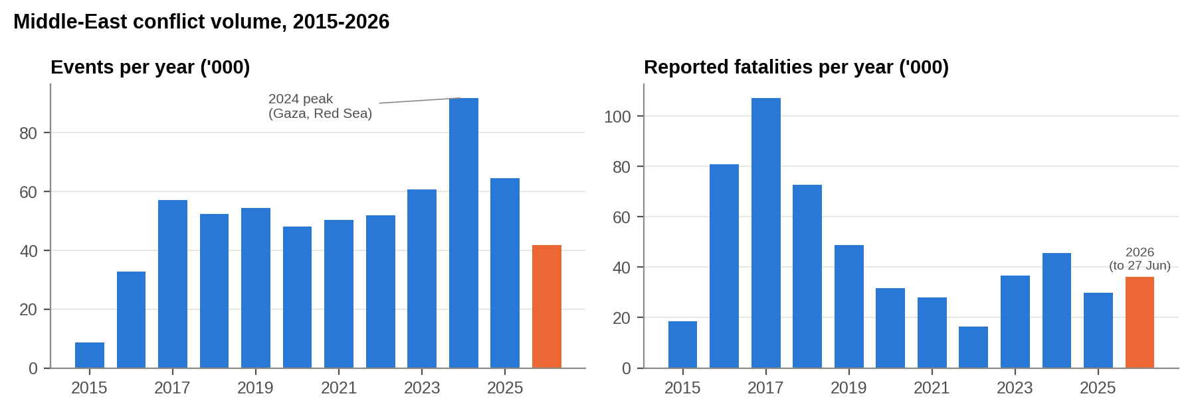
Figure 5.1 : Annual events and reported fatalities, 2015-2026 (2026 = 26 weeks)
What this shows: Violence in the Middle East peaked in 2024. In only six months, 2026 has already been one of the deadliest years of the decade.

Event volume peaked in 2024 (91,835 events), driven by the Gaza war, the Israel-Hezbollah escalation and the Red Sea campaign. In only 26 weeks, 2026 has already reached 41,865 events, and 2026 fatalities are the highest since 2019. Part of that fatality count comes from ACLED's coding of the January 2026 unrest in Iran: 27,496 fatalities in the single week of 3 January 2026, almost all coded as riots and protests. The rest comes from the war that began on 28 February.
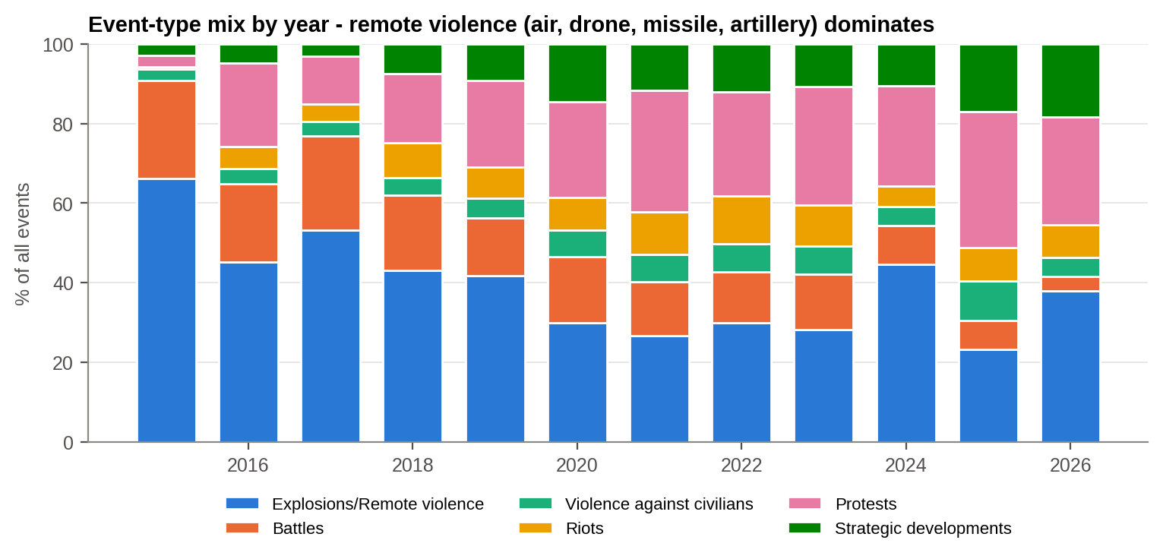
Figure 5.2 : Share of event types by year
What this shows: Each bar is one year. The blue part (missiles, drones, shelling) grows sharply whenever states go to war with each other.

Explosions/remote violence (air and drone strikes, shelling, missiles, IEDs) is the largest event type in most years. Its share rises sharply in years of inter-state war: 44.7 per cent in 2024 and 38.0 per cent in 2026. In between, protests and strategic developments dominate. The pattern for 2026 is clear: stand-off strikes (air/drone strike plus shelling/missile) made up 84 per cent of all political violence recorded between 28 February and 10 April 2026.
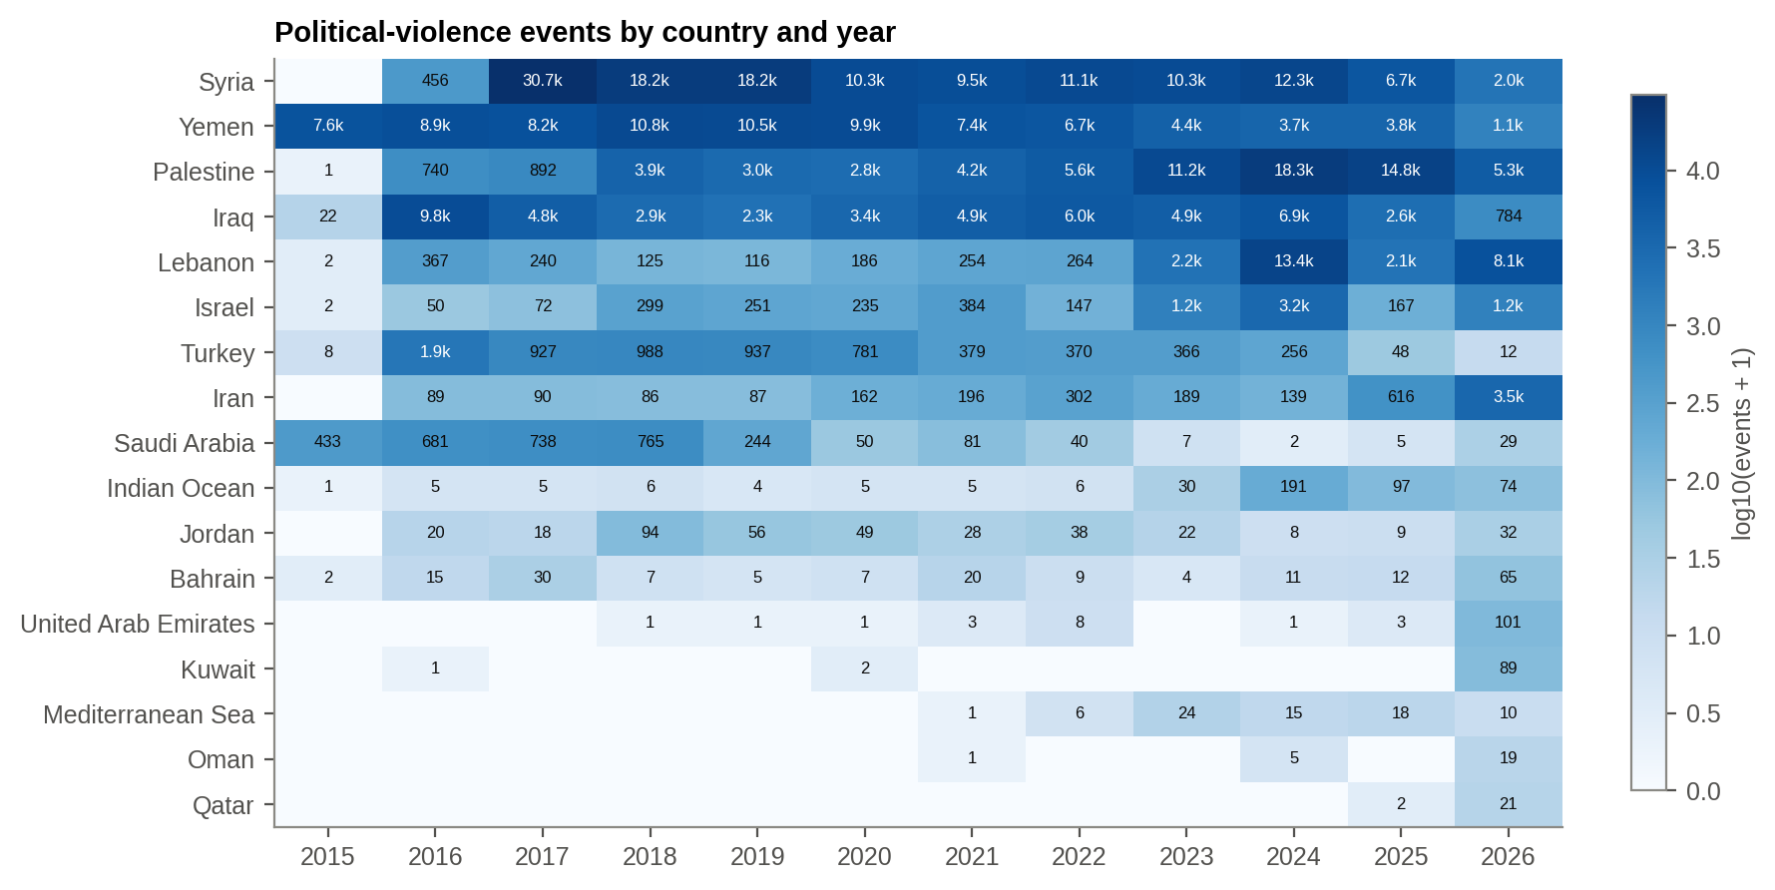
Figure 5.3 : Political-violence events by country and year (log colour scale)
What this shows: Darker cells mean more violence. Watch the conflict move from Syria and Iraq (left) to Israel, Lebanon and, in 2026, Iran and the Gulf states (right).

The heat map shows the conflict moving across the region. Syria and Iraq dominated from 2015 to 2018. Palestine, Israel and Lebanon rose after 2023. In 2026 Iran and the GCC states, which had previously seen little political violence, turned dark. Bahrain, Kuwait, the UAE, Qatar and Oman record more political violence in the first half of 2026 than in the previous decade.

5.1 Regime Shifts (H1)
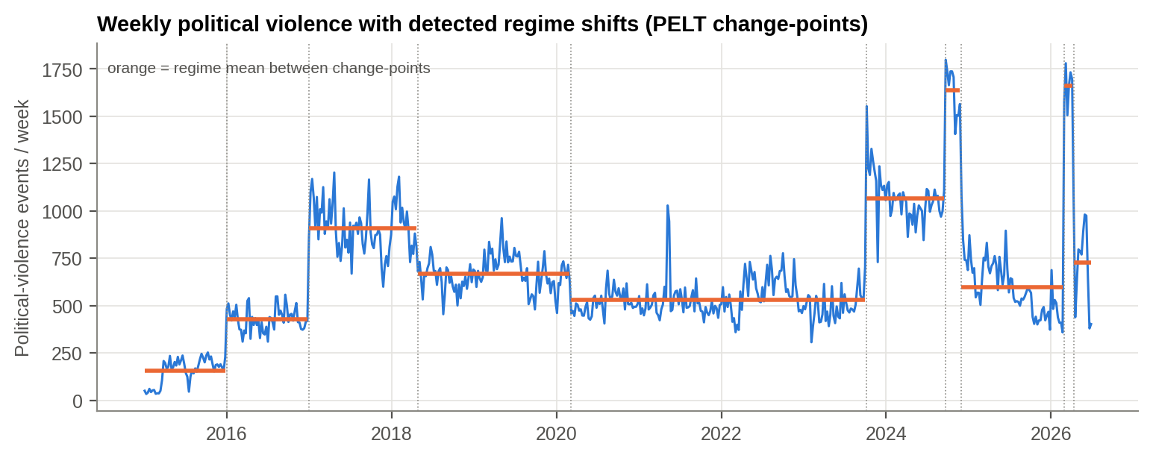
Figure 5.4 : Weekly political violence with PELT change-points (orange = regime mean)
What this shows: The orange steps are the 'battle rhythm'. The computer found, without being told, the exact weeks it changed: 7 Oct 2023 and 28 Feb 2026.

Table 5.1 : Conflict regimes detected by PELT
From | To | Weeks | Mean events/wk | SD
03 Jan 2015 | 26 Dec 2015 | 52 | 155 | 69
02 Jan 2016 | 24 Dec 2016 | 52 | 427 | 62
31 Dec 2016 | 21 Apr 2018 | 69 | 909 | 131
28 Apr 2018 | 29 Feb 2020 | 97 | 667 | 90
07 Mar 2020 | 30 Sep 2023 | 187 | 531 | 95
07 Oct 2023 | 14 Sep 2024 | 50 | 1,067 | 129
21 Sep 2024 | 23 Nov 2024 | 10 | 1,635 | 131
30 Nov 2024 | 21 Feb 2026 | 65 | 597 | 145
28 Feb 2026 | 04 Apr 2026 | 6 | 1,658 | 102
11 Apr 2026 | 27 Jun 2026 | 12 | 727 | 230

Without being told any dates, PELT placed change-points on 7 October 2023 (the Hamas attack on Israel and the start of the Gaza war), 21 September 2024 (the Israel-Hezbollah escalation), 30 November 2024 (the collapse of the Assad government followed shortly after) and 28 February 2026 (the regional war), with a de-escalation break on 11 April 2026. Weekly political violence averaged 1,658 events in the war regime against 568 in the preceding 52 weeks, a 2.9-fold rise (Mann-Whitney U, p = 3.6e-05). After the April break, violence settled at about 727 events a week, still above the pre-war level. H1 is supported.

5.2 Stand-off Warfare and the Spill-over to the Energy Coast (H2)
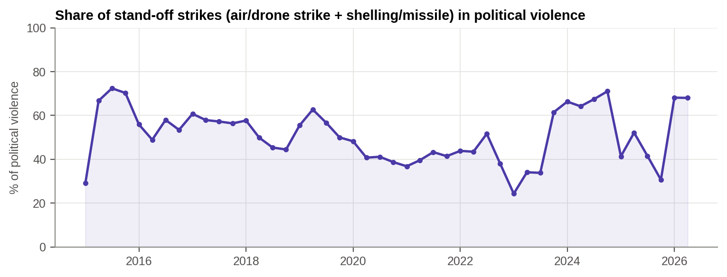
Figure 5.5 : Share of stand-off strikes (air/drone strike, shelling/missile) in political violence, quarterly
What this shows: The share of violence delivered from a distance jumps at the start of each war. A rising share is an early warning sign.

Stand-off strikes are not trending steadily upwards. Their share jumps when an inter-state war begins (linear trend p = 0.32), reaching 68 per cent in Q1-2026. The share of stand-off strikes therefore works as a signature of war: a rise in it is an early-warning signal that ranges, and with them threats to shipping and energy infrastructure, are about to extend.
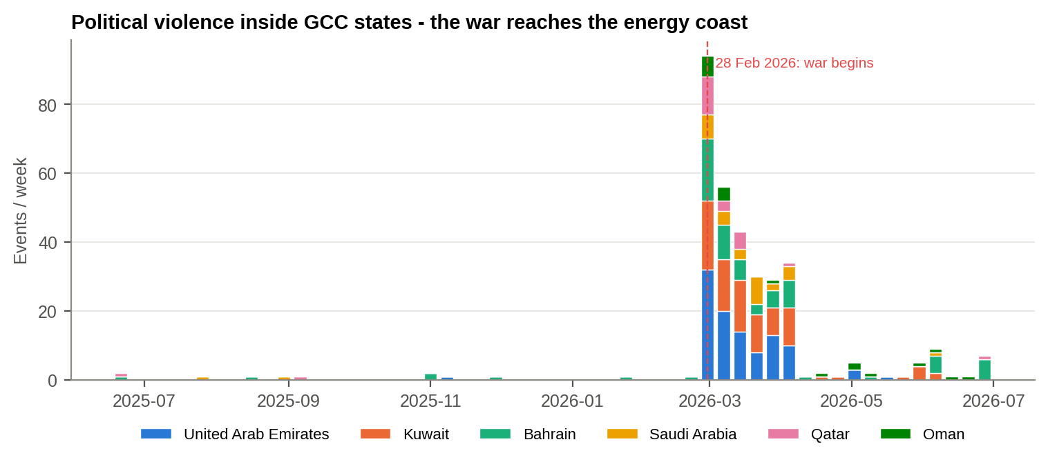
Figure 5.6 : Weekly political violence inside the GCC states, June 2025 - June 2026
What this shows: Before the war the Gulf states saw almost no violence. From 28 February they were hit every week.

Before the war the six GCC states together recorded about 0.4 political-violence events a week. In the six weeks from 28 February 2026 this rose to 47.7 a week, a 124-fold increase. The UAE, Kuwait, Bahrain and Qatar, which host the region's export terminals, refineries and LNG trains, were struck directly.
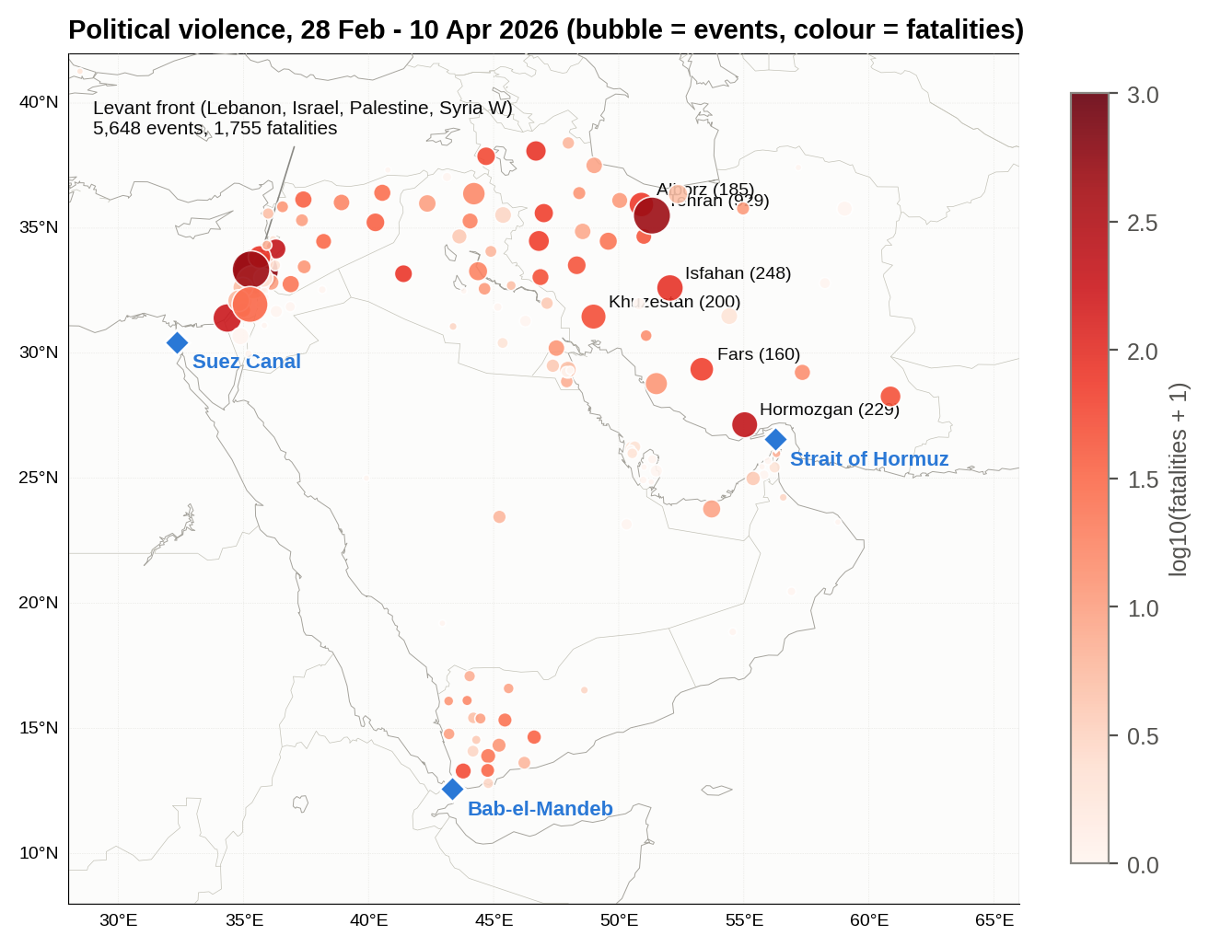
Figure 5.7 : Geography of political violence, 28 February - 10 April 2026
What this shows: Each bubble is a province: bigger means more attacks, redder means more deaths. The fighting reached the shore of the Strait of Hormuz.

Table 5.2 : Top provinces by political-violence events, 28 Feb - 10 Apr 2026
COUNTRY | ADMIN1 | EVENTS | FATALITIES
Lebanon | Al Nabatieh | 1,990 | 549
Lebanon | South | 968 | 463
Iran | Tehran | 929 | 466
Palestine | West Bank | 800 | 32
Israel | HaZafon | 586 | 3
Palestine | Gaza Strip | 328 | 180
Iran | Isfahan | 248 | 90
Iran | Hormozgan | 229 | 215
Iran | Khuzestan | 200 | 51
Iran | Alborz | 185 | 76
Iran | Fars | 160 | 68
Iraq | Erbil | 133 | 15
Lebanon | Mount Lebanon | 129 | 83
Iran | Bushehr | 125 | 11
Israel | Tel Aviv | 111 | 5

Hormozgan, the Iranian province on the northern shore of the Strait of Hormuz, recorded 229 events and 215 fatalities in six weeks. Bushehr, Khuzestan (the oil province at the head of the Gulf) and Fars were also among the most affected Iranian provinces. The fighting reached the shoreline of the world's most important energy chokepoint.
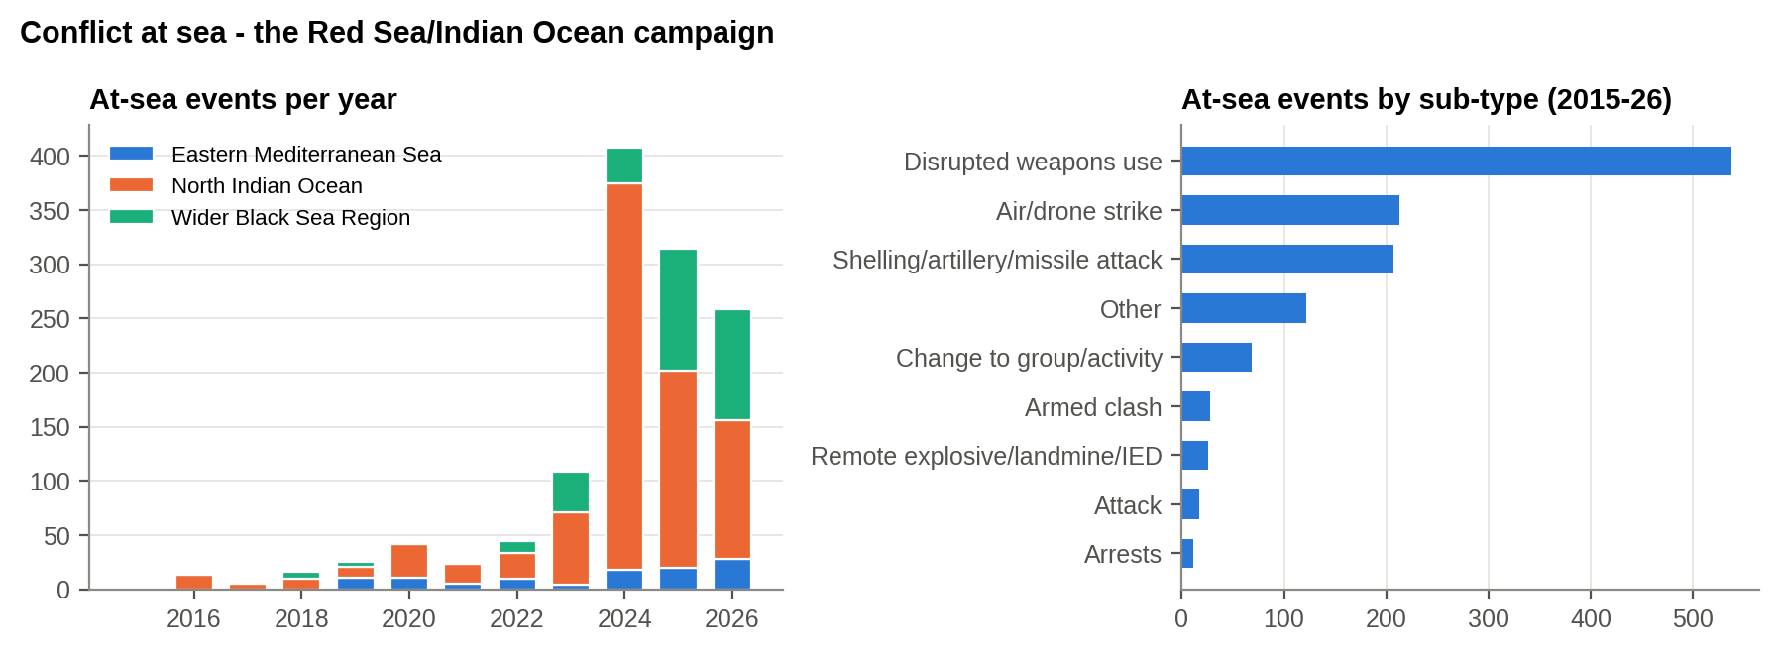
Figure 5.8 : Conflict at sea: ACLED at-sea events by year and by sub-type
What this shows: Attacks at sea were rare until late 2023, then surged with the Red Sea campaign.

ACLED recorded 44 at-sea events in 2022, 108 in 2023, 408 in 2024 and 314 in 2025, and already 258 in the first half of 2026. The dominant sub-types, 'disrupted weapons use' (missiles and drones intercepted over the sea) and shelling/missile attacks, are those of an anti-shipping campaign. H2 is supported (see also Section 6.1).
SO WHAT
The war nearly tripled regional violence (2.9x). Most of it was delivered by missiles and drones (84%), and it struck the Gulf states that export the world's energy (124x rise).
Next: Did this violence reach the sea lanes that carry India's oil?

6. CHOKEPOINT CONFLICT INTENSITY AND DISRUPTION SURVIVAL
PART II - THE STORM REACHES THE SEA LANES
THE STORY SO FAR
Chapter 5 showed the war moving to the Gulf's energy coast and being fought mainly with missiles and drones. The next question is whether that violence reached the sea lanes, and for how long.

6.1 The Chokepoint Conflict Intensity Index (CCII)
Each theatre's threat to shipping is measured where it appears in the data. Weekly political-violence events are weighted 1.5 for stand-off strikes (the type of attack that reaches ships and terminals) and 1.0 otherwise:
• Hormuz (littoral): events in ADMIN1 units within 500 km of the strait (coastal Iran, UAE, Oman, Qatar).
• Red Sea / Arabian Sea (at sea): ACLED's at-sea 'North Indian Ocean' events, i.e. the Houthi anti-shipping campaign.
• East Med (at sea) and Black Sea (at sea): ACLED's at-sea events for those waters.
A theatre is disrupted in a week when its index is above its own threshold, set at the 2015-2022 baseline mean plus 3 SD (minimum 3 weighted events).
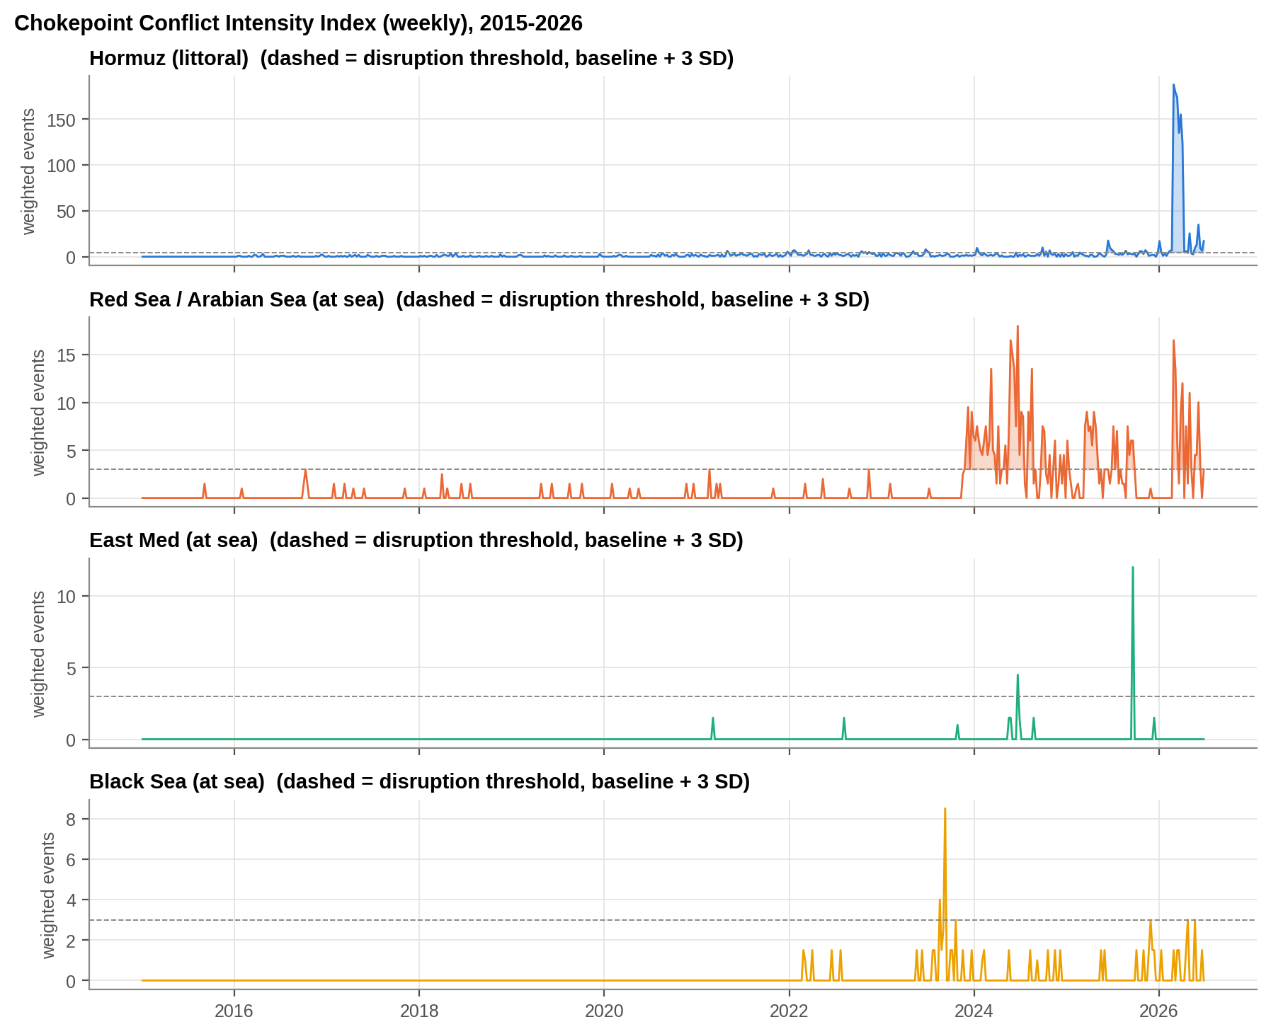
Figure 6.1 : Chokepoint Conflict Intensity Index by theatre, 2015-2026
What this shows: A 'thermometer' of violence for each sea route. When the line crosses the dashed threshold, the route is under stress.

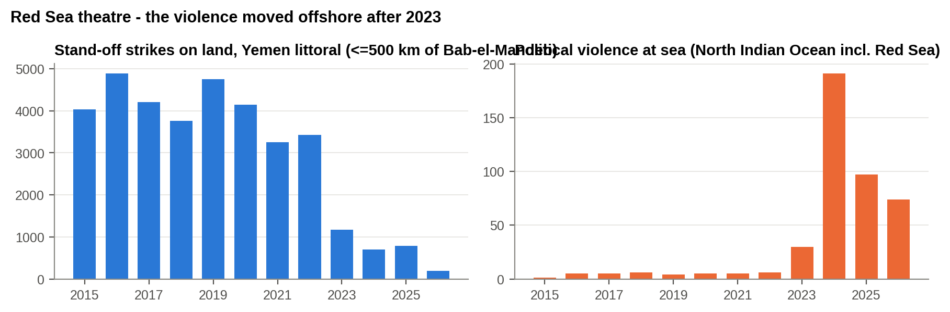
Figure 6.2 : Red Sea theatre: stand-off strikes on the Yemeni littoral versus violence at sea
What this shows: In Yemen, attacks on land fell (left) while attacks at sea rose (right). The threat moved from the shore to the shipping lanes.

The Red Sea threat moved offshore. Stand-off strikes on land within 500 km of Bab-el-Mandeb fell from 4,757 in 2019 to 791 in 2025 as Yemen's civil war froze. Over the same years violence at sea rose from 6 events in 2022 to 191 in 2024. An index built on land violence alone would have shown the Red Sea getting safer just as it became the most dangerous waterway in the world for merchant shipping. During the 2026 war the Hormuz littoral index averaged 188 times its 2015-2022 baseline, and the Red Sea at-sea index averaged 46 times its baseline from mid-November 2023 to December 2024.
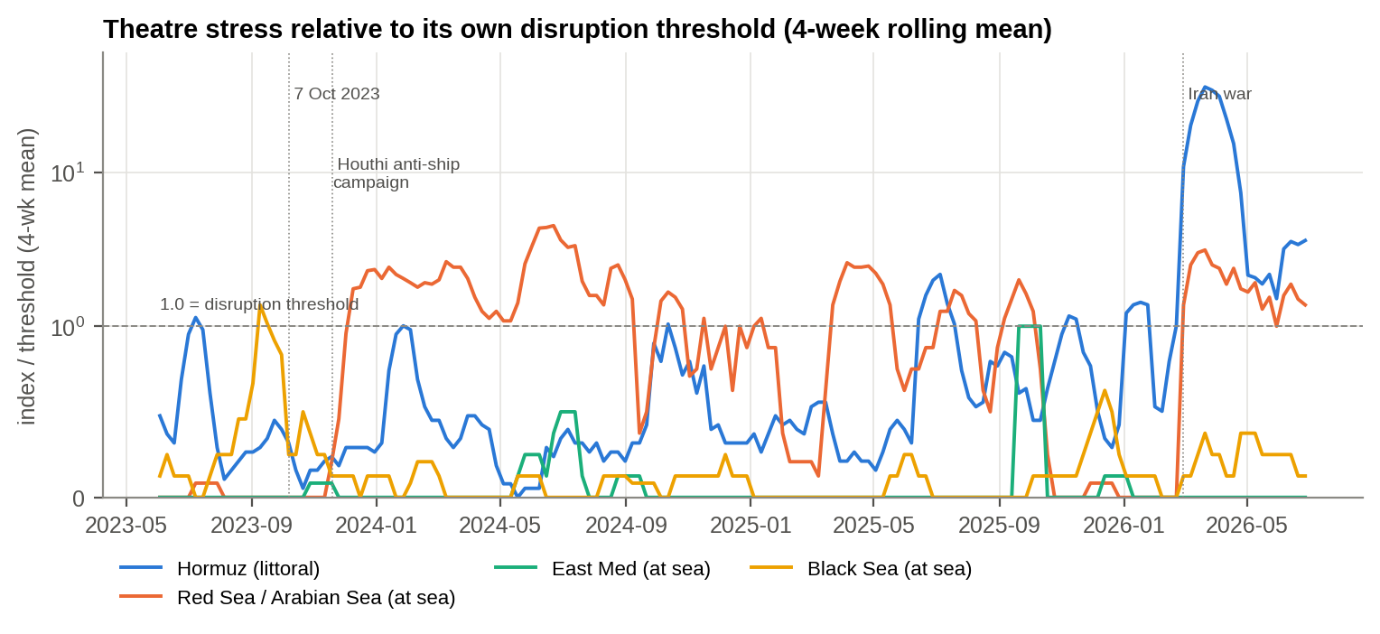
Figure 6.3 : Theatre stress relative to its disruption threshold (4-week rolling mean, symmetric-log scale)
What this shows: Above the dashed line means a route is under stress. Hormuz went off the scale in March 2026 and stayed above the line.

6.2 Forecasting the Hormuz Index
Table 6.1 : 12-week hold-out back-test of forecasting models (Hormuz littoral index)
Model | MAE (weighted events/wk) | RMSE
Naive (last value) | 112 | 112
Holt damped-trend ETS | 92.80 | 93.30
ARIMA(1,0,1) | 56.90 | 60

ARIMA(1,0,1) on the log-transformed index roughly halved the back-test error of the naive forecast and beat damped-trend exponential smoothing. It was refitted on all data and projected 13 weeks ahead, to the end of September 2026.
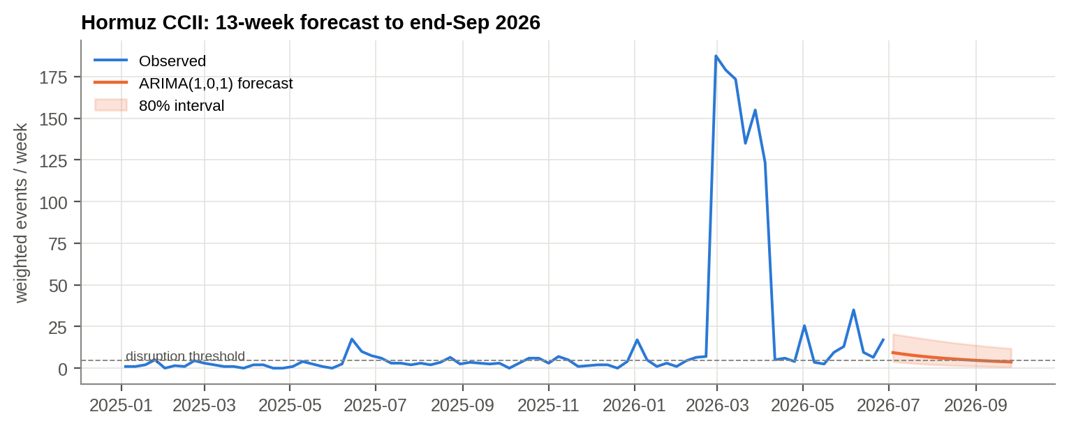
Figure 6.4 : Hormuz CCII: observed values and 13-week ARIMA forecast with 80 per cent interval
What this shows: Blue is what happened; orange is the forecast for July-September 2026. The band shows the range of likely outcomes.

The central forecast falls back towards 3.7 weighted events a week by the end of September (80 per cent interval 0.8-11.8), below the disruption threshold of 4.7. However, in 4,000 simulated paths from the fitted model, 99% cross the threshold in at least one of the 13 weeks. The Hormuz littoral has not returned to its pre-war calm. Flare-ups should be treated as the base case through the third quarter of 2026, not as a tail risk.

6.3 How Long Do Disruptions Last? Survival Analysis
Applying the threshold rule to each theatre produced 32 disruption episodes. One of them, on the Hormuz littoral, was still under way at the end of the data and is right-censored.
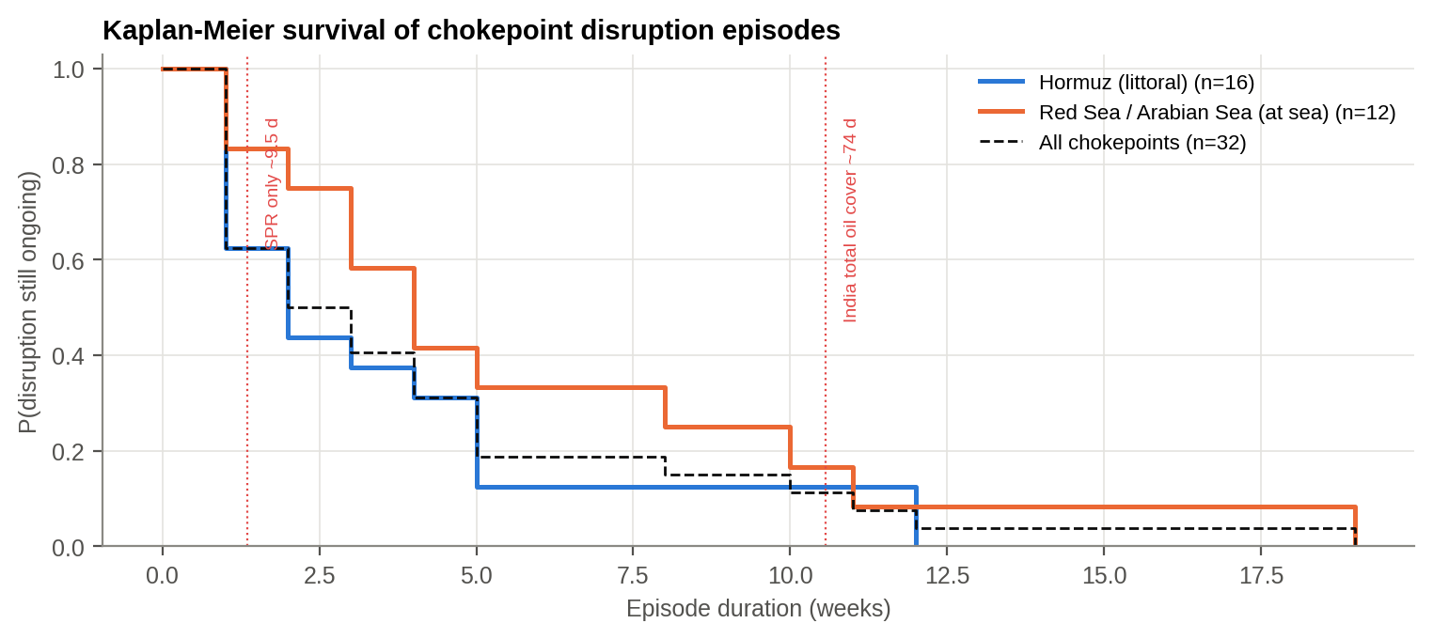
Figure 6.5 : Kaplan-Meier survival of disruption episodes; red lines mark India's strategic oil cover
What this shows: Read it like a survival curve: the line shows the share of crises still going after a given number of weeks. The red lines are India's oil reserves.

Table 6.2 : Disruption episodes by theatre
Chokepoint | Episodes | Censored (ongoing) | Median weeks | Longest weeks
Hormuz (littoral) | 16 | 1 | 2 | 12
Red Sea / Arabian Sea (at sea) | 12 | 0 | 4 | 19
East Med (at sea) | 2 | 0 | 1 | 1
Black Sea (at sea) | 2 | 0 | 1 | 1

Across the 32 episodes, the median disruption lasts 2.5 weeks, the mean 4.0 weeks and the longest 19 weeks, so the distribution is heavy-tailed. The probability that an episode outlasts 9.5 days, India's strategic petroleum reserve cover, is 62%. The probability that it outlasts 74 days, the total national cover including refiners' stocks, is 11%. Red Sea episodes last longer than Hormuz episodes (median 4.0 against 2.0 weeks; log-rank χ² = 8.52, p = 0.036).
Table 6.3 : Cox proportional-hazards model of the hazard of a disruption ending (reference: Black Sea)
Covariate | Coefficient | HR = exp(coef) | p-value | HR 95% CI
Theatre: East Med (at sea) | 0.85 | 2.33 | 0.46 | 0.25 - 21.63
Theatre: Hormuz (littoral) | -0.66 | 0.52 | 0.43 | 0.10 - 2.64
Theatre: Red Sea / Arabian Sea (at sea) | -0.77 | 0.47 | 0.42 | 0.07 - 3.03
Episode began after Oct 2023 | -0.85 | 0.43 | 0.12 | 0.15 - 1.23

A hazard ratio below 1 means an episode is less likely to end, i.e. it lasts longer. Episodes that began after October 2023 have a hazard ratio of 0.43: they are more persistent, though with only 32 episodes the estimate is not significant at the 5 per cent level (p = 0.12). H6 is supported: disruptions are heavy-tailed and most of them outlast India's strategic reserve.
SO WHAT
Yes. Violence around Hormuz reached 188 times its normal level, and in the Red Sea it moved from land to sea. Such crises usually last a few weeks, but 62% of them outlast India's emergency oil reserve.
Next: What did the ships do while this was happening?

7. MARITIME TRAFFIC AND AIS DARK ZONES
PART III - THE SHIPS GO BLIND
THE STORY SO FAR
Chapter 6 showed the violence reached the waters around Hormuz and the Red Sea, and that such crises can last for months. So what did the ships do? Here we look at the sea itself, through satellite radar that sees every ship whether it wants to be seen or not.

This chapter analyses 106,533 Sentinel-1 vessel detections from 1-14 March 2026, the first two weeks of the war, and tests hypotheses H3 and H4.
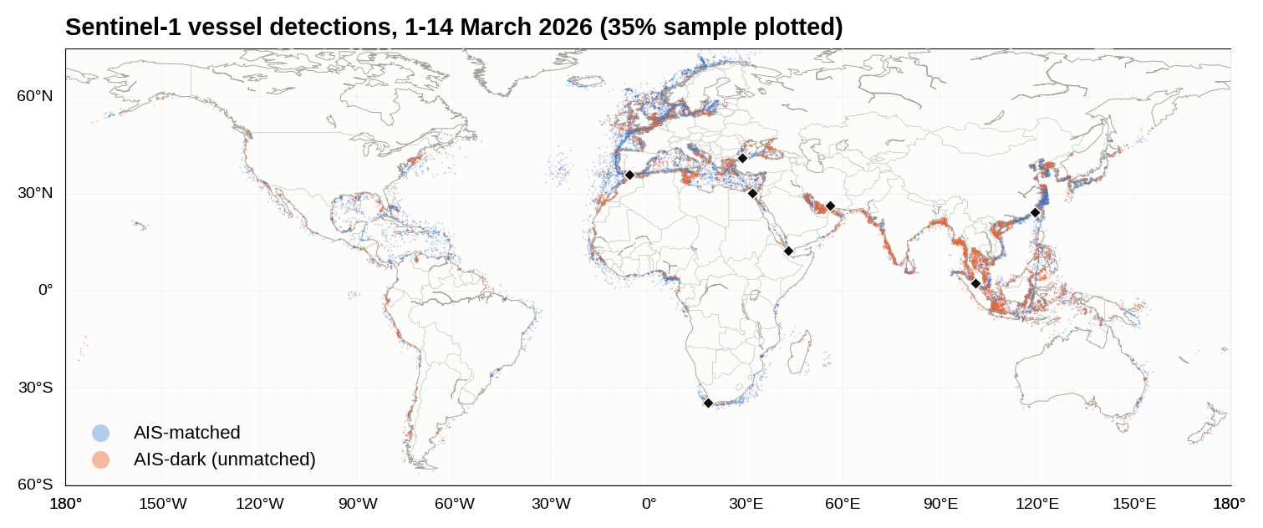
Figure 7.1 : Sentinel-1 vessel detections, 1-14 March 2026 (blue = AIS-matched, orange = AIS-dark)
What this shows: Every dot is a ship seen by satellite radar. Orange ships were not transmitting their identity. They cluster in the Gulf and the Black Sea.

7.1 Where Are Ships Dark? (H3)
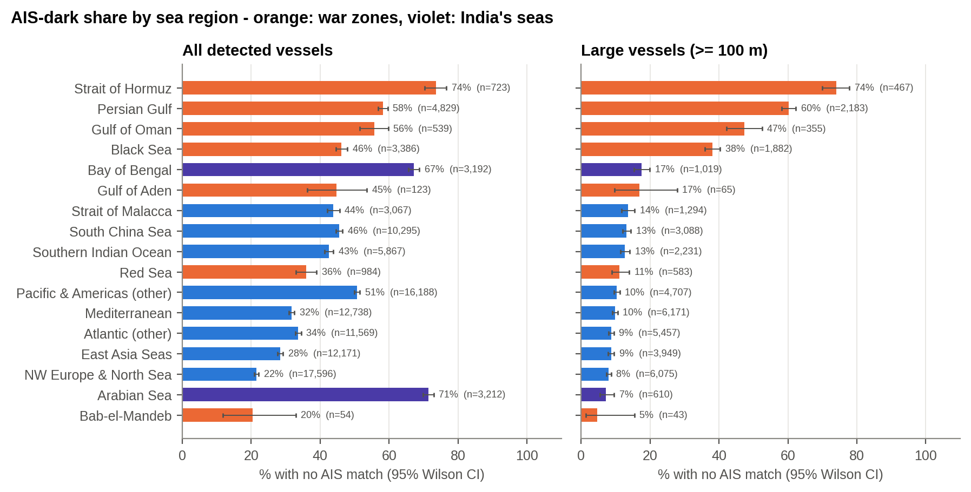
Figure 7.2 : AIS-dark share by sea region, all vessels and large vessels, with 95 per cent Wilson intervals
What this shows: Look at the right-hand panel (big ships only). War zones (orange) are four to seven times darker than peaceful seas (blue).

Table 7.1 : AIS-dark share by region (large = hull length ≥ 100 m)
Region | Detections | Dark share (all) | Large vessels | Dark share (large) | CI low | CI high
Strait of Hormuz | 723 | 73.6% | 467 | 74.1% | 69.9% | 77.9%
Persian Gulf | 4,829 | 58.2% | 2,183 | 60.2% | 58.2% | 62.3%
Gulf of Oman | 539 | 55.7% | 355 | 47.3% | 42.2% | 52.5%
Black Sea | 3,386 | 46.2% | 1,882 | 38.1% | 35.9% | 40.3%
Bay of Bengal | 3,192 | 67.2% | 1,019 | 17.5% | 15.3% | 19.9%
Gulf of Aden | 123 | 44.7% | 65 | 16.9% | 9.7% | 27.8%
Strait of Malacca | 3,067 | 43.9% | 1,294 | 13.5% | 11.8% | 15.5%
South China Sea | 10,295 | 45.6% | 3,088 | 13.2% | 12.0% | 14.4%
Southern Indian Ocean | 5,867 | 42.5% | 2,231 | 12.6% | 11.3% | 14.1%
Red Sea | 984 | 35.9% | 583 | 11.1% | 8.8% | 14.0%
Pacific & Americas (other) | 16,188 | 50.8% | 4,707 | 10.3% | 9.5% | 11.2%
Mediterranean | 12,738 | 31.7% | 6,171 | 9.8% | 9.1% | 10.6%
Atlantic (other) | 11,569 | 33.6% | 5,457 | 8.7% | 8.0% | 9.4%
East Asia Seas | 12,171 | 28.4% | 3,949 | 8.7% | 7.8% | 9.6%
NW Europe & North Sea | 17,596 | 21.5% | 6,075 | 8.0% | 7.3% | 8.7%
Arabian Sea | 3,212 | 71.5% | 610 | 7.2% | 5.4% | 9.5%
Bab-el-Mandeb | 54 | 20.4% | 43 | 4.7% | 1.3% | 15.5%

Looking at all ships gives a misleading picture, because small craft are dark almost everywhere. Once the comparison is restricted to large ships (≥100 m), which carry AIS by regulation, the war zones stand out: Strait of Hormuz 74%, Persian Gulf 60%, Gulf of Oman 47%, Black Sea 38%. Every region at peace lies between about 7 and 17 per cent, and NW Europe is lowest at 8 per cent. Large ships in war zones are dark in 47% of cases against 10% elsewhere: a relative risk of 4.7 and an odds ratio of 8.0 (χ² = 5,101, p < 10-300). H3 is strongly supported.
The Black Sea result is independent corroboration. It lies outside the ACLED Middle-East data, and it is the other theatre named in the Datathon problem statement. The Russia-Ukraine war produces the same signature: 38% of large ships dark, about four times the peacetime norm.
The Red Sea shows a different effect: only 11% of large ships are dark, and just 54 detections were made in Bab-el-Mandeb in two weeks. In the Red Sea, ships do not go dark in the war zone. They stay away. The Gulf has no route around it, so ships that must load there go dark instead. The two chokepoints show the two responses of shipping to conflict: diversion where a detour exists, blinding where it does not. These are the two dominant responses; Section 7.10 shows they are two cells of a fuller four-signature typology.
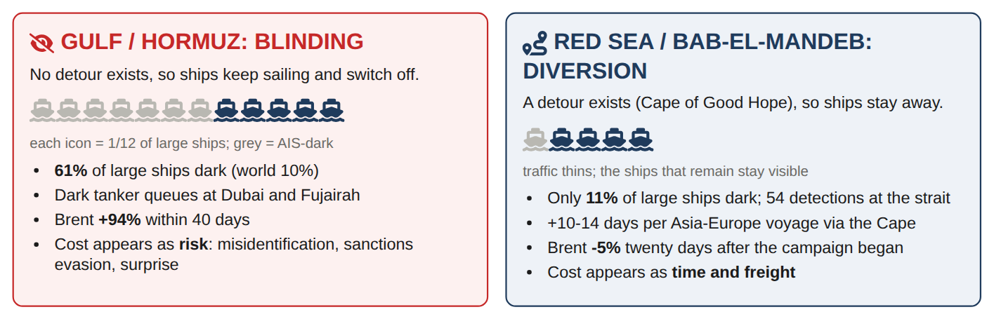
Figure 7.3 : The two dominant responses of shipping to conflict: blinding versus diversion (infographic; full typology in Figure 7.13)
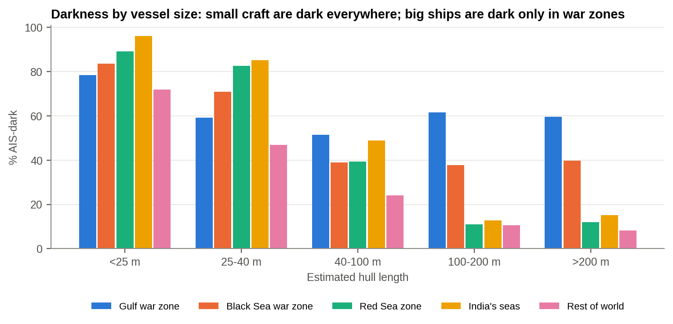
Figure 7.4 : AIS-dark share by vessel size class and zone
What this shows: In peaceful seas, bigger ships are almost always visible. In the Gulf war zone even the biggest tankers are dark 60% of the time.

In peaceful waters darkness falls steadily with size, from 72 per cent of craft under 25 m to 8 per cent of ships over 200 m. In the Gulf war zone it hardly falls at all: ships over 200 m, which is VLCC and LNG-carrier size, are dark 60 per cent of the time. In a war zone, size no longer predicts visibility.

7.2 Statistically Significant Dark Hot Spots (H4)
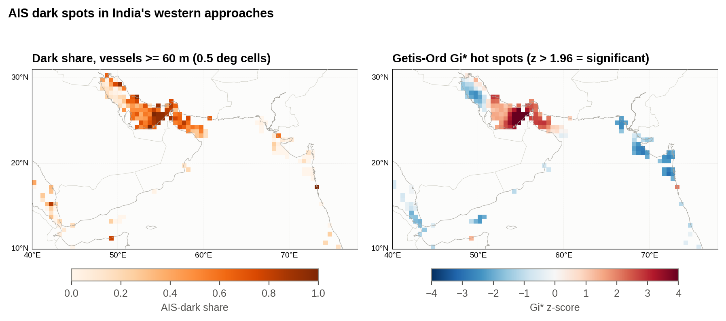
Figure 7.5 : Dark share and Getis-Ord Gi* hot spots, ships ≥ 60 m, India's western approaches (0.5° cells)
What this shows: Red squares on the right are places where dark ships bunch together more than chance would allow: a belt from Qatar to Hormuz.

Of 183 half-degree cells with enough ships in the Gulf-Arabian Sea window, 43 are significant dark hot spots (Gi* > 1.96). They form one contiguous belt from Qatar across the UAE coast and Hormuz into the Gulf of Oman. The north-western Gulf (Kuwait, Iraq, the Saudi coast) and India's west coast are cold spots: large ships there stay visible.
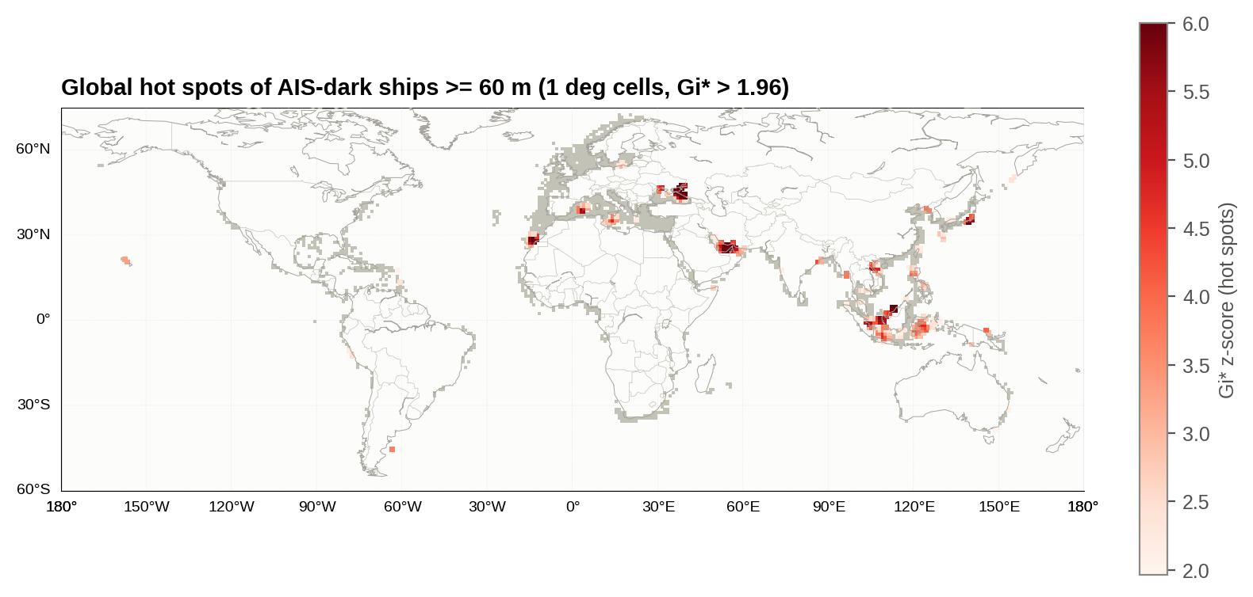
Figure 7.6 : Global Gi* hot spots of AIS-dark ships ≥ 60 m (1° cells)
What this shows: The same test worldwide. Red squares are statistically significant clusters of dark ships.

Table 7.2 : Significant dark hot-spot cells (1°) by region
Region | Hot-spot cells
Pacific & Americas (other) | 54
South China Sea | 41
Southern Indian Ocean | 35
Mediterranean | 22
Persian Gulf | 21
Black Sea | 20
Atlantic (other) | 19
East Asia Seas | 18
Strait of Malacca | 9
Gulf of Oman | 6
NW Europe & North Sea | 4
Bay of Bengal | 3
Strait of Hormuz | 2
Gulf of Aden | 1
Arabian Sea | 1

Worldwide, 256 of 1,858 one-degree cells are dark hot spots. Relative to the area of each region, the Persian Gulf, Gulf of Oman and Black Sea are the densest. Hot spots elsewhere, in the South China Sea, Southern Indian Ocean and Pacific, mark distant-water fishing grounds where small and medium craft routinely run without AIS [5]. H4 is supported.

7.3 Where Do Dark Ships Gather? DBSCAN Clusters
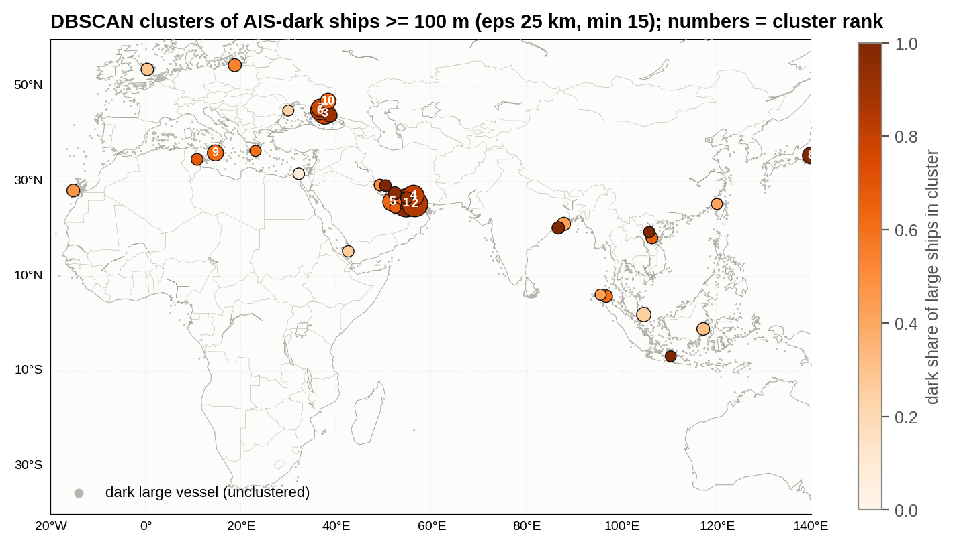
Figure 7.7 : DBSCAN clusters of AIS-dark ships ≥ 100 m (numbers = rank in Table 7.3)
What this shows: Each circle is a group of dark ships found automatically. The biggest are tanker queues off Dubai and Fujairah, waiting with identities off.

Table 7.3 : Largest clusters of dark ships ≥ 100 m
# | Cluster (nearest reference) | region | Dark large vessels | Dark share of large ships within 30 km | Median length (m) | Days observed
1 | Dubai / Jebel Ali | Persian Gulf | 660 | 97% | 184 | 6
2 | Fujairah / Khor Fakkan anchorage | Gulf of Oman | 462 | 85% | 171 | 3
3 | Novorossiysk / Kerch (Russia) | Black Sea | 226 | 75% | 174 | 5
4 | Strait of Hormuz (Bandar Abbas-Qeshm) | Strait of Hormuz | 207 | 80% | 179 | 3
5 | Ras Laffan / Doha (Qatar) | Persian Gulf | 126 | 64% | 174 | 5
6 | Novorossiysk / Kerch (Russia) | Black Sea | 122 | 83% | 149 | 4
7 | Novorossiysk / Kerch (Russia) | Black Sea | 88 | 78% | 123 | 4
8 | 35.5N 139.9E | East Asia Seas | 84 | 100% | 127 | 1
9 | Malta | Mediterranean | 69 | 62% | 167 | 3
10 | Novorossiysk / Kerch (Russia) | Black Sea | 58 | 64% | 129 | 5
11 | Singapore Strait / EOPL Johor | South China Sea | 43 | 26% | 255 | 1
12 | Novorossiysk / Kerch (Russia) | Black Sea | 39 | 91% | 164 | 4
13 | Kolkata / Haldia | Bay of Bengal | 34 | 44% | 196 | 2
14 | 54.5N 18.8E | NW Europe & North Sea | 30 | 54% | 149 | 3
15 | Ras Laffan / Doha (Qatar) | Persian Gulf | 30 | 97% | 175 | 4

DBSCAN found 36 clusters. The two largest are off Dubai/Jebel Ali (660 dark large ships; 97% of all large ships there dark) and the Fujairah/Khor Fakkan anchorage, the main bunkering and waiting area outside Hormuz. Together with the Hormuz and Ras Laffan clusters, they are fleets of tankers and gas carriers waiting at anchor with AIS off. That is the physical form of a supply chain on hold. The Novorossiysk/Kerch clusters are the Black Sea equivalent. The Kolkata/Haldia cluster (44 per cent dark) is the only large-ship cluster in India's own waters and is flagged for follow-up. The single-day Tokyo Bay cluster is most likely an AIS-matching gap and is treated as an artefact.

7.4 The Daily Picture in the Gulf
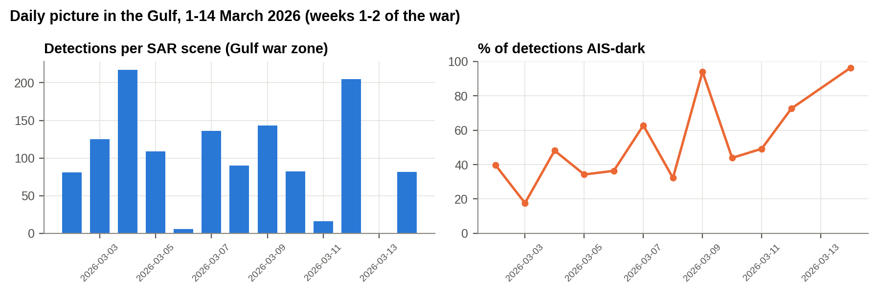
Figure 7.8 : Gulf war zone: detections per SAR scene and share AIS-dark, 1-14 March 2026
What this shows: Each day of the war's first fortnight, a larger share of ships in the Gulf went dark.

Over the first two weeks of the war, darkness in the Gulf rose from 35% of detections in the first three imaged days to 73% in the last three (Spearman ρ = 0.68, p = 0.015). Two days (6 and 12 March) had very few detections per scene, and their shares should be read with caution. The trend holds with them removed.

7.5 Who Is Sailing? Flag States of Visible Ships
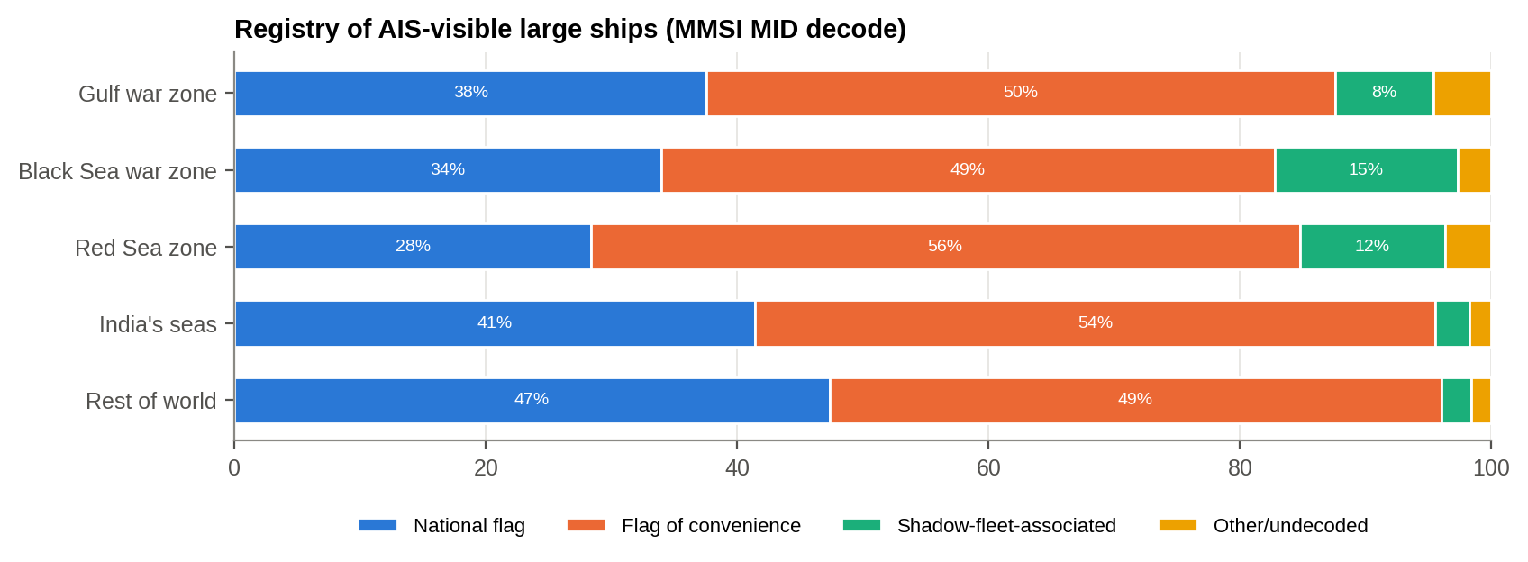
Figure 7.9 : Registry class of AIS-visible large ships by zone (MMSI MID decode)
What this shows: The green segment shows ships registered in countries often linked to sanctions evasion. Their share is about three times higher in war zones.

Table 7.4 : Top flag states of visible large ships, Gulf war zone against rest of world
Flag | Gulf war zone % | Rest of world %
Panama | 17.40 | 11.70
Liberia | 9.90 | 12.80
Marshall Islands | 9.20 | 9.50
Iran | 6.90 | 0.10
UAE | 6 | 0
Other/undecoded | 4.60 | 1.60
Singapore | 3.70 | 5
Comoros | 3.60 | 0.20
Malta | 3.20 | 5.70
Saudi Arabia | 3.20 | 0.10

Flags of convenience make up about half of visible large ships everywhere, so they do not distinguish the war zones. What does distinguish them is shadow-fleet-associated registries (Gabon, Cameroon, Comoros, Sierra Leone, Togo, Cook Islands, Palau and similar): 7.8 per cent of visible large ships in the Gulf and 14.6 per cent in the Black Sea, against 2.4 per cent elsewhere. Iranian-flagged ships make up 6.9 per cent of visible large ships in the Gulf against 0.1 per cent worldwide. The ships still transmitting in the war zone lean towards registries with weak oversight, which adds to the identity problem.

7.6 India's Maritime Neighbourhood
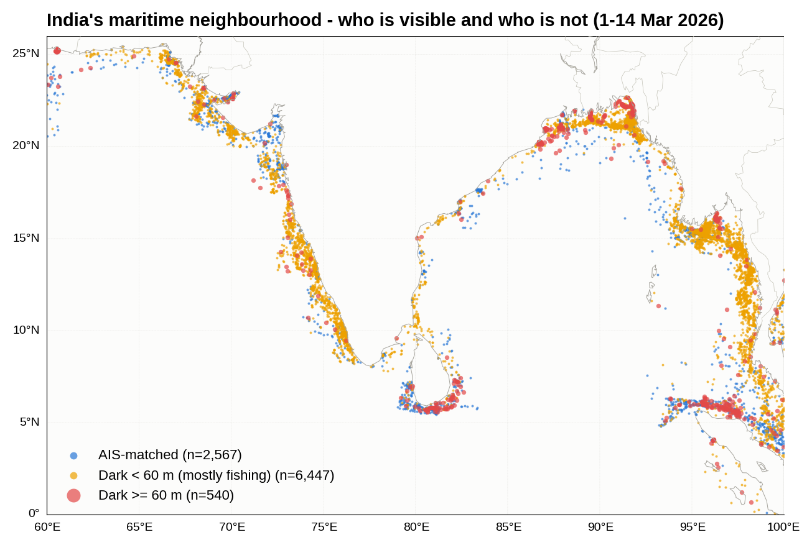
Figure 7.10 : Arabian Sea and Bay of Bengal: AIS-matched, small dark and large dark detections
What this shows: Near India most dark craft are small fishing boats (yellow). Big ships near India are visible.

India's seas have the highest overall dark shares in the dataset (Arabian Sea 72%, Bay of Bengal 67%). This is not a conflict signal: 94% of craft under 40 m are dark, and 85% of dark detections score as fishing vessels. Large ships off India are visible (Arabian Sea 7% dark, Bay of Bengal 18%). The security point is that India's near seas contain thousands of small, uncooperative craft, the same class of craft used in the 26/11 Mumbai attack. The domestic maritime picture depends on non-AIS sensing.

7.7 Identity Integrity
Table 7.5 : Indicators of AIS identity anomalies
Indicator | Global | Gulf war zone
Malformed MMSI (MID outside 2xx-7xx) | 1,565 | 17
Placeholder MMSI (xxx000000) | 94 | 6
Physically impossible re-sighting (>50 kn over >20 km) | 15 | 1
'noisy_vessel' AIS tracks | 2,187 | 73

Beyond darkness, the data show 1,565 malformed MMSIs, 94 placeholder identities (e.g. 200000000, 412000000) and 15 cases of one MMSI appearing at two places that would need speeds above 50 knots, i.e. cloned or spoofed identities. These counts are small but not negligible, and they show that an AIS match alone does not confirm a ship's identity.

7.8 Did the Ships Leave, or Stop Identifying Themselves?
A fall in AIS-visible traffic has two possible causes that demand opposite responses. If the hulls have gone, the problem is a volume shock, answered by alternative sourcing and routing. If the hulls are still there but silent, the problem is identification, answered by independent surveillance, escort and insurance. Radar separates the two. The comparison below uses only the sea area that two passes over the Strait of Hormuz both imaged, so coverage cannot explain the difference.
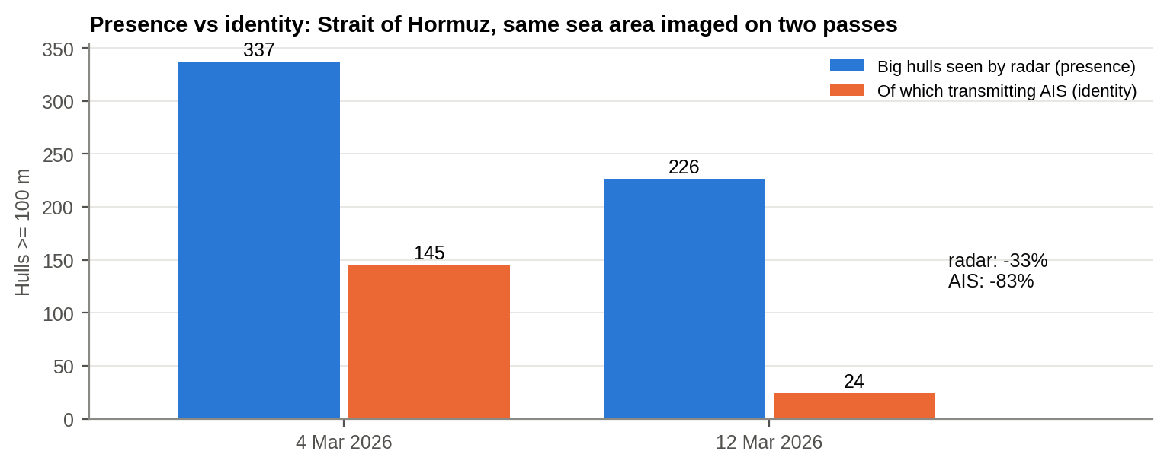
Figure 7.11 : Presence vs identity: big hulls seen by radar and those transmitting AIS, same sea area, 4 and 12 March 2026
Table 7.6 : Presence vs identity on a common footprint, Strait of Hormuz and approaches
Pass | Big hulls seen by radar | Transmitting AIS | Dark | Small craft
4 Mar 2026 | 337 | 145 | 192 | 157
12 Mar 2026 | 226 | 24 | 202 | 101

An AIS-based count would report shipping down 83% (145 to 24 transmitting hulls). Radar shows the physical fleet down only 33% (337 to 226), a fall similar to that of small craft (-36%), which suggests part of it reflects imaging conditions. Meanwhile the number of dark big hulls did not fall at all (192 to 202), and by 12 March 89% of the big hulls in the strait were silent. AIS-derived traffic counts overstated the collapse of shipping and understated the collapse of the maritime picture.
Had the ships stopped? A ship making even five knots cannot be imaged in the same 100 m square on two different days; a ship at anchor can. In Hormuz and the Persian Gulf 13.0% of dark big hulls had another detection within 100 m on a different day, against a crowding null of 10.6% (z = 5.3); for transmitting hulls the excess was smaller (z = 2.7). In the Malacca Strait and the North Sea the figure for dark hulls is about zero. At 400 m, 691 dark big-hull detections in the Gulf were held in place. Much of the dark fleet was not running the strait with transponders off: it had stopped, and then could not be identified.
Table 7.7 : Stasis index: share of hulls re-detected within 100 m on a different day, against a crowding null
Sea | Population | Hulls | Stasis index % | Crowding null % | z vs null
Hormuz + Persian Gulf | dark | 1,661 | 13 | 10.60 | 5.30
Hormuz + Persian Gulf | transmitting | 989 | 9.10 | 8 | 2.70
Strait of Malacca | dark | 175 | 1.10 | 0.80 | 0.70
Strait of Malacca | transmitting | 1,119 | 2.40 | 2 | 1.90
NW Europe & North Sea | dark | 484 | 0.40 | 0.40 | 0.40
NW Europe & North Sea | transmitting | 5,591 | 2.40 | 2.70 | -3.90
Mediterranean | dark | 606 | 6.80 | 6.10 | 1.50
Mediterranean | transmitting | 5,565 | 5.20 | 4.80 | 3.80
Black Sea | dark | 717 | 6.70 | 5.60 | 2.30
Black Sea | transmitting | 1,165 | 1.20 | 1.10 | 0.90

7.9 Who Kept Transmitting?
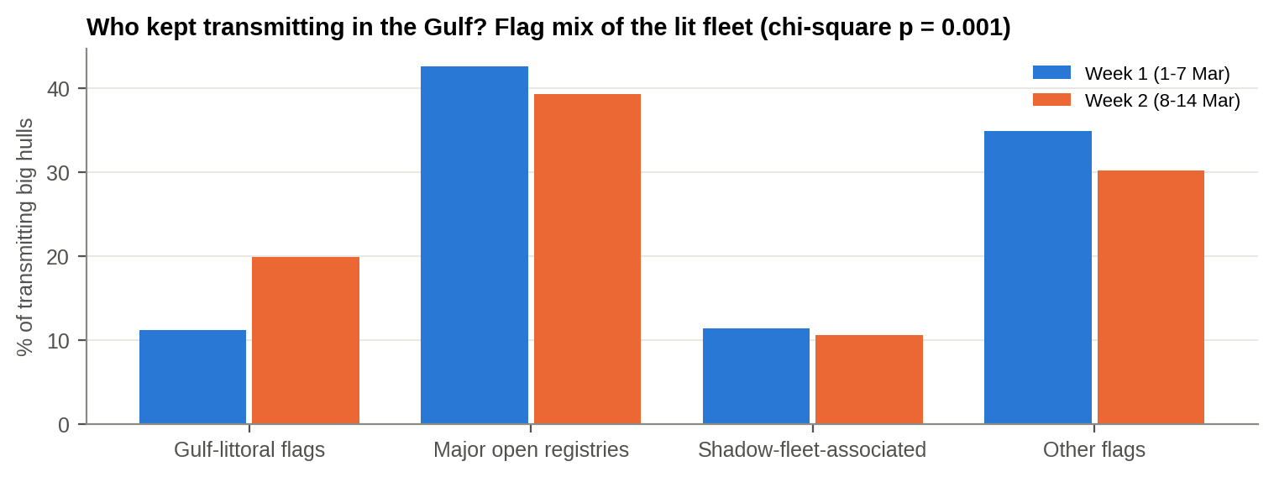
Figure 7.12 : Flag mix of the big hulls still transmitting AIS in the Gulf, week 1 against week 2
The flag of a dark ship cannot be read, but the flag of the shrinking population that kept transmitting can. Gulf-state flags (Iran, UAE, Saudi Arabia, Qatar, Bahrain, Kuwait, Iraq, Oman) rose from 11% to 20% of the lit fleet between the first and second week (chi-square p = 0.001), while the major open registries (Liberia, Marshall Islands, Panama) fell only slightly (43% to 39%). Identity was protective for local ships and dangerous for outsiders. Shadow-fleet-associated registries did not change their share materially, so the dark population is best read as mainstream international tonnage, not mainly a sanctions-evasion fleet.

7.10 Four Signatures of a Sea Line Under Stress
Chapter 7 so far points to a rule. A master switches off AIS when two conditions hold together: being identified is dangerous, and not sailing is not an option. The two conditions give four observable signatures, each with a different supply-chain consequence. Each sea was assigned by a rule declared in advance: SDR above 40% (concealment); 25-40% and flat (attrition/frozen); near baseline on an attacked route with a detour (evacuation); at or below baseline despite heavy conflict nearby (deterrence/compliance).
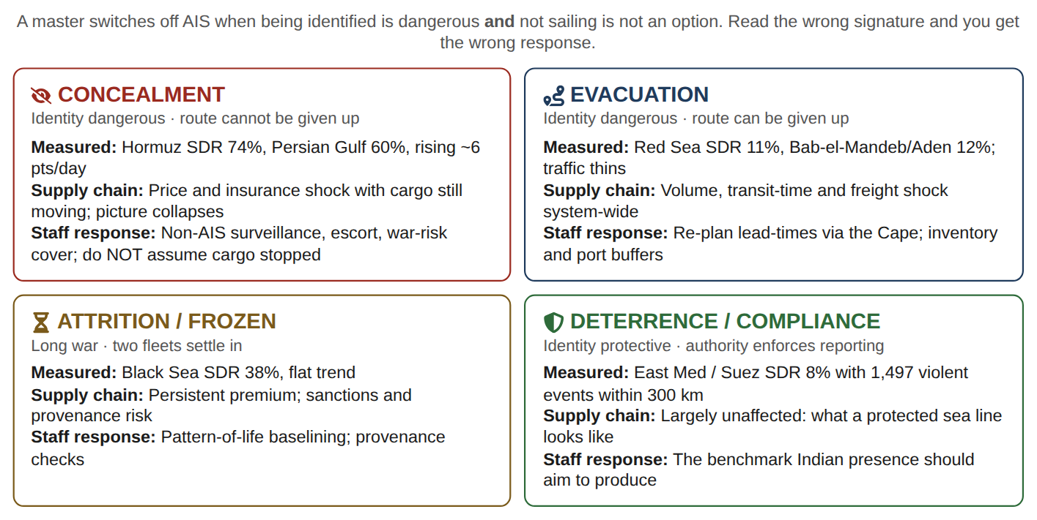
Figure 7.13 : The four signatures of a sea line under stress (infographic)
Table 7.8 : Signature assignment by rule
Sea | Big hulls | SDR % | Trend pp/day | Violent events <=300 km (war wks 1-2) | Signature
Strait of Hormuz | 467 | 74.10 | 3.50 | 117 | CONCEALMENT
Persian Gulf | 2,183 | 60.20 | 5.80 | 180 | CONCEALMENT
Gulf of Oman | 355 | 47.30 | 5.60 | 27 | CONCEALMENT
Black Sea | 1,882 | 38.10 | 1.10 | 0 | ATTRITION / FROZEN
Red Sea | 583 | 11.10 | -0.10 | 0 | EVACUATION
Bab-el-Mandeb + Gulf of Aden | 108 | 12 | -0.50 | 50 | EVACUATION
East Med / Suez approaches | 1,270 | 8 | -0 | 1,497 | DETERRENCE / COMPLIANCE
Turkish Straits | 548 | 2.40 | -0.10 | 0 | BASELINE
Strait of Malacca | 1,294 | 13.50 | -0.30 | 0 | BASELINE
NW Europe & North Sea | 6,075 | 8 | 0.10 | 0 | BASELINE

The East Mediterranean is the control that proves the instrument measures behaviour: 10% is the peaceful-sea baseline, and the East Med and Suez approaches sit at or below it despite the heaviest violence in the dataset within 300 km, because a credible authority enforces reporting there. The same war produced four different behaviours at sea; the difference is not the intensity of the fighting but whether identity is dangerous and whether the route can be given up.
SO WHAT
Big ships went dark: 74% at Hormuz against about 10% in peaceful seas. AIS counts said traffic fell 83%, but radar saw most hulls still there, many held at anchor. Four behaviours emerged: concealment in the Gulf, evacuation from the Red Sea, a frozen Black Sea, and compliance where an authority enforces reporting.
Next: Could we have predicted where ships would go dark?

8. PREDICTING AIS DARK SPOTS
PART IV - CAN WE SEE IT COMING?
THE STORY SO FAR
Chapter 7 found that ships near the fighting switch off their identity beacons: 74% of big ships at Hormuz went dark. A commander's next question is whether we could have predicted where this would happen.

The Datathon problem statement asks participants to predict AIS dark spots. A model was trained on 62,624 detections of ships ≥ 40 m (the AIS-carrying fleet; base dark rate 19.6%). It uses five features that describe the ship and its conflict geography, and it deliberately excludes latitude and longitude so that it cannot simply memorise where the dark ships are.
Table 8.1 : Logistic regression: odds ratios per 1 SD of each feature (all 62,624 ships ≥ 40 m)
Feature | Coef (per 1 SD) | Odds ratio | OR 95% CI | p-value
Hull length (log m) | -0.63 | 0.53 | 0.52 - 0.55 | <0.001
Fishing-vessel score | -0.21 | 0.81 | 0.78 - 0.83 | <0.001
Distance to nearest conflict ADMIN1 (log km) | -0.50 | 0.60 | 0.58 - 0.63 | <0.001
Conflict events within 500 km (log) | -0.03 | 0.97 | 0.94 - 1.01 | 0.092
Distance to chokepoint (log km) | 0.01 | 1.00 | 0.98 - 1.03 | 0.703

Holding size and type constant, each 1-SD increase in (log) distance from the nearest active conflict province lowers the odds of darkness to 0.60 times. The raw event count within 500 km adds nothing once distance is known. Proximity to the fighting matters; the volume of fighting does not.
Table 8.2 : Model skill, leave-one-region-out cross-validation
Model | ROC-AUC | PR-AUC | Brier | F1 @0.5 | Accuracy
Logistic regression | 0.62 | 0.28 | 0.15 | 0.09 | 0.80
Gradient-boosted trees | 0.69 | 0.37 | 0.14 | 0.20 | 0.81
Baseline (always 'not dark') | 0.50 | 0.20 | 0.16 | 0 | 0.80
GBT, random 5-fold CV (leaky, for contrast) | 0.74 | 0.48 | 0.13 | 0.32 | 0.82

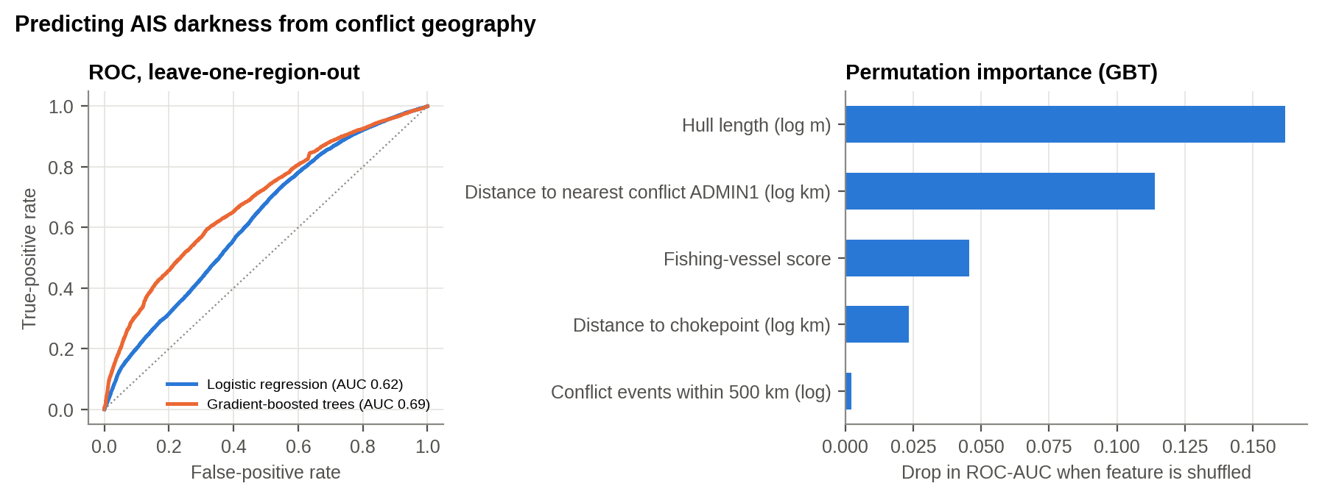
Figure 8.1 : ROC curves (leave-one-region-out) and permutation importance
What this shows: Left: the further the curve bows above the diagonal, the better the prediction. Right: distance from the fighting and ship size matter most.

Evaluated only on sea regions it had never seen, the gradient-boosted model reaches ROC-AUC 0.69 and PR-AUC 0.37, almost twice the 0.20 a random model would score. Ordinary random cross-validation would have reported AUC 0.74. That inflation from spatial leakage is exactly what Roberts et al. warn against [14], and the lower, honest figure is the one relied on here. H5 is supported: conflict geography carries real, transferable information about where ships will go dark.
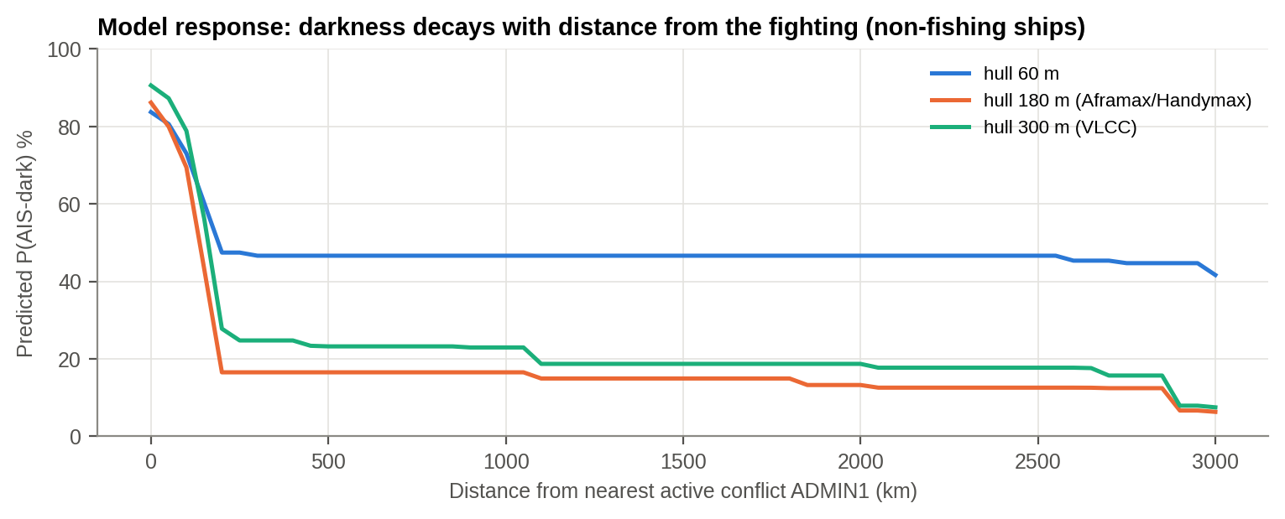
Figure 8.2 : Model response: predicted darkness against distance from active conflict
What this shows: The model's rule of thumb: the closer a big ship is to the fighting, the more likely it is to go dark.

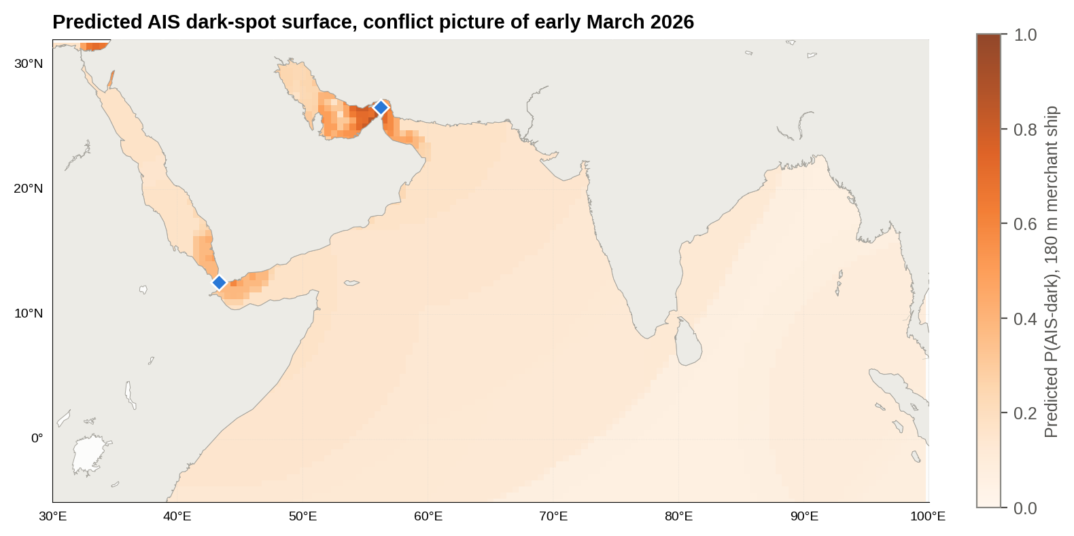
Figure 8.3 : Predicted AIS dark-spot surface for a 180 m merchant ship, early-March-2026 conflict picture
What this shows: A forecast map of where a merchant ship is likely to go dark. Darkest near Hormuz and the UAE coast, lighter near India.

Table 8.3 : Predicted probability that a 180 m merchant ship is AIS-dark at points of interest to India
Location | Predicted P(dark), 180 m ship
Strait of Hormuz | 86%
Fujairah anchorage | 60%
Gulf of Aden | 32%
Ras Tanura | 25%
Chabahar | 17%
Kandla/Mundra approaches | 15%
Mumbai approaches | 13%
Kochi approaches | 12%
Colombo | 7%

The model's surface reproduces the observed belt of darkness along Hormuz and the UAE coast and a secondary area around Bab-el-Mandeb and the Gulf of Aden. It also gives a transferable rule. Given a new conflict picture, such as a future escalation near Chabahar or the Makran coast, the same model can be re-run to predict where the cooperative maritime picture will fail before any satellite pass confirms it.
SO WHAT
Partly, and usefully. After a ship's size, its distance from the fighting is the strongest clue. The model beats chance on seas it has never seen (score 0.69, where 0.5 is a coin toss and 1.0 is perfect). It is good enough to point satellites at the right waters, though not to name individual ships.
Next: What did all this cost India?

9. ECONOMIC AND SHIPPING TRANSMISSION: EVIDENCE FROM OPEN-SOURCE DATA
PART V - THE BILL ARRIVES
THE STORY SO FAR
So far the story has been about violence and ships. But a supply chain is ultimately about goods and money. This chapter follows the shock from the strait to the oil price, the rupee and India's import bill, using public data that runs to September 2026.

The Datathon datasets measure conflict and ship behaviour. To measure the economic impact on supply chains, and to test the study's early-warning indicators against events after the data ended, four open-source datasets were added, as the General Instructions encourage [3]. The questions are simple: did the conflicts move the oil price and the rupee, does conflict intensity warn of price moves in advance, what did the 2026 war cost India, and did the June 2026 early-warning call hold?

9.1 Open-Source Data Used
Table 9.1 : Open-source datasets added to the study
Dataset | Source | Coverage | Used for
Brent and WTI crude spot prices (daily) | U.S. EIA, via the open 'datasets/oil-prices' repository [21] | 1987 - 15 Sep 2026 | Event study, war premium, out-of-sample test
INR per US$ (daily) | U.S. Federal Reserve H.10, via 'datasets/exchange-rates' [22] | 1973 - 18 Sep 2026 | Rupee pass-through
Oil consumption and production by country (annual) | Energy Institute Statistical Review, via Our World in Data [23] | 1965 - 2024 | India's import dependence and volume
World ports (point layer) | Natural Earth 10 m cultural vectors [24] | current | Theatre infographic
Daily transits at 28 world chokepoints (AIS-based) | IMF PortWatch [26] | 2019 - 16 Aug 2026 | Movement layer, shipping-disruption durations
News and official statements (verified) | PIB, AIR, The National, Al Jazeera, CNBC [27-31] | Mar - Sep 2026 | Chronology, cross-checks

9.2 Oil Price and Chokepoint Conflict
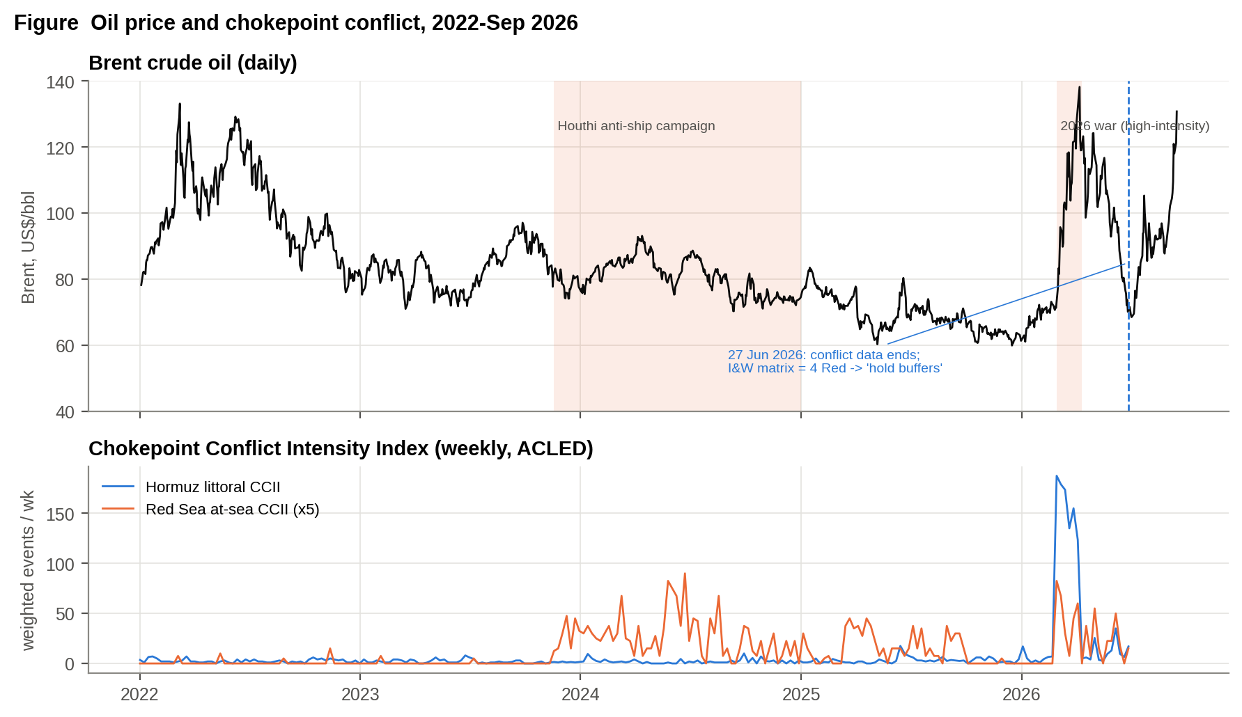
Figure 9.1 : Brent crude (daily) against the chokepoint conflict indices, 2022 - September 2026
What this shows: Top: the oil price. Bottom: the violence thermometers. Oil exploded when war reached Hormuz and rose again after June.

Brent closed at US$71 on the last trading day before the war. It passed US$100 within two weeks and was 66% higher by 20 March. Its peak so far is US$138 (07 Apr 2026). Realised volatility almost tripled, from 32% (annualised, pre-war year) to 88% in March-April 2026.

9.3 Event Study: Four Conflict Shocks
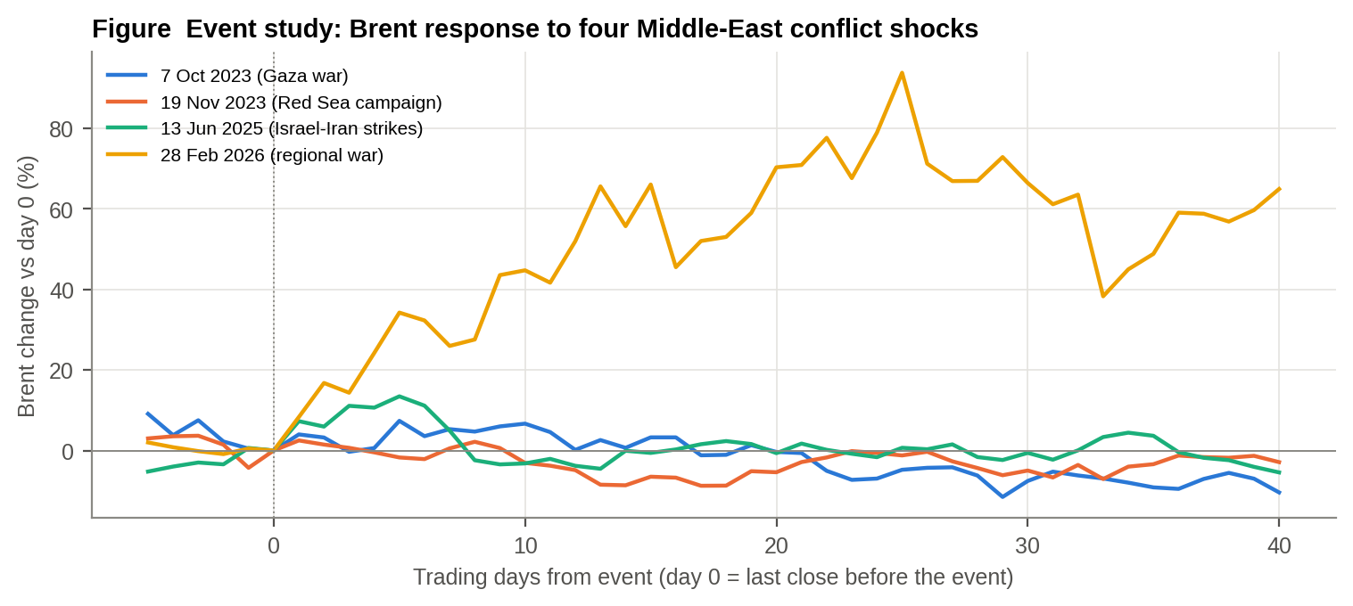
Figure 9.2 : Brent response to four Middle-East conflict shocks (per cent change from the last close before the event)
What this shows: Each line is one crisis, starting at zero on the day it began. Only the 2026 war (red) produced a lasting jump.

Table 9.2 : Event study results
Event | Day 0 | Brent day 0 ($) | +5 days % | +20 days % | Peak within 40 days %
7 Oct 2023 (Gaza war) | 06 Oct 2023 | 87.90 | 7.40 | -0.40 | 7.40
19 Nov 2023 (Red Sea campaign) | 17 Nov 2023 | 81.20 | -1.70 | -5.40 | 2.50
13 Jun 2025 (Israel-Iran strikes) | 12 Jun 2025 | 70.80 | 13.50 | -0.60 | 13.50
28 Feb 2026 (regional war) | 27 Feb 2026 | 71.30 | 34.20 | 70.30 | 93.80

The four shocks behaved very differently. The Gaza war and the June 2025 Israel-Iran strikes produced short spikes (+7% and +14%) that faded within a month. The Red Sea campaign lowered the price (-5% after 20 days): ships diverted, but no oil was lost. The 2026 war, which reached the Hormuz littoral, produced a sustained shock of +70% after 20 days and +94% at the peak. This independent market evidence confirms the 'blinding versus diversion' distinction of Chapter 7. Where a detour exists the cost appears as freight and time. Where none exists it appears as a price shock to every importer.

9.4 Does Conflict Intensity Lead the Oil Price?
Table 9.3 : Granger-causality tests, weekly, 2015 - June 2026
Direction | Lags (weeks) | F | p-value
Hormuz littoral CCII -> Brent weekly return | 1 | 0.03 | 0.87
Hormuz littoral CCII -> Brent weekly return | 2 | 0.70 | 0.50
Hormuz littoral CCII -> Brent weekly return | 4 | 0.60 | 0.66
Brent weekly return -> Hormuz littoral CCII (reverse) | 2 | 1.31 | 0.27
Red Sea at-sea CCII -> Brent weekly return | 1 | 0.20 | 0.65
Red Sea at-sea CCII -> Brent weekly return | 2 | 0.80 | 0.45
Red Sea at-sea CCII -> Brent weekly return | 4 | 0.83 | 0.51
Brent weekly return -> Red Sea at-sea CCII (reverse) | 2 | 3.45 | 0.03

It does not. Weekly conflict intensity does not Granger-cause weekly oil returns at any lag tested (p > 0.4), and the contemporaneous correlation is close to zero. Oil markets react to the event within days, and ordinary weekly fluctuations in violence carry no price information. The practical point is that the market is not an early-warning system: by the time the price moves, the disruption has begun. Warning must come from the conflict and ship-behaviour indicators, as Section 9.8 shows.

9.5 The Rupee
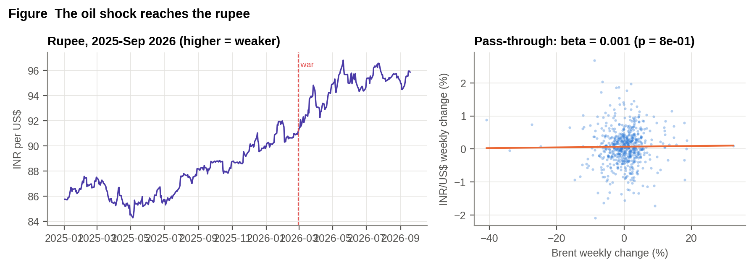
Figure 9.3 : INR per US$ since 2025, and weekly pass-through from Brent to the rupee (2015-2026)
What this shows: Left: the rupee weakened steadily during the war (a higher number means a weaker rupee).

The rupee weakened from 90.54 (pre-war average) to 94.72 (war-period average) per dollar, and stood at 95.87 in mid-September, +5.3% since the war began. Week-to-week pass-through from oil is statistically nil (beta = 0.001, p = 0.79), consistent with central-bank smoothing. The depreciation is gradual and cumulative, not sudden, and it compounds the dollar oil shock.

9.6 India's Structural Exposure
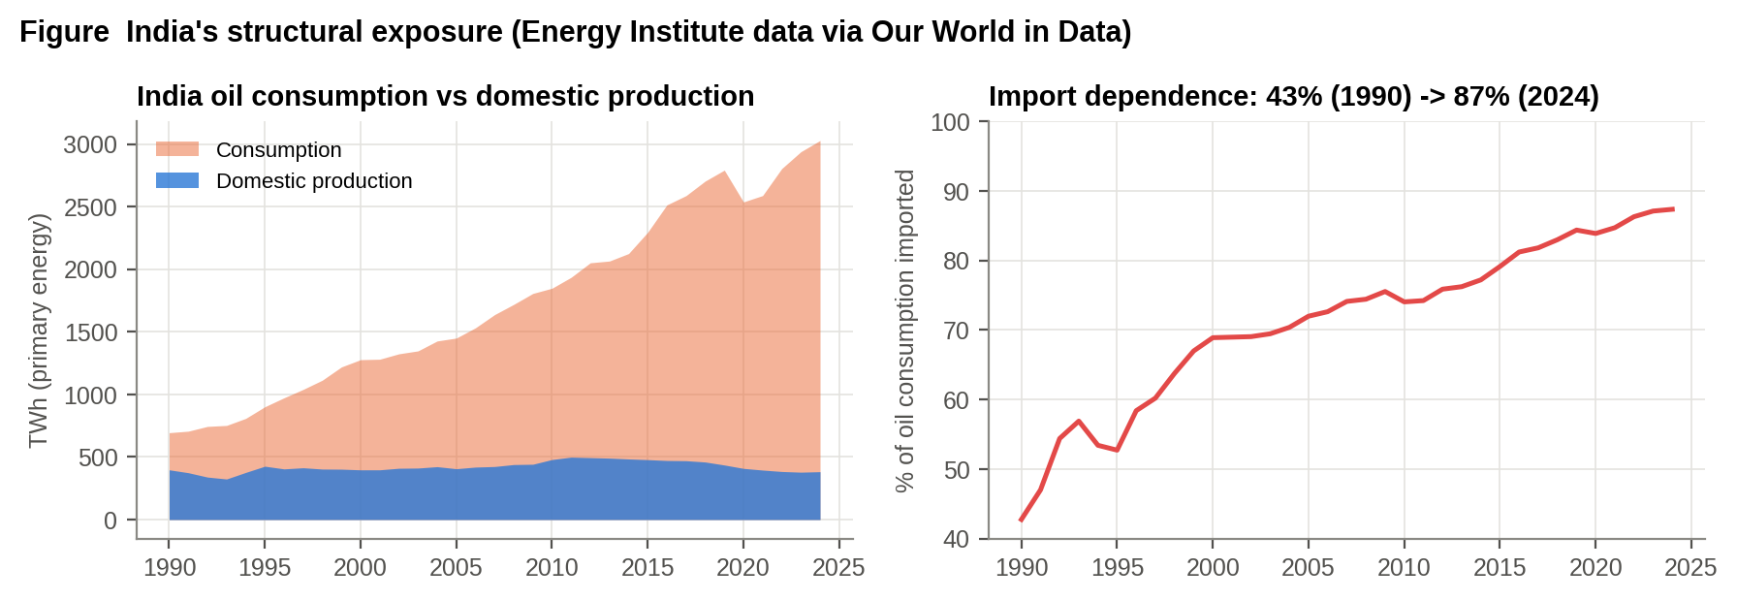
Figure 9.4 : India's oil consumption, production and import dependence, 1990-2024
What this shows: The gap between the orange (use) and blue (own production) areas is what India must import: now 87% of its oil.

From the Energy Institute data, India imported 87.4% of the oil it consumed in 2024, up from 43% in 1990. China's figure is 72%, while Japan and Korea import almost all of theirs. India's net import requirement is about 4.26 million barrels a day. Dependence is rising, not falling, so each new chokepoint shock costs India more than the last.

9.7 The War Premium on India's Import Bill
Table 9.4 : Estimated war premium on India's oil import bill (open-source data)
Quantity | Value
India net oil import volume (2024, OWID-derived) | 4.26 million bbl/day
India oil import dependence (2024) | 87.4%
Brent, pre-war baseline (1 Dec 2025 - 27 Feb 2026) | US$ 66.6/bbl
Brent, war period (1 Mar - 15 Sep 2026) | US$ 98.4/bbl (+48%)
INR/US$, pre-war vs war period | 90.54 -> 94.72 (+4.6%)
Extra import bill, war period (199 days), US$ | ~US$ 27 billion
Extra import bill incl. rupee effect, INR | ~Rs 2.8 lakh crore
Sensitivity: every US$10/bbl sustained for a year | ~US$ 15.6 billion
Volume from Energy Institute net imports (1 barrel = 1.70 MWh); prices from EIA Brent; exchange rate from Federal Reserve H.10. Order-of-magnitude estimate: actual crude purchase prices, discounts and product trade differ.

Over the 199 days from 1 March to 15 Sep 2026, the war added roughly US$27 billion (about Rs 2.8 lakh crore including the rupee effect) to India's oil import bill. Every US$10 a barrel sustained for a year costs about US$15.6 billion. This is the fiscal channel through which the war reaches the defence budget, including its POL and revenue heads.
Table 9.5 : The oil premium in defence terms
Import volume basis | Month | Premium over Feb (US$/bbl) | Extra oil bill (US$ bn/month) | Share of monthly defence budget
Net imports, Energy Institute 2024 | March 2026 | 32.20 | 4.19 | 0.59
Net imports, Energy Institute 2024 | April 2026 | 46.40 | 6.03 | 0.86
Crude imports ~5.0 mb/d (MoPNG) | March 2026 | 32.20 | 4.92 | 0.70
Crude imports ~5.0 mb/d (MoPNG) | April 2026 | 46.40 | 7.08 | 1
Monthly defence budget from the 2026-27 MoD allocation of Rs 7.85 lakh crore at the March 2026 exchange rate (US$ 7.05 bn per month). Premium = monthly Brent average minus the February average.

In the unit a defence audience uses: in March 2026 the extra oil bill was 59-70% of the entire monthly cost of the Armed Forces; in April, at US$117 Brent, it reached 100% on the crude-import basis. The Armed Forces cannot prevent this cost, but they are best placed to see it coming and to say what kind of event it is.

9.8 Out-of-Sample Test of the Early-Warning Call
The conflict data end on 27 June 2026. At that date the I&W matrix (Chapter 14) read 4 Red and 2 Amber, and its recommendation was to hold buffers and not release reserves. The oil market said the opposite: Brent had fallen back to US$70, its pre-war level. After the data ended, Brent rose +86% to US$131 by 15 Sep 2026. The indicators built in this study, from open conflict and satellite data, called a continuing crisis that the market price did not. This is a single test, but a demanding one, because the outcome was not available to the analysis. IMF PortWatch shows why the market was fooled: in late June Hormuz transits briefly recovered to about a third of normal (a false dawn), then fell back to about 5% of normal by August [26].

9.9 Movement: Chokepoint Transits (IMF PortWatch)
The CDM satellite data cover a fortnight. IMF PortWatch counts ships crossing each of 28 world chokepoints every day from AIS, and extends the picture to mid-August 2026. It measures the third layer the study needs: movement.
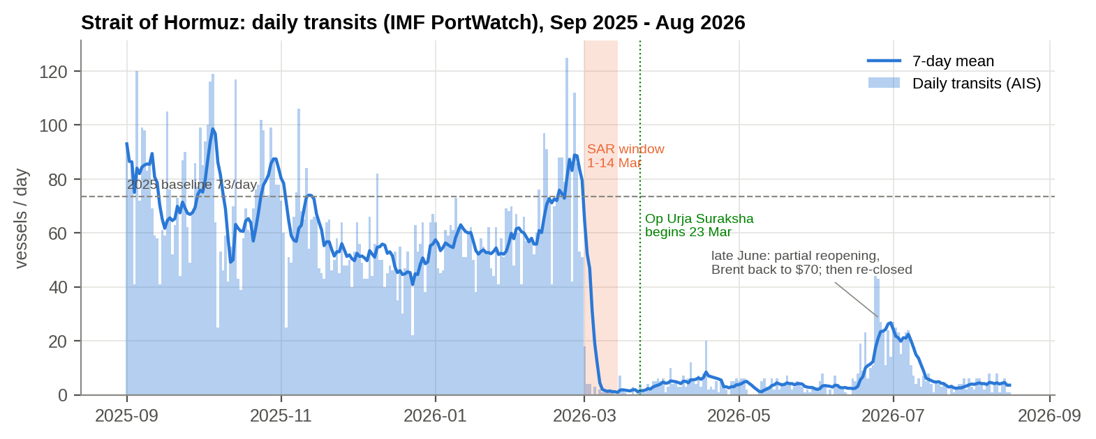
Figure 9.5 : Strait of Hormuz daily transits, September 2025 - August 2026 (IMF PortWatch)
Transits fell from a 2025 baseline of 74 a day to 5.8 after 1 March, a fall of 92% (tankers 94%). During the satellite window (1-14 March) the average was 2.6 a day and on 4 March it was 0. In the last 30 days of the record traffic was 5% of normal.
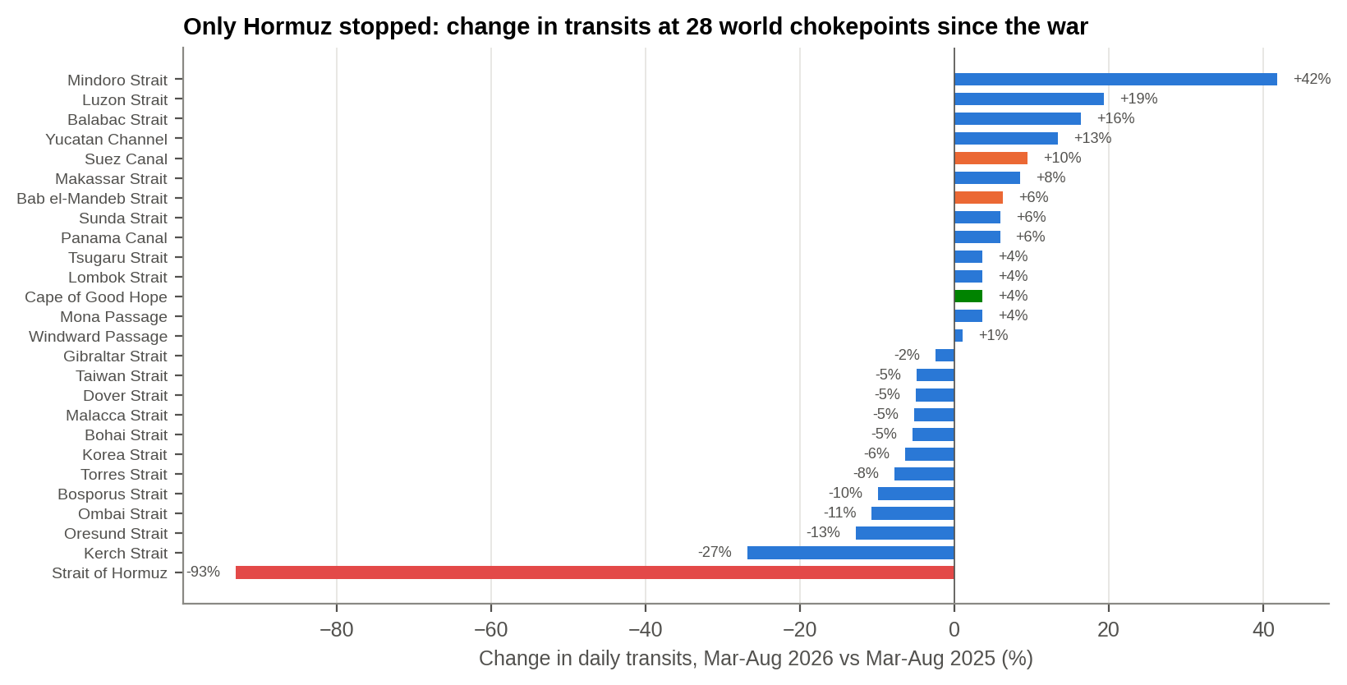
Figure 9.6 : Change in transits at 28 world chokepoints, March-August 2026 against March-August 2025
Only Hormuz stopped: -93% against an average of -4% at seven control chokepoints (Malacca, Panama, Taiwan, Korea, Bosporus, Dover, Gibraltar).

9.10 Presence, Identity and Movement Together
On 4 March 2026 PortWatch recorded 0 transits through Hormuz. On the same day Sentinel-1 radar imaged 337 big hulls in the strait and its approaches, 145 of them still transmitting AIS. The ships were there (presence), a growing share had stopped identifying themselves (identity), and almost none were crossing (movement). The stasis index (Section 7.8) had already shown dark hulls held in place; the transit data confirm it from an independent source. Three layers, three sources, one conclusion: the fleet was held, silent, inside the Gulf.
Table 9.6 : The four layers of the maritime picture, each measured
Layer | Question | Source | Evidence
Presence | Is the hull physically there? | Sentinel-1 SAR (CDM) | 337 big hulls on 4 Mar; two-thirds still present on 12 Mar
Identity | Does it say who it is? | SAR matched to AIS (CDM) | SDR 74% at Hormuz vs 10% baseline
Movement | Is it crossing, or held? | IMF PortWatch transits; SAR revisits | 0 transits on 4 Mar; stasis z = 5.3
Throughput | What cargo reaches India? | Oil price, import bill (open data) | Brent +94% peak; ~US$27 bn extra

9.11 Evacuation Confirmed at the Red Sea
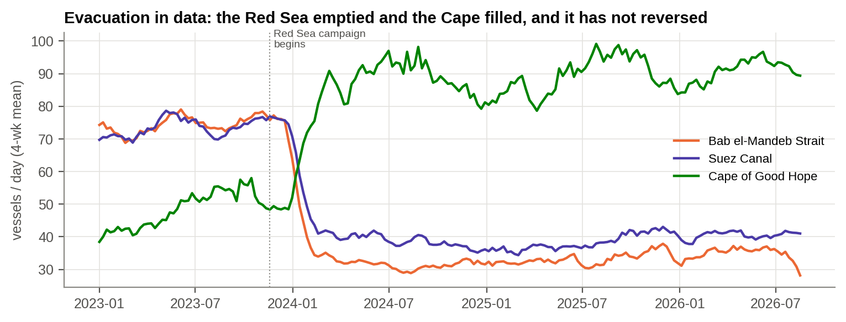
Figure 9.7 : Bab-el-Mandeb, Suez and Cape of Good Hope transits, 2023-2026 (IMF PortWatch)
The evacuation signature assigned to the Red Sea in Section 7.10 from radar alone is confirmed by movement data: Bab-el-Mandeb transits have run 55% below their 2023 level since January 2024, and Cape of Good Hope transits 82% above. The tonnage left, the ships that remained kept transmitting, and two and a half years later it has not reversed.

9.12 How Long Do Shipping Disruptions Last?
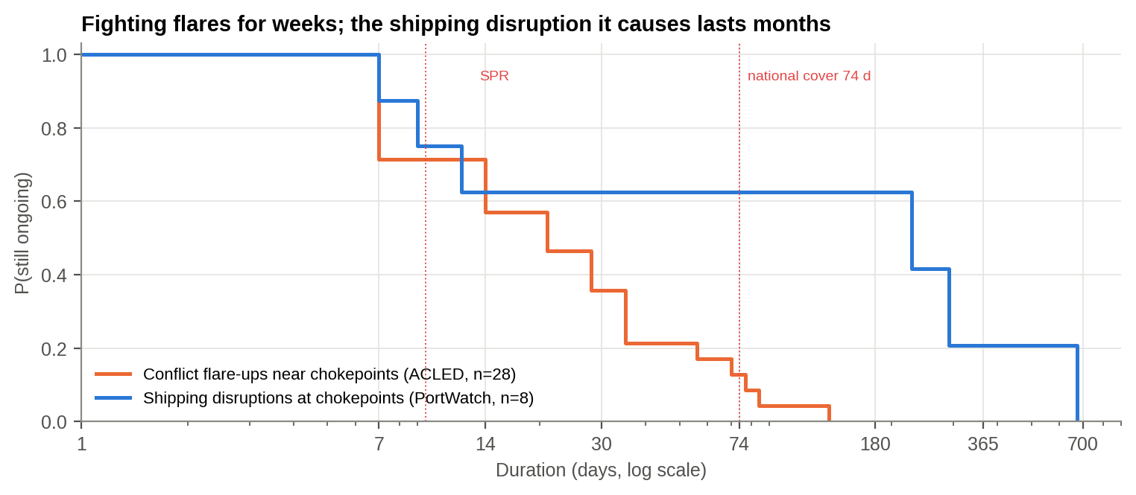
Figure 9.8 : Survival of conflict flare-ups (ACLED) against shipping disruptions (IMF PortWatch) at chokepoints
Table 9.7 : Shipping disruptions at world chokepoints, 2019-2026 (7-day transits below half of the prior-year median)
Chokepoint | Start | End | Days | Ongoing at 16 Aug 2026 | Pre-disruption transits/day
Bab el-Mandeb Strait | 2024-01-18 | 2025-11-19 | 672 | 0 | 73
Kerch Strait | 2023-05-24 | 2024-03-09 | 291 | 0 | 19
Kerch Strait | 2021-11-14 | 2022-06-29 | 228 | 0 | 51
Strait of Hormuz | 2026-03-04 | 2026-08-16 | 166 | 1 | 72
Kerch Strait | 2026-07-07 | 2026-08-16 | 41 | 1 | 13
Kerch Strait | 2023-04-02 | 2023-04-13 | 12 | 0 | 19
Kerch Strait | 2026-04-30 | 2026-05-08 | 9 | 0 | 14
Kerch Strait | 2022-12-02 | 2022-12-08 | 7 | 0 | 19

This is the most important correction the open data make. Conflict flare-ups near chokepoints last a median of 2.5 weeks (Chapter 6). The shipping disruptions they cause last a median of 104 days, and 62% outlast India's 74-day national cover. The Red Sea disruption ran about 22 months; the Hormuz closure had lasted 169 days at the end of the record and was still in force in September [31]. Fighting flares for weeks; the shipping disruption it causes lasts months.

9.13 Open-Source Chronology
Table 9.8 : Chronology of the crisis from open sources
Date | Event | Source
28 Feb 2026 | Regional war begins; weekly political violence triples | ACLED (CDM data)
1-4 Mar | Hormuz transits collapse from ~74/day to 0 on 4 Mar; SAR shows hulls present and going dark | IMF PortWatch [26]; Sentinel-1 (CDM)
11 Mar | Petroleum Ministry: 70% of India's crude now sourced outside Hormuz, up from 55% | AIR News [28]
18 Mar | Hundreds of tankers reported holding outside or stranded inside the Gulf | CNBC [31]
23 Mar | Indian Navy begins Op Urja Suraksha, escorting Indian-flagged energy carriers from the Gulf of Oman | [29]
Late Jun | Partial reopening: transits recover to about a third of normal; Brent falls to ~US$70 | IMF PortWatch [26]; EIA [21]
Jul | War-risk premiums 3-10% of hull value (from ~0.25%); Bab-el-Mandeb shut again | The National, Al Jazeera [30]
Aug-Sep | Hormuz transits ~5% of normal; strait still closed; Brent US$131 on 15 Sep 2026 | IMF PortWatch [26]; [31]; EIA [21]

SO WHAT
Oil rose from $71 to $138, the rupee weakened, and India's oil bill rose by about US$27 billion. The warning signals built here stayed Red in June while the market relaxed, and oil then rose 86%.
Next: How sure can we be of all this?

10. INFERENCE
PART VI - WHAT WE KNOW, AND HOW SURE WE ARE
THE STORY SO FAR
The evidence is now complete. Before drawing conclusions, a good staff officer asks: are we sure, and could something else explain what we see? This chapter tests the story and states each conclusion with its level of confidence.

This chapter brings together the results of Chapters 5 to 9, gives the verdict on each hypothesis and states the inferences that the impact assessments (Chapters 11-13) and the way forward (Chapter 14) are built on.

10.1 Key Findings
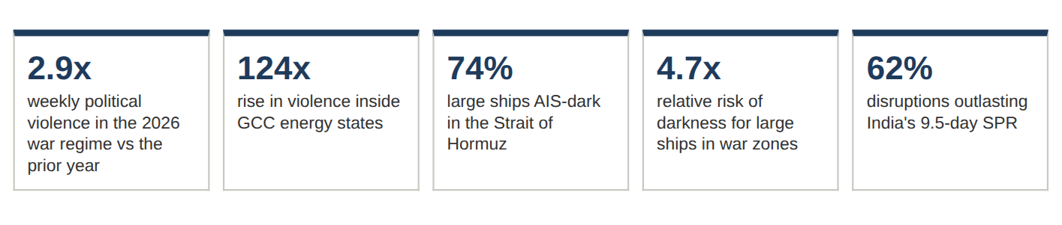
Table 10.1 : Key findings of the study
# | Finding | Section
F1 | Violence rose 2.9-fold in the 2026 war regime; PELT dated the regime shifts to 7 Oct 2023 and 28 Feb 2026 without being given the dates. | 5.1
F2 | 84% of war-period violence was stand-off strikes (air, drone, missile, artillery), a sharp jump that marks the onset of inter-state war. | 5.2
F3 | The war reached the energy coast: GCC violence rose 124-fold, the Hormuz littoral index 188-fold. | 5.2, 6.1
F4 | The Red Sea threat moved offshore: land strikes fell ~6-fold while at-sea violence rose ~30-fold; a land-based index would miss it. | 6.1
F5 | Disruptions are heavy-tailed: median 2.5 wk, max 19 wk; 62% outlast the SPR, 11% outlast 74 days; Hormuz stays elevated into Q3-2026 (99% of simulated paths cross the threshold). | 6.2, 6.3
F6 | Large ships in war zones are 4.7x more likely to be AIS-dark (Hormuz 74%, Black Sea 38%); darkness in the Gulf rose over the first two weeks of the war. | 7.1, 7.4
F7 | Blinding where there is no detour (Gulf) and diversion where there is (Red Sea): the two dominant cells of a four-signature typology (F14). | 7.1, 7.10
F8 | Dark ships gather at the Dubai/Jebel Ali and Fujairah anchorages: the supply chain is held at anchor with AIS off. Shadow-fleet registries are over-represented among visible ships (~3x), but the dark fleet is mainly mainstream tonnage. | 7.3, 7.5, 7.9
F9 | India's near seas are dominated by thousands of small, non-AIS craft; large ships off India remain visible. | 7.6
F10 | Proximity to conflict predicts darkness in unseen regions (ROC-AUC 0.69); AIS identity itself is unreliable (clones, placeholders, malformed IDs). | 7.7, 8
F11 | The Hormuz war sent Brent +94% within 40 days and the rupee +5.3%; the Red Sea campaign barely moved oil. The war added ~US$27 bn to India's oil bill. | 9.2-9.7
F12 | Weekly conflict intensity does not lead oil prices, yet the June I&W call (Red at US$70 Brent) was followed by a 86% rise: the indicators warned where the market did not. | 9.4, 9.8
F13 | AIS counts said Hormuz shipping fell 83%; radar saw the physical fleet fall only 33% and the dark fleet not at all; many dark hulls were held in place (stasis z = 5.3). | 7.8
F14 | Four signatures, not one: concealment (Gulf), evacuation (Red Sea), attrition/frozen (Black Sea), compliance (East Med, near-zero darkness beside heavy conflict). | 7.9-7.10
F15 | Movement (IMF PortWatch) confirms the picture: Hormuz transits -92% with zero on 4 Mar while radar saw 337 hulls; only Hormuz stopped among 28 chokepoints; the Red Sea evacuation has lasted over two years. | 9.9-9.11
F16 | Shipping disruptions last far longer than the fighting: median 104 days, 62% beyond 74 days; the Hormuz closure passed 169 days. | 9.12

10.2 Verdict on the Hypotheses
Table 10.2 : Verdict on the hypotheses
# | Hypothesis | Verdict and evidence
H1 | Regime shifts coincide with the 2023 and 2026 wars | Supported - change-points on 7 Oct 2023 and 28 Feb 2026; war regime 2.9x, p = 3.6e-05
H2 | War moved to the energy littoral; Red Sea threat moved offshore | Supported - GCC 124x, Hormuz littoral 188x; Yemen land strikes down, at-sea events up
H3 | Large ships are more often dark in war zones | Strongly supported - RR 4.7, OR 8.0, chi-square p < 10-300
H4 | Darkness forms significant hot spots at conflict chokepoints | Supported - 43 Gi* hot-spot cells in one belt from Qatar to the Gulf of Oman; largest DBSCAN clusters at Gulf anchorages
H5 | Proximity to conflict predicts darkness out-of-region | Supported, with moderate skill - ROC-AUC 0.69, PR-AUC 0.37 against a base rate of 0.20
H7 | Shocks transmit to oil and rupee; size depends on detour | Supported - Hormuz war: Brent +94% peak in 40 days; Red Sea campaign: -5% at +20 days; rupee +5.3%. Weekly conflict intensity does not lead prices (Granger p > 0.4)
H6 | Disruptions are heavy-tailed and outlast India's oil cover | Supported - 62% outlast the SPR, 11% outlast 74 days; post-2023 episodes more persistent (HR 0.43, not significant)

10.3 Inferences Drawn
Read together, the findings support six inferences. Each is stated with the findings it rests on.
• I1 - Conflict at a chokepoint first shows up as a loss of information, and only then as a loss of flow (F6, F8). Before cargo stops moving, the cooperative maritime picture collapses: large, AIS-obligated ships vanish from it, and tankers wait at anchor with transponders off. The large-ship dark share is therefore a leading indicator of supply disruption. It can be measured from space before trade statistics show anything.
• I2 - Two conditions decide how shipping responds: whether identity is dangerous and whether a detour exists (F4, F7, F14). Where there is an alternative route, as with the Red Sea and the Cape, conflict causes diversion: traffic thins and the cost appears as time and freight. Where there is none, as with the Gulf and Hormuz, conflict causes blinding: ships keep sailing but go dark, and the cost appears as risk. Where a credible authority enforces reporting (East Med, Suez) identity is protective and ships stay visible; in a long war (Black Sea) a two-fleet pattern freezes in place. Policy must follow the signature, not the headline.
• I3 - Stand-off weapons have removed the distance between a land war and the sea lanes (F2, F3, F4). With 84 per cent of war-period violence delivered by drones, missiles and artillery, any littoral actor can hold a chokepoint, a terminal or a logistics node at risk. Distance from the front line no longer protects rear areas.
• I4 - Supply disruption is a question of duration, not of spikes (F5). Most episodes are short, but the tail is long and persistent. Planning for the median episode leaves the force and the nation exposed for most of the expected shortfall. Buffers must be sized against the survival curve, and the prescriptive model (Chapter 13) shows the point at which extra stock stops paying off.
• I5 - Darkness is predictable, so early warning is feasible (F1, F10). Change-points in the conflict series match real-world turning points, and conflict geography predicts darkness in sea regions the model has never seen. Open conflict data combined with satellite radar can therefore give warning of where and when the maritime picture will fail.
• I6 - AIS identity is necessary but not sufficient (F8, F9, F10). Cloned, placeholder and malformed identities, shadow-fleet registries and thousands of non-AIS small craft in India's own seas mean that a trustworthy maritime picture requires independent sensing (SAR, radar) and automated identity checks.

10.4 Stress-Testing the Central Inference: Robustness
A judgement that rests on one definition or one threshold is fragile. The war-zone effect on large-ship darkness was re-estimated under eight alternative specifications: different size cut-offs, a stricter definition of darkness, high-confidence detections only, fishing vessels removed, and the Black Sea excluded. Detections from the same satellite image are not independent, so confidence intervals were obtained by a scene-cluster bootstrap (2,000 resamples of whole Sentinel-1 scenes). Here 'war zones' means the Gulf and the Black Sea, where the fighting reached the coast. This is why the baseline relative risk differs slightly from Chapter 7, which also counted the Red Sea zone.
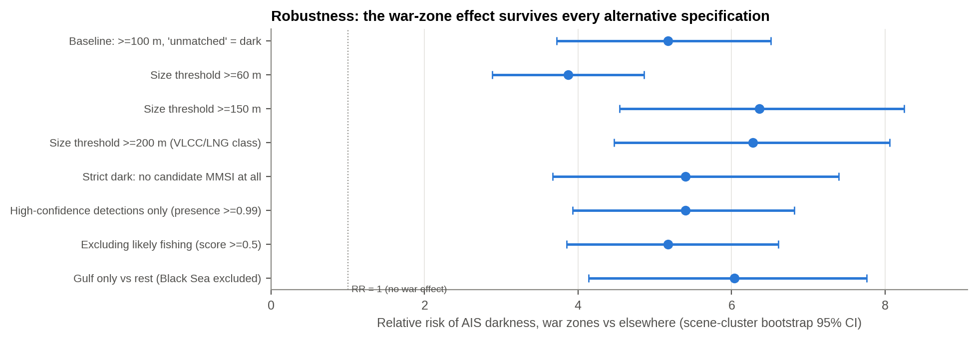
Figure 10.1 : Relative risk of AIS darkness under alternative specifications (scene-cluster bootstrap 95% CI)
What this shows: Every dot is the same question asked a different way. All are far to the right of 1, so the war effect is real however it is measured.

Table 10.3 : Robustness of the war-zone darkness effect
Specification | Ships | Dark % war zones | Dark % elsewhere | RR | RR 95% CI low | RR 95% CI high
Baseline: >=100 m, 'unmatched' = dark | 40,179 | 52.10 | 10.10 | 5.17 | 3.72 | 6.51
Size threshold >=60 m | 54,698 | 50.60 | 13.10 | 3.87 | 2.88 | 4.86
Size threshold >=150 m | 25,807 | 53.80 | 8.50 | 6.36 | 4.54 | 8.25
Size threshold >=200 m (VLCC/LNG class) | 11,873 | 54.70 | 8.70 | 6.28 | 4.47 | 8.06
Strict dark: no candidate MMSI at all | 40,179 | 38.60 | 7.20 | 5.40 | 3.67 | 7.40
High-confidence detections only (presence >=0.99) | 37,208 | 52.60 | 9.70 | 5.40 | 3.93 | 6.82
Excluding likely fishing (score >=0.5) | 40,121 | 52.10 | 10.10 | 5.17 | 3.85 | 6.61
Gulf only vs rest (Black Sea excluded) | 38,297 | 60.90 | 10.10 | 6.04 | 4.14 | 7.76

Across all eight specifications the relative risk lies between 3.9 and 6.4, and the lowest lower confidence bound is 2.9. No reasonable choice of definition makes the effect go away.
Table 10.4 : Pass-level checks: feed outages and satellite pass time
Check | Gulf SDR % | Peaceful seas SDR % | War-zone relative risk
All passes | 60.90 | 10.10 | 5.17
Excluding 67 passes that were 100% dark (possible AIS feed outage) | 56.30 | 6.50 | 7.54
Daylight passes only | 60.50 | 8.50 | 5.08
Night passes only | 60.90 | 11.20 | 5.33

Table 10.5 : Difference-in-differences: did the Gulf darken faster than 11 control seas?
Quantity | Value (percentage points per day)
Control seas trend | -0.22
Gulf excess trend (difference-in-differences) | 5.67
Permutation p-value (5,000 label shuffles) | 0.0082
Scene-sea units (treated / control) | 47 / 1483

Two further threats were tested. Feed outage: 67 satellite passes were 100% dark, which could be an AIS feed failure rather than behaviour. Removing them raises the war-zone relative risk to 7.5. Pass geometry: the Gulf SDR is 60% by day and 61% by night, against 8% and 11% in peaceful seas. Change, not just level: treating each satellite image as one observation, the Gulf SDR rose 5.7 percentage points a day faster than 11 control seas (whose trend was -0.22), permutation p = 0.008. The Gulf darkened during the fortnight, and nowhere else did.

10.5 Dose-Response Inside the Gulf
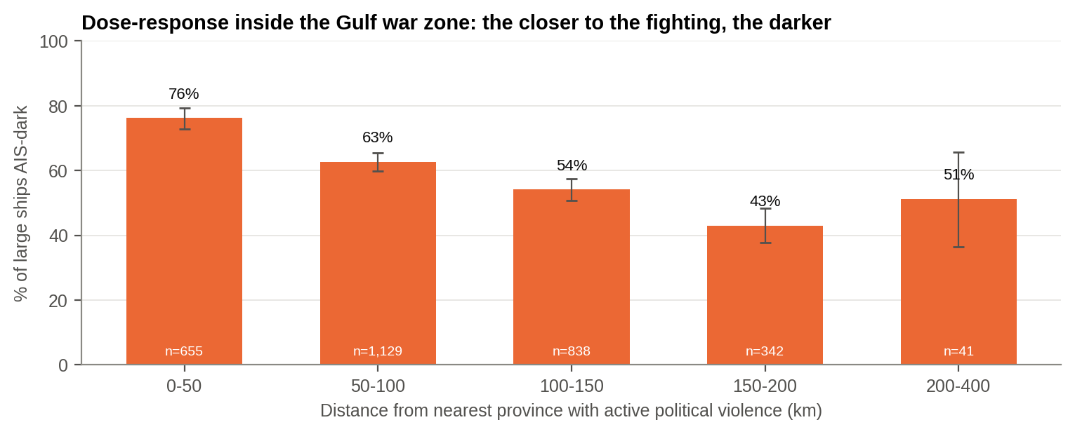
Figure 10.2 : AIS-dark share of large ships by distance from the nearest province with active fighting, Gulf war zone
What this shows: The closer ships were to the fighting, the more of them went dark: a clear sign that the war caused it.

Table 10.6 : Dose-response of darkness to proximity of fighting (Gulf war zone, ships ≥ 100 m)
Distance band (km) | Dark | Large ships | Dark % | CI low % | CI high %
0-50 | 499 | 655 | 76.20 | 72.80 | 79.30
50-100 | 708 | 1,129 | 62.70 | 59.90 | 65.50
100-150 | 454 | 838 | 54.20 | 50.80 | 57.50
150-200 | 147 | 342 | 43 | 37.80 | 48.30
200-400 | 21 | 41 | 51.20 | 36.50 | 65.70

Within the Gulf itself, where sensor, season and traffic mix are held constant, darkness falls steadily with distance from the fighting: 76% within 50 km, 54% at 100-150 km, and 43 per cent at 150-200 km. Each unit increase in log-distance multiplies the odds of darkness by 0.45 (p = 9e-28). A graded response to the strength of exposure is one of the classic criteria for inferring cause rather than coincidence.

10.6 Analysis of Competing Hypotheses
Following intelligence tradecraft (the Analysis of Competing Hypotheses method), each alternative explanation of the Gulf darkness is scored against every item of evidence as Consistent (C), Inconsistent (I) or Neutral (N). The hypothesis with the fewest inconsistencies is preferred, rather than the one with the most support.
Table 10.7 : Analysis of competing hypotheses for AIS darkness in the Gulf (C = consistent, I = inconsistent, N = neutral)
Evidence (from this study) | H-A Deliberate switch-off | H-B GNSS spoofing / jamming | H-C AIS reception gap | H-D Matching artefact
E1 Darkness rises steeply for large ships only in war zones (>200 m: Gulf 60% vs 8% elsewhere) | C | C | I | I
E2 Dose-response: 76% dark within 50 km of fighting, 54% at 100-150 km | C | C | I | I
E3 Same signature in an unrelated war (Black Sea 38%) under the same sensor and algorithm | C | C | I | I
E4 Dark share rose through the first two weeks of the war (35% -> 73%) | C | C | N | I
E5 Dark ships cluster at anchorages (Dubai 97% dark, Fujairah 85%) rather than spread evenly | C | N | I | I
E6 'Noisy' AIS tracks are NOT elevated in the Gulf (1.2% vs 2.1% worldwide) | C | I | N | N
E7 Large ships off India's west coast, same satellite pass geometry, remain visible (Arabian Sea 7%) | C | C | I | I

Inconsistencies: deliberate switch-off 0, GNSS spoofing/jamming 1, AIS reception gap 5, matching artefact 6. Reception gaps and algorithm artefacts are effectively ruled out, because they cannot produce size-selective, distance-graded, war-specific darkness. Deliberate switch-off is the best-supported explanation. GNSS interference is not ruled out and probably contributes, but the absence of any excess in 'noisy' tracks argues against it being the main mechanism.

10.7 Key Judgements and Confidence
Judgements are expressed in the standard language of estimative probability, with a separate statement of analytic confidence that reflects the quality and quantity of the evidence.
Table 10.8 : Scale of estimative probability used
Term | Probability
Almost certain | > 95%
Highly likely | 80-95%
Likely | 55-80%
Roughly even chance | 45-55%
Unlikely | 20-45%
Highly unlikely | 5-20%

Table 10.9 : Key judgements
# | Judgement | Confidence | Basis
KJ1 | It is almost certain that the war caused the excess AIS darkness of large ships in the Gulf. | High | RR 3.9-6.4 under all specifications; dose-response; replicated in the Black Sea
KJ2 | It is likely that most of the darkness is deliberate switch-off; GNSS interference probably contributes. A failed match proves identification failure, not intent. | Moderate | ACH: 0 inconsistencies for switch-off; ships held at anchor (stasis); intent cannot be observed
KJ3 | It is highly likely that the Hormuz littoral stays above its disruption threshold at least intermittently through Q3-2026. | Moderate | 99% of simulated paths breach; I&W status Red at end of data
KJ4 | A chokepoint disruption likely outlasts India's SPR (about 62%); outlasting total national cover is highly unlikely (about 11%) but not negligible. | Moderate | Kaplan-Meier on 32 episodes; wide intervals
KJ5 | It is almost certain that stand-off weapons will remain the dominant threat to rear-area logistics and energy nodes in regional wars. | High | 84% of war-period violence; consistent across 2024 and 2026 wars
KJ6 | It is likely that the Strategic Dark Ratio (SDR) leads measurable trade disruption. | Low | Plausible and consistent with anchorage clustering; not yet tested against flow data
KJ7 | It is highly likely that open conflict and satellite indicators give earlier warning than market prices. | Moderate | Prices react only to events (Granger p > 0.4); June call Red at US$70, then +86%; one out-of-sample test

10.8 Limitations
• The SAR data cover only 14 days from a single satellite (Sentinel-1A), so the pre-war level of darkness in the same waters cannot be observed directly. Peacetime regions and the Black Sea serve as the comparison groups instead.
• 'Unmatched' is not always deliberate: GNSS spoofing, AIS reception gaps and matching-algorithm limits also produce darkness. In the Gulf these are themselves effects of the war.
• ACLED aggregates are at ADMIN1 resolution, and its at-sea events carry a nominal basin centroid. Distances to conflict are therefore approximate.
• The survival analysis rests on 32 episodes, so Cox coefficients have wide intervals. MID-to-flag decoding and registry classes are approximations, and registry class is not proof of any particular ship's conduct.
• Figures quoted from secondary sources (oil import shares, reserve days, diaspora) are indicative and cited, and they were not derived from the Datathon datasets.
None of these limitations reverses the direction of the main inferences. The war-zone effect on large-ship darkness (I1) is large, significant and reproduced in two unrelated wars. Inferences I4 and I5 should be read as well supported but moderate in precision.
SO WHAT
The central finding survives every test we could devise. It holds under eight different definitions, it gets stronger the closer ships are to the fighting, and no rival explanation fits the evidence as well as deliberate switch-off.
Next: What does this mean for the world?

11. IMPACT ON THE GLOBE
PART VII - WHAT IT MEANS FOR THE WORLD
THE STORY SO FAR
Having established what we know and how sure we are, we turn to what it means, starting with the wider world before narrowing to India and then to our own forces.

• Energy security. About a fifth of the world's oil liquids and a large share of its LNG pass through Hormuz [2]. F3 and F5 show the strait's shoreline became an active front and stayed above its disruption threshold for most of February to June 2026. The world energy market now has to price chokepoint risk as a recurring condition, not a rare event (I4).
• Freight, time and cost. Where a detour exists, conflict produces diversion (I2). Cape routing adds 10-14 days to Asia-Europe voyages, absorbs fleet capacity and raises freight and insurance costs worldwide [1]. The survival curves (F5) show these episodes last weeks to months, not days.
• Loss of the common maritime picture. In war zones the cooperative identity system on which collision avoidance, search and rescue, sanctions enforcement, insurance and port-state control depend fails for most large ships (F6, I1). Navigation safety deteriorates, and the chance of misidentifying and striking a neutral ship rises.
• Sanctions and the shadow fleet. Dark ships cluster at the Gulf and Black Sea anchorages, and shadow-fleet registries are about three times over-represented among visible ships (F8), although the dark fleet itself is mainly mainstream tonnage. The informal, poorly insured fleet grows exactly where oversight is weakest, raising the risk of environmental disasters and unattributable incidents (I6).
• Contagion of stand-off warfare. Cheap drones and missiles have become the main tool of regional war (F2, I3). Any littoral actor can now hold a chokepoint at risk from the shore, and the model extends beyond the Middle East to other straits.
• A model for other chokepoints. The four signatures identified here (concealment, evacuation, attrition/frozen, compliance; I2) offer a way to anticipate what would happen in a crisis at Malacca, the Taiwan Strait or the Bosphorus, where the same data and methods can be applied.
SO WHAT
For the world, chokepoint war is now a recurring cost of trade and a hazard at sea.
Next: What does it mean for India?

12. IMPACT ON INDIA
PART VIII - WHAT IT MEANS FOR INDIA
THE STORY SO FAR
The world pays for a chokepoint war in higher prices and slower trade. India pays more than most, because it imports almost nine-tenths of its oil and sits at the end of both the Hormuz and Red Sea routes.

The impact reaches India through a chain that runs from the battlefield to the balance of payments and the defence budget. Every link in the chain below is measured in this study.
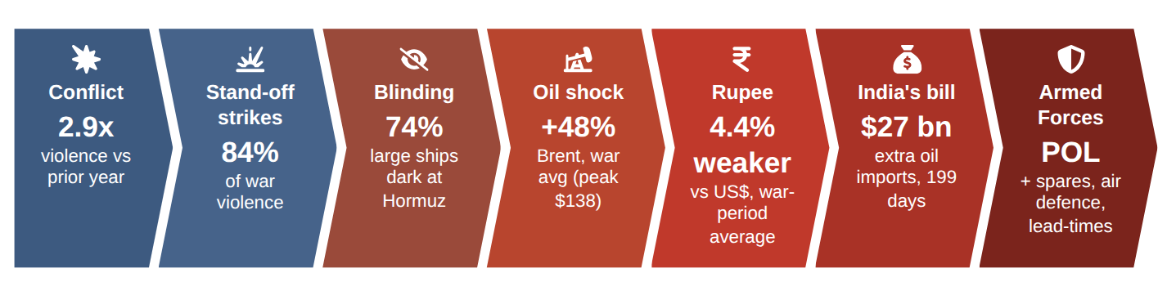
Figure 12.1 : Impact cascade: from conflict at the chokepoint to India's import bill and the Armed Forces (SmartArt)
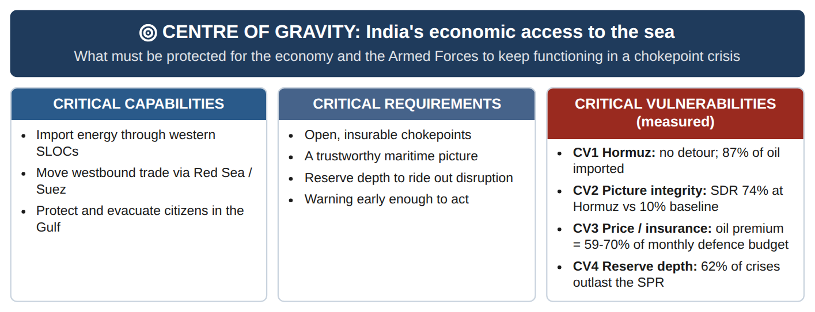
Figure 12.2 : Centre-of-gravity analysis: India's economic access to the sea, with measured critical vulnerabilities (after Strange, 1996)
CV1 (Hormuz) and CV3 (price and insurance) are familiar. CV2, the integrity of maritime identification, is the vulnerability this study adds, and no amount of tonnage fixes it: an escort must know which ship to escort, and in the water where it matters most three-quarters of the big hulls were not saying.
• Energy import exposure. India imports close to nine-tenths of its crude oil. Open-source estimates put a large share of that crude (commonly 40-50 per cent), most of its LPG and much of its LNG as coming from the Gulf through Hormuz [2, 19]. The heavy-tailed disruption curve (F5, I4) means that about 62% of disruptions would outlast the strategic petroleum reserve (~9.5 days) and about 11% would outlast the total national cover of about 74 days [19]. Hormuz is a no-detour chokepoint (I2), so for this share of India's energy there is no rerouting option, only buffers and alternative suppliers.
• Trade routes to Europe, Africa and the US East Coast. The Red Sea diversion (F4, F7) lengthens India's westbound container and product-tanker routes and raises their cost, eroding the competitiveness of exports such as refined products, engineering goods, textiles and pharmaceuticals. The Houthi campaign episodes lasted a median of four weeks and up to 19 weeks.
• Connectivity projects. The International North-South Transport Corridor through Chabahar and the India-Middle East-Europe Economic Corridor (IMEC) both pass through the theatres analysed. The predicted dark-risk at Chabahar (Table 8.3) and the violence in Sistan-Baluchestan and Hormozgan (Chapter 5) point to delays and higher risk premia for both.
• Diaspora and remittances. About nine million Indians live in the GCC, which sends India a large share of its remittances [20]. The 124-fold rise in violence inside the GCC (F3) makes large-scale non-combatant evacuation a planning case, not a contingency.
• Maritime domain awareness at home. India's own seas are dominated by thousands of small, non-AIS craft (F9), and even AIS-visible identities can be cloned or spoofed (F10). The national maritime picture cannot rely on AIS alone (I6).
• An opportunity. The inferences also favour India. National SAR assets (EOS-04, NISAR), the Information Fusion Centre - Indian Ocean Region, and a growing analytics culture give India the means to turn I1 and I5 into a regional early-warning service for partners in the Indian Ocean, strengthening its role as a net security provider.
Own-asset exposure. Decoding the flag of every AIS-visible ship shows how many Indian-flagged vessels were inside the theatres during the first two weeks of the war. These are only the ships still transmitting; any that went dark are not counted.
Table 12.1 : Indian-flagged ships detected by Sentinel-1, 1-14 March 2026
Zone | Detections | Distinct Indian-flag ships | Detections >=100 m | Median length (m)
Gulf war zone | 35 | 33 | 19 | 140
Red Sea zone | 6 | 5 | 2 | 27
Arabian Sea | 584 | 502 | 91 | 29
Bay of Bengal | 236 | 208 | 42 | 25
Rest of world | 58 | 40 | 54 | 207

At least 33 distinct Indian-flagged ships (19 detections of ships of 100 m or more) were operating inside the Gulf war zone in two weeks. This is a lower bound, since Indian-owned tonnage under foreign flags is not identified by the flag decode. It is the minimum population for which escort, evacuation of crews, and war-risk insurance support would have to be planned.
SO WHAT
For India the exposure is concentrated in oil, westbound trade, connectivity projects and nine million citizens in the Gulf.
Next: And for the Armed Forces?

13. IMPACT ON THE INDIAN ARMED FORCES
PART IX - WHAT IT MEANS FOR THE ARMED FORCES
THE STORY SO FAR
The same shocks that hit India's economy also reach the Armed Forces: through fuel, spares, the threat to bases, and the need to protect citizens abroad.

The findings affect all three Services and the joint structures that link them. The common threads are fuel and spares security (I4), the stand-off threat to bases and nodes (I3), and operating in an environment where navigation and identity can no longer be taken for granted (I1, I6).
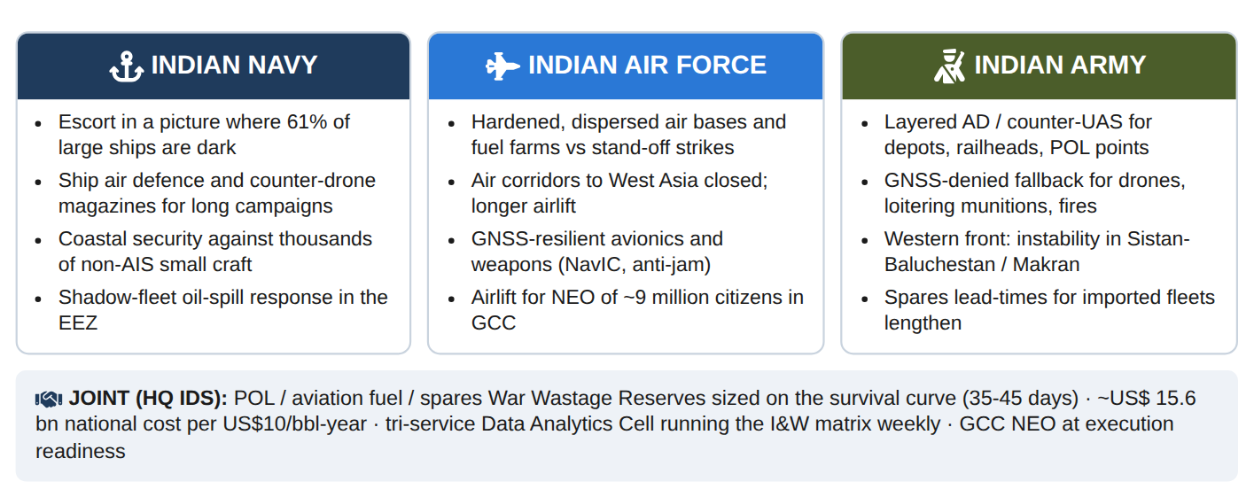
Figure 13.1 : Impact on the Indian Armed Forces at a glance (infographic)

13.1 Joint and Tri-Service Impact
• POL and war-wastage reserves. Mechanised formations, ships and aircraft all run on imported crude refined in India. A chokepoint disruption that outlasts national reserves (F5) would lead to rationing, in which defence consumption competes with the civil economy. The prescriptive model in Section 13.5 turns F5 into a stock-holding decision.
• Imported equipment, spares and ammunition. Sea-lifted defence imports and the spares for imported platforms move on the same routes. Longer, more variable lead-times (F4, F5, F7) mean that re-order points and safety stocks based on peacetime lead-times will be too low for all three Services.
• Non-combatant evacuation. The rise in GCC violence (F3) makes a large-scale evacuation of the Gulf diaspora a joint operation to plan now: Navy sealift, IAF airlift and Army reception, transit and medical support. Op Ganga (2022), Op Kaveri (2023) and Op Ajay (2023) are the reference cases.
• Space-based surveillance. The study shows what SAR can reveal in a war zone (F6, F8). The Defence Space Agency and the national SAR constellation are the natural owners of a standing dark-ship and chokepoint watch.

13.2 Indian Navy
• Escort and presence operations. The belt of darkness from Qatar to the Gulf of Oman (F6, H4) is the area in which Indian-flag tankers and gas carriers would be escorted, as in Op Sankalp. Positive identification of contacts in a picture where 60-74 per cent of large ships are dark is harder, raising the risk of surprise and of mistaken engagement.
• Stand-off threat at sea. The anti-shipping campaign (F4) and the dominance of drones and missiles (F2) call for ship air defence, counter-drone systems and magazine depth sized for long campaigns (F5), not single incidents.
• Coastal security. The thousands of non-AIS small craft in India's near seas (F9) are the population in which a 26/11-type threat hides. Coastal radar, SAR cueing and fishing-vessel transponders are needed alongside AIS.
• Shadow fleet in the Indian EEZ. Poorly insured, shadow-registered tankers (F8) crossing India's waters raise the risk of oil spills and incidents that the Navy and Coast Guard would have to respond to.

13.3 Indian Air Force
• Air-base survivability. GCC energy infrastructure far from any front line was struck directly (F3), and stand-off weapons dominate (F2, I3). Forward and depth air bases, fuel farms and radars need layered air defence, hardened shelters, dispersal and rapid runway repair.
• Air routes and airlift. Violence across the GCC and Iran closes or restricts air corridors to West Asia, Africa and Europe. That lengthens ferry and airlift routes, including those needed for evacuation and for urgent sustainment of imported spares.
• Navigation warfare. The spoofing and identity anomalies seen at sea (F10) are the maritime face of the GNSS interference that also affects aircraft. Avionics and weapons need multi-constellation (NavIC), anti-jam and inertial fallback.

13.4 Indian Army
• Logistics nodes under stand-off threat. Army depots, railheads, POL points and ammunition storage need the same layered air defence, counter-UAS, dispersal and hardening that the Gulf's terminals lacked (F2, F3, I3).
• GNSS-dependent weapons. Army drones, loitering munitions, precision artillery and timing networks need NavIC/multi-constellation, anti-jam and GNSS-denied fallback capability, and troops should train under jamming and spoofing (F6, F10).
• Western front and hybrid spill-over. Violence in Sistan-Baluchestan (among Iran's most violent provinces over the decade), the Makran littoral and a weakened Iranian periphery all border Pakistan's Balochistan. These affect the western-front threat picture and the security of connectivity projects.
• Sustainment of imported fleets. Armoured, artillery and aviation fleets with imported sub-systems face longer spares lead-times (F5). Predictive maintenance and survival-based spares forecasting of the kind the author developed for armoured vehicles [13] become more valuable.

13.5 Prescriptive Model: How Much Stock Is Enough?
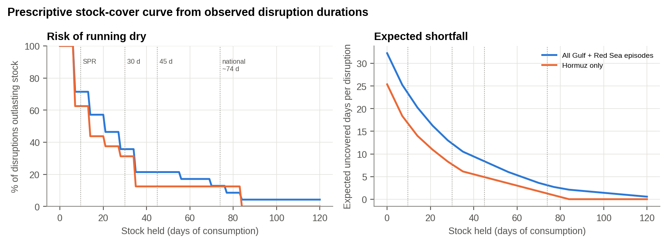
Figure 13.2 : Prescriptive stock-cover curve from observed Gulf and Red Sea disruption durations
What this shows: Left: the chance that a crisis outlasts a given stock. Right: the average days short. Beyond about 35-45 days, extra stock buys little.

Table 13.1 : Decision table: stock held against disruption risk and expected shortfall
Stock (days) | P(disruption outlasts stock) % | Expected uncovered days | Shortfall avoided vs zero stock %
0 | 100.0 | 32.2 | 0.0
10 | 71.4 | 23.1 | 28.3
15 | 57.1 | 19.7 | 39.0
30 | 35.7 | 12.3 | 61.9
45 | 21.4 | 8.4 | 74.1
60 | 17.1 | 5.3 | 83.5
74 | 12.9 | 3.1 | 90.4
90 | 4.3 | 1.8 | 94.3

With no stock, an average Gulf or Red Sea disruption leaves 32 uncovered days. Holding 30 days of stock cuts the expected shortfall to 12.3 days, and 45 days to 8.4 days, avoiding 74 per cent of the shortfall. The returns flatten at about 35 days: beyond this point each additional day of stock removes less than a quarter of a day of expected shortfall. The same curve can be applied to any disruption-sensitive commodity held by any Service (POL, lubricants, aviation fuel, critical imported spares) to set holdings on evidence rather than precedent.
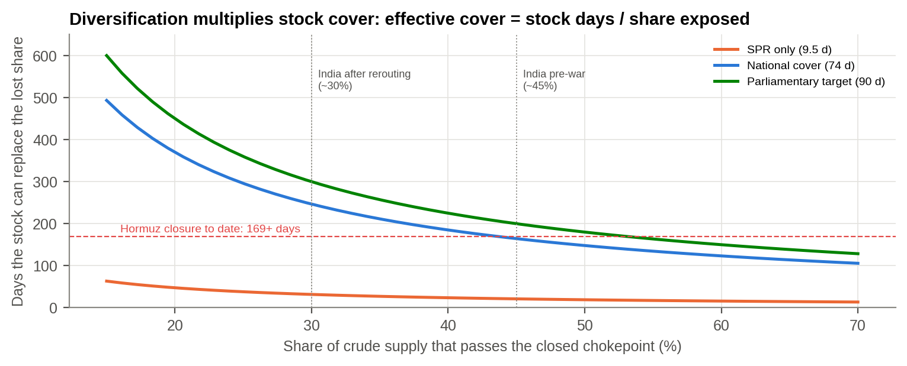
Figure 13.3 : Effective cover: how long a stock can replace the share of supply lost behind a closed chokepoint
The open data change the question from 'how many days of stock?' to 'how many days of stock per share exposed?'. A full closure has already lasted 169+ days, far beyond any stock. But a stock only has to replace the share of supply that is cut off. At India's pre-war exposure of about 45%, 74 days of national cover replaces the lost share for about 164 days; after rerouting to about 30% exposure it lasts about 246 days, longer than the closure so far. The SPR alone lasts only about 31 days even at 30%. Stocks bridge; diversification carries. The same arithmetic applies to Service holdings of fuel and critical imported spares: 35-45 days bridges a flare-up, and dual sourcing is what carries a closure.

13.6 Scenario Matrix for Force Planning
Joining the survival curve (how long disruptions last) to the stock levels (how long the nation and the Services can hold out) gives a scenario matrix of the kind used in force planning.
Table 13.2 : Hormuz / Red Sea disruption scenarios: likelihood and uncovered days
Scenario | Duration | P(disruption lasts at least this long) | Days beyond SPR (9.5 d) | Days beyond national cover (74 d) | Days beyond 30 d / 45 d Service holdings
S1 Short disruption | 2 weeks | 71% | 4 | 0 | 0 / 0
S2 Sustained disruption | 6 weeks | 21% | 32 | 0 | 12 / 0
S3 Prolonged disruption | 12 weeks | 9% | 74 | 10 | 54 / 39
S4 Campaign-length disruption | 26 weeks | < 5% (beyond the longest observed episode) | 172 | 108 | 152 / 137

S2 (six weeks) is the planning case. It is roughly a one-in-five event on the historical record (21%). It is fully covered at national level but leaves a 30-day Service holding 12 days short. A 45-day holding covers it completely. S3 (twelve weeks, about 9%) exceeds every buffer and is the case for which rationing priorities, alternative supply and the national reserve release order must be prepared in advance.
Two clocks, not one. The likelihoods above come from conflict flare-ups (Chapter 6). The shipping record tells a harder story (Section 9.12): 62% of chokepoint shipping disruptions outlasted the 74-day national cover, and the Hormuz closure had run 169 days by the end of the record. So S2 is the planning case for stock holdings, which must bridge the first six weeks, while S3-S4 is the planning case for supply, which only diversification (effective cover, Figure 13.3) can carry.
SO WHAT
For the Armed Forces it means fuel and spares stocks sized on evidence, rear areas defended against drones and missiles, navigation that does not rely on GPS alone, and a joint watch on the chokepoints.
Next: What should we do, and in what order?

14. WAY FORWARD
PART X - WHAT WE SHOULD DO
THE STORY SO FAR
The story has shown what happens, how long it lasts, what it costs and whom it affects. This chapter turns that into action: what to do, what to watch, and in what order.

The way forward has three parts: recommendations traced to the findings and inferences, a phased roadmap to implement them, and the research that would strengthen the evidence.

14.1 Recommendations
Table 14.1 : Recommendations traced to findings (F) and inferences (I)
Level | # | Recommendation | Based on
National | R1 | Treat stocks as a bridge and diversification as the cure: hold 35-45 days to ride out flare-ups, and cut the share of crude exposed to any one chokepoint, because effective cover = stock days / share exposed (74 days lasts ~8 months at 30% exposure but only ~5 months at 45%). | F5, F16, I4
National | R2 | Diversify energy sources and routes: more non-Gulf crude and LNG, access to Hormuz-bypass export points (Yanbu, Fujairah), and long-term charters that include war-risk clauses. | F3, F7, I2
National | R3 | Build a national Chokepoint Early-Warning System that tracks the CCII, the stand-off strike share and the Strategic Dark Ratio (SDR) weekly, with the thresholds from this study as triggers. | F1, F2, F6, I1, I5
Maritime / MDA | R4 | Fuse SAR (NISAR, EOS-04, commercial SAR) with AIS at IFC-IOR and flag every dark large ship automatically, prioritising the hot-spot belt and the predicted dark-risk surface. | F6, F8, I1
Maritime / MDA | R5 | Treat AIS identity as untrusted: build automated checks for impossible re-sightings, placeholder and malformed MMSIs and shadow-fleet registries, and share them with ports and insurers. | F10, I6
Maritime / MDA | R6 | Extend coverage of small craft in India's seas (fishing-vessel transponders, coastal radar, SAR) so that the non-AIS population is known. | F9, I6
Joint (HQ IDS) | R7 | Re-baseline POL, lubricant, aviation-fuel and critical-spares War Wastage Reserves for all three Services using the expected-shortfall method (Eq. 3.6), and re-order points using lead-time distributions measured during crises. | F4, F5, I4
Joint (HQ IDS) | R8 | Set up a tri-service Data Analytics Cell under HQ IDS, with Service nodes (DG Log, DGMO, Naval Operations, Air Operations), that runs this pipeline and its Power BI dashboard as a standing supply-chain and conflict early-warning product. | All
Joint (HQ IDS) | R9 | Pre-plan non-combatant evacuation from the GCC as a live case and rehearse Navy sealift, IAF airlift and Army reception, transit and medical components together. | F3
Indian Navy | R10 | Use SAR dark-ship cueing and the predicted dark-risk surface for escort and presence operations in the Gulf and Arabian Sea; plan ship air defence and counter-drone magazines for long campaigns. | F2, F4, F6
Indian Air Force | R11 | Harden and disperse air bases and fuel farms against stand-off strikes, and make multi-GNSS/NavIC, anti-jam and inertial fallback standard for avionics and weapons. | F2, F3, F10, I3
Indian Army | R12 | Give priority to layered air defence, counter-UAS, dispersal and hardening of depots, POL points and railheads, and make GNSS resilience mandatory for drones, loitering munitions and precision fires. | F2, F3, F10, I3
All Services | R13 | Weight indigenisation (Aatmanirbharta) priority lists by route exposure, so that items that move through Hormuz or the Red Sea and have long lead-times are indigenised or dual-sourced first. | F4, F5, F7
All Services | R14 | Standing instruction: no AIS-derived traffic count for a contested corridor may be used in an assessment without an SDR check or a non-cooperative sensor cross-check. | F13, I6
Joint (HQ IDS) | R15 | Institutionalise post-crisis maritime assessment: archive corridor SAR imagery and write up what shipping actually did after every chokepoint disruption. | F13, F14

Staffing. Each recommendation below has a lead, a timeline and a measure of effectiveness, so that it can be actioned and judged rather than merely noted.
Table 14.2 : Staffing of the recommendations
Recommendations | Lead | Timeline | Measure of effectiveness
R3, R8, R14 | HQ IDS (DIA) with IFC-IOR | 4 months (Phase 1) | Weekly corridor-integrity brief read and acted on by a principal; at least one AMBER not already obvious from other reporting
R4, R5, R10 | Indian Navy (IFC-IOR), DSA | 6-18 months | Share of dark big hulls in the Gulf belt cued within 24 h of a Sentinel-1 or national SAR pass
R1, R2 | MoPNG with MEA, MoD | 12 months | National cover set on the survival curve; share of Hormuz-dependent crude with pre-cleared alternatives
R7 | HQ IDS (DCIDS Log) with Service log staffs | 6 months | WWR norms re-computed with Eq. 3.6; days of cover held against the 35-45 day band
R11, R12 | IAF / Army AD, DG EME | Rolling, 3 years | Share of critical nodes with layered AD and counter-UAS; GNSS-denied drills completed
R9 | HQ IDS with MEA | 3 months, then annual | NEO plan exercised tri-service; time to first lift from alert
R15 | HQ IDS, CDM | After each crisis | Post-crisis maritime report issued within 90 days

14.2 DARKWATCH: the Indicators and Warnings (I&W) Matrix
The findings are turned into a watch-list of six indicators, named DARKWATCH. Each is measurable every week from open data and has Amber and Red thresholds and a pre-agreed action. The status shown is at the end of the data (week of 27 June 2026). This matrix is the core of the recommended weekly early-warning brief (R3, R8) and of page 2 of the Power BI dashboard.
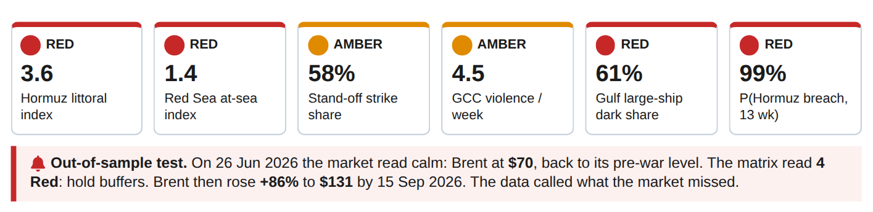
Figure 14.1 : I&W dashboard at 27 June 2026, with the out-of-sample oil-price test
Table 14.3 : Indicators and warnings matrix - status at 27 June 2026
Indicator | Source / cadence | Latest value | Amber at | Red at | Status | Action on Red
I1 Hormuz littoral CCII / threshold (4-wk mean) | ACLED weekly | 3.6 | >= 0.5 | >= 1.0 | RED | Red: activate POL stock drawdown plan; raise Gulf escort posture
I2 Red Sea at-sea CCII / threshold (4-wk mean) | ACLED weekly | 1.4 | >= 0.5 | >= 1.0 | RED | Red: add Cape-route lead-time to defence import re-order points
I3 Stand-off strike share of political violence (4-wk) | ACLED weekly | 58% | >= 53% | >= 65% | AMBER | Red: raise AD / counter-UAS state at depots, air bases, POL nodes
I4 GCC political violence (events / week, 4-wk) | ACLED weekly | 4.5 | >= 2 | >= 10 | AMBER | Red: move NEO plan to execution readiness
I5 Large-ship AIS-dark share, Gulf (latest SAR window) | SAR + AIS | 61% | >= 20% | >= 40% | RED | Red: treat Gulf maritime picture as unreliable; task national SAR
I6 P(Hormuz threshold breach in next 13 wks), model | ARIMA simulation | 99% | >= 30% | >= 60% | RED | Red: hold reserves at >= 35-45 days; do not release strategic stock

Status: 4 Red, 2 Amber, 0 Green. Four months after the war began and ten weeks after the de-escalation break, the Hormuz littoral is still at three to four times its disruption threshold and the Red Sea at-sea index remains above its threshold. Stand-off strikes are 58% of all violence, against 43% in the pre-war year. The situation is not one of recovery. It is a sustained, lower-intensity disruption, and the buffers recommended in Chapter 13 should be held, not released.

14.3 Phased Roadmap
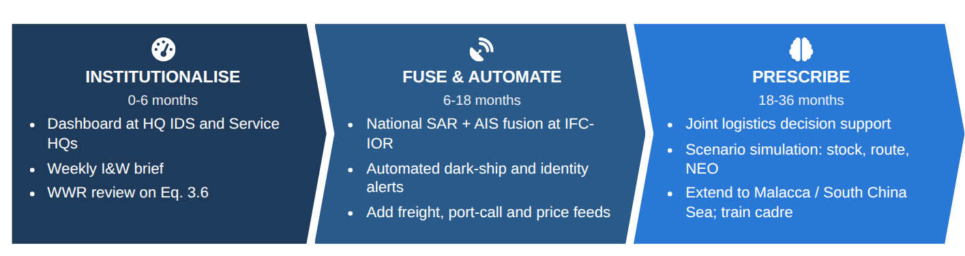
Figure 14.2 : Way-forward roadmap (SmartArt)
Table 14.4 : Phased roadmap
Phase | Actions | Deliverable and stop/go test
Phase 1 (0-4 months): proof of concept at no new cost | Institutionalise the pipeline using existing establishment, free Copernicus Sentinel-1 imagery and this code. Host the Power BI dashboard (Appendix B) at HQ IDS and Service HQs; run the weekly CCII and stand-off-share refresh from ACLED; set alert thresholds; start the tri-service WWR review using Eq. 3.6. | Weekly DARKWATCH brief; revised stock norms for trial. Stop test: has a principal acted on a DARKWATCH AMBER? If not, stop.
Phase 2 (4-18 months) | Fuse sensors and automate. Ingest national SAR (NISAR, EOS-04) and commercial SAR with AIS; run automated dark-ship and identity-anomaly detection; retrain the dark-spot model monthly; add freight-rate, insurance and port-call data to measure physical impact directly. | Near-real-time dark-ship alerts; validated dark-risk maps. Stop test: did the four signatures hold on a second crisis?
Phase 3 (18-36 months) | Move to prescriptive, joint decision support. Integrate with the tri-service logistics and inventory systems; simulate stock, route and evacuation decisions under scenarios; extend the same methods to the South China Sea and Malacca theatres; train staff in data-driven logistics through CDM and Service analytics courses. | Joint supply-chain resilience system; trained analytics cadre. Stop test: does the capability survive the posting-out of its first officers?

14.4 Future Research
Several extensions would strengthen the results: (a) extend the SAR window to a pre-war baseline for the same waters, which would give a true difference-in-differences estimate of war-induced darkness; (b) add ship-level AIS gap events and port calls to measure turnaround and diversion directly; (c) model GNSS-interference zones explicitly to separate spoofing from deliberate switch-off; (d) move from ADMIN1 centroids to event-level ACLED coordinates.
SO WHAT
Fifteen staffed actions, the DARKWATCH watch-list and a three-phase plan that starts at no new cost, each traced to a finding.

15. CONCLUSION
EPILOGUE - THE END OF THE STORY, AND THE START OF THE WATCH
THE STORY SO FAR
We end where we began, with the commander's questions, now answered with evidence.

This study set out to measure how global, and in particular Middle-East, conflicts affect maritime supply chains, to locate and predict AIS dark zones, and to turn the results into guidance for India and its Armed Forces. All six hypotheses are supported by the data.

15.1 Conflict Analytics
(a) Middle-East political violence moved through distinct regimes, and change-point detection dated the shifts to 7 October 2023 and 28 February 2026 without being given them. The war regime ran at 2.9 times the preceding year.
(b) The 2026 war was fought mainly with stand-off weapons (84 per cent of violence), reached the GCC energy coast (124-fold rise) and put the Hormuz littoral at 188 times its baseline.
(c) In the Red Sea the threat moved offshore. Chokepoint risk must be measured at sea, not only on land.

15.2 Disruption Survival
(a) Disruption episodes are heavy-tailed (median 2.5 weeks, longest 19 weeks). 62% outlast India's strategic reserve and 11% outlast total national cover.
(b) Holding about 35-45 days of stock covers most of the expected shortfall. Beyond about 35 days each extra day of stock adds little protection.

15.3 AIS Dark Zones
(a) Large ships were AIS-dark in 74% of cases in the Strait of Hormuz and 38% in the Black Sea, against about 10 per cent in peacetime waters (relative risk 4.7). The identification crisis named in the problem statement is real and measurable.
(b) The same war produced four behaviours at sea: concealment in the Gulf, evacuation from the Red Sea, a frozen Black Sea and compliance in the East Med. Dark tankers were held at the Gulf anchorages; the dark fleet was mainly mainstream tonnage, not a rogue fleet.
(c) Proximity to conflict predicts darkness in sea regions the model never saw (ROC-AUC 0.69), which makes it possible to forecast where the maritime picture will fail.

15.4 Implications
For the globe, chokepoint risk has become a recurring cost of trade and a hazard to navigation. For India, the exposure is concentrated in Gulf energy, westbound trade, connectivity projects and the Gulf diaspora. For the Indian Armed Forces, the same evidence calls for fuel and spares reserves sized on the survival curve, bases and nodes hardened against stand-off attack, navigation that does not depend on GNSS alone, and a joint data cell that watches the chokepoints every week.
The central inference was stress-tested the way an intelligence judgement should be. It survives eight alternative specifications (relative risk 3.9-6.4) and shows a clear dose-response with distance from the fighting. Of the competing explanations, only deliberate switch-off is consistent with all the evidence. At the end of the data, the I&W matrix stands at 4 Red and 2 Amber: the disruption has not ended.
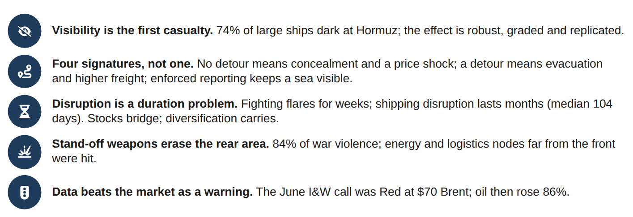
Figure 15.1 : Five takeaways (infographic)
Closing statement. The first casualty of war at a chokepoint is visibility. Physical disruption follows it, lasts longer than intuition suggests, and reaches India's energy, trade, diaspora and military sustainment. The same data and methods that measured this can warn of it. By turning the pipeline, index, dark-spot model and stock-cover curve built here into standing tools, India and the Indian Armed Forces can base these decisions on data rather than on precedent, which is the aim of the Datathon.

16. REFERENCES
1. UNCTAD (2024). Review of Maritime Transport 2024: Navigating maritime chokepoints. United Nations Conference on Trade and Development, Geneva.
2. U.S. Energy Information Administration (2024). World Oil Transit Chokepoints and Amid regional conflict, the Strait of Hormuz remains critical oil chokepoint. EIA, Washington DC.
3. College of Defence Management (2026). Datathon-2026: General Instructions and theme datasets 'Global Conflicts - Impact on Supply Chains'. CDM, Secunderabad, under HQ IDS.
4. Raleigh, C., Linke, A., Hegre, H. and Karlsen, J. (2010). Introducing ACLED: An Armed Conflict Location and Event Dataset. Journal of Peace Research, 47(5), 651-660. Data: ACLED Middle East aggregated data to week of 27 June 2026, www.acleddata.com.
5. Paolo, F.S., Kroodsma, D., Raynor, J. et al. (2024). Satellite mapping reveals extensive industrial activity at sea. Nature, 625, 85-91. Data: Global Fishing Watch SAR vessel detections.
6. Killick, R., Fearnhead, P. and Eckley, I.A. (2012). Optimal detection of changepoints with a linear computational cost. Journal of the American Statistical Association, 107(500), 1590-1598.
7. Truong, C., Oudre, L. and Vayatis, N. (2020). Selective review of offline change point detection methods. Signal Processing, 167, 107299.
8. Getis, A. and Ord, J.K. (1992). The analysis of spatial association by use of distance statistics. Geographical Analysis, 24(3), 189-206.
9. Ord, J.K. and Getis, A. (1995). Local spatial autocorrelation statistics: distributional issues and an application. Geographical Analysis, 27(4), 286-306.
10. Ester, M., Kriegel, H.-P., Sander, J. and Xu, X. (1996). A density-based algorithm for discovering clusters in large spatial databases with noise. Proc. KDD-96, 226-231.
11. Kaplan, E.L. and Meier, P. (1958). Nonparametric estimation from incomplete observations. Journal of the American Statistical Association, 53(282), 457-481.
12. Cox, D.R. (1972). Regression models and life-tables. Journal of the Royal Statistical Society, Series B, 34(2), 187-220.
13. Jayadev, A. (2021). Predictive Maintenance in Armed Forces: A Machine Learning Based Decision Support System. M.Tech Project Report, Department of Mechanical Engineering, IIT Kharagpur.
14. Roberts, D.R., Bahn, V., Ciuti, S. et al. (2017). Cross-validation strategies for data with temporal, spatial, hierarchical, or phylogenetic structure. Ecography, 40(8), 913-929.
15. Friedman, J.H. (2001). Greedy function approximation: a gradient boosting machine. Annals of Statistics, 29(5), 1189-1232.
16. Hyndman, R.J. and Athanasopoulos, G. (2021). Forecasting: Principles and Practice, 3rd ed. OTexts, Melbourne.
17. International Maritime Organization. SOLAS Chapter V, Regulation 19 - Carriage requirements for shipborne navigational systems and equipment (AIS).
18. Wilson, E.B. (1927). Probable inference, the law of succession, and statistical inference. Journal of the American Statistical Association, 22(158), 209-212.
19. Ministry of Petroleum and Natural Gas / Petroleum Planning and Analysis Cell (PPAC), Government of India. Import dependence statistics; Indian Strategic Petroleum Reserves Ltd (ISPRL) capacity (5.33 MMT) and statements on national stock cover.
20. Ministry of External Affairs, Government of India. Population of Overseas Indians; Reserve Bank of India, Survey on Cross-Border Inward Remittances.
21. U.S. Energy Information Administration, Europe Brent and Cushing WTI spot prices (daily), via the open 'datasets/oil-prices' repository (github.com/datasets/oil-prices), accessed 23 Sep 2026.
22. Board of Governors of the Federal Reserve System, H.10 Foreign Exchange Rates (INR per US$), via 'datasets/exchange-rates' (github.com/datasets/exchange-rates), accessed 23 Sep 2026.
23. Energy Institute (2025). Statistical Review of World Energy; processed by Our World in Data, energy dataset (github.com/owid/energy-data).
24. Natural Earth (public domain). 1:10m Cultural Vectors - Ports. naturalearthdata.com. Icons in the infographics: Font Awesome Free 6 (CC BY 4.0).
25. Strange, J. (1996). Centers of Gravity & Critical Vulnerabilities. Perspectives on Warfighting No. 4, Marine Corps University, Quantico.
26. International Monetary Fund, PortWatch: Daily Chokepoint Transit Calls and Trade Volume Estimates (portwatch.imf.org), 2019 - 16 Aug 2026; raw extract via an MIT-licensed public mirror (github.com/ebiisharifi/hormuz-chokepoint-analytics).
27. Press Information Bureau (1 Feb 2026). Ministry of Defence allocated an all-time high of Rs 7.85 lakh crore in Union Budget 2026-27.
28. All India Radio News (11 Mar 2026). India secures 70% of crude oil imports outside Strait of Hormuz: Petroleum Ministry.
29. Operation Urja Suraksha (Indian Navy escort of Indian-flagged energy carriers, from 23 Mar 2026). Wikipedia and contemporary news reports.
30. The National (17 Jul 2026). War-risk shipping premium surges again as tensions escalate at Strait of Hormuz; Al Jazeera (23 Jul 2026). How shipping insurance rates are rising as Hormuz, Bab al-Mandeb shut down.
31. CNBC (18 Mar 2026). Traffic is trickling through Strait of Hormuz: who's moving and who's stranded; straits.live, Strait of Hormuz closure tracker (accessed 23 Sep 2026).

APPENDIX A - TOOLCHAIN AND REPRODUCIBILITY
The analysis is fully scripted. The repository folder datathon2026/ contains the pipeline below. Running python analysis/run_all.py rebuilds every artefact from the two raw files in about one minute on a laptop.
datathon2026/
analysis/common.py shared styling, regions, chokepoints, MMSI-MID registry, helpers
analysis/01_preprocess.py cleaning, validation, feature engineering, conflict spatial join
analysis/02_conflict.py Chapter 5: trends, event mix, heat map, PELT regimes, GCC spill-over, maps
analysis/03_chokepoint_index.py Chapter 6: CCII, thresholds, ARIMA back-test and forecast, Kaplan-Meier, Cox
analysis/04_sar.py Chapter 7: dark shares, chi-square, Gi* hot spots, DBSCAN, flags, identity
analysis/05_model.py Chapter 8: logit, gradient-boosted trees, spatial CV, risk surface
analysis/06_decision.py Section 13.5: expected-shortfall stock-cover model
analysis/07_powerbi_export.py star-schema tables for the Power BI dashboard
figures/ tables/ powerbi/ data/metrics.json report/build_report.py

Table A.1 : Software stack
Layer | Tools
Language / runtime | Python 3.11
Data manipulation | pandas 2.x, NumPy, PyArrow (Parquet)
Statistics | SciPy (Mann-Whitney, chi-square, Spearman), statsmodels (Logit, ARIMA/SARIMAX, ETS, Kaplan-Meier, Cox PHReg, Wilson CI)
Machine learning | scikit-learn (HistGradientBoosting with monotonic constraints, GroupKFold spatial CV, DBSCAN, BallTree, permutation importance)
Time series | ruptures (PELT change-points)
Visualisation / GIS | Matplotlib, Basemap (coastlines), custom Getis-Ord Gi*
Dashboard | Microsoft Power BI Desktop (.pbix) on the exported star schema
Report | HTML/CSS rendered to PDF with headless Chromium; all numbers injected from metrics.json

APPENDIX B - POWER BI DASHBOARD DATA MODEL
The Datathon requires a Power BI (.pbix) file alongside this report. The pipeline exports a star schema (powerbi/) that loads directly into Power BI Desktop. The model, relationships and core DAX measures are given below. The step-by-step build of the four dashboard pages is in powerbi/POWERBI_BUILD_GUIDE.md.
Table B.1 : Power BI star schema
Table | Rows | Key columns | Relationship
FactConflictWeekly | 149,814 | WEEK, ADMIN1_ID, EVENT_TYPE, SUB_EVENT_TYPE, EVENTS, FATALITIES, flags | ADMIN1_ID -> DimAdmin1; WEEK -> DimDate[DATE]
DimAdmin1 | 243 | ADMIN1_ID, COUNTRY, ADMIN1, LAT, LON, GCC, MARITIME, KM_TO_HORMUZ ... | -
FactVesselDetections | 106,533 | DETECTION_ID, DATE, lat, lon, REGION, ZONE, length_m, AIS_DARK, LARGE_100M, flag, flag_class ... | DATE -> DimDate[DATE]
DimDate | 4,383 | DATE, YEAR, QUARTER, MONTH, WEEK_START | -
t6_ccii_weekly, t6_2_episodes, t7_4_dark_clusters, t8_3_poi_risk, t9_1_stock_decision | - | analysis outputs | stand-alone

Events = SUM(FactConflictWeekly[EVENTS])
Fatalities = SUM(FactConflictWeekly[FATALITIES])
Stand-off share = DIVIDE(CALCULATE([Events], FactConflictWeekly[DRONE_MISSILE] = TRUE()),
CALCULATE([Events], FactConflictWeekly[POLITICAL_VIOLENCE] = TRUE()))
Detections = COUNTROWS(FactVesselDetections)
Dark share = DIVIDE(CALCULATE([Detections], FactVesselDetections[AIS_DARK] = TRUE()), [Detections])
Dark share large = CALCULATE([Dark share], FactVesselDetections[LARGE_100M] = TRUE())
Dark RR vs world = DIVIDE([Dark share large],
CALCULATE([Dark share large], FactVesselDetections[ZONE] = "Rest of world"))

Dashboard pages. (1) Conflict Pulse: weekly events and fatalities, event-type mix, map of ADMIN1 bubbles, GCC slicer. (2) Chokepoint Watch: CCII lines by theatre with threshold lines, episode table, forecast. (3) Dark Ships: map of detections coloured by AIS_DARK, dark share by region and size, cluster table, flag class. (4) Decision: stock-cover decision table, points-of-interest risk, and a what-if parameter for days of stock.

