JPA Integration in Spring MVC project

Any enterprise application performs database operations by storing and retrieving vast amounts of data. Using JPA, the burden of interacting with the database reduces significantly. It forms a bridge between object models (Java program) and relational models (database program). We are using Hibernate as ORM and CrudeRepository of Spring JPA for CRUD operations.
Project directory structure:
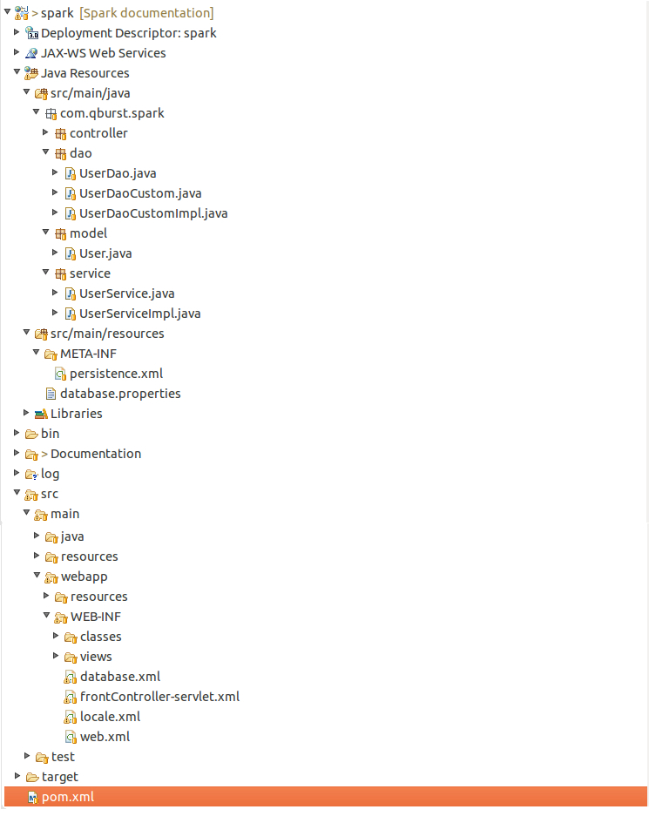

Configuration :
- Add the following dependencies to pom.xml:
- hibernate-entitymanager

<dependency>
<groupId>org.hibernate</groupId>
<artifactId>hibernate-entitymanager</artifactId>
<version>4.3.10.Final</version>
</dependency>

- spring-data-jpa

<dependency>
<groupId>org.springframework.data</groupId>
<artifactId>spring-data-jpa</artifactId>
<version>1.8.0.RELEASE</version>
</dependency>

- spring-tx

<dependency>
<groupId>org.springframework</groupId>
<artifactId>spring-tx</artifactId>
<version>4.1.6.RELEASE</version>
</dependency>

- spring-jdbc

<dependency>
<groupId>org.springframework</groupId>
<artifactId>spring-jdbc</artifactId>
<version>4.1.6.RELEASE</version>
</dependency>

- spring-orm

<dependency>
<groupId>org.springframework</groupId>
<artifactId>spring-orm</artifactId>
<version>4.1.6.RELEASE</version>
</dependency>

- servlet-api

<dependency>
<groupId>javax.servlet</groupId>
<artifactId>servlet-api</artifactId>
<version>2.5</version>
</dependency>

- Make Database.xm file in web-inf
database.xml
<beans xmlns="http://www.springframework.org/schema/beans"
xmlns:tx="http://www.springframework.org/schema/tx" xmlns:xsi="http://www.w3.org/2001/XMLSchema-instance"
xmlns:context="http://www.springframework.org/schema/context"
xmlns:util="http://www.springframework.org/schema/util" xmlns:jpa="http://www.springframework.org/schema/data/jpa"
xsi:schemaLocation="http://www.springframework.org/schema/tx
http://www.springframework.org/schema/tx/spring-tx.xsd
http://www.springframework.org/schema/beans
http://www.springframework.org/schema/beans/spring-beans.xsd
http://www.springframework.org/schema/util
http://www.springframework.org/schema/util/spring-util-3.2.xsd
http://www.springframework.org/schema/context
http://www.springframework.org/schema/context/spring-context-3.2.xsd
http://www.springframework.org/schema/data/jpa
http://www.springframework.org/schema/data/jpa/spring-jpa.xsd">

<context:property-placeholder location="classpath:database.properties" />

<jpa:repositories base-package="com.qburst.spark" />

<tx:annotation-driven transaction-manager="transactionManager" />

<bean id="dataSource"
class="org.springframework.jdbc.datasource.DriverManagerDataSource">
<property name="driverClassName" value="${database.driver}" />
<property name="url" value="${database.url}" />
<property name="username" value="${database.user}" />
<property name="password" value="${database.password}" />
</bean>

<bean id="entityManagerFactory"
class="org.springframework.orm.jpa.LocalContainerEntityManagerFactoryBean">
<property name="dataSource" ref="dataSource" />
<property name="packagesToScan" value="com.qburst.spark.model" />
<property name="jpaVendorAdapter">
<bean class="org.springframework.orm.jpa.vendor.HibernateJpaVendorAdapter" />
</property>
<property name="persistenceUnitName" value="JpaPersistenceUnit" />
<property name="jpaProperties">
<props>
<prop key="hibernate.hbm2ddl.auto">update</prop>
<prop key="hibernate.dialect">org.hibernate.dialect.MySQL5Dialect</prop>
<prop key="hibernate.show_sql">true</prop>
</props>
</property>
</bean>

<bean id="transactionManager" class="org.springframework.orm.jpa.JpaTransactionManager">
<property name="entityManagerFactory" ref="entityManagerFactory" />
</bean>

<bean id="persistenceExceptionTranslationPostProcessor"
class="org.springframework.dao.annotation.PersistenceExceptionTranslationPostProcessor" />
</beans>

- context:property-placeholder : Specifies the location database properties file.
- jpa:repositories : Specifies the base directory for jpa repositories.
- tx:annotation-driven : Enables the configuration of transactional behaviour based on annotations like @Trasactional .
- transactionManager : Transaction manager is appropriate for application that use a single JPA EntityManagerFactory for transactional data acess.
- EntityManagerFactory : LocalContainerEntityManagerFactoryBean produces a conatainer managed EntityManagerFactory. It supports links to an existing JDBC Datasource, supports both local and global transactions.
- PersistenceExceptionTranslationPostProcessor : Bean post-processor that automatically applies persistence exception translation to any bean marked with Spring's @Repository annotation, adding a corresponding PersistenceException TranslationPostProcessor to the exposed proxy.
- dataSource : Configuring database by specifing the properties. Here the values of properties are given in a seperate database.properties file.

- Create a database.propeties file in classpath
database.properties
database.driver=com.mysql.jdbc.Driver
database.url=jdbc:mysql://localhost:3306/Spark
database.user=username
database.password=password
hibernate.show_sql=true

- Create a model class which represents the entity
User.java
package com.qburst.spark.model;

import javax.persistence.Entity;
import javax.persistence.Id;

/**
* @author Arjun K, Ashwin Abraham Thomson, Sreekesh Dinesh
* @version 1.0
* @since 30-Jun-2015 2015 5:36:23 pm
*
*/

@Entity
public class User {

@Id
String username;

String password;

public String getUsername() {
return username;
}

public void setUsername(String username) {
this.username = username;
}

public String getPassword() {
return password;
}

public void setPassword(String password) {
this.password = password;
}

@Override
public String toString() {
return "User [username=" + username + ", password=" + password + "]";
}

}

- @entity Annotation : The annotation is contained in the javax.persistence package, so we import this package as the first step. Second we used the @Entity annotation to the User class which marks this class as an entity bean, so it must have a no-argument constructor that is visible with at least protected scope.
- @Id : Primary key of the class is mentioned by this annotation.

- Create the Dao layer
- CrudRepository of spring jpa is used for basic crud operations. The specific dao extends the CrudRepository and Custom dao (contains the custom functions for the project ) Interfaces to perform the database related operations therby implementing data abstraction.
UserDao.java
package com.qburst.spark.dao;
import org.springframework.data.repository.CrudRepository;
import org.springframework.stereotype.Repository;
import com.qburst.spark.model.User;

/**
* <h2>User DAO Interface</h2>
* <p>UserDao is an interface to represent the DB operations, extended from CrudRepository and UserDaoCustom interface.</p>
* <p>CrudRepository interface by Spring provides basic DB operations</p>
*/
@Repository
public interface UserDao extends CrudRepository<User, String>,UserDaoCustom {

}

- Create a service layer
- Service layer implements the business logic for the project. Calls to Dao layer are made from the service layer.

UserService.java
package com.qburst.spark.service;

import com.qburst.spark.dao.UserDao;
import com.qburst.spark.model.User;
/**
* <h3>UserService Interface</h3>
* @author Arjun K, Ashwin Abraham Thomson, Sreekesh Dinesh
* @version 1.0
* @since 30-Jun-2015 2015 5:36:23 pm
*/

public interface UserService {

public abstract void setUserDao(UserDao userDao);

public abstract String addUser(User user);

public abstract void updateUser(User user);

public abstract User findByUserName(String username);

public abstract void removeUser(String username);

}

- The above code snippet is an interface, it must be implemented according to bussiness logic in another class.
Note:
The Dao and Service layer should be implemanted from its interfaces for achieving data abstraction.

