PRODUCT REQUIREMENTS DOCUMENT
Enterprise File Storage Modernization
Centralized, AI-Enabled Digital Asset Management Platform
Prepared for: Engineering / Technical Team
Deployment model: On-Premise (self-hosted)
Version 1.0 · Status: Draft for Review

Table of Contents

1. Overview

1.1 Purpose
This document defines the product and technical requirements for a centralized, on-premise enterprise file storage platform with built-in AI enrichment. It is written for the engineering team and specifies the system architecture, application layers, information architecture, end-to-end workflow, functional and non-functional requirements, and delivery scope. The goal is a single governed storage platform that serves every application, website, and digital initiative across the institution, while automatically extracting, classifying, de-duplicating, and semantically indexing every asset.

1.2 Background
Digital assets are currently spread across 50+ enterprise applications, 50+ websites, 1,500+ promotional pages, and multiple mobile applications, amounting to millions of files. Storage today is decentralized, with inconsistent folder structures, uneven security practices, no central visibility, and no shared standards. This fragmentation drives duplicate storage, orphaned files, security gaps, rising infrastructure cost, and difficult maintenance. The platform described here consolidates storage behind one S3-compatible core and layers AI services on top to make the entire asset base searchable and self-organizing.

1.3 Goals & Success Metrics
Goal | Metric | Target
Centralize storage | Assets served from the platform | 100% standardized storage
Central governance | Buckets under policy control | 100% governed
AI-searchable corpus | Assets with embeddings + tags | ≥ 95% of eligible assets
Reduce duplication | Storage reclaimed via dedupe | ≥ 20% reduction in year one
Operational visibility | Real-time monitoring coverage | All buckets & pipelines
Retrieval quality | Semantic search top-5 relevance | ≥ 0.85 (offline eval)

2. Users & Personas

2.1 Target Users
Persona | Description | Primary Needs
Application Developer | Builds apps/sites that store & fetch assets | Standard APIs, SDKs, self-service buckets, docs
Content/Marketing Team | Manages promotional pages & media | Upload, find assets fast, avoid duplicates
Platform Administrator | Owns governance, security, capacity | RBAC, policies, audit logs, dashboards
Data/AI Engineer | Maintains enrichment pipeline & models | Pipeline observability, model versioning
End User (internal) | Searches and retrieves assets | Natural-language semantic search

2.2 User Journey (high level)
- A developer provisions a bucket via self-service and receives access keys.
- Their application uploads files through the S3-compatible API.
- Each upload automatically triggers the AI enrichment pipeline (extract → classify → dedupe → embed → index).
- Internal users find assets through semantic search; results respect each user's permissions.
- Administrators monitor usage, enforce retention, and review audit logs throughout.

3. System Architecture
The platform follows an event-driven, layered architecture. The storage core remains the single source of truth; the AI enrichment pipeline runs asynchronously beside it, producing derived metadata that never mutates the original asset. All components are self-hosted to satisfy on-premise data-sovereignty requirements, including open-weight AI models served on local GPUs.
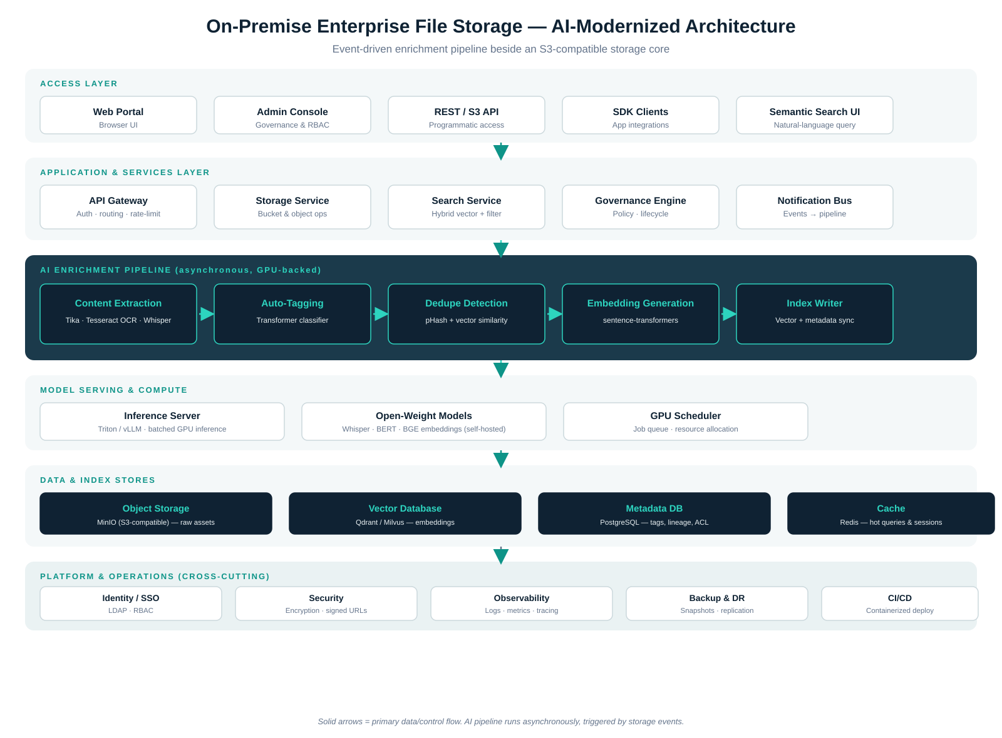
Figure 1 — On-premise AI-modernized system architecture (layered, event-driven).

3.1 Architectural Principles
- Storage as source of truth: AI outputs are derived metadata stored separately; raw objects are immutable.
- Asynchronous enrichment: A message queue decouples upload latency from GPU-bound processing and provides retry and back-pressure.
- S3 compatibility everywhere: MinIO's S3 API lets every downstream tool speak one protocol.
- Self-hosted models: Open-weight models (Whisper, BERT-class classifier, BGE/MiniLM embeddings) run on-prem; no data leaves the institution.
- Security-first retrieval: RBAC and signed URLs wrap the AI layer so search never returns assets a user cannot access.

4. End-to-End Workflow
Every file moves through eight stages from upload to searchable asset. Stages 3–7 run inside the asynchronous pipeline; stage 5 (dedupe) may short-circuit ingestion when an exact or near-duplicate is detected.
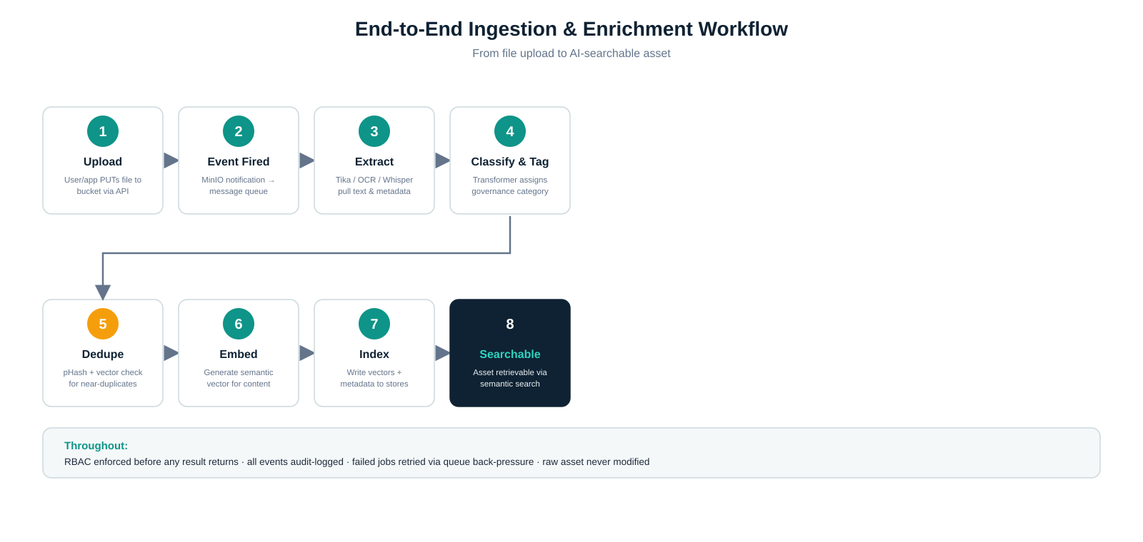
Figure 2 — Ingestion and enrichment workflow.

4.1 Stage Detail
Stage | Trigger / Action | Component | Output
1. Upload | Client PUTs object | Storage Service / MinIO | Stored raw object
2. Event | Bucket notification | Notification Bus → Queue | Enrichment job
3. Extract | Pull text & metadata | Tika · Tesseract · Whisper | Plain text + props
4. Classify | Assign category & tags | Transformer classifier | Tags + governance category
5. Dedupe | Compare hash & vectors | pHash + vector similarity | Duplicate link (if any)
6. Embed | Generate vector | sentence-transformers | Embedding vector
7. Index | Persist derived data | Index Writer | Searchable records
8. Searchable | Available to query | Search Service | Semantic + filtered results

4.2 Cross-cutting guarantees
- RBAC is evaluated before any search result is returned to a caller.
- Every action (upload, read, policy change, deletion) is written to the audit log.
- Failed enrichment jobs are retried with exponential back-off via the queue; poison messages route to a dead-letter queue.
- The raw asset is never modified by the pipeline; enrichment only writes to derived stores.

5. Application Layers
The codebase is organized into six logical layers with strict separation of concerns. Higher layers depend only on the interface of the layer directly beneath them, which keeps the AI processing layer swappable without touching the API surface.
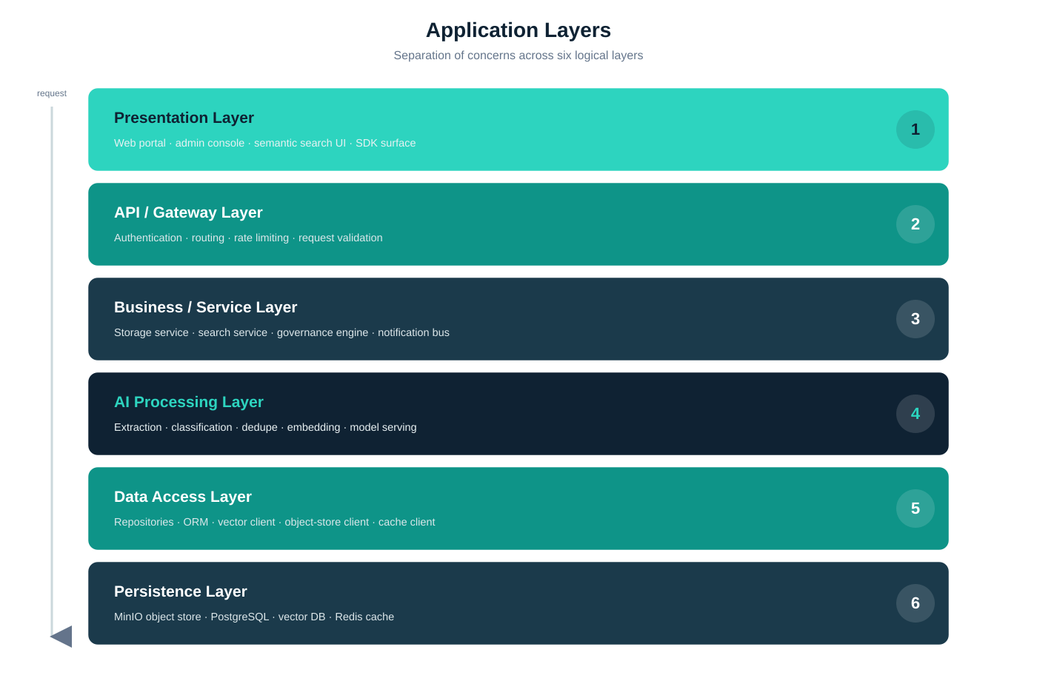
Figure 3 — Application layer stack.
Layer | Responsibility | Representative Technologies
Presentation | User-facing surfaces | Web portal, admin console, search UI, SDKs
API / Gateway | Entry, auth, routing | API gateway, OAuth/JWT, rate limiter
Business / Service | Domain logic | Storage, search, governance, notification services
AI Processing | Enrichment & inference | Tika, Tesseract, Whisper, classifier, embeddings, Triton/vLLM
Data Access | Persistence abstraction | Repositories, ORM, vector client, S3 client, cache client
Persistence | Stores of record | MinIO, PostgreSQL, Qdrant/Milvus, Redis

6. Information Architecture
The data model separates source entities (the raw asset and its governance context) from AI-derived entities (metadata, embeddings, duplicate links). This separation means models can be re-run or upgraded and derived tables rebuilt without risk to the canonical asset record.
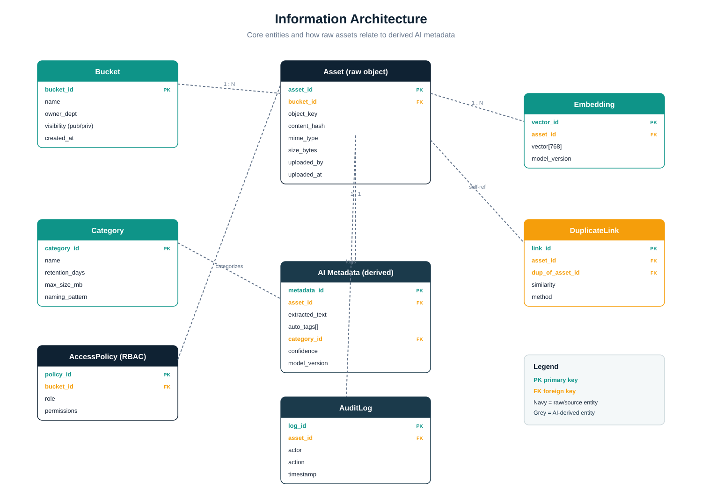
Figure 4 — Core entities and relationships.

6.1 Key Entities
Entity | Type | Purpose
Bucket | Source | Logical container; owns visibility & ownership
Asset | Source | Canonical record of a raw stored object
Category | Source/Governance | Governance class with retention & naming rules
AccessPolicy | Source/Governance | RBAC rules binding roles to bucket permissions
AI Metadata | Derived | Extracted text, auto-tags, assigned category, confidence
Embedding | Derived | Semantic vector(s) for similarity & search
DuplicateLink | Derived | Self-referential link between duplicate assets
AuditLog | Operational | Immutable record of every action

6.2 Metadata & Re-indexing Notes
- Each derived record carries a model_version so embeddings/tags can be selectively regenerated when a model is upgraded.
- Exact duplicates are detected by content hash at stage 5; near-duplicates by vector cosine similarity above a configurable threshold.
- Vector dimensionality follows the chosen embedding model (e.g., 384 for MiniLM, 768 for BGE-base); the schema records it per vector.

7. Requirements

7.1 Functional Requirements

FR-001: Self-service bucket provisioning
User Story: As a developer, I want to provision a bucket and keys without a ticket so that I can integrate storage quickly.
Acceptance Criteria:
- Bucket created via API/console in < 1 minute
- Scoped access keys issued
- Default policy & category applied
Priority: Must Have

FR-002: S3-compatible object operations
User Story: As a developer, I want standard PUT/GET/DELETE/LIST so that existing S3 tooling works unchanged.
Acceptance Criteria:
- S3 API parity for core ops
- Signed URL generation
- Multipart upload for large files
Priority: Must Have

FR-003: Automatic content extraction
User Story: As the platform, I want to extract text from documents, images, and audio so that assets become searchable.
Acceptance Criteria:
- Tika for documents
- OCR for images/scans
- Whisper for audio/video
Priority: Must Have

FR-004: Auto-tagging & classification
User Story: As a content user, I want assets auto-categorized so that governance rules apply without manual effort.
Acceptance Criteria:
- Category assigned with confidence score
- Tags stored in metadata
- Maps to governance categories
Priority: Must Have

FR-005: Duplicate & near-duplicate detection
User Story: As an administrator, I want duplicates flagged so that storage waste is reduced.
Acceptance Criteria:
- Exact dupes via content hash
- Near-dupes via vector similarity
- DuplicateLink recorded
Priority: Should Have

FR-006: Semantic search
User Story: As an end user, I want natural-language search so that I can find assets by meaning, not just filename.
Acceptance Criteria:
- Hybrid vector + metadata filter
- Permission-filtered results
- Top-K ranked by relevance
Priority: Must Have

FR-007: Governance & lifecycle
User Story: As an administrator, I want retention & lifecycle policies so that assets are archived/retired automatically.
Acceptance Criteria:
- Retention per category
- Lifecycle transitions
- Naming-standard enforcement
Priority: Must Have

FR-008: Monitoring dashboard
User Story: As an administrator, I want live dashboards so that I can plan capacity and spot anomalies.
Acceptance Criteria:
- Storage usage & growth
- Upload/download stats
- Pipeline health
Priority: Should Have

7.2 Non-Functional Requirements
ID | Category | Requirement | Target
NFR-001 | Performance | Object read latency (cached) | < 100 ms p95
NFR-002 | Performance | Enrichment completion after upload | < 60 s p95 for typical docs
NFR-003 | Performance | Semantic query latency | < 500 ms p95
NFR-004 | Scalability | Asset capacity | Millions of objects, horizontal scale
NFR-005 | Scalability | Ingestion throughput | Queue-buffered, no upload blocking
NFR-006 | Security | Encryption | At rest and in transit (TLS)
NFR-007 | Security | Access control | RBAC + signed URLs on every path
NFR-008 | Availability | Core storage uptime | ≥ 99.9%
NFR-009 | Durability | Object durability | Replicated; backup & DR snapshots
NFR-010 | Observability | Logging/metrics/tracing | All services instrumented
NFR-011 | Data sovereignty | Model & data locality | 100% on-prem; no external calls

8. Technical Considerations

8.1 Recommended Technology Stack
Concern | Recommended | Alternative | Notes
Object storage | MinIO | Ceph RGW | S3-compatible, self-hosted
Message queue | Apache Kafka | RabbitMQ | Decouples ingestion from AI
Orchestration | Apache Airflow | Custom workers | Pipeline DAGs, retries
Extraction | Tika · Tesseract · Whisper | — | Docs · OCR · transcription
Classification | DistilBERT/BERT classifier | fastText | Maps to governance categories
Embeddings | BGE / all-MiniLM | E5 | Self-hosted sentence-transformers
Vector DB | Qdrant | Milvus / Weaviate | On-prem ANN index
Metadata DB | PostgreSQL | — | Tags, lineage, ACL
Cache | Redis | — | Hot queries & sessions
Model serving | Triton / vLLM | Ollama | Batched GPU inference

8.2 System Dependencies
- On-prem GPU capacity for inference (embedding + classification + Whisper).
- Institutional identity provider (LDAP/SSO) for RBAC integration.
- Container platform (Docker/Kubernetes) for deployment and scaling.

8.3 Key Design Tradeoffs
- Sync vs. async enrichment: Async scales and protects upload latency but introduces eventual consistency (an asset is briefly stored-but-not-yet-searchable).
- Self-hosted models: Full data control and zero external dependency, at the cost of GPU spend and model-ops effort.
- Re-embedding strategy: Upgrading the embedding model requires re-indexing; the per-record model_version field makes this incremental rather than all-or-nothing.

9. Scope

9.1 In Scope
- Centralized on-prem object storage with governance and RBAC.
- Asynchronous AI pipeline: extraction, classification, dedupe, embedding, indexing.
- Semantic + filtered search with permission enforcement.
- Monitoring dashboards, audit logging, backup & DR.

9.2 Out of Scope (future phases)
- Generative AI features (summarization, Q&A over assets) — candidate for Phase 2.
- Cross-institution federation / multi-tenant SaaS offering.
- Automated content moderation and PII redaction (future).

9.3 Assumptions
- GPU hardware is available on-prem for model serving.
- Existing apps can migrate to the S3 API with adapter effort.
- An institutional SSO/LDAP exists for identity.

9.4 Dependencies
- Procurement/allocation of GPU and storage hardware.
- Network and security sign-off for on-prem deployment.

10. Timeline & Milestones
Phase | Weeks | Deliverable
1 · Audit | Weeks 1–2 | Inventory of current assets & storage footprint
2 · Standards | Weeks 3–4 | Governance framework, naming & retention standards
3 · Development | Weeks 5–8 | Storage core + AI pipeline + search service
4 · Migration | Weeks 9–10 | Asset migration & back-fill enrichment
5 · Go Live | Weeks 11–12 | Production cutover, monitoring, handover

11. Open Questions
# | Question | Owner | Status
1 | Final GPU budget & model sizing? | Platform / Infra | Open
2 | Embedding model choice (MiniLM vs BGE) pending offline eval | AI Engineer | Open
3 | Kafka vs RabbitMQ given existing ops familiarity? | Tech Lead | Open
4 | Retention defaults per governance category? | Governance Owner | Open

Appendix A — Glossary
Term | Definition
Object storage | Storage that manages data as objects with metadata, accessed via S3-style API.
Embedding | A numeric vector representing the meaning of content, used for semantic similarity.
RBAC | Role-Based Access Control — permissions granted by role.
Signed URL | Time-limited, tamper-proof link granting temporary access to an object.
pHash | Perceptual hash — a fingerprint robust to minor image changes, used for near-duplicate detection.
Back-pressure | A queue's ability to throttle producers when consumers fall behind.
Dead-letter queue | Holding queue for messages that repeatedly fail processing.

