angry:

1. [Anger: Taming a Powerful Emotion – Gary Chapman](https://www.amazon.com/dp/0802413145?tag=upjourney-20)

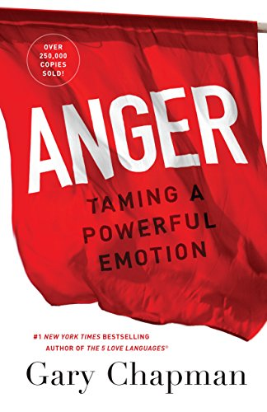

This book can teach you how to turn anger’s energy into self-acceptance energy, Make the difference between justified anger and anger as a habit, How to lower your vanity and [let go of resentment and ideas of revenge](https://upjourney.com/how-to-let-go-of-anger-and-hate), Get to [know yourself better](https://upjourney.com/how-to-get-to-know-yourself) , [Forgive yourself](https://upjourney.com/how-to-forgive-yourself) and overcome the shame that, acting angry, may have caused you, Learn how to express your anger in a respectful and constructive way

1. [The Anger Trap: Free Yourself from the Frustrations that Sabotage Your Life – Les Carter, Frank Minirth](https://www.amazon.com/dp/078796879X?tag=upjourney-20)

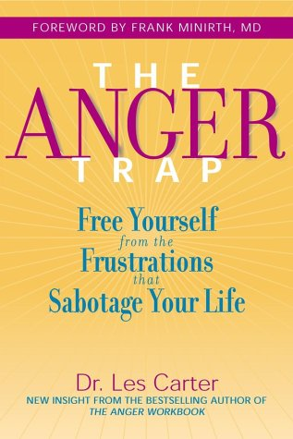

Understand your anger so that it gets more comfortable for you to put a leash on it. The traps anger plants in your mind to keep you hostage. Do you want to get calm? Learn how to change your mind

1. [Letting Go of Anger: The Eleven Most Common Anger Styles And What to Do About Them – Ronald Potter-Efron, Patricia Potter-Efron](https://www.amazon.com/dp/1572244488?tag=upjourney-20)

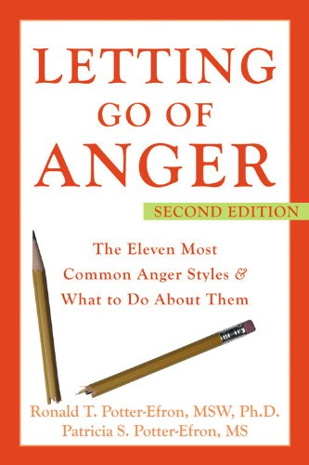

Discover in this book how you can Put out the fire of anger, Express your love with grace, [Communicate](https://upjourney.com/best-books-on-communication-skills) with compassion and understanding, Feel more content about who you are  
and much more

1. [Rage: A Step-by-Step Guide to Overcoming Explosive Anger – Ronald Potter-Efron MSW Ph.D.](https://www.amazon.com/dp/1572244623?tag=upjourney-20)

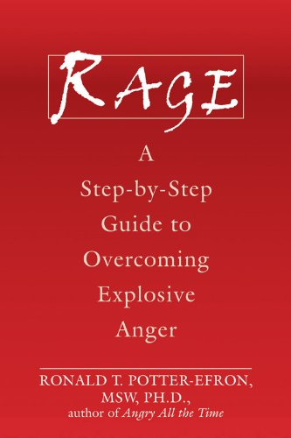

Being a calm and collected person is not a matter of nature, but nurture. It’s a skill that you learn, practice, and improve. You can help yourself… more than anyone else can help you. Discover in this book, how to train your brain to be less angry and become quieter, more content, happier. This book is a step-by-step guide on how to put a lead on your anger and experience the joy of feeling in control of yourself.

Disgusted:

1. The Art of Happiness, Dalai Lama and Howard Cutler

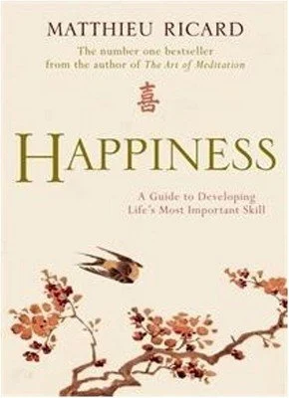

It was very powerful to gain this comprehension of happiness because I always assumed someone or something was supposed to make me happy. The book also details the techniques and tools you can utilize in order to implement a more happy existence.

1. The Power of Now: A Guide to Spiritual Enlightenment, Eckhart Tolle

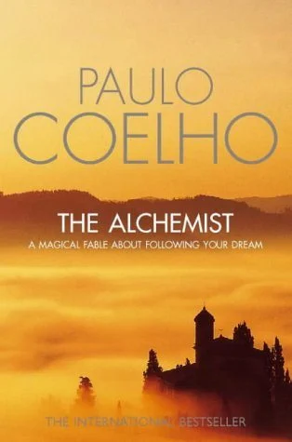

The books is formatted with real-life questions posed to Tolle, as well as his in-depth responses. Many of the questions raised have to do with the mind and why living in the present is such a challenge for many people. Tolle does a great job of weeding through the clutter that the mind can create, thoroughly detailing how each person has the ability to enjoy the present moment. This ability will lead to a much more fulfilling and meaningful life. Sometimes the simplest idea, such as living in the now, can lead to the most powerful results.

1. The Alchemist, Paulo Coelho

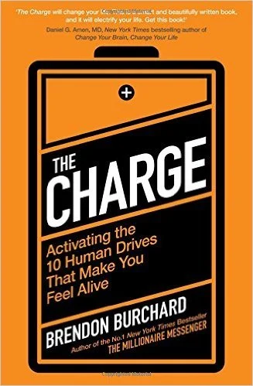

Coelho uses a fictional story to portray the underlying theme of this book. You have the power to create your own destiny. Only you have the capacity to create the kind of life you want for yourself. A popular quote from this book is, “When you really want something to happen, the whole universe conspires so that your wish comes true.” Obviously, you are required to work and dedicate yourself to achieving your goals, but the overall motif of this story is quite persuasive.

1. The Charge: Activating the 10 Human Drives That Make You Feel Alive, Brendan Burchard

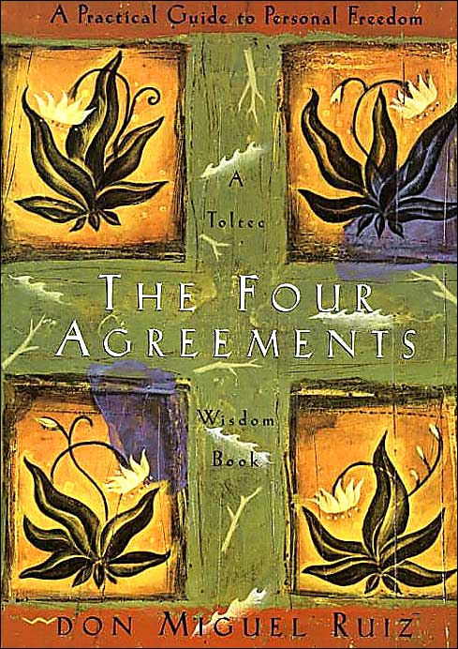

I am a big Brendan Burchard fan so it was a no-brainer for me to purchase his book in the summer of 2014. It is an easy read that outlines simple action steps for infusing more spark into your life. It is easy to get stuck in a rut where you feel like a robot just taking care of the next menial task on your list. The good news is: your life doesn’t have to feel that way. This book is a great motivator for relocating your path in life.

Fear:

1. The Big Leap by Gay Hendricks-

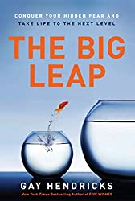

The goal of this book is to help you take your life to the next level. The author discusses the Upper Limit Problem, which is preventing us from progressing to the next level. Four underlying barriers based on our anxieties and incorrect beliefs cause this difficulty. If you've been stuck in life for a long time, this book will help you overcome your anxieties.

1. Daring Greatly by Brené Brown

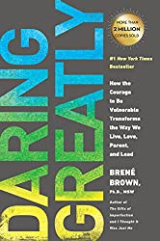

This book is about facing your fears of vulnerability. Allowing others to know your true self will only keep you from having meaningful events in your life. This is the book for you if you're terrified of getting hurt or judged by others.

1. Rejection Proof by Jia Jiang

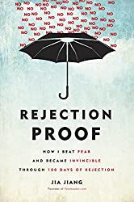

This book is about overcoming rejection anxiety. Jia's initial attempt at pursuing his entrepreneurial ambitions was unsuccessful. Even though he had terrific work at the time, he was unhappy later on. So his wife persuaded him to leave his work for six months and chase his goals.Read this book if you're terrified of being rejected and want to overcome your phobia. Its friendly tone and amusing anecdotes will motivate you to take action.

1. Go For No! by Richard Fenton and Andrea Waltz

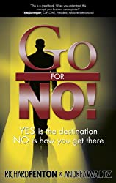

Do you have a lack of self-assurance? Is your fear of failure and self-doubt getting in the way of your success?If that's the case, this book is for you. In this book, Russ advises that we overcome our fears by practising self-acceptance and mindfulness.

Read this book if you wish to overcome low self-confidence, shyness, and insecurity.

Happy:

1. Red, White & Royal Blue by Casey McQuiston

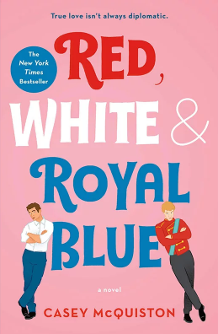

After his mother became president, Alex Claremont-Diaz rose to stardom—and infamy. When pictures of his argument with a British prince are splashed all over the tabloids, heads of state devise a fake truce between the two. But what starts as a bogus friendship slowly turns into a romance they struggle to keep secret. If you’re looking for the sweet, romantic novel of the year, your search is over.

1. Rough Magic by Lara Prior-Palmer

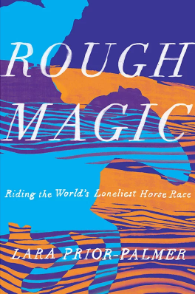

The Mongol Derby is a distance horse race that’s touted as the longest, toughest race in the world. At the age of 19, Lara Prior-Palmer traveled across the world, and, with almost no training, she went on to become the first female and the youngest person ever to win. If you want to feel like you can accomplish anything in the face of even the most extreme odds, read Prior-Palmer’s lyrical memoir.

1. The Happy Brain by Dean Burnett

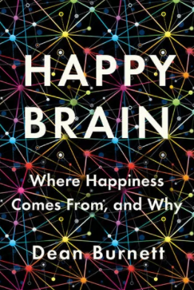

We all want to be happy. Our quest for happiness often motivates our choices, from how we make a living to our choice of partners and where we live. But happiness isn’t just some magical feeling produced by puppies and sunflowers. Psychologists and neuroscientists have been studying the science of happiness for decades. Learn their theories and more in this witty pop-sci take on the best of bliss.

1. Big Magic by Elizabeth Gilbert

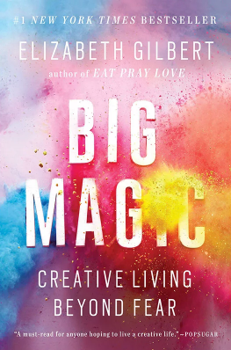

Does your life feel a little stifling? It might be time to feed your creativity. As small as the act may seem, making something from the heart—whether that’s writing, cooking, painting, or crafting!—takes some serious bravery. Gilbert, who also wrote Eat, Pray, Love, should know. With Big Magic, Gilbert goes deep with the spiritual side of creativity.

Sad:

1. A LITTLE LIFE BY HANYA YANAGIHARA

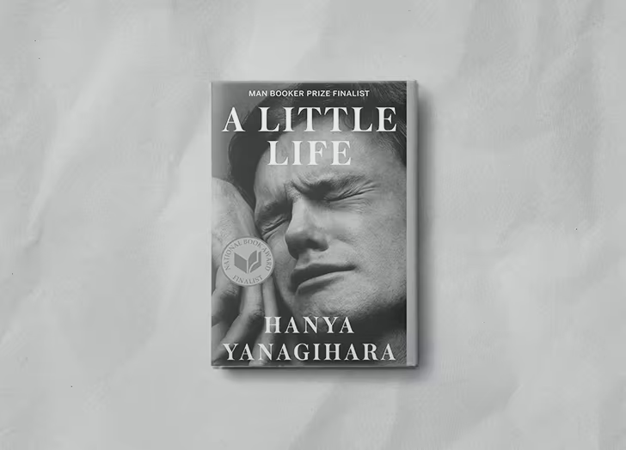

Four graduates from a small college in Massachusetts move to New York to follow their dreams and escape their demons. There, their relationships deepen, and painful (like, seriously messed up) secrets from their past emerge.

1. NEVER LET ME GO BY KAZUO ISHIGURO

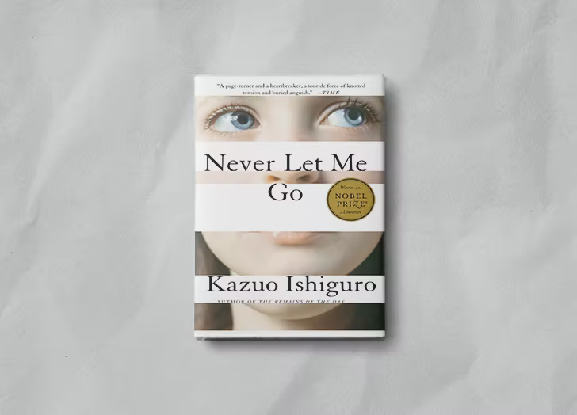

Anything but your typical dystopian sci-fi, this remarkably subtle novel imagines what life would be like if you were a clone, born to have your organs harvested in early adulthood. (We repeat: It’s haunting and weirdly subtle.)

1. EVERYTHING I NEVER TOLD YOU BY CELESTE NG

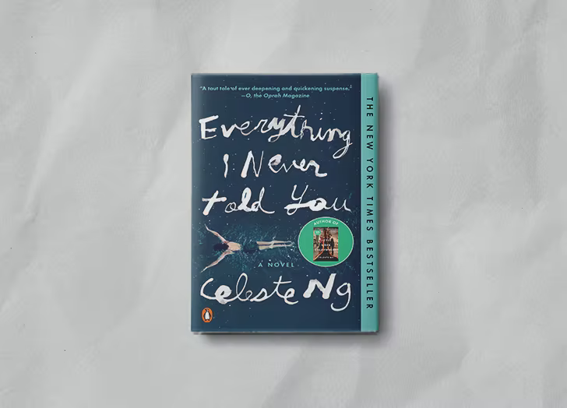

In 1970s Ohio, a Chinese-American family is rocked by the disappearance of its favorite daughter. When her body is found in the local lake, the Lees’ carefully crafted façade is destroyed. What follows is a moving and sensitive family portrait about the ways in which mothers and daughters, fathers and sons, and husbands and wives struggle to understand one another.

1. ALL THE LIGHT WE CANNOT SEE BY ANTHONY DOERR

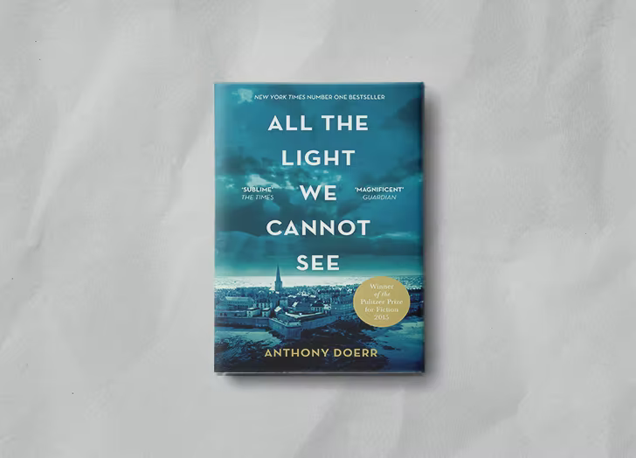

Doerr’s Pulitzer Prize winner tells the story of a French girl and a German boy on opposite sides of World War II. Doerr examines the horrors of war, treating both characters with equal empathy.

Surprised:

1. Surprisingly Funny: The One-Hundred-Year Old Man Who Climbed Out The Window And Disappeared – Jonas Jonasson

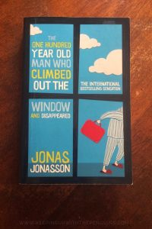

A book about a centenarian who escapes his nursing home and ends up on the run from a gang of drug dealers should probably be sad, not funny… but it’ll surprise you! [The One-Hundred-Year Old Man Who Climbed Out The Window And Disappeared](https://amzn.to/2S7UWJO) in question is Allan Karlsson, and he has lived one heck of a life. He’s living proof that vodka is cleansing, and you can make friends with just about anybody if you approach them with an open mind. You’ll be rooting for this elderly Swede before you know it, and you’ll get more literal lols out of this story than you can poke a stick at.

1. Surprisingly Masterful: The Adventures Of Sherlock Holmes – Arthur Conan Doyle

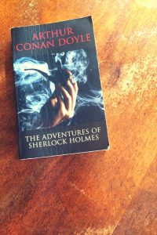

They’re just detective stories, right? How good could they really be? Damn good! [The Adventures Of Sherlock Holmes](https://amzn.to/2QZjdV9) is officially my favourite classic short-story collection, and I am in awe of Arthur Conan Doyle’s mastery of the craft. He managed to squeeze incredibly complex, intricate stories into surprisingly few words, while simultaneously making them easy to understand and follow. Seriously, it will take you longer to explain the plot of a Holmes story to a friend than it will for you to read it in the first place. Impressive, eh?

1. Surprisingly Accessible: An Artist Of The Floating World – Kazuo Ishiguro

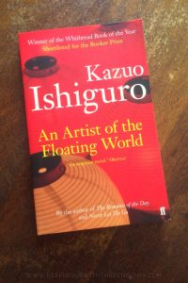

Kazuo Ishiguro has won pretty much every serious literary award there is, so I expected [An Artist Of The Floating World](https://amzn.to/2QWmzYZ) to be dense. I mean, that’s what award-winners are, right? Serious Books For Grown Ups? Turns out, [I was dead wrong](https://keepingupwiththepenguins.com/an-artist-of-the-floating-world-kazuo-ishiguro/)! This slim tome was a highly engaging and fascinating look into the mind of an ageing Japanese artist. It picks apart the role he played distributing propaganda and dobbing in his mates during the Second World War. If you want to read more “serious” fiction, but you don’t want to wear out your thinking meat, this is a great one to start with.

1. Surprising Plot Twist: We Are All Completely Beside Ourselves – Karen Joy Fowler

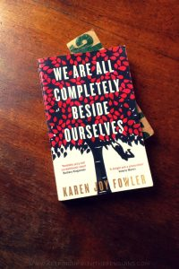

I’m cynical to a fault, and always thinking three steps ahead in books and movies. I’m the one who says “I bet this is what happens next!” and ruins it for everyone (I’m sorry, I know, I’m hateful!). That’s why I was so bowled over by a book with a plot twist that I did. not. see. coming! Not for one second! And that book was [We Are All Completely Beside Ourselves](https://amzn.to/2R1t1hi). It’s one of the very few books for which I give an actual spoiler warning, because the twist is just so damn good I can’t bear the thought of ruining it for someone else. I can’t say any more here, for obvious reasons, but if plot twists are your thing, this one is a must-read!

Neutral:

1. Beloved

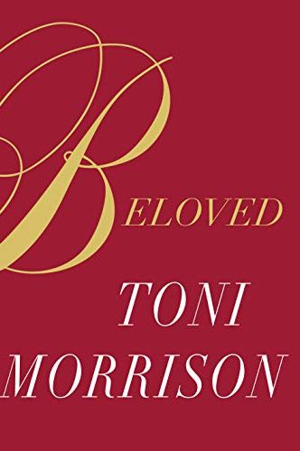

One of Morrison's most treasured novels, this one follows a formerly enslaved woman who escapes to Ohio. But the traumas she experienced, especially the loss of her baby, follows her in the form of both literal and figurative specters. It's a stunning book that will stay with you forever.

1. Minor Feelings: An Asian American Reckoning

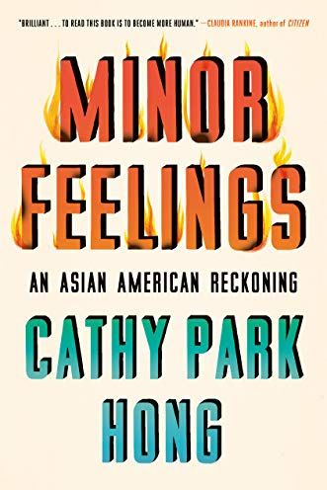

With elements of memoir, cultural criticism and plenty of wit, this essay collection explores Hong's own reckoning with her identity as the daughter of Korean immigrants, as well as the role race plays in America as a whole.

1. When Breath Becomes Air

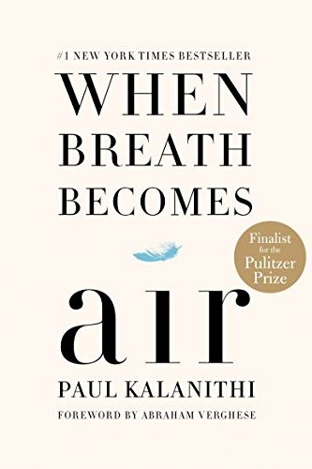

This memoir by a neurosurgeon grappling with his own terminal cancer diagnosis is both gutting and illuminating. In this day and age, its message of making the most of the time you're given is more impactful than ever.

1. 1984

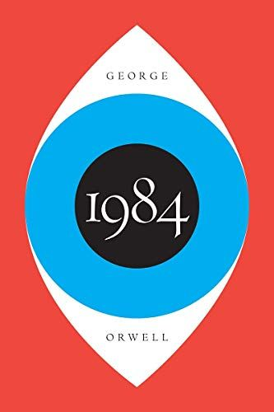

A chilling look at an imaginary future in which the government is always watching, this sci-fi masterpiece will remind us all of the dangers that can arise when we stop paying attention.