CS 6868 – Concurrent Programming
Assignment no. 1 – Problem 2
Roll no : CS13M006, Name : ARJUNLAL B
Game of Life

Program uses two matrices - currentGen and nextGen.
Using the values in current generation, next generation values are calculated and is appropriately updated.

Approach used :

Tried different methods and observed that cell-by-cell parallelization is possible, but is taking more time in practice, possibly because per-thread workload is very low. Hence I've used row-by-row parallelization, so that each thread have enough workload and the thread management overhead do not impact performance.

Cilkscreen report :

Cilkscreen reported no errors

Program is giving right output for all 3 test given public test cases.

Parallelism report using Cilkview:

Test Case 1 :
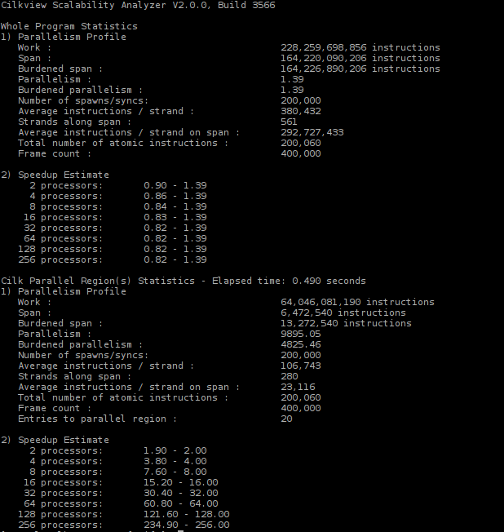

Test Case 2 :
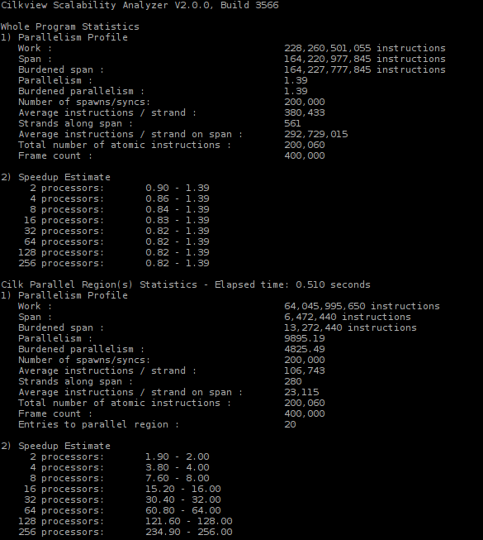

Test Case 3 :

