Raster Triangle

For PVN 3D, to generate synthetic data we need to execute two commands.

python3 rgbd_renderer.py --cls ape --render_num 70000

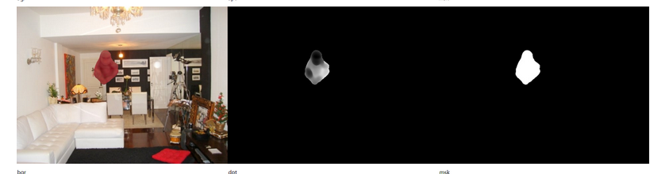
python3 fuse.py --cls ape --fuse_num 10000

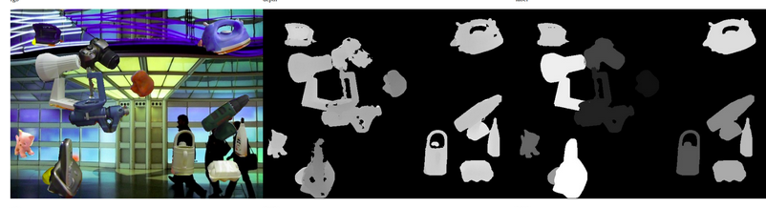
Folders in it
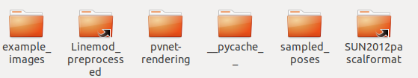
Sampled Poses folder contains 70,000 RT (x,y,z) value of each object
rgbd_renderer.py is a python file which takes background image (from SUN2012 folder) and creates Mask, RGB and Debth array value.
It then add merge these value with background images.
It takes RT value in a for loop from Sampled Poses
fuse.py Takes RGB, Mask and Depth value from Linemod Dataset and their RT values.
It then fuses region in each category(RGB, Mask, Depth)

