## Minor Project Report

## ON

Parameter Tuning using Differential Evolution

## SUBMITTED BY

|  |  |
| --- | --- |
| **Arjun Rajpal** | **(2K14/SE/21)** |
| **Dushyant Rathore** | **(2K14/SE/29)** |
| **Manav Middha** | **(2K14/SE/43)** |

## 

## Under the supervision of

Dr. RUCHIKA MALHOTRA

## Assistant Professor

## Dept. of Computer Science, Delhi Technological University



DECLARATION

I hereby certify that the work which is presented in the Minor Project entitled “***Parameter Tuning using Differential Evolution***” in fulfilment of the requirement for the award of the Degree of Bachelor of Technology and submitted to the Department of Computer Engineering, Delhi Technological University (Formerly Delhi College Of Engineering), New Delhi is an authentic record of my own, carried out during a period from January 2017 to May 2017, under the supervision of Dr. Ruchika Malhotra, Assistant Professor, CSE Department.

The matter presented in this report has not been submitted by me for the award of any other degree of this or any other Institute/University.

Signature

ARJUN RAJPAL 2K14/SE/021

DUSHYANT RATHORE 2K14/SE/029

MANAV MIDDHA 2K14/SE/043

ACKNOWLEDGEMENT

“The successful completion of any task would be incomplete without acknowledging the people who made it all possible and whose constant guidance and encouragement secured us the success.”

First of all, we are grateful to the Almighty for establishing us to complete this minor project. We are grateful to Dr. Ruchika Malhotra, Assistant Professor (Department of Computer Science and Engineering), Delhi Technological University (Formerly Delhi College of Engineering), New Delhi and all other faculty members of our department, for their astute guidance, constant encouragement and sincere support for this project work.

We owe a debt of gratitude to our guide, Dr. Ruchika Malhotra, CSE Department for incorporating in us the idea of a creative Minor Project, helping us in undertaking this project and also for being there whenever we needed her assistance.

We also place on record, our sense of gratitude to one and all, who directly or indirectly have lent their helping hand in this venture. We feel proud and privileged in expressing my deep sense of gratitude to all those who have helped me in presenting this project.

Last but never the least, we thank our parents for always being with us, in every sense.

SUPERVISOR CERTIFICATE

This is to certify that **Arjun Rajpal (2K14/SE/021), Dushyant Rathore (2K14/SE/29), Manav Middha (2K14/SE/43),** the bonafide students of Bachelor of Technology in Software Engineering of Delhi Technological University (formerly Delhi College of Engineering), New Delhi of 2014–2018 batch have completed their minor project entitled “Parameter Tuning using Differential Evolution” under the supervision of Dr. Ruchika Malhotra (Assistant Professor).

It is further certified that the work done in this dissertation is a result of candidates’ own efforts.

I wish them all success in their life.

Date: _______________

**Dr. Ruchika Malhotra**

Assistant Professor

Delhi Technological University

(Formerly Delhi College of Engineering)

Shahbad, Daulatpur, Bawana Road, Delhi – 110042

CONTENTS

1. Chapter 1: Introduction 4
2. Chapter 2: Literature Survey 7
3. Chapter 3: Proposed Work 113
4. Chapter 4: Experiments and Results 38
5. Chapter 5: Conclusion 47
6. Chapter 6: References 48

ABSTRACT

Parameter Tuning is a process in which one or more parameters of a device or model are adjusted upwards or downwards to achieve an improved or a specified result.

Software Defect Prediction involves detecting any flaw or imperfection in a software work product or a software process.

Data miners have been widely used in software engineering to generate defect predictors from static code measures. Static code defect predictors show better performance compared to manual methods. However, one of the essential components of data mining is setting the tunings that control the miner.

We seek simple, automatic, and effective method for finding tunings that give optimum value for the desired goal.

Our methodology consisted ofexperimentation with different data sets on which we ran Differential Evolution as an optimizer to explore the tuning space Then we tested the tunings using test data.

The results were astonishing. Contrary to our expectations, we found that tuning was remarkably simple i.e it only required few attempts to obtain excellent results.

We concludethat atleast for defect prediction, it is no longer sufficient to just run a data miner and present the result *without* conducting a tuning optimization study. The implication for other kinds of analytics is now an open and pressing issue.

# 

# Chapter 1: Introduction

***1.1 Organization***

In Chapter 2, we discuss the various pieces if work that we’ve studied and analysed in order to get a better grasp of the problem.

In Chapter 3, we discuss the explanation of the workflow, the various equations involved, pseudocode of the solution proposed, etc.

In Chapter 4, we plot graphs to help us visualize the dataset and solution model. We also analyse the algorithms used with the help of parameters such as accuracy, precision, etc.

In Chapter 5, we finally provide our conclusion by critically analysing the algorithms used in terms of their significance and the results seen. We explain why our work is a possible efficient solution to the problem of Parameter Tuning. We also discuss what can be the future improvements in this field.

***1.2 Background***

The ultimate goal of machine learning is to make a machine system that can automatically build models from data without requiring tedious and time consuming human involvement. One of the difficulties is that learning algorithms require the programmer to set parameters before you use the models (or at least to set constraints on those parameters). The goal, is usually to set those parameters to so optimal values that enable you to complete a learning task in the best way possible. Thus, tuning an algorithm or machine learning technique, can be simply thought of as process which one goes through in which they optimize the parameters that impact the model in order to enable the algorithm to perform the best.

For example,  If you take a machine learning algorithm for clustering like KNN, you will note that you, as the programmer, must specify the number of K's in your model (or centroids), that are used. How do you do this? You tune the model. There are many ways that you can do this. One of these can be trying many different values of K for a model, and looking to understand how the inter and intra group error as you very the number of K's in your model.

Data analysts are given a large amount of data to analyse. Many researchers are now turning towards automatic data miners. These learners automatically generate numbers that help in tuning.

***1.3 Research Objective***

In this report it is shown that using learners along with default parameters is not good enough. Therefore, tuning the learners to get the best parameters on the basis on performance measures like precision and f-measures is essential.

This report deals with Differential Evolution [9] tuning method. Impacts of both the methods on defect predictors have been investigated. It is shown that differential evolution is as effective as other available methods while being faster than them.

The specific conclusion in this report is related to defect predictors but the techniques discussed can be extended to various fields like data science and software engineering. The goal is to comment how quickly tuning can be performed without incurring excessive CPU costs.

# Chapter 2: Literature Survey

***2.1 Defect Prediction***

Defect prediction is a mechanism which can be effectively employed in predicting the defective classes or the fault prone classes in early development phases of software lifecycle. With the passage of time defect prediction [10] has become a very important area of research. As the development of software progresses, the cost of maintenance increases manifold. The cost of correcting an error is 1000 times in the testing phase as compared to in the requirement phase. Since the available time and resources are limited, it is very crucial to identify the defective classes in the early development phases of software lifecycle [6].

Any method that focusses on testing certain parts can miss out on errors in other parts so some sampling policy should be used to explore the system. One of the sampling policy is defect predictors learned from static attributes [3]. Given defect attributes, data miners can find out where or when error is most likely to occur. This technique is faster and less labour intensive than manual code reviews.

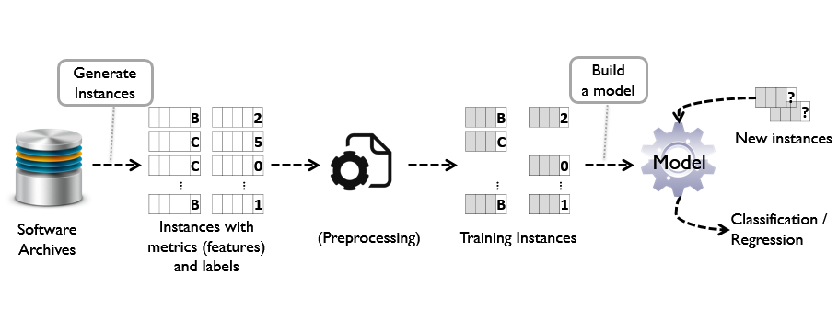

***Figure 2.1: Defect Prediction using Machine Learning***

***2.2 Differential Evolution***

Differential evolution (DE) is a method that optimizes a problem by iteratively trying to improve a candidate solution with regard to a given measure of quality. The Differential Evolution algorithm [7] involves maintaining a population of candidate solutions subjected to iterations of recombination, evaluation, and selection. The recombination approach involves the creation of new candidate solution components based on the weighted difference between two randomly selected population members added to a third population member. This perturbs population members relative to the spread of the broader population. In conjunction with selection, the perturbation effect self-organizes the sampling of the problem space, bounding it to known areas of interest.

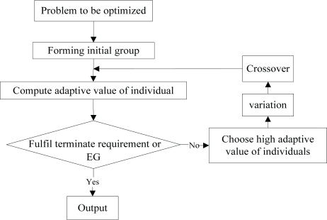

***Figure 2.2: Differential Evolution flowchart***

DE is an optimization technique which iteratively modifies a population of candidate solutions to make it converge to an optimum value of your function.

First initialize candidate solutions randomly. Then at each iteration and for each candidate solution x, do the following:

1. Produce a trial vector: v = a + ( b - c ) / 2, where a, b, c are three distinct candidate solutions picked randomly among your population.
2. Randomly swap vector components between x and v to produce v'. At least one component from v must be swapped.
3. Replace x in your population with v' only if it is a better candidate (i.e. it better optimise your function).

***2.3 Random Forest Algorithm***

It is a classification and regression technique. It operates by constructing a multitude of decision trees at training time and outputting the mode or the mean of the classes.

Random Forest [8] is a collection of decision trees. Decision trees can overfit but random forest prevents it i.e. that is prevents overfitting.

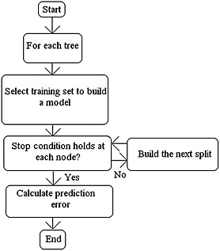

***Figure 2.3: Random Forest flowchart***

**Advantages**

1. High Accuracy.
2. Runs efficiently on large data bases.
3. Handles thousands of input variables without variable deletion.
4. Gives estimates of what variables are important in the classification.
5. Generates an internal unbiased estimate of the generalization error as the forest building progresses.
6. Provides effective methods for estimating missing data.
7. Maintains accuracy when a large proportion of the data are missing.
8. Provides methods for balancing error in class population unbalanced data sets.

Random Forest is very effective in eliminating noise in the model input data.  Given a long list of input variables and a potentially sparse dataset, it is very likely that any predictive model will discover spurious relationships between those inputs and the chosen target variable.  This results in overfitting and the model does not generalize well enough to future input it has not seen.

Because Random Forest builds many trees using a subset of the available input variables and their values, it inherently contains some underlying decision trees that omit the noise generating variable/feature(s).  In the end, when it is time to generate a prediction, a vote among all the underlying trees takes place and the majority prediction value wins.

***2.4 Classification And Regression Trees Algorithm***

Decision Trees are commonly used in data mining with the objective of creating a model that predicts the value of a target (or dependent variable) based on the values of several input (or independent variables).

**Classification Trees**: Where the target variable is categorical and the tree is used to identify the "class" within which a target variable would likely fall into.

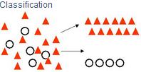

***Figure 2.4: Classification Trees***

**Regression Trees**: Where the target variable is continuous and tree is used to predict it's value.

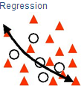

***Figure 2.5: Regression Trees***

The main elements of CART (and any decision tree algorithm) are:

1. Rules for splitting data at a node based on the value of one variable.
2. Stopping rules for deciding when a branch is terminal and can be split no more.
3. Finally, a prediction for the target variable in each terminal node.

***2.5 Logistics Regression Algorithm***

Logistic regression predicts the probability of an outcome that can only have two values (i.e. a dichotomy). The prediction is based on the use of one or several predictors (numerical and categorical). A linear regression is not appropriate for predicting the value of a binary variable for two reasons.

* A linear regression will predict values outside the acceptable range (e.g. predicting

probabilities outside the range 0 to 1).

* Since the dichotomous experiments can only have one of two possible values for each experiment, the residuals will not be normally distributed about the predicted line.

On the other hand, a logistic regression produces a logistic curve, which is limited to values between 0 and 1. Logistic regression is similar to a linear regression, but the curve is constructed using the natural logarithm of the “odds” of the target variable, rather than the probability. Moreover, the predictors do not have to be normally distributed or have equal variance in each group.

***Figure 2.6: Comparison of linear regression model and logistic regression model***

In the logistic regression the constant (bo) moves the curve left and right and the slope (b1) defines the steepness of the curve. By simple transformation, the logistic regression equation can be written in terms of an odds ratio.

Finally, taking the natural log of both sides, we can write the equation in terms of log-odds (logit) which is a linear function of the predictors. The coefficient (b1) is the amount the logit (log-odds) changes with a one unit change in x.

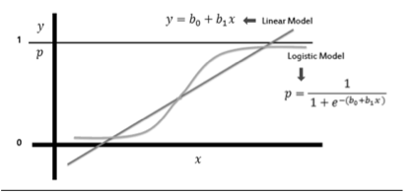

As mentioned before, logistic regression can handle any number of numerical and/or

categorical variables.

There are several analogies between linear regression and logistic regression. Just as ordinary least square regression is the method used to estimate coefficients for the best fit line in linear regression, logistic regression uses maximum likelihood estimation (MLE) to obtain the model coefficients that relate predictors to the target. After this initial function is estimated, the process is repeated until LL (Log Likelihood) does not change significantly.



# Chapter 3: Proposed Work

Defect prediction [5] is a mechanism which can be effectively employed in predicting the defective classes or the fault prone classes in early development phases of software lifecycle. With the passage of time defect prediction has become very a very important area of research.

In order to understand the relative merits of differential evolution for defect prediction, we performed the following study.

***3.1 Tuning Parameters****:*

Our DE and grid search explored the parameter space of Figure 3.1. Specifically, since Tantithamthavorn et al. divide each tuning range into 5 bins (if applicable), we also use the same policy here. For example, we pick values [50,75,100,125,150] for n estimators. Other parameters grid will generate in the same way. As to why we used the “Tuning Range” shown in Figure 3.1, and not some other ranges, we note that (1) those ranges included the defaults; (2) the results shown below show that by exploring those ranges, we achieved large gains in the performance of our defect predictors. This is not to say that larger tuning ranges might not result in greater improvements.

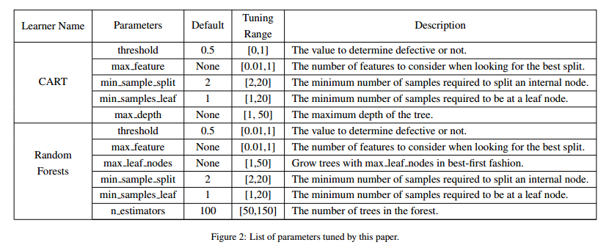

***Figure 3.1: List of parameters tuned by this paper***

***3.2 Data:***

Our defect data, shown in Figure 3.2 comes from PROMISE [1] repository. This data pertains to open source Java systems: ant, camel, ivy, jedit, log4j, lucene, poi, synapse, velocity and xerces. We selected these data sets since they have at least three consecutive releases (where release i+1 was built after release i). This will allow us to build defect predictors [2] based on the past data and then predict (test) defects on future version projects, which will be a more practical scenario.

More specifically, when tuning a learner:

• Release i was used for training a learner with tunings generated by grid search or differential evolution.

• During the search, each candidate has to be evaluated by some model, which we build using CART or Random Forests from release i+1.

• After grid search or differential evolution terminated, we tested the tunings found by those methods on CART or Random Forests applied to release i+2.

• For comparison purposes, CART and Random Forests were also trained (with default tunings) on releases i and i+1 then tested on release i+2.

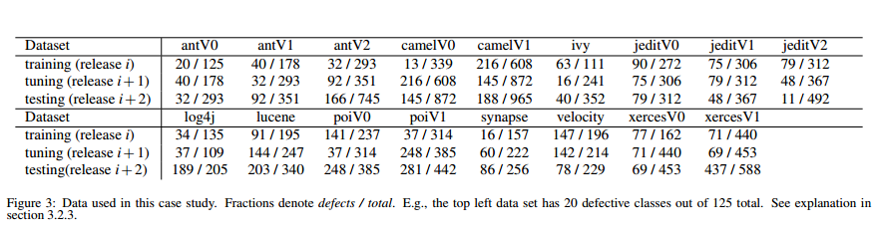

***Figure 3.2 Data used in this case study. Fractions denore defects I total. Eg: the top left dataset has 20 defective classes out of 125 total.***

***3.3 Algorithm Description:***

**Differential Evolution**

The working of DE algorithm is very simple. Consider you need to optimize (minimize, for example) **∑Xi^2** (sphere model) within a given range, say **[-100,100]**. We know that the minimum value is 0. Let's see how DE works.

DE is a population-based algorithm. And for each individual in the population, a fixed number of chromosomes will be there (imagine it as a set of human beings and chromosomes or genes in each of them). Let us explain DE w.r.t above function

We need to fix the population size and the number of chromosomes or genes (named as parameters). For instance, let's consider a population of size 4 and each of the individual has 3 chromosomes (or genes or parameters). Let's call the individuals R1, R2, R3, R4.

**Step 1: Initialize the population**

We need to randomly initialise the population within the range [-100,100]

**G1 G2 G3 objective function value R1 -> |-90 | 2 | 1 | =>8105 R2 -> | 7 | 9 | -50 | =>2630 R3 -> | 4 | 2 | -9.2| =>104.64 R4 -> | 8.5 | 7 | 9 | =>202.25**

objective function value is calculated using the given objective function. In this case, it's **∑Xi^2**. So for R1, objective function value will be **-90^2+2^2+2^2 = 8105**. Similarly, it is found for all.

**Step 2: Mutation**

Fix a target vector, say for example R1 and then randomly select three other vectors (individuals) say for example, R2, R3, R4 and performs mutation. Mutation is done as follows,

**Mutant Vector = R2 + F(R3-R4)**

(vectors can be chosen randomly, need not be in any order). **F (scaling factor/mutation constant) within range [0,1]** is one among the few control parameters DE is having. In simple words, it describes how different the mutated vector becomes. Let's keep F =0.5.

**| 7 | 9 | -50 | + 0.5 * | 4 | 2 | -9.2| + | 8.5 | 7 | 9 |**

Now performing Mutation will give the following Mutant Vector:

**MV = | 13.25 | 13.5 | -50.1 | =>2867.82**

**Step 3: Crossover**

Now that we have a target vector(R1) and a mutant vector MV formed from R2, R3 & R4, we need to do a crossover. Consider R1 and MV as two parents and we need a child from these two parents. Crossover is done to determine how much information is to be taken from both the parents. It is controlled by **Crossover rate(CR)**. Every gene/chromosome of the child is determined as follows, a random number between 0 & 1 is generated, if it is greater than CR , then inherit a gene from target(R1) else from mutant(MV).

Let's set CR = 0.9. Since we have 3 chromosomes for individuals, we need to generate 3 random numbers between 0 and 1. Say for example, those numbers are 0.21,0.97,0.8 respectively. First and last are lesser than CR value, so those positions in the child's vector will be filled by values from MV and second position will be filled by gene taken from target(R1).

**Target-> |-90| 2| 1| Mutant-> | 13.25 | 13.5 | -50.1 |**

**random num - 0.21, => `Child -> |13.25| -- | -- |` random num - 0.97, => `Child -> |13.25| 2 | -- |` random num - 0.80, => `Child -> |13.25| 2 | -50.1 |` Trial vector/child vector -> | 13.25 | 2 | -50.1 | =>2689.57**

**Step 4: Selection**

Now we have child and target. Compare the objective function of both, see which is smaller (minimization problem). Select that individual out of the two for next generation

**R1 -> |-90 | 2 | 1 | =>8105 Trial vector/child vector -> | 13.25 | 2 | -50.1 | =>2689.57**

Clearly, the child is better so replace target(R1) with the child. So the new population will become

**G1 G2 G3 objective fn value R1 -> | 13.25 | 2 | -50.1 | =>2689.57 R2 -> | 7 | 9 | -50 | =>2500 R3 -> | 4 | 2 | -9.2 | =>104.64 R4 -> | -8.5 | 7 | 9 | =>202.25**

This procedure will be continued either till the number of generations desired has reached or till we get our desired value.

**Random Forest**

The implementation of Random Forest as given in sklearn is as follows :

*class* sklearn.ensemble.RandomForestClassifier (*n_estimators=10*, *criterion='gini'*, *max_depth=None*, *min_samples_split=2*, *min_samples_leaf=1*, *min_weight_fraction_leaf=0.0*, *max_features='auto'*, *max_leaf_nodes=None*, *min_impurity_split=1e-07*, *bootstrap=True*, *oob_score=False*, *n_jobs=1*, *random_state=None*, *verbose=0*, *warm_start=False*, *class_weight=None*)

**Cart**

*def cart(a, b, c, d, candidate):*

*ct = DecisionTreeClassifier(max_depth=candidate["tunings"][4], min_samples_split=candidate["tunings"][2], min_samples_leaf=candidate["tunings"][3], max_features=candidate["tunings"][1], min_impurity_split=candidate["tunings"][0])*

*ct.fit(a, b)*

*pred = ct.predict(c)*

***3.4 Codes:***

1. ***Untuned Logistics Regression, Random Forest & Cart***

from sklearn.linear_model import LogisticRegression

from sklearn.ensemble import RandomForestClassifier

from sklearn.tree import DecisionTreeClassifier

from sklearn.metrics import precision_score,f1_score

import pandas as pd

import numpy as np

import matplotlib.pyplot as plt

from prettytable import PrettyTable

dataset = ['antV0', 'antV1', 'antV2', 'camelV0', 'camelV1', 'ivy', 'jeditV0', 'jeditV1', 'jeditV2', 'log4j', 'lucene', 'poiV0', 'poiV1', 'synapse', 'velocity', 'xercesV0', 'xercesV1']

precision_cart = []

precision_rf = []

precision_lr = []

fscore_cart = []

fscore_rf = []

fscore_lr = []

# CART

def cart(a, b, c, d):

ct = DecisionTreeClassifier(min_impurity_split=0.5, min_samples_split=2, min_samples_leaf=1, max_features=None, max_depth=None)

ct.fit(a, b)

pred = ct.predict(c)

# print "Predicted Matrix : " + str(pred)

p = precision_score(d, pred, average='weighted')

# p = accuracy_score(d, pred)

# print p

precision_cart.append(p * 100)

f = f1_score(d, pred, average='weighted')

fscore_cart.append(f * 100)

# Random Forest

def random_forest(a, b, c, d):

rf = RandomForestClassifier(min_impurity_split=0.5, min_samples_split=2, min_samples_leaf=1, n_estimators=100, max_features=None, max_leaf_nodes=None)

rf.fit(a, b)

pred = rf.predict(c)

# print "Predicted Matrix : " + str(pred)

p = precision_score(d, pred, average='weighted')

# p = accuracy_score(d, pred)

# print p

precision_rf.append(p * 100)

f = f1_score(d, pred, average='weighted')

fscore_rf.append(f * 100)

# Logistic Regression

def logistic_regression(a, b, c, d):

lr = LogisticRegression()

lr.fit(a, b)

pred = lr.predict(c)

# print "Predicted Matrix : " + str(pred)

p = precision_score(d, pred, average='weighted')

# p = accuracy_score(d, pred)

# print p

# print "\n"

precision_lr.append(p * 100)

f = f1_score(d, pred, average='weighted')

fscore_lr.append(f * 100)

def perform_calculation(loc_train, loc_test):

f1 = pd.read_csv(loc_train, delimiter=",")

df1 = pd.DataFrame(f1)

f2 = pd.read_csv(loc_test, delimiter=",")

df2 = pd.DataFrame(f2)

# Training Set

X_Train_DF = df1.ix[:, 3:23]

X_Train = X_Train_DF.values.astype(float)

y_Train = np.asarray(list(df1["bug"]))

# print X_Train

# print Y_Train

# Testing Set

X_Test_DF = df2.ix[:, 3:23]

X_Test = X_Test_DF.values.astype(float)

y_Test = np.asarray(list(df2["bug"]))

# print X_Test

# print Y_Test

cart(X_Train, y_Train, X_Test, y_Test)

random_forest(X_Train, y_Train, X_Test, y_Test)

logistic_regression(X_Train, y_Train, X_Test, y_Test)

def calculate_all():

# antV0

perform_calculation("../combined_dataset_modified/antV0/1.csv", "../combined_dataset_modified/antV0/3.csv")

# antV1

perform_calculation("../combined_dataset_modified/antV1/2.csv", "../combined_dataset_modified/antV1/4.csv")

# antV2

perform_calculation("../combined_dataset_modified/antV2/3.csv", "../combined_dataset_modified/antV2/5.csv")

# camelV0

perform_calculation("../combined_dataset_modified/camelV0/1.csv", "../combined_dataset_modified/camelV0/3.csv")

# camelV1

perform_calculation("../combined_dataset_modified/camelV1/2.csv", "../combined_dataset_modified/camelV1/4.csv")

# ivy

perform_calculation("../combined_dataset_modified/ivy/1.csv", "../combined_dataset_modified/ivy/3.csv")

# jeditV0

perform_calculation("../combined_dataset_modified/jeditV0/1.csv", "../combined_dataset_modified/jeditV0/3.csv")

# jeditV1

perform_calculation("../combined_dataset_modified/jeditV1/2.csv", "../combined_dataset_modified/jeditV1/4.csv")

# jeditV2

perform_calculation("../combined_dataset_modified/jeditV2/3.csv", "../combined_dataset_modified/jeditV2/5.csv")

# log4j

perform_calculation("../combined_dataset_modified/log4j/1.csv", "../combined_dataset_modified/log4j/3.csv")

# lucene

perform_calculation("../combined_dataset_modified/lucene/1.csv", "../combined_dataset_modified/lucene/3.csv")

# poiV0

perform_calculation("../combined_dataset_modified/poiV0/1.csv", "../combined_dataset_modified/poiV0/3.csv")

# poiV1

perform_calculation("../combined_dataset_modified/poiV1/2.csv", "../combined_dataset_modified/poiV1/4.csv")

# synapse

perform_calculation("../combined_dataset_modified/synapse/1.csv", "../combined_dataset_modified/synapse/3.csv")

# velocity

perform_calculation("../combined_dataset_modified/velocity/1.csv", "../combined_dataset_modified/velocity/3.csv")

# xercesV0

perform_calculation("../combined_dataset_modified/xercesV0/1.csv", "../combined_dataset_modified/xercesV0/3.csv")

# xercesV1

perform_calculation("../combined_dataset_modified/xercesV1/2.csv", "../combined_dataset_modified/xercesV1/4.csv")

# Print Precision table for Cart, Random Forest and Logistic Regression

sequence_precision = ["Dataset", "Cart", "RF "]

t_precision = PrettyTable(sequence_precision)

for i in range(0, len(dataset)):

t_precision.add_row([dataset[i],precision_cart[i], precision_rf[i]])

print "Table for precision of Untuned Learner"

print str(t_precision) + "\n"

# Print fscore table for Cart, Random Forest

sequence_fscore = ["Dataset", "Cart", "RF"]

t_fscore = PrettyTable(sequence_fscore)

for i in range(0, len(dataset)):

t_fscore.add_row(

[dataset[i], fscore_cart[i], fscore_rf[i]])

print "Table for fscore of Untuned Learner"

print t_fscore

return precision_cart,precision_rf, precision_lr,fscore_cart,fscore_rf,fscore_lr

if __name__ == "__main__":

calculate_all()

1. ***Tuned Random Forest using Precision & F_measure as Goal state one by one***

from sklearn.ensemble import RandomForestClassifier

from sklearn.tree import DecisionTreeClassifier

from sklearn.metrics import precision_score

import pandas as pd

import numpy as nump

import math

from data import data

import random

from prettytable import PrettyTable

class color:

PURPLE = '\033[95m'

CYAN = '\033[96m'

DARKCYAN = '\033[36m'

BLUE = '\033[94m'

GREEN = '\033[92m'

YELLOW = '\033[93m'

RED = '\033[91m'

BOLD = '\033[1m'

UNDERLINE = '\033[4m'

END = '\033[0m'

# np, f, cr, life, Goal, noOfParameters = 10, 0.75, 0.3, 5, [], 0 #input

# sBest = [] #ouput

global global_best_score

global_best_score = []

global global_best

global_best= []

# Runs Random Forest on the dataset using parameters present in candidate

def random_forest(a, b, c, d, candidate):

# print "Candidate in Random Forest : " + str(candidate)

# print "Threshold :" + str(candidate["tunings"][0])

# print "Max feature : " + str(candidate["tunings"][1])

# print "Max leaf nodes : " + str(candidate["tunings"][2])

# print "Min sample split : " + str(candidate["tunings"][3])

# print "Min samples leaf : " + str(candidate["tunings"][4])

# print "Max no of estimators : " + str(candidate["tunings"][5])

rf = RandomForestClassifier(min_impurity_split=candidate["tunings"][0], max_features=candidate['tunings'][1],

max_leaf_nodes=candidate['tunings'][2], min_samples_split=candidate['tunings'][3],

min_samples_leaf=candidate['tunings'][4], n_estimators=candidate['tunings'][5])

rf.fit(a, b)

pred = rf.predict(c)

# print "Predicted Matrix : " + str(pred)

p = precision_score(d, pred, average='weighted')

return p

# Retrieves the appropriate dataset from readDataset function present in data.py and passes

# the Training and Testing dataset to Random Forest function

# Retrieves the appropriate dataset from readDataset function present in data.py and passes

# the Training and Testing dataset to Random Forest function

def score(candidate, datasets):

df1, df2 = data.readDataset(datasets)

# Training Set

X_Train_DF = df1.ix[:, 3:23]

X_Train = X_Train_DF.values.astype(float)

Y_Train = nump.asarray(list(df1["bug"]))

# print X_Train

# print Y_Train

# Testing Set

X_Test_DF = df2.ix[:, 3:23]

X_Test = X_Test_DF.values.astype(float)

Y_Test = nump.asarray(list(df2["bug"]))

# print X_Test

# print Y_Test

p = random_forest(X_Train, Y_Train, X_Test, Y_Test, candidate)

return p

def score_test(candidate, datasets):

df1, df2 = data.readDataset_for_testing(datasets)

# Training Set

X_Train_DF = df1.ix[:, 3:23]

X_Train = X_Train_DF.values.astype(float)

Y_Train = nump.asarray(list(df1["bug"]))

# print X_Train

# print Y_Train

# Testing Set

X_Test_DF = df2.ix[:, 3:23]

X_Test = X_Test_DF.values.astype(float)

Y_Test = nump.asarray(list(df2["bug"]))

# print X_Test

# print Y_Test

p = random_forest(X_Train, Y_Train, X_Test, Y_Test, candidate)

return p

# Initialises the population such that each parameter of each candidate

# in the population gets a random value from the parameter's valid range

def initialisePopulation(np,noOfParameters):

population = []

for i in range(0,np):

candidate = {}

tunings = []

# tunings.append(nump.random.uniform(algoParameters[0]['low'], algoParameters[0]['high']))

threshold = nump.random.uniform(algoParameters[0]['low'], algoParameters[0]['high'])

# print "Threshold for index " + str(i) + " : " + str(threshold)

tunings.append(threshold)

max_feature = int(nump.random.uniform(algoParameters[1]['low'], algoParameters[1]['high']))

# print "Max Feature selected for index " + str(i) + " : " + str(max_feature)

tunings.append(max_feature)

max_leaf_nodes = int(nump.random.uniform(algoParameters[2]['low'], algoParameters[2]['high']))

# print "Max Leaf Nodes for index " + str(i) + " : " + str(max_leaf_nodes)

tunings.append(max_leaf_nodes)

min_sample_split = int(nump.random.uniform(algoParameters[3]['low'], algoParameters[3]['high']))

# print "Min sample split for index " + str(i) + " : " + str(min_sample_split)

tunings.append(min_sample_split)

min_samples_leaf = int(nump.random.uniform(algoParameters[4]['low'], algoParameters[4]['high']))

# print "Min samples leaf for index " + str(i) + " : " + str(min_samples_leaf)

tunings.append(min_samples_leaf)

n_estimators = int(nump.random.uniform(algoParameters[5]['low'], algoParameters[5]['high']))

# print "n_estimators for index " + str(i) + " : " + str(n_estimators) + "\n"

tunings.append(n_estimators)

# population[i]['tunings']

# print tunings[4]

candidate['tunings'] = tunings

candidate['score'] = 0

population.append(candidate)

# print "Population"

# print population

return population

# Returns three random candidates from a population of size 10 such that

# neither of them is equal to the target candidate i.e old

def threeOthers(pop,old,index):

# while(1):

three = range(0,10,1)

three.remove(index)

three = random.sample(three, 3) # Array Formation

# print pop[three[0]['tunings']]

# print pop[three[0]['tunings']]

# print pop[three[0]['tunings']]

return pop[three[0]]['tunings'], pop[three[1]]['tunings'], pop[three[2]]['tunings']

# Returns True if the newly computed population is different than the old generation otherwise False

def improve(population, oldGeneration):

if population != oldGeneration:

return True

else:

return False

# Compares the precision score of each candidate in the population and

# returns the candidate with the highest precision score as the Best Solution

def getBestSolution(population):

max = -1

bestSolution = {}

for i in range(0,len(population)):

scores = population[i]['score']

# print scores

if scores > max:

max = scores

bestSolution = population[i]

return bestSolution

# Creates a mutant whose each parameter value is either taken from the target candidate(old) or is

# computed using (a+f*(b-c)) depending on value of cr

def extrapolate(old, pop, cr, f, noOfParameters, index, dataset):

a, b, c = threeOthers(pop, old, index) # index is for the target row

newf = []

# print "\nThe other 3 selected rows for index " + str(index) + " : "

# print a

# print b

# print c

for i in range(0, noOfParameters):

x = nump.random.uniform(0, 1)

# print "Random number for comparison with cr : " + str(x)

if cr < x:

# print "Old tuning Value for index " + str(index) + " : " + (str(old['tunings'][i]))

newf.append(old['tunings'][i])

elif type(old['tunings'][i]) == bool:

newf.append(not old['tunings'][i])

else:

lo = algoParameters[i]["low"]

hi = algoParameters[i]["high"]

value = a[i] + (f * (b[i] - c[i]))

# print "Value before trim : " + str(value)

if i != 0:

mutant_value = int(max(lo, min(value, hi)))

else:

mutant_value = max(lo, min(value, hi))

# print "Mutant Value : " + str(mutant_value)

newf.append(mutant_value)

dict_mutant = {'tunings': newf}

score_mutant = score(dict_mutant, dataset)

score_original = score(old, dataset)

# print "Original Score : " + str(score_original)

# print "Mutant Score : " + str(score_mutant)

global global_best

global global_best_score

if score_mutant > score_original:

global_best_score.append(score_mutant * 100)

global_best.append({'score': score_mutant * 100, 'tunings': newf})

else:

global_best_score.append(score_original)

global_best.append({'score': score_original * 100, 'tunings': old["tunings"]})

# print global_best

newCandidate = {'score': 0, 'tunings': newf}

# print newCandidate

return newCandidate

# Performs Differential Evolution

def DE(np, f, cr, life, noOfParameters, dataset):

population = initialisePopulation(np, noOfParameters) # Intial population formation

while life > 0:

global global_best

global_best = []

global global_best_score

global_best_score = []

for i in range(0, np):

extrapolate(population[i], population, cr, f, noOfParameters, i, dataset)

# print "Global Best :"

# print global_best

oldPopulation = []

globalPopulation = []

for row in population:

oldPopulation.append(row['tunings'])

for row in global_best:

globalPopulation.append(row['tunings'])

# print "Old Population :"

# print oldPopulation

#

# print "Global Population :"

# print globalPopulation

if oldPopulation != globalPopulation:

population = global_best

# print population

else:

life -= 1

s_Best = getBestSolution(global_best)

return s_Best

# Sets the valid range for each parameter of the machine learning algorithm

algoParameters = [{'low': 0.01, 'high': 1}, {'low': 1, 'high': 20}, {'low': 2, 'high': 50}, {'low': 2, 'high': 20},

{'low': 1, 'high': 20}, {'low': 50, 'high': 150}]

# Invokes DE

all_data_precision_rf = []

print "Precision Random Forest"

def calculate():

for i in range(0, 17):

dataset = i

parameters = DE(10, 0.75, 0.3, 5, 6, dataset)

score_p = (score_test(parameters, dataset) * 100)

print color.BOLD + color.CYAN + "\nBest Parameters for Random Forest in dataset ", str(dataset + 1), " are ", str(parameters) + color.END

print color.BOLD + color.GREEN + "Precision Score : " + str(score_p) + color.END + "\n"

all_data_precision_rf.append(score_p)

if __name__ == "__main__":

calculate()

1. ***Tuned CART using Precision & F_measure as Goal state one by one***

from sklearn.ensemble import RandomForestClassifier

from sklearn.tree import DecisionTreeClassifier

from sklearn.metrics import precision_score

import pandas as pd

import numpy as nump

import math

from data import data

import random

from prettytable import PrettyTable

class color:

PURPLE = '\033[95m'

CYAN = '\033[96m'

DARKCYAN = '\033[36m'

BLUE = '\033[94m'

GREEN = '\033[92m'

YELLOW = '\033[93m'

RED = '\033[91m'

BOLD = '\033[1m'

UNDERLINE = '\033[4m'

END = '\033[0m'

# np, f, cr, life, Goal, noOfParameters = 10, 0.75, 0.3, 5, [], 0 #input

# sBest = [] #ouput

global global_best_score

global_best_score = []

global global_best

global_best= []

# Runs Random Forest on the dataset using parameters present in candidate

def cart(a, b, c, d, candidate):

# print "\nCandidate in Cart : " + str(candidate)

# # value_threshold = nump.random.uniform(0.01, 1)

# # print "Threshold :" + str(value_threshold)

# print "Threshold :" + str(candidate["tunings"][0])

# print "Max feature : " + str(candidate["tunings"][1])

# print "Min sample split : " + str(candidate["tunings"][2])

# print "Min samples leaf : " + str(candidate["tunings"][3])

# print "Max depth : " + str(candidate["tunings"][4])

ct = DecisionTreeClassifier(max_depth=candidate["tunings"][4], min_samples_split=candidate["tunings"][2], min_samples_leaf=candidate["tunings"][3], max_features=candidate["tunings"][1], min_impurity_split=candidate["tunings"][0])

ct.fit(a, b)

pred = ct.predict(c)

# print "Predicted Matrix : " + str(pred)

p = precision_score(d, pred, average='weighted')

return p

# Retrieves the appropriate dataset from readDataset function present in data.py and passes

# the Training and Testing dataset to Random Forest function

def score(candidate, dataset):

df1, df2 = data.readDataset(dataset)

# Training Set

X_Train_DF = df1.ix[:, 3:23]

X_Train = X_Train_DF.values.astype(float)

Y_Train = nump.asarray(list(df1["bug"]))

# print X_Train

# print Y_Train

# Testing Set

X_Test_DF = df2.ix[:, 3:23]

X_Test = X_Test_DF.values.astype(float)

Y_Test = nump.asarray(list(df2["bug"]))

# print X_Test

# print Y_Test

p = cart(X_Train, Y_Train, X_Test, Y_Test, candidate)

return p

def score_test(candidate, dataset):

df1, df2 = data.readDataset_for_testing(dataset)

# Training Set

X_Train_DF = df1.ix[:, 3:23]

X_Train = X_Train_DF.values.astype(float)

Y_Train = nump.asarray(list(df1["bug"]))

# print X_Train

# print Y_Train

# Testing Set

X_Test_DF = df2.ix[:, 3:23]

X_Test = X_Test_DF.values.astype(float)

Y_Test = nump.asarray(list(df2["bug"]))

# print X_Test

# print Y_Test

p = cart(X_Train, Y_Train, X_Test, Y_Test, candidate)

return p

# Initialises the population such that each parameter of each candidate

# in the population gets a random value from the parameter's valid range

def initialisePopulation(np,noOfParameters):

population = []

for i in range(0,np):

candidate = {}

tunings = []

# tunings.append(nump.random.uniform(algoParameters[0]['low'], algoParameters[0]['high']))

threshold= nump.random.uniform(algoParameters[0]['low'], algoParameters[0]['high'])

# print "Threshold for index " + str(i) + " : " + str(threshold)

tunings.append(threshold)

max_feature = int(nump.random.uniform(algoParameters[1]['low'], algoParameters[1]['high']))

# print "Max Feature selected for index " + str(i) + " : " + str(max_feature)

tunings.append(max_feature)

min_sample_split = int(nump.random.uniform(algoParameters[2]['low'], algoParameters[2]['high']))

# print "Max Leaf Nodes for index " + str(i) + " : " + str(min_sample_split)

tunings.append(min_sample_split)

min_samples_leaf = int(nump.random.uniform(algoParameters[3]['low'], algoParameters[3]['high']))

# print "Min sample split for index " + str(i) + " : " + str(min_samples_leaf)

tunings.append(min_samples_leaf)

max_depth = int(nump.random.uniform(algoParameters[4]['low'], algoParameters[4]['high']))

# print "Min samples leaf for index " + str(i) + " : " + str(max_depth)

tunings.append(max_depth)

# population[i]['tunings']

# print tunings[4]

candidate['tunings'] = tunings

candidate['score'] = 0

population.append(candidate)

# print "Population"

# print population

return population

# Returns three random candidates from a population of size 10 such that

# neither of them is equal to the target candidate i.e old

def threeOthers(pop,old,index):

# while(1):

three = range(0,10,1)

three.remove(index)

three = random.sample(three, 3) # Array Formation

# print pop[three[0]['tunings']]

# print pop[three[0]['tunings']]

# print pop[three[0]['tunings']]

return pop[three[0]]['tunings'], pop[three[1]]['tunings'], pop[three[2]]['tunings']

# Returns True if the newly computed population is different than the old generation otherwise False

def improve(population, oldGeneration):

if population != oldGeneration:

return True

else:

return False

# Compares the precision score of each candidate in the population and

# returns the candidate with the highest precision score as the Best Solution

def getBestSolution(population):

max = -1

bestSolution = {}

for i in range(0,len(population)):

scores = population[i]['score']

# print scores

if scores > max:

max = scores

bestSolution = population[i]

return bestSolution

# Creates a mutant whose each parameter value is either taken from the target candidate(old) or is

# computed using (a+f*(b-c)) depending on value of cr

def extrapolate(old, pop, cr, f, noOfParameters, index, dataset):

a, b, c = threeOthers(pop, old, index) # index is for the target row

newf = []

# print "\nThe other 3 selected rows for index " + str(index) + " : "

# print a

# print b

# print c

for i in range(0, noOfParameters):

x = nump.random.uniform(0, 1)

# print "Random number for comparison with cr : " + str(x)

if cr < x:

# print "Old tuning Value for index " + str(index) + " : " + (str(old['tunings'][i]))

newf.append(old['tunings'][i])

elif type(old['tunings'][i]) == bool:

newf.append(not old['tunings'][i])

else:

lo = algoParameters[i]["low"]

hi = algoParameters[i]["high"]

value = a[i] + (f * (b[i] - c[i]))

# print "Value before trim : " + str(value)

if i != 0:

mutant_value = int(max(lo, min(value, hi)))

else:

mutant_value = max(lo, min(value, hi))

# print "Mutant Value : " + str(mutant_value)

newf.append(mutant_value)

dict_mutant = {'tunings': newf}

score_mutant = score(dict_mutant, dataset)

score_original = score(old, dataset)

# print "Original Score : " + str(score_original)

# print "Mutant Score : " + str(score_mutant)

global global_best

global global_best_score

if score_mutant > score_original:

global_best_score.append(score_mutant * 100)

global_best.append({'score': score_mutant * 100, 'tunings': newf})

else:

global_best_score.append(score_original)

global_best.append({'score': score_original * 100, 'tunings': old["tunings"]})

# print global_best

# newCandidate = {'score': 0, 'tunings': newf}

# print newCandidate

# return newCandidate

# Performs Differential Evolution

def DE(np, f, cr, life, noOfParameters, dataset):

population = initialisePopulation(np, noOfParameters) # Intial population formation

while life > 0:

global global_best

global_best = []

global global_best_score

global_best_score = []

for i in range(0, np):

extrapolate(population[i], population, cr, f, noOfParameters, i, dataset)

# print "Global Best :"

# print global_best

oldPopulation = []

globalPopulation = []

for row in population:

oldPopulation.append(row['tunings'])

for row in global_best:

globalPopulation.append(row['tunings'])

# print "Old Population :"

# print oldPopulation

#

# print "Global Population :"

# print globalPopulation

if oldPopulation != globalPopulation:

population = global_best

# print population

else:

life -= 1

s_Best = getBestSolution(global_best)

return s_Best

# Sets the valid range for each parameter of the machine learning algorithm

algoParameters = [{'low': 0, 'high': 1}, {'low': 1, 'high': 20}, {'low': 2, 'high': 20}, {'low': 1, 'high': 20},

{'low': 1, 'high': 50}]

# Invokes DE

print "Precision Cart"

def calculate():

all_data_precision_cart = []

for i in range(0, 17):

dataset = i

parameters = DE(10, 0.75, 0.3, 5, 5, dataset)

score_p = (score_test(parameters, dataset) * 100)

# print color.BOLD + color.CYAN + "\nBest Parameters for Cart in dataset ", str(dataset + 1), " are ", str(parameters) + color.END

# print color.BOLD + color.GREEN + "Precision Score : " + str(score_p) + color.END + "\n"

all_data_precision_cart.append(score_p)

return all_data_precision_cart

if __name__ == "__main__":

calculate()

1. ***Plotting Graphs***

import matplotlib.pyplot as plt

import lr_vs_rf_vs_cart

import DE_cart

import DE_cart_fscore

import DE_random_forest

import DE_random_forest_fscore

class color:

PURPLE = '\033[95m'

CYAN = '\033[96m'

DARKCYAN = '\033[36m'

BLUE = '\033[94m'

GREEN = '\033[92m'

YELLOW = '\033[93m'

RED = '\033[91m'

BOLD = '\033[1m'

UNDERLINE = '\033[4m'

END = '\033[0m'

# Untuned Models

precision_cart_untuned, precision_rf_untuned, precision_lr_untuned, fscore_cart_untuned, fscore_rf_untuned, \

fscore_lr_untuned = lr_vs_rf_vs_cart.calculate_all()

print color.BOLD + color.RED + "Untuned Model" + color.END

print color.BOLD + color.CYAN + "Precision list for Untuned Cart" + color.END + str(precision_cart_untuned)

print color.BOLD + color.CYAN + "Fscore list for Untuned Cart " + color.END + str(fscore_cart_untuned)

print color.BOLD + color.CYAN + "Precision list for Untuned Random Forest" + color.END + str(precision_rf_untuned)

print color.BOLD + color.CYAN + "Fscore list for Untuned Random Forest " + color.END + str(fscore_rf_untuned)

# Tuned Models

precision_cart_tuned = DE_cart.calculate()

fscore_cart_tuned = DE_cart_fscore.calculate()

precision_rf_tuned = DE_random_forest.calculate()

fscore_rf_tuned = DE_random_forest_fscore.calculate()

print color.BOLD + color.RED + "Tuned Model" + color.END

print color.BOLD + color.CYAN + "Precision list for Tuned Cart" + color.END + str(precision_cart_tuned)

print color.BOLD + color.CYAN + "Fscore list for Tuned Cart " + color.END + str(fscore_cart_tuned)

print color.BOLD + color.CYAN + "Precision list for Tuned Random Forest" + color.END + str(precision_rf_tuned)

print color.BOLD + color.CYAN + "Fscore list for Tuned Random Forest " + color.END + str(fscore_rf_tuned)

print "\n"

# Graph Plotting

data = []

for i in range(0,17):

data.append(i+1)

delta_cart_precision = []

for i in range(0,17):

delta_cart_precision.append(abs(precision_cart_tuned[i] - precision_cart_untuned[i]))

plt.figure(1)

plt.title("Precision for Tuned vs Untuned Cart")

plt.plot(data, precision_cart_untuned, color='r', label='Untuned CART')

plt.plot(data, precision_cart_tuned, color='g', label='Tuned CART')

plt.legend()

plt.figure(2)

plt.title("Fscore for Tuned vs Untuned Cart")

plt.plot(data, fscore_cart_untuned, color='r', label='Untuned CART')

plt.plot(data, fscore_cart_tuned, color='g', label='Tuned CART')

plt.legend()

plt.figure(3)

plt.title("Delta in precision for Cart")

plt.plot(data, delta_cart_precision, color='r')

plt.legend()

plt.figure(4)

plt.title("Delta in fscore for Cart")

plt.plot(data, delta_cart_fscore, color='r')

plt.legend()

plt.figure(5)

plt.title("Precision for Tuned vs Untuned Random Forest")

plt.plot(data, precision_rf_untuned, color='r', label='Untuned Random Forest')

plt.plot(data, precision_rf_tuned, color='g', label='Tuned Random Forest')

plt.legend()

plt.figure(6)

plt.title("Fscore for Tuned vs Untuned Random Forest")

plt.plot(data, fscore_rf_untuned, color='r', label='Untuned Random Forest')

plt.plot(data, fscore_rf_tuned, color='g', label='Tuned Random Forest')

plt.legend()

plt.figure(7)

plt.title("Delta in precision for Random Forest")

plt.plot(data, delta_rf_precision, color='r')

plt.legend()

plt.figure(8)

plt.title("Delta in fscore for Random Forest")

plt.plot(data, delta_rf_fscore, color='r')

plt.legend()

plt.figure(9)

plt.title("Precision for Untuned Cart, Random Forest and Logistic Regression")

plt.plot(data, precision_cart_untuned, color='r', label='Untuned CART')

plt.plot(data, precision_rf_untuned, color='g', label='Untuned Random Forest')

plt.plot(data, precision_lr_untuned, color='b', label='Untuned Logistic Regression')

plt.legend()

plt.figure(10)

plt.title("Fscore for Untuned Cart, Random Forest and Logistic Regression")

plt.plot(data, fscore_cart_untuned, color='r', label='Untuned CART')

plt.plot(data, fscore_rf_untuned, color='g', label='Untuned Random Forest')

plt.plot(data, fscore_lr_untuned, color='b', label='Untuned Logistic Regression')

plt.legend()

plt.show()

***3.4 Optimization Goals:***

Our optimizers explore tuning improvements for precision and the F-measure, defined as follows. Let {A, B, C, D} denote the true negatives, false negatives, false positives, and true positives (respectively) found by a binary detector. Certain standard measures can be computed from A, B, C, D, as shown below. Note that for f-measure, the better scores are smaller while for all other scores, the better scores are larger.

pd = recall = D/(B+D)

pf = C/(A+C)

prec = precision = D/(D+C)

F = 2 ∗ pd ∗ prec/(pd + prec)

# 

# Chapter 4 – Experiments and Results

We propose to evaluate the performance of Machine Learning algorithms like Logistic Regression, CART (Classification And Regression Trees) and Random Forest on the basis of whether they were tuned or untuned before they were applied on the different datasets.

The objective was to determine the effect of tuning the parameters of the algorithms on Defect Prediction in terms of Precision and F-measure.

1. ***UNTUNED DATASETS***

Each of the three algorithms - Logistics Regression, Random Forest and CART were applied on all the 17 datasets one by one by taking default values of their parameters. The Precision and F-measure was noted for each dataset.

1. **PRECISION**

|  |  |  |  |
| --- | --- | --- | --- |
| **Datasets** | **Logistics Regression** | **Random Forest** | **CART** |
| antV0 | 81.99404 | 82.12890 | 82.12890 |
| antV1 | 34.82052 | 25.0 | 25.0 |
| antV2 | 45.54957 | 38.30409 | 43.75047 |
| camelV0 | 40.01302 | 35.20200 | 35.81006 |
| camelV1 | 44.19069 | 40.94668 | 39.41437 |
| ivy | 72.0 | 77.35 | 69.97899 |
| jeditV0 | 31.35724 | 28.28278 | 37.60467 |
| jeditV1 | 39.58333 | 36.82598 | 47.81746 |
| jeditV2 | 90.90909 | 79.54545 | 92.72727 |
| log4j | 29.61348 | 7.99419 | 22.00978 |
| lucene | 23.83467 | 22.11611 | 24.33392 |
| poiV0 | 9.21960 | 9.55334 | 34.85078 |
| poiV1 | 47.11064 | 48.57635 | 56.35903 |
| synapse | 36.52034 | 36.56030 | 36.56030 |
| velocity | 29.27350 | 34.65811 | 36.55555 |
| xercesV0 | 30.60640 | 29.34782 | 28.44961 |
| xercesV1 | 29.64043 | 14.79973 | 16.17081 |

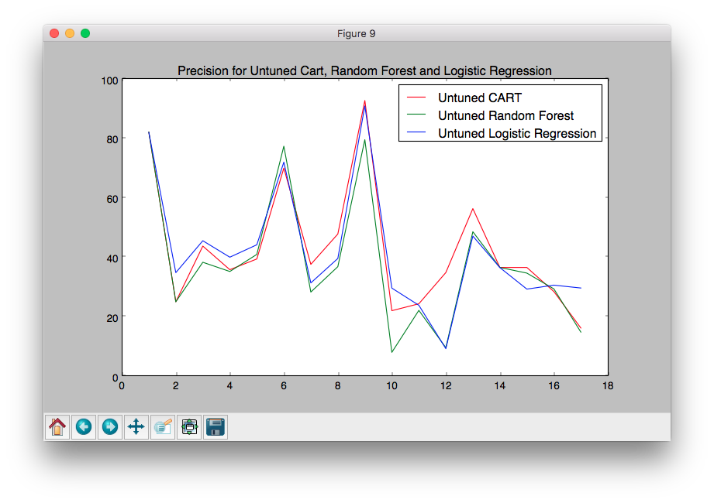

***Figure 4.1: Precision for Untuned CART, Random Forest & Logistics Regression***

1. **F-MEASURE**

|  |  |  |  |
| --- | --- | --- | --- |
| **Datasets** | **Logistics Regression** | **Random Forest** | **CART** |
| antV0 | 68.875 | 86.16803 | 86.16803 |
| antV1 | 36.85300 | 33.33333 | 33.33333 |
| antV2 | 47.90314 | 43.51349 | 44.47823 |
| camelV0 | 40.17245 | 39.66459 | 38.20472 |
| camelV1 | 46.27693 | 44.88794 | 42.94473 |
| ivy | 60.41666 | 64.641241 | 55.07692 |
| jeditV0 | 33.75733 | 35.788262 | 36.04078 |
| jeditV1 | 40.90909 | 38.104838 | 49.96580 |
| jeditV2 | 41.95804 | 70.707070 | 44.98834 |
| log4j | 10.68724 | 3.36276 | 10.02873 |
| lucene | 24.96998 | 24.98323 | 25.49327 |
| poiV0 | 13.79928 | 14.56590 | 21.50814 |
| poiV1 | 37.14868 | 57.46920 | 61.73726 |
| synapse | 38.87745 | 45.56791 | 45.56791 |
| velocity | 32.32905 | 36.88751 | 38.05422 |
| xercesV0 | 31.19771 | 34.82035 | 31.87025 |
| xercesV1 | 31.64147 | 18.30648 | 19.61072 |

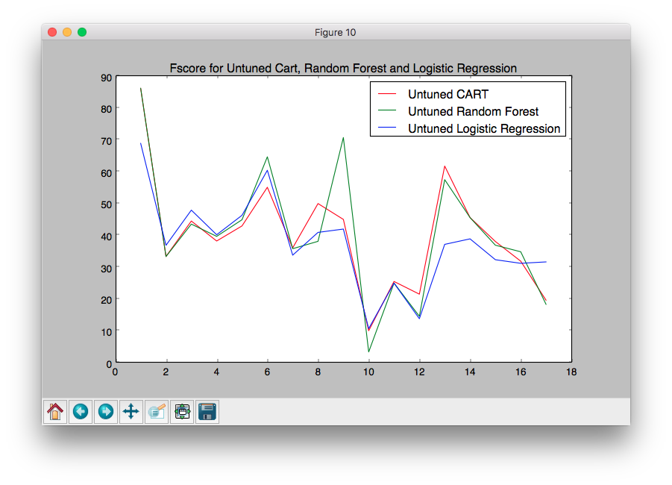

***Figure 4.2: F-measure for Untuned CART, Random Forest & Logistics Regression***

1. ***TUNED DATASETS***

Differential Evolution is applied on Random Forest and CART one by one for each of the 17 datasets with the aim of optimising one of the performance parameters like Precision and F-measure. DE is executed twice for each dataset in case of each algorithms by taking Precision as optimising goal in one case and F-measure in the other.

1. **RANDOM FOREST USING PRECISION AS OPTIMISING GOAL**

|  |  |  |  |  |  |  |  |
| --- | --- | --- | --- | --- | --- | --- | --- |
| **Datasets** | **Precision** | **Parameters** | | | | | |
|  | Threshold | max_  feature | max_  leaf_  nodes | min_  sample_  split | min_  samples_  leaf | n_estimators |
| antV0 | 82.12890 | 0.46754 | 6 | 42 | 10 | 13 | 94 |
| antV1 | 25 | 0.46754 | 6 | 30 | 5 | 14 | 130 |
| antV2 | 41.38699 | 0.76280 | 11 | 49 | 5 | 19 | 124 |
| camelV0 | 23.97621 | 0.79167 | 9 | 44 | 7 | 11 | 119 |
| camelV1 | 58.32742 | 0.01 | 27 | 45 | 2 | 5 | 90 |
| ivy | 74.54545 | 0.23476 | 13 | 21 | 6 | 4 | 148 |
| jeditV0 | 36.21157 | 0.01 | 17 | 50 | 5 | 1 | 149 |
| jeditV1 | 39.24557 | 0.21 | 7 | 51 | 5 | 1 | 127 |
| jeditV2 | 92.99988 | 0.07 | 2 | 49 | 14 | 6 | 140 |
| log4j | 18.56332 | 0.39227 | 14 | 26 | 8 | 4 | 105 |
| lucene | 24.56772 | 0.19334 | 14 | 29 | 10 | 7 | 105 |
| poiV0 | 37.77988 | 0.01 | 8 | 49 | 14 | 4 | 140 |
| poiV1 | 51.16576 | 0.03063 | 10 | 29 | 8 | 4 | 115 |
| synapse | 36.56030 | 0.33090 | 9 | 3 | 11 | 9 | 133 |
| velocity | 32.56332 | 0.34522 | 14 | 36 | 8 | 2 | 105 |
| xercesV0 | 37.50374 | 0.46991 | 16 | 41 | 19 | 9 | 123 |
| xercesV1 | 15.48091 | 0.05803 | 15 | 50 | 2 | 14 | 50 |

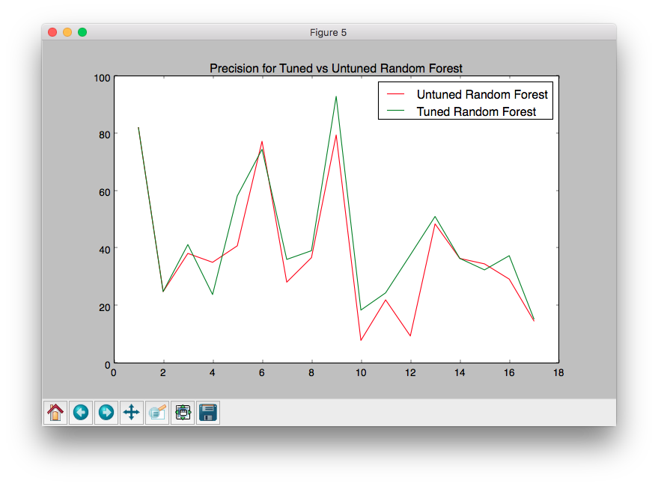

***Figure 4.3: Precision for Tuned vs Untuned Random Forest***

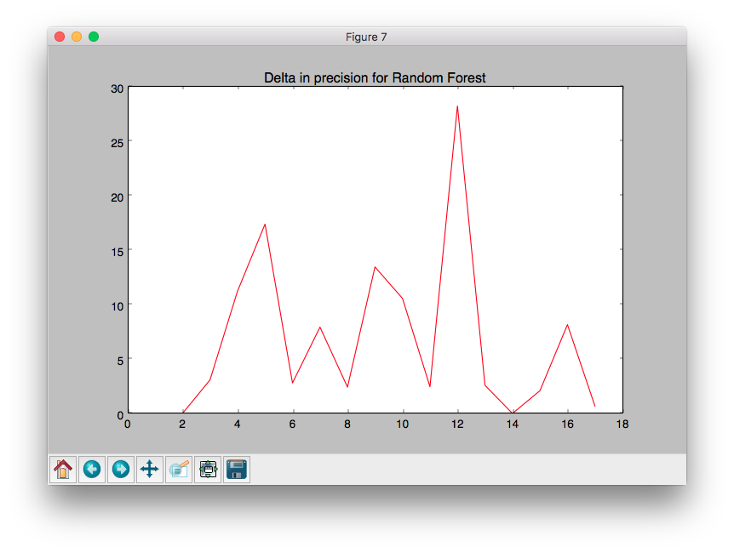

***Figure 4.4: Delta in Precision for Random Forest***

1. **RANDOM FOREST USING F-MEASURE AS OPTIMISING GOAL**

|  |  |  |  |  |  |  |  |
| --- | --- | --- | --- | --- | --- | --- | --- |
| **Dataset** | **F-Measure** | **Parameters** | | | | | |
|  | **Threshold** | **max_**  **feature** | **max_**  **leaf_**  **nodes** | **min_**  **sample_**  **split** | **min_**  **samples_**  **leaf** | **n_estimators** |
| antV0 | 86.16803 | 0.82704 | 6 | 7 | 2 | 2 | 143 |
| antV1 | 33.33333 | 0.83924 | 8 | 26 | 8 | 19 | 106 |
| antV2 | 40.23352 | 0.20340 | 1 | 12 | 7 | 12 | 94 |
| camelV0 | 52.19029 | 0.89316 | 13 | 23 | 12 | 3 | 138 |
| camelV1 | 48.42361 | 0.02943 | 1 | 12 | 12 | 4 | 53 |
| ivy | 77.64705 | 1 | 6 | 19 | 16 | 18 | 135 |
| jeditV0 | 32.42361 | 0.03091 | 1 | 11 | 17 | 1 | 50 |
| jeditV1 | 39.44761 | 0.03245 | 3 | 18 | 17 | 9 | 54 |
| jeditV2 | 85.52344 | 0.21 | 4 | 27 | 9 | 1 | 58 |
| log4j | 7.04038 | 0.01 | 17 | 50 | 2 | 1 | 65 |
| lucene | 25.52924 | 0.01 | 14 | 24 | 2 | 1 | 52 |
| poiV0 | 14.71215 | 0.02907 | 3 | 43 | 6 | 16 | 128 |
| poiV1 | 59.65800 | 0.47390 | 15 | 9 | 16 | 19 | 134 |
| synapse | 45.56791 | 0.10599 | 2 | 39 | 11 | 1 | 132 |
| velocity | 37.99794 | 0.12500 | 5 | 39 | 9 | 1 | 142 |
| xercesV0 | 31.96121 | 0.04975 | 14 | 50 | 18 | 4 | 132 |
| xercesV1 | 20.14329 | 0.04677 | 24 | 40 | 8 | 9 | 132 |

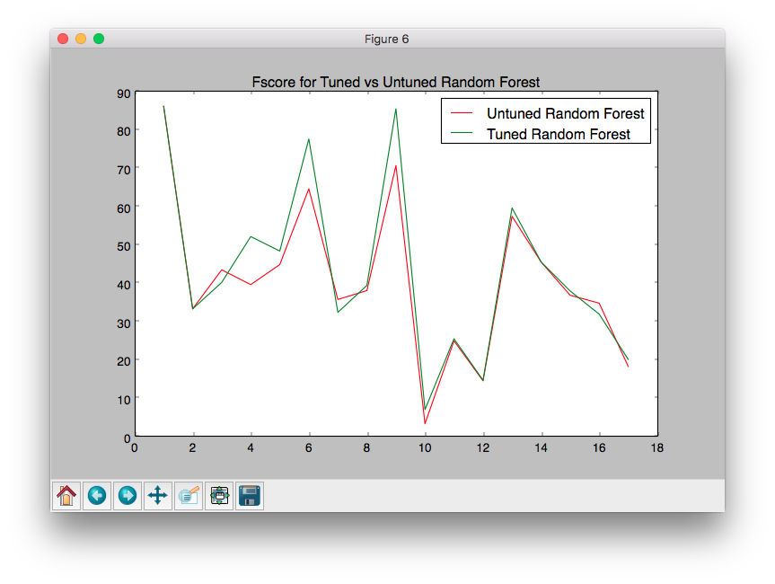

***Figure 4.5: F-Measure for Tuned vs Untuned Random Forest***

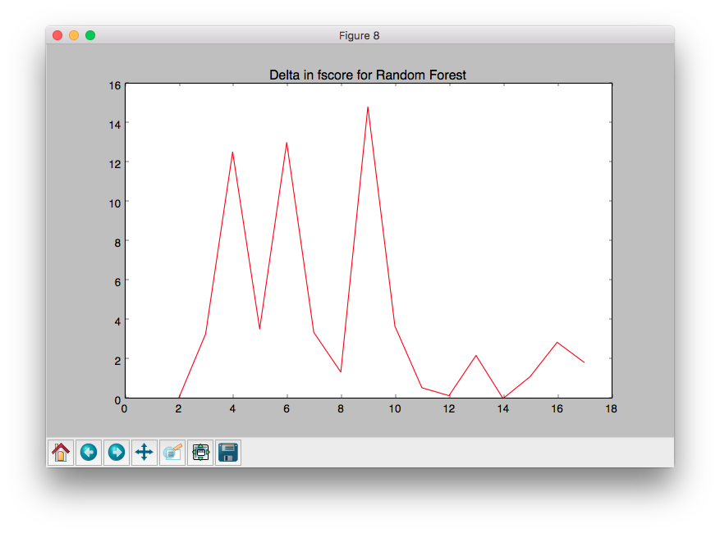

***Figure 4.6: Delta in F-measure for Random Forest***

1. **CART USING PRECISION AS OPTIMISING GOAL**

|  |  |  |  |  |  |  |
| --- | --- | --- | --- | --- | --- | --- |
| **Dataset** | **Precision** | **Parameters** | | | | |
|  | Threshold | max_feature | min_sample_split | min_samples_leaf | max_depth |
| antV0 | 87.16911 | 0.29195 | 15 | 6 | 1 | 30 |
| antV1 | 25 | 0.77025 | 14 | 17 | 13 | 6 |
| antV2 | 38.10515 | 0.77025 | 10 | 3 | 1 | 28 |
| camelV0 | 23.97621 | 0.83379 | 15 | 7 | 12 | 4 |
| camelV1 | 40.08975 | 0.09840 | 8 | 2 | 1 | 37 |
| ivy | 74.82758 | 0.10299 | 7 | 11 | 10 | 25 |
| jeditV0 | 37.24989 | 0.21380 | 13 | 2 | 11 | 44 |
| jeditV1 | 51.04166 | 0.13830 | 16 | 19 | 8 | 1 |
| jeditV2 | 92.72727 | 0.08227 | 1 | 2 | 1 | 28 |
| log4j | 25.58944 | 0.12746 | 11 | 2 | 1 | 50 |
| lucene | 24.60080 | 0.28243 | 11 | 2 | 1 | 50 |
| poiV0 | 39.64516 | 0.10013 | 14 | 2 | 14 | 12 |
| poiV1 | 51.16576 | 0.05920 | 12 | 17 | 15 | 10 |
| synapse | 37.43078 | 0.12409 | 16 | 6 | 1 | 35 |
| velocity | 36.90497 | 0 | 17 | 2 | 1 | 7 |
| xercesV0 | 30.58586 | 0.03072 | 17 | 8 | 6 | 42 |
| xercesV1 | 42.66239 | 0.00051 | 1 | 2 | 5 | 1 |

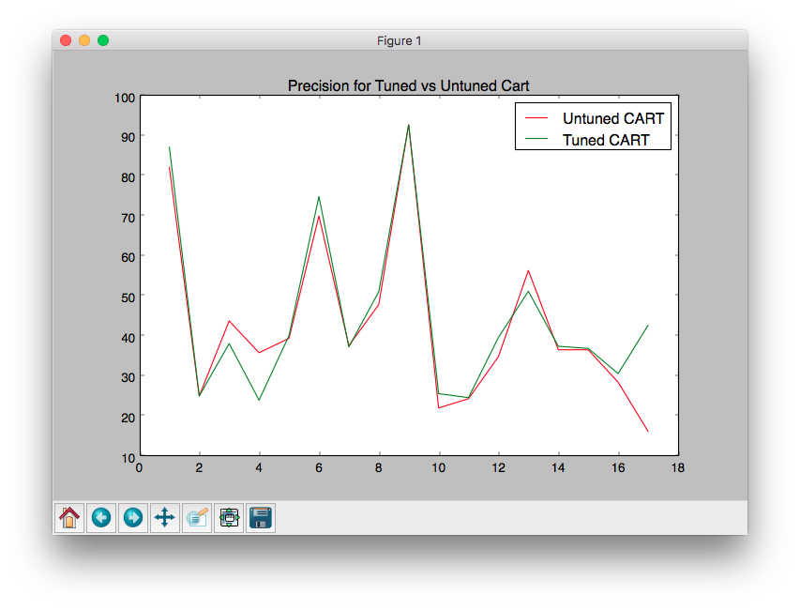

***Figure 4.7: Precision for Tuned vs Untuned CART***

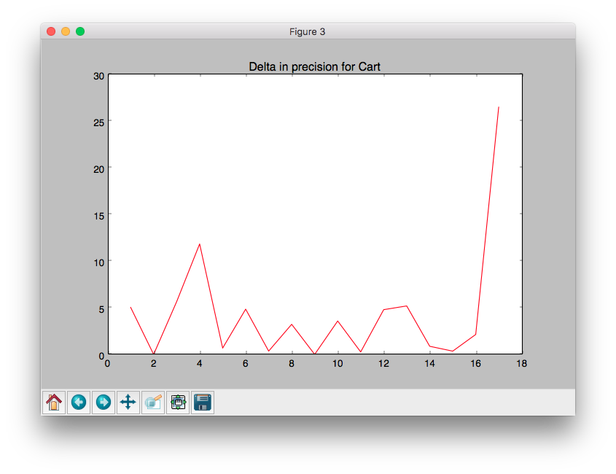

***Figure 4.8: Delta in precision for CART***

1. **CART USING F-MEASURE AS OPTIMISING GOAL**

|  |  |  |  |  |  |  |
| --- | --- | --- | --- | --- | --- | --- |
| **Dataset** | **F-Measure** | **Parameters** | | | | |
|  | Threshold | max_feature | min_sample_split | min_samples_leaf | max_ depth |
| antV0 | 86.168032 | 0.46886 | 16 | 16 | 20 | 6 |
| antV1 | 33.333333 | 0.04293 | 16 | 19 | 2 | 15 |
| antV2 | 44.968650 | 0 | 10 | 9 | 2 | 13 |
| camelV0 | 32.190293 | 0.71334 | 11 | 11 | 9 | 44 |
| camelV1 | 43.674080 | 0.52299 | 4 | 13 | 1 | 27 |
| ivy | 57.647058 | 0.88934 | 1 | 11 | 15 | 1 |
| jeditV0 | 34.844543 | 0.06356 | 13 | 2 | 16 | 18 |
| jeditV1 | 76.171875 | 0.06549 | 6 | 10 | 20 | 26 |
| jeditV2 | 86.58008 | 0.44666 | 1 | 3 | 20 | 50 |
| log4j | 16.15153 | 0 | 17 | 2 | 1 | 50 |
| lucene | 27.17951 | 0.43343 | 16 | 6 | 18 | 40 |
| poiV0 | 18.07379 | 0.03188 | 1 | 14 | 3 | 1 |
| poiV1 | 61.77111 | 0.04206 | 13 | 2 | 1 | 32 |
| synapse | 55.56791 | 0.97398 | 12 | 2 | 15 | 5 |
| velocity | 38.39882 | 0 | 17 | 2 | 1 | 8 |
| xercesV0 | 32.60869 | 0.34557 | 17 | 2 | 1 | 50 |
| xercesV1 | 22.54361 | 0 | 1 | 2 | 20 | 31 |

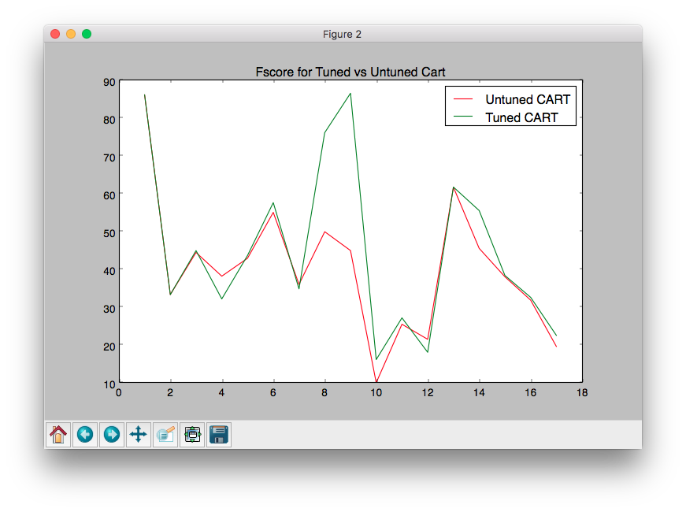

***Figure 4.9: F-Measure for Tuned vs Untuned CART***

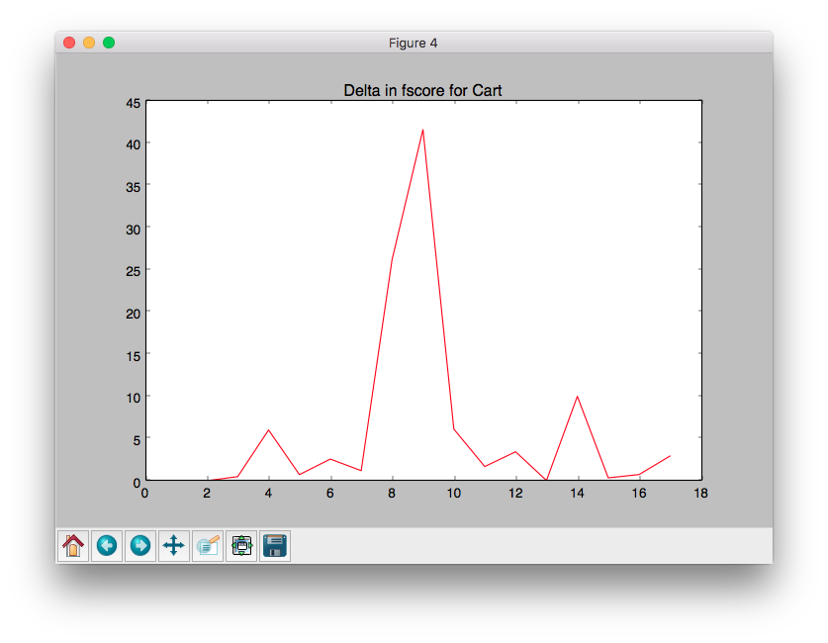

***Figure 4.10: Delta in F-Measure for CART***

# 

# Chapter 5 – Conclusion

1. ***Contributions***

In this project, we studied the impact of Parameter Tuning in the field of Software Defect Prediction. Differential Evolution, a tuning algorithm was applied on machine learning algorithms like Random Forest and Classification And Regression Trees (CART) with the aim of optimising Precision or F-Measure. It was found that tuning parameters improved both these performance measures substantially as compared to default parameters.

It was also observed that tuning the parameters of the learning algorithms was simple and that Differential Evolution showed greater improvement as compared to CART.

Our exploration in the field of Parameter Tuning showed that when learning defect predictors for static code attributes [4], analytics without tuning are considered harmful and misleading.

1. ***Future Work***

It is now important to explore the implications of these conclusions to other kinds of software analytics. This project has investigated some learners using one optimizer. Hence, we can make no claim that DE is the best optimizer for all learners. Rather, our point is that there exists at least some learners whose performance can be dramatically improved by at least one simple optimization scheme.

# Chapter 6 – References

[1] T. Menzies, C. Pape, M. Rees-Jones, *The promise repository of empirical soft- ware engineering data*, 2015, URL: http://openscience.us/repo

[2] D. Rodriguez, I. Herraiz, R. Harrison, *On software engineering repositories and their open problems*, in: Proceedings RAISE’12, 2012.

[3] N. Nagappan, T. Ball, *Static analysis tools as early indicators of pre-release de- fect density*, in: ICSE ’05, ACM, 2005, pp. 580–586.

[4] S. Lessmann, B. Baesens, C. Mues, S. Pietsch, *Benchmarking classification models for software defect prediction: a proposed framework and novel findings*, IEEE Trans. Softw. Eng. 34 (4) (2008) 485–496.

[5] R. Malhotra, “*Empirical Research in Software Engineering*”, CRC Press

[6] Y. Singh and R. Malhotra, ”*Object Oriented Software Engineering*”, PHI

[7] R. Storn, K. Price, *Differential evolution–a simple and efficient heuristic for global optimization over continuous spaces*, J. Global Optim. 11 (4) (1997) 341–359.

[8] L. Breiman, A. Cutler, *Random forests*, 2001, https://www.stat.berkeley.edu/

∼breiman/RandomForests .

[9] J. Vesterstrom, R. Thomsen, *A comparative study of differential evolution, particle*

*swarm optimization, and evolutionary algorithms on numerical benchmark*

*problems*, IEEE Congress on Evolutionary Computation ’04, 2004, doi: 10.

1109/CEC.2004.1331139 .

[10] A.E. Hassan, *Predicting faults using the complexity of code changes, in: Proceedings of the 31st International Conference on Software Engineering*, in: ICSE ’09, IEEE Computer Society, Washington, DC, USA, 2009, pp. 78–88, doi:10.1109/ICSE.2009.5070510.