Credit Card Fraud Case Summary – Arjun Singh Thakur

1. Introduction
This document provides a complete summary of the credit card fraud incident involving Arjun Singh Thakur, including how the fraud occurred, actions taken, interactions with ICICI Bank, and the current case status.

2. Case Overview
• Bank: ICICI Bank
• Credit Card (Last 4 digits): 0003
• Total Disputed Amount: ₹1,70,000 (approx.)
• Provisional Credit Received: ₹25,000 on 31‑Jan‑2026
• Remaining Disputed Amount: ₹1,45,854.18
• Primary SR: SR1079868523
• Linked SR: SR1080431726

3. How the Fraud Happened
On the date of incident, Arjun received a message directing him to a webpage that impersonated a DTDC courier payment portal. Believing it to be genuine, he entered his card details and the OTP. This OTP was used on a fraudulent phishing website, leading to an unauthorized transaction with merchant IFP*WONDERFUL TRIP V. Arjun did not intend or authorize this transaction.

Below Screenshots shows that the, I got fraud link at 11:57Am and and fraud transaction is made at 12:11 PM
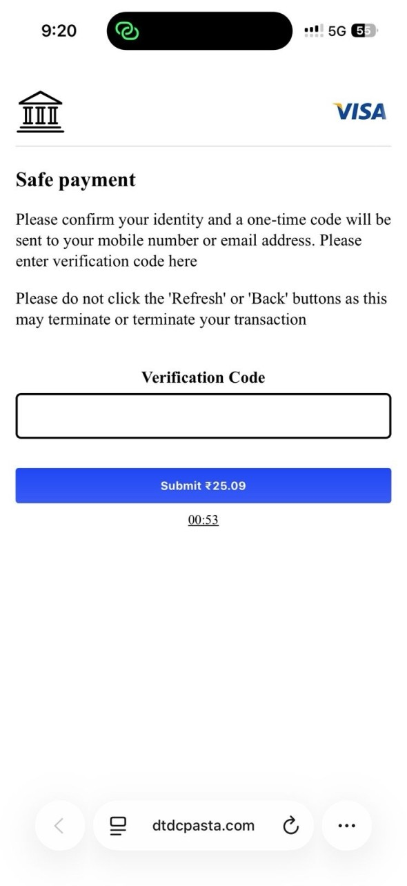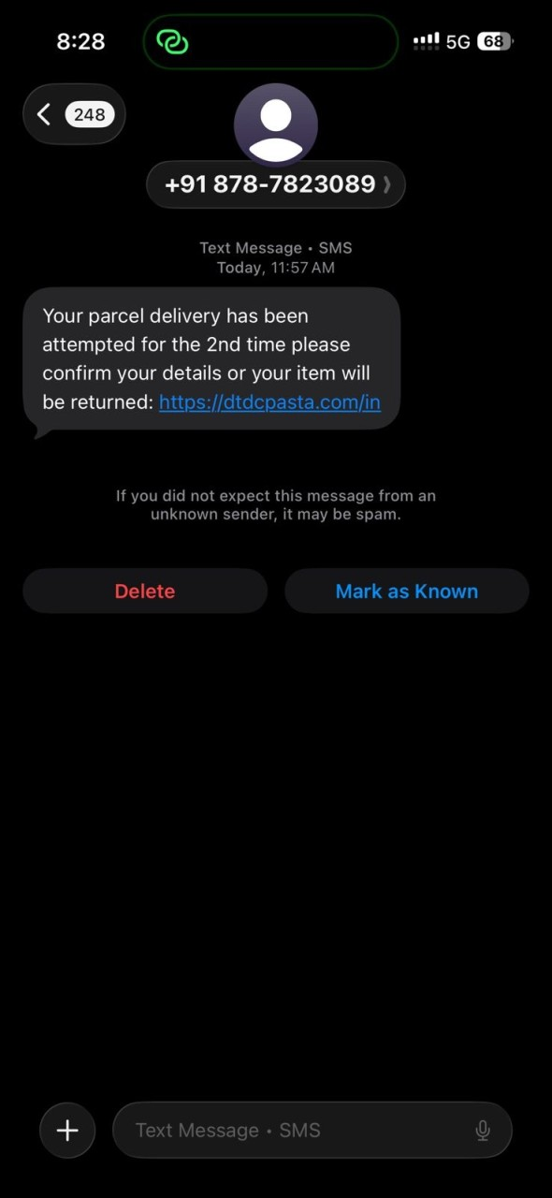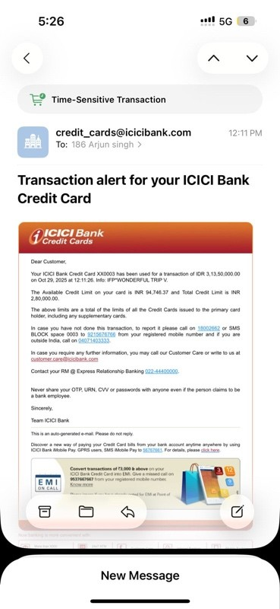

4. Immediate Actions Taken
• Reported the incident immediately to ICICI Bank.(SAME DAY)
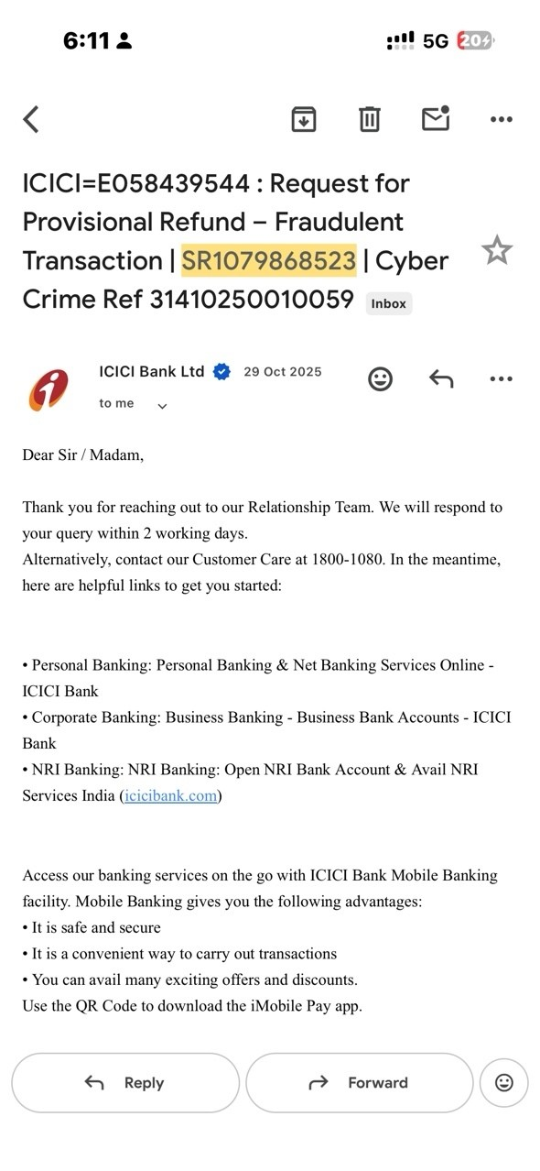
• Received SR numbers as confirmation: SR1079868523 and SR1080431726.
• Reported the fraud on the National Cyber Crime Reporting Portal. (Same DAY)
• Cybercrime Acknowledgement No.: 31410250010059.
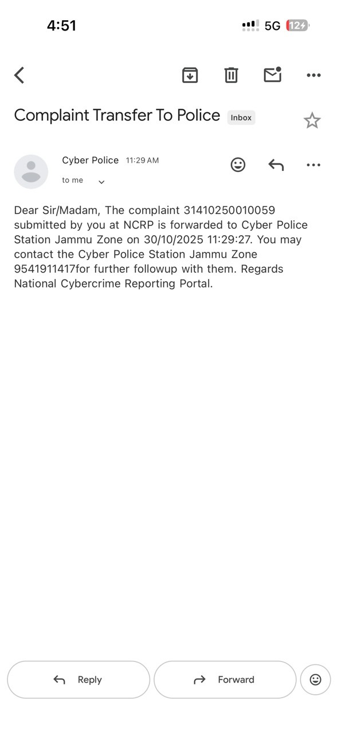

5. Response Received from ICICI Bank
• ICICI Bank provided a provisional credit of ₹25,000 on 31‑Jan‑2026.
• Later, Arjun received an SMS stating the remaining amount was not eligible for refund due to OTP/3D Secure authentication.
• This created conflicting communication since the OTP was entered under phishing/social‑engineering circumstances.
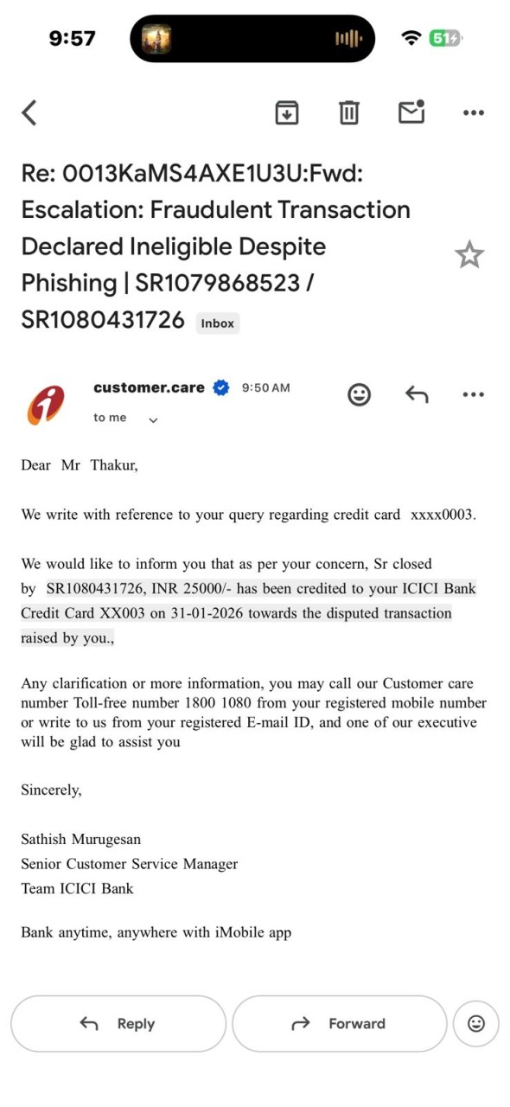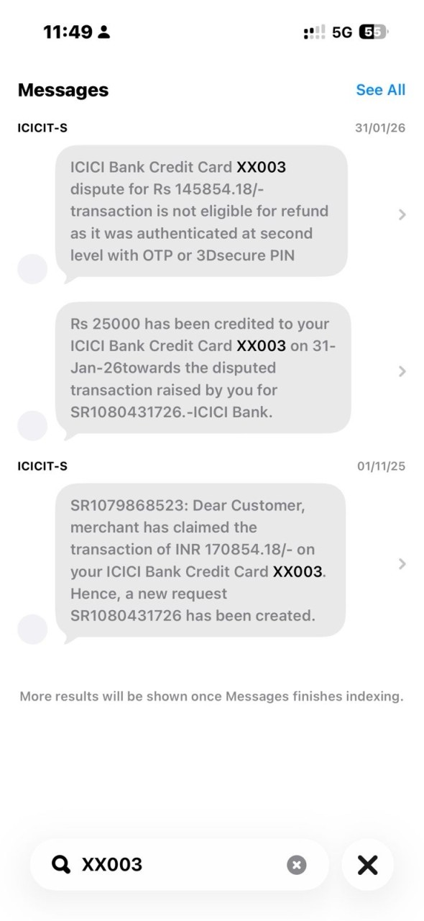

6. Basis of Dispute / Customer Position
• The OTP was entered on a fraudulent phishing website, not on a legitimate merchant site.
• The transaction was unauthorized and constitutes a case of social engineering fraud.
• The customer did not authorize any payment to the merchant IFP*WONDERFUL TRIP V.

7. Regulatory Protection (RBI Guidelines)
As per the RBI’s Customer Protection circular on unauthorized electronic banking transactions (2017) and subsequent clarifications, customers are not liable for losses resulting from phishing, vishing, or fraudulent impersonation, provided the incident is reported promptly. Arjun reported immediately and thus falls under zero‑liability or limited‑liability protection.

8. Current Status
• Partial refund of ₹25,000 received.
• Remaining amount of ₹1,45,854.18 still under dispute.
• Awaiting clarification from ICICI Bank’s senior dispute/grievance team.

9. Customer Request for Resolution
Arjun requests ICICI Bank to:
1. Reconsider the rejection of the remaining amount.
2. Treat the case as confirmed fraud based on phishing/social engineering.
3. Provide full reversal of the remaining ₹1,45,854.18.
4. Provide a written explanation if any part of the claim is denied.
5. Share investigation status and final resolution timelines.

10. Contact Information
Name: Arjun Singh Thakur
Mobile: 6005044194
Email: arjunsinghthakur770@gmail.com

