

Frequency Detector Design Project

Student’s Name: Arjun Sapkota
Instructor’s Name: Dr. Melani Plett

Project overview and description:
The goal of the project was to design and implement an IR channel detection filter system which can identify specific audio frequencies that were transmitted using infrared (IR) modulation. The received signal contained combination of three frequencies—roughly 10 kHz, 17 kHz, and 25 kHz, and the objective was to detect when a particular frequency was present and indicate it using an LED.

For this project, the circuit was designed to detect the 10 kHz signal while rejecting the other frequencies present in the system. To accomplish this, a two-stage Sallen-Key bandpass filter was implemented and tuned so that its center frequency was approximately 10 kHz. This filter allows signals close to 10 kHz to pass through while attenuating the unwanted frequencies of 17 kHz and 25 kHz, ensuring that only the desired channel is detected.

The output of the bandpass filter is then fed into a peak detector, which converts the filtered AC signal into a DC voltage proportional to the amplitude of the detected 10 kHz signal. This DC level is applied to a comparator, which compares the detected voltage to a preset threshold. When the 10 kHz signal is present and the detected voltage exceeds the threshold, the comparator output switches high.

Finally, the comparator output drives an LED indicator, which turns on when the 10 kHz frequency is detected and remains off when the signal is absent. This provides a clear visual indication of whether the target frequency is present in the received IR signal.

Filter Design:
The IR system provides an input amplitude of approximately 2–3 V. The 10 kHz bandpass filter was designed using a two-stage Sallen-Key topology with stage quality factors:
$Q_{1}=Q_{2}=3$.
From the Sallen-Key gain relation,
$A=3-\frac{1}{Q}=3-\frac{1}{3}$,
$A=2.67$.
The expected passband gain at 10 kHz is therefore:
$$A_{v}={\left(bAQ\right)}^{2}$$
$$={\left(0.2165*2.67*3\right)}^{2}=3\text{V/V}$$
Final Gain in decibels is,
Gain = 20log₁₀(3) $≈$ 9.54dB
Gain for each stage is 20log₁₀($bAQ$) =20log₁₀($1.734$)= 4.781dB.

MATLAB verification:
The transfer function is given as follows,
$$H\left(s\right)={\left\{\frac{bAQ\left(\frac{ω_{0}}{Q}\right)s}{\left(s^{2}+ \frac{ω_{0}}{Q}s + {ω_{0}}^{2}\right)}\right\}}^{2}$$
$$ω_{0}=62831.85\frac{rad}{s}, Q=3 , b=0.2165, A=3-\frac{1}{Q}=2.67$$
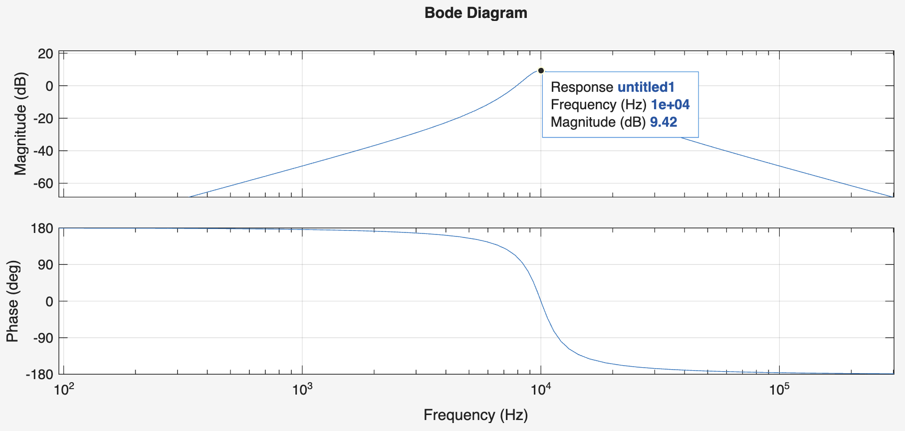
Fig: MATLAB bode plot for my circuit.

Final LTSPICE circuit:
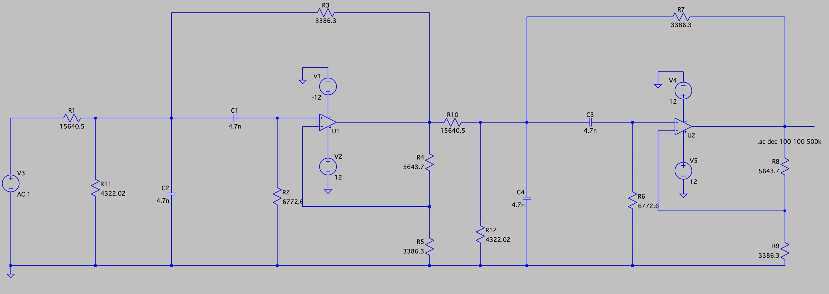Fig: Final filter circuit for the design.

LTSPICE verification:
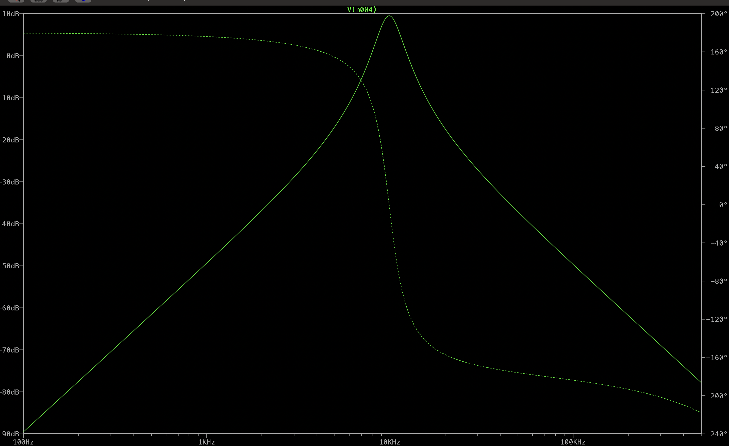
Fig: Bode plot from LTSPICE.

Physical Build:
For the physical implementation of the circuit, two TL081 op amps were used to construct the two-stage Sallen Key bandpass filter. The two filter stages work together to allow signals near the desired center frequency to pass and attenuates the effect of the other frequencies present in the system.

The output of the bandpass filter is then connected to a peak detector circuit, which was implemented using a TL082 dual op amp. The purpose of the peak detector is to convert the filtered AC signal into a corresponding DC voltage level. This DC voltage represents the amplitude of the detected 10 kHz signal and makes it easier to determine whether the signal is present.

The DC output from the peak detector is then applied to an LM339 comparator. The comparator compares the detected voltage with a preset reference voltage. If the detected signal level exceeds the reference threshold, the comparator output switches to a high state. This high output turns on the LED, which indicates that the 10 kHz signal is present. When the 10 kHz signal is turned off, the comparator output remains low and the LED stays off.

Overall, the completed circuit successfully detects the presence of the 10 kHz IR signal while attenuating the other channel frequencies, providing a clear visual indication through the LED output.

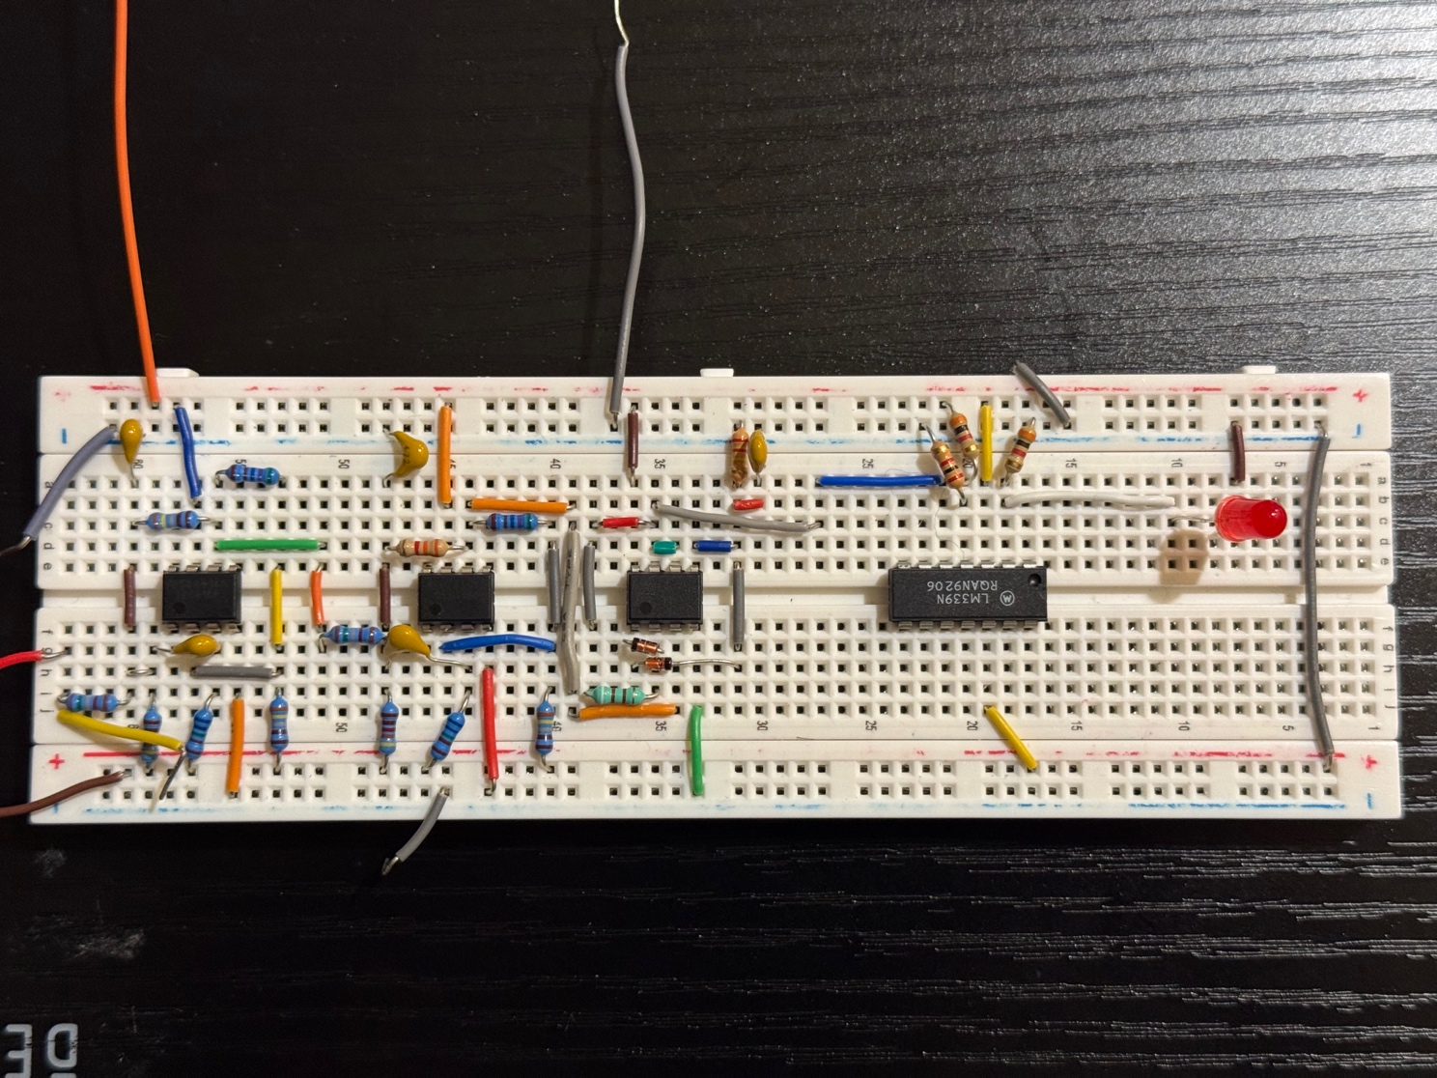
Fig: Final and fully functional circuit on breadboard.

FRA from the circuit:
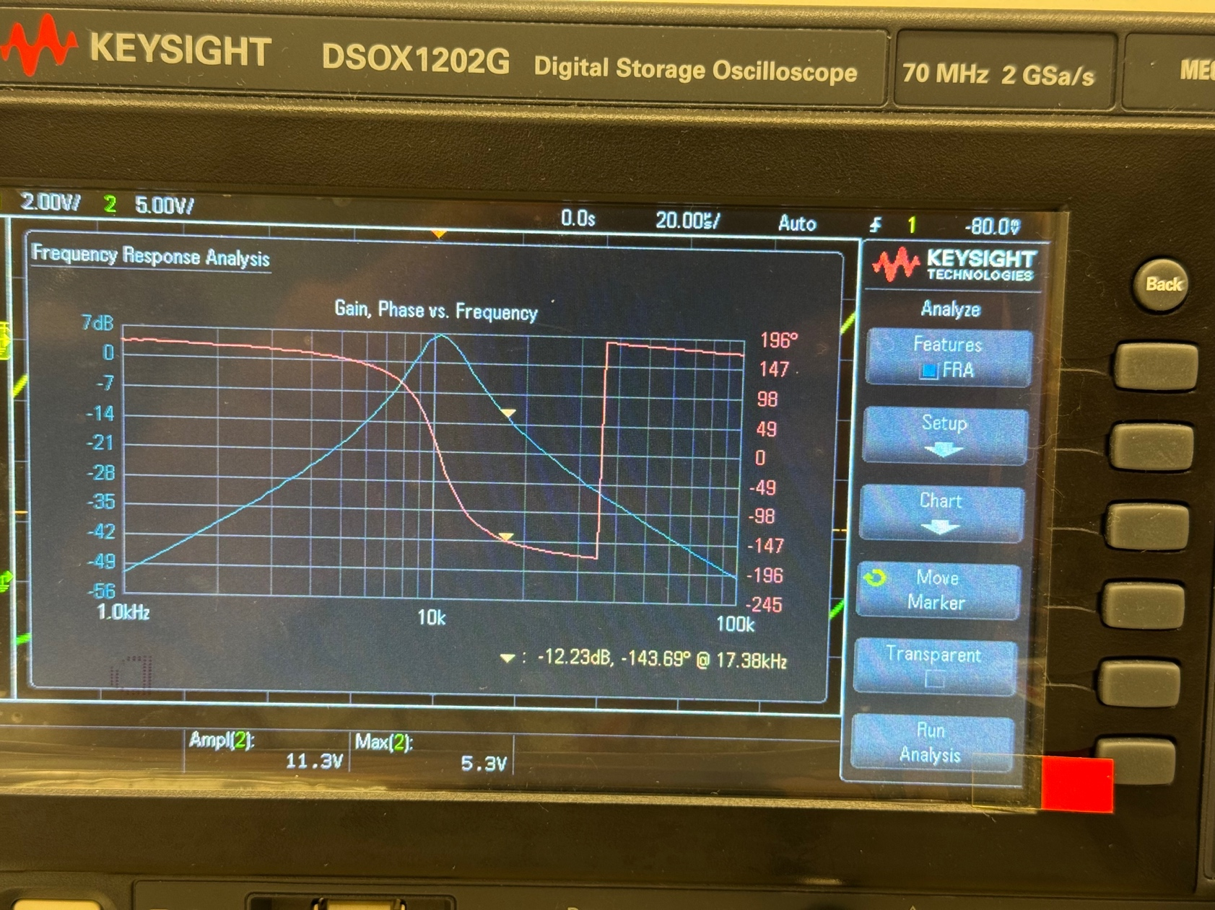
Fig: FRA of the filter from the final circuit.

Gain Comparison:
Frequency | Gain in MATLAB (dB) | Gain in LTSPICE (dB) | Gain in Lab (dB)
10 kHz | 9.42 | 9.48 | 7.04
17kHz | -11.9 | -12.67 | -12.09
25kHz | -22.7 | -23.18 | -22.25

Gain Analysis:
The results show good agreement between the theoretical MATLAB calculations and the LTSPICE simulations. At the target frequency of 10 kHz, the predicted gain was approximately 9.4 dB, while the laboratory measurement was 7.04dB. The gap between the gains at 10kHz and other frequencies is around 20dB which meets the requirement. The lower measured gain in the physical circuit can be caused due to practical factors such as component tolerances, non-ideal op-amp behavior, and minor losses in the physical circuit.

At 17 kHz and 25 kHz, the filter successfully attenuates the unwanted frequencies. The experimental results closely match the theoretical and simulated values, which confirms that the filter is effectively suppressing these channels. Overall, the results demonstrate that the designed system successfully detects the 10 kHz signal while rejecting 17kHz and 25kHz signals.

Video confirmation for the working circuit:
https://drive.google.com/file/d/1sbpBMG1wq2eahjRzA-maF9iVTexVw8_B/view?usp=drivesdk

Conclusion
In this frequency detector project, an IR channel detection system was successfully designed and implemented to detect a 10 kHz frequency signal transmitted through infrared modulation. A two-stage Sallen-Key bandpass filter was used to isolate the desired frequency and attenuate the unwanted 17 kHz and 25 kHz signals. The filtered signal was passed through a peak detector and a comparator. This allowed the circuit to convert the AC signal into a DC level and turn on the LED indicator when the 10kHz frequency was present.

Theoretical calculations, MATLAB verification, LTSpice simulations, and experimental measurements were compared to evaluate the performance of the design. Although the measured gain at the center frequency was slightly lower (~2dB) than the predicted value, the overall results showed good agreement. The final circuit successfully demonstrated reliable frequency detection and channel separation, confirming the effectiveness of the filter design.

