DEPARTMENT OF COMPUTER SCIENCE & ENGINEERING
PES UNIVERSITY, BENGALURU
SOFTWARE ENGINEERING LAB (SE LAB) — LAB 3 REPORT
Component Modelling & Architectural Pattern Selection
Student Name & SRN | Arjun Srikanth | PES1UG24AM920 (Section H)
Assigned Problem Statement | #48: Incident Escalation & On-Call Rotation Engine
Handout Scenario | Self-Service Coffee Kiosk System
Domain & Focus Area | Developer Tools & IT Operations | Embedded Systems Architecture
GitHub Repository | https://github.com/arjunsrikanthh/PES1UG24AM920_se_lab

1. Comparative Analysis of Architectural Styles
Before selecting an architecture, three foundational architectural patterns were evaluated against the operational constraints and quality attributes required by modern enterprise and kiosk systems:
Pattern | Structural Organization | Key Strengths (Pros) | Key Limitations (Cons)
Layered  (N-Tier) | Organized in horizontal tiers: Presentation, Business Logic, Data Access. Unidirectional call flow. | • Clear separation of concerns  • Intuitive mental model  • Simple localized testing | • Performance sinkhole overhead  • Monolithic blast radius  • Inflexible uniform scaling
Microservices | Decoupled autonomous services around business capabilities, interacting via gRPC/REST/event brokers. | • Fault isolation prevents cascades  • Independent horizontal scaling  • Technology stack flexibility | • Distributed systems complexity  • Eventual consistency overhead  • Complex telemetry & tracing
Client-Server | Centralized application/database server serving thin or rich distributed client nodes. | • Centralized governance & rules  • Direct ACID transactions  • Simpler client hardware needs | • Server is Single Point of Failure  • Network partition locks clients  • Scalability bottleneck under peak

2. Assigned Scenario (Problem Statement #48): Incident Escalation & On-Call Rotation Engine
Architecture Selection Statement: "We chose an Event-Driven Microservices Architecture for the Incident Escalation & On-Call Rotation Engine."

Technical Justification
• Architectural Choice: An Event-Driven Microservices Architecture partitioned into 6 domain-aligned microservices communicating asynchronously over gRPC and an event bus (Kafka/RabbitMQ), backed by partitioned transactional stores.
• Scenario-Related Reason 1 (Fault Isolation During Major Outages): During catastrophic P1 incidents, monitoring clusters emit alert floods (>= 500 alerts/sec). If external telecom carrier gateways (Twilio Voice/SMS) encounter rate limits or transient degradation, the Multi-Channel Notification Service buffers dispatch events without degrading the Webhook Ingestion Gateway or stalling the Escalation Engine timers.
• Scenario-Related Reason 2 (Targeted Independent Scaling): Alert ingestion workloads are highly bursty and volatile, while schedule management and escalation policy edits are infrequent administrative transactions. Microservices allow autoscaling solely the Ingestion and Notification containers during surges, satisfying NFR-001 (initiating alert dispatch within 3 seconds) cost-effectively.
• Security Advantage: Zero-trust network segregation isolates external-facing ingestion webhooks from internal business logic. Payloads require HMAC-SHA256 signature verification at the gateway before admittance. Internal service-to-service communications are encrypted via mutual TLS (mTLS), and sensitive engineer phone/email data is strictly compartmentalized within the notification worker, satisfying NFR-002.
• Performance Benefit: Sub-100ms asynchronous webhook ingestion acknowledgment. Decoupling alert ingestion from downstream rotation queries and notification dispatch prevents blocking on synchronous telecom I/O, guaranteeing end-to-end alert dispatch initiation under 3 seconds under peak concurrent loads.

UML Component Diagram — Problem Statement #48
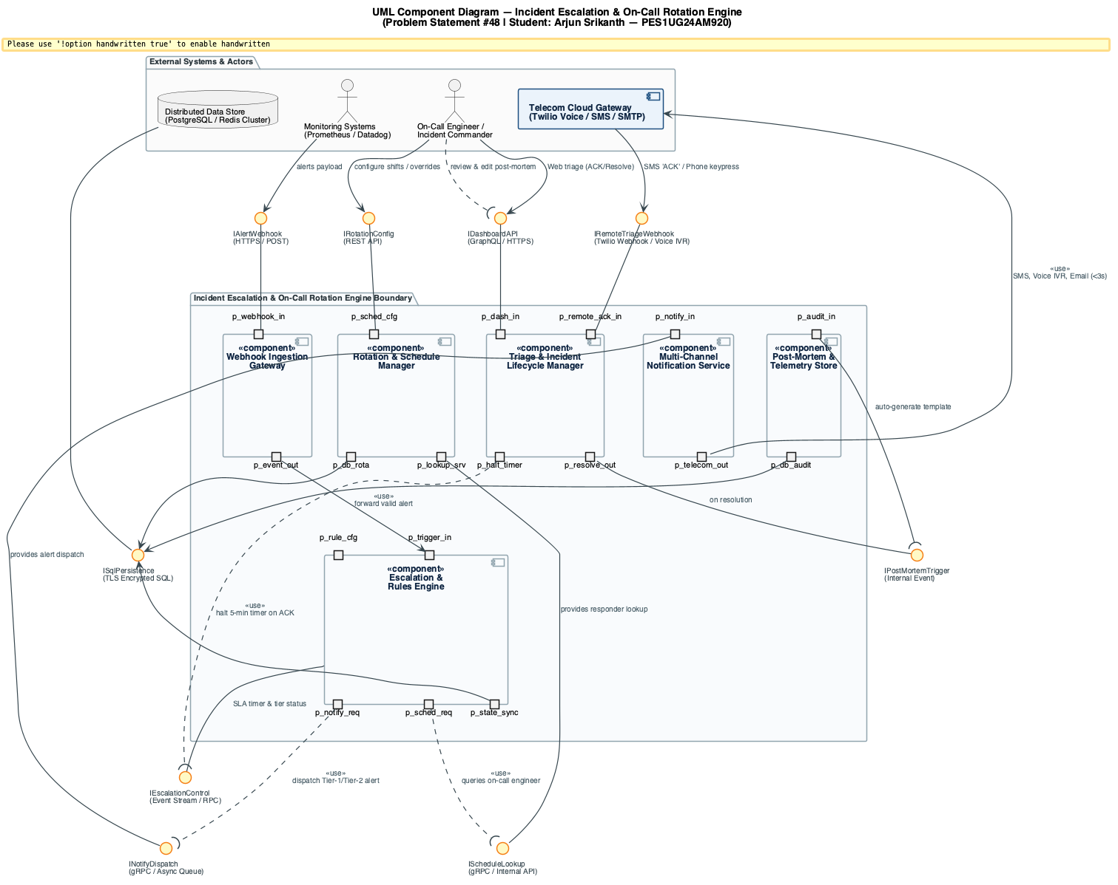
Figure 1: UML Component Diagram for Incident Escalation & On-Call Rotation Engine (6 components, 8 ball-and-socket interfaces)

Component & Interface Dictionary (Problem Statement #48)
Component Name | Stereotype | Provided Interfaces (Ball) | Required Interfaces (Socket)
Webhook Ingestion Gateway | <<component>> | IAlertWebhook (HTTPS POST) | IEscalationControl (Event bus)
Rotation & Schedule Manager | <<component>> | IScheduleLookup, IRotationConfig | ISqlPersistence (PostgreSQL)
Escalation & Rules Engine | <<component>> | IEscalationControl (RPC/Timer) | IScheduleLookup, INotifyDispatch, ISqlPersistence
Multi-Channel Notification Service | <<component>> | INotifyDispatch (Async queue) | ITelecomGateway (Twilio Voice/SMS/SMTP)
Triage & Incident Lifecycle Manager | <<component>> | IDashboardAPI, IRemoteTriageWebhook | IEscalationControl, IPostMortemTrigger
Post-Mortem & Telemetry Store | <<component>> | IPostMortemTrigger (Event) | ISqlPersistence (Encrypted audit log)

3. Handout Scenario: Self-Service Coffee Kiosk System
Architecture Selection Statement: "We chose a Layered Component-Based Architecture for the Self-Service Coffee Kiosk System."

Technical Justification
• Architectural Choice: A Layered Component-Based Architecture organized into Presentation (Touchscreen UI), Business Logic (Order Manager & Menu Catalog), and Hardware Abstraction (Payment Service & Printer Controller) deployed locally on embedded kiosk hardware.
• Scenario-Related Reason 1 (Hardware-Software Locality & Peripheral Control): The kiosk operates as a single physical standalone terminal connected to local peripherals (touchscreen, EMV chip card reader, and ESC/POS thermal receipt printer). A layered component architecture maintains hardware drivers locally, avoiding network latency and network partition risks when handling serial card swipes and printing.
• Scenario-Related Reason 2 (Deterministic Sequential Ordering Lifecycle): Customer interactions follow an atomic linear state machine: Beverage Selection (Espresso/Americano/Latte) -> Size Selection (Small/Large) -> Card Authorization -> Receipt Dispensing. The Order Manager orchestrates this flow with strict state transitions without distributed transaction overhead.
• Security Advantage: PCI-DSS Compliance Scope Minimization via Hardware Sandboxing. The Payment Service Component interfaces directly with the EMV PIN-pad hardware via encrypted serial protocol and connects to the banking gateway via TLS 1.3. Credit card numbers and PIN blocks never enter the Order Manager or UI memory space, protecting customer payment security.
• Performance Benefit: Zero-Latency Touch Screen Responsiveness & Fast Printing. Menu and pricing data are cached in local memory, enabling instantaneous UI updates (< 16ms, 60fps) during customer ordering. In addition, the Printer Controller directly streams binary ESC/POS bytecode over USB/Serial, dispensing receipts in under 1 second following payment confirmation.

UML Component Diagram — Self-Service Coffee Kiosk System
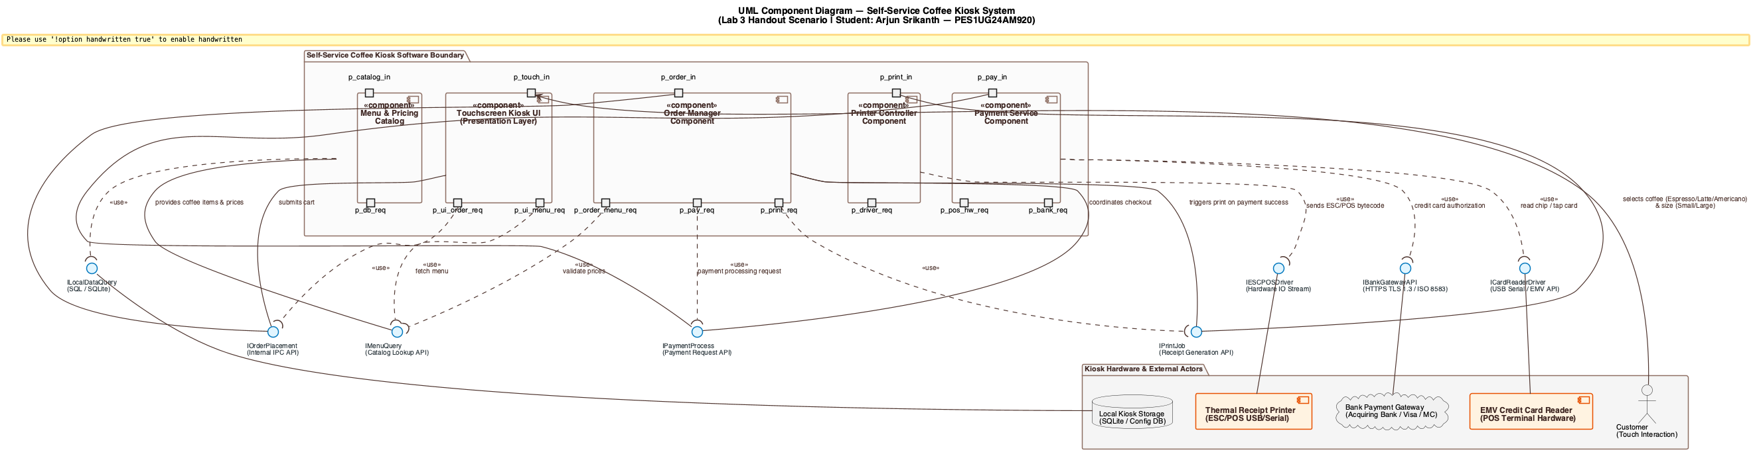
Figure 2: UML Component Diagram for Self-Service Coffee Kiosk System (5 components, 8 ball-and-socket interfaces)

Component & Interface Dictionary (Coffee Kiosk System)
Component Name | Stereotype | Provided Interfaces (Ball) | Required Interfaces (Socket)
Touchscreen Kiosk UI | <<component>> | — | IMenuQuery, IOrderPlacement
Order Manager Component (Given) | <<component>> | IOrderPlacement | IMenuQuery, IPaymentProcess, IPrintJob
Payment Service Component (Given) | <<component>> | IPaymentProcess | ICardReaderDriver, IBankGatewayAPI
Menu & Pricing Catalog | <<component>> | IMenuQuery | ILocalDataQuery (SQLite)
Printer Controller Component | <<component>> | IPrintJob | IESCPOSDriver (USB Serial)

