## OUTPUT

## EX NO:1 Create Maven Build Pipeline in Azure

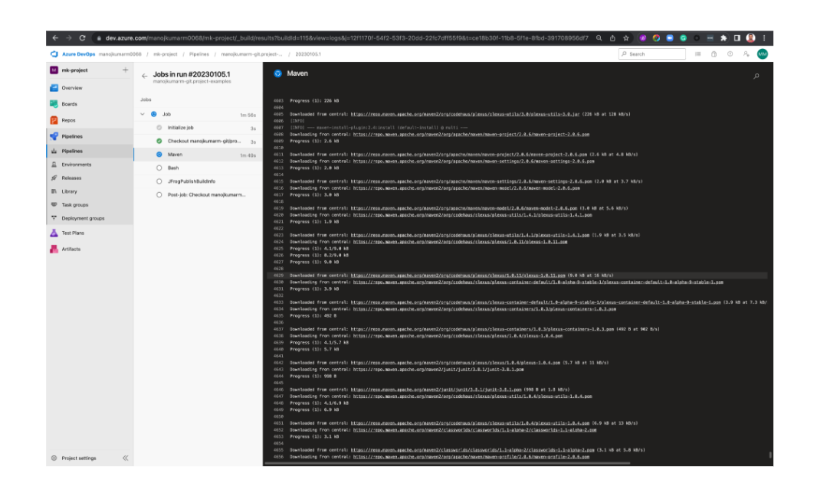

EXP 2: Run Regression Tests using Maven Build Pipeline in Azure

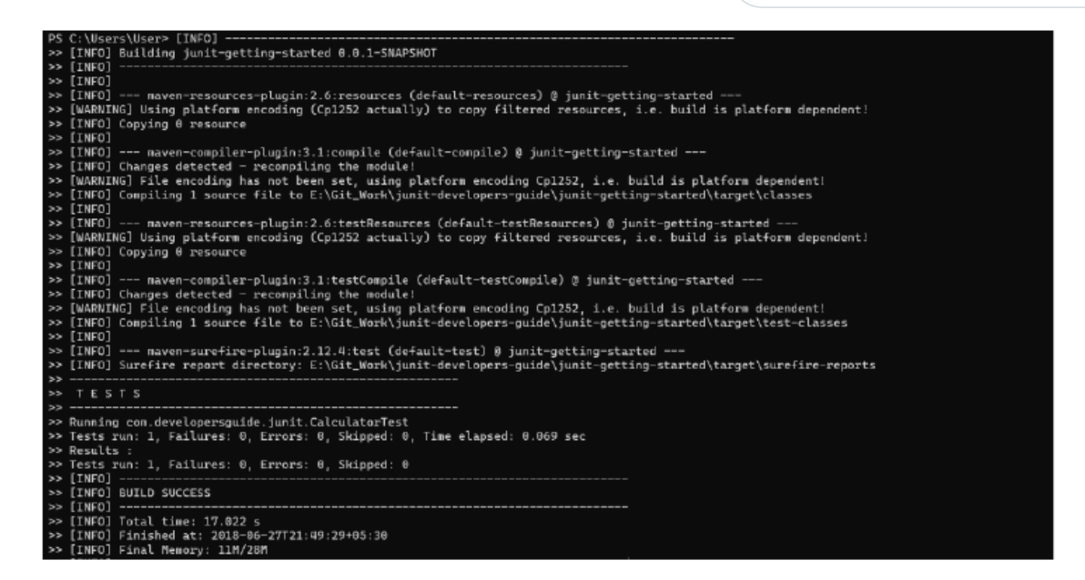

EXP 3: Install Jenkins in Cloud

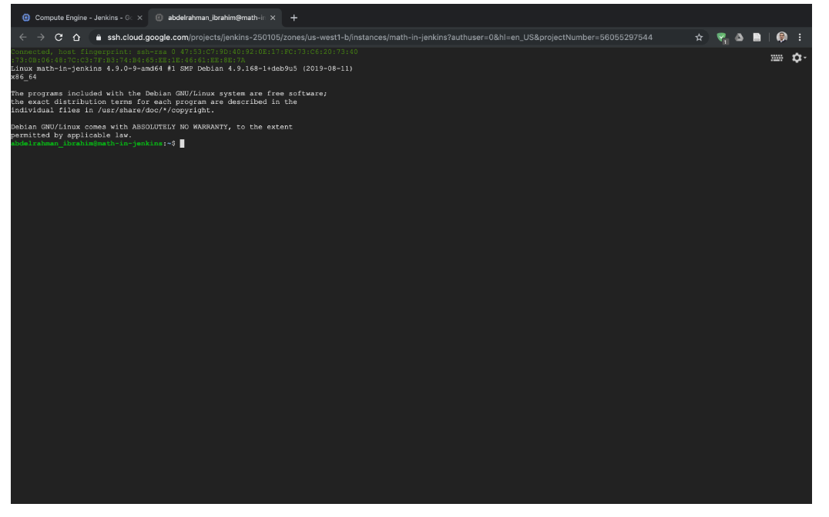

EXP 4: Create a CI Pipeline Using Jenkins

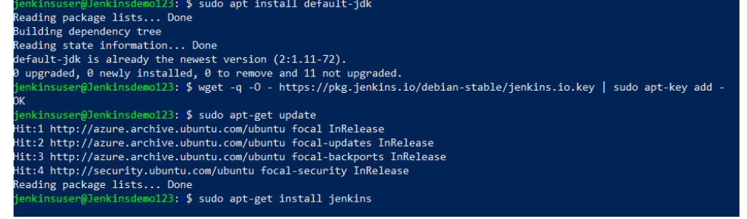

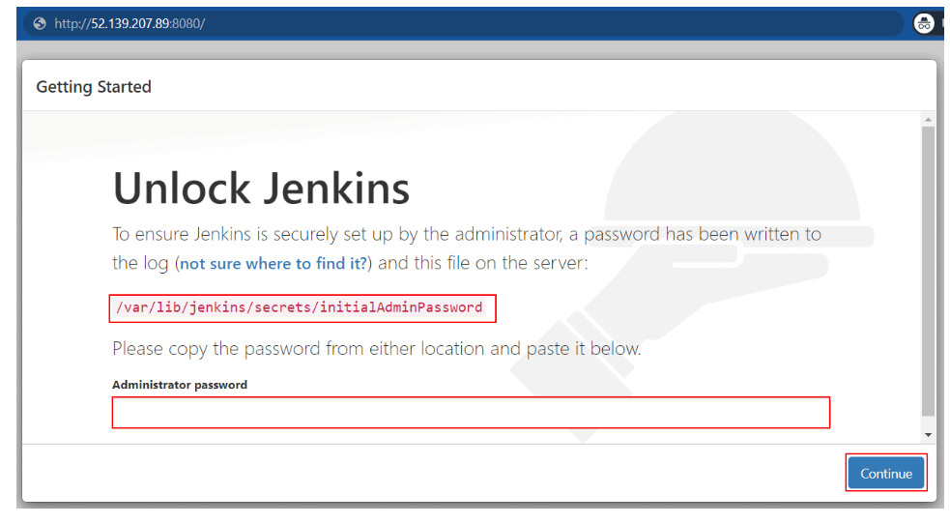

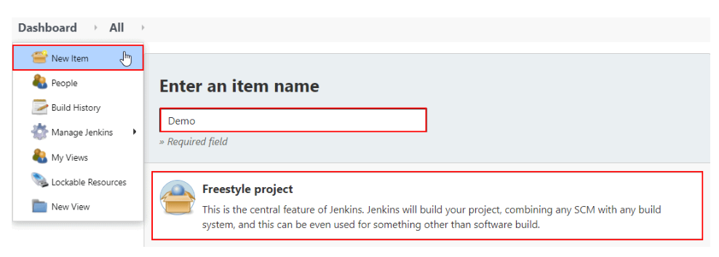

EXP 5: CI/CD Pipeline with Jenkins and Cloud Deployment

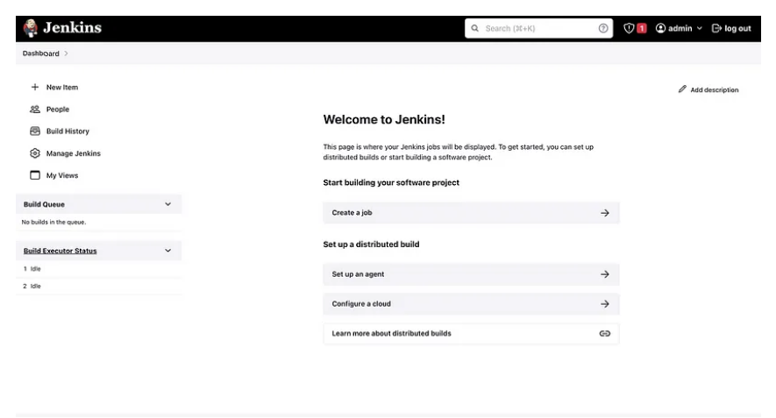

EXP 6: Ansible Playbook for Simple Web Application Infrastructure

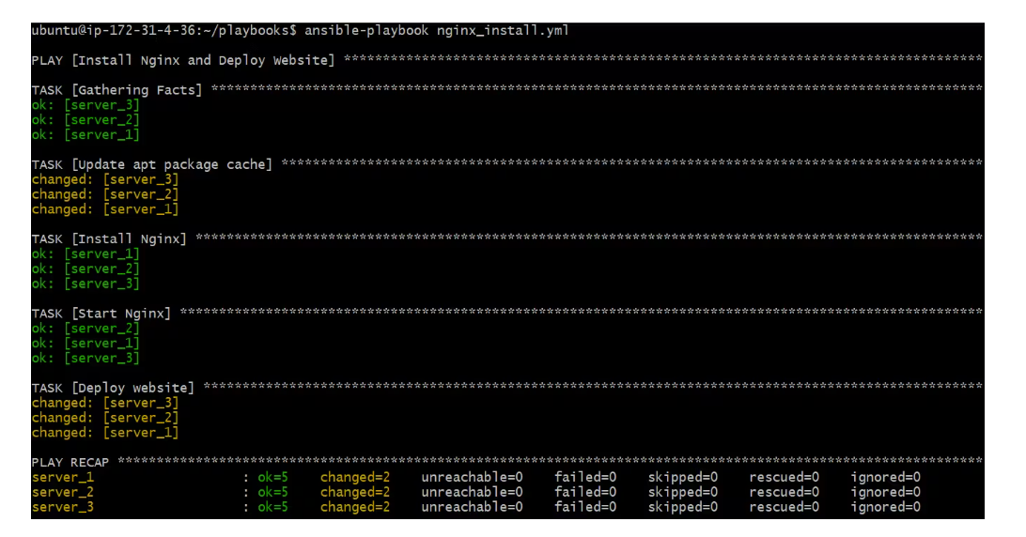

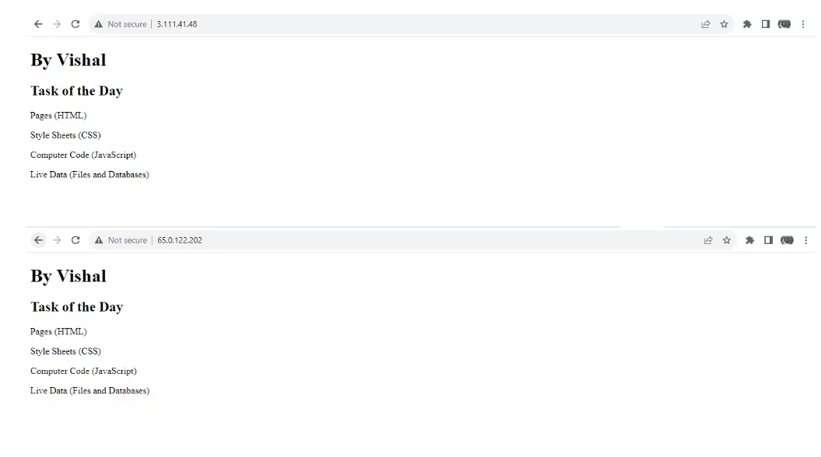

EXP 7: Build a Simple Application using Gradle

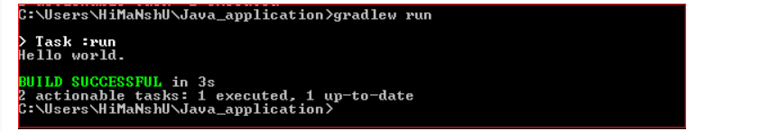

EXP 8: Ansible Installation, Roles, and Playbooks

