EMBED experiments
The method has two ingredients: anchor alignment, which pulls every group into one shared latent space, and regret optimization, which weights groups by how far they are from their own best achievable loss rather than by their raw loss.
Use cross-entropy as the loss everywhere: training, reference losses, and all reported numbers.

Step 1. Data
Task: 4-class breast density (tissueden = 1,2,3,4; drop missing and class 5).
Four views:
 | Image type | View
M1 | C-view (synthetic) | CC
M2 | C-view (synthetic) | MLO
M3 | FFDM | CC
M4 | FFDM | MLO

- One row per (exam, breast side). Join clinical and image tables on accession AND laterality, not accession alone.
- Drop spot and magnification views. One image per view per row.
- Set group_id from the set of views present. There should be six groups. Check your frequencies against the table below.

Group | Views | Frequency | Tail?
g1 | M3 | 3.0% | yes
g2 | M1 + M3 | 0.6% | yes
g3 | M4 | 1.2% | yes
g4 | M3 + M4 | 57.8% | no
g5 | M1 + M3 + M4 | 0.3% | yes
g6 | M1 + M2 + M3 + M4 | 37.1% | no

If they don't roughly match, fix the image-type mapping before going further.
- Split by patient (empi_anon), 70/10/20. Save the split file and never regenerate it.
- Resize images to 224x224, replicate grayscale to 3 channels, ImageNet normalization.
- Encode every image with a frozen ViT-Base and cache its 768-dimensional CLS embedding, keyed by image ID. One vector per image. Everything after this step runs on cached embeddings, never on raw images.

Step 2. Reference losses R*_g
R*_g is the lowest loss achievable using only the views that group g has. It is the quantity our objective subtracts, so it has to be estimated before anything else. One number per group, six in total.
We estimate it by training a model on group g alone. That model is one branch of our full method, with its own head instead of the shared one.
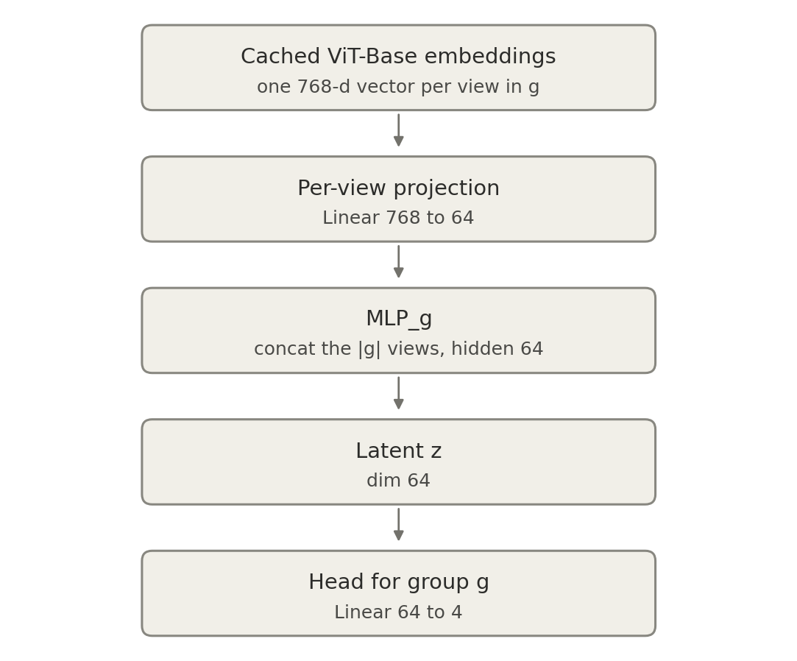
Figure 1. The model used to estimate R*_g. Everything below the frozen ViT is trained on group g alone.

2a. The model
Input: for a sample in group g, take the cached 768-d embedding of each view present in g. There are |g| of them: one for g1, two for g4, four for g6.
- Per-view projection. One Linear(768 -> 64) for each view. The frozen ViT is the same network for every image, so this projection is the only place view-specific processing can happen. M1 is a synthetic reconstruction and M3 is a real exposure, so their feature statistics differ and the model needs somewhere to adapt. Output: |g| vectors of dim 64.
- MLP_g. Concatenate the |g| projected vectors in a fixed order (M1, M2, M3, M4, skipping absent ones) to get a vector of dim |g| x 64. Pass it through Linear(|g|*64 -> 64), GELU, Linear(64 -> 64). Output: the latent z in R^64. This is the group encoder. Its input dimension differs by group, which is exactly what "heterogeneous feature spaces" means here: g1 has 64 inputs, g4 has 128, g6 has 256.
- Head. Linear(64 -> 4), used only for this group.
Everything above is trained on group g alone: its projections, its MLP_g, and its head. Nothing is shared with any other group at this step.

2b. How to compute R*_g
For each group g separately:
- Split group g's training data into 5 folds.
- Train the model above on 4 folds using mean cross-entropy over group g only.
- Record the per-sample cross-entropy on the held-out fold.
- Rotate through all 5 folds.
- R*_g = the mean of all out-of-fold per-sample losses.
Two things to get right:
- Never evaluate on data the model trained on. That is the entire point of the 5-fold rotation. Training loss is optimistically biased and the bias is worse for small groups, which would distort every downstream number.
- Be cautious with groups g2 and g5 (0.6% and 0.3%) Training from scratch on a few hundred samples will not converge, and a model that fails to converge gives an inflated R*_g.
Freeze the six numbers. They are constants for the rest of the project and carry no gradient.

Step 3. Our model
One model trained on all groups at once. Each group keeps its own encoder, but they all now map into a single shared latent space, read by a single shared head.
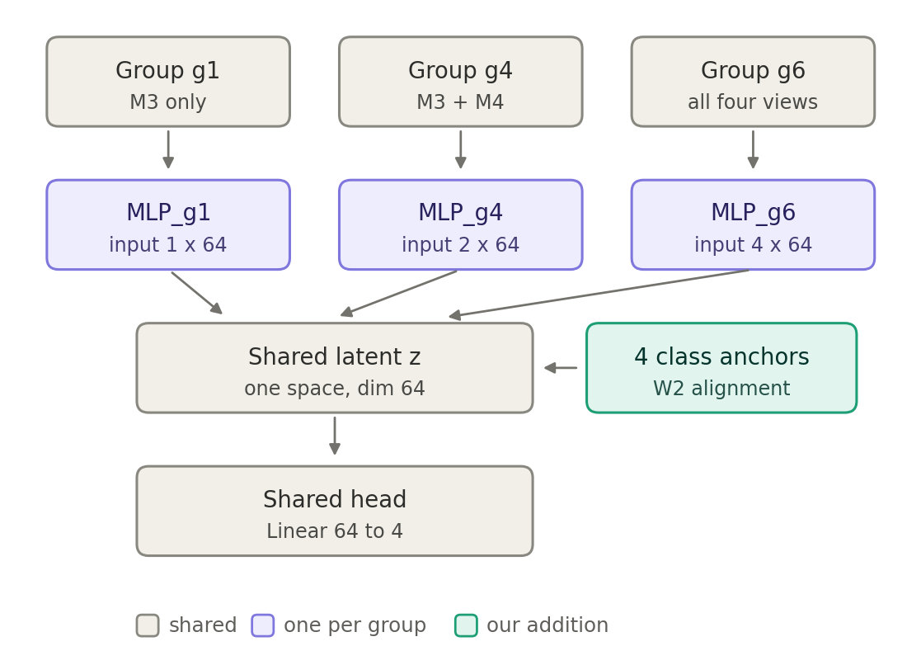
Figure 2. Our method. Three of the six groups shown; g2, g3 and g5 work the same way.

The components
Per-view projections: Linear(768 -> 64), one per view, now shared across groups. M3 is the same object wherever it appears, so relearning how to read an FFDM CC separately in five groups would waste the head groups’ data. Group-dependence belongs in the fusion, not in reading a single image.
MLP_g: exactly as in Step 2, one per group, six in total. Input dim |g| x 64, hidden 64, output the latent z in R^64.
Shared head psi: Linear(64 -> 4), the same for every group. This is the difference from Step 2, and it is the whole point. One head can only serve all six groups if their latents are comparable, which is what the anchors are for. Keep the head linear: it carves the latent into half-spaces, which pairs naturally with Gaussian class anchors, and an MLP head could undo misalignment nonlinearly and make the alignment ablation impossible to interpret.
Class anchors: four learnable Gaussians in the latent space, one per density class.
m_c in R^64 # mean, learnable
rho_c in R^64 # learnable
s_c = softplus(rho_c) + 1e-4 # diagonal variance, positive by construction
Initialize m_c from a normal with standard deviation 0.1, and rho_c so that s_c starts near 1. Diagonal covariance, not full: a full 64x64 covariance estimated from the handful of g5 samples in a batch would be near-singular.
These four anchors are the only parameters our method adds on top of the Step 2 architecture. Everything else is the same encoders with a shared head bolted on instead of six separate ones.

Step 4. The objective
Written out in full:
min over theta max over lambda in the simplex

SUM_g lambda_g * [ ( L_g^task - R*_g ) + lam_fit * L_g^fit ]

+ lam_sep * L^sep
theta is every trainable parameter: the per-view projections, the six MLP_g, the shared head, and the anchors. lambda is a weight per group on the simplex.
Every term that depends on g sits inside the brackets. L^sep sits outside the sum because it is a property of the anchors and the head only and has no group index.
Note that L_g^fit is not corrected by a reference value. Its minimum is zero for every group, since perfect alignment is achievable no matter which views a group has. Only the task term has a group-dependent floor.

L_g^task
Mean cross-entropy over the group-g samples in the batch.
L_g^task = mean over { i : group(i) == g } of CE( head(z_i), y_i )

L_g^fit (the alignment term)
Squared Wasserstein-2 distance between group g’s class-c latents and anchor c, summed over the four classes. Both are diagonal Gaussians, so it has a closed form with no matrix operations:
for each class c:
S = { z_i : group(i) == g and y_i == c } in this batch
if |S| < 8: skip this (g, c) cell
mhat = mean(S) # R^64
shat = variance(S) + 1e-4 # R^64

W2sq[c] = sum_j ( mhat[j] - m_c[j] )^2
+ sum_j ( sqrt(shat[j]) - sqrt(s_c[j]) )^2

L_g^fit = ( sum over c of W2sq[c] ) / 64
Dividing by 64 keeps the scale independent of the latent dimension. This term never touches the head, so there is nothing to detach.

L^sep (stops the anchors collapsing)
Without it, putting all four anchors at the same point would satisfy L_g^fit perfectly and be useless. Sample from each anchor and check the head can still classify it. Use the reparameterization so the gradient reaches the anchors:
for each class c:
eps = randn(16, 64)
Z_c = m_c + sqrt(s_c) * eps # 16 samples
loss_c = mean CE( head(Z_c), c )

L^sep = mean over c of loss_c

The training loop
R_star[g] = the six constants from Step 2
lambda[g] = empirical group proportion p_g
ema_loss[g] = R_star[g]

DECAY = 0.9; N = 50; dro_gamma = 0.02
lam_fit = 1.0; lam_sep = 1.0

for each batch:
per_sample = CE(head(z_i), y_i) # no reduction

for g in groups present in this batch:
L_task[g] = mean(per_sample[group_id == g])
L_fit[g] = as defined above
obj[g] = (L_task[g] - R_star[g]) + lam_fit * L_fit[g]

ema_loss[g] = DECAY * ema_loss[g]
+ (1 - DECAY) * (L_task[g] + lam_fit * L_fit[g])

loss = sum_g lambda[g] * obj[g] + lam_sep * L_sep
loss.backward(); optimizer.step()

if step % N == 0:
for g in ALL six groups:
excess[g] = max(0.0, ema_loss[g] - R_star[g])
lambda[g] = lambda[g] * exp(dro_gamma * excess[g])
lambda = lambda / sum(lambda)
- R*_g is a constant, so subtracting it does not change any per-group gradient. It only changes lambda. Setting all R*_g to zero recovers standard GroupDRO exactly, so that baseline must be a flag in this code, not a separate implementation.
- lambda is detached. It is updated by the rule above, not by the optimizer.
- The EMA exists because g5 is 0.3% of the data and is absent from most batches. Without it, its lambda would update from stale information.
- Clamp the excess at zero. R*_g is an estimate, so the difference can come out slightly negative.
- MLP_g only receives gradient when group g appears in the batch. If g5 trains too slowly, use a group-stratified sampler that guarantees a few samples per group per batch, and use the same sampler for every method in Step 5.
- Log lambda[g] and ema_loss[g] to a CSV every epoch.

Sizes you can change
The defaults are a starting point. Whatever you change, use the same value for every method in Step 5.

Variable | Default | Change to | When
Epochs (dev runs) | 20 | 5 to 10 | Always, while iterating. Use 20 only for final numbers.
Latent dim | 64 | 32 | The anchor statistics look noisy or L_g^fit is unstable. Fewer dimensions means the per-class mean and variance are estimated from the same samples in a smaller space.
 |  | 128 | Only if the model is clearly underfitting the head groups.
MLP_g hidden width | 64 | 32 | Together with the latent dim, if g5 overfits.
MLP_g depth | 1 hidden layer | 0 (linear) | If the tail groups will not train at all. A linear MLP_g is still a valid group encoder.
Samples in L^sep | 16 | 8 | Anywhere. This term is cheap and not sensitive.
lam_fit | 1.0 | sweep 0.1, 1, 10 | Always sweep this. It trades task accuracy against alignment.
dro_gamma | 0.02 | sweep 0.02, 0.1, 0.5 | Always sweep this. It controls how sharply lambda concentrates on the worst group.
Folds for R*_g | 5 | 3 | Only for g2 and g5 if 5 folds leaves too few samples per fold to train on. Say so in the table if you do.
Minimum cell size in L_g^fit | 8 | 4 | Last resort. Below 8 the per-class variance estimate gets unreliable, especially for tail groups.

Step 5. Methods to run
"Anchors off" means lam_fit = 0, lam_sep = 0, and the anchors are not created. Everything else in the Step 3 model stays in place, so rows 1, 2, 5, 6 and 7 all have identical capacity and differ only in the objective.

Method | Architecture | Objective
1. ERM | Step 3 model, anchors off | Mean cross-entropy over all samples. No lambda.
2. GroupDRO | Step 3 model, anchors off | Step 4 with R*_g set to 0
3. Group-only models | Step 2 model, one per group | Mean cross-entropy within group g
4. REMIND | As published — use their released code | As published
5. Ours | Step 3 model, anchors on | Step 4 with R*_g from Step 2
6. Ablation: alignment only | Step 3 model, anchors on | Mean cross-entropy over all samples. No lambda.
7. Ablation: regret only | Step 3 model, anchors off | Step 4 with R*_g from Step 2

Rows 2, 5, 6 and 7 form a 2x2: anchors on or off, crossed with R*_g used or set to zero. That is what separates the two ingredients of the method. Row 2 versus row 5 is the headline comparison.
Row 4 is the external comparison. It is a different architecture, so report parameter counts for every row.
Seeds 0, 1, 42. Report mean and standard deviation.
Config for rows 1, 2, 5, 6, 7: AdamW, lr 5e-5, weight decay 5e-5, batch size 32, max 20 epochs, StepLR(step_size = 5, gamma = 0.1).
Checkpoint selection on validation: rows 1 and 6 on average loss, rows 2 and 4 on worst-group loss, rows 5 and 7 on max excess loss.

Step 6. What to report
Write one file, metrics_long.csv, with these columns:
method, seed, group, n, accuracy, macro_f1, loss, R_star, excess_loss, n_params
Everything below is a pivot of that file.

Per group (all six, including the tiny ones)
- accuracy
- macro-F1
- loss
- R*_g
- excess loss = loss minus R*_g

Overall
- accuracy and macro-F1 on the entire dataset
- mean accuracy over the tail groups g1, g2, g3, g5
- worst-group raw loss, max over g of L_g, and which group it is
- max excess loss, max over g of (L_g minus R*_g), and which group it is
The last two are the headline numbers, and we expect them to point at different groups. Use the same R*_g values for every method, including ERM and REMIND, or the columns are not comparable.

One plot
R*_g on the x-axis, final lambda_g on the y-axis, one line for GroupDRO (row 2) and one for ours (row 5). If the mechanism works, GroupDRO’s weight should track R*_g and ours should not.

