**Name**: Venkata Krishnarjun Vuppala **Semester**:6 **SRN**: PES2UG19CS451 **Section**: G

**Subject:** Cloud Computing

**Assignment 3**

**Deliverables:**

a. Screenshot showing successful creation of table name <your-srn>. Refer: pes1201801295_1a.jpg

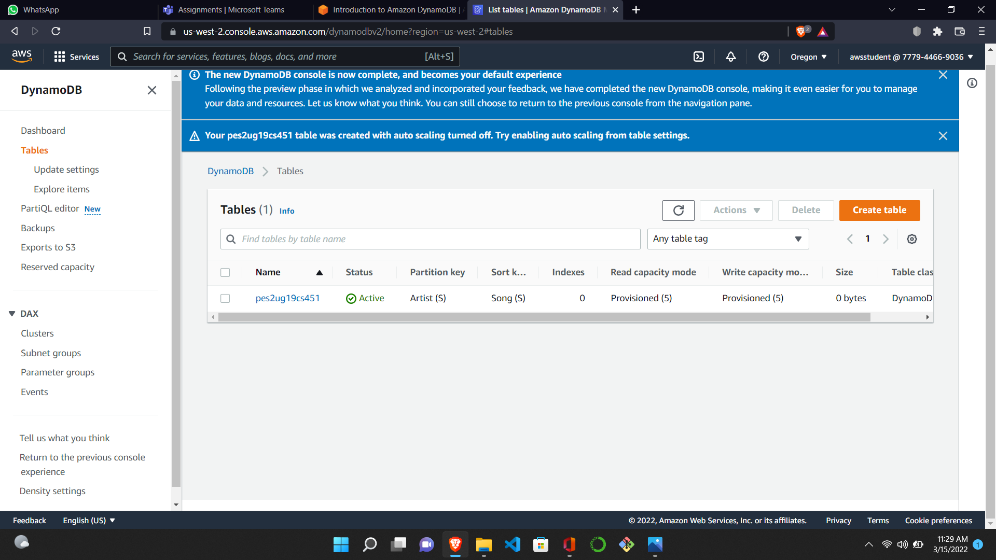

b. Screenshot the inserted items in DynamoDB. Steps to reproduce:

i. Left Navigation list: DynamoDB -> Tables -> explore items

ii. Click on run, Make sure table <your-srn> is selected.

iii. Scroll down to see table name and returned items from DynamoDB. Refer: pes1201801295_2a.jpg

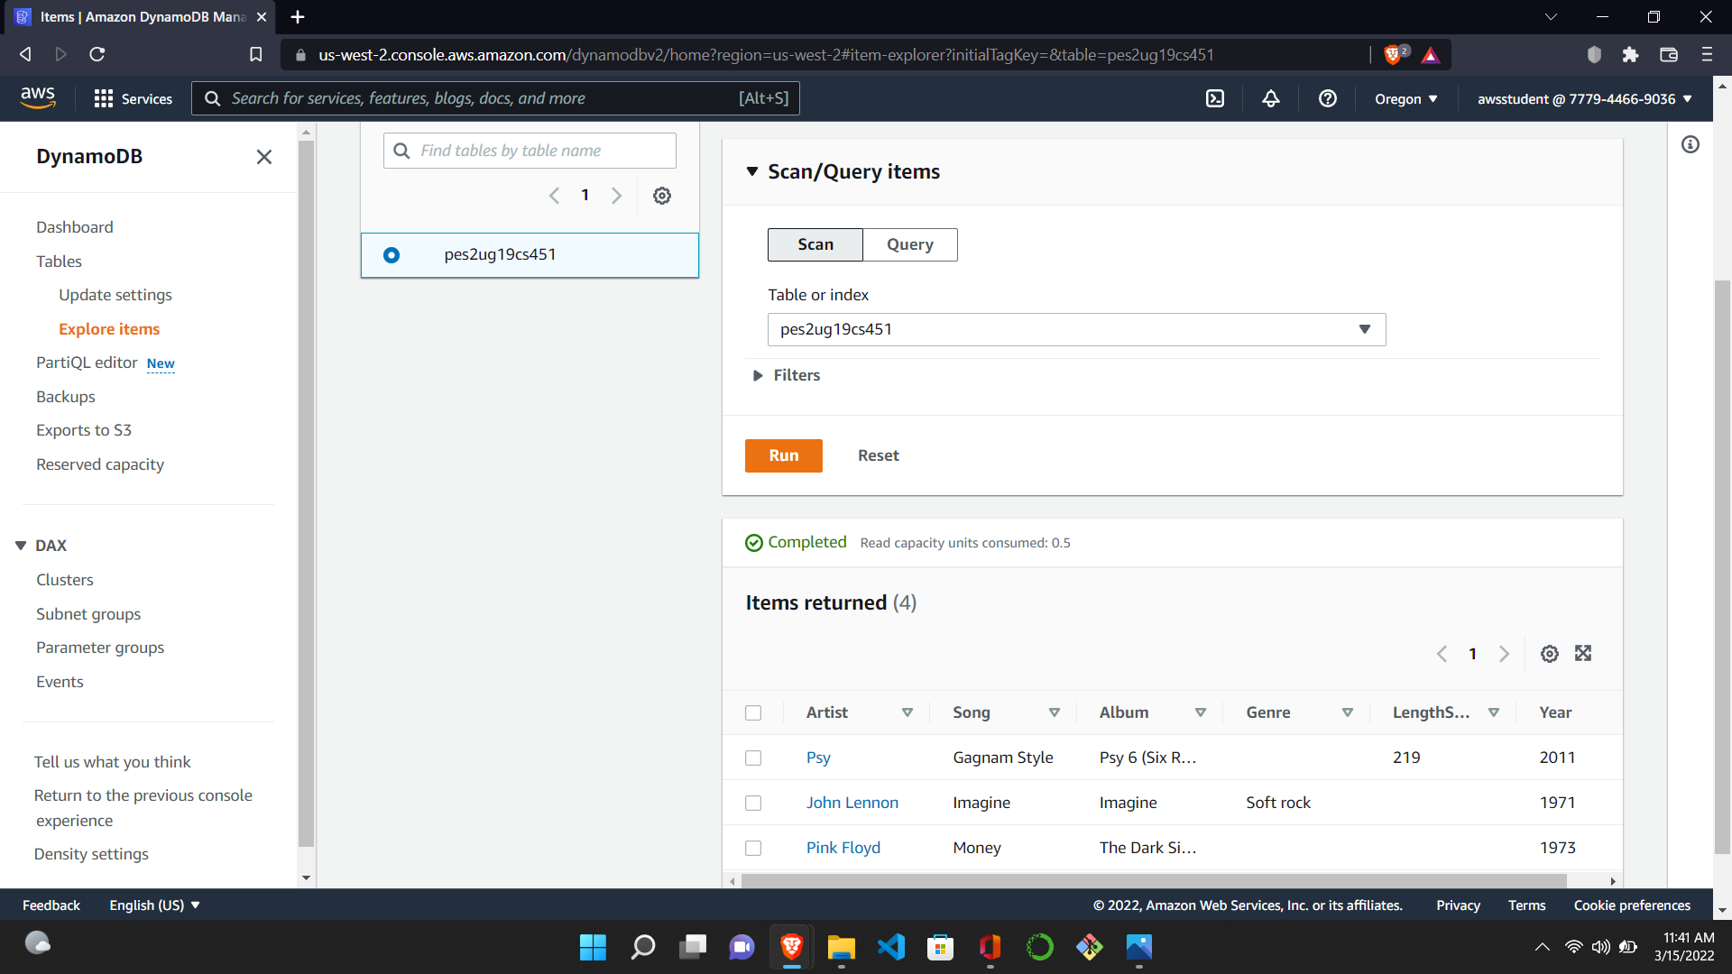

c. Screenshot showing the updated data. Artist Psy's year attribute updated to 2012. Refer pes1201801295_3a.jpg.

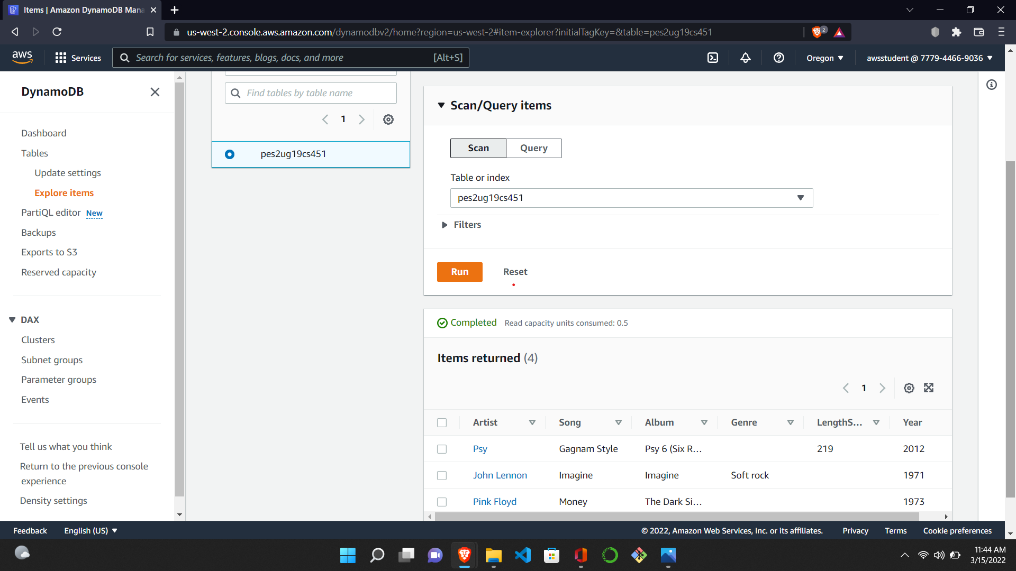

d. Screenshot showing query results. Refer pes1201801295_4a.jpg.

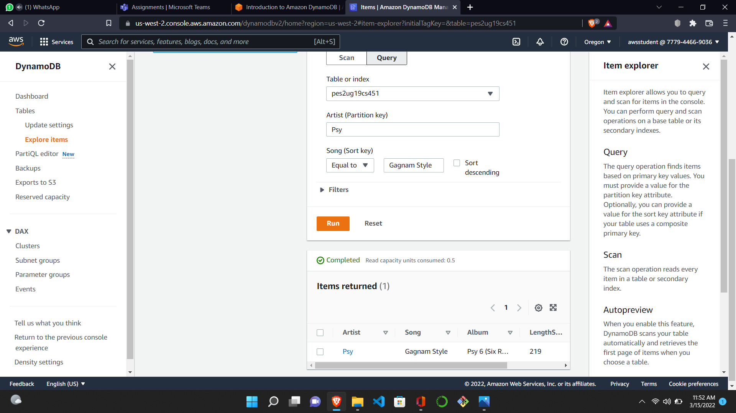

e. Screenshot showing scan results. Refer pes1201801295_4b.jpg

