**Name**: Venkata Krishnarjun Vuppala **Semester**: 6 **SRN**: PES2UG19CS451 **Section**: G

**Subject:** Cloud Computing

**Lab 2**

**Deliverables:**

**The following screenshots are to be submitted:**

* **1a.jpg:** Screenshot of running docker hello-world.

* A screenshot of a computer

  Description automatically generated with medium confidence**2a.jpg:** Screenshot of C Program successfully run inside the container.
* Graphical user interface, text, application, email

  Description automatically generated**2b.jpg:** Screenshot of the image pushed to Dockerhub.
* Graphical user interface, text, application

  Description automatically generated**3a.jpg:** Sample.html showing the web page on the browser.
* Text

  Description automatically generated**3b.jpg:** Screenshot of docker container running nginx
* Text

  Description automatically generated**3c.jpg:** Screenshot of python application successfully writing and reading from the MongoDB database
* **3d.jpg:** Screenshot showing mongodb being run within the network(docker command has to be clearly highlighted)

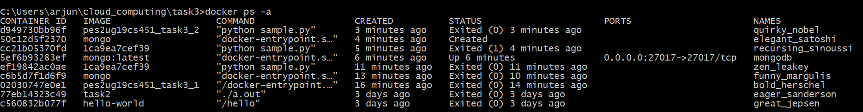

* **Text

  Description automatically generated3e.jpg:** Screenshot showing python file being run within the network and successfully writing and reading from MongoDB(docker command has to be clearly highlighted)
* Background pattern

  Description automatically generated with medium confidence**4a.jpg:** Screenshot of python-mongodb application running as a docker-compose application(logs of the application)
* A picture containing text

  Description automatically generated**4b.jpg:** Screenshot of 3 python application writes and reads from MongoDB after scaling the python application.