**Name**: Venkata Krishnarjun Vuppala **Semester**:6 **SRN**: PES2UG19CS451 **Section**: G

**Subject:** Cloud Computing

**Lab 2**

**Deliverables:**

**The following screenshots are to be submitted:**

1. 1a.png: Showing S3 bucket created. The name of the buckets should be: <Your SRN> Eg: pes1201900001.

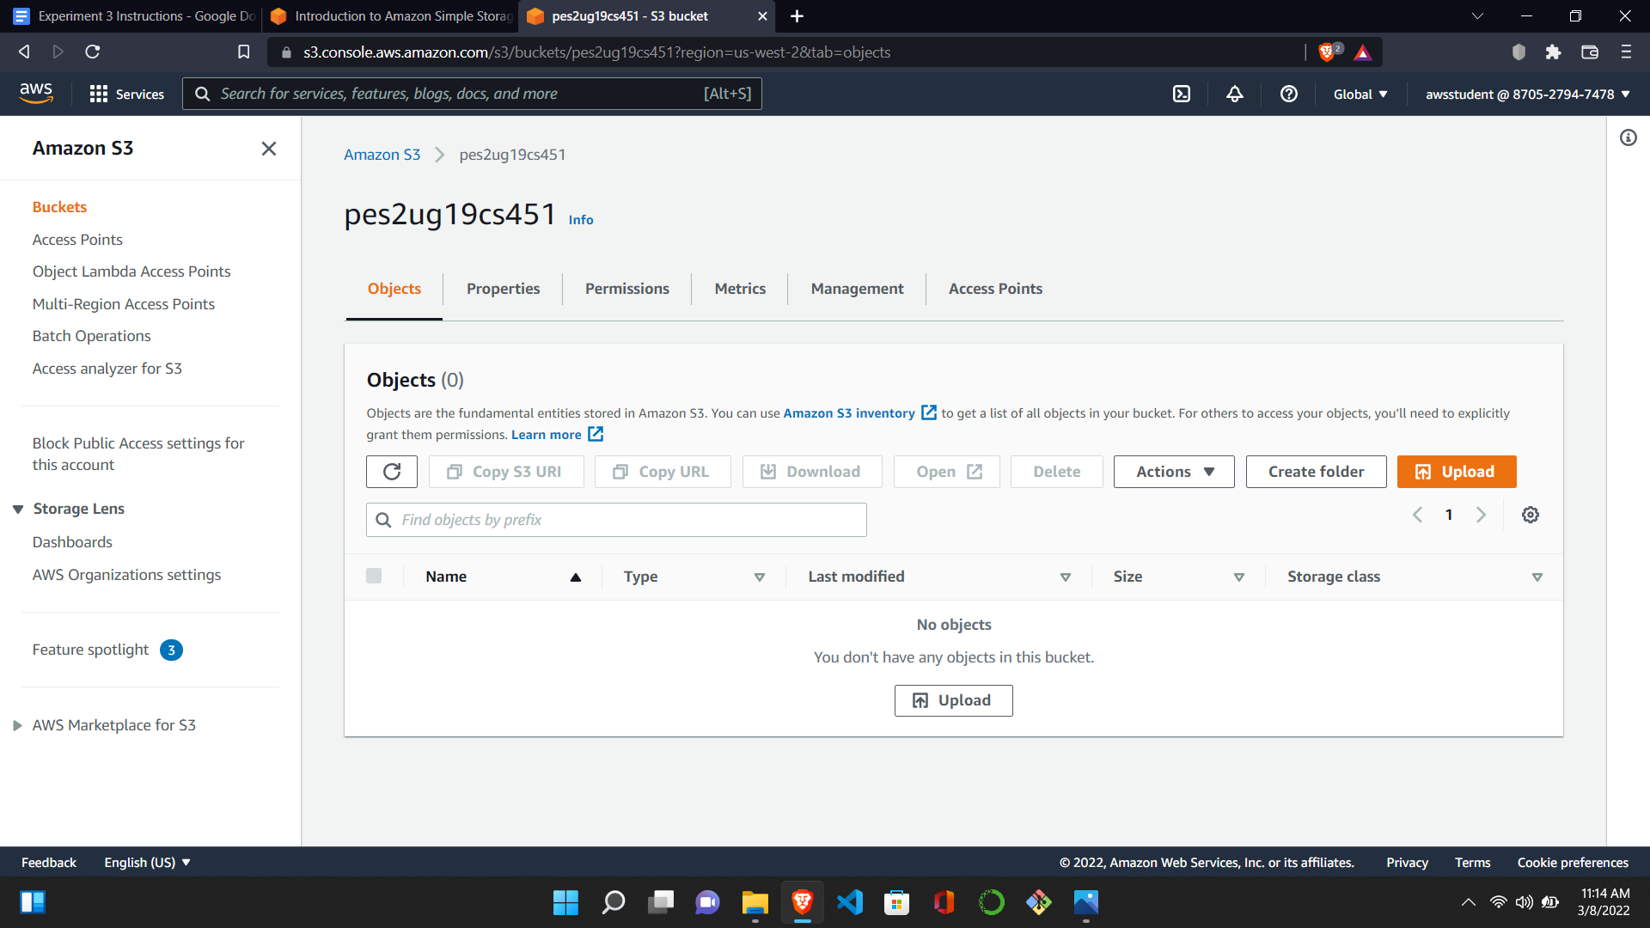

1. 2a.png: Showing the file upload successfully (Include Details).

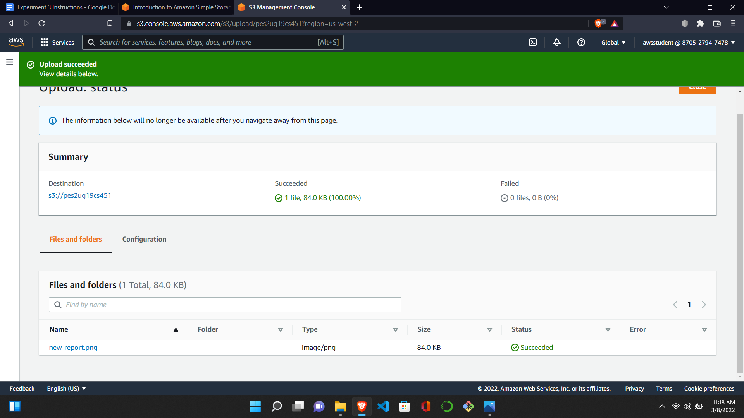

1. 3a.png: Showing the new-report.png successfully displayed on the browser tab.

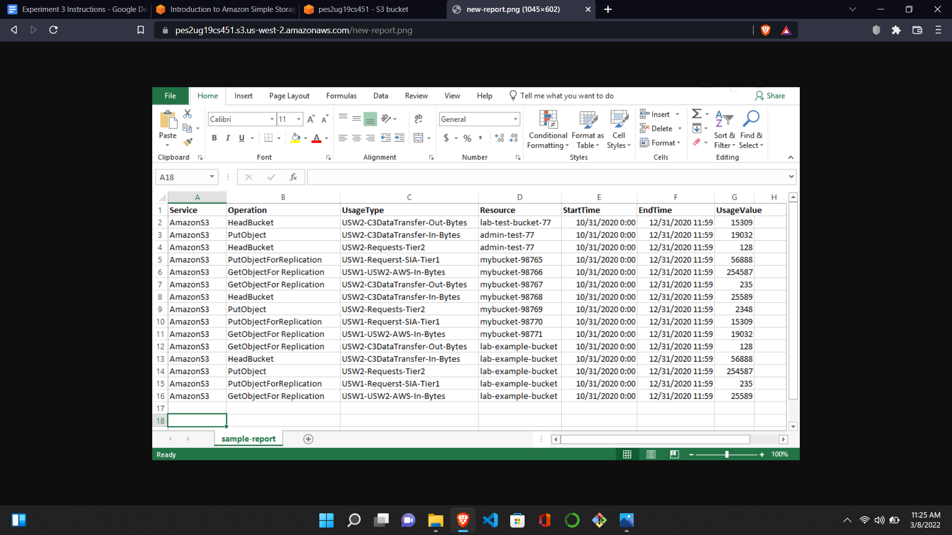

1. 4a.png: Showing all commands executed on the Bastion host including the upload failed error.

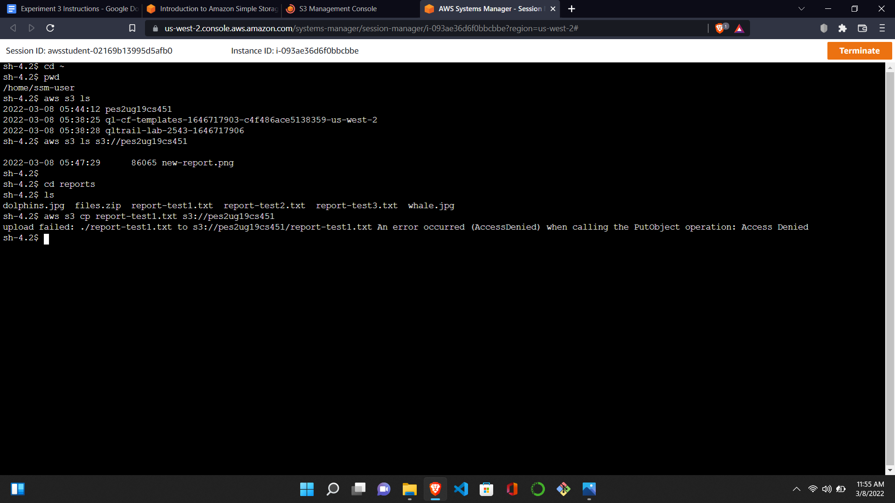

1. 5a.png: Showing all commands executed on the Bastion host including successful retrieval (GetObject) and upload (PutObject).

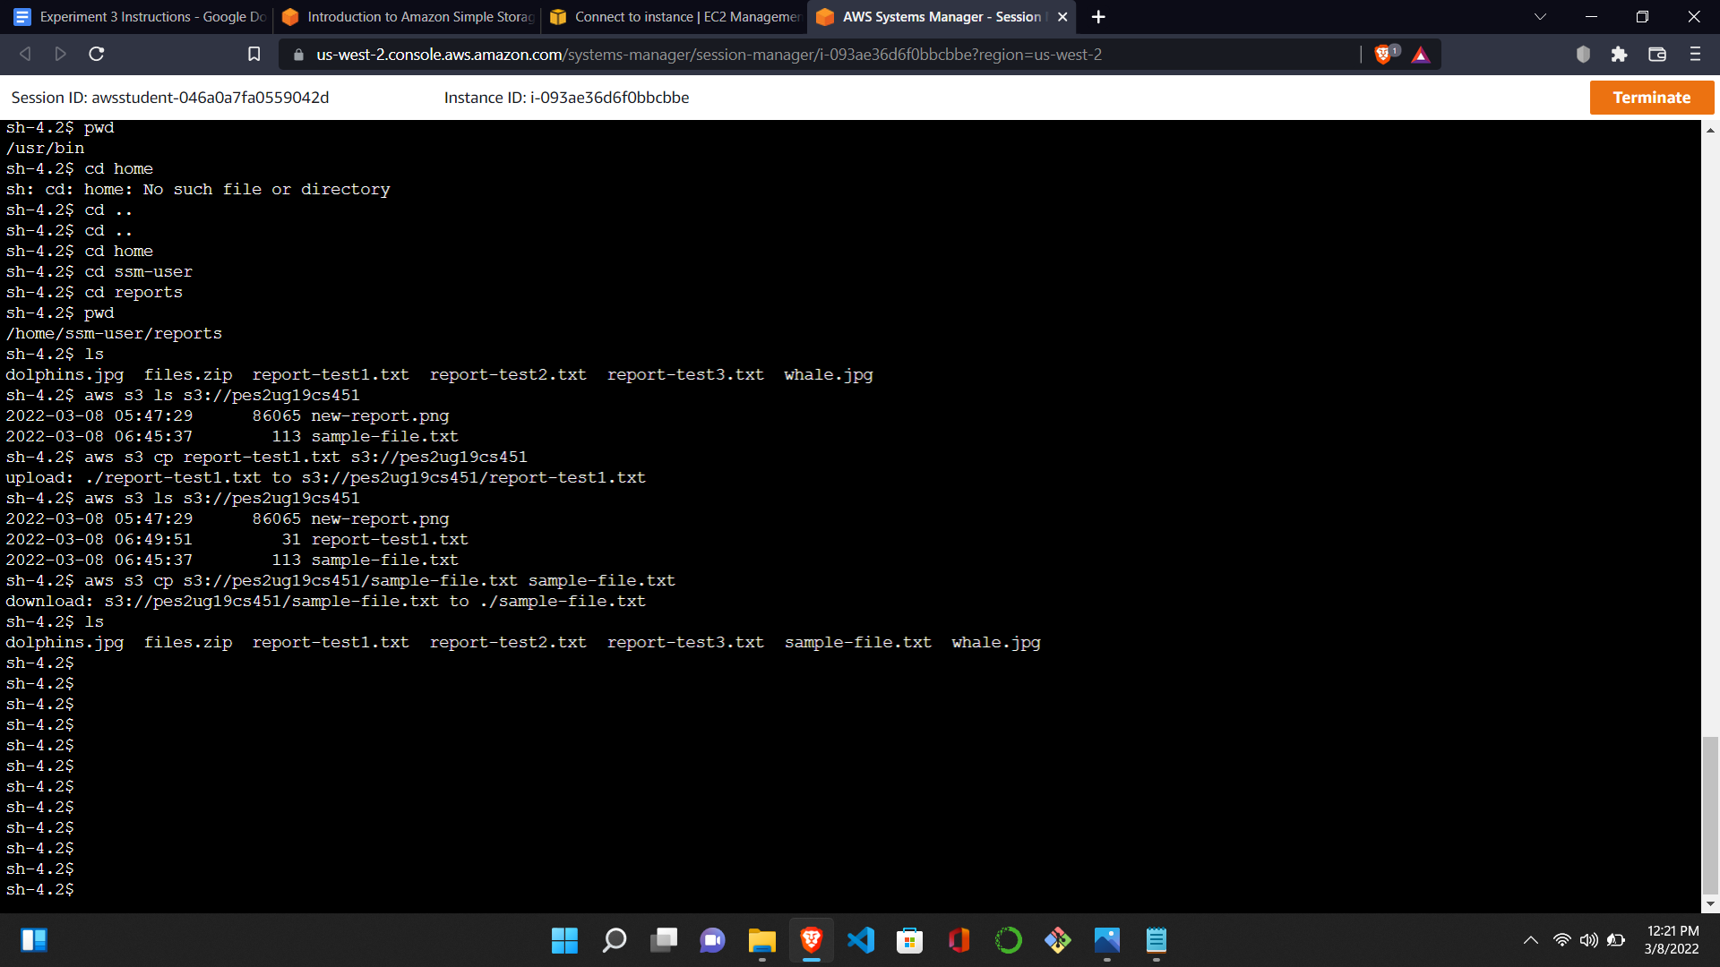

1. 5b.png: Showing the sample-file.txt displayed on the browser tab

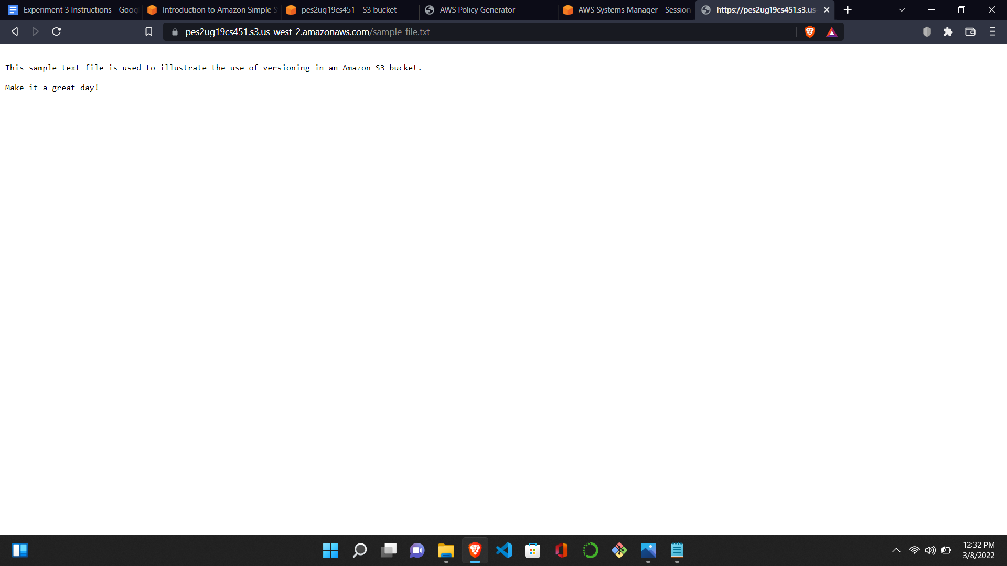

1. 6a.png: Showing the new contents of the sample-file.txt on the browser tab.

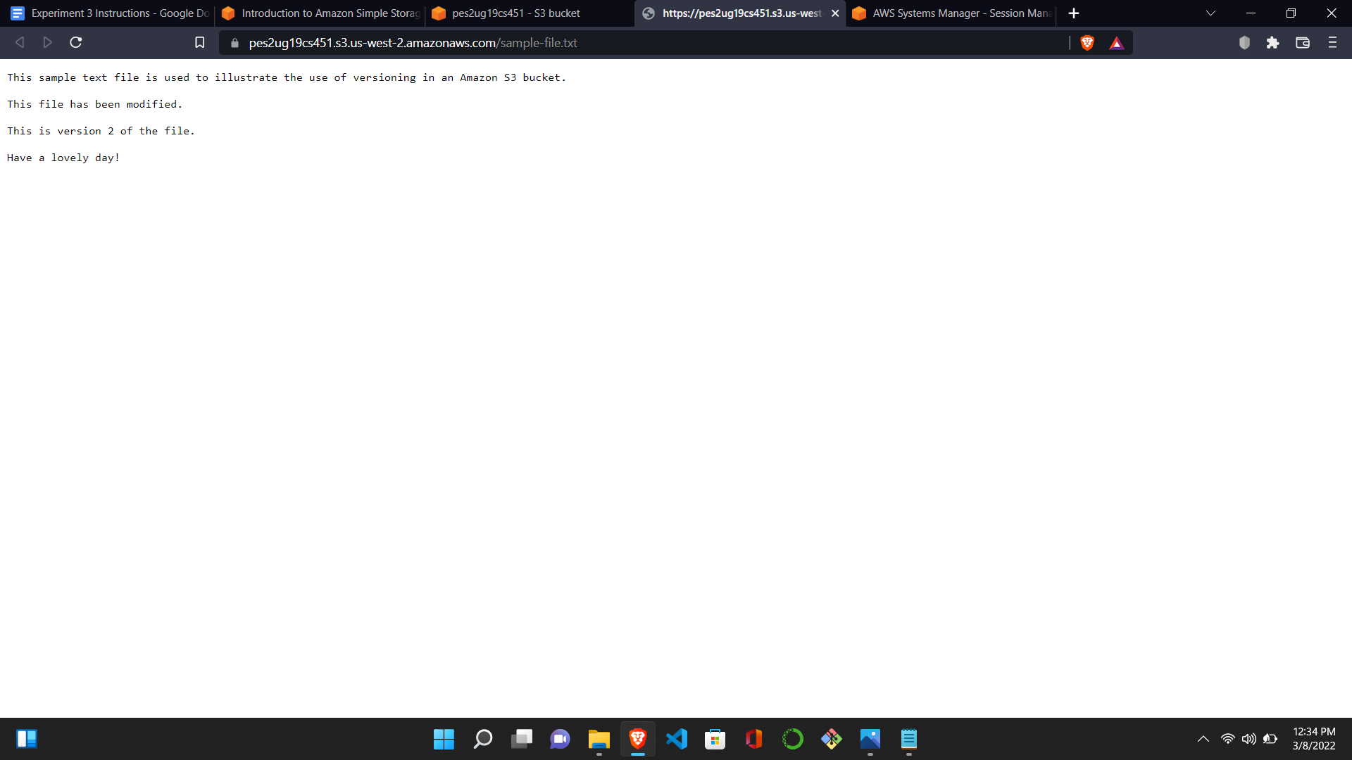

1. 6b.png: Showing the objects tab for the bucket created with the *Show versions* toggle on.

