Corvi technologies
About Page
1)Incorrect spelling for “Precisio” actual word is “ Precision” at last “n” letter was missing, add it


2) Remove the red marked character
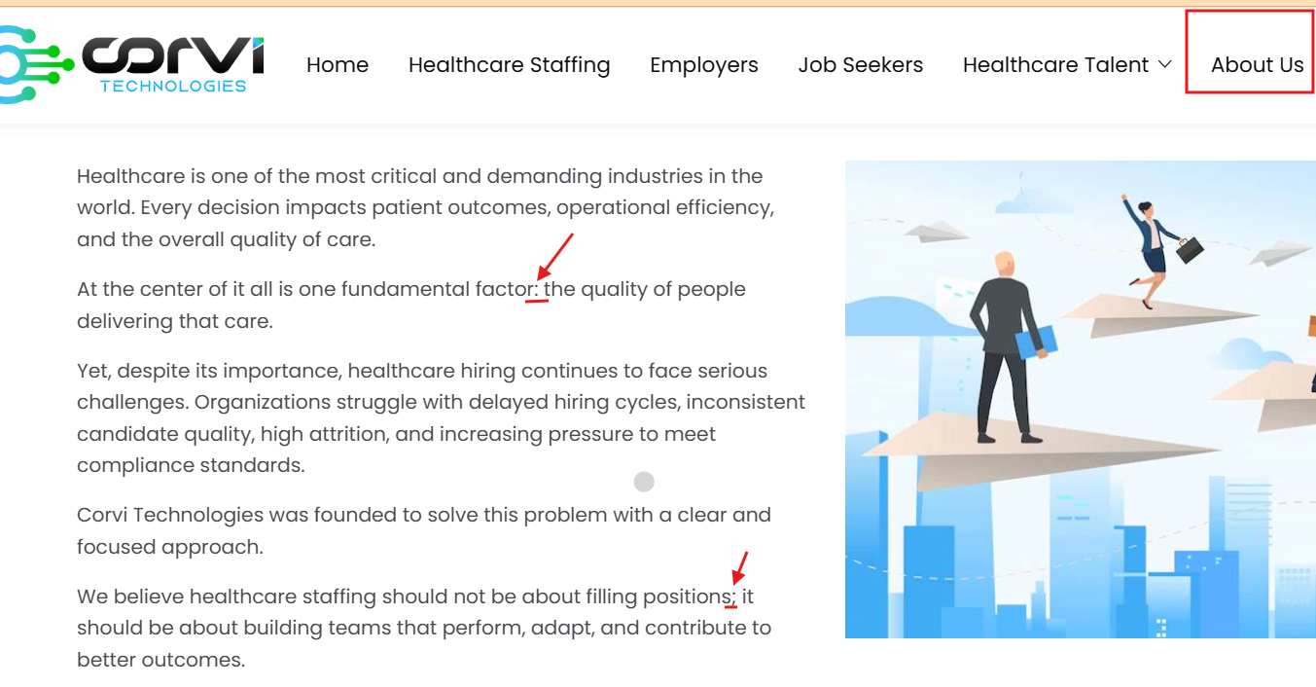
Replace with the fullstop symbol
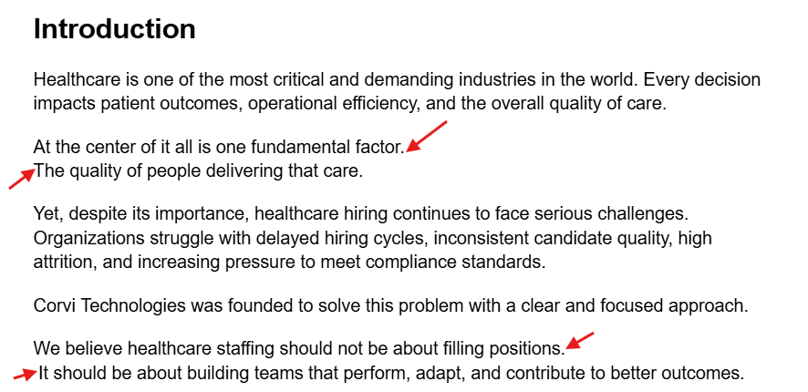

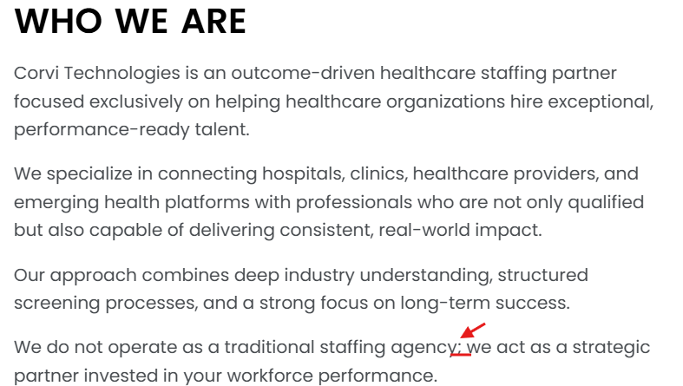

4)
Job seekers page
- Nursing professional give the correct content by refereeing the site map


- Under allied nursing professional give the correct content based for the site map
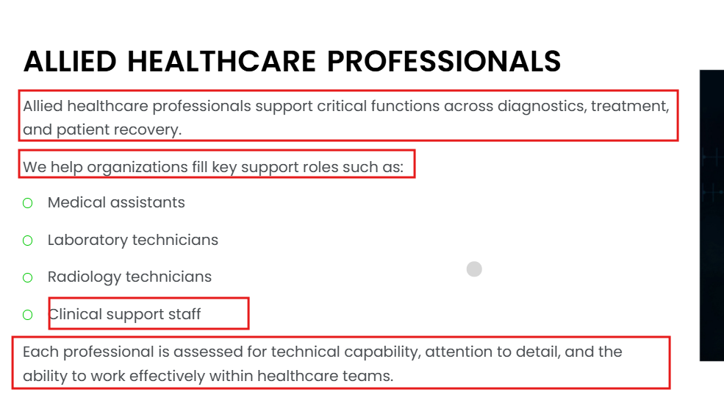
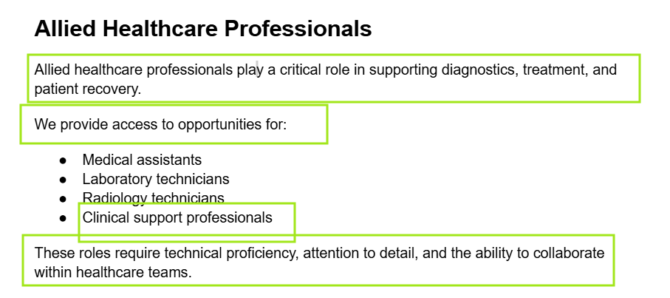

3)

