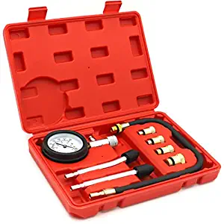
STHIRA® 8PCS Professional Tester Test Kit Cylinder Compression Gas Engine Set Automotive Tool Gauge for Car & Truck
Item Price INR2024.00
Item Price रू 3238.40
Service Fees रू 97.15
Tax Amount रू 767.18
Shipping Fees NPR 390.00
Total Amount NPR 4492.73

