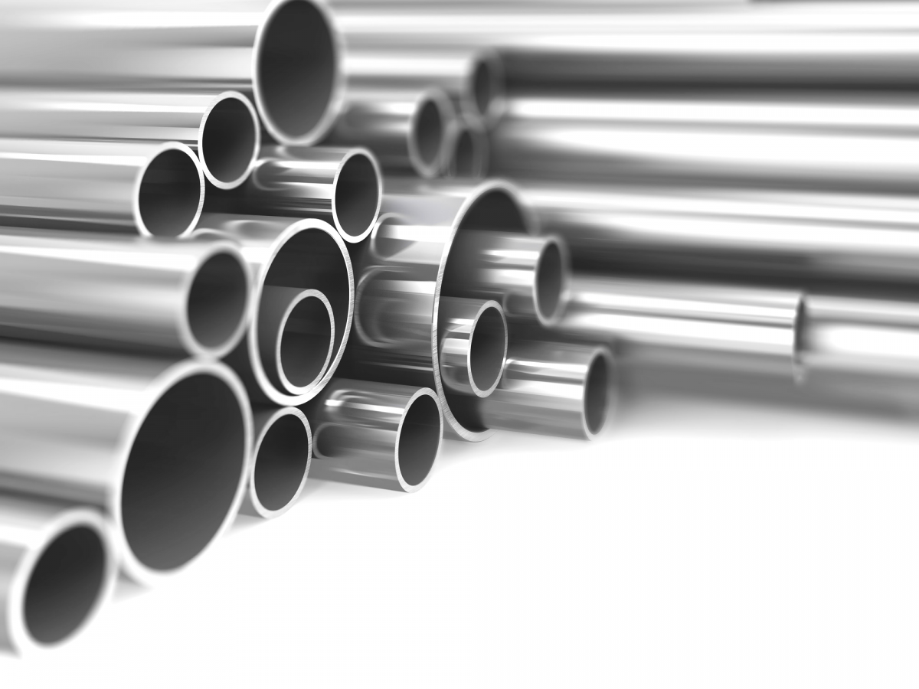
Aluminum 6061 grade Tubings
https://mount-everest-aluminium-suppliers-pvtltd.business.site/
Naikap 984-9754430
Bagh Bhairav Alumin & Steel Tech, 9851207149
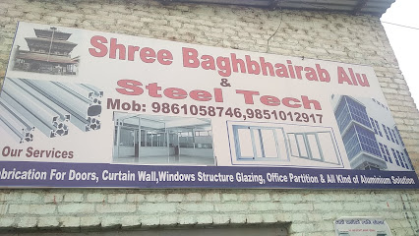

Anish Enterprises Teku 984-0052826
G.S. Aluminium Enterprises, swayambhu
014285860

Everest Aluminium
014483734

Swarna Laxmi Aluminum Pvt. Ltd.
9851246890

Specialized Aluminium Steel, Gongabu
9810241038

Rohit Impex, Narayantar 9801025289
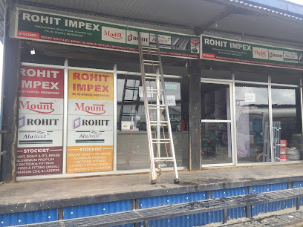

SAB Traders, jadibuti
9851061041

HighTech Alumnium World, Samakhusi
014356881
विशेष एल्यूमिनियम र इस्पात
9843430405

Shiva Bishwakama aluminium Pvt LTD
Kalopul

ANS Aluminium PVT. LTD, pepsicola 9851146035
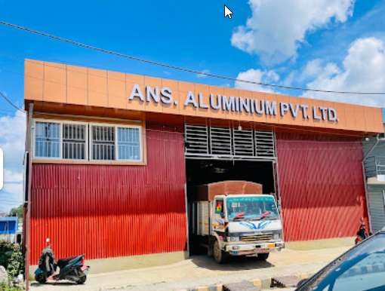
Aluminium Intex, 9840014810
Balaju

Kathmandu aluminum house, laltipur
015204176
Rikesh Aluminum Enterprise, Bansbari
016924911

New Buddha Almunium Udhyog, nagarjun
9843413413

S.T.I TRIPURA INTERNATIONAL PVT LTD Bhaktapur 9845762150
