Google Analytics:
QA Doc - LG

Prepared For:





MightyHive
394 Pacific Ave
San Francisco, CA 94111

How to
For instructions on how to complete the items below please refer to this document.

QA Round 1

Testing details
Date: 3/20/23
Testing device: MacBook Pro (13-inch, 2019) - Chrome
userAgent String: Mozilla/5.0 (Macintosh; Intel Mac OS X 10_15_7) AppleWebKit/537.36 (KHTML, like Gecko) Chrome/104.0.0.0 Safari/537.36

Staging Site:

Event Status Summary
EVENT NO. - EVENT NAME | Overall Status | Comments
e5.1 | Fail | - Incorrect Values & Extra Event Executions
e5.2 | Pass
e5.3 | Pass
e5.4 | Pass
e5.5 | Fail | - Incorrect Value
e5.6 | Pass with Notes | - No orders with accessories and/or additional services (wall mounting powered by handy, subscription products and subscription options or LG premium care) included were associated with a manage order button on the Orders Section therefore orders with accesories and/or additional services were not QA’d.
 | Fail | - Missing Data Layer Event Execution
 | Unable to test | - Need info on when pencil banner is going live
 | Unable to test | - Need info on when pencil banner is going live
e5.10 | Fail | - Incorrect Value
e5.11 | Pass
e5.12 | Pass
e5.13 | Pass with Notes | - https://www.lg.com/us/support/contact and https://wwwstg.us.lg.com/us/support/product/lg-13U70P-G.AAW7U1 are not a part of MyLG. The event has not been implemented or QA’d on these pages.
 | Fail | - Incorrect Value
e5.15 | Pass
e5.16 | Pass
e5.17 | Pass
e5.19 | Pass with Notes | - As of 3/28/23, Ghanashyam said the some products you might carousel is not available for QA because “This has not been developed due to dependency on coveo so will update once this will be developed.”
e5.21 | Fail | - Incorrect Value
e5.22 | Pass
e5.23 | Pass
e5.24 | Pass
e5.25 | Fail | - Incorrect Value
e5.26 | Pass
 | Pass | - Passed GTM QA on lg.com staging
e5.28 | Pass with Notes | - No orders with additional services (wall mounting powered by handy, subscription products and subscription options or LG premium care) included were associated with a return/replace button on the Orders Section therefore orders with additional services were not QA’d.
e5.29 | Pass
e5.30 | Pass
e5.31 | Pass
e5.32 | Pass
e5.33 | Pass
e5.34 | Pass
e5.35 | Pass
e5.36 | Pass
e5.37 | Pass
e5.38 | Fail | - Missing data layer event execution
e5.39 | Fail | - Missing data layer event execution
e5.40 | Pass

Detailed Event QA

e5.1 - bs_dataLayerLoaded
URL:
- Test Case #1:
  - MyLG Products Section
    - https://www.lg.com/us/mylg/products
- Test Case #2:
  - MyLG Product Registration
    - https://www.lg.com/us/mylg/products/registration?from=products
    - https://www.lg.com/us/mylg/products/registration-success
- Test Case #3:
  - MyLG Orders Section
    - https://www.lg.com/us/mylg/my-order
    - https://wwwstg.us.lg.com/us/new-mylg/my-order/order-detail/974829?currentPage=1&active=items&hasReturns=false&showReturnOrReplace=false
- Test Case #4:
  - MyLG Favorites Section
    - https://www.lg.com/us/mylg/favorites
- Test Case #5:
  - MyLG Subscriptions Section
    - https://wwwstg.us.lg.com/us/new-mylg/subscription?currentPage=1
    - https://wwwstg.us.lg.com/us/new-mylg/subscription/detail/251387?currentPage=2
    - https://wwwstg.us.lg.com/us/new-mylg/subscription/edit/251496?currentPage=1
- Test Case #6:
  - MyLG Repair Requests Section
    - https://www.lg.com/us/mylg/repair-requests
    - https://wwwstg.us.lg.com/us/support/repair-service/schedule-repair
    - https://wwwstg.us.lg.com/us/support/repair-service/schedule-repair-continued-mylg
- Test Case #7:
  - MyLG Ask Us Section
    - https://www.lg.com/us/mylg/ask-us
    - https://wwwstg.us.lg.com/us/mylg/ask-us/detail/GCN002861
    - https://wwwstg.us.lg.com/us/support/email-appointment
    - https://wwwstg.us.lg.com/us/support/emailResult
- Test Case #8:
  - MyLG FAQ Section
    - https://www.lg.com/us/mylg/faq
- Test Case #9:
  - MyLG Contact Us Section
    - https://www.lg.com/us/mylg/support
- Test Case #10:
  - MyLG Profile Section
    - https://www.lg.com/us/mylg/profile
    - https://www.lg.com/us/mylg/profile/edit
- Test Case #11:
  - MyLG Address Book Section
    - https://www.lg.com/us/mylg/address-book
    - https://www.lg.com/us/mylg/address-book/add
    - https://www.lg.com/us/mylg/address-book/edit/2544863
- Test Case #12:
  - MyLG Password Section
    - https://www.lg.com/us/mylg/change-password

Status: Fail - Incorrect Values & Extra Event Executions
- Test Case #3:
  - On 8/31/23 MM is unable to fully QA the Order details page because MM does not have access to a MyLG account with orders in it on lg.com. QA was conducted several months ago on wwwstg.us.lg.com but MM cannot confirm how this event is behaving on 8/31/23 because MM credentials to wwwstg.us.lg.com do not work any more. The indented bullet below describes the observed behavior when this event was tested several months ago so MM cannot confirm if this behavior is currently happening on lg.com
    - When the user clicks the manage order button on the Orders sections and loads an Order Details page, bs_dataLayerLoaded fires multiple times. This behaivor is incorrect. Please make it so the bs_dataLayerLoaded event only fires once when Orders Details pages load.
  - Order details pages with orders including a subscription product and subscription (aka reoccuring delivery) option selected or handy wall mounting service selected or LG premium care option selected were not QA’d because the provided MyLG account did not have any orders with these additional services included.
- Test Case #5:
  - On 8/31/23 MM is unable to fully QA the Subscriptions section (especially the subscriptions details and edit pages) of MyLG because MM does not have access to a MyLG account with subscriptions in it on lg.com. QA was conducted several months ago on wwwstg.us.lg.com but MM cannot confirm how this event is behaving on 8/31/23 because MM credentials to wwwstg.us.lg.com do not work any more. The below detailed QA feedback is from several months ago when we were able to QA on wwwstg.us.lg.com
  - See below detailed QA for information on how to fix the product_count parameter
- Test Case #6:
  - On 8/31/23 MM is unable to fully QA the Repair Requests section (especially the schedule repairs section) of MyLG because MM does not have access to a MyLG account with active repairs in it on lg.com. QA was conducted several months ago on wwwstg.us.lg.com but MM cannot confirm how this event is behaving on 8/31/23 because MM credentials to wwwstg.us.lg.com do not work any more. The below detailed QA feedback is from several months ago when we were able to QA on wwwstg.us.lg.com
- Test Case #7:
  - On 8/31/23 MM is unable to fully QA the Ask us section (especially on the submit question, success submit question, inquiry details pages) of MyLG because MM does not have access to a MyLG account with submitted questions in it on lg.com. QA was conducted several months ago on wwwstg.us.lg.com but MM cannot confirm how this event is behaving on 8/31/23 because MM credentials to wwwstg.us.lg.com do not work any more.

Expected dataLayer:

<script>
window.dataLayer = window.dataLayer || [];
window.dataLayer.push({
"event": "bs_dataLayerLoaded",
"sub_brand": "{{signature}}",
"collection": "{{lifestyle}}",
"business_unit": "{{mu}}",
"product_category_1": "{{tvs}}",
"product_category_2": "{{oled}}",
"product_category_3": "{{category level 3}}",
"product_category_4": "{{category level 4}}",
"page_category_1": "{{tvs}}",
"page_category_2": "{{oled}}",
"page_category_3": "{{category level 3}}",
"page_category_4": "{{category level 4}}",
"country_code": "{{us}}",
"site_type": "{{b2c}}",
"preorder_count": {{1}},
"add_to_cart_count": {{4}},
"where_to_buy_count": {{4}},
"inquire_to_buy_count": {{4}},
"find_dealer_count": {{4}},
"page_type": "{{subcategory}}",
"cart_length": {{4}},
"cart_value": {{4000.99}},
"cart_id": "{{37329572r2fh2ff3f3f}}",
"language": "{{en}}",
"product_compare": "{{t}}",
"no_product_compare": {{3}},
"sku_compare": "{{oled65c9pua|oled65e9pua|oled65b9pua}}",
"site_version": "{{BlueSky}}",
"product_count": {{6}},
"product_condition": {{new}},
"user_id": "{{b71e277ab272fe5cf7a0294bbce6002c6c1100612301268236066a517bf111a9}}",
"login_state": "{{logged in}}",
"microsite_name": "{{g8x-thinq-dual-screen}}",
"store_name": "{{s4-store}}",
"company": "{{mightyhive}}",
"shopping_limits_purchased": {{4}},
"shopping_limits_actual": {{7}},
"hashed_zipcode": "{{b6ce2b2c9b16a7be459247ee117a84e9a7e7ff714cbca7c4562664d51249a966}}"
});
</script>
<!-- Google Tag Manager -->
...
<!-- End Google Tag Manager -->

Test Case #1:
On page dataLayer for when the user loads the “Products” section of MyLG:
The below screenshot is produced by the Adswerve chrome extension:
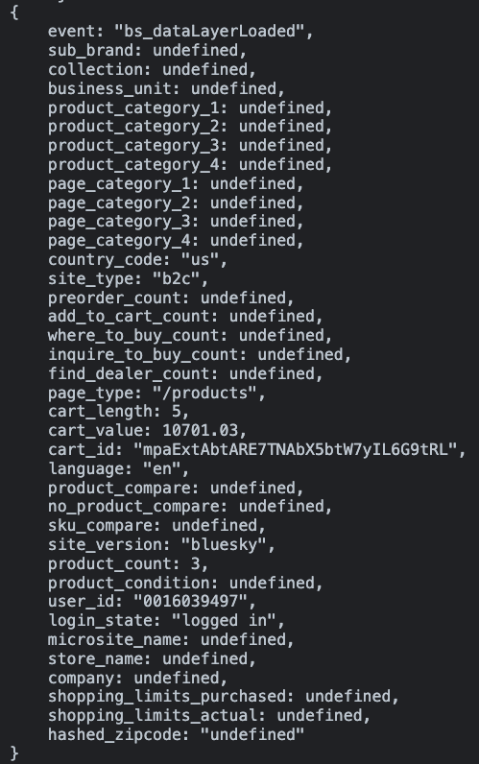

Spec vs on-page dataLayer for when the user loads the “Products” section of MyLG:
Key | Value | Pass | Note
event | "bs_dataLayerLoaded" | Y
sub_brand | undefined | Y | - We can only confirm if the formatting of this value is correct, we cannot confirm the value is correct
collection | undefined | Y | - We can only confirm if the formatting of this value is correct, we cannot confirm the value is correct
business_unit | undefined | Y | - We can only confirm if the formatting of this value is correct, we cannot confirm the value is correct
product_category_1 | undefined | Y | - We can only confirm if the formatting of this value is correct, we cannot confirm the value is correct
product_category_2 | undefined | Y | - We can only confirm if the formatting of this value is correct, we cannot confirm the value is correct
product_category_3 | undefined | Y | - We can only confirm if the formatting of this value is correct, we cannot confirm the value is correct
product_category_4 | undefined | Y | - We can only confirm if the formatting of this value is correct, we cannot confirm the value is correct
page_category_1 | undefined | Y | - We can only confirm if the formatting of this value is correct, we cannot confirm the value is correct
page_category_2 | undefined | Y | - We can only confirm if the formatting of this value is correct, we cannot confirm the value is correct
page_category_3 | undefined | Y | - We can only confirm if the formatting of this value is correct, we cannot confirm the value is correct
page_category_4 | undefined | Y | - We can only confirm if the formatting of this value is correct, we cannot confirm the value is correct
country_code | “us” | Y
site_type | “b2c” | Y
preorder_count | undefined | Y
add_to_cart_count | undefined | Y
where_to_buy_count | undefined | Y
inquire_to_buy_count | undefined | Y
find_dealer_count | undefined | Y
page_type | “/products” | Y | - We can only confirm if the formatting of this value is correct, we cannot confirm the value is correct
cart_length | 5 | Y
cart_value | 10701.03 | Y
cart_id | "mpaExtAbtARE7TNAbX5btW7yIL6G9tRL" | Y | - We can only confirm if the formatting of this value is correct, we cannot confirm the value is correct
language | “en” | Y
product_compare | undefined | Y
no_product_compare | undefined | Y
sku_compare | undefined | Y
site_vesrion | “bluesky” | Y
product_count | 3 | Y
product_condition | undefined | Y
user_id | "0016039497" | Y
login_state | “logged in” | Y
microsite_name | undefined | Y
store_name | undefined | Y
company | undefined | Y
shopping_limits_purchased | undefined | Y
shopping_limits_actual | undefined | Y
hash_zip_code | undefined | Y | - We can only confirm if the formatting of this value is correct, we cannot confirm the value is correct

Test Case #2:
On page dataLayer for when the user loads the product registration form page of MyLG:
The below screenshot is produced by the Adswerve chrome extension:
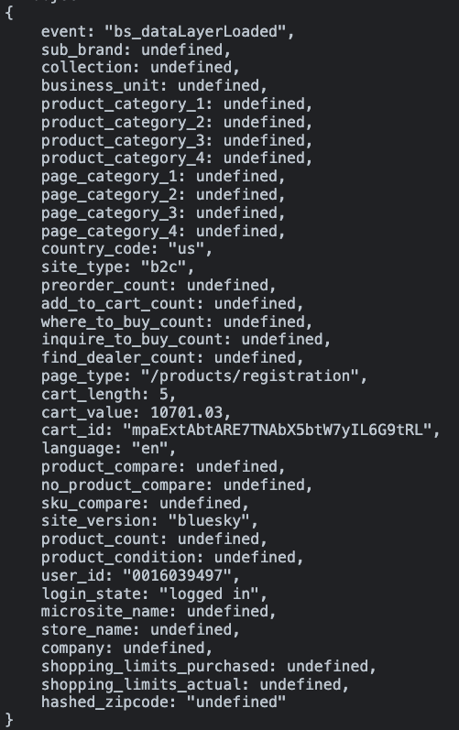

Spec vs on-page dataLayer for when the user loads the product registration form page of MyLG:
Key | Value | Pass | Note
event | "bs_dataLayerLoaded" | Y
sub_brand | undefined | Y | - We can only confirm if the formatting of this value is correct, we cannot confirm the value is correct
collection | undefined | Y | - We can only confirm if the formatting of this value is correct, we cannot confirm the value is correct
business_unit | undefined | Y | - We can only confirm if the formatting of this value is correct, we cannot confirm the value is correct
product_category_1 | undefined | Y | - We can only confirm if the formatting of this value is correct, we cannot confirm the value is correct
product_category_2 | undefined | Y | - We can only confirm if the formatting of this value is correct, we cannot confirm the value is correct
product_category_3 | undefined | Y | - We can only confirm if the formatting of this value is correct, we cannot confirm the value is correct
product_category_4 | undefined | Y | - We can only confirm if the formatting of this value is correct, we cannot confirm the value is correct
page_category_1 | undefined | Y | - We can only confirm if the formatting of this value is correct, we cannot confirm the value is correct
page_category_2 | undefined | Y | - We can only confirm if the formatting of this value is correct, we cannot confirm the value is correct
page_category_3 | undefined | Y | - We can only confirm if the formatting of this value is correct, we cannot confirm the value is correct
page_category_4 | undefined | Y | - We can only confirm if the formatting of this value is correct, we cannot confirm the value is correct
country_code | “us” | Y
site_type | “b2c” | Y
preorder_count | undefined | Y
add_to_cart_count | undefined | Y
where_to_buy_count | undefined | Y
inquire_to_buy_count | undefined | Y
find_dealer_count | undefined | Y
page_type | “/products/registration” | Y | - We can only confirm if the formatting of this value is correct, we cannot confirm the value is correct
cart_length | 5 | Y
cart_value | 10701.03 | Y
cart_id | "mpaExtAbtARE7TNAbX5btW7yIL6G9tRL" | Y | - We can only confirm if the formatting of this value is correct, we cannot confirm the value is correct
language | “en” | Y
product_compare | undefined | Y
no_product_compare | undefined | Y
sku_compare | undefined | Y
site_vesrion | “bluesky” | N
product_count | undefined | Y | - We can only confirm if the formatting of this value is correct, we cannot confirm the value is correct
product_condition | undefined | Y
user_id | "0016039497" | Y
login_state | “logged in” | Y
microsite_name | undefined | Y
store_name | undefined | Y
company | undefined | Y
shopping_limits_purchased | undefined | Y
shopping_limits_actual | undefined | Y
hash_zip_code | undefined | Y | - We can only confirm if the formatting of this value is correct, we cannot confirm the value is correct

On page dataLayer for when the user loads the product registration success page of MyLG:
The below screenshot is produced by the Adswerve chrome extension:
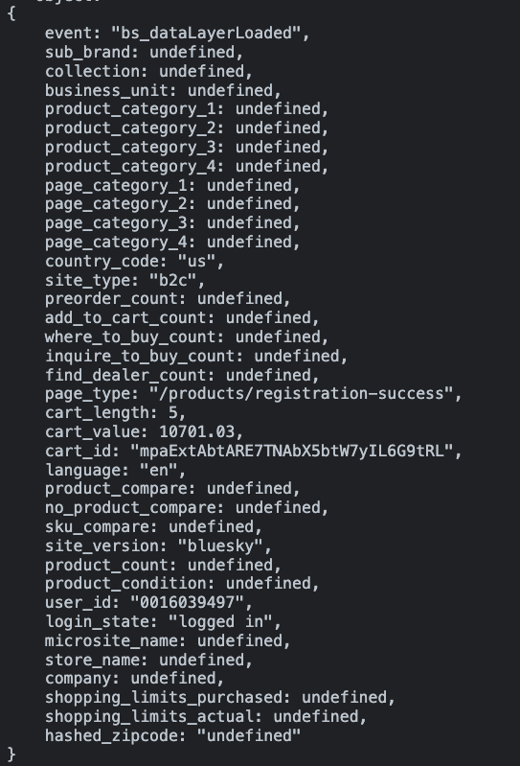

Spec vs on-page dataLayer for when the user loads the product registration success page of MyLG:
Key | Value | Pass | Note
event | "bs_dataLayerLoaded" | Y
sub_brand | undefined | Y | - We can only confirm if the formatting of this value is correct, we cannot confirm the value is correct
collection | undefined | Y | - We can only confirm if the formatting of this value is correct, we cannot confirm the value is correct
business_unit | undefined | Y | - We can only confirm if the formatting of this value is correct, we cannot confirm the value is correct
product_category_1 | undefined | Y | - We can only confirm if the formatting of this value is correct, we cannot confirm the value is correct
product_category_2 | undefined | Y | - We can only confirm if the formatting of this value is correct, we cannot confirm the value is correct
product_category_3 | undefined | Y | - We can only confirm if the formatting of this value is correct, we cannot confirm the value is correct
product_category_4 | undefined | Y | - We can only confirm if the formatting of this value is correct, we cannot confirm the value is correct
page_category_1 | undefined | Y | - We can only confirm if the formatting of this value is correct, we cannot confirm the value is correct
page_category_2 | undefined | Y | - We can only confirm if the formatting of this value is correct, we cannot confirm the value is correct
page_category_3 | undefined | Y | - We can only confirm if the formatting of this value is correct, we cannot confirm the value is correct
page_category_4 | undefined | Y | - We can only confirm if the formatting of this value is correct, we cannot confirm the value is correct
country_code | “us” | Y
site_type | “b2c” | Y
preorder_count | undefined | Y
add_to_cart_count | undefined | Y
where_to_buy_count | undefined | Y
inquire_to_buy_count | undefined | Y
find_dealer_count | undefined | Y
page_type | “/products/registration-success” | Y | - We can only confirm if the formatting of this value is correct, we cannot confirm the value is correct
cart_length | 5 | Y
cart_value | 10701.03 | Y
cart_id | "mpaExtAbtARE7TNAbX5btW7yIL6G9tRL" | Y | - We can only confirm if the formatting of this value is correct, we cannot confirm the value is correct
language | “en” | Y
product_compare | undefined | Y
no_product_compare | undefined | Y
sku_compare | undefined | Y
site_vesrion | “bluesky” | N
product_count | undefined | Y | - We can only confirm if the formatting of this value is correct, we cannot confirm the value is correct
product_condition | undefined | Y
user_id | "0016039497" | Y
login_state | “logged in” | Y
microsite_name | undefined | Y
store_name | undefined | Y
company | undefined | Y
shopping_limits_purchased | undefined | Y
shopping_limits_actual | undefined | Y
hash_zip_code | undefined | Y | - We can only confirm if the formatting of this value is correct, we cannot confirm the value is correct

Test Case #3:
On page dataLayer for when the user loads the “Orders” section of MyLG:
The below screenshot is produced by the Adswerve chrome extension:
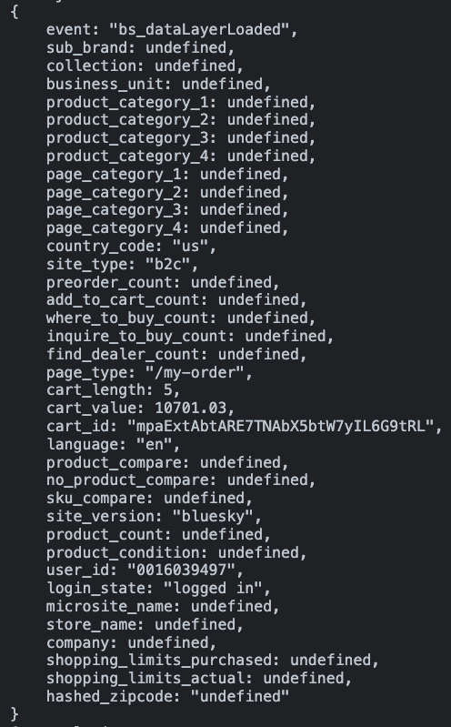

Spec vs on-page dataLayer for when the user loads the “Orders” section of MyLG:
Key | Value | Pass | Note
event | "bs_dataLayerLoaded" | Y
sub_brand | undefined | Y | - We can only confirm if the formatting of this value is correct, we cannot confirm the value is correct
collection | undefined | Y | - We can only confirm if the formatting of this value is correct, we cannot confirm the value is correct
business_unit | undefined | Y | - We can only confirm if the formatting of this value is correct, we cannot confirm the value is correct
product_category_1 | undefined | Y | - We can only confirm if the formatting of this value is correct, we cannot confirm the value is correct
product_category_2 | undefined | Y | - We can only confirm if the formatting of this value is correct, we cannot confirm the value is correct
product_category_3 | undefined | Y | - We can only confirm if the formatting of this value is correct, we cannot confirm the value is correct
product_category_4 | undefined | Y | - We can only confirm if the formatting of this value is correct, we cannot confirm the value is correct
page_category_1 | undefined | Y | - We can only confirm if the formatting of this value is correct, we cannot confirm the value is correct
page_category_2 | undefined | Y | - We can only confirm if the formatting of this value is correct, we cannot confirm the value is correct
page_category_3 | undefined | Y | - We can only confirm if the formatting of this value is correct, we cannot confirm the value is correct
page_category_4 | undefined | Y | - We can only confirm if the formatting of this value is correct, we cannot confirm the value is correct
country_code | “us” | Y
site_type | “b2c” | Y
preorder_count | undefined | Y
add_to_cart_count | undefined | Y
where_to_buy_count | undefined | Y
inquire_to_buy_count | undefined | Y
find_dealer_count | undefined | Y
page_type | “/my-order” | Y | - We can only confirm if the formatting of this value is correct, we cannot confirm the value is correct
cart_length | 5 | Y
cart_value | 10701.03 | Y
cart_id | "mpaExtAbtARE7TNAbX5btW7yIL6G9tRL" | Y | - We can only confirm if the formatting of this value is correct, we cannot confirm the value is correct
language | “en” | Y
product_compare | undefined | Y
no_product_compare | undefined | Y
sku_compare | undefined | Y
site_vesrion | “bluesky” | Y
product_count | undefined | Y
product_condition | undefined | Y
user_id | "0016039497" | Y
login_state | “logged in” | Y
microsite_name | undefined | Y
store_name | undefined | Y
company | undefined | Y
shopping_limits_purchased | undefined | Y
shopping_limits_actual | undefined | Y
hash_zip_code | undefined | Y | - We can only confirm if the formatting of this value is correct, we cannot confirm the value is correct

On page dataLayer for when the user loads an order details page of MyLG (below QA is out of date and unconfirmed because it was tested prior to 8/31/23 when MM had access to wwwstg.us.lg.com):
The below screenshot is produced by the Adswerve chrome extension:
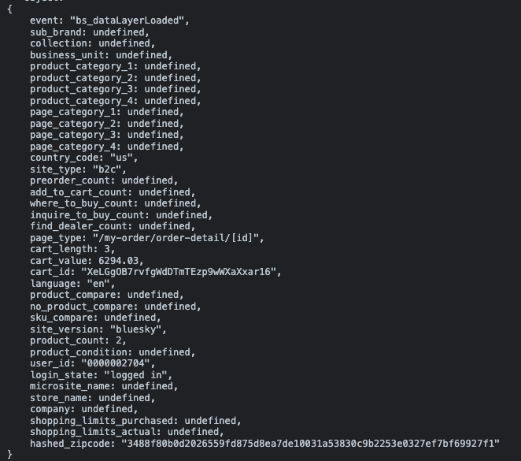

Spec vs on-page dataLayer for when the user loads an order details page of MyLG:
Key | Value | Pass | Note
event | "bs_dataLayerLoaded" | Y
sub_brand | undefined | Y | - We can only confirm if the formatting of this value is correct, we cannot confirm the value is correct
collection | undefined | Y | - We can only confirm if the formatting of this value is correct, we cannot confirm the value is correct
business_unit | undefined | Y | - We can only confirm if the formatting of this value is correct, we cannot confirm the value is correct
product_category_1 | undefined | Y | - We can only confirm if the formatting of this value is correct, we cannot confirm the value is correct
product_category_2 | undefined | Y | - We can only confirm if the formatting of this value is correct, we cannot confirm the value is correct
product_category_3 | undefined | Y | - We can only confirm if the formatting of this value is correct, we cannot confirm the value is correct
product_category_4 | undefined | Y | - We can only confirm if the formatting of this value is correct, we cannot confirm the value is correct
page_category_1 | undefined | Y | - We can only confirm if the formatting of this value is correct, we cannot confirm the value is correct
page_category_2 | undefined | Y | - We can only confirm if the formatting of this value is correct, we cannot confirm the value is correct
page_category_3 | undefined | Y | - We can only confirm if the formatting of this value is correct, we cannot confirm the value is correct
page_category_4 | undefined | Y | - We can only confirm if the formatting of this value is correct, we cannot confirm the value is correct
country_code | “us” | Y
site_type | “b2c” | Y
preorder_count | undefined | Y
add_to_cart_count | undefined | Y
where_to_buy_count | undefined | Y
inquire_to_buy_count | undefined | Y
find_dealer_count | undefined | Y
page_type | “/my-orde/order-detail/[id]” | Y | - We can only confirm if the formatting of this value is correct, we cannot confirm the value is correct
cart_length | 3 | Y
cart_value | 6294.03 | Y
cart_id | "XeLGgOB7rvfgWdDTmTEzp9wWXaXxar16" | Y | - We can only confirm if the formatting of this value is correct, we cannot confirm the value is correct
language | “en” | Y
product_compare | undefined | Y
no_product_compare | undefined | Y
sku_compare | undefined | Y
site_vesrion | “bluesky” | Y
product_count | 2 | Y
product_condition | undefined | Y
user_id | "0000002704" | Y
login_state | “logged in” | Y
microsite_name | undefined | Y
store_name | undefined | Y
company | undefined | Y
shopping_limits_purchased | undefined | Y
shopping_limits_actual | undefined | Y
hash_zip_code | "3488f80b0d2026559fd875d8ea7de10031a53830c9b2253e0327ef7bf69927f1" | Y | - We can only confirm if the formatting of this value is correct, we cannot confirm the value is correct

Test Case #4:
On page dataLayer for when the user loads the “Favorites” section of MyLG:
The below screenshot is produced by the Adswerve chrome extension:
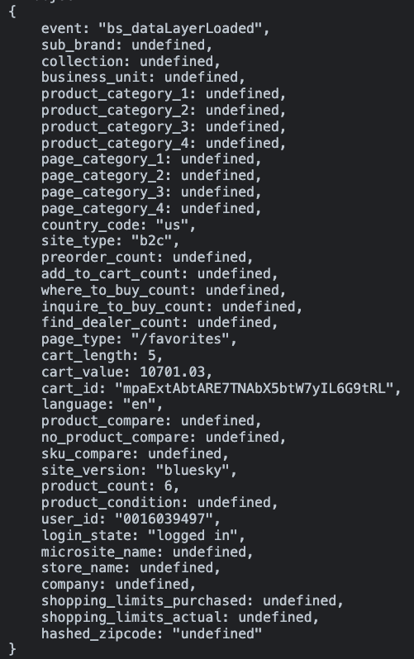

Spec vs on-page dataLayer for when the user loads the “Favorites” section of MyLG:
Key | Value | Pass | Note
event | "bs_dataLayerLoaded" | Y
sub_brand | undefined | Y | - We can only confirm if the formatting of this value is correct, we cannot confirm the value is correct
collection | undefined | Y | - We can only confirm if the formatting of this value is correct, we cannot confirm the value is correct
business_unit | undefined | Y | - We can only confirm if the formatting of this value is correct, we cannot confirm the value is correct
product_category_1 | undefined | Y | - We can only confirm if the formatting of this value is correct, we cannot confirm the value is correct
product_category_2 | undefined | Y | - We can only confirm if the formatting of this value is correct, we cannot confirm the value is correct
product_category_3 | undefined | Y | - We can only confirm if the formatting of this value is correct, we cannot confirm the value is correct
product_category_4 | undefined | Y | - We can only confirm if the formatting of this value is correct, we cannot confirm the value is correct
page_category_1 | undefined | Y | - We can only confirm if the formatting of this value is correct, we cannot confirm the value is correct
page_category_2 | undefined | Y | - We can only confirm if the formatting of this value is correct, we cannot confirm the value is correct
page_category_3 | undefined | Y | - We can only confirm if the formatting of this value is correct, we cannot confirm the value is correct
page_category_4 | undefined | Y | - We can only confirm if the formatting of this value is correct, we cannot confirm the value is correct
country_code | “us” | Y
site_type | “b2c” | Y
preorder_count | undefined | Y
add_to_cart_count | undefined | Y
where_to_buy_count | undefined | Y
inquire_to_buy_count | undefined | Y
find_dealer_count | undefined | Y
page_type | “/favorites” | Y | - We can only confirm if the formatting of this value is correct, we cannot confirm the value is correct
cart_length | 5 | Y
cart_value | 10701.03 | Y
cart_id | "mpaExtAbtARE7TNAbX5btW7yIL6G9tRL" | Y | - We can only confirm if the formatting of this value is correct, we cannot confirm the value is correct
language | “en” | Y
product_compare | undefined | Y
no_product_compare | undefined | Y
sku_compare | undefined | Y
site_vesrion | “bluesky” | Y
product_count | 2 | Y
product_condition | undefined | Y
user_id | "0016039497" | Y
login_state | “logged in” | Y
microsite_name | undefined | Y
store_name | undefined | Y
company | undefined | Y
shopping_limits_purchased | undefined | Y
shopping_limits_actual | undefined | Y
hash_zip_code | undefined | Y | - We can only confirm if the formatting of this value is correct, we cannot confirm the value is correct

Test Case #5:
On page dataLayer for when the user loads the “Subscriptions” section of MyLG:
The below screenshot is produced by the Adswerve chrome extension:
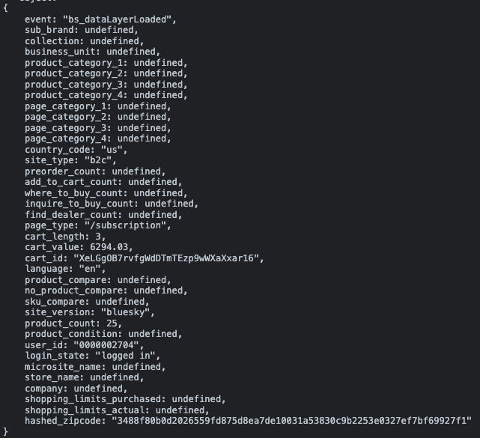

Spec vs on-page dataLayer for when the user loads the “Subscriptions” section of MyLG:
Key | Value | Pass | Note
event | "bs_dataLayerLoaded" | Y
sub_brand | undefined | Y | - We can only confirm if the formatting of this value is correct, we cannot confirm the value is correct
collection | undefined | Y | - We can only confirm if the formatting of this value is correct, we cannot confirm the value is correct
business_unit | undefined | Y | - We can only confirm if the formatting of this value is correct, we cannot confirm the value is correct
product_category_1 | undefined | Y | - We can only confirm if the formatting of this value is correct, we cannot confirm the value is correct
product_category_2 | undefined | Y | - We can only confirm if the formatting of this value is correct, we cannot confirm the value is correct
product_category_3 | undefined | Y | - We can only confirm if the formatting of this value is correct, we cannot confirm the value is correct
product_category_4 | undefined | Y | - We can only confirm if the formatting of this value is correct, we cannot confirm the value is correct
page_category_1 | undefined | Y | - We can only confirm if the formatting of this value is correct, we cannot confirm the value is correct
page_category_2 | undefined | Y | - We can only confirm if the formatting of this value is correct, we cannot confirm the value is correct
page_category_3 | undefined | Y | - We can only confirm if the formatting of this value is correct, we cannot confirm the value is correct
page_category_4 | undefined | Y | - We can only confirm if the formatting of this value is correct, we cannot confirm the value is correct
country_code | “us” | Y
site_type | “b2c” | Y
preorder_count | undefined | Y
add_to_cart_count | undefined | Y
where_to_buy_count | undefined | Y
inquire_to_buy_count | undefined | Y
find_dealer_count | undefined | Y
page_type | “/subscription” | Y | - We can only confirm if the formatting of this value is correct, we cannot confirm the value is correct
cart_length | 3 | Y
cart_value | 6294.03 | Y
cart_id | "XeLGgOB7rvfgWdDTmTEzp9wWXaXxar16" | Y | - We can only confirm if the formatting of this value is correct, we cannot confirm the value is correct
language | “en” | Y
product_compare | undefined | Y
no_product_compare | undefined | Y
sku_compare | undefined | Y
site_vesrion | “bluesky” | Y
product_count | 25 | Y
product_condition | undefined | Y
user_id | "0000002704" | Y
login_state | “logged in” | Y
microsite_name | undefined | Y
store_name | undefined | Y
company | undefined | Y
shopping_limits_purchased | undefined | Y
shopping_limits_actual | undefined | Y
hash_zip_code | "3488f80b0d2026559fd875d8ea7de10031a53830c9b2253e0327ef7bf69927f1" | Y | - We can only confirm if the formatting of this value is correct, we cannot confirm the value is correct

On page dataLayer for when the user loads a subscription details page of MyLG:
The below screenshot is produced by the Adswerve chrome extension:
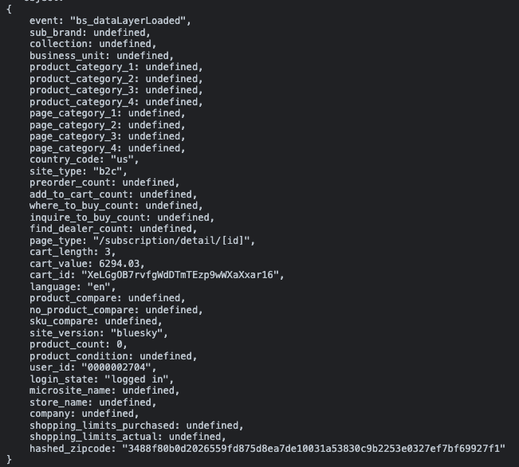

Spec vs on-page dataLayer for when the user loads a subscription details page of MyLG:
Key | Value | Pass | Note
event | "bs_dataLayerLoaded" | Y
sub_brand | undefined | Y | - We can only confirm if the formatting of this value is correct, we cannot confirm the value is correct
collection | undefined | Y | - We can only confirm if the formatting of this value is correct, we cannot confirm the value is correct
business_unit | undefined | Y | - We can only confirm if the formatting of this value is correct, we cannot confirm the value is correct
product_category_1 | undefined | Y | - We can only confirm if the formatting of this value is correct, we cannot confirm the value is correct
product_category_2 | undefined | Y | - We can only confirm if the formatting of this value is correct, we cannot confirm the value is correct
product_category_3 | undefined | Y | - We can only confirm if the formatting of this value is correct, we cannot confirm the value is correct
product_category_4 | undefined | Y | - We can only confirm if the formatting of this value is correct, we cannot confirm the value is correct
page_category_1 | undefined | Y | - We can only confirm if the formatting of this value is correct, we cannot confirm the value is correct
page_category_2 | undefined | Y | - We can only confirm if the formatting of this value is correct, we cannot confirm the value is correct
page_category_3 | undefined | Y | - We can only confirm if the formatting of this value is correct, we cannot confirm the value is correct
page_category_4 | undefined | Y | - We can only confirm if the formatting of this value is correct, we cannot confirm the value is correct
country_code | “us” | Y
site_type | “b2c” | Y
preorder_count | undefined | Y
add_to_cart_count | undefined | Y
where_to_buy_count | undefined | Y
inquire_to_buy_count | undefined | Y
find_dealer_count | undefined | Y
page_type | “/subscription/detail/[id]” | Y | - We can only confirm if the formatting of this value is correct, we cannot confirm the value is correct
cart_length | 3 | Y
cart_value | 6294.03 | Y
cart_id | "XeLGgOB7rvfgWdDTmTEzp9wWXaXxar16" | Y | - We can only confirm if the formatting of this value is correct, we cannot confirm the value is correct
language | “en” | Y
product_compare | undefined | Y
no_product_compare | undefined | Y
sku_compare | undefined | Y
site_vesrion | “bluesky” | Y
product_count | 0 | N | - Please set this value to the total number of subscription products and their chosen subscription option. In this test case, since “LG LT500P - 6 Month / 500 Gallon Capacity Replacement Refrigerator Water Filter (NSF42*)” is the only product in the subscription, product_count should be set to 2. One for the single water filter and one for the 6 month subscription option
product_condition | undefined | Y
user_id | "0000002704" | Y
login_state | “logged in” | Y
microsite_name | undefined | Y
store_name | undefined | Y
company | undefined | Y
shopping_limits_purchased | undefined | Y
shopping_limits_actual | undefined | Y
hash_zip_code | "3488f80b0d2026559fd875d8ea7de10031a53830c9b2253e0327ef7bf69927f1" | Y | - We can only confirm if the formatting of this value is correct, we cannot confirm the value is correct

On page dataLayer for when the user loads an edit subscription page of MyLG:
The below screenshot is produced by the Adswerve chrome extension:
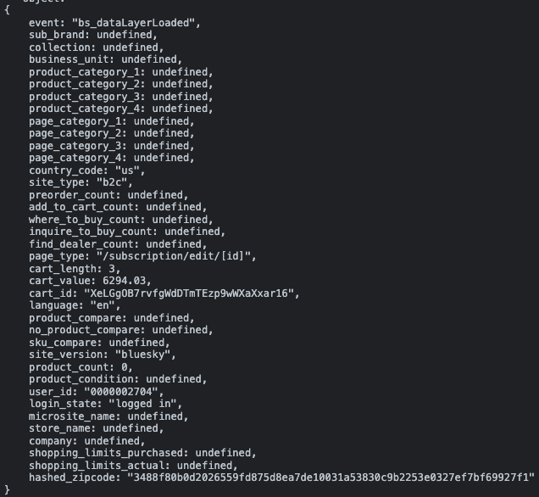

Spec vs on-page dataLayer for when the user loads an edit subscription page of MyLG:
Key | Value | Pass | Note
event | "bs_dataLayerLoaded" | Y
sub_brand | undefined | Y | - We can only confirm if the formatting of this value is correct, we cannot confirm the value is correct
collection | undefined | Y | - We can only confirm if the formatting of this value is correct, we cannot confirm the value is correct
business_unit | undefined | Y | - We can only confirm if the formatting of this value is correct, we cannot confirm the value is correct
product_category_1 | undefined | Y | - We can only confirm if the formatting of this value is correct, we cannot confirm the value is correct
product_category_2 | undefined | Y | - We can only confirm if the formatting of this value is correct, we cannot confirm the value is correct
product_category_3 | undefined | Y | - We can only confirm if the formatting of this value is correct, we cannot confirm the value is correct
product_category_4 | undefined | Y | - We can only confirm if the formatting of this value is correct, we cannot confirm the value is correct
page_category_1 | undefined | Y | - We can only confirm if the formatting of this value is correct, we cannot confirm the value is correct
page_category_2 | undefined | Y | - We can only confirm if the formatting of this value is correct, we cannot confirm the value is correct
page_category_3 | undefined | Y | - We can only confirm if the formatting of this value is correct, we cannot confirm the value is correct
page_category_4 | undefined | Y | - We can only confirm if the formatting of this value is correct, we cannot confirm the value is correct
country_code | “us” | Y
site_type | “b2c” | Y
preorder_count | undefined | Y
add_to_cart_count | undefined | Y
where_to_buy_count | undefined | Y
inquire_to_buy_count | undefined | Y
find_dealer_count | undefined | Y
page_type | “/subscription/edit/[id]” | Y | - We can only confirm if the formatting of this value is correct, we cannot confirm the value is correct
cart_length | 3 | Y
cart_value | 6294.03 | Y
cart_id | "XeLGgOB7rvfgWdDTmTEzp9wWXaXxar16" | Y | - We can only confirm if the formatting of this value is correct, we cannot confirm the value is correct
language | “en” | Y
product_compare | undefined | Y
no_product_compare | undefined | Y
sku_compare | undefined | Y
site_vesrion | “bluesky” | Y
product_count | 0 | N | - Please set this value to the total number of subscription products and the chosen subscription option. In this test case, since “LG LT500P - 6 Month / 500 Gallon Capacity Replacement Refrigerator Water Filter (NSF42*)” is the only product in the subscription, product_count should be set to 2. One for the single water filter and one for the 6 month subscription option
product_condition | undefined | Y
user_id | "0000002704" | Y
login_state | “logged in” | Y
microsite_name | undefined | Y
store_name | undefined | Y
company | undefined | Y
shopping_limits_purchased | undefined | Y
shopping_limits_actual | undefined | Y
hash_zip_code | "3488f80b0d2026559fd875d8ea7de10031a53830c9b2253e0327ef7bf69927f1" | Y | - We can only confirm if the formatting of this value is correct, we cannot confirm the value is correct

Test Case #6:
On page dataLayer for when the user loads the “Repair Requests” section that lists no products of MyLG section:
The below screenshot is produced by the Adswerve chrome extension:
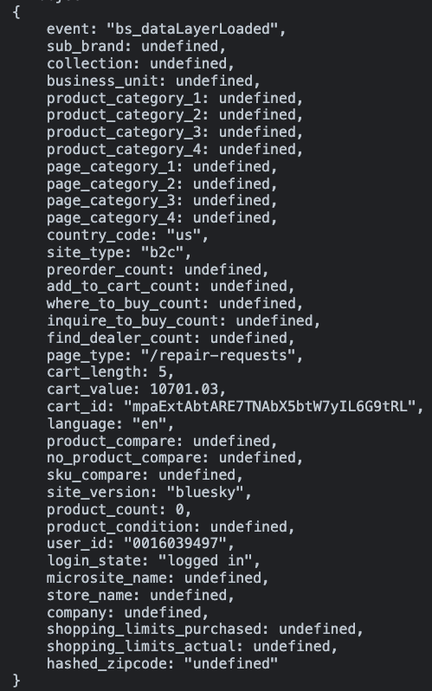

Spec vs on-page dataLayer for when the user loads the “Repair Requests” section that lists no products of MyLG:
Key | Value | Pass | Note
event | "bs_dataLayerLoaded" | Y
sub_brand | undefined | Y | - We can only confirm if the formatting of this value is correct, we cannot confirm the value is correct
collection | undefined | Y | - We can only confirm if the formatting of this value is correct, we cannot confirm the value is correct
business_unit | undefined | Y | - We can only confirm if the formatting of this value is correct, we cannot confirm the value is correct
product_category_1 | undefined | Y | - We can only confirm if the formatting of this value is correct, we cannot confirm the value is correct
product_category_2 | undefined | Y | - We can only confirm if the formatting of this value is correct, we cannot confirm the value is correct
product_category_3 | undefined | Y | - We can only confirm if the formatting of this value is correct, we cannot confirm the value is correct
product_category_4 | undefined | Y | - We can only confirm if the formatting of this value is correct, we cannot confirm the value is correct
page_category_1 | undefined | Y | - We can only confirm if the formatting of this value is correct, we cannot confirm the value is correct
page_category_2 | undefined | Y | - We can only confirm if the formatting of this value is correct, we cannot confirm the value is correct
page_category_3 | undefined | Y | - We can only confirm if the formatting of this value is correct, we cannot confirm the value is correct
page_category_4 | undefined | Y | - We can only confirm if the formatting of this value is correct, we cannot confirm the value is correct
country_code | “us” | Y
site_type | “b2c” | Y
preorder_count | undefined | Y
add_to_cart_count | undefined | Y
where_to_buy_count | undefined | Y
inquire_to_buy_count | undefined | Y
find_dealer_count | undefined | Y
page_type | “/repair-requests” | Y | - We can only confirm if the formatting of this value is correct, we cannot confirm the value is correct
cart_length | 5 | Y
cart_value | 10701.03 | Y
cart_id | "mpaExtAbtARE7TNAbX5btW7yIL6G9tRL" | Y | - We can only confirm if the formatting of this value is correct, we cannot confirm the value is correct
language | “en” | Y
product_compare | undefined | Y
no_product_compare | undefined | Y
sku_compare | undefined | Y
site_vesrion | “bluesky” | Y
product_count | 0 | Y
product_condition | undefined | Y
user_id | "0016039497" | Y
login_state | “logged in” | Y
microsite_name | undefined | Y
store_name | undefined | Y
company | undefined | Y
shopping_limits_purchased | undefined | Y
shopping_limits_actual | undefined | Y
hash_zip_code | undefined | Y | - We can only confirm if the formatting of this value is correct, we cannot confirm the value is correct

Test Case #7:
On page dataLayer for when the user loads the “Ask Us” section of MyLG:
The below screenshot is produced by the Adswerve chrome extension:
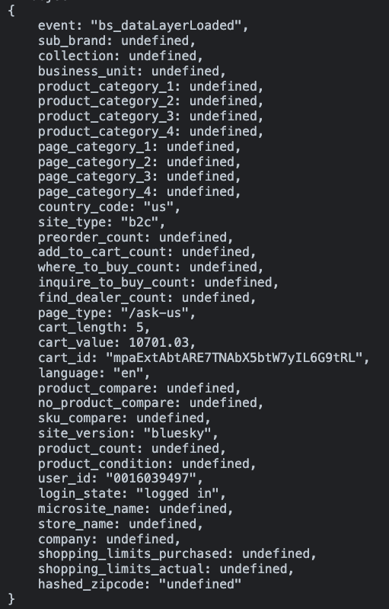

Spec vs on-page dataLayer for when the user loads the “Ask Us” section of MyLG:
Key | Value | Pass | Note
event | "bs_dataLayerLoaded" | Y
sub_brand | undefined | Y | - We can only confirm if the formatting of this value is correct, we cannot confirm the value is correct
collection | undefined | Y | - We can only confirm if the formatting of this value is correct, we cannot confirm the value is correct
business_unit | undefined | Y | - We can only confirm if the formatting of this value is correct, we cannot confirm the value is correct
product_category_1 | undefined | Y | - We can only confirm if the formatting of this value is correct, we cannot confirm the value is correct
product_category_2 | undefined | Y | - We can only confirm if the formatting of this value is correct, we cannot confirm the value is correct
product_category_3 | undefined | Y | - We can only confirm if the formatting of this value is correct, we cannot confirm the value is correct
product_category_4 | undefined | Y | - We can only confirm if the formatting of this value is correct, we cannot confirm the value is correct
page_category_1 | undefined | Y | - We can only confirm if the formatting of this value is correct, we cannot confirm the value is correct
page_category_2 | undefined | Y | - We can only confirm if the formatting of this value is correct, we cannot confirm the value is correct
page_category_3 | undefined | Y | - We can only confirm if the formatting of this value is correct, we cannot confirm the value is correct
page_category_4 | undefined | Y | - We can only confirm if the formatting of this value is correct, we cannot confirm the value is correct
country_code | “us” | Y
site_type | “b2c” | Y
preorder_count | undefined | Y
add_to_cart_count | undefined | Y
where_to_buy_count | undefined | Y
inquire_to_buy_count | undefined | Y
find_dealer_count | undefined | Y
page_type | “/ask-us” | Y | - We can only confirm if the formatting of this value is correct, we cannot confirm the value is correct
cart_length | 5 | Y
cart_value | 10701.03 | Y
cart_id | "mpaExtAbtARE7TNAbX5btW7yIL6G9tRL" | Y | - We can only confirm if the formatting of this value is correct, we cannot confirm the value is correct
language | “en” | Y
product_compare | undefined | Y
no_product_compare | undefined | Y
sku_compare | undefined | Y
site_vesrion | “bluesky” | Y
product_count | 0 | Y
product_condition | undefined | Y
user_id | "0016039497" | Y
login_state | “logged in” | Y
microsite_name | undefined | Y
store_name | undefined | Y
company | undefined | Y
shopping_limits_purchased | undefined | Y
shopping_limits_actual | undefined | Y
hash_zip_code | undefined | Y | - We can only confirm if the formatting of this value is correct, we cannot confirm the value is correct

On page dataLayer for when the user loads an inquiry details page of MyLG:
The below screenshot is produced by the Adswerve chrome extension:
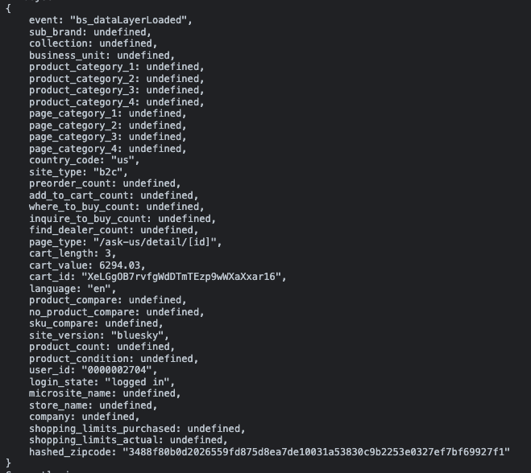

Spec vs on-page dataLayer for when the user loads an inquiry details page of MyLG:
Key | Value | Pass | Note
event | "bs_dataLayerLoaded" | Y
sub_brand | undefined | Y | - We can only confirm if the formatting of this value is correct, we cannot confirm the value is correct
collection | undefined | Y | - We can only confirm if the formatting of this value is correct, we cannot confirm the value is correct
business_unit | undefined | Y | - We can only confirm if the formatting of this value is correct, we cannot confirm the value is correct
product_category_1 | undefined | Y | - We can only confirm if the formatting of this value is correct, we cannot confirm the value is correct
product_category_2 | undefined | Y | - We can only confirm if the formatting of this value is correct, we cannot confirm the value is correct
product_category_3 | undefined | Y | - We can only confirm if the formatting of this value is correct, we cannot confirm the value is correct
product_category_4 | undefined | Y | - We can only confirm if the formatting of this value is correct, we cannot confirm the value is correct
page_category_1 | undefined | Y | - We can only confirm if the formatting of this value is correct, we cannot confirm the value is correct
page_category_2 | undefined | Y | - We can only confirm if the formatting of this value is correct, we cannot confirm the value is correct
page_category_3 | undefined | Y | - We can only confirm if the formatting of this value is correct, we cannot confirm the value is correct
page_category_4 | undefined | Y | - We can only confirm if the formatting of this value is correct, we cannot confirm the value is correct
country_code | “us” | Y
site_type | “b2c” | Y
preorder_count | undefined | Y
add_to_cart_count | undefined | Y
where_to_buy_count | undefined | Y
inquire_to_buy_count | undefined | Y
find_dealer_count | undefined | Y
page_type | “/ask-us/detail/[id]” | Y | - We can only confirm if the formatting of this value is correct, we cannot confirm the value is correct
cart_length | 3 | Y
cart_value | 6294.03 | Y
cart_id | "XeLGgOB7rvfgWdDTmTEzp9wWXaXxar16" | Y | - We can only confirm if the formatting of this value is correct, we cannot confirm the value is correct
language | “en” | Y
product_compare | undefined | Y
no_product_compare | undefined | Y
sku_compare | undefined | Y
site_vesrion | “bluesky” | Y
product_count | undefined | Y
product_condition | undefined | Y
user_id | "0000002704" | Y
login_state | “logged in” | Y
microsite_name | undefined | Y
store_name | undefined | Y
company | undefined | Y
shopping_limits_purchased | undefined | Y
shopping_limits_actual | undefined | Y
hash_zip_code | "3488f80b0d2026559fd875d8ea7de10031a53830c9b2253e0327ef7bf69927f1" | Y | - We can only confirm if the formatting of this value is correct, we cannot confirm the value is correct

Test Case #8:
On page dataLayer for when the user loads the “FAQ” section of MyLG:
The below screenshot is produced by the Adswerve chrome extension:
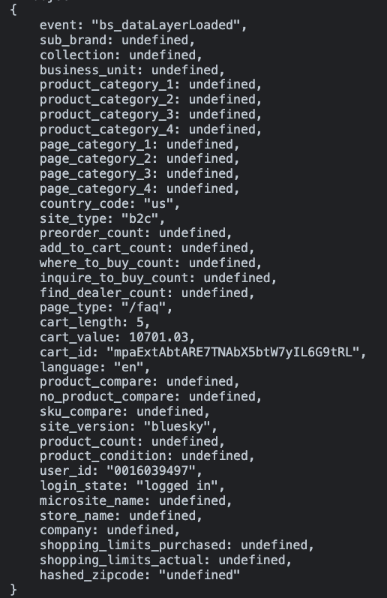

Spec vs on-page dataLayer for when the user loads the “FAQ” section of MyLG:
Key | Value | Pass | Note
event | "bs_dataLayerLoaded" | Y
sub_brand | undefined | Y | - We can only confirm if the formatting of this value is correct, we cannot confirm the value is correct
collection | undefined | Y | - We can only confirm if the formatting of this value is correct, we cannot confirm the value is correct
business_unit | undefined | Y | - We can only confirm if the formatting of this value is correct, we cannot confirm the value is correct
product_category_1 | undefined | Y | - We can only confirm if the formatting of this value is correct, we cannot confirm the value is correct
product_category_2 | undefined | Y | - We can only confirm if the formatting of this value is correct, we cannot confirm the value is correct
product_category_3 | undefined | Y | - We can only confirm if the formatting of this value is correct, we cannot confirm the value is correct
product_category_4 | undefined | Y | - We can only confirm if the formatting of this value is correct, we cannot confirm the value is correct
page_category_1 | undefined | Y | - We can only confirm if the formatting of this value is correct, we cannot confirm the value is correct
page_category_2 | undefined | Y | - We can only confirm if the formatting of this value is correct, we cannot confirm the value is correct
page_category_3 | undefined | Y | - We can only confirm if the formatting of this value is correct, we cannot confirm the value is correct
page_category_4 | undefined | Y | - We can only confirm if the formatting of this value is correct, we cannot confirm the value is correct
country_code | “us” | Y
site_type | “b2c” | Y
preorder_count | undefined | Y
add_to_cart_count | undefined | Y
where_to_buy_count | undefined | Y
inquire_to_buy_count | undefined | Y
find_dealer_count | undefined | Y
page_type | “/faq” | Y | - We can only confirm if the formatting of this value is correct, we cannot confirm the value is correct
cart_length | 5 | Y
cart_value | 10701.03 | Y
cart_id | "mpaExtAbtARE7TNAbX5btW7yIL6G9tRL" | Y | - We can only confirm if the formatting of this value is correct, we cannot confirm the value is correct
language | “en” | Y
product_compare | undefined | Y
no_product_compare | undefined | Y
sku_compare | undefined | Y
site_vesrion | “bluesky” | Y
product_count | 0 | Y
product_condition | undefined | Y
user_id | "0016039497" | Y
login_state | “logged in” | Y
microsite_name | undefined | Y
store_name | undefined | Y
company | undefined | Y
shopping_limits_purchased | undefined | Y
shopping_limits_actual | undefined | Y
hash_zip_code | undefined | Y | - We can only confirm if the formatting of this value is correct, we cannot confirm the value is correct

Test Case #9:
On page dataLayer for when the user loads the “Contact Us” section of MyLG:
The below screenshot is produced by the Adswerve chrome extension:
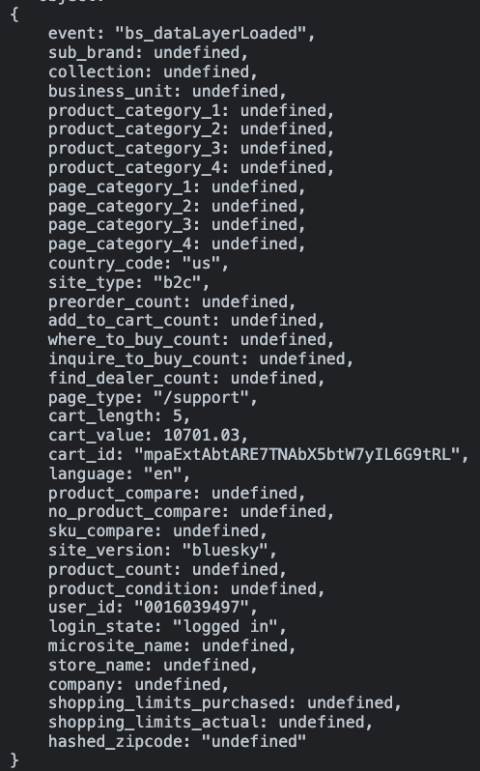

Spec vs on-page dataLayer for when the user loads the “Contact Us” section of MyLG:
Key | Value | Pass | Note
event | "bs_dataLayerLoaded" | Y
sub_brand | undefined | Y | - We can only confirm if the formatting of this value is correct, we cannot confirm the value is correct
collection | undefined | Y | - We can only confirm if the formatting of this value is correct, we cannot confirm the value is correct
business_unit | undefined | Y | - We can only confirm if the formatting of this value is correct, we cannot confirm the value is correct
product_category_1 | undefined | Y | - We can only confirm if the formatting of this value is correct, we cannot confirm the value is correct
product_category_2 | undefined | Y | - We can only confirm if the formatting of this value is correct, we cannot confirm the value is correct
product_category_3 | undefined | Y | - We can only confirm if the formatting of this value is correct, we cannot confirm the value is correct
product_category_4 | undefined | Y | - We can only confirm if the formatting of this value is correct, we cannot confirm the value is correct
page_category_1 | undefined | Y | - We can only confirm if the formatting of this value is correct, we cannot confirm the value is correct
page_category_2 | undefined | Y | - We can only confirm if the formatting of this value is correct, we cannot confirm the value is correct
page_category_3 | undefined | Y | - We can only confirm if the formatting of this value is correct, we cannot confirm the value is correct
page_category_4 | undefined | Y | - We can only confirm if the formatting of this value is correct, we cannot confirm the value is correct
country_code | “us” | Y
site_type | “b2c” | Y
preorder_count | undefined | Y
add_to_cart_count | undefined | Y
where_to_buy_count | undefined | Y
inquire_to_buy_count | undefined | Y
find_dealer_count | undefined | Y
page_type | “/support” | Y | - We can only confirm if the formatting of this value is correct, we cannot confirm the value is correct
cart_length | 5 | Y
cart_value | 10701.03 | Y
cart_id | "mpaExtAbtARE7TNAbX5btW7yIL6G9tRL" | Y | - We can only confirm if the formatting of this value is correct, we cannot confirm the value is correct
language | “en” | Y
product_compare | undefined | Y
no_product_compare | undefined | Y
sku_compare | undefined | Y
site_vesrion | “bluesky” | Y
product_count | 0 | Y
product_condition | undefined | Y
user_id | "0016039497" | Y
login_state | “logged in” | Y
microsite_name | undefined | Y
store_name | undefined | Y
company | undefined | Y
shopping_limits_purchased | undefined | Y
shopping_limits_actual | undefined | Y
hash_zip_code | undefined | Y | - We can only confirm if the formatting of this value is correct, we cannot confirm the value is correct

Test Case #10:
On page dataLayer for when the user loads the “Profile” section of MyLG:
The below screenshot is produced by the Adswerve chrome extension:
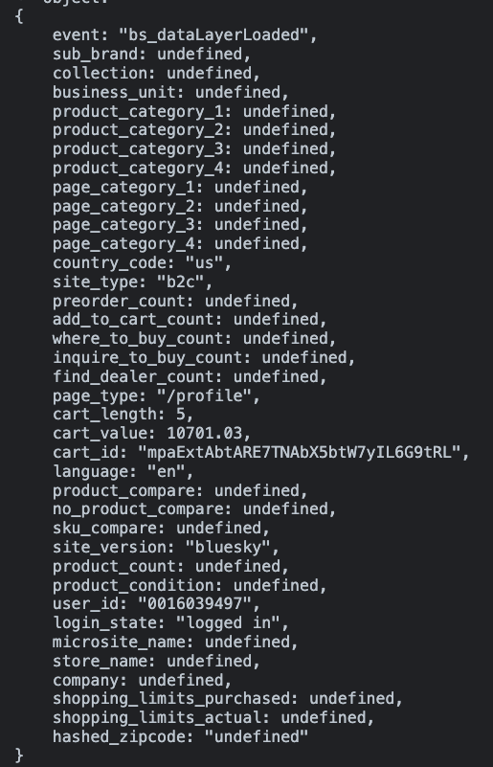

Spec vs on-page dataLayer for when the user loads the “Profile” section of MyLG:
Key | Value | Pass | Note
event | "bs_dataLayerLoaded" | Y
sub_brand | undefined | Y | - We can only confirm if the formatting of this value is correct, we cannot confirm the value is correct
collection | undefined | Y | - We can only confirm if the formatting of this value is correct, we cannot confirm the value is correct
business_unit | undefined | Y | - We can only confirm if the formatting of this value is correct, we cannot confirm the value is correct
product_category_1 | undefined | Y | - We can only confirm if the formatting of this value is correct, we cannot confirm the value is correct
product_category_2 | undefined | Y | - We can only confirm if the formatting of this value is correct, we cannot confirm the value is correct
product_category_3 | undefined | Y | - We can only confirm if the formatting of this value is correct, we cannot confirm the value is correct
product_category_4 | undefined | Y | - We can only confirm if the formatting of this value is correct, we cannot confirm the value is correct
page_category_1 | undefined | Y | - We can only confirm if the formatting of this value is correct, we cannot confirm the value is correct
page_category_2 | undefined | Y | - We can only confirm if the formatting of this value is correct, we cannot confirm the value is correct
page_category_3 | undefined | Y | - We can only confirm if the formatting of this value is correct, we cannot confirm the value is correct
page_category_4 | undefined | Y | - We can only confirm if the formatting of this value is correct, we cannot confirm the value is correct
country_code | “us” | Y
site_type | “b2c” | Y
preorder_count | undefined | Y
add_to_cart_count | undefined | Y
where_to_buy_count | undefined | Y
inquire_to_buy_count | undefined | Y
find_dealer_count | undefined | Y
page_type | “/profile” | Y | - We can only confirm if the formatting of this value is correct, we cannot confirm the value is correct
cart_length | 5 | Y
cart_value | 10701.03 | Y
cart_id | "mpaExtAbtARE7TNAbX5btW7yIL6G9tRL" | Y | - We can only confirm if the formatting of this value is correct, we cannot confirm the value is correct
language | “en” | Y
product_compare | undefined | Y
no_product_compare | undefined | Y
sku_compare | undefined | Y
site_vesrion | “bluesky” | Y
product_count | 0 | Y
product_condition | undefined | Y
user_id | "0016039497" | Y
login_state | “logged in” | Y
microsite_name | undefined | Y
store_name | undefined | Y
company | undefined | Y
shopping_limits_purchased | undefined | Y
shopping_limits_actual | undefined | Y
hash_zip_code | undefined | Y | - We can only confirm if the formatting of this value is correct, we cannot confirm the value is correct

On page dataLayer for when the user loads the “Edit Profile” section of MyLG:
The below screenshot is produced by the Adswerve chrome extension:
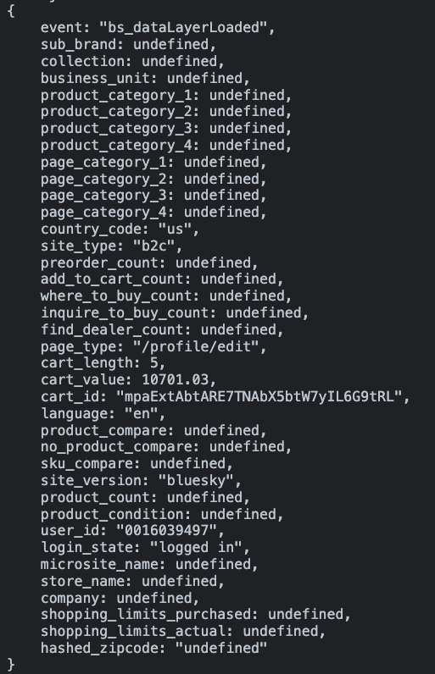

Spec vs on-page dataLayer for when the user loads the “Edit Profile” section of MyLG:
Key | Value | Pass | Note
event | "bs_dataLayerLoaded" | Y
sub_brand | undefined | Y | - We can only confirm if the formatting of this value is correct, we cannot confirm the value is correct
collection | undefined | Y | - We can only confirm if the formatting of this value is correct, we cannot confirm the value is correct
business_unit | undefined | Y | - We can only confirm if the formatting of this value is correct, we cannot confirm the value is correct
product_category_1 | undefined | Y | - We can only confirm if the formatting of this value is correct, we cannot confirm the value is correct
product_category_2 | undefined | Y | - We can only confirm if the formatting of this value is correct, we cannot confirm the value is correct
product_category_3 | undefined | Y | - We can only confirm if the formatting of this value is correct, we cannot confirm the value is correct
product_category_4 | undefined | Y | - We can only confirm if the formatting of this value is correct, we cannot confirm the value is correct
page_category_1 | undefined | Y | - We can only confirm if the formatting of this value is correct, we cannot confirm the value is correct
page_category_2 | undefined | Y | - We can only confirm if the formatting of this value is correct, we cannot confirm the value is correct
page_category_3 | undefined | Y | - We can only confirm if the formatting of this value is correct, we cannot confirm the value is correct
page_category_4 | undefined | Y | - We can only confirm if the formatting of this value is correct, we cannot confirm the value is correct
country_code | “us” | Y
site_type | “b2c” | Y
preorder_count | undefined | Y
add_to_cart_count | undefined | Y
where_to_buy_count | undefined | Y
inquire_to_buy_count | undefined | Y
find_dealer_count | undefined | Y
page_type | “/profile/edit” | Y | - We can only confirm if the formatting of this value is correct, we cannot confirm the value is correct
cart_length | 5 | Y
cart_value | 10701.03 | Y
cart_id | "mpaExtAbtARE7TNAbX5btW7yIL6G9tRL" | Y | - We can only confirm if the formatting of this value is correct, we cannot confirm the value is correct
language | “en” | Y
product_compare | undefined | Y
no_product_compare | undefined | Y
sku_compare | undefined | Y
site_vesrion | “bluesky” | Y
product_count | 0 | Y
product_condition | undefined | Y
user_id | "0016039497" | Y
login_state | “logged in” | Y
microsite_name | undefined | Y
store_name | undefined | Y
company | undefined | Y
shopping_limits_purchased | undefined | Y
shopping_limits_actual | undefined | Y
hash_zip_code | undefined | Y | - We can only confirm if the formatting of this value is correct, we cannot confirm the value is correct

Test Case #11:
On page dataLayer for when the user loads the “Address Book” section of MyLG:
The below screenshot is produced by the Adswerve chrome extension:
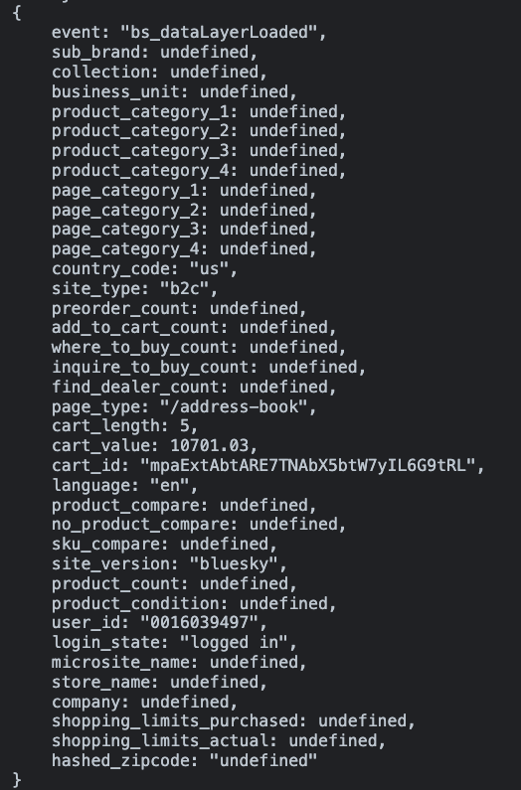

Spec vs on-page dataLayer for when the user loads the “Address Book” section of MyLG:
Key | Value | Pass | Note
event | "bs_dataLayerLoaded" | Y
sub_brand | undefined | Y | - We can only confirm if the formatting of this value is correct, we cannot confirm the value is correct
collection | undefined | Y | - We can only confirm if the formatting of this value is correct, we cannot confirm the value is correct
business_unit | undefined | Y | - We can only confirm if the formatting of this value is correct, we cannot confirm the value is correct
product_category_1 | undefined | Y | - We can only confirm if the formatting of this value is correct, we cannot confirm the value is correct
product_category_2 | undefined | Y | - We can only confirm if the formatting of this value is correct, we cannot confirm the value is correct
product_category_3 | undefined | Y | - We can only confirm if the formatting of this value is correct, we cannot confirm the value is correct
product_category_4 | undefined | Y | - We can only confirm if the formatting of this value is correct, we cannot confirm the value is correct
page_category_1 | undefined | Y | - We can only confirm if the formatting of this value is correct, we cannot confirm the value is correct
page_category_2 | undefined | Y | - We can only confirm if the formatting of this value is correct, we cannot confirm the value is correct
page_category_3 | undefined | Y | - We can only confirm if the formatting of this value is correct, we cannot confirm the value is correct
page_category_4 | undefined | Y | - We can only confirm if the formatting of this value is correct, we cannot confirm the value is correct
country_code | “us” | Y
site_type | “b2c” | Y
preorder_count | undefined | Y
add_to_cart_count | undefined | Y
where_to_buy_count | undefined | Y
inquire_to_buy_count | undefined | Y
find_dealer_count | undefined | Y
page_type | “/address-book” | Y | - We can only confirm if the formatting of this value is correct, we cannot confirm the value is correct
cart_length | 5 | Y
cart_value | 10701.03 | Y
cart_id | "mpaExtAbtARE7TNAbX5btW7yIL6G9tRL" | Y | - We can only confirm if the formatting of this value is correct, we cannot confirm the value is correct
language | “en” | Y
product_compare | undefined | Y
no_product_compare | undefined | Y
sku_compare | undefined | Y
site_vesrion | “bluesky” | Y
product_count | 0 | Y
product_condition | undefined | Y
user_id | "0016039497" | Y
login_state | “logged in” | Y
microsite_name | undefined | Y
store_name | undefined | Y
company | undefined | Y
shopping_limits_purchased | undefined | Y
shopping_limits_actual | undefined | Y
hash_zip_code | undefined | Y | - We can only confirm if the formatting of this value is correct, we cannot confirm the value is correct

On page dataLayer for when the user loads an add new address page of MyLG:
The below screenshot is produced by the Adswerve chrome extension:
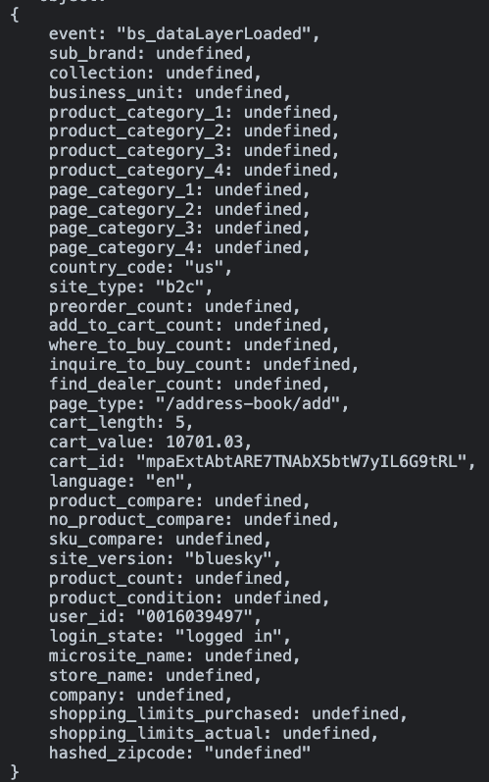

Spec vs on-page dataLayer for when the user loads an add new address page of MyLG:
Key | Value | Pass | Note
event | "bs_dataLayerLoaded" | Y
sub_brand | undefined | Y | - We can only confirm if the formatting of this value is correct, we cannot confirm the value is correct
collection | undefined | Y | - We can only confirm if the formatting of this value is correct, we cannot confirm the value is correct
business_unit | undefined | Y | - We can only confirm if the formatting of this value is correct, we cannot confirm the value is correct
product_category_1 | undefined | Y | - We can only confirm if the formatting of this value is correct, we cannot confirm the value is correct
product_category_2 | undefined | Y | - We can only confirm if the formatting of this value is correct, we cannot confirm the value is correct
product_category_3 | undefined | Y | - We can only confirm if the formatting of this value is correct, we cannot confirm the value is correct
product_category_4 | undefined | Y | - We can only confirm if the formatting of this value is correct, we cannot confirm the value is correct
page_category_1 | undefined | Y | - We can only confirm if the formatting of this value is correct, we cannot confirm the value is correct
page_category_2 | undefined | Y | - We can only confirm if the formatting of this value is correct, we cannot confirm the value is correct
page_category_3 | undefined | Y | - We can only confirm if the formatting of this value is correct, we cannot confirm the value is correct
page_category_4 | undefined | Y | - We can only confirm if the formatting of this value is correct, we cannot confirm the value is correct
country_code | “us” | Y
site_type | “b2c” | Y
preorder_count | undefined | Y
add_to_cart_count | undefined | Y
where_to_buy_count | undefined | Y
inquire_to_buy_count | undefined | Y
find_dealer_count | undefined | Y
page_type | “/address-book/add” | Y | - We can only confirm if the formatting of this value is correct, we cannot confirm the value is correct
cart_length | 5 | Y
cart_value | 10701.03 | Y
cart_id | "mpaExtAbtARE7TNAbX5btW7yIL6G9tRL" | Y | - We can only confirm if the formatting of this value is correct, we cannot confirm the value is correct
language | “en” | Y
product_compare | undefined | Y
no_product_compare | undefined | Y
sku_compare | undefined | Y
site_vesrion | “bluesky” | Y
product_count | 0 | Y
product_condition | undefined | Y
user_id | "0016039497" | Y
login_state | “logged in” | Y
microsite_name | undefined | Y
store_name | undefined | Y
company | undefined | Y
shopping_limits_purchased | undefined | Y
shopping_limits_actual | undefined | Y
hash_zip_code | undefined | Y | - We can only confirm if the formatting of this value is correct, we cannot confirm the value is correct

On page dataLayer for when the user loads an edit address page of MyLG:
The below screenshot is produced by the Adswerve chrome extension:
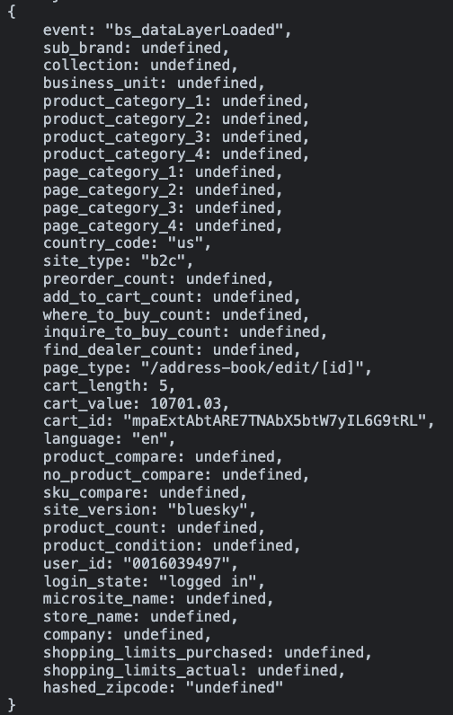

Spec vs on-page dataLayer for when the user loads an edit address page of MyLG:
Key | Value | Pass | Note
event | "bs_dataLayerLoaded" | Y
sub_brand | undefined | Y | - We can only confirm if the formatting of this value is correct, we cannot confirm the value is correct
collection | undefined | Y | - We can only confirm if the formatting of this value is correct, we cannot confirm the value is correct
business_unit | undefined | Y | - We can only confirm if the formatting of this value is correct, we cannot confirm the value is correct
product_category_1 | undefined | Y | - We can only confirm if the formatting of this value is correct, we cannot confirm the value is correct
product_category_2 | undefined | Y | - We can only confirm if the formatting of this value is correct, we cannot confirm the value is correct
product_category_3 | undefined | Y | - We can only confirm if the formatting of this value is correct, we cannot confirm the value is correct
product_category_4 | undefined | Y | - We can only confirm if the formatting of this value is correct, we cannot confirm the value is correct
page_category_1 | undefined | Y | - We can only confirm if the formatting of this value is correct, we cannot confirm the value is correct
page_category_2 | undefined | Y | - We can only confirm if the formatting of this value is correct, we cannot confirm the value is correct
page_category_3 | undefined | Y | - We can only confirm if the formatting of this value is correct, we cannot confirm the value is correct
page_category_4 | undefined | Y | - We can only confirm if the formatting of this value is correct, we cannot confirm the value is correct
country_code | “us” | Y
site_type | “b2c” | Y
preorder_count | undefined | Y
add_to_cart_count | undefined | Y
where_to_buy_count | undefined | Y
inquire_to_buy_count | undefined | Y
find_dealer_count | undefined | Y
page_type | “/address-book/edit/[id]” | Y | - We can only confirm if the formatting of this value is correct, we cannot confirm the value is correct
cart_length | 5 | Y
cart_value | 10701.03 | Y
cart_id | "mpaExtAbtARE7TNAbX5btW7yIL6G9tRL" | Y | - We can only confirm if the formatting of this value is correct, we cannot confirm the value is correct
language | “en” | Y
product_compare | undefined | Y
no_product_compare | undefined | Y
sku_compare | undefined | Y
site_vesrion | “bluesky” | Y
product_count | 0 | Y
product_condition | undefined | Y
user_id | "0016039497" | Y
login_state | “logged in” | Y
microsite_name | undefined | Y
store_name | undefined | Y
company | undefined | Y
shopping_limits_purchased | undefined | Y
shopping_limits_actual | undefined | Y
hash_zip_code | undefined | Y | - We can only confirm if the formatting of this value is correct, we cannot confirm the value is correct

Test Case #12:
On page dataLayer for when the user loads the “Password” section of MyLG:
The below screenshot is produced by the Adswerve chrome extension:
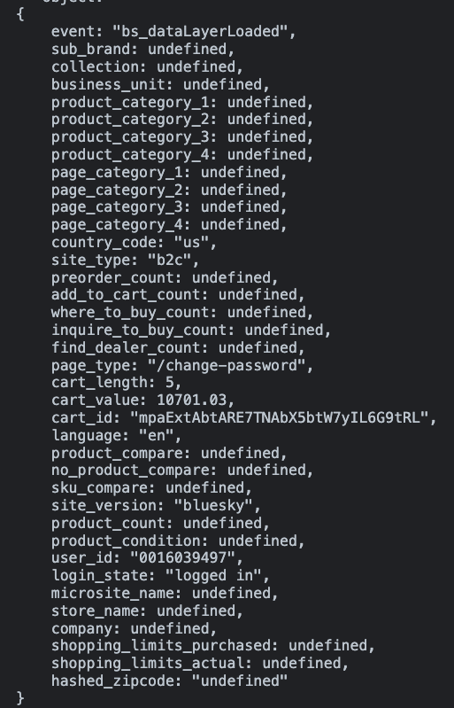

Spec vs on-page dataLayer for when the user loads an “Password” page of MyLG:
Key | Value | Pass | Note
event | "bs_dataLayerLoaded" | Y
sub_brand | undefined | Y | - We can only confirm if the formatting of this value is correct, we cannot confirm the value is correct
collection | undefined | Y | - We can only confirm if the formatting of this value is correct, we cannot confirm the value is correct
business_unit | undefined | Y | - We can only confirm if the formatting of this value is correct, we cannot confirm the value is correct
product_category_1 | undefined | Y | - We can only confirm if the formatting of this value is correct, we cannot confirm the value is correct
product_category_2 | undefined | Y | - We can only confirm if the formatting of this value is correct, we cannot confirm the value is correct
product_category_3 | undefined | Y | - We can only confirm if the formatting of this value is correct, we cannot confirm the value is correct
product_category_4 | undefined | Y | - We can only confirm if the formatting of this value is correct, we cannot confirm the value is correct
page_category_1 | undefined | Y | - We can only confirm if the formatting of this value is correct, we cannot confirm the value is correct
page_category_2 | undefined | Y | - We can only confirm if the formatting of this value is correct, we cannot confirm the value is correct
page_category_3 | undefined | Y | - We can only confirm if the formatting of this value is correct, we cannot confirm the value is correct
page_category_4 | undefined | Y | - We can only confirm if the formatting of this value is correct, we cannot confirm the value is correct
country_code | “us” | Y
site_type | “b2c” | Y
preorder_count | undefined | Y
add_to_cart_count | undefined | Y
where_to_buy_count | undefined | Y
inquire_to_buy_count | undefined | Y
find_dealer_count | undefined | Y
page_type | “/change-password” | Y | - We can only confirm if the formatting of this value is correct, we cannot confirm the value is correct
cart_length | 5 | Y
cart_value | 10701.03 | Y
cart_id | "mpaExtAbtARE7TNAbX5btW7yIL6G9tRL" | Y | - We can only confirm if the formatting of this value is correct, we cannot confirm the value is correct
language | “en” | Y
product_compare | undefined | Y
no_product_compare | undefined | Y
sku_compare | undefined | Y
site_vesrion | “bluesky” | Y
product_count | 0 | Y
product_condition | undefined | Y
user_id | "0016039497" | Y
login_state | “logged in” | Y
microsite_name | undefined | Y
store_name | undefined | Y
company | undefined | Y
shopping_limits_purchased | undefined | Y
shopping_limits_actual | undefined | Y
hash_zip_code | undefined | Y | - We can only confirm if the formatting of this value is correct, we cannot confirm the value is correct

e5.2 - initiate_specifc_product_registration
URL:
- https://wwwstg.us.lg.com/us/new-mylg/products

Status: Pass

Expected dataLayer:

<!-- Google Tag Manager -->
...
<!-- End Google Tag Manager -->
<script>
window.dataLayer = window.dataLayer || [];
window.dataLayer.push({
"event": "bs_lg_event",
"event_name": "initiate_specific_product_registration",
"event_params": {
"order_date":"{{ORDER PLACED DATE}}",
"order_number":"{{ORDER NUMBER}}",
"product_registration_name":"{{NAME OF THE PRODUCT THE USER IS INITIATING PRODUCT REGISTRATION FOR}}",
"product_registration_sku":"{{SKU OF THE PRODUCT THE USER IS INITIATING PRODUCT REGISTRATION FOR}}",
"product_registration_condition":"{{CONDITION OF THE PRODUCT THE USER IS INITIATING PRODUCT REGISTRATION FOR}}"
}
});
</script>

On page dataLayer for when the user clicks the register button on under the Unregistered Products section of the Products section of MyLG:
The below screenshot is produced by the Adswerve chrome extension:
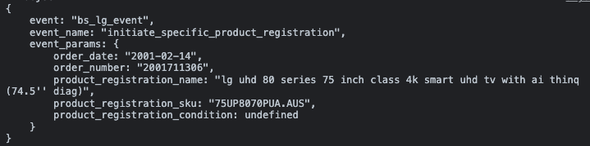

Spec vs on-page dataLayer for when the user clicks the register button on under the Unregistered Products section of the Products section of MyLG:
Key | Value | Pass | Note
event | “bs_lg_event” | Y
event_name | “initiate_specific_product_registration” | Y
event_params.order_date | "2001-02-14" | Y
event_params.order_number | "2001711306" | Y
event_params.product_registration_name | "lg uhd 80 series 75 inch class 4k smart uhd tv with ai thinq (74.5'' diag)" | Y
event_params.product_registration_sku | "75UP8070PUA.AUS" | Y
event_params.product_registration_condition | undefined | Y

GTM Tag QA:

GA4:

UA:

e5.3 - form_error_state
URL:
- https://wwwstg.us.lg.com/us/mylg/products/registration

Status: Pass

Notes:
- This event was only implemented and QA’d on the product registration form as the email form and repair request form are out of scope for the MyLG developers

Expected dataLayer:
<!-- Google Tag Manager -->
...
<!-- End Google Tag Manager -->
<script>
window.dataLayer = window.dataLayer || [];
window.dataLayer.push({
"event": "bs_error_state",
"event_name": "form_error_state",
"event_params": {
"error_form":"{{NAME OF THE FORM}}",
"error_field":"{{ERROR FIELD}}",
"error_code":"{{CODE ASSOCIATED WITH THE ERROR}}",
"error_text":"{{ERROR MESSAGE}}"
}
});
</script>

On page dataLayer:
The below screenshot is produced by the Adswerve chrome extension:
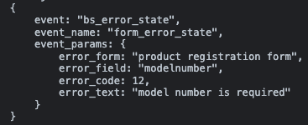

Spec vs on-page dataLayer:
Key | Value | Pass | Note
event | “bs_lg_event” | Y
event_name | “form_error_state” | Y
event_params.errror_form | “product registration form” | Y
event_params.error_field | "modelnumber” | Y
event_params.error_code | 12 | Y
event_params.error_text | “model number is required” | Y

On page dataLayer:
The below screenshot is produced by the Adswerve chrome extension:
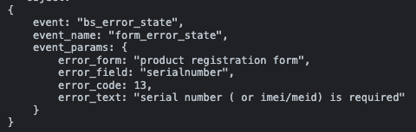

Spec vs on-page dataLayer:
Key | Value | Pass | Note
event | “bs_lg_event” | Y
event_name | “form_error_state” | Y
event_params.errror_form | “product registration form” | Y
event_params.error_field | "serialnumber” | Y
event_params.error_code | 13 | Y
event_params.error_text | "serial number ( or imei/meid) is required" | Y

e5.4 - submit_product_registration
URL:
- https://wwwstg.us.lg.com/us/new-mylg/products/registration-success

Status: Pass

Expected dataLayer:
<!-- Google Tag Manager -->
...
<!-- End Google Tag Manager -->
<script>
window.dataLayer = window.dataLayer || [];
window.dataLayer.push({
"event": "bs_lg_event",
"event_name": "submit_product_registration",
"event_params": {
"product_registration_name":"{{NAME OF THE PRODUCT THE USER IS INITIATING PRODUCT REGISTRATION FOR}}",
"product_registration_sku_model_no":"{{SKU OF THE PRODUCT THE USER IS INITIATING PRODUCT REGISTRATION FOR}}",
"product_registration_condition":"{{CONDITION OF THE PRODUCT THE USER IS INITIATING PRODUCT REGISTRATION FOR}}",
"product_registration_serial_number":"{{SERIAL NUMBER FROM SERIAL NUMBER FORM FIELD}}",
"purchase_registration_place":"{{PLACE OF PURCHASE FROM PLACE OF PURCHASE FORM FIELD}}",
"product_registration_purchase_date":"{{DATE OF PURCHASE FROM PURCHASE DATE FORM FIELD}}",
"product_registration_file_upload":"{{T OR F DEPENDING ON IF A FILE WAS UPLOADED TO THE FORM}}"
}
});
</script>

On page dataLayer:
The below screenshot is produced by the Adswerve chrome extension:
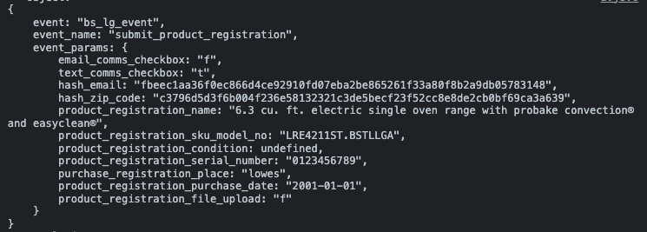

Spec vs on-page dataLayer for when the user clicks the register button on under the Unregistered Products section of the Products section of MyLG:
Key | Value | Pass | Note
event | “bs_lg_event” | Y
event_name | “submit_product_registration” | Y
event_params.email_comms_checkbox | “t” | Y
event_params.text_comms_checkbox | "2001711306" | Y
event_params.hash_email | "fbeec1aa36f0ec866d4ce92910fd07eba2be865261f33a80f8b2a9db05783148" | Y
event_params.hash_zip_code | "c3796d5d3f6b004f236e58132321c3de5becf23f52cc8e8de2cb0bf69ca3a639" | Y
event_params.product_registration_name | "6.3 cu. ft. electric single oven range with probake convection® and easyclean®" | Y
event_params.product_registration_condition | undefined | Y
event_params.product_registration_serial_number | “0123456789” | Y
purchase_registration_place | “lowes”
event_params.product_registration_purchase_date | "2001-01-01" | Y | - We can only confirm if the formatting of this value is correct, we cannot confirm the value is correct
event_params.product_registration_file_upload | “f” | Y

e5.5 - success_product_registration
URL:
- https://wwwstg.us.lg.com/us/new-mylg/products/registration-success

Status: Pass

Expected dataLayer:
<!-- Google Tag Manager -->
...
<!-- End Google Tag Manager -->
<script>
window.dataLayer = window.dataLayer || [];
window.dataLayer.push({
"event": "bs_lg_event",
"event_name": "success_product_registration",
"event_params": {
"product_registration_name":"{{NAME OF THE PRODUCT THE USER IS INITIATING PRODUCT REGISTRATION FOR}}",
"product_registration_sku_model_no":"{{SKU OF THE PRODUCT THE USER IS INITIATING PRODUCT REGISTRATION FOR}}",
"product_registration_condition":"{{CONDITION OF THE PRODUCT THE USER IS INITIATING PRODUCT REGISTRATION FOR}}",
"product_registration_serial_number":"{{SERIAL NUMBER FROM SERIAL NUMBER FORM FIELD}}",
"purchase_registration_place":"{{PLACE OF PURCHASE FROM PLACE OF PURCHASE FORM FIELD}}",
"product_registration_purchase_date":"{{DATE OF PURCHASE FROM PURCHASE DATE FORM FIELD}}",
"product_registration_file_upload":"{{T OR F DEPENDING ON IF A FILE WAS UPLOADED TO THE FORM}}"
}
});
</script>

On page dataLayer:
The below screenshot is produced by the Adswerve chrome extension:
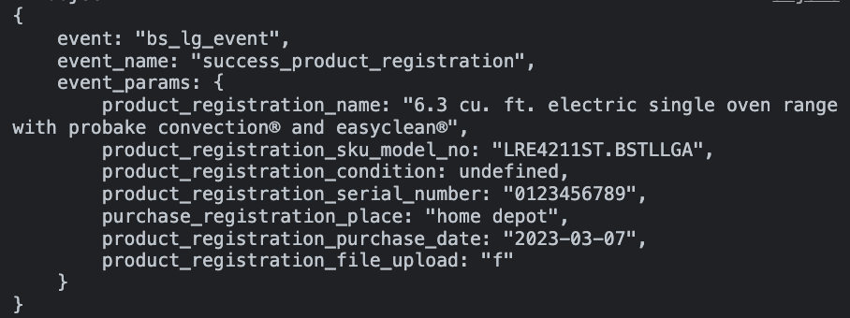

Spec vs on-page dataLayer:
Key | Value | Pass | Note
event | “bs_lg_event” | Y
event_name | “sucess_product_registration” | Y
event_params.product_registration_name | "6.3 cu. ft. electric single oven range with probake convection® and easyclean®" | Y
event_params.product_registration_sku_model_no | "LRE4211ST.BSTLLGA” | Y
event_params.product_registration_condition | undefined | Y
event_params.product_registration_serial_number | “0123456789” | Y
event_params.purchase_registration_place | “home depot” | Y
event_params.product_registration_purchase_date | “2023-03-03” | Y
event_params_product_registration_file_upload | “f” | Y

e5.6 - manage_order
URL:
- https://wwwstg.us.lg.com/us/mylg/my-order/order-detail/960526?currentPage=25&active=items&hasReturns=false&showReturnOrReplace=false&tagManageOrder=true

Status: Pass with Notes

Notes:
- No orders with accessories and/or additional services (wall mounting powered by handy, subscription products and subscription options or LG premium care) included were associated with a manage order button on the Orders Section therefore orders with accesories and/or additional services were not QA’d.

Expected dataLayer:

<!-- Google Tag Manager -->
...
<!-- End Google Tag Manager -->
<script>
window.dataLayer = window.dataLayer || [];
window.dataLayer.push({
"event": "bs_lg_event",
"event_name": "manage_order",
"event_params": {
"order_date":"{{ORDER PLACED DATE}}",
"status":"{{ORDER STATUS}}",
"order_number":"{{ORDER NUMBER}}",
"total_order_value":"{{TOTAL DOLLAR AMOUNT OF THE ORDER}}"
"items":[
{
"item_name": "{{ITEM NAME}}",
"item_id": "{{ITEM SKU}}",
"price": "{{ITEM PRICE}}",
"item_category": "{{CATEGORY LV 1}}",
"item_category2": "{{CATEGORY LV 2}}",
"item_category3": "{{CATEGORY LV 3}}",
"item_category4": "{{CATEGORY LV 4}}",
"item_category5": "{{CATEGORY LV 5}}",
"item_variant": "{{ITEM 3 LETTER CODE}}",
"quantity": "{{QUANTITY OF ITEM}}",
"item_delivery_option":"{{SELECTED DELIVERY OPTION FOR THE ITEM}}",
"selected_delivery":"{{ESTIMATED DELIVERY DATE}}",
"days_to_delivery":"{{DELIVERY DATE MINUS CURRENT DATE}}",
"additional_services_sku":"{{PIPE DELIMITED LIST OF TV WALL MOUNTING SKU AND/OR PREMIUM CARE SKUS}}",
"accessories_sku":"{{PIPE DELIMITED LIST OF PRODUCT ACCESSORIES SKUS}}",
"coupon":"{{APPLIED PROMO CODE STRING}}",
"shipment_number":"{{SHIPMENT NUMBER THE PRODUCT IS BEING DELIVERED IN}}",
"return_window":"{{RETURN BY DATE OR RETURN WINDOW CLOSED}}",
"cancellation_date":"{{DATE THE PRODUCT ORDER WAS CANCELED}}",
"awaiting_tracking_flag":"{{T OR F DEPENDING ON IF THE SHIPMENT IS AWAITING THE TRACKING INFO}}",
"product_condition":"{{PLACEHOLDER FOR TRACKING IF THE PRODUCT IS USED OR REFURBISHED}}"
},
{
"item_name": "{{ITEM NAME}}",
"item_id": "{{ITEM SKU}}",
"price": "{{ITEM PRICE}}",
"item_category": "{{CATEGORY LV 1}}",
"item_category2": "{{CATEGORY LV 2}}",
"item_category3": "{{CATEGORY LV 3}}",
"item_category4": "{{CATEGORY LV 4}}",
"item_category5": "{{CATEGORY LV 5}}",
"item_variant": "{{ITEM 3 LETTER CODE}}",
"quantity": "{{QUANTITY OF ITEM}}",
"item_delivery_option":"{{SELECTED DELIVERY OPTION FOR THE ITEM}}",
"selected_delivery":"{{ESTIMATED DELIVERY DATE}}",
"days_to_delivery":"{{DELIVERY DATE MINUS CURRENT DATE}}",
"additional_services_sku":"{{ADDITIONAL SERVICES SKU}}",
"accessories_sku":"{{PIPE DELIMITED LIST OF PRODUCT ACCESSORIES SKUS}}",
"coupon":"{{APPLIED PROMO CODE STRING}}",
"shipment_number":"{{SHIPMENT NUMBER THE PRODUCT IS BEING DELIVERED IN}}",
"return_window":"{{RETURN BY DATE OR RETURN WINDOW CLOSED}}",
"cancellation_date":"{{DATE THE PRODUCT ORDER WAS CANCELED}}",
"awaiting_tracking_flag":"{{T OR F DEPENDING ON IF THE SHIPMENT IS AWAITING THE TRACKING INFO}}",
"product_condition":"{{PLACEHOLDER FOR TRACKING IF THE PRODUCT IS USED OR REFURBISHED}}"
}
]}
/*Please include all product IDs, services and names, inside of the order*/
});

</script>

On page dataLayer:
The below screenshot is produced by the Adswerve chrome extension:
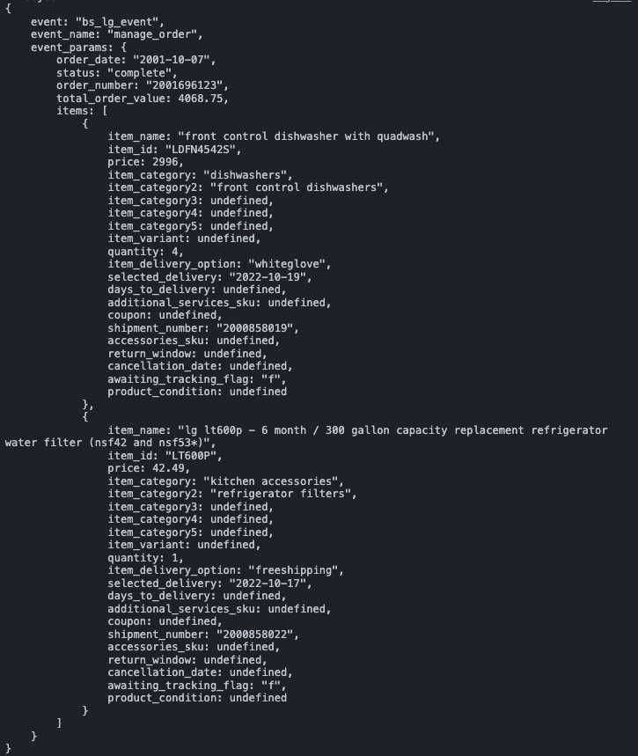

Spec vs on-page dataLayer:
Key | Value | Pass | Note
event | “bs_lg_event” | Y
event_name | “manage_order” | Y
event_params.order_date | "2001-10-07" | Y
event_params.status | “complete” | Y
event_params.order_number | "2001696123" | Y
event_params.total_order_value | 4068.75 | Y
event_params.items[0].item_name | "front control dishwasher with quadwash" | Y
event_params.items[0].item_id | "LDFN4542S" | Y
event_params.item[0].price | 2996 | Y
event_params.items[0].item_category | "dishwashers" | Y
event_params.items[0].item_category2 | "front control dishwashers" | Y
event_params.items[0].item_category3 | undefined | Y | - We can only confirm if the formatting of this value is correct, we cannot confirm the value is correct
event_params.items[0].item_category4 | undefined | Y | - We can only confirm if the formatting of this value is correct, we cannot confirm the value is correct
event_params.items[0].item_category5 | undefined | Y | - We can only confirm if the formatting of this value is correct, we cannot confirm the value is correct
event_params.items[0].item_variant | undefined | Y | - We can only confirm if the formatting of this value is correct, we cannot confirm the value is correct
event_params.items[0].quantity | 4 | Y
event_params.items[0].item_delivery_option | “whiteglove” | Y
event_params.items[0].selected_delivery | "2022-10-19" | Y | - We can only confirm if the formatting of this value is correct, we cannot confirm the value is correct
event_params.items[0].days_to_delivery | undefined | Y | - From a Dev on 4/12/23: is properly mapped in the frontend as well. If the magento passes data to the microservice then it will have valid data for dataLayer.
event_params.items[0]additional_services_sku | undefined | Y
event_params.items[0].coupon | undefined | Y
event_params.items[0].shipment_number | "2000858019" | Y
event_params.items[0].accessories_sku | undefined | Y
event_params.items[0].return_window | undefined | Y
event_params.items[0].cancellation_date | undefined | Y
event_parms.items[0].awaiting_tracking_flag | “f” | Y
event_parms.items[0].product_condition | undefined | Y
event_params.items[1].item_name | "lg lt600p - 6 month / 300 gallon capacity replacement refrigerator water filter (nsf42 and nsf53*)" | Y
event_params.items[1].item_id | "LT600P" | Y
event_params.items[1].price | 42.49 | Y
event_params.items[2].item_category | "kitchen accessories" | Y
event_params.items[1].item_category2 | "refrigerator filters" | Y
event_params.items[1].item_category3 | undefined | Y | - We can only confirm if the formatting of this value is correct, we cannot confirm the value is correct
event_params.items[1].item_category4 | undefined | Y | - We can only confirm if the formatting of this value is correct, we cannot confirm the value is correct
event_params.items[1].item_category5 | undefined | Y | - We can only confirm if the formatting of this value is correct, we cannot confirm the value is correct
event_params.items[1].item_variant | undefined | Y | - We can only confirm if the formatting of this value is correct, we cannot confirm the value is correct
event_params.items[1].quantity | 1 | Y
event_params.items[1].item_delivery_option | “freeshipping” | Y
event_params.items[1].selected_delivery | "2022-10-17" | Y | - We can only confirm if the formatting of this value is correct, we cannot confirm the value is correct
event_params.items[1].days_to_delivery | undefined | Y | - From a Dev on 4/12/23: is properly mapped in the frontend as well. If the magento passes data to the microservice then it will have valid data for dataLayer.
event_params.items[1]additional_services_sku | undefined | Y
event_params.items[1].coupon | undefined | Y
event_params.items[1].shipment_number | "2000858022" | Y
event_params.items[1].accessories_sku | undefined | Y
event_params.items[1].return_window | undefined | Y
event_params.items[1].cancellation_date | undefined | Y
event_parms.items[1]awaiting_tracking_flag | “f” | Y
event_parms.items[1].product_condition | undefined | Y

e5.7 - cancel_order
URL:
- https://wwwstg.us.lg.com/us/mylg/my-order/order-detail/967479?currentPage=10&active=items&hasReturns=false&showReturnOrReplace=false&tagManageOrder=true

Status: Fail - Incorrect Value
- item_id is missing. Please add it in and set the value to the product SKU not the MD number.
- Please set the value of days_to_delivery to the total number of days between the order date and the delivery date
- item_delivery_option should never be set to undefined. Please set the value to whats listed as the “shipping method” on the order.
- The value of additional_services_sku is incorrect. additional_services_sku should always be set to the SKU (not MD number) of the handy wall mounting service, the product’s selected subscription option and/or the product’s selected LG premium care option (the “none” premium care option does not have a SKU therefore undefined)
  - In this test case, the order cancelled included a subscription product. Because of this, additional_services_sku should be set to the SKU of the 6 month subscription option associated with the product.

Expected dataLayer:

<!-- Google Tag Manager -->
...
<!-- End Google Tag Manager -->
<script>
window.dataLayer = window.dataLayer || [];
window.dataLayer.push({
"event": "bs_lg_event",
"event_name": "cancel_order",
"event_params": {
"order_date":"{{ORDER PLACED DATE}}",
"status":"{{ORDER STATUS}}",
"order_number":"{{ORDER NUMBER}}",
"items":[
{
"item_name": "{{ITEM NAME}}",
"item_id": "{{ITEM SKU}}",
"price": "{{ITEM PRICE}}",
"item_category": "{{CATEGORY LV 1}}",
"item_category2": "{{CATEGORY LV 2}}",
"item_category3": "{{CATEGORY LV 3}}",
"item_category4": "{{CATEGORY LV 4}}",
"item_category5": "{{CATEGORY LV 5}}",
"item_variant": "{{ITEM 3 LETTER CODE}}",
"quantity": "{{QUANTITY OF ITEM}}",
"item_delivery_option":"{{SELECTED DELIVERY OPTION FOR THE ITEM}}",
"selected_delivery":"{{ESTIMATED DELIVERY DATE}}",
"days_to_delivery":"{{DELIVERY DATE MINUS CURRENT DATE}}",
"additional_services_sku":"{{ADDITIONAL SERVICES SKU}}",
"accessories_sku":"{{PIPE DELIMITED LIST OF PRODUCT ACCESSORIES SKUS}}",
"coupon":"{{APPLIED PROMO CODE STRING}}",
"shipment_number":"{{SHIPMENT NUMBER THE PRODUCT IS BEING DELIVERED IN}}",
"awaiting_tracking_flag":"{{T OR F DEPENDING ON IF THE SHIPMENT IS AWAITING THE TRACKING INFO}}"
},
{
"item_name": "{{ITEM NAME}}",
"item_id": "{{ITEM SKU}}",
"price": "{{ITEM PRICE}}",
"item_category": "{{CATEGORY LV 1}}",
"item_category2": "{{CATEGORY LV 2}}",
"item_category3": "{{CATEGORY LV 3}}",
"item_category4": "{{CATEGORY LV 4}}",
"item_category5": "{{CATEGORY LV 5}}",
"item_variant": "{{ITEM 3 LETTER CODE}}",
"quantity": "{{QUANTITY OF ITEM}}",
"item_delivery_option":"{{SELECTED DELIVERY OPTION FOR THE ITEM}}",
"selected_delivery":"{{ESTIMATED DELIVERY DATE}}",
"days_to_delivery":"{{DELIVERY DATE MINUS CURRENT DATE}}",
"additional_services_sku":"{{ADDITIONAL SERVICES SKU}}",
"accessories_sku":"{{PIPE DELIMITED LIST OF PRODUCT ACCESSORIES SKUS}}",
"coupon":"{{APPLIED PROMO CODE STRING}}",
"shipment_number":"{{SHIPMENT NUMBER THE PRODUCT IS BEING DELIVERED IN}}",
"awaiting_tracking_flag":"{{T OR F DEPENDING ON IF THE SHIPMENT IS AWAITING THE TRACKING INFO}}"
}
]}
/*Please include all product IDs, services and names, inside of the order*/
});
</script>

On page dataLayer:
The below screenshot is produced by the Adswerve chrome extension:
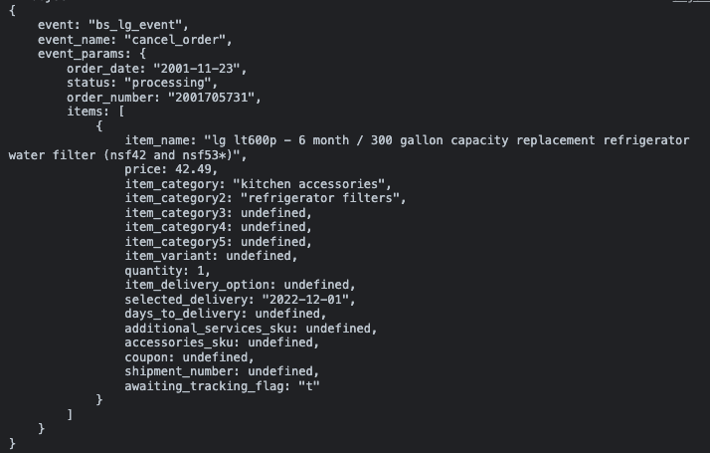

Spec vs on-page dataLayer:
Key | Value | Pass | Note
event | “bs_lg_event” | Y
event_name | “cancel_order” | Y
event_params.order_date | "2001-11-23" | Y
event_params.status | "processing” | Y
event_params.order_number | "2001705731" | Y
event_params.items[0].item_name | "lg lt600p - 6 month / 300 gallon capacity replacement refrigerator water filter (nsf42 and nsf53*)" | Y
event_params.items[0].item_id |  | N | - This parameter is missing. Please add it in and set the value to the product SKU not the MD number.
event_params.item[0].price | 42.49 | Y
event_params.items[0].item_category | “kitchen accessories” | Y | - We can only confirm if the formatting of this value is correct, we cannot confirm the value is correct
event_params.items[0].item_category2 | “refrigerator filters” | Y | - We can only confirm if the formatting of this value is correct, we cannot confirm the value is correct
event_params.items[0].item_category3 | undefined | Y | - We can only confirm if the formatting of this value is correct, we cannot confirm the value is correct
event_params.items[0].item_category4 | undefined | Y | - We can only confirm if the formatting of this value is correct, we cannot confirm the value is correct
event_params.items[0].item_category5 | undefined | Y | - We can only confirm if the formatting of this value is correct, we cannot confirm the value is correct
event_params.items[0].item_variant | undefined | Y | - We can only confirm if the formatting of this value is correct, we cannot confirm the value is correct
event_params.items[0].quantity | 1 | Y
event_params.items[0].item_delivery_option | undefined | N | - This value should be set to the “shipping method” listed on the order
event_params.items[0].selected_delivery | "2022-12-01" | Y | - We can only confirm if the formatting of this value is correct, we cannot confirm the value is correct
event_params.items[0].days_to_delivery | undefined | N | - This value is incorrect. Please set to the total number of days between the order date and the delivery date
event_params.items[0]additional_services_sku | undefined | N | - This value is incorrect. In this test case, the order cancelled included a subscription product. Because of this, additional_services_sku should be set to the SKU of the 6 month subscription option associated with the product.
event_params.items[0].accessories_sku | undefined | Y
event_params.items[0].coupon | undefined | Y
event_params.items[0].shipment_number | undefined | Y
event_parms.items[0].awaiting_tracking_flag | “t” | Y

e5.8 - reschedule_delivery
URL:
- https://wwwstg.us.lg.com/us/mylg/my-order/order-detail/974802?currentPage=1&active=items&hasReturns=false&showReturnOrReplace=false&tagManageOrder=true

Status: Fail - Missing Event Execution
- This is event is not firing when the user clicks the “reschedule delivery” button. Please make it so this event fires every time the “reschedule delivery” button is clicked.
- item_delivery_option should never be undefined. The value should be set to the “shipping method” listed on the order.
- The value of days_to_delivery is incorrect. Please set to the total number of days between the order date and the delivery date

Expected dataLayer:

<!-- Google Tag Manager -->
...
<!-- End Google Tag Manager -->
<script>
window.dataLayer = window.dataLayer || [];
window.dataLayer.push({
"event": "bs_lg_event",
"event_name": "reschedule_delivery",
"event_params": {
"order_date":"{{ORDER PLACED DATE}}",
"status":"{{ORDER STATUS}}",
"order_number":"{{ORDER NUMBER}}",
"items":[
{
"item_name": "{{ITEM NAME}}",
"item_id": "{{ITEM SKU}}",
"price": "{{ITEM PRICE}}",
"item_category": "{{CATEGORY LV 1}}",
"item_category2": "{{CATEGORY LV 2}}",
"item_category3": "{{CATEGORY LV 3}}",
"item_category4": "{{CATEGORY LV 4}}",
"item_category5": "{{CATEGORY LV 5}}",
"item_variant": "{{ITEM 3 LETTER CODE}}",
"quantity": "{{QUANTITY OF ITEM}}",
"item_delivery_option":"{{SELECTED DELIVERY OPTION FOR THE ITEM}}",
"selected_delivery":"{{ESTIMATED DELIVERY DATE}}",
"days_to_delivery":"{{DELIVERY DATE MINUS CURRENT DATE}}",
"additional_services_sku":"{{ADDITIONAL SERVICES SKU}}",
"coupon":"{{APPLIED PROMO CODE STRING}}",
"shipment_number":"{{SHIPMENT NUMBER THE PRODUCT IS BEING DELIVERED IN}}"
},
{
"item_name": "{{ITEM NAME}}",
"item_id": "{{ITEM SKU}}",
"price": "{{ITEM PRICE}}",
"item_category": "{{CATEGORY LV 1}}",
"item_category2": "{{CATEGORY LV 2}}",
"item_category3": "{{CATEGORY LV 3}}",
"item_category4": "{{CATEGORY LV 4}}",
"item_category5": "{{CATEGORY LV 5}}",
"item_variant": "{{ITEM 3 LETTER CODE}}",
"quantity": "{{QUANTITY OF ITEM}}",
"item_delivery_option":"{{SELECTED DELIVERY OPTION FOR THE ITEM}}",
"selected_delivery":"{{ESTIMATED DELIVERY DATE}}",
"days_to_delivery":"{{DELIVERY DATE MINUS CURRENT DATE}}",
"additional_services_sku":"{{ADDITIONAL SERVICES SKU}}",
"coupon":"{{APPLIED PROMO CODE STRING}}",
"shipment_number":"{{SHIPMENT NUMBER THE PRODUCT IS BEING DELIVERED IN}}"
}
/*Please include all product IDs, services and names, inside of the order*/
]}
});
</script>

Spec vs on-page dataLayer:
Key | Value | Pass | Note
event | “bs_lg_event” | Y
event_name | “reschedule_delivery” | Y
event_params.order_date | "2001-03-27" | Y
event_params.status | "processing” | Y
event_params.order_number | "2001713303" | Y
event_params.items[0].item_name | "lg c1 83 inch class 4k smart oled tv w/ai thinq (82.5\" diag)" | Y
event_params.items[0].item_id | "OLED83C1PUA" | Y
event_params.item[0].price | 11999.97 | Y
event_params.items[0].item_category | “tvs” | Y
event_params.items[0].item_category2 | “oled tvs” | Y
event_params.items[0].item_category3 | undefined | Y | - We can only confirm if the formatting of this value is correct, we cannot confirm the value is correct
event_params.items[0].item_category4 | undefined | Y | - We can only confirm if the formatting of this value is correct, we cannot confirm the value is correct
event_params.items[0].item_category5 | undefined | Y | - We can only confirm if the formatting of this value is correct, we cannot confirm the value is correct
event_params.items[0].item_variant | undefined | Y | - We can only confirm if the formatting of this value is correct, we cannot confirm the value is correct
event_params.items[0].quantity | 3 | Y
event_params.items[0].item_delivery_option | undefined | N | - This value should be set to the “shipping method” listed on the order
event_params.items[0].selected_delivery_date | "2023-04-08" | Y | - We can only confirm if the formatting of this value is correct, we cannot confirm the value is correct
event_params.items[0].days_to_delivery | undefined | N | - This value is incorrect. Please set to the total number of days between the order date and the delivery date
event_params.items[0]additional_services_sku | undefined | Y
event_params.items[0].accessories_sku | undefined | Y
event_params.items[0].coupon | undefined | Y
event_params.items[0].shipment_number | undefined | Y

e5.10 - delivery_reschedule_success
URL:
- https://wwwstg.us.lg.com/us/mylg/my-order/order-detail/975491?currentPage=2&active=items&hasReturns=false&showReturnOrReplace=false&tagManageOrder=true

Notes:
- QA’d using accoun: hemaobs11@yopmail.com/ Admin@2022
- QA’d using order numbers:
  - 2001713845
  - 2001713848

Status: Pass

Expected dataLayer:

<!-- Google Tag Manager -->
...
<!-- End Google Tag Manager -->
<script>
window.dataLayer = window.dataLayer || [];
window.dataLayer.push({
"event": "bs_lg_event",
"event_name": "delivery_reschedule_success",
"event_params": {
"order_date":"{{ORDER PLACED DATE}}",
"status":"{{ORDER STATUS}}",
"order_number":"{{ORDER NUMBER}}",
"items":[ {
"item_name": "{{ITEM NAME}}",
"item_id": "{{ITEM SKU}}",
"price": "{{ITEM PRICE}}",
"item_category": "{{CATEGORY LV 1}}",
"item_category2": "{{CATEGORY LV 2}}",
"item_category3": "{{CATEGORY LV 3}}",
"item_category4": "{{CATEGORY LV 4}}",
"item_category5": "{{CATEGORY LV 5}}",
"item_variant": "{{ITEM 3 LETTER CODE}}",
"quantity": "{{QUANTITY OF ITEM}}",
"item_delivery_option":"{{SELECTED DELIVERY OPTION FOR THE ITEM}}",
"selected_delivery":"{{ESTIMATED DELIVERY DATE}}",
"days_to_delivery":"{{DELIVERY DATE MINUS CURRENT DATE}}",
"additional_services_sku":"{{ADDITIONAL SERVICES SKU}}",
"coupon":"{{APPLIED PROMO CODE STRING}}",
"shipment_number":"{{SHIPMENT NUMBER THE PRODUCT IS BEING DELIVERED IN}}",
"awaiting_tracking_flag":"{{T OR F DEPENDING ON IF THE SHIPMENT IS AWAITING THE TRACKING INFO}}"
},
{
"item_name": "{{ITEM NAME}}",
"item_id": "{{ITEM SKU}}",
"price": "{{ITEM PRICE}}",
"item_category": "{{CATEGORY LV 1}}",
"item_category2": "{{CATEGORY LV 2}}",
"item_category3": "{{CATEGORY LV 3}}",
"item_category4": "{{CATEGORY LV 4}}",
"item_category5": "{{CATEGORY LV 5}}",
"item_variant": "{{ITEM 3 LETTER CODE}}",
"quantity": "{{QUANTITY OF ITEM}}",
"item_delivery_option":"{{SELECTED DELIVERY OPTION FOR THE ITEM}}",
"selected_delivery":"{{ESTIMATED DELIVERY DATE}}",
"days_to_delivery":"{{DELIVERY DATE MINUS CURRENT DATE}}",
"additional_services_sku":"{{ADDITIONAL SERVICES SKU}}",
"coupon":"{{APPLIED PROMO CODE STRING}}",
"shipment_number":"{{SHIPMENT NUMBER THE PRODUCT IS BEING DELIVERED IN}}",
"awaiting_tracking_flag":"{{T OR F DEPENDING ON IF THE SHIPMENT IS AWAITING THE TRACKING INFO}}"
}
]}
});
</script>

On page dataLayer:
The below screenshot is produced by the Adswerve chrome extension:
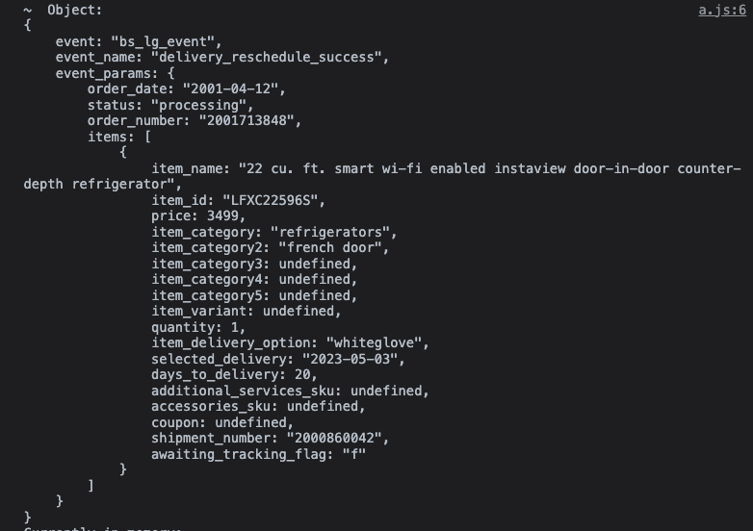

Spec vs on-page dataLayer:
Key | Value | Pass | Note
event | “bs_lg_event” | Y
event_name | “delivery_reschedule_success” | Y
event_params.order_date | "2001-04-12" | Y
event_params.status | "processing” | Y
event_params.order_number | "2001713848" | Y
event_params.items[0].item_name | "22 cu. ft. smart wi-fi enabled instaview door-in-door counter-depth refrigerator" | Y
event_params.items[0].item_id | "LFXC22596S" | Y
event_params.item[0].price | 3499 | Y
event_params.items[0].item_category | “refrigerators” | Y
event_params.items[0].item_category2 | “french door” | Y | - We can only confirm if the formatting of this value is correct, we cannot confirm the value is correct
event_params.items[0].item_category3 | undefined | Y | - We can only confirm if the formatting of this value is correct, we cannot confirm the value is correct
event_params.items[0].item_category4 | undefined | Y | - We can only confirm if the formatting of this value is correct, we cannot confirm the value is correct
event_params.items[0].item_category5 | undefined | Y | - We can only confirm if the formatting of this value is correct, we cannot confirm the value is correct
event_params.items[0].item_variant | undefined | Y | - We can only confirm if the formatting of this value is correct, we cannot confirm the value is correct
event_params.items[0].quantity | 1 | Y
event_params.items[0].item_delivery_option | “whiteglove” | Y | - We can only confirm if the formatting of this value is correct, we cannot confirm the value is correct
event_params.items[0].selected_delivery | “2023-05-03” | Y | - We can only confirm if the formatting of this value is correct, we cannot confirm the value is correct
event_params.items[0].days_to_delivery | 20 | Y
event_params.items[0]additional_services_sku | undefined | Y
event_params.items[0].coupon | undefined | Y
event_params.items[0].shipment_number | “2000860042” | Y
event_parms.items[0].awaiting_tracking_flag | “f” | Y

e5.11 - manage_subscription
URL:
- https://wwwstg.us.lg.com/us/new-mylg/subscription/detail/250933?currentPage=2

Status: Pass

Expected dataLayer:
<!-- Google Tag Manager -->
...
<!-- End Google Tag Manager -->
<script>
window.dataLayer = window.dataLayer || [];
window.dataLayer.push({
"event": "bs_lg_event",
"event_name": "manage_subscriptions",
"event_params": {
"subscription_id":"{{SUBSCRIPTION ID NUMBER}}",
"subscription_status":"{{PLAN STATUS VALUE}}",
"subscription_created_date":"{{CREATED ON DATE}}",
"subscription_next_shipment":"{{NEXT SHIPMENT DATE}}"
"subscription_product_name":"{{NAME OF THE PRODUCT THAT THE USER IS MANAGING THE SUBSCRIPTION FOR}}",
"subscription_product_sku":"{{SKU OF THE PRODUCT THAT THE USER IS MANAGING THE SUBSCRIPTION FOR}}"
}
});
</script>

On page dataLayer:
The below screenshot is produced by the Adswerve chrome extension:
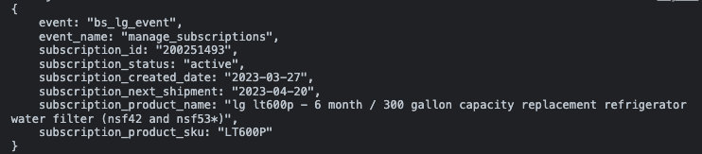

Spec vs on-page dataLayer:
Key | Value | Pass | Note
event | “bs_lg_event” | Y
event_name | “manage_subscription” | Y
event_params.subscription_id | "200251496" | Y
event_params.subscription_status | “active” | Y
event_params.subscription_created_date | "2022-03-27" | Y
event_params.subscription_next_shipment | "2023-04-20" | Y
event_params.subscription_product_name | "lg lt600p - 6 month / 300 gallon capacity replacement refrigerator water filter (nsf42 and nsf53*)" | Y
event_params.subscription_product_sku | "LT600P" | Y

e5.12 - skip_subscription
URL:
- https://wwwstg.us.lg.com/us/new-mylg/subscription/detail/250933?currentPage=2

Status: Pass

Expected dataLayer:

<!-- Google Tag Manager -->
...
<!-- End Google Tag Manager -->
<script>
window.dataLayer = window.dataLayer || [];
window.dataLayer.push({
"event": "bs_lg_event",
"event_name": "skip_subscription",
"event_params": {
"subscription_id":"{{SUBSCRIPTION ID NUMBER}}",
"subscription_skip_shipment_date":"{{DATE OF NEXT SHIPMENT THAT IS BEING CANCELED}}",
"subscription_created_date":"{{SUBSCRIPTION START DATE}}",
"subscription_frequency":"{{SUBSCRIPTION FREQUENCY}}",
"subscription_next_shipment":"{{RENEWAL DATE}}",
"subscription_order_history":"{{ORDER HISTORY}}",
"subscription_quantity":{{SUBSCRIPTION QUANTITY}},
"subscription_product_name":"{{NAME OF THE PRODUCT THAT THE USER IS MANAGING THE SUBSCRIPTION FOR}}",
"subscription_product_sku":"{{SKU OF THE PRODUCT THAT THE USER IS MANAGING THE SUBSCRIPTION FOR}}",
"subscription_billing_price":"{{SUBSCRIPTION BILLING PRICE}}",
"subscription_initial_discount":"{{SUBSCRIPTION INITIAL DISCOUNT}}",
}
});
</script>

On page dataLayer:
The below screenshot is produced by the Adswerve chrome extension:

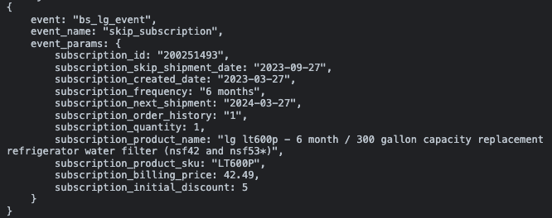

Spec vs on-page dataLayer:
Key | Value | Pass | Note
event | “bs_lg_event” | Y
event_name | “skip_subscription” | Y
event_params.subscription_id | "200251493" | Y
event_params.subscription_skip_shipment_date | "2023-09-27" | Y
event_params.subscription_created_date | "2023-03-27" | Y
event_params.subscription_frequency | "6 months" | Y
event_params.subscription_next_shipment | "2024-03-27" | Y
event_params.subscription_order_history | “1” | Y
event_params.subscritption_quantity | 1 | Y
event_params.subscription_product_name | "lg lt600p - 6 month / 300 gallon capacity replacement refrigerator water filter (nsf42 and nsf53*)" | Y
event_params.subscription_product_sku | "LT600P" | Y
event_params.subscription_billing_price | 42.49 | Y
event_params.subscription_initial_discount | 5 | Y

e5.13 - repair_request
URL:
- https://wwwstg.us.lg.com/us/new-mylg/repair-requests

Status: Pass with Notes
- https://www.lg.com/us/support/contact and https://wwwstg.us.lg.com/us/support/product/lg-13U70P-G.AAW7U1 are not a part of MyLG. The event has not been implemented or QA’d on these pages.

Expected dataLayer:

<!-- Google Tag Manager -->
...
<!-- End Google Tag Manager -->
<script>
window.dataLayer = window.dataLayer || [];
window.dataLayer.push({
"event": "bs_lg_event",
"event_name": "repair_request"
});
</script>

On page dataLayer when the user clicks the “submit a request” button in the repair requests section of MyLG:
The below screenshot is produced by the Adswerve chrome extension:
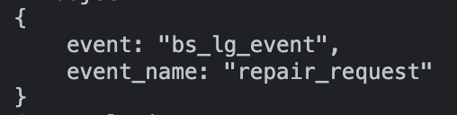

Spec vs on page dataLayer when the user clicks the “submit a request” button in the repair requests section of MyLG:
The below screenshot is produced by the Adswerve chrome extension:

Key | Value | Pass | Note
event | “bs_lg_event” | Y
event_name | “repair_request” | Y

e5.14 - add_to_cart
URL:
- https://wwwstg.us.lg.com/us/new-mylg/repair-requests

Status:

Notes:
- The below credentials were used to log in to an account for testing test case #2.
  - stagingbuildtest47@mailinator.com
  - QAinfotech@5

Expected dataLayer:

<!-- Google Tag Manager -->
...
<!-- End Google Tag Manager -->
<script>
window.dataLayer = window.dataLayer || [];
window.dataLayer.push({
"event": "bs_lg_event",
"event_name": "repair_request"
});
</script>

e5.15 - cancel_subscription
URL:
- https://wwwstg.us.lg.com/us/mylg/subscription/detail/251496?currentPage=1

Status: Pass

Expected dataLayer:

<!-- Google Tag Manager -->
...
<!-- End Google Tag Manager -->
<script>
window.dataLayer = window.dataLayer || [];
window.dataLayer.push({
"event": "bs_lg_event",
"event_name": "cancel_subscription",
"event_params": {
"subscription_id":"{{SUBSCRIPTION ID NUMBER}}",
"subscription_skip_shipment_date":"{{DATE OF NEXT SHIPMENT THAT IS BEING CANCELED}}",
"subscription_created_date":"{{SUBSCRIPTION START DATE}}",
"subscription_frequency":"{{SUBSCRIPTION FREQUENCY}}",
"subscription_next_shipment":"{{RENEWAL DATE}}",
"subscription_order_history":"{{ORDER HISTORY}}",
"subscription_quantity":"{{SUBSCRIPTION QUANTITY}}",
"subscription_product_name":"{{NAME OF THE PRODUCT THAT THE USER IS MANAGING THE SUBSCRIPTION FOR}}",
"subscription_product_sku":"{{SKU OF THE PRODUCT THAT THE USER IS MANAGING THE SUBSCRIPTION FOR}}",
"subscription_billing_price":"{{SUBSCRIPTION BILLING PRICE}}",
"subscription_initial_discount":"{{SUBSCRIPTION INITIAL DISCOUNT}}",
}
});
</script>

On page dataLayer:
The below screenshot is produced by the Adswerve chrome extension:
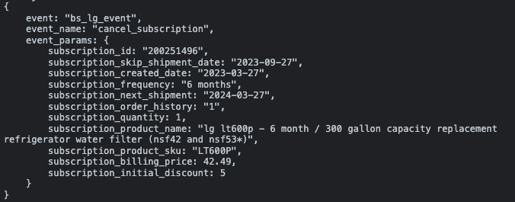

Spec vs on-page dataLayer:
Key | Value | Pass | Note
event | “bs_lg_event” | Y
event_name | “skip_subscription” | Y
event_params.subscription_id | "200251496" | Y
event_params.subscription_skip_shipment_date | "2023-09-27" | Y
event_params.subscription_created_date | "2023-03-27" | Y
event_params.subscription_frequency | "6 months" | Y
event_params.subscription_next_shipment | "2024-03-27" | Y
event_params.subscription_order_history | “1” | Y
event_params.subscritption_quantity | 1 | Y
event_params.subscription_product_name | "lg lt600p - 6 month / 300 gallon capacity replacement refrigerator water filter (nsf42 and nsf53*)" | Y
event_params.subscription_product_sku | "LT600P" | Y
event_params.subscription_billing_price | 42.49 | Y
event_params.subscription_initial_discount | 5 | Y

e5.16 - view_repair_details
URL:
- https://wwwstg.us.lg.com/us/mylg/repair-requests

Status: Pass

Expected dataLayer:

<!-- Google Tag Manager -->
...
<!-- End Google Tag Manager -->
<script>
window.dataLayer = window.dataLayer || [];
window.dataLayer.push({
"event": "bs_lg_event",
"event_name": "view_repair_details",
"event_params": {
"repair_receipt_ra_number":"{{REPAIR REQUEST RECEIPT OR RA NUMBER}}",
"repair_status":"{{REPAIR STATUS}}",
"repair_service":"{{REPAIR SERVICE}}",
"repair_product_name":"{{NAME OF THE PRODUCT THAT THE USER IS VIEWING DETAILS FOR}}",
"repair_product_sku":"{{SKU OF THE PRODUCT THAT THE USER IS VIEWING DETAILS FOR}}",
"repair_quantity":"{{QUANTITY OF THE PRODUCT BEING REPAIRED}}"
}
});
</script>

On page dataLayer:
The below screenshot is produced by the Adswerve chrome extension:
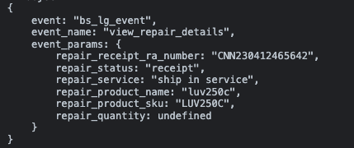

Spec vs on page dataLayer:
Key | Value | Pass | Note
event | “bs_lg_event” | Y
event_name | “view_repair_details” | Y
event_params.repair_receipt_ra_number | "CNN230412465642" | Y
event_params.repair_status | “receipt” | Y
event_params.repair_service | “ship in service” | Y
event_params.repair_product_name | “luv250c” | Y
event_params.repair_product_sku | “LUV250C” | Y
event_params.repair_quantity | undefined | Y

e5.17 - initiate_generic_product_registration
URL:
- https://wwwstg.us.lg.com/us/mylg/products

Status: Pass

Expected dataLayer:
<!-- Google Tag Manager -->
...
<!-- End Google Tag Manager -->
<script>
window.dataLayer = window.dataLayer || [];
window.dataLayer.push({
"event": "bs_lg_event",
"event_name": "initiate_generic_product_registration"
});
</script>

On page dataLayer:
The below screenshot is produced by the Adswerve chrome extension:
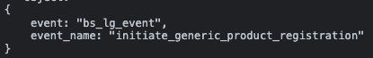

Spec vs on page dataLayer:
Key | Value | Pass | Note
event | “bs_lg_event” | Y
event_name | “initiate_generic_product_registration” | Y

e5.18 - select_item
URL:
- Products Section
  - https://wwwstg.us.lg.com/us/mylg/products
- Orders Section
  - https://wwwstg.us.lg.com/us/mylg/my-order
- Favorites Section
  - https://wwwstg.us.lg.com/us/mylg/favorites
- Subscriptions Section
  - https://wwwstg.us.lg.com/us/mylg/subscription
  - https://wwwstg.us.lg.com/us/mylg/subscription/detail/251496?currentPage=1

Status: Fail - Incorrect Value
- Please set the correct item’s price value.
- item_category value should never be set to undefined. Every product has an associated product category. Please set the value to the products category.
- Please add “mylg” at the start of the every item list name of the selected product. For example, in the test case, the value should be set to something like “mylg products list” because the product was selected from the MyLG products list
- The “product_condition” parameter is missing. Please add this value in and set it to “undefined”
- The “in_stock_flag” parameter is missing. Please add this value in and set it to “t” if the product shown to the user is available and in stock otherwise set the value to “f” if the product shown to the user is NOT available and NOT in stock

Expected dataLayer:

<!-- Google Tag Manager -->
...
<!-- End Google Tag Manager -->
<script>
window.dataLayer = window.dataLayer || [];
window.dataLayer.push({
"event": "bs_select_item",
"event_name": "select_item",
"ecommerce":{
"items":[{
"item_name": "{{ITEM NAME}}",
"item_id": "{{ITEM SKU}}",
"price": "{{ITEM PRICE}}",
"item_category": "{{CATEGORY LV 1}}",
"item_category2": "{{CATEGORY LV 2}}",
"item_category3": "{{CATEGORY LV 3}}",
"item_category4": "{{CATEGORY LV 4}}",
"item_category5": "{{CATEGORY LV 5}}",
"item_list_id": "{{ID OF THE LIST THE SELECTED ITEM IS IN}}",
"item_list_name": "{{NAME OF THE LIST THE SELECTED ITEM IS IN}}",
"item_variant": "{{ITEM 3 LETTER CODE}}",
"index": "{{SELECTED PRODUCT POSITION}}",
"product_tags": "{{LIST OF PRODUCT TAGS}}",
"product_rating": "{{STAR RATING OF SELECTED PRODUCT}}",
"product_suggestion_flag": "{{PRODUCT SUGGESTION FLAG}}",
"favorites_flag":"{{T OR F DEPENDING ON IF THE SELECTED PRODUCT IS A FAVORITED}}",
"product_condition":"{{PLACEHOLDER FOR TRACKING IF THE PRODUCT IS USED OR REFURBISHED}}",
"in_stock_flag":"{{t|f}}"
}]
}
});
</script>

On page dataLayer for when the user clicks a product name on the Products section of MyLG:
The below screenshot is produced by the Adswerve chrome extension:
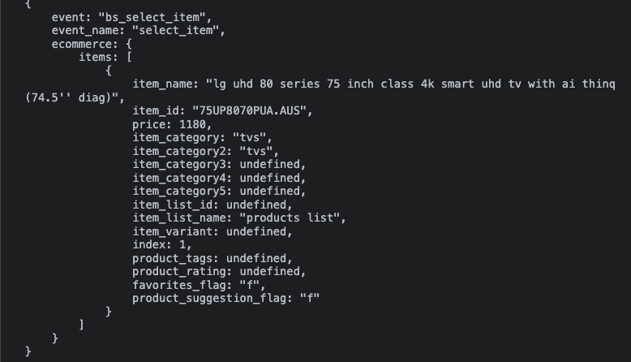

Spec vs on-page dataLayer for when the user clicks a product name on the Products section of MyLG:
Key | Value | Pass | Note
event | “bs_select_item” | Y
event_name | “select_item” | Y
ecommerce.items[0].item_name | "lg uhd 80 series 75 inch class 4k smart uhd tv with ai thinq (74.5'' diag)" | Y
ecommerce.items[0].item_id | "75UP8070PUA.AUS" | Y
ecommerce.items[0].price | 1180 | N | - The price value set is incorrect. Please always set the value to the cost of the product.
ecommerce.items[0]. item_category | “tvs” | Y
ecommerce.items[0].item_catgeory2 | “tvs” | Y | - We can only confirm if the formatting of this value is correct, we cannot confirm the value is correct
ecommerce.items[0].item_catgory3 | undefined | Y
ecommerce.items[0].item_category4 | undefined | Y
ecommerce.items[0].item_category5 | undefined | Y
ecommerce.items[0].item_list_id | undefined | Y | - We can only confirm if the formatting of this value is correct, we cannot confirm the value is correct
ecommerce.items[0].item_list_name | “products list” | N | - Please set the value to the name of the list the selected product comes from. In this test case, the value should be set to something like “mylg products list” because the product was selected from the MyLG favorites list.
ecommerce.items[0].item_variant | undefined | Y | - We can only confirm if the formatting of this value is correct, we cannot confirm the value is correct
ecommerce.items[0].index | 1 | Y
ecommerce.items[0].product_tags | undefined | Y | - We can only confirm if the formatting of this value is correct, we cannot confirm the value is correct
ecommerce.items[0].product_rating | undefined | Y
ecommerce.items[0].favorites_flag | “f” | Y
ecommerce.items[0].product_suggestion_flag | “f” | Y
ecommerce.items[0].product_condition |  | N | - This parameter is missing. Please add this value in and set it to “undefined”
ecommerce.items[0].in_stock_flag |  | N | - This parameter is missing. Please add this value in and set it to “t” if the product shown to the user is available and in stock otherwise set the value to “f” if the product shown to the user is NOT available and NOT in stock

On page dataLayer for when the user clicks a product name on the Orders section of MyLG:
The below screenshot is produced by the Adswerve chrome extension:
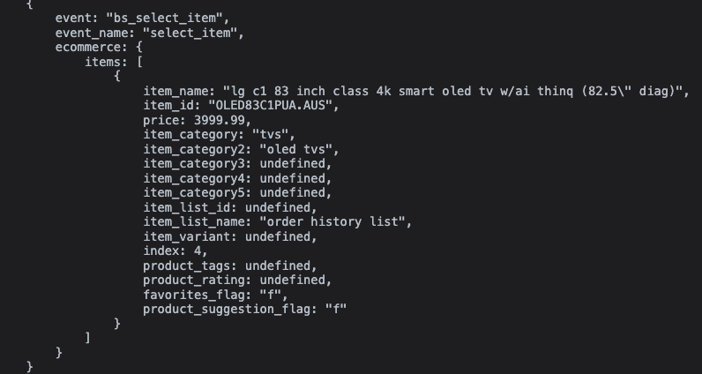

Spec vs on-page dataLayer for when the user clicks a product name on the Orders section of MyLG:
Key | Value | Pass | Note
event | “bs_select_item” | Y
event_name | “select_item” | Y
ecommerce.items[0].item_name | "lg c1 83 inch class 4k smart oled tv w/ai thinq (82.5\" diag)" | Y
ecommerce.items[0].item_id | OLED83C1PUA.AUS | Y
ecommerce.items[0].price | 3999.99 | Y
ecommerce.items[0]. item_category | “tvs” | Y
ecommerce.items[0].item_catgeory2 | “oled tvs” | Y | - We can only confirm if the formatting of this value is correct, we cannot confirm the value is correct
ecommerce.items[0].item_catgory3 | undefined | Y
ecommerce.items[0].item_category4 | undefined | Y
ecommerce.items[0].item_category5 | undefined | Y
ecommerce.items[0].item_list_id | undefined | Y | - We can only confirm if the formatting of this value is correct, we cannot confirm the value is correct
ecommerce.items[0].item_list_name | “order history list” | N | - Please set the value to the name of the list the selected product comes from. In this test case, the value should be set to something like “mylg order history list” because the product was selected from the MyLG favorites list.
ecommerce.items[0].item_variant | undefined | Y | - We can only confirm if the formatting of this value is correct, we cannot confirm the value is correct
ecommerce.items[0].index | 4 | Y
ecommerce.items[0].product_tags | undefined | Y | - We can only confirm if the formatting of this value is correct, we cannot confirm the value is correct
ecommerce.items[0].product_rating | undefined | Y
ecommerce.items[0].favorites_flag | “f” | Y
ecommerce.items[0].product_suggestion_flag | “f” | Y
ecommerce.items[0].product_condition |  | N | - This parameter is missing. Please add this value in and set it to “undefined”
ecommerce.items[0].in_stock_flag |  | N | - This parameter is missing. Please add this value in and set it to “t” if the product shown to the user is available and in stock otherwise set the value to “f” if the product shown to the user is NOT available and NOT in stock

On page dataLayer for when the user clicks a product name on the Favorites page of MyLG:
The below screenshot is produced by the Adswerve chrome extension:
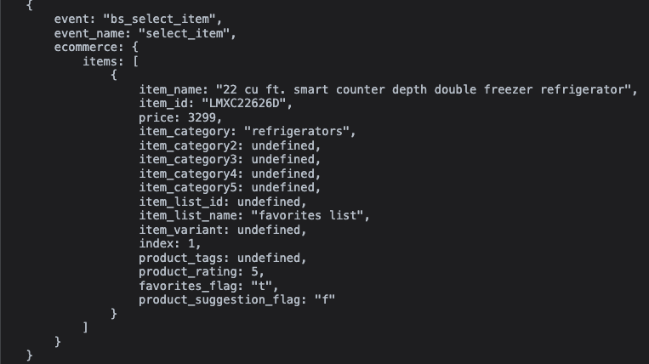

Spec vs on-page dataLayer for when the user clicks a product name on the Favorites section of MyLG:
Key | Value | Pass | Note
event | “bs_select_item” | Y
event_name | “select_item” | Y
ecommerce.items[0].item_name | "22 cu ft. smart counter depth double freezer refrigerator" | Y
ecommerce.items[0].item_id | “LMXC22626D” | Y
ecommerce.items[0].price | 3299 | Y
ecommerce.items[0]. item_category | “refrigerators” | Y
ecommerce.items[0].item_catgeory2 | undefined | Y
ecommerce.items[0].item_catgory3 | undefined | Y
ecommerce.items[0].item_category4 | undefined | Y
ecommerce.items[0].item_category5 | undefined | Y
ecommerce.items[0].item_list_id | undefined | Y | - We can only confirm if the formatting of this value is correct, we cannot confirm the value is correct
ecommerce.items[0].item_list_name | "favorites list" | N | - Please set the value to the name of the list the selected product comes from. In this test case, the value should be set to something like “mylg favorites list” because the product was selected from the MyLG favorites list.
ecommerce.items[0].item_variant | undefined | Y | - We can only confirm if the formatting of this value is correct, we cannot confirm the value is correct
ecommerce.items[0].index | 1 | Y
ecommerce.items[0].product_tags | undefined | Y | - We can only confirm if the formatting of this value is correct, we cannot confirm the value is correct
ecommerce.items[0].product_rating | 5 | Y
ecommerce.items[0].favorites_flag | “t” | Y
ecommerce.items[0].product_suggestion_flag | “f” | Y
ecommerce.items[0].product_condition |  | N | - This parameter is missing. Please add this value in and set it to “undefined”
ecommerce.items[0].in_stock_flag |  | N | - This parameter is missing. Please add this value in and set it to “t” if the product shown to the user is available and in stock otherwise set the value to “f” if the product shown to the user is NOT available and NOT in stock

On page dataLayer for when the user clicks a product name on the Subscriptions page of MyLG:
The below screenshot is produced by the Adswerve chrome extension:
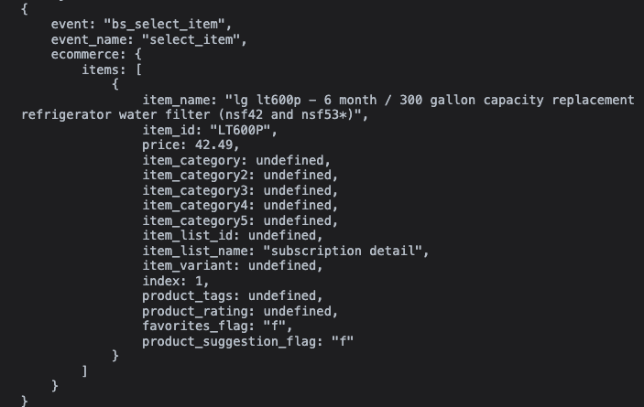

Spec vs on-page dataLayer for when the user clicks a product name on the Susbcriptions page of MyLG:
Key | Value | Pass | Note
event | “bs_select_item” | Y
event_name | “select_item” | Y
ecommerce.items[0].item_name | "lg lt600p - 6 month / 300 gallon capacity replacement refrigerator water filter (nsf42 and nsf53*)" | Y
ecommerce.items[0].item_id | "LT600P" | Y
ecommerce.items[0].price | 42.49 | Y
ecommerce.items[0]. item_category | undefined | N | - This value should never be set to undefined. Please set the value to the item category.
ecommerce.items[0].item_catgeory2 | undefined | Y | - We can only confirm if the formatting of this value is correct, we cannot confirm the value is correct
ecommerce.items[0].item_catgory3 | undefined | Y
ecommerce.items[0].item_category4 | undefined | Y
ecommerce.items[0].item_category5 | undefined | Y
ecommerce.items[0].item_list_id | undefined | Y | - We can only confirm if the formatting of this value is correct, we cannot confirm the value is correct
ecommerce.items[0].item_list_name | “subscription detail” | Y
ecommerce.items[0].item_variant | undefined | Y | - We can only confirm if the formatting of this value is correct, we cannot confirm the value is correct
ecommerce.items[0].index | 1 | Y
ecommerce.items[0].product_tags | undefined | Y | - We can only confirm if the formatting of this value is correct, we cannot confirm the value is correct
ecommerce.items[0].product_rating | undefined | Y | - We can only confirm if the formatting of this value is correct, we cannot confirm the value is correct
ecommerce.items[0].favorites_flag | “f” | Y
ecommerce.items[0].product_suggestion_flag | “f” | Y
ecommerce.items[0].product_condition |  | N | - This parameter is missing. Please add this value in and set it to “undefined”
ecommerce.items[0].in_stock_flag |  | N | - This parameter is missing. Please add this value in and set it to “t” if the product shown to the user is available and in stock otherwise set the value to “f” if the product shown to the user is NOT available and NOT in stock

e5.19 - view_item_list
URL:
- https://wwwstg.us.lg.com/us/new-mylg/favorites

Status: Pass with Notes
- As of 3/28/23, Ghanashyam said the “some products you might like” carousel is not available for QA because “This has not been developed due to dependency on coveo so will update once this will be developed.”

Expected dataLayer:
<!-- Google Tag Manager -->
...
<!-- End Google Tag Manager -->
<script>
window.dataLayer = window.dataLayer || [];
window.dataLayer.push({
"event": "bs_view_item_list",
"event_name": "view_item_list",
"ecommerce": {
"items":[{
"item_name": "{{ITEM NAME}}",
"item_id": "{{ITEM SKU}}",
"price": "{{ITEM PRICE}}",
"item_category": "{{CATEGORY LV 1}}",
"item_category2": "{{CATEGORY LV 2}}",
"item_category3": "{{CATEGORY LV 3}}",
"item_category4": "{{CATEGORY LV 4}}",
"item_category5": "{{CATEGORY LV 5}}",
"item_list_id": "{{ID OF THE LIST THE SELECTED ITEM IS IN}}",
"item_list_name": "{{NAME OF THE LIST THE SELECTED ITEM IS IN}}",
"item_variant": "{{ITEM 3 LETTER CODE}}",
"index":"{{POSITION IN THE LIST THE PRODUCT IS IN}}",
"quantity":"1",
"product_tags": "{{LIST OF PRODUCT TAGS}}",
"product_rating":"{{STAR RATING OF SELECTED PRODUCT}}",
"product_condition":"{{PLACEHOLDER FOR TRACKING IF THE PRODUCT IS USED OR REFURBISHED}}",
"favorites_flag":"{{T OR F DEPENDING ON IF THE SELECTED PRODUCT IS A FAVORITED}}",
"in_stock_flag":"{{t|f}}"
},
{
"item_name": "{{ITEM NAME}}",
"item_id": "{{ITEM SKU}}",
"price": "{{ITEM PRICE}}",
"item_category": "{{CATEGORY LV 1}}",
"item_category2": "{{CATEGORY LV 2}}",
"item_category3": "{{CATEGORY LV 3}}",
"item_category4": "{{CATEGORY LV 4}}",
"item_category5": "{{CATEGORY LV 5}}",
"item_list_id": "{{ID OF THE LIST THE SELECTED ITEM IS IN}}",
"item_list_name": "{{NAME OF THE LIST THE SELECTED ITEM IS IN}}",
"item_variant": "{{ITEM 3 LETTER CODE}}",
"index":"{{POSITION IN THE LIST THE PRODUCT IS IN}}",
"quantity":"1",
"product_tags": "{{LIST OF PRODUCT TAGS}}",
"product_rating":"{{STAR RATING OF SELECTED PRODUCT}}",
"product_condition":"{{PLACEHOLDER FOR TRACKING IF THE PRODUCT IS USED OR REFURBISHED}}",
"favorites_flag":"{{T OR F DEPENDING ON IF THE SELECTED PRODUCT IS A FAVORITED}}",
"in_stock_flag":"{{t|f}}"
}]
}
});
</script>

On page dataLayer for when the user loads the Favorites section of MyLG:
The below screenshot is produced by the Adswerve chrome extension:
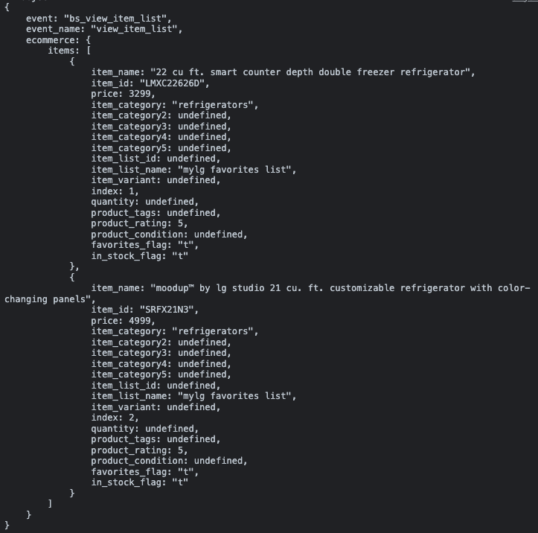

Spec vs on page dataLayer for when the user loads the Favorites section of MyLG:
Key | Value | Pass | Note
event | "bs_view_item_list" | Y
event_name | "view_item_list" | Y
event_params.items[0].item_name | "22 cu ft. smart counter depth double freezer refrigerator" | Y
event_params.items[0].item_id | "LMXC22626D" | Y
event_params.items[0].price | 3299 | Y
event_params.items[0].item_category | "refrigerators" | Y
event_params.items[0].item_category2 | undefined | Y
event_params.items[0].item_category3 | undefined | Y
event_params.items[0].item_category4 | undefined | Y
event_params.items[0].item_category5 | undefined | Y
event_params.items[0]item_list_id | undefined | Y | - We can only confirm if the formatting of this value is correct, we cannot confirm the value is correct
event_params.items[0].item_list_name | "mylg favorites list" | Y
event_params.items[0].item_variant | undefined | Y | - We can only confirm if the formatting of this value is correct, we cannot confirm the value is correct
event_params.items[0].index | 1 | Y
event_params.items[0].quantity | undefined | Y
event_params.items[0].product_tags | undefined | Y | - We can only confirm if the formatting of this value is correct, we cannot confirm the value is correct
event_params.items[0].product_rating | 5 | Y
event_params.items[0].product_condition | undefined | Y
event_params.items[0].favorites_flag | “t” | Y
event_params.items[0].in_stock_flag | “t” | Y
event_params.items[1].item_name | "moodup™ by lg studio 21 cu. ft. customizable refrigerator with color-changing panels" | Y
event_params.items[1].item_id | "SRFX21N3" | Y
event_params.items[1].price | 4999 | Y
event_params.items[1].item_category | "refrigerators" | Y
event_params.items[1].item_category2 | undefined | Y
event_params.items[1].item_category3 | undefined | Y
event_params.items[1].item_category4 | undefined | Y
event_params.items[1].item_category5 | undefined | Y
event_params.items[1]item_list_id | undefined | Y | - We can only confirm if the formatting of this value is correct, we cannot confirm the value is correct
event_params.items[1].item_list_name | "mylg favorites list" | Y
event_params.items[1].item_variant | undefined | Y | - We can only confirm if the formatting of this value is correct, we cannot confirm the value is correct
event_params.items[1].index | 2 | Y
event_params.items[1].product_tags | undefined | Y | - We can only confirm if the formatting of this value is correct, we cannot confirm the value is correct
event_params.items[1].product_rating | 5 | Y
event_params.items[1].product_condition | undefined | Y
event_params.items[1].favorites_flag | “t” | Y
event_params.items[1].in_stock_flag | “t” | Y

On page dataLayer for when the user loads the the “some products you may like” carousel in the repairs requests section of MyLG:
The below screenshot is produced by the Adswerve chrome extension:

e5.21 - user_manual
URL:
- https://wwwstg.us.lg.com/us/mylg/products

Status: Fail - Incorrect Value
- product_suggestion_flag should never be set to undefined. Please set the value to “t” if the product card the user clicked the user manual button from was displayed to the user by Coveo. Please set the value to “f” if the product card the user clicked the user manual button from was displayed to the user by something other than Coveo.

Expected dataLayer:
<!-- Google Tag Manager -->
...
<!-- End Google Tag Manager -->
<script>
window.dataLayer = window.dataLayer || [];
window.dataLayer.push({
"event": "bs_lg_event",
"event_name": "user_manual",
"event_params": {
"search_term":undefined,
"product_name": "{{ITEM NAME}}",
"product_id": "{{ITEM SKU}}",
"product_suggestion_flag":undefined,
"product_category":"{{CATEGORY THE CLICKED ON PRODUCT USER MANUAL IS ASSOCIATED WITH}}",
"product_registration_flag":"{{T OR F DEPENDING ON IF THE PRODUCT THE USER MANUAL IS REGISTERED OR NOT}}"
}
});
</script>

On page dataLayer:
The below screenshot is produced by the Adswerve chrome extension:
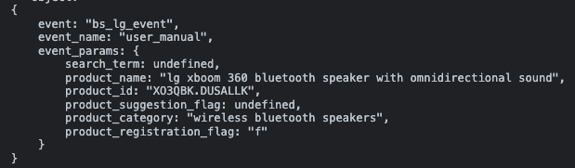

Spec vs on-page dataLayer:
Key | Value | Pass | Note
event | “bs_lg_event” | Y
event_name | “user_manual” | Y
event_params.search_term | undefined | Y
event_params.product_name | "lg uhd 80 series 75 inch class 4k smart uhd tv with ai thinq (74.5'' diag)" | Y
event_params.product_id | "75UP8070PUA.AUS" | Y
event_params.product_suggestion_flag | undefined | N | - This value should never be undefined. Please set the value to “t” if the product card the user clicked the user manual button from was displayed to the user by Coveo. Please set the value to “f” if the product card the user clicked the user manual button from was displayed to the user not by Coveo. In this test case the value should be set to “f”.
event_params.product_category | “tvs” | Y
event_params.product_registration_flag | “f” | Y

e5.22 - product_support
URL:
- https://wwwstg.us.lg.com/us/mylg/products

Status: Pass

Expected dataLayer:
<!-- Google Tag Manager -->
...
<!-- End Google Tag Manager -->
<script>
window.dataLayer = window.dataLayer || [];
window.dataLayer.push({
"event": "bs_lg_event",
"event_name": "product_support",
"event_params": {
"search_term":undefined,
"product_name": "{{ITEM NAME}}",
"product_id": "{{ITEM SKU}}",
"product_category":"{{CATEGORY THE CLICKED ON PRODUCT SUPPORT IS ASSOCIATED WITH}}",
"product_suggestion_flag":"f",
"product_registration_flag":"{{T OR F DEPENDING ON IF THE PRODUCT THE USER MANUAL IS REGISTERED OR NOT}}",
"selection_text":"{{TEXT OF THE LINK OR BUTTON THE USER CLICKED ON}}"
}
});
</script>

On page dataLayer:
The below screenshot is produced by the Adswerve chrome extension:
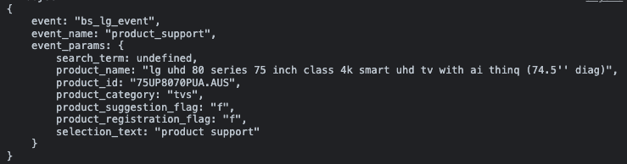

Spec vs on-page dataLayer:
Key | Value | Pass | Note
event | “bs_lg_event” | Y
event_name | “user_manual” | Y
event_params.search_term | undefined | Y
event_params.product_name | "lg uhd 80 series 75 inch class 4k smart uhd tv with ai thinq (74.5'' diag)" | Y
event_params.product_id | "75UP8070PUA.AUS" | Y
event_params.product_category | “tvs” | Y
event_params.product_suggestion_flag | “f” | Y
event_params.product_registration_flag | “f” | Y
event_params.selection_text | “product support” | Y

e5.23 - order_number_hyperlink
URL:
- Products section
  - https://wwwstg.us.lg.com/us/mylg/products
- Orders Section
  - https://wwwstg.us.lg.com/us/mylg/my-order

Status: Pass

Expected dataLayer:
<!-- Google Tag Manager -->
...
<!-- End Google Tag Manager -->
<script>
window.dataLayer = window.dataLayer || [];
window.dataLayer.push({
"event": "bs_lg_event",
"event_name": "order_number_hyperlink",
"event_params": {
"order_number":"{{NUMBER OF THE ORDER}}"
}
});
</script>

On page dataLayer for when users clicks the order number hyperlink in the product cards on the products section:
The below screenshot is produced by the Adswerve chrome extension:
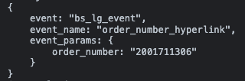

Spec vs on-page dataLayer for when users clicks the order number hyperlink in the product cards on the products section:
Key | Value | Pass | Note
event | “bs_lg_event” | Y
event_name | “order_number_hyperlink” | Y
event_params.order_number | "2001711306" | Y

On page dataLayer for when users clicks the order number hyperlink in the order cards on the orders section:
The below screenshot is produced by the Adswerve chrome extension:
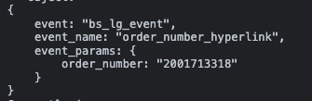

Spec vs on-page dataLayer for when users clicks the order number hyperlink in the order cards on the orders section:
Key | Value | Pass | Note
event | “bs_lg_event” | Y
event_name | “order_number_hyperlink” | Y
event_params.order_number | "2001713318" | Y

e5.24 - privacy_policy
URL:
- https://wwwstg.us.lg.com/us/mylg/products/registration?from=products

Status: Pass

Expected dataLayer:
<!-- Google Tag Manager -->
...
<!-- End Google Tag Manager -->
<script>
window.dataLayer = window.dataLayer || [];
window.dataLayer.push({
"event": "bs_lg_event",
"event_name": "privacy_policy"
});
</script>

On page dataLayer:
The below screenshot is produced by the Adswerve chrome extension:
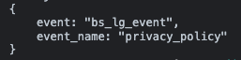

Spec vs on-page dataLayer:
Key | Value | Pass | Note
event | “bs_lg_event” | Y
event_name | “privacy_policy” | Y

e5.25 - insurance_quote
URL:
- https://wwwstg.us.lg.com/us/new-mylg/my-order

Status: Pass

Expected dataLayer:
<!-- Google Tag Manager -->
...
<!-- End Google Tag Manager -->
<script>
window.dataLayer = window.dataLayer || [];
window.dataLayer.push({
"event": "bs_lg_event",
"event_name": "insurance_quote",
"event_params": {
"product_name": "{{NAME OF THE ITEM THAT WAS SUCCESSFULLY REGISTERED}}",
"product_id": "{{SKU OF THE ITEM THAT WAS SUCCESSFULLY REGISTERED}}",
"product_category":"{{CATEGORY OF THE ITEM THAT WAS SUCCESSFULLY REGISTERED}}"
}
});
</script>

On page dataLayer:
The below screenshot is produced by the Adswerve chrome extension:
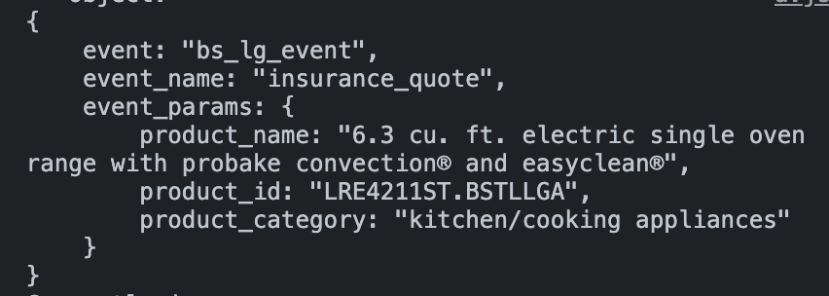

Spec vs on-page dataLayer:
Key | Value | Pass | Note
event | “bs_lg_event” | Y
event_name | “insurance_quote” | Y
event_params.product_name | "6.3 cu. ft. electric single oven range with probake convection® and easyclean®" | Y
event_params.product_id | "LRE4211ST.BSTLLGA" | Y
event_params.product_category | "kitchen/cooking appliances" | Y

e5.26 - what_is_premium_care
URL:
- https://wwwstg.us.lg.com/us/mylg/products/registration-success

Status: Pass

Expected dataLayer:
<!-- Google Tag Manager -->
...
<!-- End Google Tag Manager -->
<script>
window.dataLayer = window.dataLayer || [];
window.dataLayer.push({
"event": "bs_lg_event",
"event_name": "product_support",
"event_params": {
"selection_text":"{{TEXT OF THE LINK OR BUTTON THE USER CLICKED ON}}",
"product_name": "{{NAME OF THE ITEM THAT WAS SUCCESSFULLY REGISTERED}}",
"product_id": "{{SKU OF THE ITEM THAT WAS SUCCESSFULLY REGISTERED}}",
"product_category":"{{CATEGORY OF THE ITEM THAT WAS SUCCESSFULLY REGISTERED}}"
}
});
</script>

On page dataLayer:
The below screenshot is produced by the Adswerve chrome extension:
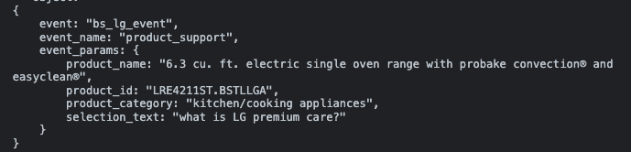

Spec vs on-page dataLayer:
Key | Value | Pass | Note
event | “bs_lg_event” | Y
event_name | “insurance_quote” | Y
event_params.product_name | "6.3 cu. ft. electric single oven range with probake convection® and easyclean®" | Y
event_params.product_id | "LRE4211ST.BSTLLGA" | Y
event_params.product_category | "kitchen/cooking appliances" | Y
event_params.selection_text | "what is LG premium care?" | Y

e5.28 - return_replace
URL:
- https://wwwstg.us.lg.com/us/new-mylg/my-order

Status: Pass with Notes

Notes:
- No orders with additional services (wall mounting powered by handy, subscription products and subscription options or LG premium care) included were associated with a return/replace button on the Orders Section therefore orders with additional services were not QA’d.
- MyLG account used in testing: hemaobs11@yopmail.com/ Admin@2022

Expected dataLayer:
<!-- Google Tag Manager -->
...
<!-- End Google Tag Manager -->
<script>
window.dataLayer = window.dataLayer || [];
window.dataLayer.push({
"event": "bs_lg_event",
"event_name": "return_replace",
"event_params": {
"order_date":"{{ORDER PLACED DATE}}",
"status":"{{ORDER STATUS}}",
"order_number":"{{ORDER NUMBER}}",
"total_order_value":"{{TOTAL DOLLAR AMOUNT OF THE ORDER}}"
"items":[
{
"item_name": "{{ITEM NAME}}",
"item_id": "{{ITEM SKU}}",
"price": "{{ITEM PRICE}}",
"item_category": "{{CATEGORY LV 1}}",
"item_category2": "{{CATEGORY LV 2}}",
"item_category3": "{{CATEGORY LV 3}}",
"item_category4": "{{CATEGORY LV 4}}",
"item_category5": "{{CATEGORY LV 5}}",
"item_variant": "{{ITEM 3 LETTER CODE}}",
"quantity": "{{QUANTITY OF ITEM}}",
"additional_services_sku":"{{PIPE DELIMITED LIST OF TV WALL MOUNTING SKU AND/OR PREMIUM CARE SKUS}}",
"accessories_sku":"{{PIPE DELIMITED LIST OF PRODUCT ACCESSORIES SKUS}}",
"return_window":"{{RETURN BY DATE OR RETURN WINDOW CLOSED}}",
"product_condition":"{{PLACEHOLDER FOR TRACKING IF THE PRODUCT IS USED OR REFURBISHED}}"
},
{
"item_name": "{{ITEM NAME}}",
"item_id": "{{ITEM SKU}}",
"price": "{{ITEM PRICE}}",
"item_category": "{{CATEGORY LV 1}}",
"item_category2": "{{CATEGORY LV 2}}",
"item_category3": "{{CATEGORY LV 3}}",
"item_category4": "{{CATEGORY LV 4}}",
"item_category5": "{{CATEGORY LV 5}}",
"item_variant": "{{ITEM 3 LETTER CODE}}",
"quantity": "{{QUANTITY OF ITEM}}",
"additional_services_sku":"{{PIPE DELIMITED LIST OF TV WALL MOUNTING SKU AND/OR PREMIUM CARE SKUS}}",
"accessories_sku":"{{PIPE DELIMITED LIST OF PRODUCT ACCESSORIES SKUS}}",
"return_window":"{{RETURN BY DATE OR RETURN WINDOW CLOSED}}",
"product_condition":"{{PLACEHOLDER FOR TRACKING IF THE PRODUCT IS USED OR REFURBISHED}}"
}
]}
/*Please include all product IDs, services and names, inside of the order*/
});
</script>

On page dataLayer:
The below screenshot is produced by the Adswerve chrome extension:
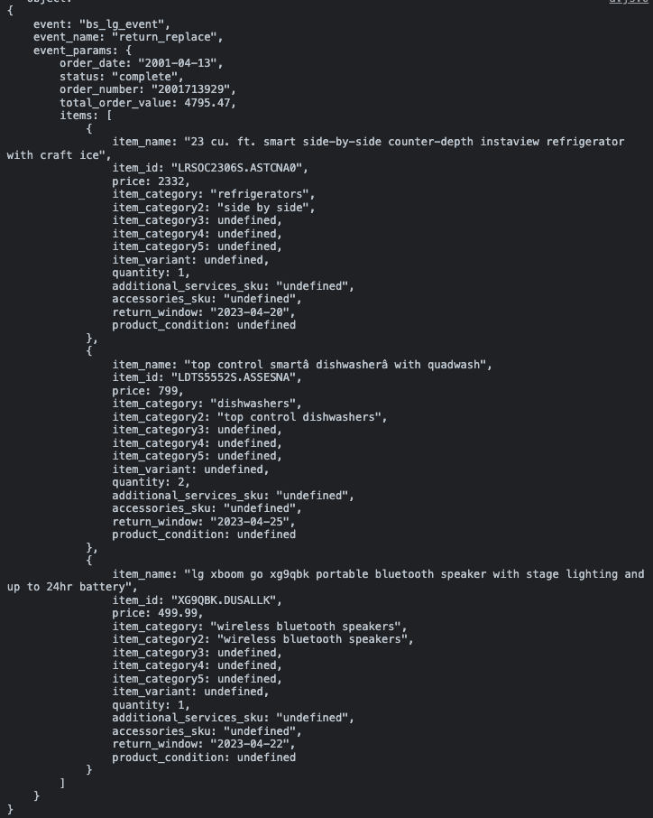

Spec vs on page dataLayer:
Filling out the table for the first and last items in the items array should provide a strong enough example of the QA that should be applied to all elements within the items array.
Key | Value | Pass | Note
event | “bs_lg_event” | Y
event_name | “return_replace” | Y
event_params.order_date | “2001-04-13” | Y
event_params.order_status | “complete” | Y
event_params.order_number | "2001713929" | Y
event_params.total_order_value | 4795.47 | Y
event_params.items[0].item_name | "23 cu. ft. smart side-by-side counter-depth instaview refrigerator with craft ice" | Y
event_params.items[0].item_id | "LRSOC2306S.ASTCNA0" | Y
event_params.items[0].price | 2332 | Y
event_params.items[0].item_category | "refrigerators" | Y
event_params.items[0].item_category2 | “side by side” | Y
event_params.items[0].item_category3 | undefined | Y
event_params.items[0].item_category4 | undefined | Y
event_params.items[0].item_category5 | undefined | Y
event_params.items[0].item_variant | undefined | Y | - We can only confirm if the formatting of this value is correct, we cannot confirm the value is correct
event_params.items[0].quantity | 1 | Y
event_params.items[0].additional_services_sku | undefined | Y
event_params.items[0].accessories_sku | undefined | Y
event_params.items[0].return_window | “2023-04-20” | Y
event_params.items[0].product_condition | undefined | Y
event_params.items[3].item_name | "lg xboom go xg9qbk portable bluetooth speaker with stage lighting and up to 24hr battery" | Y
event_params.items[3].item_id | "XG9QBK.DUSALLK" | Y
event_params.items[3].price | 499.99 | Y
event_params.items[3].item_category | "wireless bluetooth speakers" | Y
event_params.items[3].item_category2 | "wireless bluetooth speakers" | Y
event_params.items[3].item_category3 | undefined | Y
event_params.items[3].item_category4 | undefined | Y
event_params.items[3].item_category5 | undefined | Y
event_params.items[3].item_variant | undefined | Y | - We can only confirm if the formatting of this value is correct, we cannot confirm the value is correct
event_params.items[3].quantity | 1 | Y
event_params.items[3].additional_services_sku | undefined | Y
event_params.items[3].accessories_sku | undefined | Y
event_params.items[3].return_window | "2023-04-22" | Y
event_params.items[3].product_condition | undefined | Y

e5.29 - switch_tab
URL:
- https://wwwstg.us.lg.com/us/mylg/subscription/detail/251496?currentPage=1

Status: Pass

Expected dataLayer:
<!-- Google Tag Manager -->
...
<!-- End Google Tag Manager -->
<script>
window.dataLayer = window.dataLayer || [];
window.dataLayer.push({
"event": "bs_lg_event",
"event_name": "switch_tab",
"event_params": {
"selection_text":"{{TEXT OF THE LINK OR BUTTON THE USER CLICKED ON}}"
}
});
</script>

On page dataLayer for when the user clicks to open the related orders tab on a subscription details page:
The below screenshot is produced by the Adswerve chrome extension:
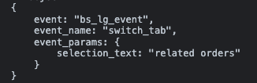

Spec vs on-page dataLayer for when the user clicks to open the related orders tab on a subscription details page:
Key | Value | Pass | Note
event | “bs_lg_event” | Y
event_name | “switch_tab” | Y
event_params.selection_text | “related orders” | Y

On page dataLayer for when the user clicks to open the related orders tab on a subscription details page:
The below screenshot is produced by the Adswerve chrome extension:
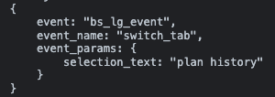

Spec vs on-page dataLayer for when the user clicks to open the plan history tab on a subscription details page:
Key | Value | Pass | Note
event | “bs_lg_event” | Y
event_name | “switch_tab” | Y
event_params.selection_text | “plan history” | Y

On page dataLayer for when the user clicks to open the plan information tab on a subscription details page:
The below screenshot is produced by the Adswerve chrome extension:
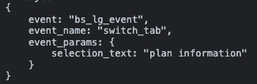

Spec vs on-page dataLayer for when the user clicks to open the plan information tab on a subscription details page:
Key | Value | Pass | Note
event | “bs_lg_event” | Y
event_name | “switch_tab” | Y
event_params.selection_text | “plan information” | Y

e5.30 - edit_subscription
URL:
- https://wwwstg.us.lg.com/us/mylg/subscription/detail/251487?currentPage=1

Status: Pass

Expected dataLayer:
<!-- Google Tag Manager -->
...
<!-- End Google Tag Manager -->
<script>
window.dataLayer = window.dataLayer || [];
window.dataLayer.push({
"event": "bs_lg_event",
"event_name": "edit_subscription",
"event_params": {
"subscription_id":"{{SUBSCRIPTION ID NUMBER}}",
"subscription_created_date":"{{SUBSCRIPTION START DATE}}",
"subscription_frequency":"{{SUBSCRIPTION FREQUENCY}}",
"subscription_next_shipment":"{{RENEWAL DATE}}",
"subscription_order_history":"{{ORDER HISTORY}}",
"subscription_quantity":"{{SUBSCRIPTION QUANTITY}}",
"subscription_product_name":"{{NAME OF THE PRODUCT THAT THE USER IS MANAGING THE SUBSCRIPTION FOR}}",
"subscription_product_sku":"{{SKU OF THE PRODUCT THAT THE USER IS MANAGING THE SUBSCRIPTION FOR}}",
"subscription_billing_price":"{{SUBSCRIPTION BILLING PRICE}}",
"subscription_initial_price":"{{SUBSCRIPTION INITIAL PRICE}}",
}
});
</script>

On page dataLayer:
The below screenshot is produced by the Adswerve chrome extension:
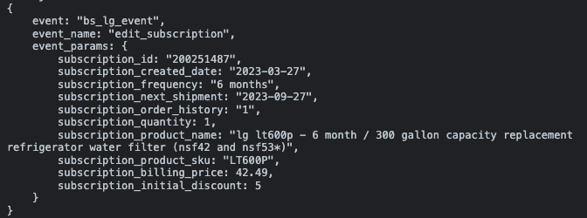

Spec vs on-page dataLayer:
Key | Value | Pass | Note
event | “bs_lg_event” | Y
event_name | “edit_subscription” | Y
event_params.subscription_id | "200251487" | Y
event_params.subscription_created_date | "2023-03-27" | Y
event_params.subscription_frequency | "6 months" | Y
event_params.subscription_next_shipment | "202-09-27" | Y
event_params.subscription_order_history | “1” | Y
event_params.subscritption_quantity | 1 | Y
event_params.subscription_product_name | "lg lt600p - 6 month / 300 gallon capacity replacement refrigerator water filter (nsf42 and nsf53*)" | Y
event_params.subscription_product_sku | "LT600P" | Y
event_params.subscription_billing_price | 42.49 | Y
event_params.subscription_initial_discount | 5 | Y

e5.31 - save_subscription_updates
URL:
- https://wwwstg.us.lg.com/us/new-mylg/subscription/detail/250933?currentPage=2

Status: Pass

Expected dataLayer:
<!-- Google Tag Manager -->
...
<!-- End Google Tag Manager -->
<script>
window.dataLayer = window.dataLayer || [];
window.dataLayer.push({
"event": "bs_lg_event",
"event_name": "save_subscription_updates",
"event_params": {
"subscription_id":"{{SUBSCRIPTION ID NUMBER}}",
"subscription_product_name":"{{NAME OF THE PRODUCT THAT THE USER IS MANAGING THE SUBSCRIPTION FOR}}",
"subscription_product_sku":"{{SKU OF THE PRODUCT THAT THE USER IS MANAGING THE SUBSCRIPTION FOR}}",
"field_updated":"{{PIPE DELIMITED LIST OF FIELD NAMES THE USER UPDATED}}"
}
});
</script>

On page dataLayer when the user updates only the shipping address field:
The below screenshot is produced by the Adswerve chrome extension:
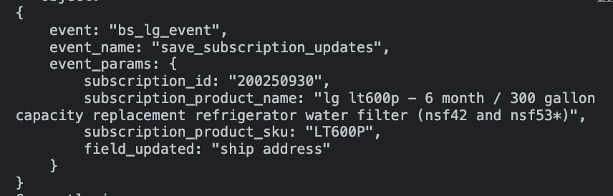

Spec vs on page dataLayer when the user updates only the shipping address field:
Key | Value | Pass | Note
event | “bs_lg_event” | Y
event_name | “skip_subscription” | Y
event_params.subscription_id | "200250933" | Y
event_params.subscription_product_name | "lg lt600p - 6 month / 300 gallon capacity replacement refrigerator water filter (nsf42 and nsf53*)" | Y
event_params.subscription_product_sku | "LT600P" | Y
event_params.field_updated | “ship address” | Y

On page dataLayer when the user updates the shipping address, billing address and payment:
The below screenshot is produced by the Adswerve chrome extension:
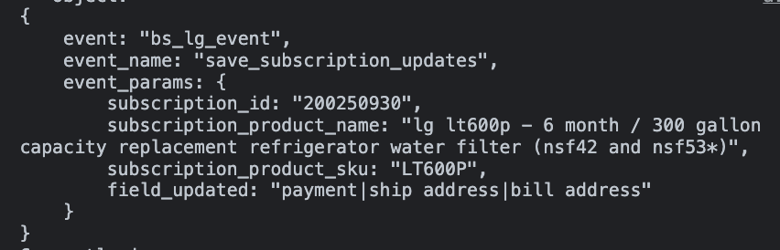

Spec vs on page dataLayer when the user updates the shipping address, billing address and payment:
The below screenshot is produced by the Adswerve chrome extension:
Key | Value | Pass | Note
event | “bs_lg_event” | Y
event_name | “skip_subscription” | Y
event_params.subscription_id | "200250933" | Y
event_params.subscription_product_name | "lg lt600p - 6 month / 300 gallon capacity replacement refrigerator water filter (nsf42 and nsf53*)" | Y
event_params.subscription_product_sku | "LT600P" | Y
event_params.field_updated | “payment|ship address|bill address” | Y

On page dataLayer when the user only updates the renewal date:
The below screenshot is produced by the Adswerve chrome extension:
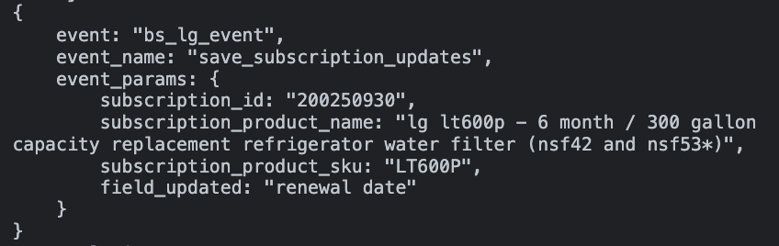

Spec vs on page dataLayer when the user only updates the renewal date:
The below screenshot is produced by the Adswerve chrome extension:
Key | Value | Pass | Note
event | “bs_lg_event” | Y
event_name | “skip_subscription” | Y
event_params.subscription_id | "200250933" | Y
event_params.subscription_product_name | "lg lt600p - 6 month / 300 gallon capacity replacement refrigerator water filter (nsf42 and nsf53*)" | Y
event_params.subscription_product_sku | "LT600P" | Y
event_params.field_updated | “renewal date” | Y

On page dataLayer when the user updates only the billing address field:
The below screenshot is produced by the Adswerve chrome extension:
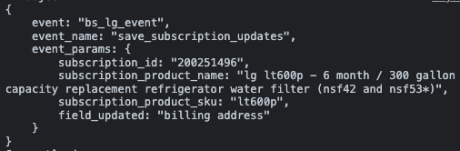

Spec vs on page dataLayer when the user updates only the billing address field:
Key | Value | Pass | Note
event | “bs_lg_event” | Y
event_name | “skip_subscription” | Y
event_params.subscription_id | "200251496" | Y
event_params.subscription_product_name | "lg lt600p - 6 month / 300 gallon capacity replacement refrigerator water filter (nsf42 and nsf53*)" | Y
event_params.subscription_product_sku | "LT600P" | Y
event_params.field_updated | “billing address” | Y

e5.32 - submit_question
URL:
- https://wwwstg.us.lg.com/us/new-mylg/ask-us

Status: Pass

Expected dataLayer:
<!-- Google Tag Manager -->
...
<!-- End Google Tag Manager -->
<script>
window.dataLayer = window.dataLayer || [];
window.dataLayer.push({
"event": "bs_lg_event",
"event_name": "submit_question"
});
</script>

On page dataLayer:
The below screenshot is produced by the Adswerve chrome extension:
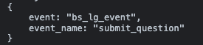

Spec vs on page dataLayer:
Key | Value | Pass | Note
event | “bs_lg_event” | Y
event_name | “submit_question” | Y

e5.33 - ask_us_view_details
URL:
- https://wwwstg.us.lg.com/us/new-mylg/ask-us

Status: Pass

Expected dataLayer:
<!-- Google Tag Manager -->
...
<!-- End Google Tag Manager -->
<script>
window.dataLayer = window.dataLayer || [];
window.dataLayer.push({
"event": "bs_lg_event",
"event_name": "ask_us_view_details",
"event_params": {
"receipt_number":"{{RECEIPT NUMBER}}",
"receipt_date":"{{RECEIPT DATE}}",
"receipt_status":"{{RECEIPT STATUS}}"
}
});
</script>

On page dataLayer:
The below screenshot is produced by the Adswerve chrome extension:
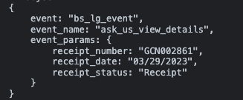

Spec vs on page dataLayer:
Key | Value | Pass | Note
event | “bs_lg_event” | Y
event_name | “ask_us_view_details” | Y
event_params.receipt_number | "GCN002861" | Y
event_params.receipt_date | "03/29/2023" | Y
event_params.receipt_status | “Receipt” | Y

e5.34 - expand_faq
URL:
- https://wwwstg.us.lg.com/us/new-mylg/faq

Status: Pass

Expected dataLayer:

<!-- Google Tag Manager -->
...
<!-- End Google Tag Manager -->
<script>
window.dataLayer = window.dataLayer || [];
window.dataLayer.push({
"event": "bs_lg_event",
"event_name": "expand_faq",
"event_params": {
"faq_text":"{{TEXT OF THE QUESTION THE USER IS EXPANDING TO SEE THE ANSWER FOR}}",
"faq_section":"{{SECTION HEADER THE EXPANDED FAQ ALIGNS TO}}"
}
});
</script>

On page dataLayer for when the user loads the FAQ page:
The below screenshot is produced by the Adswerve chrome extension:
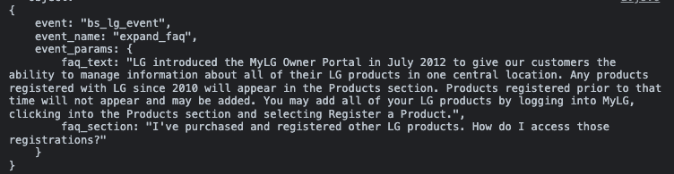

Spec vs on page dataLayer for when the user loads the FAQ page:
Key | Value | Pass | Note
event | “bs_lg_event” | Y
event_name | “expand_faq” | Y
event_params.faq_text | "LG introduced the MyLG Owner Portal in July 2012 to give our customers the ability to manage information about all of their LG products in one central location. Any products registered with LG since 2010 will appear in the Products section. Products registered prior to that time will not appear and may be added. You may add all of your LG products by logging into MyLG, clicking into the Products section and selecting Register a Product." | Y
event_params.faq_section | "I've purchased and registered other LG products. How do I access those registrations?" | Y

On page dataLayer for when the user clicks on an accordion:
The below screenshot is produced by the Adswerve chrome extension:
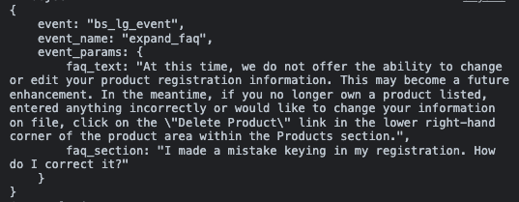

Spec vs on page dataLayer for when the user clicks on an accordion:
Key | Value | Pass | Note
event | “bs_lg_event” | Y
event_name | “expand_faq” | Y
event_params.faq_text | "At this time, we do not offer the ability to change or edit your product registration information. This may become a future enhancement. In the meantime, if you no longer own a product listed, entered anything incorrectly or would like to change your information on file, click on the \"Delete Product\" link in the lower right-hand corner of the product area within the Products section." | Y
event_params.faq_section | "I made a mistake keying in my registration. How do I correct it?" | Y

e5.35 - customer_support_link
URL:
- https://wwwstg.us.lg.com/us/new-mylg/support

Status: Pass
- Please make it so the event fires when the user clicks on the online chat links on https://wwwstg.us.lg.com/us/support/repair-service/schedule-repair

Expected dataLayer:

<!-- Google Tag Manager -->
...
<!-- End Google Tag Manager -->
<script>
window.dataLayer = window.dataLayer || [];
window.dataLayer.push({
"event": "bs_lg_event",
"event_name": "customer_support_link"
});
</script>

On page dataLayer:
The below screenshot is produced by the Adswerve chrome extension:
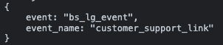

Spec vs on page dataLayer when the user only updates the renewal date:
Key | Value | Pass | Note
event | “bs_lg_event” | Y
event_name | “customer_support_link” | Y

e5.36 - help_desk_call
URL:
- https://wwwstg.us.lg.com/us/new-mylg/support

Status: Pass

Expected dataLayer:

<!-- Google Tag Manager -->
...
<!-- End Google Tag Manager -->
<script>
window.dataLayer = window.dataLayer || [];
window.dataLayer.push({
"event": "bs_lg_event",
"event_name": "help_desk_call"
"event_params": {
"phone_number": "{{SELECTED PHONE NUMBER}}",
"number_type":"{{CUSTOMER SUPPORT AND SUPPORT OR ORDERS AND RETURN INQUIRIES}}"
}
});
</script>

On page dataLayer for when the user clicks to call the customer support phone number:
The below screenshot is produced by the Adswerve chrome extension:
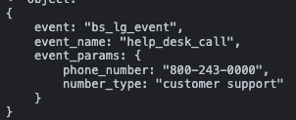

Spec vs on page dataLayer for when the user clicks to call the customer support phone number:
Key | Value | Pass | Note
event | “bs_lg_event” | Y
event_name | “hekp_desk_call” | Y
event_params.phone_number | “800-243-0000” | Y
event_params.number_type | “customer service” | Y

On page dataLayer for when the user clicks to call the ordeer or return phone number:
The below screenshot is produced by the Adswerve chrome extension:
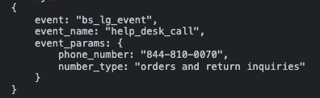

Spec vs on page dataLayer for when the user clicks to call the customer support phone number:
Key | Value | Pass | Note
event | “bs_lg_event” | Y
event_name | “hekp_desk_call” | Y
event_params.phone_number | “844-810-0070” | Y
event_params.number_type | “orders and return inquiries” | Y

e5.37 - return_exchange_policy
URL:
- https://wwwstg.us.lg.com/us/new-mylg/support

Status: Pass

Expected dataLayer:

<!-- Google Tag Manager -->
...
<!-- End Google Tag Manager -->
<script>
window.dataLayer = window.dataLayer || [];
window.dataLayer.push({
"event": "bs_lg_event",
"event_name": "return_exchange_policy"
});
</script>

On page dataLayer:
The below screenshot is produced by the Adswerve chrome extension:
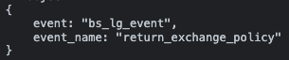

Spec vs on page dataLayer:
Key | Value | Pass | Note
event | “bs_lg_event” | Y
event_name | “return_exchange_policy” | Y

e5.38 - online_chat
URL:
- https://wwwstg.us.lg.com/us/new-mylg/support
- https://wwwstg.us.lg.com/us/support/repair-service/schedule-repair
- https://www.lg.com/us/support/contact

Status: Fail - Missing data layer event execution
- Please make it so the event fires when the user clicks on the online chat links on https://wwwstg.us.lg.com/us/support/repair-service/schedule-repair & https://www.lg.com/us/support/contact

Expected dataLayer:

<!-- Google Tag Manager -->
...
<!-- End Google Tag Manager -->
<script>
window.dataLayer = window.dataLayer || [];
window.dataLayer.push({
"event": "bs_lg_event",
"event_name": "online_chat"
});
</script>

On page dataLayer when the user clicks the online chat button in the contact us section of MyLG:
The below screenshot is produced by the Adswerve chrome extension:
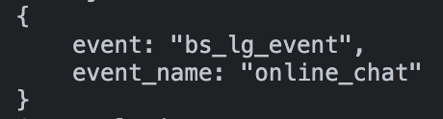

Spec vs on page dataLayer when the user clicks the online chat button in the contact us section of MyLG:
Key | Value | Pass | Note
event | “bs_lg_event” | Y
event_name | “online_chat” | Y

On page dataLayer when the user clicks the online chat button in the schedule repair section of MyLG:
The below screenshot is produced by the Adswerve chrome extension:

e5.39 - social_click
URL:
- https://wwwstg.us.lg.com/us/new-mylg/support
- https://wwwstg.us.lg.com/us/support/repair-service/schedule-repair
- https://www.lg.com/us/support/contact

Status: Fail - Missing data layer event execution
- Please make it so the event fires when the user clicks on the twitter handle link on https://wwwstg.us.lg.com/us/support/repair-service/schedule-repair & https://www.lg.com/us/support/contact

Expected dataLayer:

<!-- Google Tag Manager -->
...
<!-- End Google Tag Manager -->
<script>
window.dataLayer = window.dataLayer || [];
window.dataLayer.push({
"event": "bs_lg_event",
"event_name": "social_click"
"event_parms": {
"selection_text":"{{/LGUSSUPPORT OR @LGUSSUPPORT}}",
"social_platform":"{{FACEBOOK OR TWITTER}}"
}
});
</script>

On page dataLayer when the user clicks the facebook handle link in the contact us section of MyLG:
The below screenshot is produced by the Adswerve chrome extension:
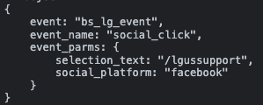

Spec vs on page dataLayer when the user clicks the facebook handle link in the contact us section of MyLG:
Key | Value | Pass | Note
event | “bs_lg_event” | Y
event_name | “social_click” | Y
event_params.selection_text | “/lgussupport” | Y
event_params.social_platform | “facebook” | Y

On page dataLayer when the user clicks the twitter handle link in the contact us section of MyLG:
The below screenshot is produced by the Adswerve chrome extension:
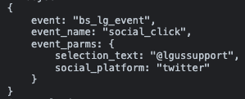

Spec vs on page dataLayer when the user clicks the twitter handle link in the contact us section of MyLG:
Key | Value | Pass | Note
event | “bs_lg_event” | Y
event_name | “social_click” | Y
event_params.selection_text | “@lgussupport” | Y
event_params.social_platform | “twitter” | Y

e5.40 - set_default_shipping_address
URL:
- https://wwwstg.us.lg.com/us/mylg/address-book

Status: Pass

Expected dataLayer:

<!-- Google Tag Manager -->
...
<!-- End Google Tag Manager -->
<script>
window.dataLayer = window.dataLayer || [];
window.dataLayer.push({
"event": "bs_lg_event",
"event_name": "set_default_shipping_address"
"event_params":{
"selected_ship_zip":"{{SHIPPING ADDRESS ZIPCODE}}"
"hash_zip_code":"{{SHA256 ENCODING OF THE ZIP CODE}}"
}
});
</script>

On page dataLayer:
The below screenshot is produced by the Adswerve chrome extension:
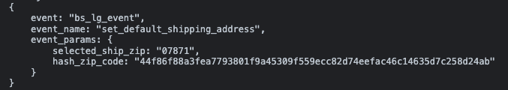

Spec vs on page dataLayer:
Key | Value | Pass | Note
event | “bs_lg_event” | Y
event_name | “set_default_shipping_address” | Y
event_params.selected_ship_zip | “07871” | Y
event_params.has_zip_code | "44f86f88a3fea7793801f9a45309f559ecc82d74eefac46c14635d7c258d24ab" | Y

