Instruction: Paper > Google

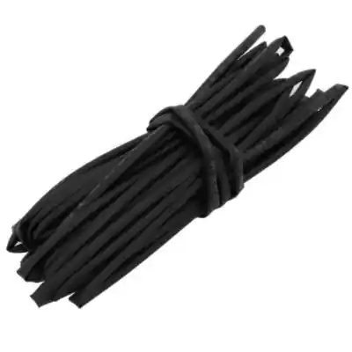  Heat Shrink Tube  5mm 1m = रू69 | 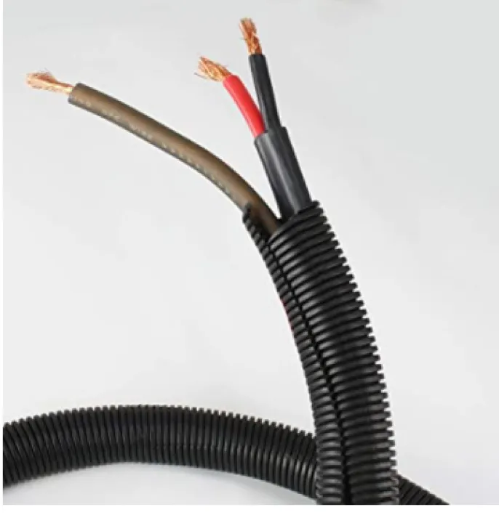  7mm 5m Wire cover  रू 226 | 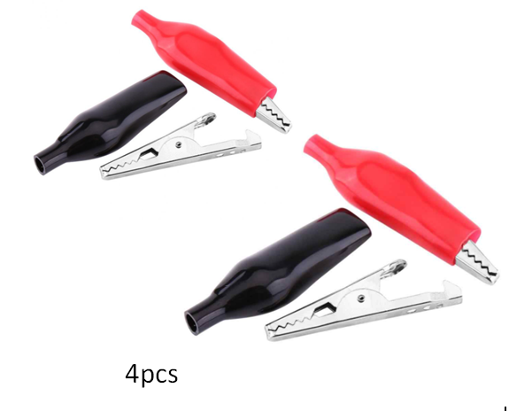  Aligator clip 45mm  Pair of 2  रू 100 | 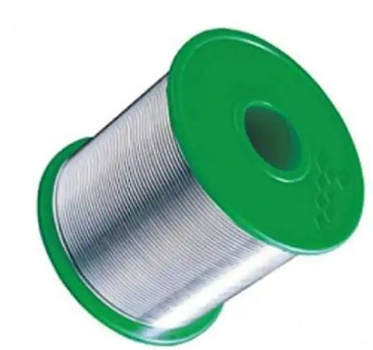  Solder wire  20/22 40gm  6040 tin lead  रू 296
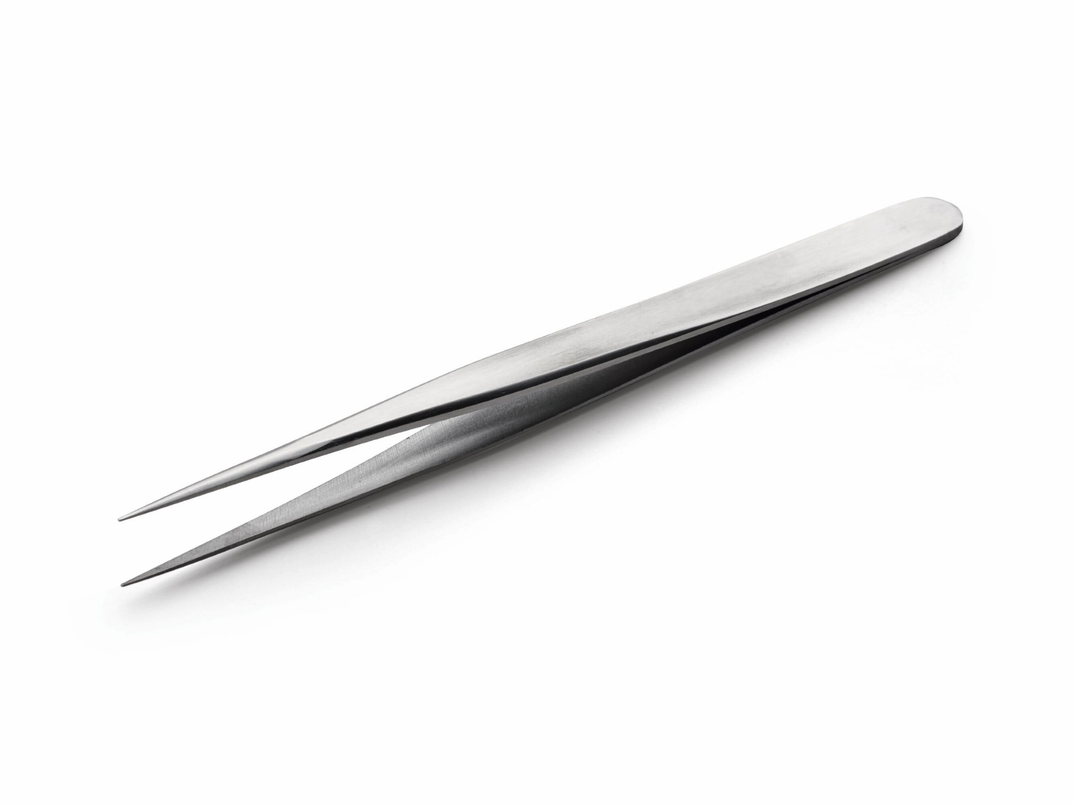  Tweezer Rs. 176 | 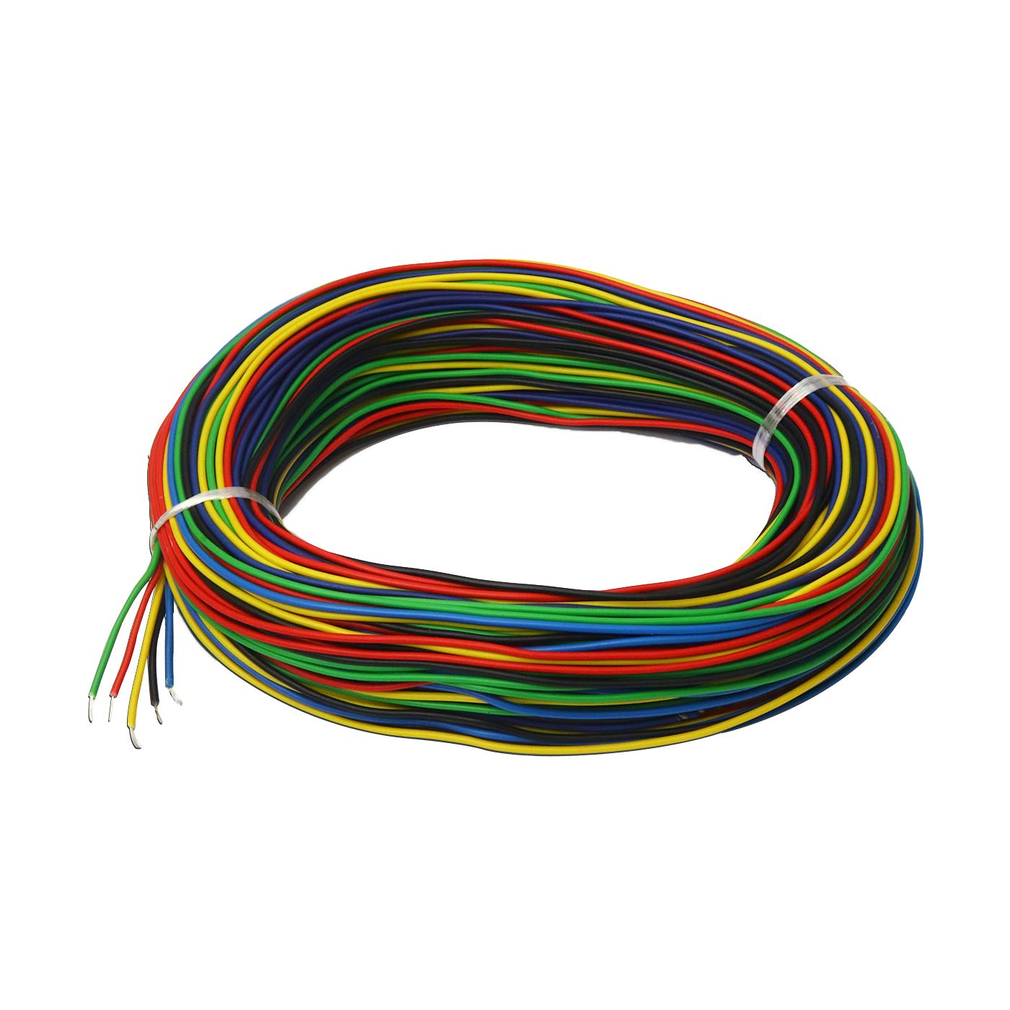  Multi Color wire for science projects | 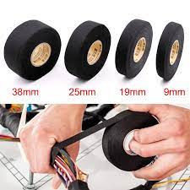  Wire harness tape |   Crimp Terminal Connectors
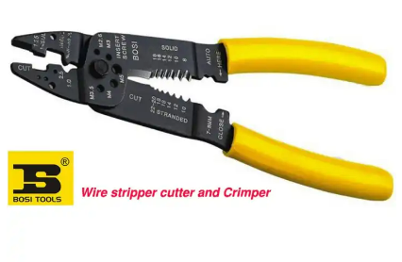  Bosi Multi-Purpose Wire Stripper,Cutter,Crimper Heavy Duty, 0.6-2.6mm  रू865 |   Deli wire stripper 0.6-2.6mm  रू 350 | 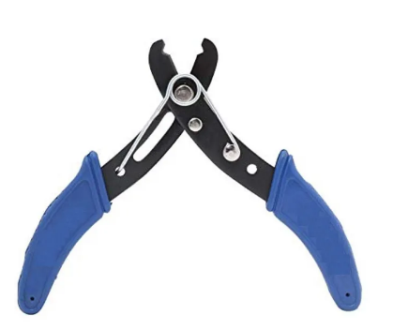  Wire stripper cutter  140 | 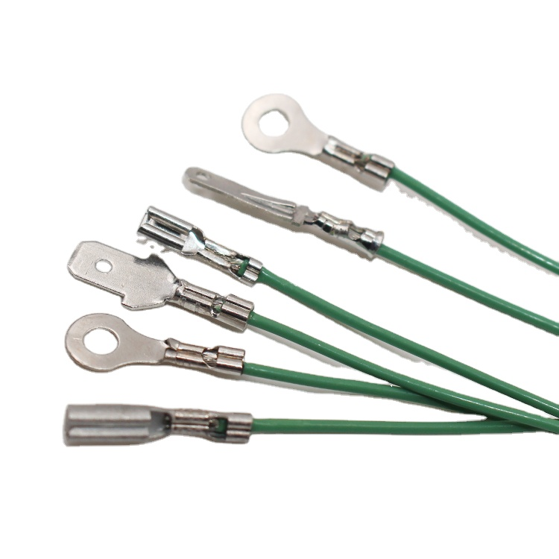  Crimp Terminal Connectors
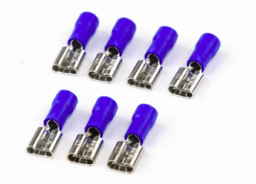  10 pcs 5mm female connector, terminal crimp  रू115 | 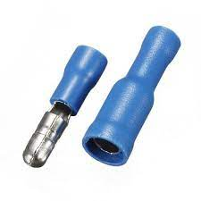  Bullet terminal crimp | 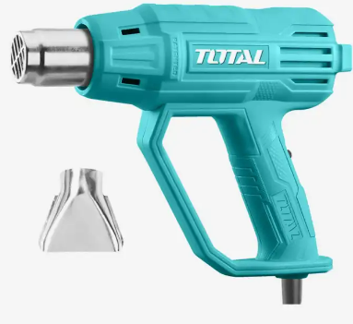  Total Heat Gun 2000w  रू2185 | 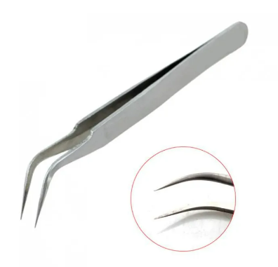  Twizzer  रू176
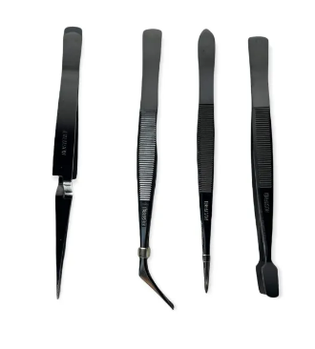  ProsKit twizzer set  रू 1450 | 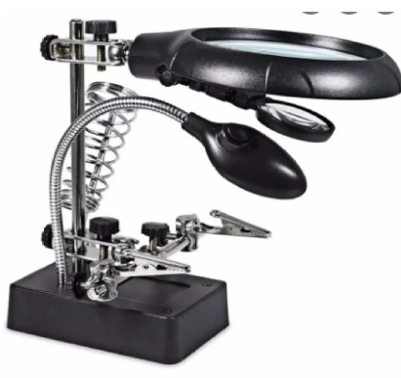  Stand 10x zoom  2881 | 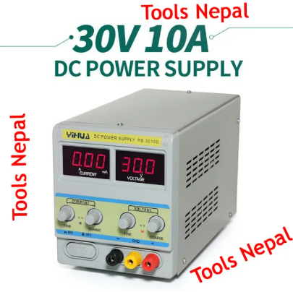  30v 10A रू 18500  30V 5A रू 12425  30 V 5A रू 12500  30 V 5 A रू 7999  15V 1A रू 3,450 | 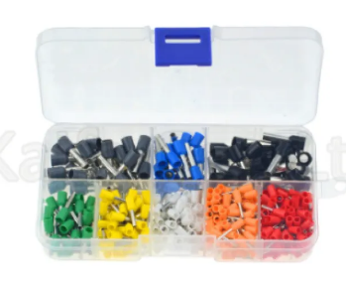  रू866

