- 🇨🇦 🤦Canada Immigration scam, consultancy, social media hype
- Crisis + Labour Update – May 2025
- 🕳️ immigration Fraud, asylum abuse, illegal cheap labour
- 🚨 Crime, retail theft, cyber scams rising
- 🏃‍♂️ Brain Drain: Tech, Doctors, Nurses leaving
- 🏥 Worst Health Care (ER delays, staff shortages)
- 💸 High Taxes, Overwork, Low ROI
- 📉 Recession threat, job cuts, housing unaffordable
- 🌍 Global South Rising: 🇨🇳 China, Yuan (¥) power, tariffs
- 👥 Total Labour force: 2.27 crore
- ✅ Employed: 2.1 crore
- ❌ Unemployed: 17 lakh
- 📉 Unemployment Rate: 7.1% (↑ from 6.9%)
- 🇨🇦 Ontario Labour
- 👥 Labour Force: ~8.9 million (89 lakh)
- ✅ Employed: ~8.18 million (81.8 lakh)
- ❌ Unemployed: ~720,000 (7.2 lakh)
- 📈 Unemployment Rate: 8.1% (↑ 0.3 pts)
- 📉 Jobs Lost: -20,000 (-0.2%)
- 📍 Windsor: 11.0%
- 📍 Toronto: 8.8%
- 🇳🇵

5 Rate: 7.1% (↑ from 6.9%)

🇨🇦 Ontario Labour
👥 Labour Force: ~8.9 million (89 lakh)
✅ Employed: ~8.18 million (81.8 lakh)
❌ Unemployed: ~720,000 (7.2 lakh)
📈 Unemployment Rate: 8.1% (↑ 0.3 pts)
📉 Jobs Lost: -20,000 (-0.2%)
📍 Windsor: 11.0%
📍 Toronto: 8.8%
🇳🇵

Immigration Crisis 🇨🇦🤦. Illegal fraud cheap labour immigrants? Recession. Brain Drain (Tech, Doctors, Nurses). High Taxes, Over Work. Worst Health Care. Global South Rising 🇨🇳.
🇨🇦 Canada Labour Update – April 2025
👥 Total Labour force: 2.26 crore
✅ Employed: 2.1 crore
❌ Unemployed: 16 lakh
📉 Unemployment rate: 6.9%

🇨🇦 Ontario Labour Market – April 2025
👥 Total Labour Force: ~8.89 million (88.9 lakh)
✅ Employed: ~8.2 million (82 lakh)
❌ Unemployed: ~690,000 (6.9 lakh)
📈 Unemployment Rate: 7.8% (↑ 0.3 pts from March)
📉 Employment Change: -34,600 jobs (-0.4%)
📍 Windsor Unemployment: 10.7%
📍 Toronto Unemployment: 8.6%
🇳🇵

Immigration Crisis 🇨🇦🤦. May 2025 Updates:
Canada’s population is about 4 crore. Around 25 lakh people are unemployed. Ontario alone has 1.58 crore people, and youth unemployment is at 14.1% — that’s nearly 22 lakh young job seekers struggling.

https://www.youtube.com/live/H3ObuOPKm7w
1.31.35

Deporting fraud wife soon
🇨🇦 IRPA 40.1 Misrepresent. Reported to IRCC CSBA. On Single Status. 🇳🇵 Court case filed. Fake Work Experience. Niru Ghalan Sep'23 Sault College, Brampton.

https://www.instagram.com/neel_i41?igsh=djV3OGc0b290czNx

https://www.snapchat.com/add/nghalan1

https://supremecourt.gov.np/weekly_dainik/pesi/daily/39

https://www.linkedin.com/posts/niruta-ghatani-31616b211_healthcareleadership-patientexperience-williamosler-activity-7320867359986982913-cTEW

Completion
https://www.linkedin.com/posts/aravind-sajan-39a670248_proud-to-share-that-ive-completed-my-300-activity-7318743239375679488-WAHr

parthmarch25@gmail.com

Birthday post…
https://www.facebook.com/share/p/15v3JMcBxe/

म अर्जुन योञ्जन, निरु घलानको श्रीमान, उनी र उनको परिवार विरुद्ध घरेलु हिंसा मुद्दा दायर गरिएको जानकारी गराउदछु । उनी धोखाधडी गरी क्यानडा पुगेकी हुन।

https://vt.tiktok.com/ZSMqPKhjE/

https://vt.tiktok.com/ZSMqPgVvY/

https://vt.tiktok.com/ZSMqapUrf/

https://vt.tiktok.com/ZSMqQk5QA/

Inside Canada
https://bwl-lsf.cbsa-asfc.cloud-nuage.canada.ca/tip-sub-en.html

Outside Canada
https://www.cbsa-asfc.gc.ca/security-securite/bwl-lsf-eng.html?utm_source=chatgpt.com
https://bwl-lsf.cbsa-asfc.cloud-nuage.canada.ca/tip-sub-en.html

Fraud Report Jan 19 2025
BL1737281201470

—----------

https://www.linkedin.com/feed/update/urn:li:ugcPost:7280713056475574272?commentUrn=urn%3Ali%3Acomment%3A%28ugcPost%3A7280713056475574272%2C7282199120801374209%29&dashCommentUrn=urn%3Ali%3Afsd_comment%3A%287282199120801374209%2Curn%3Ali%3AugcPost%3A7280713056475574272%29

https://www.facebook.com/share/1AAQg2mZRp/

Snapchat 3378
https://www.snapchat.com/add/nghalan1?share_id=_5Ydut9s-UY&locale=en-US

IRCC.CitizenshipFraudTips-Fraudedecitoyennete.IRCC@cic.gc.ca

https://www.signalhire.com/profiles/niru-ghalan/230493140

https://resumes.indeed.com/search?q=Niru+ghalan+Sault+College+health&l=Canada&jk=&ek=

Patti's Food

https://www.instagram.com/niru_ghalan/
https://www.tiktok.com/@niru02ghalan

https://www.facebook.com/share/p/1Mp9Zh6rDf/

Heart Change…

https://www.instagram.com/aadityatamang487?igsh=YWgxdDB6MXc0azNm

Level 3 Local Guide
https://maps.app.goo.gl/8TTUqTodnZajbPpn6

https://ca.linkedin.com/in/niru-ghalan-a76b3828b

https://www.linkedin.com/jobs/view/3726562506

https://youtu.be/RaDYllG90fQ?si=S89pmjUqo4VN6Qaw. 1hr 2 min 35 sec

FB profile neeru
https://www.facebook.com/share/1B5gHduTjL/

Zya aanie
https://www.facebook.com/share/164bAFUv1Y/

Rakshya blocked
https://www.facebook.com/rakshya.poudel.77
https://tiktok.com/@rakshyapoudel7

Samjhana blocked
https://www.facebook.com/share/1DwXBEz1WJ/

https://www.linkedin.com/in/niruta-ghatani-31616b211/?originalSubdomain=ca

Sunita blocked
https://www.facebook.com/share/16MvsroKCZ/

What was on your mind after 15th July?
When did you change your mind for me?
2 Months…?
Why did not you called me during 2 months?
Why was me and my parents called?
What was the reality of see off?

What were you suffering from???
What do you want to heal from?

Did you thought of moving on? New marriage plan?
Why secretly?

https://m.facebook.com/story.php?story_fbid=pfbid02oMyuPauVHdZ1hFtv85DERRZmrrQZRBumred9o9uWwwLto2JP169VkucjkpL6ZcCAl&id=100001369946063&mibextid=Nif5oz

Conflict 2022
September 6 2022, Tired of Job, Sick

Conflict 2023
July 15 2023, Visa Arrival and Abroad
https://www.saultcollege.ca/programs/business/health-care-leadership-canadian-context-brampton

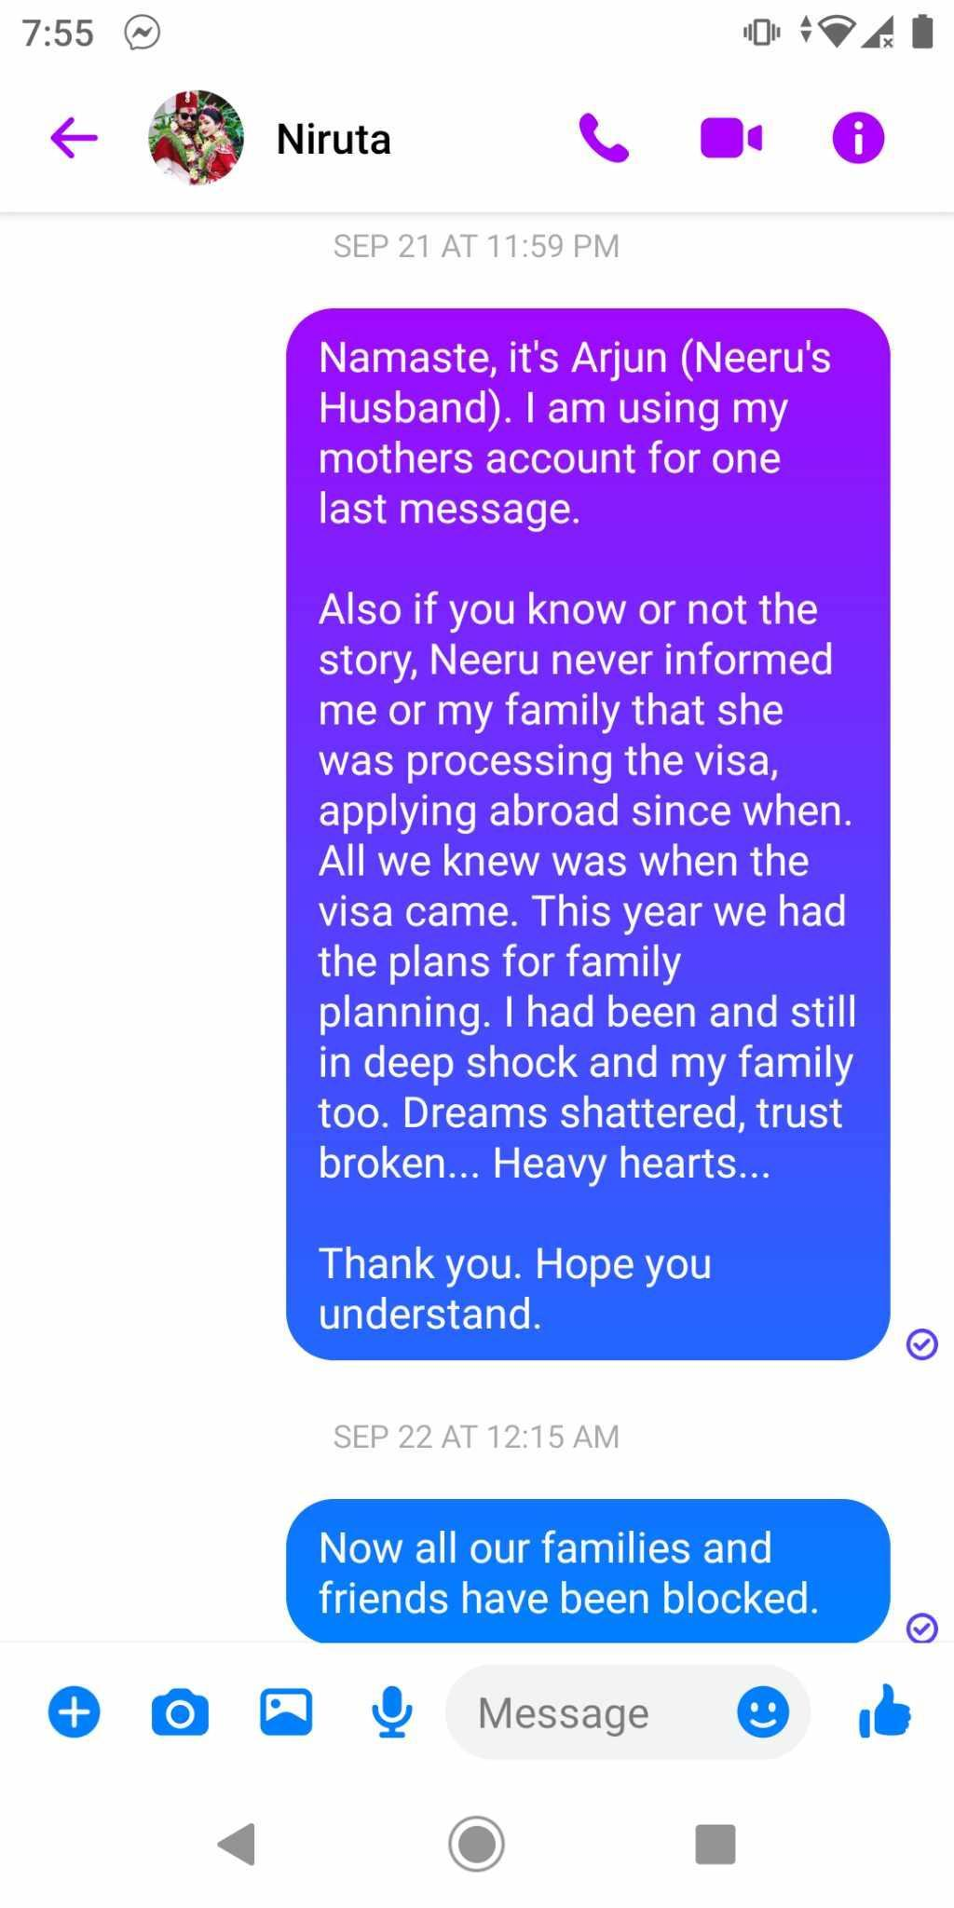
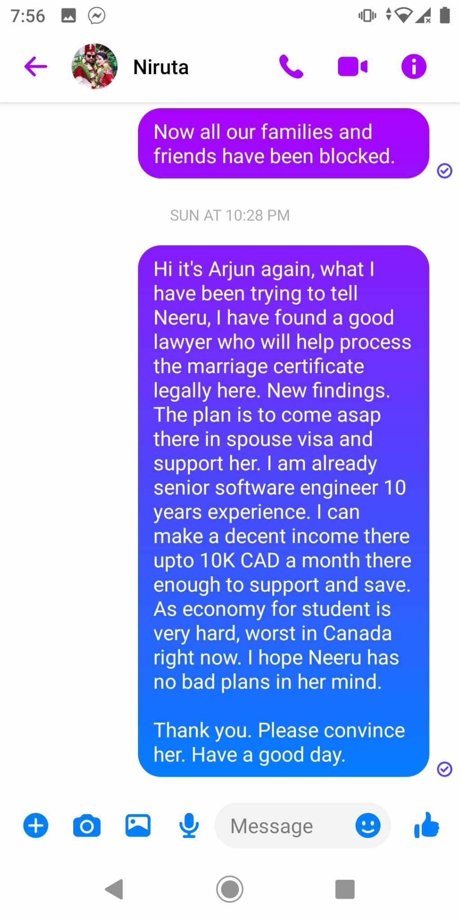
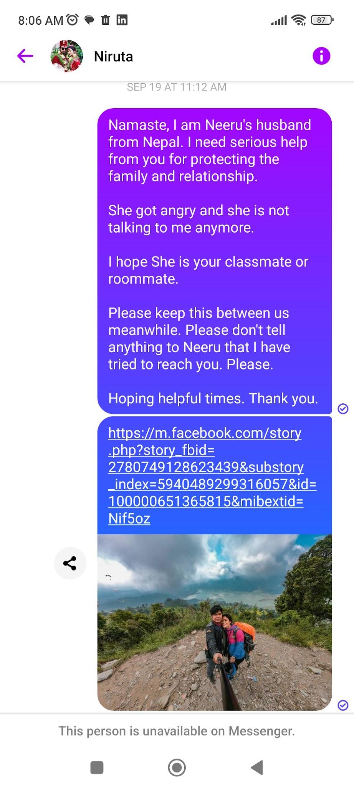

International courier:

DHL: $25-$45
FedEx: $30-$50
UPS: $25-$45
International mail:

Canada Post: $5-$10

https://www.facebook.com/tmgsubagni?mibextid=2JQ9oc

Sagita Sapkota Adhikari Shankar Raj husband wife
Niruta Ghatani

https://instagram.com/nirjarajwellers?igshid=NTc4MTIwNjQ2YQ==

https://www.facebook.com/sheela.shrestha.9400?mibextid=ZbWKwL

https://www.facebook.com/profile.php?id=100011092748131&mibextid=kFxxJD

Sudha Shrestha

Suhan Silwal

Rajesh Biswakarma
https://www.facebook.com/profile.php?id=61550512186344&mibextid=haYZDX
https://www.instagram.com/niru_ghalan/

https://www.facebook.com/profile.php?id=100011040672814

https://www.tiktok.com/@niru02ghalan

https://www.linkedin.com/in/niru-ghalan-a76b3828b
https://www.linkedin.com/in/sangita-sapkota-5b3755149?lipi=urn%3Ali%3Apage%3Ad_flagship3_notifications%3Bfl%2BTuuSWQCKPsGl4Qecg8w%3D%3D

Sault College Calendar 2023-2024
Saltec 2023-2024.pdf
Holiday
Dec 15, 2023 - Jan 8, 2024
April 19 - May 6, 2024
Aug 16 2024 - September 2024

June July August September Full Time work Summer month $3000 per month average…
Other months $1500 per month average …
Job Opportunity | Years of Experience | Salary  per year | Degree (in field)
Healthcare Administrator | 2-5 years | $65,000 - $95,000 | Bachelor's degree in healthcare administration, business administration, or a related field
Clinical Manager | 3-6 years | $70,000 - $100,000 | Bachelor's degree in nursing or a related field
Healthcare Consultant | 5-10 years | $80,000 - $150,000 | Bachelor's degree in healthcare administration, business administration, or a related field
Healthcare Information Manager | 5-10 years | $80,000 - $150,000 | Bachelor's degree in health informatics, health information management, or a related field
Patient Safety and Risk Management Coordinator | 3-6 years | $65,000 - $95,000 | Bachelor's degree in healthcare administration, nursing, or a related field
Healthcare Policy Analyst | 5-10 years | $75,000 - $125,000 | Bachelor's degree in healthcare administration, policy analysis, or a related field
Program Director | 5-10 years | $80,000 - $150,000 | Bachelor's degree in healthcare administration, business administration, or a related field
Director of Nursing | 10-15 years | $100,000 - $180,000 | Bachelor's degree in nursing or a related field
Healthcare Educator | 5-10 years | $65,000 - $100,000 | Bachelor's degree in healthcare education, health promotion, or a related field
Healthcare Researcher | 5-10 years | $70,000 - $120,000 | Bachelor's degree in healthcare research, health sciences, or a related field

Role | Salary Range | Experience  years | Education in a related field
Clinical Coordinator | $65,000 - $85,000 | 2-5 | Bachelor's
Team Leader | $70,000 - $90,000 | 3-6 | Bachelor's
Charge Nurse | $75,000 - $95,000 | 4-8 | Bachelor's in nursing or a related field
Department Manager | $80,000 - $110,000 | 5-10 | Bachelor's
Assistant Director | $90,000 - $130,000 | 7-12 | Master's
Department Manager | $100,000 - $150,000 | 8-15 | Master's
Program Manager | $110,000 - $160,000 | 10-15 | Master's
Director | $130,000 - $180,000 | 10-15 | Master's
Executive Director | $160,000 - $220,000 | 15-20 | Master's
Vice President | $180,000 - $250,000 | 15-25 | Master's
Chief Executive Officer (CEO) | $250,000 - $500,000 | 15-30 | Master's
Chief Operating Officer (COO) | $220,000 - $450,000 | 15-30 | Master's
Chief Financial Officer (CFO) | $200,000 - $400,000 | 15-30 | Master's

Passport issue date
13 september 2021

IELTS 3 March 2022
Listening 6.0 Reading 6.5 Writing 6.0 Speaking 7.0
Overall Band Score 6.5
CEFR Level B2

During the summer, PG students in Brampton can potentially earn an average of $3,000 per month from part-time work.This is because they are eligible to work full-time during the summer months.
The summer months in Canada: June, July, August, September.

Other months: Average of $1500 per month.

Keep Looking...
Thanks for blocking me....
Arjun...

Plus:
Here is a more detailed breakdown of the salary range for software engineers in Brampton and Toronto:
Senior-level: $100,000 - $120,000
Lead-level: $120,000 - $150,000
Executive-level: $150,000+

Trivikram…
Family issue?
How much loan?
PG?
How much bank interest?
Part time job conditions?
How long???
How consultancy helped in Relocation???

Nepal Embassy Plan

Greyhound Canada
Megabus
FlixBus
You can book tickets on the bus company's website or through a third-party website such as Busbud

Brampton to Ottawa bus fair $200
Ottawa one night stay $200 with food and lodging
$500 all set...

Rs. 5000 to send courier
Gage Park: Park with a wading pool, events & weekly concerts in the warm months, plus an ice rink in winter. It has a 4.6 star rating on Google Maps.

Garden Square: Chill town square & gathering place known for special events & proximity to a variety of local eats. It has a 4.5 star rating on Google Maps.

Historic Bovaird House: 1850s Georgian-style farmhouse featuring period exhibits, tours & a shop selling local crafts. It has a 4.6 star rating on Google Maps.

Claireville Conservation Area: Protected area of wetlands, valleys, forests, grasslands & the west branch of the Humber River. It has a 4.4 star rating on Google Maps.

Eldorado Park: Riverside park featuring an outdoor pool with chairs & umbrellas, 5 picnic areas & 2 playgrounds. It has a 4.5 star rating on Google Maps.

Chinguacousy Park
Heart Lake Conservation Park
Claireville Conservation Area
Brampton Fairgrounds
Peel Art Gallery Museum & Archive

