Business Comms…

25 Feb 2024
+977 985-1071504
Birgunj, mini desk lathe
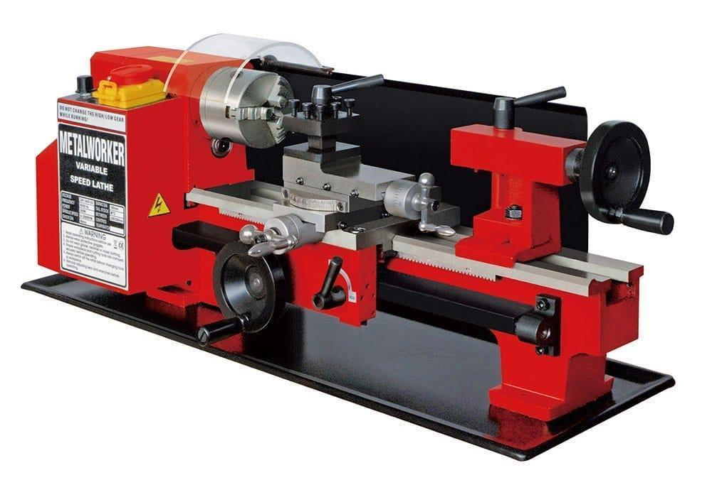
PRICE catalog? Ktm supplier, warranty, repair service, servicing…

Do they have CNC mill, CNC lathe?
Cost to import 5 axis CNC?

