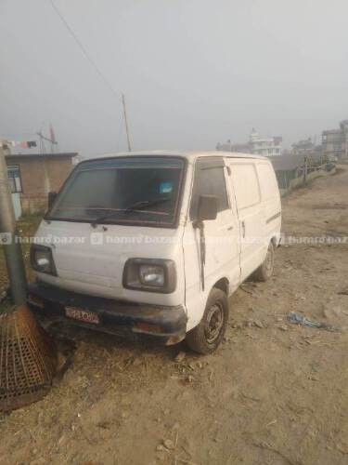  Sasto 1 lakh van  https://hamrobazaar.com/cars/maruti-suzuki/maruti-cargo-van-in-lalitpur/f85555a8faa74f5fb8cad3694babff20 | 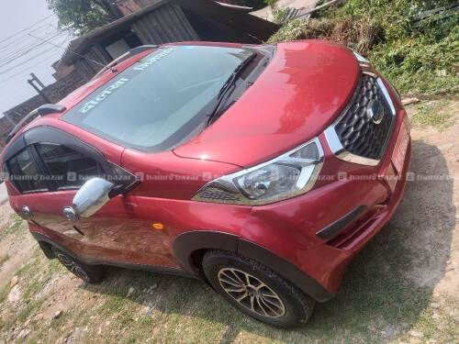  1000cc redi go  Rs 10,00,000  https://hamrobazaar.com/cars/datsun/datsun-redi-go-in-lalitpur/88e32dd624f44af2969137e7a97b4f09 | 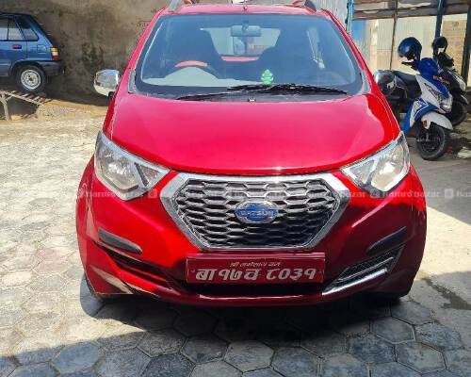  Redi go 800cc  890,000  https://hamrobazaar.com/cars/datsun/2016-ko-redi-go-sell-in-nepal/70972db84d224b6ea574b0030020db96
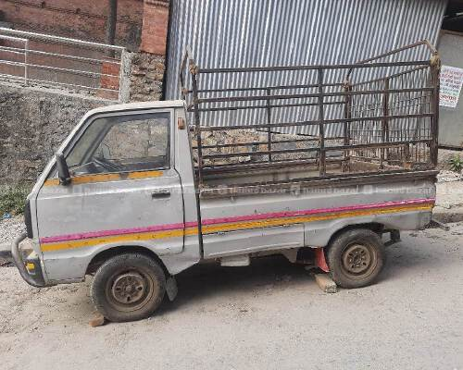  Rs. 180,000  https://hamrobazaar.com/cars/other-brands/pik-up-van-in-nepal/68689f24e6854e939b2eb06b5ef14c22 | 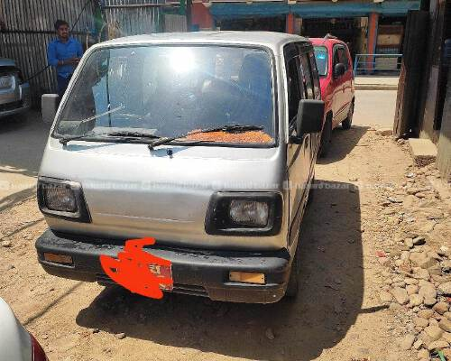  2,20,000  https://hamrobazaar.com/cars/maruti-suzuki/maruti-seater-van-tax-cleared-in-nepal/7210b06318ca40a69b43600b78816020 | 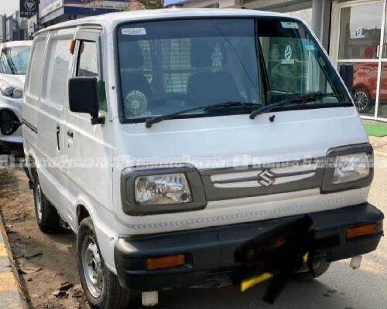  2,50,000  2007 full dent pent cargo van  https://hamrobazaar.com/cars/maruti-suzuki/2007-full-dent-pent-cargo-van-in-bhaktapur/f031bdc0a26546b8840ce0a05e064865
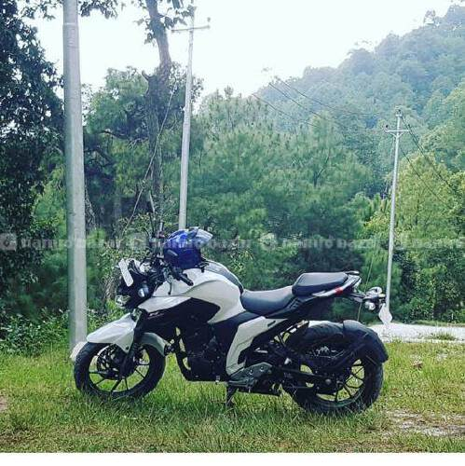  1,50,000  https://hamrobazaar.com/motorcycles/yamaha/fz250-in-kathmandu/4c03dc1354dd4068bc2d3f6ad05f8eaa | 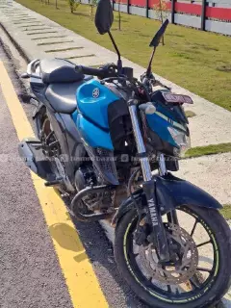  150,000  https://hamrobazaar.com/motorcycles/yamaha/yamaha-fz25-in-kathmandu/c0fad6140e4449cfb2310b324821d433 | 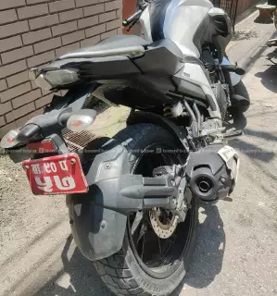  160,000  https://hamrobazaar.com/motorcycles/yamaha/yamaha-fz-25-make-year-ba-90-pa-57-in-nepal/31f66fe5bb294db59d0a56f8b895dd88
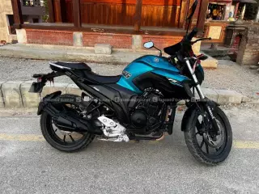
160,000
https://hamrobazaar.com/motorcycles/yamaha/yamaha-fz250-in-lalitpur/8055291974ae417ab65ea9b0f734a571
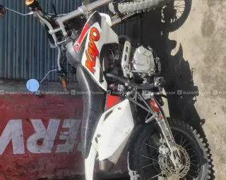  200,000  https://hamrobazaar.com/motorcycles/other-motorcycle-brands/dirt-bike-in-nepal/e767efc4b4634ccaba5c7ea7c96eee32 | 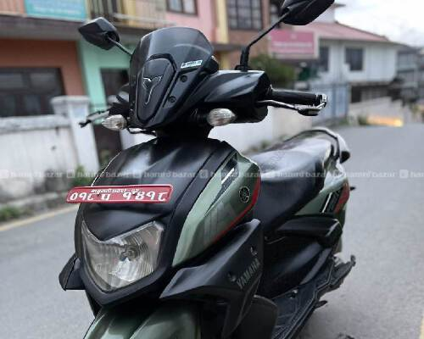  1,79,000  https://hamrobazaar.com/motorcycles/yamaha/yamaha-ray-zr-rally-125-fi-bs6-model-in-nepal/85403f49af1b447ebb8166f46b3252f7 | 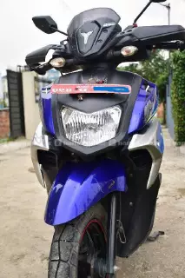  220,000 (dec 2021)  https://hamrobazaar.com/motorcycles/yamaha/yamaha-ray-zr-rally-125-fi-bs6-model-in-kathmandu/2d7397fec45d4e46a57e4d4002b54cc7
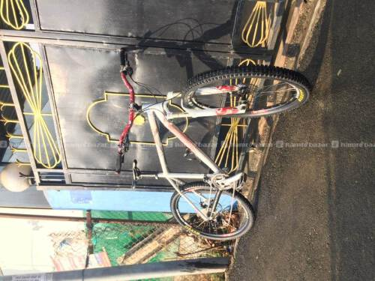  Sunn primx 1 - size 18 - 1.9kg  MTB Frame & Handlebar  7000  https://hamrobazaar.com/bicycle-parts-accessories/mtb-frame-handlebar-in-kathmandu/59aef26b9e854ca284f12cbe8510e32d | 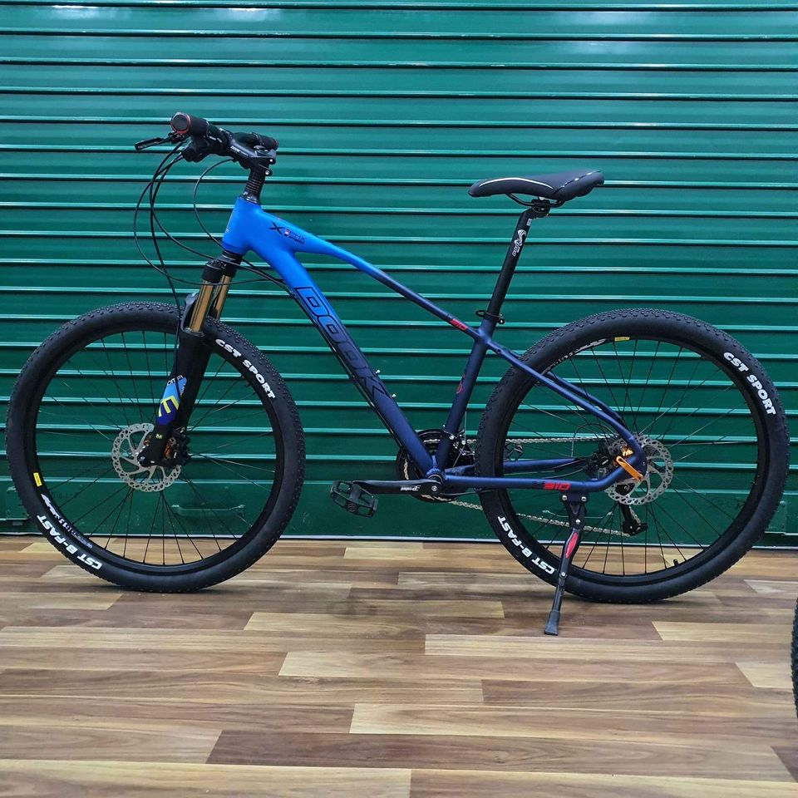  Dook 3*10  40000  https://www.facebook.com/marketplace/item/881623253106111https://www.facebook.com/marketplace/item/881623253106111

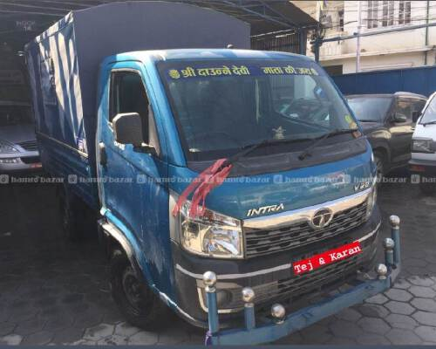
Tata Intra v20
16,50,000

