THAPAR INSTITUTE OF ENGINEERING AND TECHNOLOGY, PATIALA
Department of Computer Science and Engineering

JeevanSetu: AI Assisted Clinical Triage, Referral and Routing System with Human in Loop

Capstone Project Proposal

Submitted by:
(102303595) Priyanshu Patel
(102315167) Bhumika Bandyopadhyay
(102315176) Arjun Singh
(102303698) Krish Garg
(12303001) Arpita Verma
BE Third Year CSE

CPG No. 187

Under the Mentorship of
Dr. Garima Singh
Associate Professor, Department of CSE

March 2026

TABLE OF CONTENTS

Mentor Consent Form…………………………………………………………………3
Project Overview………………………………………………………………………4
Problem Statement……………………………………………………………….……5
Need Analysis…………………………………………………………………………6
Literature Survey……………………………………………………………...………7
Objectives…………………………………………………………………………..…9
Methodology…………………………………………………………………………10
Project Outcomes and Individual Roles……………………………………...………11
Work Plan………………………………………………………………………….…12
Course Subjects………………………………………………………………………13
References……………………………………………………………………………14

It is hereby agreed to serve as the mentor of the following Capstone Project Team:

JeevanSetu: AI Assisted Clinical Triage, Referral and Routing System
Roll No. | Name | Signature
102303595 | Priyanshu Patel
102315167 | Bhumika Bandyopadhyay
102315176 | Arjun Singh
102303698 | Krish Garg
12303001 | Arpita Verma

NAME of Mentor: Dr. Garima Singh
SIGNATURE of Mentor: ____________________________
NAME of Co Mentor: N/A
SIGNATURE of Co Mentor: ____________________________

PROJECT OVERVIEW
The current healthcare triage system faces major challenges due to fragmented data, manual processes, and lack of real time coordination. In busy emergency environments, doctors and nurses often have to make critical decisions with incomplete or poorly structured information. Important patient details like vital signs or medical history can be missed or recorded incorrectly, leading to wrong prioritization and delays in treatment. At the same time, hospitals operate in silos with limited visibility into available specialists, beds, or resources. This often results in patients being transferred to facilities that are not equipped to handle their condition, wasting valuable time during the most critical moments.

The proposed project, JeevanSetu, aims to address these issues by building an AI powered clinical triage and referral system that focuses on safety and accuracy. The platform gathers patient data from multiple sources and analyzes it in real time to ensure that all critical information is complete and reliable before any decision is made. Instead of blindly processing incomplete data, the system flags missing or inconsistent inputs and alerts the medical staff to take corrective action. Once the data is verified, it intelligently matches patients with the most suitable hospital and specialist based on factors like urgency, availability, and required expertise, enabling faster and more informed decision making.

By improving data quality, reducing manual workload, and enabling better coordination between healthcare providers, this system can significantly improve patient outcomes. It minimizes delays in emergency care, reduces the chances of misrouting patients, and supports medical staff with clear, structured insights instead of raw data. In addition, it helps hospitals optimize resource utilization and maintain better visibility across the system. Overall, JeevanSetu aims to make the triage and referral process safer, faster, and more efficient, ensuring that patients receive the right care at the right time without unnecessary delays.

PROBLEM STATEMENT
The current healthcare system, especially in emergency and triage situations, faces major challenges due to fragmented data, lack of coordination, and heavy reliance on manual processes. Patient information is often incomplete or scattered across different systems, making it difficult for doctors and nurses to get a clear and accurate understanding of a patient's condition. As a result, critical decisions are made under pressure with limited data, which can lead to delays, incorrect prioritization, and inefficient use of hospital resources.

In addition to this, there is very little real time visibility into hospital capacity, specialist availability, and treatment readiness. Patients are often transferred without proper coordination, leading to situations where the required doctor or facility is not available upon arrival. This not only wastes valuable time but also increases the risk for critical patients. The lack of structured and reliable data also makes it difficult for hospital administrators to monitor operations, identify bottlenecks, and improve overall efficiency in the system.

The proposed project, JeevanSetu, aims to address these challenges by building an AI powered clinical triage and referral platform. The system ensures that all critical patient data is complete and verified before any decision is made, reducing the chances of errors caused by missing information. It also enables smarter patient routing by matching cases with the right specialists and hospitals based on real time data. By improving data quality, coordination, and decision making, the platform aims to make healthcare delivery faster, safer, and more efficient, ultimately improving patient outcomes and reducing delays in critical care.

NEED ANALYSIS
The healthcare system, especially in emergency and triage scenarios, involves multiple stakeholders including patients, triage nurses, doctors, hospitals, ambulance services, and administrators. Since these actors operate under time critical conditions, strong coordination and smooth flow of accurate information are essential. However, current systems rely heavily on manual processes and fragmented data, making it difficult to ensure timely and effective decision making. Improvements cannot be achieved by focusing only on one part of the system, as efficient care delivery depends on proper coordination across patient intake, diagnosis, referral, and treatment.

1. Growing Need for Better Decision Support
Medical staff require timely and reliable decision support to assess patient conditions accurately and prioritize cases effectively. Traditional methods and incomplete data often lead to incorrect judgments, which can delay critical care.

2. Need for Better Coordination Between Healthcare Units
Patient routing decisions must be aligned with real time availability of specialists, hospital capacity, and required medical facilities. Stronger coordination between emergency units, hospitals, and specialists is therefore needed.

3. Need for Transparency and Trust in Clinical Decisions
As patients move through different stages of care, systems that ensure transparency, data accuracy, and accountability are increasingly important to build trust and reduce errors.

4. Need for Reduction in Delays and Operational Inefficiencies
Significant time is lost in manual paperwork, referral creation, and communication gaps. Better planning and automation are required to reduce delays, especially during critical emergencies.

5. Need for Reduced Cognitive Load on Medical Staff
Doctors and nurses operate under high stress and must process large amounts of information quickly. Systems that simplify workflows and provide clear, structured insights are essential to support them.

6. Need for Practical and Inclusive Digital Solutions
Due to varying infrastructure, connectivity, and resource availability across healthcare centers, solutions must be simple, scalable, and adaptable to different environments.

The strengthening of the healthcare triage and referral system is important not only at the hospital level but also at a broader network level. By improving coordination, visibility, and decision making, delays in treatment can be reduced and patient outcomes can be significantly improved. Hence, the need for an integrated, intelligent, and data driven system is strongly highlighted to make healthcare delivery faster, safer, and more efficient.

LITERATURE SURVEY

1. AI Assisted Medical Referral Triage
Goal: Prioritizing patient letters based on clinical urgency to reduce specialist workload.
Limitation: Static models lack medical trust and fail to handle the nuanced reasoning required for life-critical decisions.
Solution: LLM reasoning is used to understand medical nuance and a mandatory Human in the Loop step is incorporated to ensure clinical accountability [1].

2. Interoperable Predictive Models (HL7 FHIR)
Goal: Connecting hospital databases for seamless, standardized patient data flow.
Limitation: Critical data is often trapped in incompatible silos, leading to fragmented and incomplete patient profiles.
Solution: FHIR compliant MIMIC-IV data is ingested to create a unified stream that provides a comprehensive view of the patient [2].

3. Multi Agent Clinical Pipelines
Goal: Using specialized AI agents (Triage, Routing, Scrub) to handle specific parts of the workflow.
Limitation: Complex workflows risk cascading failures where an error in one agent corrupts the entire referral path.
Solution: A Node.js/Python Orchestration layer acts as a supervisor, ensuring all agents remain synchronized and accurate [3][4].

4. Explainable AI (XAI) in Decision Support
Goal: Making AI logic transparent so doctors understand the reasoning behind every urgency tag.
Limitation: Automation bias can lead doctors to blindly trust AI outputs without critically verifying the underlying logic.
Solution: A React Dashboard visualizes the AI step by step reasoning, allowing clinicians to audit decisions before finalizing [5].

5. Retrieval Augmented Generation (RAG) for Guidelines
Goal: Grounding AI decisions in official standards (such as ICMR) to prevent hallucinations.
Limitation: If a system retrieves the wrong section of a medical manual, the resulting triage logic will be fundamentally flawed.
Solution: Pinecone Vector DB is used to precisely map guidelines, ensuring every decision includes a verifiable citation [7].

6. Real Time Resource Mapping (Graph Database)
Goal: Finding the best hospital based on real time bed availability and specialty connections.
Limitation: Traditional relational databases are too slow and rigid to map complex, changing relationships between facilities.
Solution: A Neo4j Graph Database is used to instantly calculate the optimal routing path based on real world facility connections [6].

Conclusion
The existing healthcare systems address specific components such as data storage, advisory, emergency response, and hospital management. However, they lack integration into a unified system that supports real time, data driven decision making during critical situations. A major gap exists in handling incomplete data, coordinating between multiple stakeholders, and ensuring accurate patient routing. Therefore, there is a need for a system that integrates fragmented healthcare data sources, analyzes patient conditions and system constraints in real time, and provides safe, reliable, and intelligent triage and referral decisions.

OBJECTIVES
A comprehensive and technology enabled solution is proposed to improve healthcare triage and referral systems by focusing on real time decision making, accurate documentation, and better coordination across hospitals. The objectives of the project are as follows:

To Enable Intelligent Clinical Triage
The system is intended to assist in assessing patient conditions using available data, identifying critical cases, and ensuring that no important clinical information is missed during initial evaluation.

To Automate and Standardize Referral Documentation
Referral reports are intended to be generated automatically in a structured format, reducing manual effort and ensuring that all necessary patient details are accurately captured.

To Provide Smart Patient Routing Across Hospitals
The system is intended to match patients with appropriate hospitals and specialists based on their condition and availability, reducing delays and avoiding incorrect transfers.

To Develop a Real Time Monitoring Dashboard for Administrators (CMO Dashboard)
A centralized dashboard is intended to provide insights into patient flow, hospital capacity, delays, and system performance, enabling better decision making at the administrative level.
METHODOLOGY
The methodology for the proposed AI assisted medical triage, routing, and referral system is structured across five key phases: Knowledge Ingestion and Data Preparation, Input Processing and Safety Layer, AI Assisted Triage Decision Engine, Hospital Routing and Referral Generation, and Human in the Loop Validation, Monitoring and Testing. Figure 1 presents the overall system architecture and information flow.

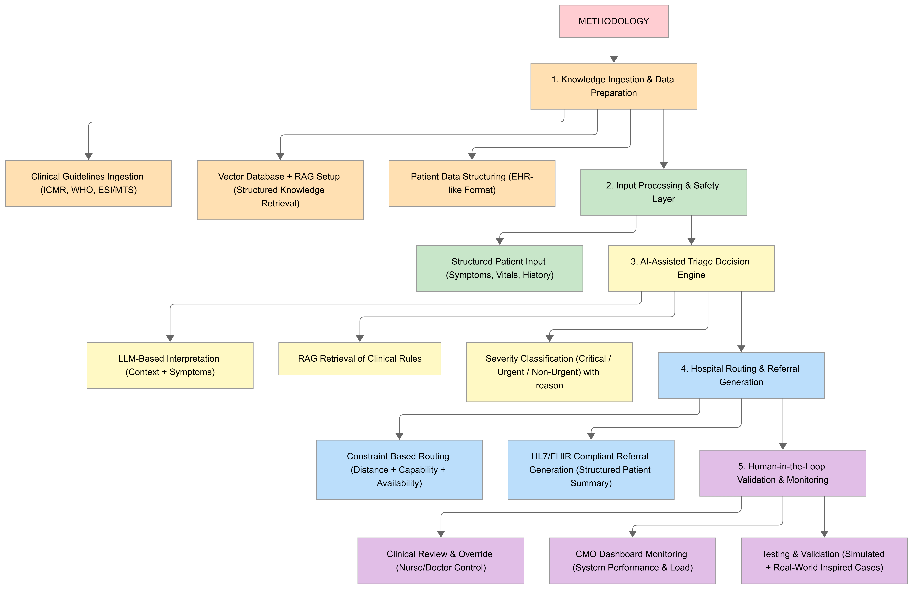
Figure 1. System architecture and methodology flow for JeevanSetu. (Refer to: https://ibb.co/HL1n5xfK for the detailed flow diagram.)

1. Knowledge Ingestion and Data Preparation
The system begins by ingesting validated clinical guidelines such as ICMR approved protocols, WHO emergency care guidelines, and standardized triage frameworks like ESI and MTS. These are structured and stored for retrieval during runtime using a RAG based approach. Patient data is also organized in a structured, EHR like format inspired by real world datasets. This phase ensures that both medical knowledge and patient inputs are standardized and reliable.

2. Input Processing and Safety Layer
Patient inputs including symptoms, vital signs, and medical history are collected through a structured interface and validated for completeness. A rule based safety layer is applied to detect life threatening conditions such as cardiac arrest, stroke, or severe trauma. These conditions are immediately classified as critical, overriding any AI based decision to ensure patient safety.

3. AI Assisted Triage Decision Engine
A hybrid decision system is used where AI interprets patient symptoms and context, supported by retrieval of relevant clinical guidelines. This layer handles complex or non obvious cases and assigns a severity level along with reasoning. All decisions remain constrained by the safety layer. Importantly, this system is designed as a decision support tool, where AI assists but does not replace clinical judgment.

4. Hospital Routing and Referral Generation
Based on the triage outcome, the system selects the most appropriate hospital by considering required medical facilities, distance, and availability. It ensures that patients are directed to the nearest capable hospital. A structured referral document is automatically generated, compliant with HL7 FHIR standards, enabling consistent and interoperable communication between healthcare facilities.

5. Human in the Loop Validation, Monitoring and Testing
A core aspect of the system is the human in the loop mechanism, where nurses or doctors actively review AI generated triage decisions, routing suggestions, and referral outputs. They have full authority to accept, modify, or override the system's recommendations, especially in critical or uncertain cases. This ensures safety, accountability, and real world usability. Additionally, a centralized dashboard provides system level monitoring of triage accuracy, routing efficiency, and hospital load. The system is validated using real world inspired and synthetic scenarios to ensure reliability before deployment.

PROJECT OUTCOMES AND INDIVIDUAL ROLES
Expected Deliverables
AI Assisted Triage.
The system provides real time decision support for patient triage using symptoms, vitals, and history. It classifies severity levels and assists medical staff in making faster, more consistent decisions.

Intelligent Hospital Routing and Referral Pipeline.
The system suggests the most appropriate hospital based on capability, distance, and availability. It automatically generates structured referral documents and ensures seamless coordination between hospitals.

User Friendly Clinical Interface.
A simple and intuitive interface for nurses and staff is developed to input patient data and receive AI assisted recommendations, reducing cognitive load and improving workflow efficiency.

CMO Dashboard for System Monitoring.
A centralized dashboard provides insights into triage accuracy, hospital load, referral trends, and system performance to support administrative decision making.

Reduction in Delays and Improved Care Coordination.
By enabling faster triage decisions and correct hospital routing, the system reduces treatment delays, minimizes re transfers, and improves overall emergency care efficiency.

Individual Team Member Roles
Table 1 presents the individual responsibilities assigned to each team member for the execution of the capstone project.

Table 1. Individual roles and responsibilities of project team members.
Roll No. | Name | Role | Responsibilities
102303595 | Priyanshu Patel | Backend, GenAI and Agent Orchestration | Backend and GenAI workflows; triage and routing orchestration.
102315176 | Arjun Singh | Backend, RAG and Deployment | RAG, backend logic, and deployment handling.
102315167 | Bhumika Bandyopadhyay | UI/UX and Frontend Development | UI/UX design; seamless frontend development.
102303698 | Krish Garg | Frontend Development | Frontend features; dashboard integration.
12303001 | Arpita Verma | Testing and Validation | Testing, validation, and bug fixing.

WORK PLAN
The project is planned to be executed over a twelve month period spanning January to December 2026. Table 2 presents the Gantt chart illustrating the scheduled phases and their temporal overlap. The Data Integration and Processing phase is presently in progress.

Table 2. Project work plan (Gantt chart) from January to December 2026.
Phase / Month | Jan | Feb | Mar | Apr | May | Jun | Jul | Aug | Sep | Oct | Nov | Dec
Data Integration & Processing
AI System Design & Core Development
Interface & Core System Components
Triage, Routing & Referral Engine
Deployment & Testing
Final Rollout & Reporting

The milestones associated with each phase are listed below:

January to March 2026: Data collection and integration of patient datasets, hospital capability data, and referral data. Implementation of semi automated data ingestion and structuring of triage-related information (symptoms, vitals, severity levels).
February to April 2026: AI system design and configuration. Development of initial triage logic (rule based and basic ML) and setup of models for severity prediction.
April to June 2026: Development of nurse interface and core system components for triage input, decision display, and backend integration.
June to August 2026: Implementation of triage decision engine, hospital routing logic (based on distance, capability, availability), and automated referral generation.
August to October 2026: System integration and testing. Validation of triage accuracy, routing decisions, and referral workflows using simulated scenarios. UI/UX refinement.
November to December 2026: Final deployment of the prototype, documentation, performance evaluation, and preparation for final presentation and reporting.

COURSE SUBJECTS
Table 3 lists the undergraduate course subjects whose conceptual knowledge and practical skill sets are expected to be applied during the execution of the capstone project.

Table 3. Course subjects and their relevance to the capstone project.
UCS411 | Design and Analysis of Algorithms | Core system for triage decision making, reasoning, and routing logic.
UML501 | Database Management Systems | Models for severity prediction, triage classification, and risk scoring.
UCS420 | Cognitive Computing | Automated referral document generation and patient data summarization.
UCS420 | Artificial Intelligence | Assisting human decision making under uncertainty in emergency scenarios.
UMA035 | Machine Learning | Efficient implementation of triage and routing logic.
UCS415 | Database Management Systems | Managing patient records, hospital data, and referrals.
UCS310 | Software Engineering | Building scalable and maintainable system architecture.
UCS503 | Computer Networks | Real time data exchange between hospitals and systems.
UCS414 | Optimization Techniques | Selecting optimal hospital based on constraints (distance, capacity, capability).
UCS303 | Operating Systems | Handling real time processing and system level resource management.

REFERENCES

[1] Guzman, J., et al. (2026). Artificial intelligence in medical referrals triage based on Clinical Prioritization Criteria (CPC): A similarity based reasoning approach. ResearchGate / Digital Health Journal. Published March 2026.

[2] Kumar, A., and Sharma, V. (2026). AI Powered Predictive Models for Patient Referral Resolution: Leveraging HL7 FHIR for Cross Institutional Data Ingestion. International Journal of Medical Informatics. Published February 2026.

[3] Zhao, X., et al. (2025). Self Correction Loops and Supervisor Agents in Clinical LLM Pipelines. Journal of Biomedical Informatics.

[4] Patel, R., et al. (2026). Impact of Transformer based NLP Models on Diagnosis and Acronym Disambiguation in Emergency Care. BMC Medical Informatics and Decision Making. Published February 2026.

[5] Hussain, M., et al. (2026). Explainable AI (XAI) for Clinical Decision Support: Enhancing Transparency through reason in Referral Prioritization. Scientific Reports. Published March 2026.

[6] Ilic, M., et al. (2025). Graph Database vs Relational Database: A Comparative Study for Interconnected Clinical Data. InterSystems / IEEE Digital Library.

[7] Mugambiwa, T., and Ndlovu, B. (2026). Multi Agent Retrieval Augmented Generation for Clinical Decision Support: A Systematic Review. Journal of Applied Informatics and Computing.

